Bristol Airport Limited
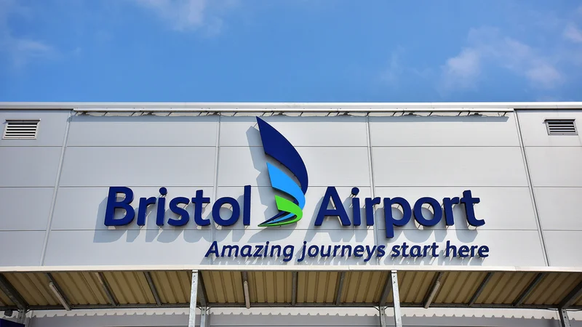

Green Electricity Generation using
Wind Turbines

Generation of electricity from waste rapid moving air:
It is proposed that this project will look at the potential for utilising the exhaust/waste fast moving air generated by an aircraft’s jet turbine engine during take-off (also known as Jet Blast), to power wind turbines and generate green electricity for the airport, while also contributing towards Bristol Airports plan of becoming net carbon zero by 2030.

Background:
Bristol Airport is located within the Mendip Hills in North Somerset, South-West England. As Bristol Airport sits relatively high at 192 meters above sea level, the airport and surrounding areas can encounter severe weather conditions. In 1940 the RAF used the airfield for training in low cloud conditions (bad weather) due to its elevated location. In 1957 it was opened as Bristol (Lulsgate) Airport. Over the past decade, passenger numbers and flights have been growing rapidly and the Airport is quickly heading towards 12 million passengers a year, just shy of Birmingham’s push for 14 million passengers and Edinburgh’s 15 million passengers. (Statista, 2023)
During Bristol Airport’s first wave of departures between 05:30 and 09:00, there are typically 40 departures every morning, not to mention the rest of the of the days movements which averages an additional 80 departures. (BRS, 2023)
With around 120 departures throughout the day and each aircraft producing an enormous amount of fast-moving air (jet blast), there could be an opportunity to harness this kinetic energy and convert it into green electricity using wind turbines.

Proposal:
As Bristol Airport is growing at an alarming, yet exciting rate, there will be a requirement for a greater maximum electricity demand/capacity. As Bristol Airport already utilising green electricity, and has recently commissioned a 1.5 MW solar farm, it is felt that there is still room for further improvement. This project will look at different types of aircraft that fly from Bristol Airport, along with their jet blast air speeds and their jet blast radius/areas affected. Different aircrafts have different engines and will therefore displace different amounts of air.
As the area to be analysed is an active runway, there are many different regulations to consider. The airfield is governed to operate to the regulations put in place by the Civil Aviation Authority (CAA). There are many instruments within the airfield that guide/assist an aircraft to depart and land safely and within certain tolerances of the runway. A possibility as to whether a wind turbine can be erected on the airfield will be considered and whether it will cause interference to the extremely sensitive instruments that assist departing/arriving aircrafts. Figure 1 shows an aerial view of Bristol Airport’s airfield, and the red circle indicates the area of investigation for potential turbine installation.
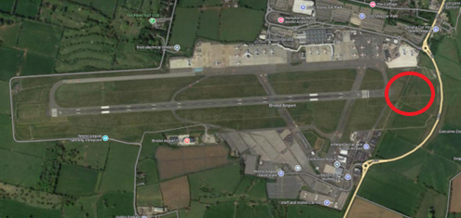
Figure 1 (Google, 2023)
This project will look at several different types/models of wind turbines (some concept and some already in manufacture) and obtain specialist data of each product and compare them to understand their pros, cons, and potential impact they may have to the operation of the airfield.
As there are many different wind turbines and all have different costs to procure and install, along with different levels of efficiencies, all will be analysed, and the cost-to-profit/benefit ratio will be looked at to see if the project would be beneficial to the airport and contribute towards obtaining net carbon zero.
The project will work with manufacturers to ensure their product is suitable for an airfield due to the harsh weather conditions and wind speeds (from the jet blast) the turbine will be encountering. While working with the manufacturers the design of the product will be analysed and the potential for future designs and implementations could be discussed to enable their product to be used for different applications around the airfield. Figures 2-5 show three possible wind turbines to be investigated for suitability.
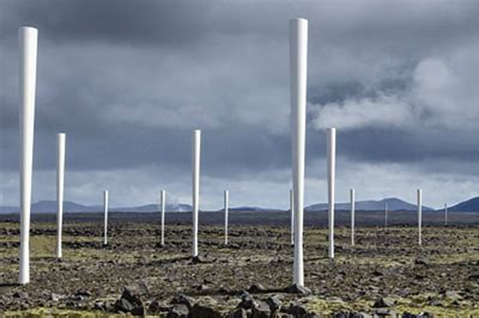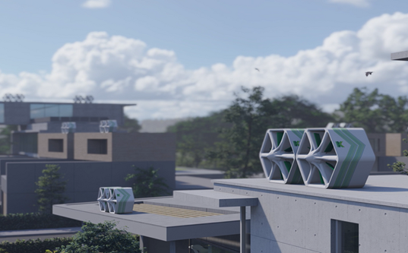
Figure 2(Vortex, 2023) Figure 3 (Hope, 2022)

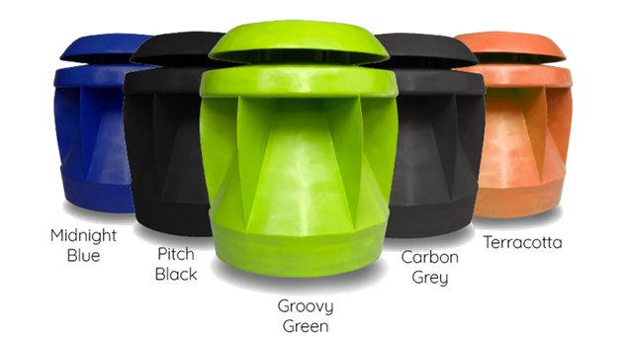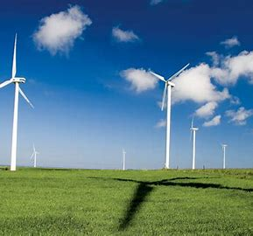
Figure 4 (Powerpod, 2023) Figure 5 (Wonderful Engineering, 2014)

Each product will have its own pros and cons, and different efficiencies and levels of power generation.
The project will engage with several different departments within the Airport including Airside Operations, National Air Traffic Services (NATS), Engineering, Health and Safety, Procurement, and Development to work collaboratively and obtain as much information as possible to understand the potential impact of installing a bladeless wind turbine within a critical part of the airfield and the effect it may have on the operation.
Manufactures of wind turbines have been contacted via email, to obtain further information and to try and establish if their product would be suitable for this particular environment (they are yet to reply).
If a product is determined acceptable to be tested on the live airfield, then this project will look to carry out live testing when the weather conditions improve in the spring of 2024. Before any testing can be approved, it must be proved with certainty that there will be no interference/impact to any instrumentation and not cause any obstacle for a departing or arriving aircraft. It is hoped that by December 2023, a decision on a suitable product can be made and progress to agreeing regulation compatibility agreed.

Conclusion
In conclusion, the project will determine if wind turbine technology is suitable for use within an airfield to harness wasted kinetic energy and produce green electricity, while abiding with CAA regulations. If this can be obtained, then a soft test will be carried out to gain calculations of energy generation and practicality of the chosen product. An evaluation will be made as to whether or not, installing such a product will assist or hinder the Airport and its operation.

References
BRS. (2023, September). Arrivals and Departures.
Google. (2023). Google Maps.
Hope, B. (2022). Katrick Technologies’.
Powerpod. (2023). Powerpod.
Statista. (2023). Average Annual Numbers in UK Airports.
Vortex. (2023). Vortex Bladeless.
Wonderful Engineering. (2014). 38 Wind Turbines from around the world.

