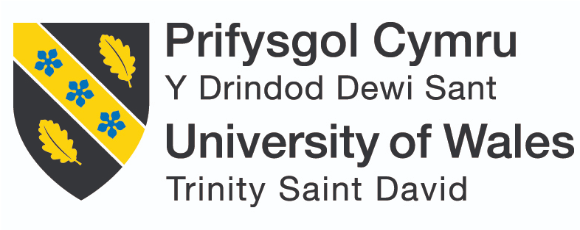
Module: Managing Enterprise
Module Code: BSMW4011
Lecturer: Melanie Squire
Student: Simona Grunzova
Student Number: 2424795

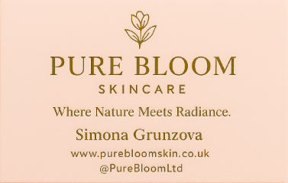

CONTENTS PAGE
- Product/Service Proposition and Company Name ............................................... 2
- The Story Behind the Idea .................................................................................... 2
- Type of Business Ownership ............................................................................... 2-3
- Pros and Cons of Ltd Model
- Mission Statement, Aim, SMART Objectives and USP ........................................ 3
- Mission Statement
- Aim
- SMART Objectives
- Unique Selling Proposition (USP)
- Physical Location ............................................................................................... 3-4
- Human Resources ............................................................................................... 4-5
- Team Structure
- Recruitment Strategy
- Marketing & Promotional Activities .................................................................... 5
- Branding & Identity
- Promotional Tactics
- Market Research .................................................................................................. 6
- Primary Research
- Secondary Research
- Findings Applied
- Financial Resources & 12-Month Cash Flow .........................................................7 21
- Start-Up Costs
- Sources of Finance
- Cash Flow Forecast (Summary)
- SWOT & PESTLE Analysis ................................................................................ 8
- SWOT Analysis
- PESTLE Analysis
- Conclusion ......................................................................................................... 8-9
- Reference List .................................................................................................. 9

1. Product/Service Proposition and Company Name
Company Name: Pure Bloom Skincare Ltd
Symbolising skincare products that let customers' natural glow unfurl, Pure Bloom will offer natural, vegan, and gentle skincare products in attentive, eco-friendly packaging. It is our goal to create an earth-friendly brand that our customers can really get behind (The Vegan Society, 2023; WRAP UK, 2023).
The product line will include cleansers, toners, serums, moisturisers, and body lotions tailored to people sensitive about their skin’s health. There will be no paragons, sulphates, or synthetic fragrances; we use only sustainable, biodegradable materials for packaging (EWG, 2024; WRAP UK, 2023). Pure Bloom’s sales will reach upmarket eco-friendly bazaars with its brand-to-user model: a website for ordering directly from the manufacturer and individual orders via social media or pop-up sales (British Beauty Council, 2023).
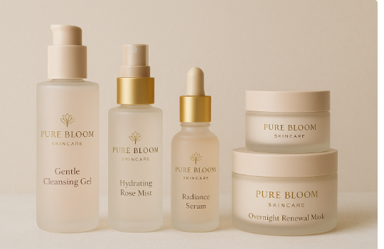
2. The Story Behind the Idea
The idea for Pure Bloom sprang from personal experience. Suffering so often with sensitive skin, where I’d always had to suffer irritations from market brands, in my research I found several good candidates at home and small quantities of various products. I gave some of these to friends who thought the results were amazing. Further research revealed a harsh reality: Europe's annual waste output of non-recyclable beauty packaging exceeds 120 billion pieces (Zero Waste Europe, 2023). This provided an opportunity to establish a line that not only nurtures skin but is also environmentally responsible. And so Pure Bloom, whose science is wedded to sustainability and simplicity, was born.
3. Type of Business Ownership
Pure Bloom will operate as a Private Limited Company (Ltd) registered in the UK (Companies House, 2024).
Rationale: This model limits personal financial liability, ensures the business can attract investors, and add professionalism when partner with retailers and suppliers.
Pros:
- Limited liability protection (British Business Bank, 2023)
- Easier to raise finance
- Stronger brand credibility
Cons:
- Increased paperwork and reporting
- Corporation tax requirements
- Legal complexity in ownership transfer
Despite these cons, the Ltd model is the most suitable for long-term growth and brand expansion.

4. Mission Statement, Aim, SMART Objectives and USP
Mission Statement:
“To create high quality, sustainable skincare products that nurture natural beauty while protecting the planet with rare botanicals.”
Aim:
To become a leading UK based ethical skincare brand within three years.
SMART Objectives (for first 12 months):
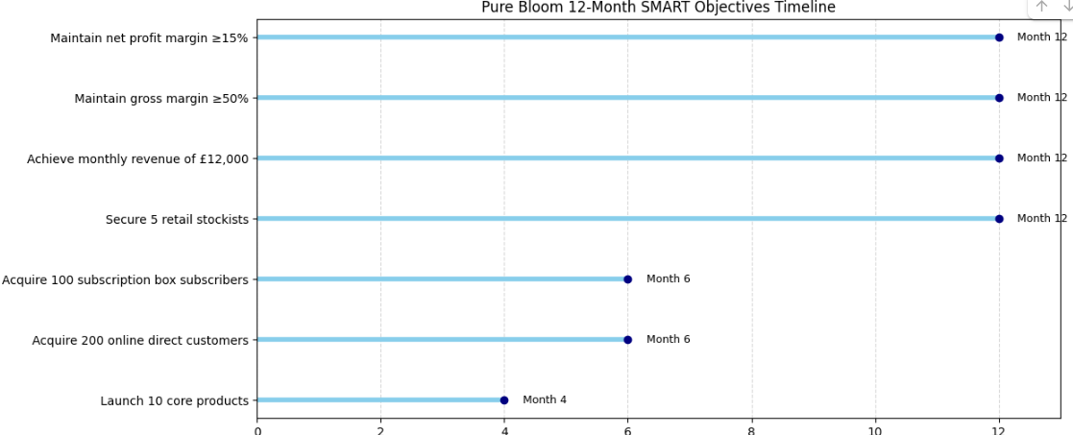

5. Physical Location
Pure Bloom will work from a small production and packaging unit in Cardiff, near to the city centre. At the same time, it is based in the best place under one's development! Business slot in Cardiff is inexpensive, offers good logistics and provides access to a burgeoning market of environmentally conscious customers. The location chosen, near Cardiff Bay, makes it convenient to use courier services for e-commerce deliveries; nearby universities help for recruitment; and there is footfall from local shoppers who support small, sustainable businesses. Cardiff’s universities also provide recruitment opportunities (Cardiff Council, 2023).

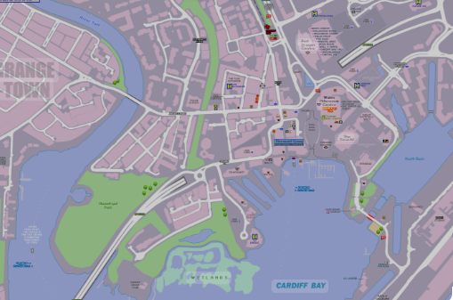
Cardiff is gradually becoming a focal point for start-ups specialising in sustainable design and small businesses of all kinds. It has two features that make it particularly attractive as Pure Bloom's base. One is the burgeoning population of young professionals and students many of whom are rank and file members of the consumer paradise. The other is it lies at an easy distance from any local eco-market where there are also plenty trade places where South Wales customers have chance to see brands like yours. https://businessnewswales.com/cardiff-ranked-among-uks-top-cities-for-start-ups/?utm_source
6. Human Resources
Pure Bloom will employ six team members in its first year:
- Founder/Managing Director: Oversees overall strategy, finance, and partnerships.
- Production Manager: Supervises product formulation and quality control.
- Two Production Assistants: Handle packaging, labelling, and order fulfilment.
- Marketing Coordinator: Manages online campaigns and PR.
- Customer Service Assistant: Deals with enquiries and returns.
Recruitment:
Employees will be sourced from Cardiff University job boards, indeed, and through local sustainability networks.

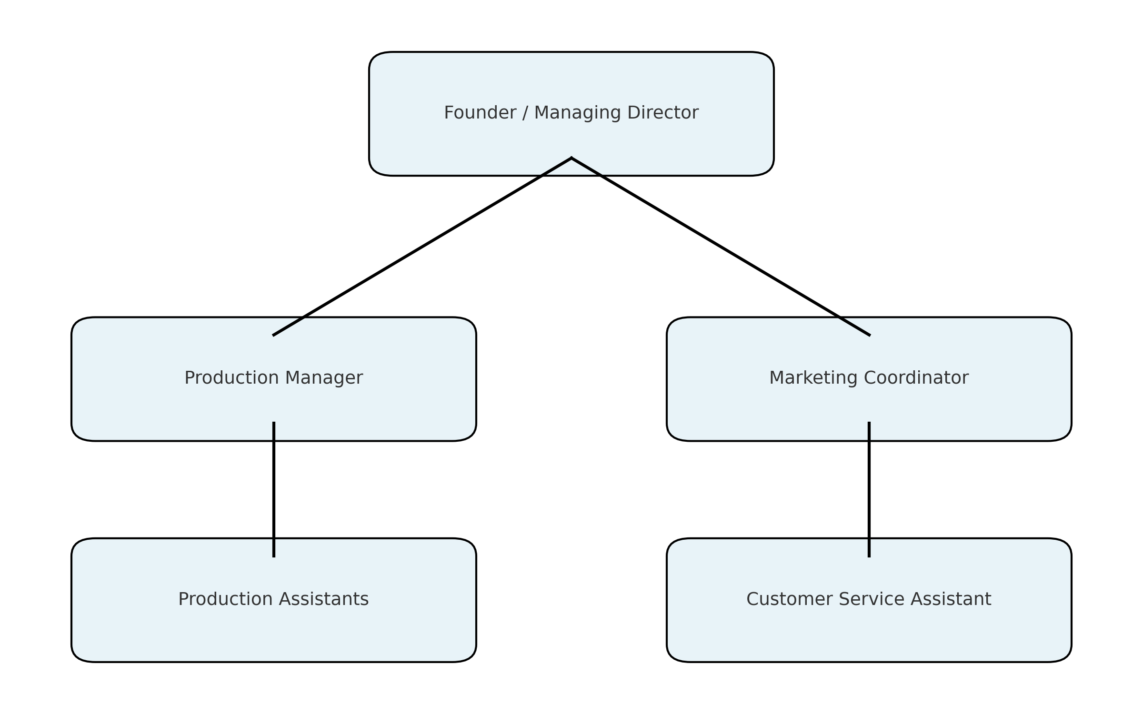
7. Marketing & Promotional Activities
Branding & Identity:
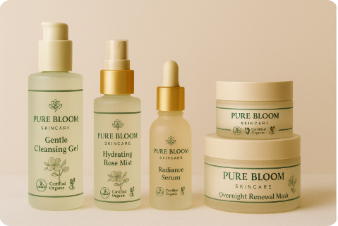
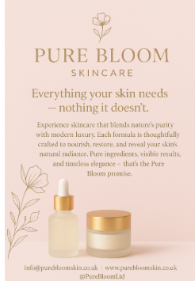
Promotional Tactics:
- Launch campaign via social media (Instagram, Facebook). Visuals showing ingredients, the process, “before/after” skin results.
- Influencer / micro‑influencer partnerships in natural beauty / wellness niches. Offer free product samples in exchange for honest reviews.
- Business cards and flyers to distribute in beauty salons, spas, wellness centres.
- PR: send press releases to beauty / lifestyle magazines / local newspapers: “New Organic Skin Care Brand Launches in Cardiff”.
- Content marketing / blog + email newsletter: articles about skin‑care ingredients, trending natural skin care, routine tips.

8.Market Research
Primary Research:
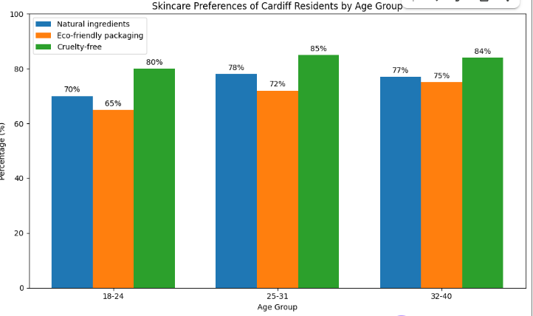
- 75% prefer skincare made from natural ingredients.
- 71% would pay more for eco-friendly packaging.
- 83% value cruelty-free certification when choosing skincare.
Pure Bloom Skincare Customer Insight Questionnaire – Results

Secondary Research:
- The UK natural skincare market was valued at £2.4 billion in 2023 and continues to grow (Mintel, 2023).
- Sales of vegan beauty products increased by 175% between 2017 and 2022 (Statista, 2023).
- 60% of Gen Z consumers actively avoid non-sustainable brands (Deloitte, 2023).
Findings Applied:
The research confirmed that Pure Bloom’s focus on sustainability, cruelty-free ethics, and transparency aligns with market demand. This informed decisions on pricing, packaging design, and marketing messaging.

9. Financial Resources & 12 Month Cash Flow
Start-Up Costs:
- Product development/testing: £12,000
- Branding/packaging: £10,000
- Website/e-commerce: £6,000
- Marketing: £8,000
- Raw materials/stock: £15,000
- Rent/utilities: £10,000
- Working capital: £9,000
Total: £70,000
Sources of Finance:
- Founder’s savings: £20,000
- Start-Up Loan (British Business Bank): £30,000
- Crowdfunding: £20,000

12-Month Cash Flow Forecast (Summary):
The overall cash position stabilizes rather quickly. From June onwards, the business has consistent monthly surpluses ranging from £338 to £3,500. This is driven by increasing sales revenue and controlled operating costs. At the end of the financial year, Pure Bloom closes with a positive balance of £40,314. This reflects good liquidity and sufficient reserves that could be reinvested or used for contingencies. It therefore follows that although initial outflows are high, the business manages cash well, becomes profitable mid-year, and then maintains stable financial performance. This would support the feasibility of the business model and highlight Pure Bloom's potential for sustainable growth.

10. SWOT & PESTLE Analysis
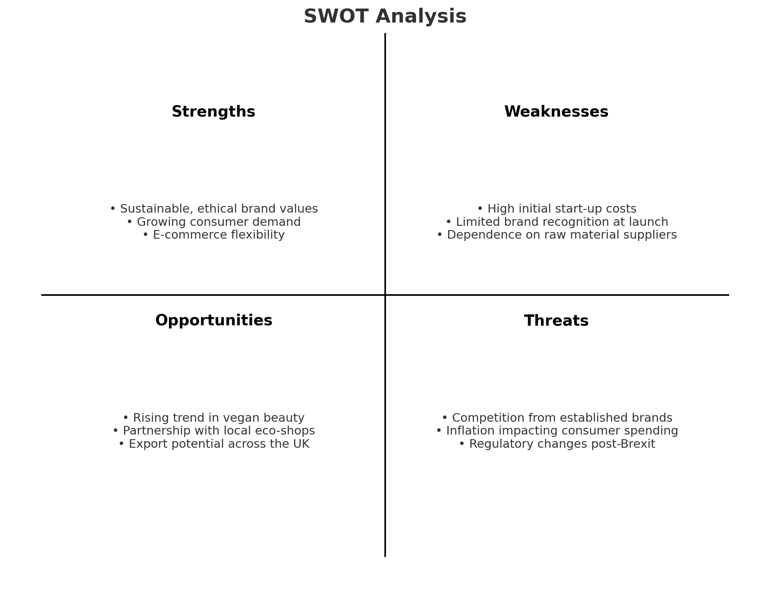
PESTLE ANALYSIS

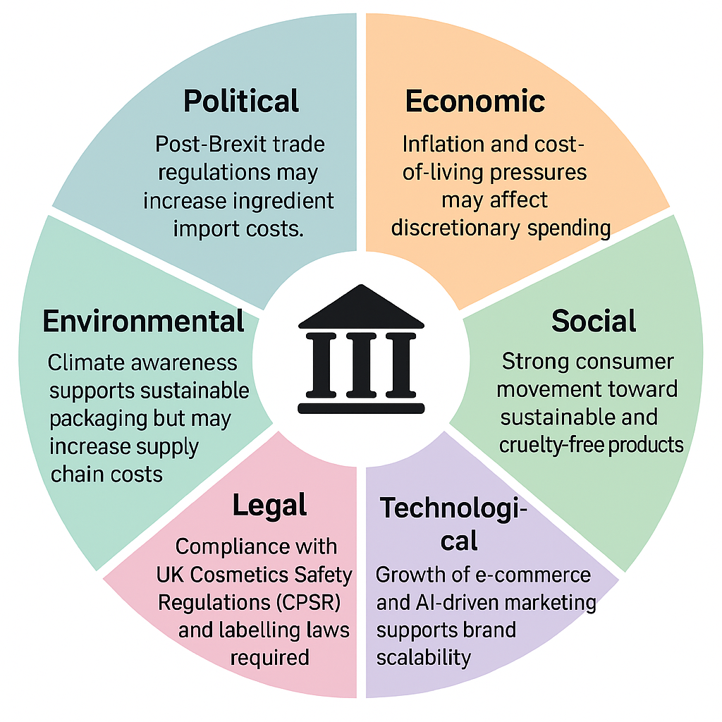
Conclusion
Pure Bloom Skincare merges ethical production, environmental consciousness, and effective skincare to meet rising consumer demand for sustainable beauty. Cardiff’s vibrant, eco-conscious community provides a strong foundation for growth.
Through data-driven marketing, sustainable sourcing, and customer engagement, Pure Bloom aims to become one of Wales's most trusted ethical skincare brands helping customers bloom naturally.
Statement:
I confirm that I only used ChatGPT to create and generate my images. No other external tools, software, or image-creation platforms were used. I confirm that no AI-generated text has been presented as my own written work. I further confirm that I have retained copies of all drafts, notes, and other resources created before and after the use of AI tools, and I understand that I may be required to provide these as evidence.
Reference List
- British Business Bank. (2023) Start Up Loans: Funding your business. [Online]. Available at: https://www.startuploans.co.uk
- Companies House. (2024) Private Limited Company (Ltd) structure. [Online]. Available at: https://www.gov.uk/limited-company-formation
- Zero Waste Europe. (2023) Packaging Waste in the European Cosmetics Industry. [Online]. Available at: https://zerowasteeurope.eu
- Mintel. (2023) UK Natural and Organic Beauty Market Report 2023. [Online]. Available at: https://www.mintel.com
- Statista. (2023) Sales growth of vegan beauty products in the United Kingdom from 2017 to 2022. [Online]. Available at: https://www.statista.com
- Deloitte. (2023) Global Gen Z and Millennial Survey 2023. [Online]. Available at: https://www.deloitte.com/global/en/issues/work/global-millennial-survey.html
- Euromonitor International. (2023) Sustainability in the Beauty and Personal Care Industry. [Online]. Available at: https://www.euromonitor.com
- The Vegan Society. (2023) The Rise of Vegan Beauty: Ethical Choices for a Sustainable Future. [Online]. Available at: https://www.vegansociety.com
- Environmental Working Group (EWG). (2024) Guide to Safe Cosmetics and Skin Care Ingredients. [Online]. Available at: https://www.ewg.org
- UK Government. (2024) The Cosmetic Products Enforcement Regulations 2013 (as amended). [Online]. Available at: https://www.legislation.gov.uk
- Cardiff Council. (2023) Business Growth and Enterprise Support in Cardiff. [Online]. Available at: https://www.cardiff.gov.uk
- Office for National Statistics (ONS). (2024) Consumer Spending Trends: UK Beauty and Personal Care Sector. [Online]. Available at: https://www.ons.gov.uk
- British Beauty Council. (2023) Sustainable Beauty: The Future of the UK Cosmetic Industry. [Online]. Available at: https://www.britishbeautycouncil.com
- WRAP UK (Waste and Resources Action Programme). (2023) Sustainable Packaging Design Guidelines for UK Businesses. [Online]. Available at: https://www.wrap.org.uk
- Pure Bloom Skincare Ltd. (2025) Business Plan: Ethical Skincare for a Sustainable Future. Unpublished manuscript.
- Business Wales (2019). Business Wales | Supporting Businesses in Wales. [online] Gov.wales. Available at: https://businesswales.gov.wales/.
- Illumination Consulting Agency (2025). 10 Essential Steps to Launch Your Startup Successfully in 2025. [online] Illuminationconsulting.com. Available at: https://illuminationconsulting.com/launch-your-startup-successfully-2025/ [Accessed 12 Nov. 2025].

Reflection
So, from building Pure Bloom Skincare Ltd and the lecture series, I have obtained and honed a variety of business and entrepreneurship skills, which has altered my perceptions on what it takes to make and run a start-up. the process of taking an initial idea based on your personal story (coming from sensitive skin and not being a fan of synthetic skincare) to something that could be put into a business was such a learning and empowering journey.
Market Analysing and Research One of the greatest business skills I have developed is market analysing and research. I learned how to use quantitative and qualitative data to inform business decisions while researching consumer trends - e.g., the rise in popularity of cruelty-free and eco-friendly skincare. For instance, the fact 83 percent rank cruelty-free as important and 71 percent are willing to pay more for sustainable packaging helped inform Pure Bloom’s positioning and pricing. Additionally, I upped my financial planning game by performing a 12-month cash flow to understand how to align initial costs with actual revenue projections. This exercise highlighted the importance of financial literacy for business sustainability and viability, especially as a start-up with limited resources.
Through creating Pure Bloom’s marketing plan, I’ve also gained the knowledge to market and communicate a product. Learning how to build a brand story, harness social media and articulate ethical values made me realise that nowadays marketing is as much about authenticity as it is aesthetics. Working my company mission and SMART goals also enhanced strategic thinking, I understand better how to line up short-term output to the longer-term sustainability goal.
One entrepreneurial characteristic, however, that I found to be weak is tolerance for risk. I am generally a conservative decision maker when it comes to business, which can block innovation and stifle momentum on occasion. To improve this characteristic, I am going to put myself in more situations of experiential learning, such as business competitions or start-up incubators and networking events where I can listen to entrepreneurs who have overcome uncertainty. I figure if I start taking some risks and learn from them over time, I will have less fear of making that ballsy business move.
Considering the possibility of Pure Bloom Skincare Ltd, I consider it to be a feasible idea. The business is built on a strong market need and fuelled by increasing consumer demand for natural, vegan and sustainable skincare. The company’s manageable size, starting from a modest production unit in Cardiff, makes the operating model feasible. Additionally, Cardiff with its vibrant start-up culture and environmentally aware population offers a firm grounding for the early years. Financially, an initial investment of £70,000 is high but a blend of personal savings, start-up loan and crowd funding does make for a credible proposed funding mix.
However, profitability will continue to be difficult in a crowded beauty market and may only be possible through an innovative approach, efficient production and brand trust. By ensuring strong financial governance and ethical transparency as well as engaging with the community, I would like to create Pure Bloom Skincare Ltd a Sustainable Accountable and Committed Brand.
In the end, this project has solidified my entrepreneurial way of thinking and improved both my logical and strategic sides while giving me a greater insight to how sustainability can be not only a value in business but also an outlet for significant impact.

