Marketing plan
Component A
BMIH4005
Shereen Garraghan
2242394
Table of Contents
Introduction 3
Situation analysis 3
Objective 6
Strategy 6
Tactics 7
Action 8
Control 8
Conclusion 8
References 9
Apeendix 12

Introduction
The study will summarise the SOSTAC model and 4p's along with the Ansoff matrix to demonstrate the digital marketing plan of Premier Inn. From the situation analysis, a brief introduction will be given about its customers, competitors as well and climates which have provided mixed experiences about its business growth. By discussing its digital marketing tactics and market entrance strategy It will introduce a proper marketing plan for Premier Inn. Recommendations will be given about different communication mix techniques such as advertisement, pay-per-click, public relations, and direct marketing to represent their service quality to the broader audience.

Situation analysis
SWOT Analysis
Strengths
The company offers their guests premium quality economical price through their hotel chain and their customer service has often won frequent awards from the industry (Premierinn, 2023a).
Weaknesses
Premier Inn's owner Whitbread has given predictions about higher costs after returning to profit in post-pandemic situations. Economic uncertainties in the UK have hampered its business (Reuters, 2023).
Opportunities
With their service quality, Premier Inn provides an opportunity for its customers to live and work well to create a positive impact on the world around us.
Threats
The hotel industry is very active in the UK so intense brand competition can pose a threat to the company's customers if it does not set its margin properly (Whitbread, 2023a).
Customers
Premier Inn's demographic segmentation includes a variety of components of age, gender and income (Hughesconsultancy, 2023).
Premier Inn mainly targets leisure customers. Total visit of the customer 8.9m. The bounce rate is 39.05%. There are 4.17 visits per page. Over the last three months, the global ranking of the company has increased (Similarweb, 2023).
Competitors
Perceptual positioning map
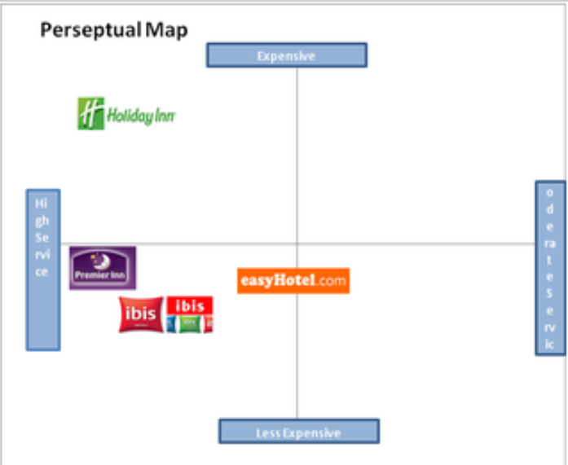
Figure: Perceptual map of Premier Inn
Source: ((Facebook, 2023).

Premier Inn has plenty of competitors in the market. Its nearest competitor Holiday Inn offers high service at an expensive price. Another competitor easyHotel provides an ordered service at a less expensive rate. Ibis Hotel Group is its other competitor which also offers high service at a much less expensive price than Premier Inn. Premier Inn provides high quality and low expensive service (Facebook, 2023).
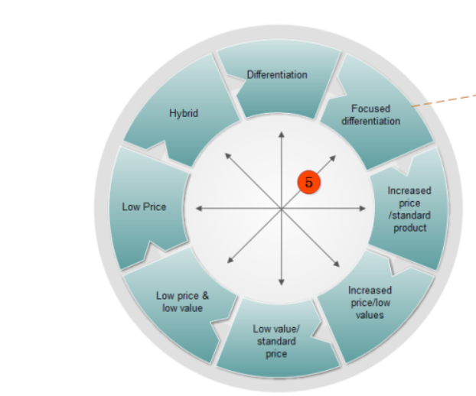
Figure: Bowman strategy clock
Source: (Praxie, 2023).

According to the Bowman strategy clock, there are 8 combinations of prices in which Premier Inn has chosen risky high margins because their customers are demanding high-quality products by keeping their prices low. It keeps them competitive in the marketplace (Praxie, 2023).
Collaboration
Premier Inn has made a strategic partnership with Emirates Group to create a major upgrade in its product (Premierinn, 2023b).
Climate
Political
The owner of the hotel brand has reported Brexit has caused a 40% profit fall in their annual profit (Theguardian, 2023).
Economic
Through recently conducted research, it has been figured out that loyal customers of the brand have spent £137 for their leisure purposes in the hotel (Whitbread, 2023b).
Social
Acute political and economic uncertainty has sometimes given short-term market challenges to the company (Travelweekly, 2023).
Technological
The company has adopted what3words location technology to guide its customers towards the right entrance. It has served positively to their business growth (Premierinn, 2023c).
Environmental
The hotel brand is committed to minimising the environmental impact on the world. And It is working towards it.
Legal
Just after the pandemic labour shortage issues in Premier Inn have brought to the forefront about its owner's bullish outlook (Reuters, 2021).
Marketing mix
Product
Premier Inn provides high-quality service by giving customers comfort first choice.
Price
Affordable pricing is their unique triumph card.
Place
Premier Inn supports multichannel marketing through its business app (Linkedin, 2023).
Promotion
The company applies different kinds of media marketing techniques by giving its customers a sneak preview of its service.

Objective
To encourage more open external business communication through their digital media marketing channel within 1 year.
Specific
To encourage more pen communication through their social media marketing channel Premier Inn will do more border customer research. It will help them to know about more customers' preferences and their ideas.
Measurable
The success of the objective will be achievable when Premier Inn is able to increase the visibility of media coverage. To measure the success of external communication they will focus on brand budding promotion (Iarusov and Nasir, 2018).
Achievable
Effective external communications will open up the avenue for business opportunities. So to achieve industry instinct through marketing plan organisations will engage themselves in strategic communication initiatives (Change management insight, 2023).
Relevant
This objective is relevant because it will enable them to see marketing opportunities through external marketing communication and help them to take the best option in the current climate.
Time-bound
This will be achievable within one year.

Strategy
Value proposition: "Force to Good" is the value which is compiled by Premier Inn as the company never ignores any scope to make justice to the business and the community. Serving surplus food to the community people pledging to become net zero and providing support to the life-changing work are some of the major initiatives which have been taken by the company. The company is in a leading position with respect of community support conducting big changes to change the world in a positive way (Premier Inn, 2023).
Ansoff’s Matrix
The services of Premier Inn required some new configuration in their marketing strategies which can make their brand reputation more conclusive and the poor customer feedback can be eradicated with new initiatives. There are four sectors of Ansoff's matrix including Market Penetration, Market Development, Product Development and Diversification. Among them, product development will fit with the current needs of Premier Inn (CFI, 2023).
Product Development: The state refers the company to develop new products or services in the existing market. Premier Inn needs to make its services more conclusive with variety and higher quality. Different ranges of hospitality and related entertainment must be included in the business. In the marketing mix, the product of the company needs some modification as boutique hotels need to be launched, more touch of nature into the residences is required to implement and luxury must be blended with affordability as well.

Tactics
RACE model
This model was created by Dave Chaffey in 2010. This is a digital marketing model which is going to be applied to Premier Inn digital marketing plan to promote their service (Chaffey and Ellis-Chadwick, 2019).
Reach
In This stage, Premier Inn will successfully target the right customer in the right way. Premier Inn will focus on building brand awareness through various online channels. They will make connections with the driving traffic like microstes as well as social media pages to target their customer To reach out to their customer they can use advertising techniques, personal selling techniques, and sales promotion techniques. Besides this, they can use public relations and direct marketing etc as their digital marketing strategy (Cgifurniture, 2023).
Act
In this stage, Premier Inn can directly encourage their customer through their communication channel to provide feedback about the service. In this stage, social media and website as well as website visitors will work through a marketing funnel to encourage customer interactions with the company. The company's goal will be to see their visitors' conversations among themselves and encourage them to take the next step about reflecting on their own experience with the product.
Convert
In this stage, the focus will be on paying customers. Their purchasing and service preference options will be monitored by Premier Inn (Ryan, 2016). The company will measure average order value through their digital marketing channel to guess its revenues as well as benefits. However, there can be drawbacks in this stage (Gondan and Minakata, 2016). Converting will help Premier Inn to make a deal and perceive payment for it. They can promote email marketing, Pay-per-click ads etc several kinds of communication mix options in this stage (Fourweekmba, 2023).
Engage
Finally, there will come the last stage of the model where Premier Inn is going to focus on the repeat purchase of their service by customers. They will check customer loyalty by using its frequency. They will also analyse the reason behind customer satisfaction in this stage. They will go for establishing proper engagement with their consumer which will be possible by establishing different kinds of communication techniques for their business in which their direct marketing, public relations advertising etc will be included (Consuunt, 2023).

Action
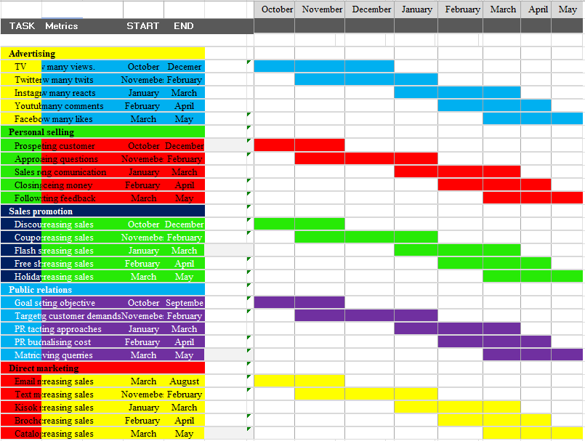
Table 1: Gantt Chart
(Source: Self developed)

Control
To seed out the high-quality service news across the broader customer base Premier Inn will encourage its employees as well as customers to give proper statements about their service improvements. The administrative committee of the Premier Inn will consider customer feedback and team retention as their key performance indicator (Whitbread, 2021).

Conclusion
The study has summarised the SOSTAC model and 4p's along with the Ansoff matrix to demonstrate the digital marketing plan of Premier Inn. From the situation analysis, a brief introduction has been made about its customers competitors as well and climates which has provided mixed experience about its business growth. By discussing its digital marketing tactics and market entrance strategy It has induced a proper marketing plan for Premier Inn. Recommendations can be given about different communication mix techniques such as advertisement, pay-per-click, public relations, and direct marketing to represent their service quality to the broader audience.

References
CFI (2023) Ansoff matrix, Corporate Finance Institute. Available at: https://corporatefinanceinstitute.com/resources/management/ansoff-matrix/ (Accessed: 20 October 2023).
Cgifurniture (2023) Race Marketing Model: 4 steps of performing a Digital Marketing Plan, CGI Furniture. Available at: https://cgifurniture.com/race-marketing-model-4-steps/ (Accessed: 20 October 2023).
Chaffey, D. and Ellis-Chadwick, F., (2019). Digital marketing. Pearson uk.
Changemanagementinsight (2023) 18 external communication KPI examples, CMI. Available at: https://changemanagementinsight.com/external-communication-kpi-examples/ (Accessed: 20 October 2023).
Consuunt (2023) Race planning, Consuunt. Available at: https://www.consuunt.com/race-planning/ (Accessed: 20 October 2023).
Facebook (2023) Log into Facebook, Facebook. Available at: https://m.facebook.com/academichelp1234/photos/perceptual-map-budget-hotel-industry/1622671714646445/ (Accessed: 20 October 2023).
Fourweekmba (2023) What is the race model?, FourWeekMBA. Available at: https://fourweekmba.com/race-model/ (Accessed: 20 October 2023).
Gondan, M. and Minakata, K., (2016). A tutorial on testing race model inequality. Attention, Perception, & Psychophysics, 78, pp.723-735.https://link.springer.com/article/10.3758/s13414-015-1018-y
Hughesconsultancy (2023) Premier inn’s bizarre market segment targeting on mass-media, Hughes Consultancy. Available at: https://www.hughesconsultancy.co.uk/premier-inns-bizarre-market-segment-targeting-on-mass-media/ (Accessed: 20 October 2023).
Iarusov, I. and Nasir, S., (2018). Marketing Plan: Case company:Standard.https://www.theseus.fi/handle/10024/155857
Praxie (2023) Bowman Strategy Clock Best Practices, tools & templates – the best free online resources, Praxie.com. Available at: https://praxie.com/bowman-strategy-clock-model-online-tools-templates/# (Accessed: 20 October 2023).
Premier Inn (2023) Force for good, Force for Good | About Us | Premier Inn. Available at: https://www.premierinn.com/gb/en/why/force-for-good.html (Accessed: 20 October 2023).
Premiering (2023b) Attractions & Partners, Premier Inn Hotel Partners and Tourist Attractions. Available at: https://mena.premierinn.com/en/attractions-partners (Accessed: 20 October 2023).
Premierinn (2023a) International development, Business | Premier Inn. Available at: https://www.premierinn.com/gb/en/business/international-development.html(Accessed: 20 October 2023).
Premierinn (2023c) What3words, News | Premier Inn. Available at: https://www.premierinn.com/gb/en/news/2019/what3words.html (Accessed: 20 October 2023).
Reuters (2021) Labour Shortages Cloud Premier Inn owner’s Bullish Outlook, Reuters. Available at: https://www.reuters.com/world/uk/premier-inn-owner-eyes-full-uk-recovery-2022-losses-narrow-2021-10-26/ (Accessed: 20 October 2023).
Reuters (2023) Premier Inn owner Whitbread warns of higher costs after returning to profit, Reuters. Available at: https://www.reuters.com/business/retail-consumer/premier-inn-owner-whitbread-turns-profit-leisure-travel-picks-up-pace-2022-10-25/ (Accessed: 20 October 2023).
Ryan, D., (2016). Understanding digital marketing: marketing strategies for engaging the digital generation. Kogan Page Publishers.
Similarweb (2023) Premierinn.com Traffic Analytics, ranking stats & tech stack - similarweb. Available at: https://www.similarweb.com/website/premierinn.com/ (Accessed: 20 October 2023).
Theguardian (2023) Premier Inn owner says Brexit uncertainty has hit bookings, The Guardian. Available at: https://www.theguardian.com/business/2019/apr/30/premier-inn-owner-brexit-bookings-whitbread-london (Accessed: 20 October 2023).
Travelweekly (2023) Premier Inn suffers from ‘acute political and economic uncertainty’, Travel Weekly. Available at: https://travelweekly.co.uk/articles/330491/premier-inn-suffers-from-acute-political-and-economic-uncertainty (Accessed: 20 October 2023).
Turton, D. (2023) What can brands learn from Premier Inn’s marketing masterclass?, LinkedIn. Available at: https://www.linkedin.com/pulse/20141011134315-45850910-what-can-brands-learn-from-premier-inn-s-marketing-masterclass/ (Accessed: 20 October 2023).
Whitbread (2023b) New Economic Analysis Shows Premier Inn guests contribute more than £3m each year to communities that host them, Whitbread PLC. Available at: https://www.whitbread.co.uk/new-economic-analysis-shows-premier-inn-guests-contribute-more-than-3m-each-year-to-communities-that-host-them (Accessed: 20 October 2023).
Whitbread (2021) Premierinnhotelslimited - cdn.whitbread.co.uk. Available at: https://cdn.whitbread.co.uk/media/2021/02/12122648/pihl-accounts-final-signed.pdf (Accessed: 20 October 2023).
Whitbread (2023) About Us, Whitbread PLC. Available at: https://www.whitbread.co.uk/about-us/ (Accessed: 20 October 2023).

Apeendix


