Name: Lee Hind
Student No.: 2124769
Module: Operational Policing Practice 3
Academic Assignment

Essay 1 –
How Effective is Crime Prevention Through Environmental Design (CPTED) as a Means of Reducing Crime?

Crime Prevention Through Environmental Design (CPTED) posits the notion that crime can be both prevented and discouraged by manipulation of the ‘built urban environment’ (Cozens and Love, 2015). CPTED has been prevalent throughout history, with concrete principles being observed as far back as 1285 with the Statute of Winchester, where landowners were held liable for removal of concealment opportunities for criminals, such as vegetation (Cozens; Love, 2015). Considering its continuation throughout history there is some legitimacy to its function, if only through persistence alone.
The term CPTED (“sep-ted”) was first coined by C. Ray Jefferey in 1971 (Jeffery, 1971), who further developed the concepts of ‘defensible space’ by engineer Oscar Newman (Neuman, 1972). Throughout the years, CPTED has undergone further development, culminating in the Dynamic Integrated Model for CPTED (Cozens, 2014).
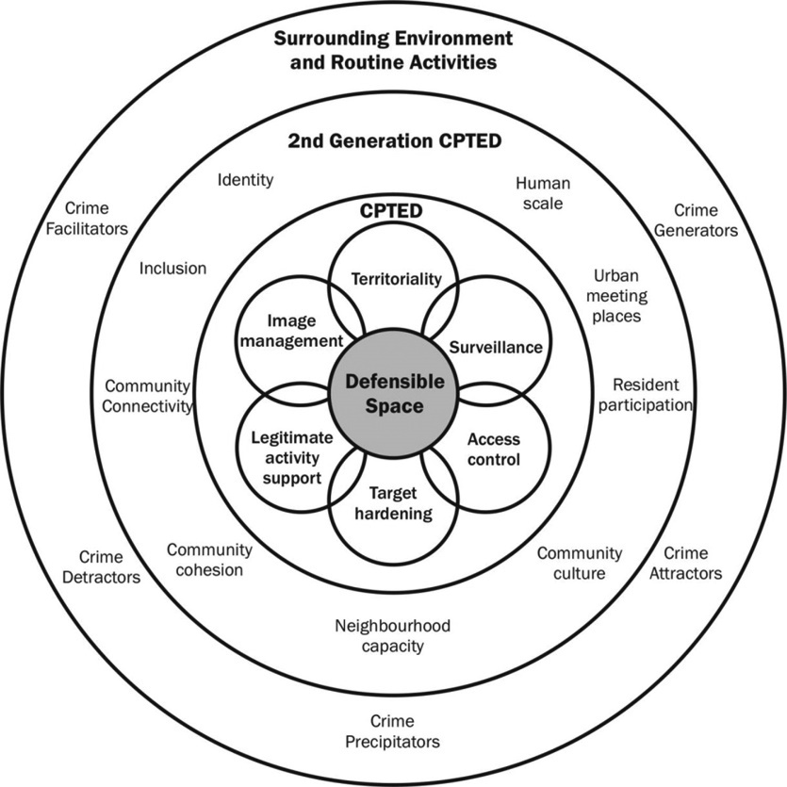
Figure 1 – (Cozens, 2014)
Figure 1 is the visual representation of CPTED in its most developed form, with the evolutionary aspects inhabiting the outer circles, encompassing the fundamental principles of Defensible Space and first generation CPTED. Defensible Space primarily focused on a residential setting, suggesting that the physical design, including its aesthetic, layout, upkeep, and environment, could promote the inhabitants to have agency in their own security (Newman, 1973). Newman having been influenced by J. Jacobs’ concept of the delineation of private and public space (Jacobs, 1961), argued that the built environment could facilitate criminal activity, as such, manipulating the built environment through defensible space could antithetically discourage it through community control of common terrain (Newman, 1973). This ideology evolved from the examination of social housing projects in New York, where higher criminality was observed in high-rise blocks as opposed to the low-level buildings. Due to the relative similarity of the inhabitants in terms of socioeconomic standing, the variable in this setting was the environmental design, with the high-rise buildings being more complex, maze like and having limited surveillance opportunities (Cozens and Love, 2015). Defensible Space and CPTED principles and research projects were extensively funded and promoted in the years since its inception, with most developed countries (US, UK, Canada, Australia etc.) adopting the principles in some capacity, applying them to not only residential settings, but also commercial, public, and healthcare settings. Again, whilst not providing empirical data supporting the efficacy of CPTED in crime prevention, mass adoption alone suggests legitimacy to the principles.
CPTED is as much a concept of behavioural psychology as of engineering, focusing on the relationship between environment and people (Cozens and Love, 2015). Traditional crime prevention relies on authoritative presence, such as police, however CPTED relies on environmental design. By controlling placement of windows, access points, street design and lighting, it increases the potential for intervention and apprehension through community engagement (Cozens and Love, 2015). By manipulating the environment, the psychology of both inhabitants and criminals can also be influenced. There has been extensive research supporting the maintenance of a positive image of a built environment to encourage crime prevention through inhabitant participation. Conversely the same research shows that poorly maintained space can attract crime and deter use by legitimate users (Cozens and Love, 2015).
Empirical data supporting the efficacy of CPTED as a means of crime prevention is extensive, but often sceptical for several reasons. CPTED as a concept is relatively complex, being a product of social psychology, engineering, and criminology. Since the inception of CPTED, socioeconomic and demographic dynamics and conditions have been shown to compromise the efficacy of CPTED (Cozens and Love, 2015). Second generation CPTED evolved in consideration of socioeconomic factors, highlighting the deficiency in consideration to these dynamics in the original concept of CPTED (Saville and Cleveland, 1997). However, second generation CPTED is poorly supported evidentially and empirically, with the primary evidential premise being that certain social interventions demonstrably reduce crime (Cozens and Love, 2015).
Due to the complexity of CPTED, a major detractor of its efficacy has been a lack of understanding and oversimplification (Ekblom, 2011). Even in its simplest form, CPTED demands a robust understanding of environmental design and environmental criminology. Crime prevention is immensely complex and nuanced; however, it has been observed that practitioners (planners, architects, policy makers) refuse to adopt a mindset that accepts this complexity and would prefer to oversimplify and ultimately undermine the efficacy of CPTED (Ekblom, 2011; Taylor, 2002). This oversimplification has ultimately led to CPTED being undermined. It is assumed that by adopting generic CPTED principles, without considering the individual needs of a given setting or situation, that there will be a generalised reduction in crime (Cozens, 2014). Additionally, the application of CPTED has been misinterpreted as outcome based as opposed to a participatory process (Johnson, Gibson, and Stevens 2014). This generic mindset and misinterpretation inevitably feed into a lack of adaptability. CPTED as a concept began in 1971, with research and adaptation being implemented over several decades. However, the rate of advancement and change technologically, culturally, and criminologically, demands a more comprehensive revision and adaptation of CPTED to ensure a progressive efficacy and implementation (Cozens and Love, 2015; Armitage, 2013).
Another issue CPTED faces is the organisation that implements it. Different countries utilise different institutions with wildly varying expertise, political motivators, budgets, and purposes. With the lack of clarity in definitions and concepts observed within the underpinning theory of CPTED (Armitage, 2013) a globalised standard of application does not exist. Considering both points, the lack of globalised professionalism of CPTED and the variability of the implementing body results in a non-standardised application of CPTED, which in turn effects the perception of its efficacy to prevent crime. Several steps have been taken to mitigate this, such as Netherlands and UK implementing legislative change to institutionalise CPTED and create a specific standard for the security in new builds (Cozens and Love, 2015).
Extensive empirical data and evidence has shown CPTED to have reasonable efficacy in the reduction and prevention of crime, however poor implementation, poor understanding, and oversimplification has ultimately undermined the perception of CPTED, which in turn may lead to a reduction in application. Despite this, CPTED has seen significant adoption and research across numerous countries and organisations including the UN, UK, US, Canada, Europe, and South America (Cozens and Love, 2015).

Word Count – 1036

Essay 2 –

Why is it Important to Manage Trauma and Mental Wellbeing in Response Policing?

Policing is widely recognised as a highly stressful occupation. Organisational restructuring and resource deficiency following the 2010 austerity cuts, shifts in role expectations in recent years, and the emotional labour of police, have been shown to lead to emotive dissonance, which can result in burnout (Schaible and Six, 2015). Policing presents a unique emotional burden on its employees. The standardised customer focused expectation of a singularly positive emotional expression is exchanged for a more dichotomic expression. Dealing with both victims and suspects means that from an empathetic perspective, officers must be able to display the whole gamut of emotions, benefiting from the capacity to both manage their own emotions and those of the people they deal with (Lumsden and Black, 2020). However, due to this requirement, officers will often be faced with an asynchrony in their emotional expression, needing to ‘Surface Act’ a deviation from their own internal feelings, which ultimately can lead to a sense of cognitive dissonance (Lumsden and Black, 2020). This is only exacerbated by value dissonance, where an officer’s held values on their role and function, differ from their reference groups, such as the public and senior officers. Where an officer superficially adopts values that contradict their own, either from organisational pressure or peer influence, this can lead to depersonalisation and emotional exhaustion and further the road to burnout (Schaible and Gecas, 2010).
Due to the poor documentation and research surrounding the negative impacts of policing on both physical and mental wellbeing (McDaniel, Moss and Pease, 2020), several studies have sought to empirically validate the stressors and outcomes of policing on physical and mental health. The Trauma Resilience in the UK Policing Project (2019) used a series of qualitative and quantitative research methods to understand the impact of exposure to trauma on operational officers. 20 percent of the participants showed symptoms of PTSD and 66 percent of participant relayed that they were experiencing psychological or mental health issues as a direct consequence of police work (Phythian, Birdsall and Boulton, 2022). It is clear from this research that whilst there is a transparent impact on mental health from policing, there is an absence of trauma and mental wellbeing management from the institution itself, whether the blame falls to the individual officers for not recognising their issues, a lack of supervisory action or institutional issues, or an amalgam of all of these is debatable. However, policing culture has been shown to be a significant barrier in police wellbeing. Despite work from several institutions to normalise mental health issues within policing, (Contrersas-Negretti, 2019) observed that hegemonic masculinity was still prevalent within police culture resulting in individuals suffering in silence. Further to this, stigmatisation, and discrimination for mental health issues within policing has resulted in a barrier to the implementation of wellbeing agendas, resulting in a poor individual and supervisory management of mental health issues and a reluctance to speak out about these issues (Cohen et al, 2019; Bell and Eski, 2016; Phythian, Birdsall and Boulton, 2022). The consequence of this is an impact to the decision making of the individual to manage their symptoms, resulting in them masking, not taking time off to deal with these issues, not seek treatment and ultimately compromising their capacity to work effectively (Phythian, Birdsall and Boulton, 2022).
Several methods have been adopted to combat the decline in mental health of operational police, one of these has been to implement resilience training within the workplace. Whilst it has been argued that the research surrounding the efficacy of resilience training is tentative (Robertson et. al, 2015), further studies have noted that in policing, resilience training can be very effective, contributing to positive well-being outcomes (Hesketh, Cooper and Ivy, 2018). Resilience is fundamentally the capacity to adapt to challenges and stressors, retaining an overall positive psychological wellbeing (Haglund et. al, 2007). Resilience is both impactive from an individual perspective and from a leadership perspective. When leaders exude a resilient outlook, it both impacts the perception from staff and their own capacity to lead (Hesketh, Cooper and Ivy, 2018).
Recently, there have been several efforts to improve well-being within the policing world. In 2017 Oscar Kilo and the Blue Light Wellbeing Framework launched, allowing nominated individuals from each force to access sector-specific framework that sets a wellbeing standard for emergency services (Oscar Kilo, 2017). Following this, Home Office (2019) conducted a front-line review, subsequently launching the National Police Wellbeing Service. This review noted that wellbeing was a primary factor impacting working lives of police and police staff, citing that there was a lack of commitment to the promotion of positive wellbeing (Home Office, 2019; Knight, 2019).
Despite the movement to promote wellbeing within the policing workplace, organisational and individual perspectives still challenge the adoption and efficacy of both resilience training and positive wellbeing outcomes. Research has shown that the individual wellbeing remains less developed than institutional process (Phythian, Birdsall and Boulton, 2022). This discrepancy begs the question, has wellbeing become an institutional tick-box exercise at the detriment of the individual. With institutional processes, namely absence management, recruitment, promotion, and grievance being shown to negatively impact individual wellbeing, despite them being deemed fully developed by the BLWF (Phythian, Birdsall and Boulton, 2022, this seems to show an organisational deficiency, highlighting a lack of consideration for individual wellbeing and misunderstanding of individual needs. (Phythian, Birdsall and Boulton, 2021) note that despite movements towards a better workplace wellbeing within policing, traditional management structures and policies do not align with the complexity of modern policing. Subsequently, this challenges the global adoption of wellbeing, due to misaligned individual and organisational perspectives. Considering the adoption of wellbeing and promotion of resilience is shown to positively influence the psychological and mental wellbeing of police (Hesketh, Cooper and Ivy, 2018; Phythian, Birdsall and Boulton, 2022), it seems as though a pivotal shift is required in both organisation structure and mindset and individual perspectives.
It is worth noting that during research for this essay, there is a lack of secondary research and case study on modern traumatic incidents (e.g. Logan Mwangi, Sarah Everard etc.) and their impact on the frontline police that managed or responded to these incidents. When considering the long-term impacts of trauma and their effect on mental health and wellbeing, these seem pivotal in understanding and adapting organisational responses to best support officers. However, research seems predominantly focused on a global perspective of generalised incidents and organisation structure.

Word Count – 1078

Essay 3 –

Why is it Necessary to Challenge the Negative Aspects of Organisational Culture within Policing?

Organisational culture has many academic definitions but is not clearly defined (CIPD, 2022). Edger Schein (1985; 2016) sought to gather an understanding of organisational culture within a coherent framework that can be adapted and applied. Schein is widely considered a prominent figure on organisational culture with his framework still being used today (CIPD, 2022). To understand organisational culture, we must first understand culture. Schein posits that to define a concept as abstract as culture, it should be considered from an evolutionary perspective, so culture is what a group has learned to survive, grow, deal with its environment, and organise itself (Schein, 2016). Schein also notes that the strength of a culture is proportionate to the shared learning and history of the group. Forming through length of time, stability of the group and the emotional intensity of the shared learning experiences (Schein, 2016). Contextualising this in terms of policing culture, consider a standard operational response team within South Wales Police. Teams consist of 5 to 9 officers and a sergeant, who spend at least 54 hours a week together, responding to potentially traumatic incidents. Considering Schein’s (2016) notion of cultural evolution, even on a micro level, teams form significant bonds and a strong sense of organisational culture. Expanding this across the policing platform on an organisational level, the nature of policing creates a shared experience that forms a cogent organisational culture. Observations of policing culture have often cited the strong bond between colleagues; however, this is not always a positive, as accompanying this bond is often isolation and solidarity (Westmarland, 2016). The oft unintentional result of solidarity is the perpetuation of detrimental norms within the organisation.
In 2014, the College of Policing implemented a Code of Ethics, that standardised the expected behaviour of all officers and staff within UK forces (College of Policing, 2014). Embedded within this code of ethics is the notion of challenging inappropriate behaviour. Following the introduction of the Code of Ethics, the then Home Secretary, Theresa May, spoke at the 2014 Police Federation Conference, directly challenging the prevalence of misconduct within the policing culture. May commented on the systemic issues within the police of organisational corruption, refusal to cooperate with external investigations into police misconduct and a general tendency to ‘not do the right thing’ (Torrible, 2020). Implementing a Code of Ethics ultimately does not resolve the cultural issues within the police, as evidence suggests that these principles need to be embedded within the culture of policing as an everyday consideration to have meaningful impact (College of Policing, 2014). The Code of Ethics demands a self-awareness, to ensure that people feel comfortable in doing the right things and are confident in challenging colleagues regardless of rank (College of Policing, 2014).
In 2018, the Independent Officer for Police Conduct (IOPC) launched an investigation into the Metropolitan Police by special commission from the Secretary of State. After several years of investigation into different Basic Command Units within the Met, exploring the conduct of different teams, a learning report was published in February 2022. This report found numerous systemic issues within the Met, including bullying, aggressive behaviour, ‘banter’ used to excuse oppressive and offensive behaviours, discrimination, toxic masculinity, misogyny, and sexual harassment (Home Office, 2022). Despite the College of Policing implementing the Code of Ethics and encouraging the ‘challenging of inappropriate behaviour; (College of Policing, 2014), these behaviours were allowed to persist, remained unreported and seemed fundamentally embedded into the culture of the Met. In Reiner’s 2015 review of the three major seminal founders of policing study, he notes that Skolnick perceived policing culture as characterised by isolation, solidarity, suspiciousness, and conservatism (Reiner, 2015; Skolnick 1966). Despite there being more than 50 years since Skolnick’s observations, his findings on police culture are still relevant today. The IOPC’s findings clearly highlight the persistent cultural solidarity within policing, whilst also displaying that despite efforts to encourage reporting of misdemeanour and misconduct, the ‘cop code’ or ‘blue code’ still overcomes the integrity within the organisational culture of the police (Westmarland, 2016; Skolnick, 2002).
Tyler (2006) suggested that procedural justice and how the police conduct themselves impacts the legitimacy of the police, which in turn promotes public confidence. It is suggested that the concept of procedural justice and legitimacy can be applied internally. Employees perceptions of an organisations legitimacy and fairness tend to promote self-regulation (Tyler et al., 2007). Further studies into this have shown that positive perceptions of organisational justice discourage deviance, whilst encourage following of organisational rules (Tyler et. al, 2007). CIPD observe that the area of mutual trust and fairness within organisational culture directly effects ethical behaviour (CIPD, 2019). Evidence shows that low levels of perceived trust, perceived unfairness of resource allocation and unfair procedures results in counterproductive working behaviour (CIPD, 2019). This attitude towards fair and ethical treatment requires representation from leaders to embed it within organisational culture. Effective ethical leadership relies on role-modelling ethical behaviours and effective communication of adherence to ethical codes, to encourage concurrent behaviour within the leader-followership relationship (CIPD, 2019). Within Schein’s framework of organisational culture, norms and values about appropriate attitudes and behaviours should be espoused by leaders (Schein, 2016).
It is transparent that the organisational culture of policing is laden with systemic issues. These issues have tried to be resolved through efforts from different organisations (College of Policing, 2014; Lammy, 2017; Home Office, 2022) trying to imbue the culture with integrity, accountability, and confidence to challenge inappropriate behaviour. However, the persistent solidarity of policing culture has resulted in these efforts being undermined, ultimately acting as a detriment to the organisation. With the public view of the police being at an all time low, it is more important than ever to challenge the negative aspects of policing culture to restore public confidence and by proxy, reinstate both internal and external legitimacy of the police as an institution.

Word Count – 986

Essay 4 –

How Effective is MAPPA as a Means of Protecting Vulnerable People from Harm

Multi-Agency Public Protection Arrangements (MAPPA), are arrangements designed to protect the public, including victims of crime, from harm by sexual, violent, or other dangerous offenders (College of Policing, 2017). MAPPA is a methodology by which relevant agencies can disseminate their statutory responsibilities and protect the public in a co-ordinated manner (Ministry of Justice, 2012). A multi-agency approach aims to facilitate a more cohesive and well-rounded approach to public protection. The shortcomings of a single organisation can be mitigated by a cooperative approach, ensuring vulnerable persons are exposed to less risk by offenders within the community.

MAPPA is structured into three categories, based on the nature of the offenders’ crimes, with three levels of management, based on the required extent of agency involvement and the number of agencies involved (Ministry of Justice, 2012). Category 1, Sexual Offenders required to comply with notification requirements under the Sexual Offences Act 2003, part 2; Category 2, Offenders convicted of an offence under Criminal Justice Act 2003, schedule 1; and Category 3, which covers Other dangerous offenders who may not have been convicted, but have had other disposals, and have shown that they can cause serious harm. The three levels of management guide the level of agency involvement and information sharing/disclosure, from level 1 being the least to level 3 having the most scrutiny (Ministry of Justice, 2012). By having a structured approach to risk assessment and management, it allows for the appropriate application of resources, relevant agencies, and time based on both the nature of the offences committed and the needs of the public they put at risk. This in turn allows effective protection of vulnerable persons within the community by relevant agencies involved in the management of these offenders.

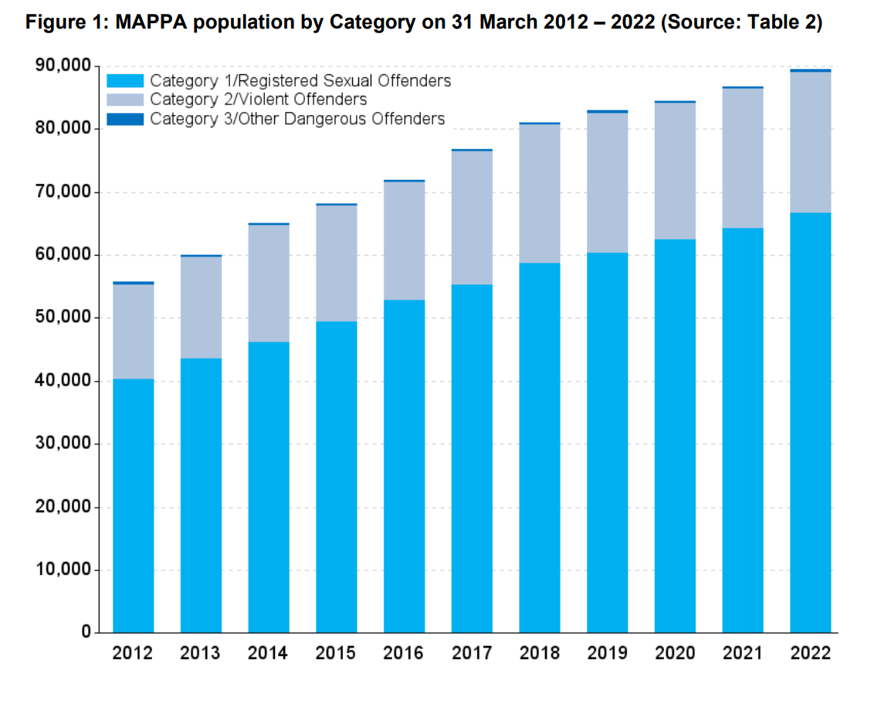

(Ministry of Justice, 2022)

When considering the efficacy of MAPPA to protect vulnerable people, it is prudent to consider the predominant constituents of these categories. An overwhelming majority (between 70% to 75%) are category 1 offenders (sexual offenders), with 98% of all offenders (as of 2022) being managed at level 1 (Ministry of Justice, 2022). There is a clear and consistent growth in MAPPA population year by year, with the makeup of the categories being relatively consistent. 2021/2022 saw an increase of license recalls to custody or prison by 11% and an increase by 42% of offenders being remanded to custody for breaches in Sexual Harm Prevention Orders or Sexual Offence Prevention Orders (Ministry of Justice, 2022). These increases can be perceived as an attestation of one of two points. Either MAPPA has achieved its purpose, and the appropriate information has been disseminated through the appropriate channels to allow for correct monitoring of offenders and subsequent follow-up action, or the process has failed to identify those at risk of re-offending and deal with them accordingly.
This second point was identified in a 2015 review by His Majesties Inspectorate of the Constabulary and Fire Rescue Service (HMICFRS). The review noted that risk management plans for individual offenders were both inconsistent and lacked representation from all responsible authorities and cooperating agencies (HIMCFRS, 2015). Additionally, the review noted that policing teams, particularly Neighbourhood Policing Teams, were not being appropriately informed of registered sex offenders being released into the community (HMICFRS, 2015). With most MAPPA subjects being sexual offenders, this in turn poses a risk to vulnerable people within the community. With essential lines of protection within the community, i.e. police, being poorly informed of potential risks, they lack the replete capacity to act accordingly. Although it is worth noting that this review was conducted in 2015 and several improvements have been made since this time, however, further reviews have not been conducted. This increase in re-offending may be attributed to the proportionality of the offenders themselves. The 2022 annual report of MAPPA included diversity statistics. These statistics highlighted that most offenders (93%) are male, with most of those offenders being between the age of 31-50 (Ministry of Justice, 2017). Comparing that data to the Office of National statistics census data from 2021, there is a proportionate increase in the general population of males within those age groups (Office of National Statistics, 2023).
Whilst MAPPA is primarily a mode of risk assessment and management, ultimately the prevention of harm upon vulnerable people within the community rests with the individual organisations responsible. As previously stated, most MAPPA subjects are category 1, sexual offenders, with most of those being managed at level 1. At level 1, offenders are typically dealt with by one or two agencies (e.g. police and probation), with information sharing between other agencies if “necessary and appropriate” (Ministry of Justice, 2012). MAPPA’s risk assessment also doesn’t inherently define an offender’s risk to vulnerable people. Whilst an offender may be subject to level 1, this doesn’t mean that they do not have the capacity to cause serious harm. Whilst these levels are flexible (based on re-assessment), it could be suggested that defining an offender within a risk category could result in less oversight from responsible authorities (Thomas, 2016), therefore placing vulnerable persons at risk due to the lack of appropriate management of dangerous persons and re-offenders.
There is a lack of empirical data discerning the effectiveness of police management of registered sex offenders. However, the data that is available, suggests that this management of registered sex offenders is ineffective. Operation Notarise, a 2014 National Crime Association operation, during which 660 arrests were made of people alleged to have accessed indecent images of children, 39 of which were already registered sex offenders being monitored by police (Thomas, 2016). If we consider a level 1 offender with the capacity to cause serious harm to a vulnerable person, their management is overseen predominantly by a single agency, such as the police. Once their registration requirements are met, the onus of monitoring their action falls to the police, who by most accounts operate with limited resources, posing a real threat to those at risk (Thomas, 2016). This in essence highlights an oversight in the capacity of MAPPA to protect vulnerable persons from harm. If inappropriate risk assessment is applied, or if the responsible authority for managing that risk does not have the capacity to effectively manage the offender, a real risk is imposed on vulnerable persons within the community.
Whilst MAPPA has its shortcomings, a multi-agency risk assessment and management service has been readily welcomed (Thomas, 2016) and has proved highly effective in the management of offenders and mitigating risks to the public (HMICFRS, 2015). Whilst improvements can be made, the close monitoring, information sharing and co-operative approach of MAPPA ensures that vulnerable persons at risk are safeguarded from potentially dangerous offenders.

Word Count - 1100

Bibliography

Armitage , R. “Crime Prevention through Environmental Design” - the Encyclopedia of Criminology and Criminal Justice. Edited by Gerben Bruinsma and David Weisburg, Hoboken, N.J., John Wiley & Sons Inc, 2014, pp. 720–31.
CIPD. “Organisational Climate and Culture.” CIPD, 17 Oct. 2022, www.cipd.org/uk/knowledge/factsheets/organisation-culture-change-factsheet/. Accessed 5 Sept. 2023.
College of Policing. “Code of Ethics.” College of Policing, 2014, www.college.police.uk/ethics/code-of-ethics. Accessed 5 Sept. 2023.
---. “Multi-Agency Public Protection Arrangements (MAPPA).” College of Policing, 18 July 2017, www.college.police.uk/app/major-investigation-and-public-protection/managing-sexual-offenders-and-violent-offenders/multi-agency-public-protection-arrangements-mappa. Accessed 4 Sept. 2023.
Contrersas-Negretti, V. Blending Light and Dark: A Qualitative Analysis of the Experiences of Stress and Growth in Retired Police Officers. Jan. 2019, repository.uel.ac.uk/item/874xz. Accessed 5 Sept. 2023.
Cozens, Paul M. Think Crime! : Using Evidence, Theory and Crime Prevention through Environmental Design (CPTED) for Planning Safer Cities. Quinns Rocks, Western Australia, Praxis Education, 2014.
Cozens, Paul, and Terence Love. “A Review and Current Status of Crime Prevention through Environmental Design (CPTED).” Journal of Planning Literature, vol. 30, no. 4, 6 Aug. 2015, pp. 393–412, https://doi.org/10.1177/0885412215595440. Accessed 5 Sept. 2023.
Ekblom, Paul. Crime Prevention, Security and Community Safety Using the 5Is Framework. London Palgrave Macmillan Uk, 2011.
Fridell, Lorie A., et al. “The Relationship between Organisational Justice and Police Officer Attitudes toward Misconduct.” Policing and Society, vol. 31, no. 9, 26 Oct. 2020, pp. 1–19, www-tandfonline-com.ezproxy.uwtsd.ac.uk/doi/full/10.1080/10439463.2020.1834558, https://doi.org/10.1080/10439463.2020.1834558. Accessed 5 Sept. 2023.
Gifford, Jonny , and Melanie Green. ROTTEN APPLES, BAD BARRELS and STICKY SITUATIONS an Evidence Review of Unethical Workplace Behaviour. 2019.
Haglund, M. E. M., et al. “Psychobiological Mechanisms of Resilience: Relevance to Prevention and Treatment of Stress-Related Psychopathology.” Development and Psychopathology, vol. 19, no. 3, June 2007, pp. 889–920, www.cambridge.org/core/journals/development-and-psychopathology/article/psychobiological-mechanisms-of-resilience-relevance-to-prevention-and-treatment-of-stressrelated-psychopathology/3E61FA3AA373F469FCABBBE7510D87D4, https://doi.org/10.1017/s0954579407000430. Accessed 5 Sept. 2023.
Hesketh, Ian, et al. “Leading the Asset: Resilience Training Efficacy in UK Policing.” The Police Journal: Theory, Practice and Principles, vol. 92, no. 1, 18 Mar. 2018, pp. 56–71, journals-sagepub-com.ezproxy.uwtsd.ac.uk/doi/full/10.1177/0032258X18763101, https://doi.org/10.1177/0032258x18763101. Accessed 5 Sept. 2023.
His Majesties Inspectorate of the Constabulary. A Follow-up Inspection of Multi-Agency Public Protection Arrangements. Oct. 2015.
Knight, Laura. Home Office Front Line Review - Key Themes in Qualitative Research Projects with Police Forces in England and Wales. 2019.
Lammy, David. “The Lammy Review: An Independent Review into the Treatment Of, and Outcomes For, Black, Asian and Minority Ethnic Individuals in the Criminal Justice System.” 8 Sept. 2017.
MAPPA. “Multi-Agency Public Protection Arrangements.” Mappa.justice.gov.uk, 2012, mappa.justice.gov.uk/MAPPA/groupHome. Accessed 4 Sept. 2023.
Mcdaniel, John L M, et al. Policing and Mental Health : Theory, Policy and Practice. Abingdon, Oxon ; New York, Ny, Routledge, 2020.
McDaniel, John L. M, et al. Policing and Mental Health. Routledge - Taylor and Francis Group, 2020.
Ministry of Justice . Multi-Agency Public Protection Arrangements (MAPPA) Annual Report 2021/22. 27 Oct. 2022.
Newmam, Oscar. Defensible Space : Crime Prevention through Urban Design. New York, Collier Books, 1972.
Office for National Statistics. “Population and Household Estimates, England and Wales - Office for National Statistics.” Www.ons.gov.uk, 28 June 2022, www.ons.gov.uk/peoplepopulationandcommunity/populationandmigration/populationestimates/bulletins/populationandhouseholdestimatesenglandandwales/census2021. Accessed 4 Sept. 2023.
Office, Home . The Front Line Review . Home Office, July 2019.
Oscar Kilo. “Oscar Kilo.” Oscar Kilo, 2022, www.oscarkilo.org.uk/. Accessed 5 Sept. 2023.
Phythian, Rebecca, et al. “Developments in UK Police Wellbeing: A Review of Blue Light Wellbeing Frameworks.” The Police Journal: Theory, Practice and Principles, vol. 95, no. 1, 2 Mar. 2022, p. 0032258X2110730, journals-sagepub-com.ezproxy.uwtsd.ac.uk/doi/full/10.1177/0032258X211073003#bibr6-0032258X211073003, https://doi.org/10.1177/0032258x211073003. Accessed 5 Sept. 2023.
---. “Organisational and Individual Perspectives of Police Wellbeing in England and Wales.” The Police Journal: Theory, Practice and Principles, vol. 96, no. 1, 26 Oct. 2021, p. 0032258X2110522, journals-sagepub-com.ezproxy.uwtsd.ac.uk/doi/10.1177/0032258X211052250?icid=int.sj-full-text.similar-articles.1, https://doi.org/10.1177/0032258x211052250. Accessed 5 Sept. 2023.
Robertson, Ivan T., et al. “Resilience Training in the Workplace from 2003 to 2014: A Systematic Review.” Journal of Occupational and Organizational Psychology, vol. 88, no. 3, 25 Apr. 2015, pp. 533–562, web-p-ebscohost-com.ezproxy.uwtsd.ac.uk/ehost/pdfviewer/pdfviewer?vid=0&sid=b02f9cb1-ff7c-4505-af7b-096209196e11%40redis, https://doi.org/10.1111/joop.12120. Accessed 5 Sept. 2023.
Saville, G., and G. Cleveland. 2nd Generation CPTED: An Antidote to the Social Y2K Virus of Urban Design. 1997, www.veilig-ontwerp-beheer.nl/publicaties/2nd-generation-cpted-an-antidote-to-the-social-y2k-virus-of-urban-design. Accessed 5 Sept. 2023.
Schaible, Lonnie M., and Viktor Gecas. “The Impact of Emotional Labor and Value Dissonance on Burnout among Police Officers.” Police Quarterly, vol. 13, no. 3, 21 July 2010, pp. 316–341, journals-sagepub-com.ezproxy.uwtsd.ac.uk/doi/abs/10.1177/1098611110373997, https://doi.org/10.1177/1098611110373997. Accessed 5 Sept. 2023.
Schaible, Lonnie M., and Michelle Six. “Emotional Strategies of Police and Their Varying Consequences for Burnout.” Police Quarterly, vol. 19, no. 1, 26 Oct. 2015, pp. 3–31, journals-sagepub-com.ezproxy.uwtsd.ac.uk/doi/full/10.1177/1098611115604448, https://doi.org/10.1177/1098611115604448. Accessed 5 Sept. 2023.
Schein, Edgar H, and Peter Schein. Organizational Culture and Leadership. 1985. 5th ed., Hoboken, New Jersey Wiley, 2017.
Skolnick, Jerome. “Corruption and the Blue Code of Silence.” Police Practice and Research, vol. 3, no. 1, Jan. 2002, pp. 7–19, www-tandfonline-com.ezproxy.uwtsd.ac.uk/doi/10.1080/15614260290011309, https://doi.org/10.1080/15614260290011309. Accessed 5 Sept. 2023.
Skolnick, Jerome H. Justice without Trial. Classics of Law and Society , 1966.
“Special Commission on the Resignation of the Commissioner of Police of the Metropolis: Final Report (Accessible).” GOV.UK, 2 Sept. 2022, www.gov.uk/government/publications/commissioner-accountability-review/special-commission-on-the-resignation-of-the-commissioner-of-police-of-the-metropolis-final-report-accessible. Accessed 5 Sept. 2023.
Taylor, R. Crime Prevention through Environmental Design (CPTED): Yes, No, Maybe, Unknowable, and All of the above -Handbook of Environmental Psychology. New York, J. Wiley & Sons, 2002, pp. 413–426.
Thomas, Terry. Policing Sexual Offences and Sex Offenders. London Palgrave Macmillan Uk :Imprint: Palgrave Pivot, 2016.
Torrible, Clare. “Police Complaints and Discipline: Integrity, Lesson Learning, Independence and Accountability: Some Implications of the Reforms under the Policing and Crime Act 2017.” Policing and Society, vol. 31, no. 9, 30 Oct. 2020, pp. 1–16, www-tandfonline-com.ezproxy.uwtsd.ac.uk/doi/full/10.1080/10439463.2020.1838516, https://doi.org/10.1080/10439463.2020.1838516. Accessed 5 Sept. 2023.
“Trauma Resilience in UK Policing.” Www.policingtrauma.sociology.cam.ac.uk, 2022, www.policingtrauma.sociology.cam.ac.uk/. Accessed 5 Sept. 2023.
Tyler, Tom R., et al. “Armed, and Dangerous (?): Motivating Rule Adherence among Agents of Social Control.” Law & Society Review, vol. 41, no. 2, June 2007, pp. 457–492, onlinelibrary-wiley-com.ezproxy.uwtsd.ac.uk/doi/full/10.1111/j.1540-5893.2007.00304.x, https://doi.org/10.1111/j.1540-5893.2007.00304.x. Accessed 5 Sept. 2023.
Westmarland, Louise, and Michael Rowe. “Police Ethics and Integrity: Can a New Code Overturn the Blue Code?” Policing and Society, vol. 28, no. 7, 5 Dec. 2016, pp. 854–870, www-tandfonline-com.ezproxy.uwtsd.ac.uk/doi/full/10.1080/10439463.2016.1262365, https://doi.org/10.1080/10439463.2016.1262365. Accessed 5 Sept. 2023.

