Kai Higgins | 2104154
Database Analysis and Design CW 2 of 2

DFD Diagram
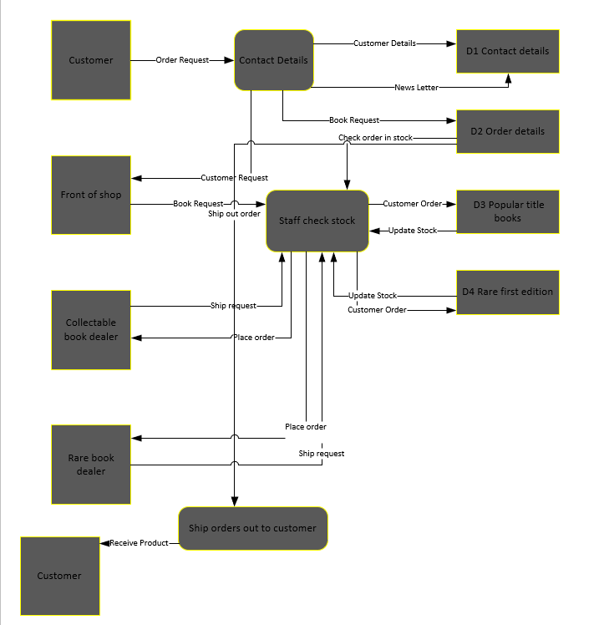

Context Diagram
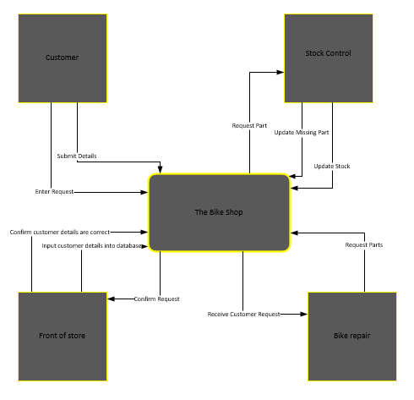

Relationship Diagram

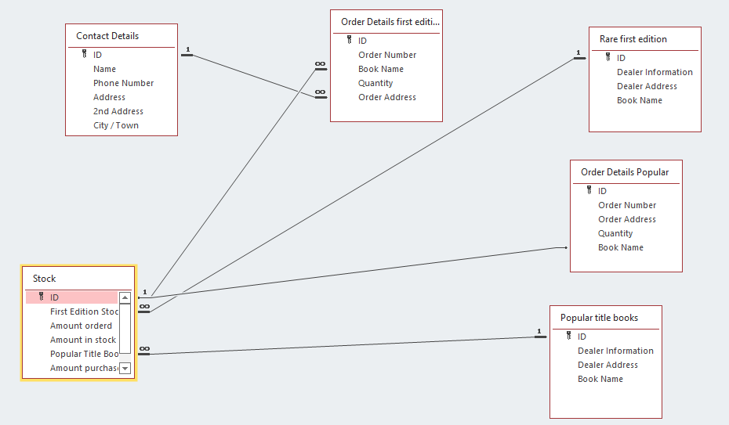

Annotated descriptions for each relationship
The above table is complicated to understand at first but let me explain what is going on, it all starts off with popular title books and rare first edition books containing the book data then the books link to the stock due to stock having 2 different holders for this, both First edition stock and second edition stock I made a separate table to link both into relationships. Then from stock I have it going into Order details first edition and order details popular books and once again using that book data from the initial tables to fill in the tables. I am also connecting the contact details to order details to extract the order address.

