University of Wales Trinity Saint David
Wales Institute of Science & Art

Motorcycle geometry and dynamic handling investigation
Motorcycle Technology ACHA4003

Rhys Ewin
2004294
Date (12/2021)
Contents
1 Introduction 2
2 Calculations 2
2.1 Centre of gravity 2
2.2 Rake angle 3
2.3 Trail 3
2.4 Squat & anti-squat 3
2.5 Resistance to motion 3
2.5.1 Aerodynamic drag 3
2.5.2 Rolling resistance 4
2.5.3 Driving force 4
2.5.4 Gearing calculator 4
3 Honda CBR1000RR 5
3.1 Schematic diagram 5
3.1.1 Centre of Gravity 5
3.1.2 Squat & anti-squat 5
3.1.3 Rake, trail & wheelbase 6
3.2 Frontal area 6
3.3 Resistance to motion 6
3.4 Graphs 7
3.4.1 RPM drop between gear changes 7
3.4.2 Power & torque curve 8
4 Zero SRF 8
4.1 Schematic diagram 8
4.1.1 Centre of gravity 9
4.1.2 Rake, trail & wheelbase 9
4.2 Frontal area 10
4.3 Resistance to motion 10
4.4 Graphs 11
4.4.1 Power & torque curve 11
4.4.2 Driving power in each mode 11
5 Modern motorcycles 12
5.1 MotoGP bike - RC213V 12
5.1.1 Geometry 12
5.1.2 Rake, trail & wheelbase 12
5.2 Paris Dakar Rally bike - KTM 450 Rally 13
5.2.1 Geometry 13
5.2.2 Rake, trail & wheelbase 13
6 Discussion 13
6.1 Frontal area inaccuracies 13
6.2 Measurement inaccuracies 13
7 Conclusions 14
8 References 14

Introduction
This report will cover motorcycle geometry of two accurately measured motorcycles, and the geometry dimensions of two modern motorcycles from different disciplines of racing. The aim is to find the differences in geometry and give reasons as to why these values better set up the motorcycles for their discipline.

Also, in this report will be whether the measured motorcycles can produce enough driving force to reach their theoretical top speed.

Calculations

Centre of gravity
All values are in standard units; weight = kilograms, length = metres, angles = degrees.
Stool weight = 22.15kg, stool height = 0.35m
L = wheelbase length
Wr = weight at rear wheel, Wf = weight at front wheel, Wt = Wr+Wf = total weight
Wrlifted = weight at rear wheel when lifted = $(Wr-stool weight)$

$$Rav=wheel radius average= \frac{front wheel radius + rear wheel radiuis}{2}$$

$$lifted angle (θ)=\arcsin\left(\frac{stool height}{wheelbase}\right)$$

$$xCoG= \frac{Wr*L}{Wt}$$

$$yCoG= \frac{L*(Wr-Wrlifted)}{Wt*tanθ}+Rav$$

Rake angle
Rake (also known as caster or steering angle) is measured as the angle between the steering column and the plumb line through the front axle. Cossalter stated, (2006) rake angle prevents the forks from being deformed, this is important as forks perform poorly under tension and flex, generally, when the rake angle is increased the trail will also see an increase. Rake angle will also provide a perception of a more comfortable riding position. (Lai, H.-C. et al, 2003)

Trail
Trail of a motorcycle is important as it provides stability, the more positive trail the more stable the motorcycle will be as it will want to maintain a straight pathway.

Trail = $\frac{Rav*\sin\left(rake angle\right)-triple clamp offset}{cos⁡(rake angle)}$

Squat & anti-squat
The squat line goes through the instantaneous force centre from the rear wheel centre.

The load transfer line goes through the 100% anti squat line which is the horizontal from the centre of gravity above the centre of the front wheel.

Squat ratio (R) = $\frac{tan⁡(load transfer line angle to horizontal)}{tan⁡(squat line angle to horizontal)}$

Resistance to motion
In this chapter, the calculations to find the forces resisting motion are covered. With these equations we can find the driving force required to move the motorcycle.

Aerodynamic drag
Fd = $0.5ρ*Cd*A*V^{2}$
Where;
$$ρ=density of air=1.167kg/m^{3}$$
Cd = coefficient of drag
A = frontal area ($m^{2})$
V = velocity (m/s)

Rolling resistance
$$Fw=0.02*m*g$$
Where;
m = mass (kg)
g = gravitational pull (N/kg)

Driving force
$$Driving force=\frac{1000P}{V}$$
Where;
P = Power (kW)
Conversion of bhp to kW = /1.341
V = Velocity (m/s)
Conversion of km/h to m/s = *(1000/3600)

Gearing calculator
Requirements;
- Wheel dimensions (width, aspect ratio, rim size)
- Sprocket sizes
- Gear ratios (including primary drive)
- Maximum engine operating rpm

$$Wheel diameter=\frac{\frac{(\frac{width}{25.4}*\frac{aspect ratio}{100}+\frac{rim size}{2}*2*pi*25.4)}{pi}}{1000}$$

$$Road speed=(\frac{rpm*60*\frac{mainshaft in}{countershaft out}*\frac{primary in}{primary out}*wheel diameter*pi}{1000})*(\frac{front sprocket}{rear sprocket})$$

Honda CBR1000RR

Schematic diagram
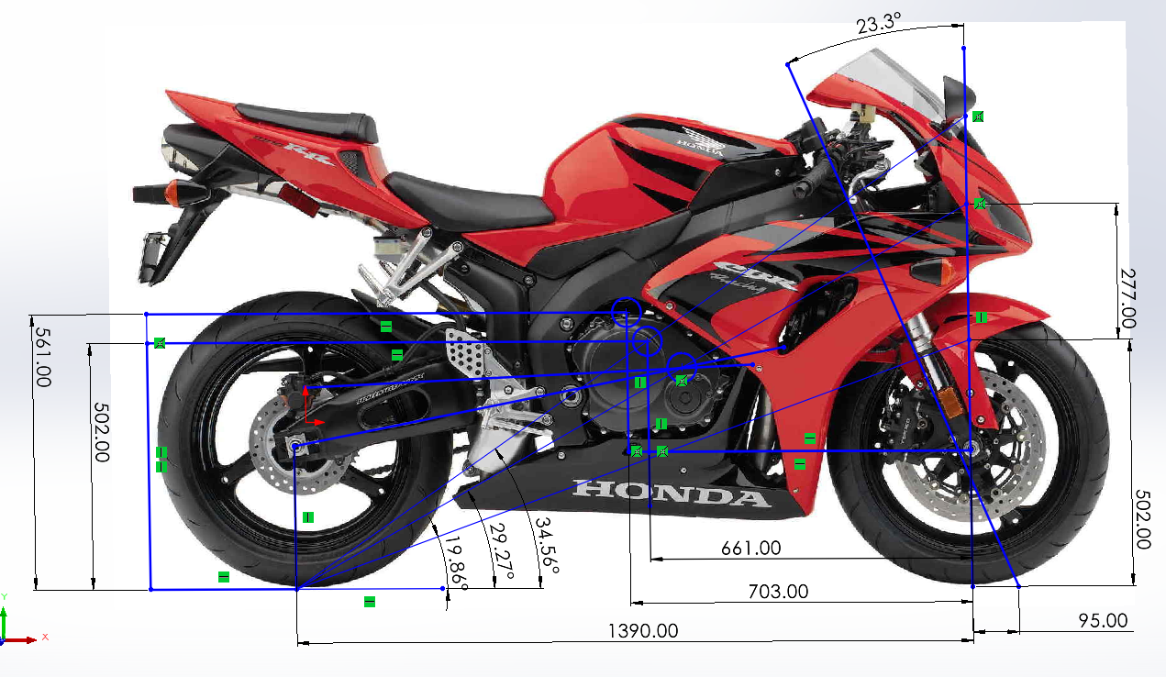
00
Figure 1 – Kodack, A. (2007) Annotated in solidworks.

Centre of Gravity
the green circle shows the centre of gravity location without a rider.
xCoG (without rider) = $\frac{94.65*1.39}{199.05}$ = 0.661m
yCoG (without rider) = $\frac{1.39*(94.65-(109.2-22.15))}{199.05*tan⁡(\arcsin\left(\frac{0.35}{1.39}\right))}+0.298$ = 0.502m
the yellow circle shows the centre of gravity location with a rider.
xCoG (with rider) = $\frac{137.2*1.39}{271.2}=0.$703m
yCoG (with rider) = $\frac{1.39*(137.2-(146-22.15)}{271.2*tan⁡(\arcsin\left(\frac{0.35}{1.39}\right))}+0.298=0.561m$
The centre of gravity position with the rider is close to a 50/50 weight distribution, which means the weight is evenly distributed on the front and rear tyre. This gives the rider control over the motorcycle making it easier to lean into corners.

Squat & anti-squat
the red circle shows the instantaneous force centre location
R = $\frac{502+277}{502}$*100 = 155%

Rake, trail & wheelbase
RAKE | 23.3°
TRAIL | 95mm
WHEELBASE | 1390mm

Usually, sports bikes will have a rake around 21-24° (Cossalter, 2006 p.1-11) the rake angle allows a longer trail and therefore more straight-line stability. The wheelbase is short which creates a more agile handling characteristic, it is easier for the rider to manoeuvre the bike with a shorter wheelbase therefore meaning the bike will turn faster.

Frontal area
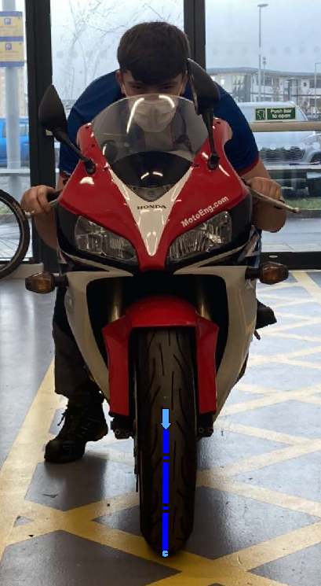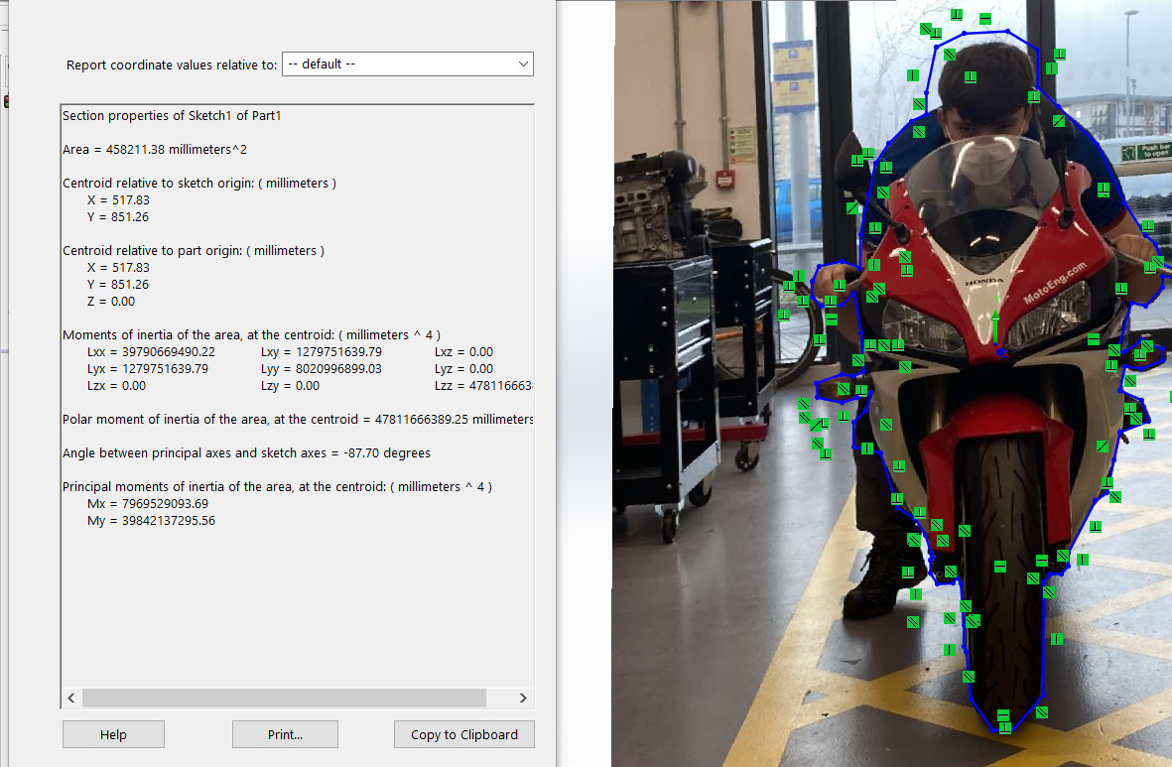
Figure 2 - CBR front facing photo, scaled and annotated in solidworks (Ewin, 2021)
The frontal area of this motorcycle with a rider in a tucked position came to: ${458211.38mm}^{2}$ or ${0.458m}^{2}$

The dotted line, scales the image using a known dimension (the wheel radius in this case), therefore allowing a frontal area to be calculated. The CBR has smooth, flowing curvature which reduces aerodynamic drag.

Resistance to motion
The coefficient of drag of a sports bike with a rider in full tuck is 0.6 (Uhlarik, 2016). To find the force needed for the CBR to reach its theoretical top speed of 301km/h the aerodynamic drag must be added to the rolling resistance.
$0.5\left(1.167\right)*0.6*0.458*{\left(301*\frac{1000}{3600}\right)}^{2}=$1120.95N
$0.02*199.05*9.81=39.05$N
Total driving force needed = 39.05 + 1120.95 = 1160N
This value shows the CBR can reach its theoretical top speed as it produces a driving force of 1477N at redline in 6th gear. The CBR produces 118kW of power.

Driving force = $\frac{118*1000}{301*\frac{1000}{3600}}=1477N$

Graphs

RPM drop between gear changes

Power & torque curve

Zero SRF

Schematic diagram
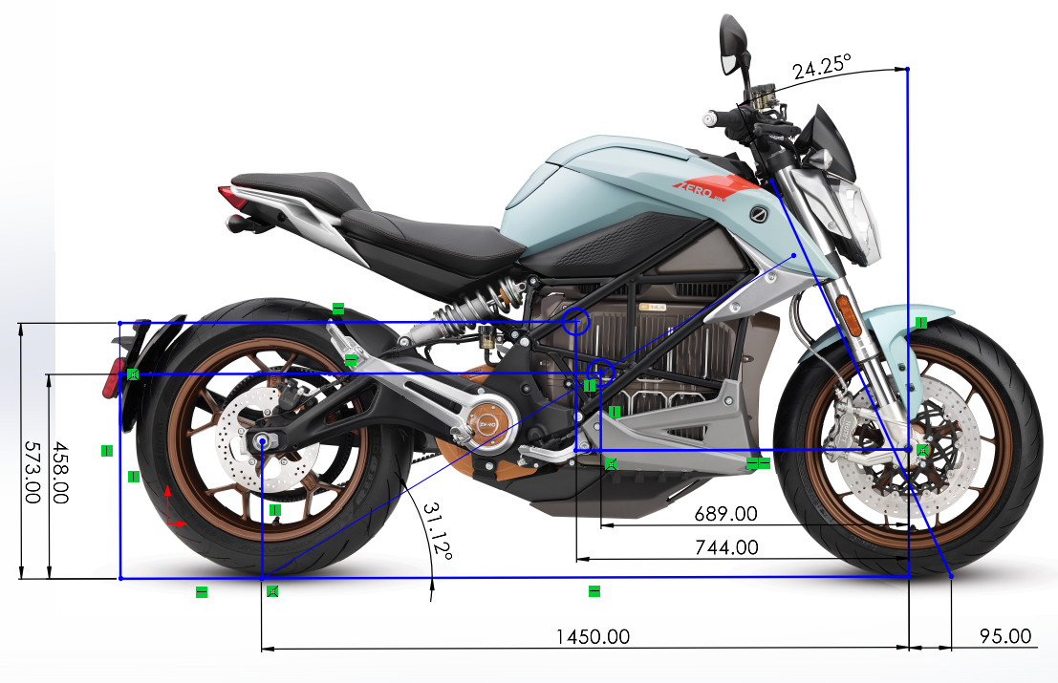
Figure 3 – thebikemarket.co.uk, (2019) Annotated in solidworks

Centre of gravity
the green circle shows the centre of gravity location without a rider.
xCoG (without rider) = $\frac{106.55*1.45}{224.25}=0.689m$
yCoG (without rider) = $\frac{1.45*(106.55-(122.8-22.15))}{224.25*tan⁡(\arcsin\left(\frac{0.35}{1.45}\right))}+0.305$ = 0.458m
the yellow circle shows the centre of gravity location with a rider.
xCoG (with rider) = $\frac{152.6*1.45}{297.9}=0.744m$
yCoG (with rider) = $\frac{1.45*(152.6-(161.1-22.15)}{297.4*tan⁡(\arcsin\left(\frac{0.35}{1.45}\right))}+0.305=0.573m$

Rake, trail & wheelbase
Rake | 24.25°
Trail | 95mm
Wheelbase | 1450mm

This motorcycle is not for high speeds or racing, it is built for commuting in urban environments. The wheelbase reflects this as it is a long wheelbase, this allows a much smoother riding feel especially in a straight line. The centre of gravity with a rider shows how the weight is high and central on the motorcycle, this means the bike will be stable and less likely to wheelie.

Frontal area
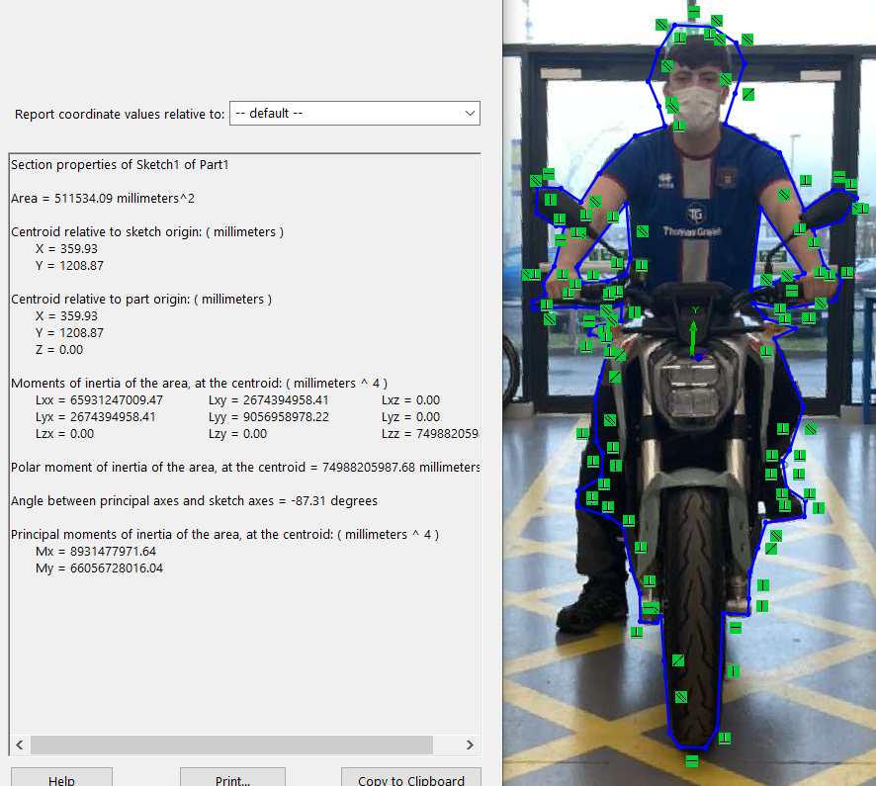
Figure 4 - Zero SRF frontal area, scaled and annotated in Solidworks (Ewin. 2021)
The frontal area of the Zero and rider: ${511534.09mm}^{2}$ or ${0.511m}^{2}$
The Zero has a much larger frontal area than the CBR due to the less aerodynamic approach. There is no fairing which means the rider is more exposed therefore increasing aerodynamic drag, the rider will feel the wind when riding especially at higher speeds, this is another indicator that the motorcycle is intended to be used for commuting.

Resistance to motion
The theoretical top speed of the zero is 356km/h. If we estimate the drag coefficient for the zero is three times as much as the CBR with a rider in standard riding position, 1.8.
$Fd=0.5\left(1.167\right)*1.8*0.511*\left(356*\frac{1000}{3600}\right)=5248.43N$
$$0.02*271.2*9.81=53.21N$$
Total driving force needed = 3498.95 + 53.21 = 5301.64N
The largest driving force produced by the zero in race mode is 1535N, this shows the zero cannot reach its theoretical top speed. The top speed the zero can reach is found by rearranging the equation and making velocity the subject.

$$V=\sqrt{\frac{2(Fd-Fw)}{A*Cd*ρ}}$$
$$V=\sqrt{\frac{2*(1535-53.21)}{0.511*1.8*1.167}}=52.54m/s$$
Top speed of Zero SRF (km/h) = 52.54*3.6 = 189.20km/h

Graphs

Power & torque curve

Driving force in each mode

Modern motorcycles

MotoGP bike - RC213V
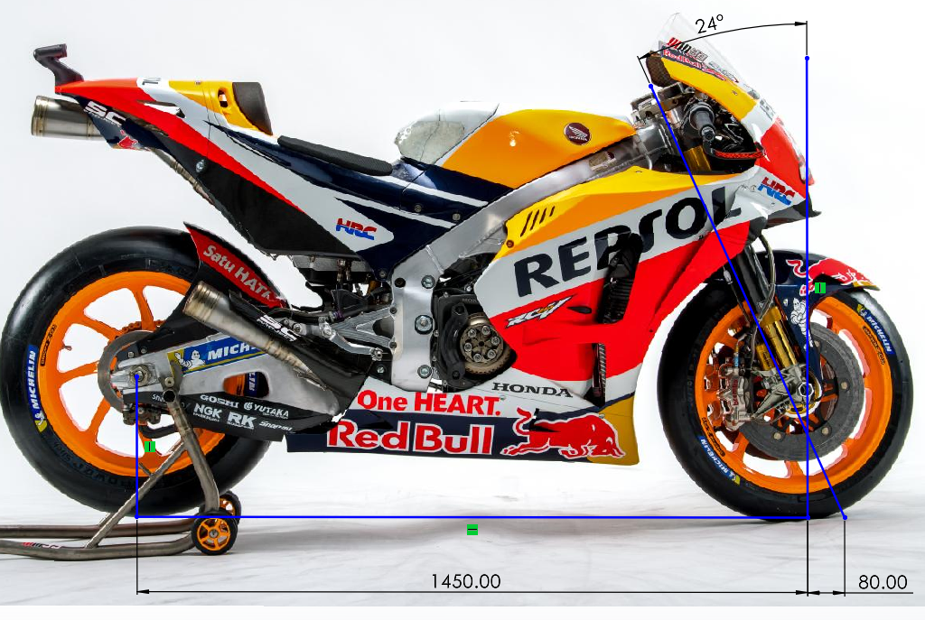
Figure 5 - motogp.com (2021) Annotated in solidworks (2021)

Geometry
Wheelbase dimension = 1.45m (hondaracingcoorporation, 2012)
Using the wheelbase dimension, a side profile image of the motorcycle can be scaled in solidworks, then the rake angle and trail dimensions can be estimated using the smart dimension feature. The value of the rake angle is 24° and the trail dimension is 80mm. These are results that can be expected of competition motorcycles. (Cossalter, 2006 p.1-11)

Rake, trail & wheelbase
MotoGP prototypes are the pinnacle of racing motorcycles, they can reach speeds in excess of 220mph and therefore must be lightweight, agile and stable.
The rake angle of the RC213V is steeper than the CBR as it allows a longer wheelbase, providing more stability in a straight line which is necessary due to the higher accessible speeds of the MotoGP bike. A longer wheelbase also means less load transfer when accelerating or braking therefore reducing tyre wear. The trail maintains the straight-line trajectory of the motorcycle as long as the trail is a positive value, the RC213V has a shorter trail than the CBR as a longer trail makes turning feel heavier. A shorter trail is more likely to be thrown off-course by bumps in the road surface although this usually is not going to be problem for prototype racing bikes as they are used exclusively on tracks. (Bradley, 1996 p.104-117)

Paris Dakar Rally bike - KTM 450 Rally
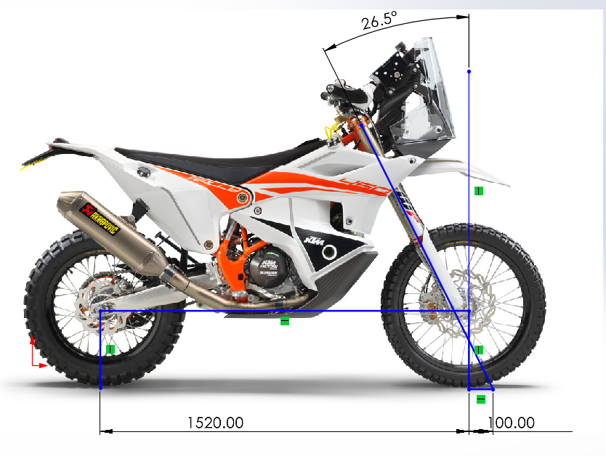
Figure 6 - enduro21.com (2020). Annotated in solidworks (2021)

Geometry
Wheelbase length = 1.520m (KTM, 2020)
The wheelbase length scaled the image to find the rake and trail of the motorcycle.

Rake, trail & wheelbase
Rake | 26.5°
Trail | 100mm
Wheelbase | 1520mm

The wheelbase of this motorcycle is long to suit its need for stability, the 100mm trail length is also longer than the sports bikes trail as the bike is likely to encounter bumps in the ground it is made to travel on. If the trail was short, hitting a bump would temporarily reduce the rake angle to zero, causing stress in the forks, potentially damaging them. (Bradley, 1996 p.110)

Discussion

Frontal area inaccuracies
When finding the frontal area of the motorcycles the outline of the motorcycle was sketched with the rider in a tucked position, the motorcycle did not have a rear stand to keep it balanced therefore the stretched leg holding the bike up was removed, the rider was not wearing a helmet or leathers which will increase surface area therefore an estimated area of a helmet was added to the sketch.

Measurement inaccuracies
Measurement inaccuracies could have occurred due to the equipment used to find the measurements not being entirely accurate, therefore systematic errors could be present in the results.

Conclusions

CBR Improvements
We can see from the geometry of the RC213V, that the MotoGP prototype is designed to be stable in a straight line due to the long wheelbase, while also being easy to handle with the short trail, changing the CBR’s geometry to closer match the RC213V will have benefits to the CBR’s on-track performance. The CBR is set up to be agile and easy to handle at the detriment of straight-line stability. Should the CBR’s wheelbase be increased the rider would find it slightly more difficult to manoeuvre the bike although the straight-line stability will see an improvement, if the CBR is to be used on track, it would benefit from a longer wheelbase as it would allow more braking force on corner entry and more power to the ground on corner exit as the load transfer is less.

Summary
Motorcycle geometry creates the characteristics of handing, when manufacturers design motorcycles, engineers decide upon the dimensions by finding the best compromise, as changing one area of the geometry will have positive and negative effects on the handling.
Finding the correct geometry for a motorcycle sometimes isn’t what theoretically seems to be the best, the rider will judge the feeling of the ride and then explain what differences would positively affect them.

References
- Bradley, J. (1996). The racing motorcycle a technical guide for constructors. Broadband leisure publications.
- Cossalter, V. (2006). Motorcycle Dynamics. 2nd English edition. Lulu.com
- Enduro21.com (2020) KTM 450 Rally. Available at: https://enduro21.com/en/bikes/latest/first-look-2022-ktm-450-rally-factory-replica (Accessed: 29/11/2021)
- Hondaracingcoorporation. (2012) RC213V. Available at: https://motogp.hondaracingcorporation.com/rc213v/ (Accessed: 28/11/2021)
- Kodack, A. (2007). 2007 Honda CBR1000RR. Available at: https://www.topspeed.com/motorcycles/motorcycle-reviews/honda/2007-honda-cbr1000rr-ar18537.html (Accessed: 28/11/2021)
- KTM (2020). 2020 KTM 450 Rally factory replica owners’ manual. Available at: https://manualzz.com/doc/52242252/ktm-450-rally-factory-replica-2020-enduro-bike-owner-manual (Accessed: 29/11/2021)
- Lai, H.-C. et al. (2003). ‘Design parameters study on the stability and perception of riding comfort of the electrical motorcycles under rider leaning’, Mechatronics (Oxford), 13(1), pp. 49–76. doi:10.1016/S0957-4158(01)00082-4.
- Motogp.com (2021). Repsol Honda Team 2018. Available at: https://www.motogp.com/en/gallery/2021/02/22/repsol-honda-bike-evolution/281828 (Accessed: 28/11/2021)
- Thebikemarket.co.uk (2019). Zero SRF. Available at: https://www.thebikemarket.co.uk/zero/srf (Accessed: 28/11/2021)
- Uhlarik, M. (2016). Motorcycle Aerodynamics. Available at: https://canadamotoguide.com/2016/05/04/motorcycle-aerodynamics/ (Accessed: 5/12/2021)

