Student name: Madalin Liviu Noada
Student number: 2232425
Programme: BA International Hotel Management
Module: Food & Beverage Operations
Module code: BMIH4002
Lecturer: Ffion Cumberpatch, Muhammad Cassamo, Jaliya De Silva
Internal Verifier: Charlotte Joyner

Title: Does the required skill set of a Food & Beverage employee change, based on the type of business and the type of service that is offered?

Arros Qd Restaurant
The award-winning chef Quique Dacosta's lifelong love of paella, tapas, and the skill of wood-fired cooking is embodied in the culinary masterpiece Arros QD. The chef at Arros QD is a versatile individual who plays the responsibilities of manager, innovator, flavour expert, and artist in addition to being a skilled cook. This celebrated chef is the proud owner of an incredible 8 Michelin stars, a monument to their extraordinary culinary talent and knowledge (Baldwin, 2018).
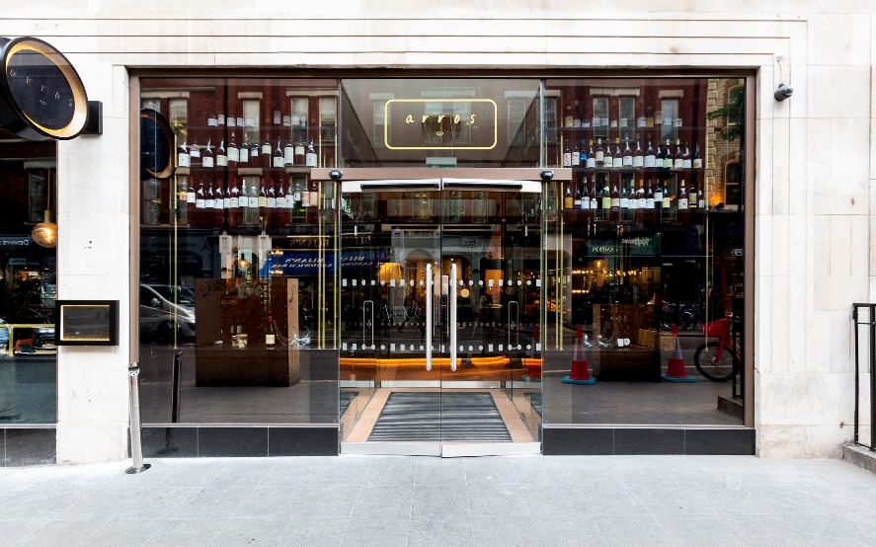

Arros QD's skills requirements for a chef:
Culinary Skills:
A chef at Arros QD should have high-level culinary abilities and a thorough knowledge of Spanish cuisine. They should be skilled in preparing paella, grilling, and making tapas, among other traditional Spanish cooking methods. For the recipes to remain original, knowledge of ingredient sources and selection is also crucial.
Creativity and Innovation:
Arros QD strives to bring a contemporary take on traditional Spanish food through creativity and innovation. The chefs should be creative to create original dishes and combine fresh flavours and ingredients while honouring the fundamental elements of the cuisine. They should be able to strike a balance between modern culinary trends and heritage to produce dishes that are both distinctive and memorable (Taylor, 2019).

Presentation and Attention to Detail:
Arros QD places a strong emphasis on how their meals look. To make visually attractive presentations, the chef appointed should have a great eye for detail and be proficient in plating techniques. They pay attention to flavour profiles when preparing each dish.

Developing Menu:
The chef at Arros QD may be involved in menu development and should have a thorough awareness of item seasonality. They should be able to create a menu that is appealing and diversified, showcasing the finest of Spanish cooking while taking consumer tastes and industry trends into account (Gregory, 2011).

Ganapati Restaurant:
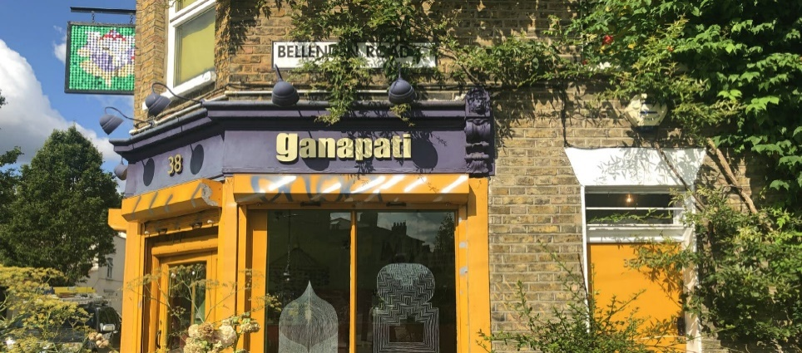

Expertise in South Indian Cuisine: The chefs at Ganapati have a wealth of experience and understanding in South Indian cuisine. They are knowledgeable about the distinctive tastes, spices, and cooking methods that characterize this local culinary tradition. Their specialties include improving the fermentation process, manufacturing delicious curries and chutneys, and mastering the technique of making dosas (Shlebak, 2021).
Knowledge about ingredients: Chefs at Ganapati have a thorough understanding of the essential ingredients used in South Indian cuisine. They are skilled at choosing and locating premium ingredients including flavorful spices, lentils, different kinds of rice, and fresh herbs. To ensure authentic flavours and preserve the traditional elements of South Indian cuisine, they can recognize the best produce (Hansen, 2015).
Concentrating on tiny details: Paying great attention to even the smallest details and keeping consistency are skills that the cooks at Ganapati excel at. Because of their dedication to accuracy, they make sure that every meal is cooked with extreme care and adherence to traditional methods. This commitment ensures that diners may regularly experience the true flavours of South Indian food when they visit the restaurant (Brennan, 2020).

Comparison
Comparison | Arros QD | Ganapati
Culinary Expertise | The chefs have a wide range of culinary skills that have been polished through considerable training and experience. They are excellent at a wide range of culinary techniques, including complex plating, taste combinations, and advanced cooking procedures. Their expertise enables them to produce creative and innovative dishes in a variety of cuisines (Ellis, 2019). | South Indian cuisine is the area of culinary competence for the cooks of Ganapati. They are quite knowledgeable about the distinctive spices, flavours, and cooking methods that make up this regional cuisine. Their expertise is in perfecting South Indian cuisine's classic dishes and recreating the true flavours of the area.
Creative Menu Development | Chefs are excellent at coming up with unique menus. They experiment with flavours, textures, and presentations to produce sophisticated and varied menus. Their innovative combinations and creative plating of their dishes demonstrate their creative abilities and demonstrate their capacity to provide a multi-sensory eating experience. | In the context of South Indian cuisine, the chefs at Ganapati demonstrate inventiveness. Although their menu may be more narrowly focused, they demonstrate their creativity by using traditional goods and cooking methods in their recipes. They manage to maintain the original flavours of South Indian food while incorporating inventiveness into their dishes.
Management of the kitchen | They have expertise leading and overseeing a larger crew in a fine dining environment. They keep an eye on each aspect of the kitchen operation and uphold strict standards for the food quality, consistency, and presentation of the cuisine. | The chefs show remarkable kitchen management abilities. They oversee organizing the staff, upholding quality control, and making sure that orders are processed efficiently (Decker, 2018).

References
Baldwin, W., 2018. Chef's sabbatical: An analysis of chef's gastronomic research through culinary tourism, s.l.: s.n.
Brennan, A., 2020. 21 of our favourite small restaurants, from The Palomar to Otto’s. [Online]
Available at: https://www.standard.co.uk/reveller/restaurants/best-small-restaurants-london-a4538416.html
Decker, F., 2018. What Are Some Hard Skills in the Restaurant Business?. [Online]
Available at: https://smallbusiness.chron.com/soft-skills-needed-waitress-35497.html
Ellis, D., 2019. Quique Dacosta: To understand Arros QD, people must 'look into the fire'. [Online]
Available at: https://www.standard.co.uk/reveller/restaurants/quique-dacosta-arros-qd-restaurant-london-a4160206.html
Gregory, J., 2011. Chef, s.l.: s.n.
Hansen, S., 2015. Society of the Appetite. [Online]
Available at: https://www.tandfonline.com/doi/abs/10.2752/155280108X276050
Shlebak, R., 2021. Ganpati. [Online]
Available at: https://www.theinfatuation.com/london/reviews/ganapati
Taylor, S., 2019. What Skills Do You Need To Be a Chef?. [Online]
Available at: https://www.highspeedtraining.co.uk/hub/requirements-to-be-a-chef/

