Problem
Analysis and Solution
Development

Module Name: Analysing and Solving Problems
Module Code: ACCA4019
Student Name: Oleksii Chepurnyi
Student ID: 2442065
Group: 1
Lecturer’s Name: Dr. Fahad Ahmed

Table of Contents
Table of Contents 1
1. Introduction. 2
2. Deconstruct the Problem. 2
2.1 MoSCoW Technique Requirement. 2
2.2 Variables Identification. 3
3. Proposed Solution. 3
3.1 Assumptions. 3
3.2 Flowchart. 3
3.3 Flowchart Explanation. 5
4. Reflection and Justification 6
4.1 Abstract thinking 6
4.2 Sub-dividing 6
4.3 Justification of solution 7
4.4 Limitation 7
5. Conclusion 7
References: 7
Appendix: 8

Introduction.
The effectiveness of educational institutions depends largely on the seamless synchronization of physical infrastructure and the academic schedule. One local college is currently experiencing systemic failures in classroom management, characterized by a dual problem: overcrowding in some areas and significant underutilization in others. This inefficiency not only wastes physical space but also creates overlap, with staff and students losing valuable instructional time traveling between remote locations [1].
This report aims to deconstruct the complexities of classroom allocation using abstract thinking and systems theory. By identifying key constraints such as classroom capacity and travel time, the paper proposes a logical algorithmic solution designed to optimize space, minimize travel, and eliminate scheduling conflicts. The proposed solution focuses on a scalable, universal approach that can be adapted to various institutional sizes [2].

Deconstruct the Problem.
Deconstruction involves breaking down the complex organizational task of allocating audiences and time for activities into its component parts to understand the underlying mechanisms.

MoSCoW Technique Requirement.

To prioritize the needs of the college, the MoSCoW technique is applied.
Must Have: The solution must ensure that room capacity is always greater than or equal to class size to meet safety and pedagogical standards. Furthermore, it must prevent "double-booking," where two classes are assigned the same room and time slot .
Should Have: The system should prioritize geographical location. This means classes for a specific cohort should be assigned to the same building or adjacent zones to minimize travel time .
Could Have: The solution could incorporate lecturer preferences for specific room layouts or environmental factors like natural lighting or proximity to staff offices.
Won't Have: At this stage, the solution will not involve physical expansion of the campus or the modification of the curriculum structure itself.

Variables Identification.
The following table shows the variables and the quantitative and qualitative data needed to solve the problem:
Variables | Description
ClassSize | The total number of students enrolled in a specific module.
RoomCapacity | The maximum seating capacity of a specific classroom.
TimeSlot | The discrete period (e.g.,10:00-12:00am and 14:00-16:00pm) in the academic calendar.
ZoneID | The physical location/building code used to calculate proximity.
Equipment | Special requirements (e.g., PC labs, chemistry sinks).

Proposed Solution.
The proposed solution is a matching algorithm that treats class seat assignment as an optimization problem with multiple constraints.

Assumptions.
To ensure the viability of our model, we assume the following:
Data integrity: All reported student class sizes and room capacities are accurate and ordered in ascending order.
Uniform movement: Travel time between rooms within the same building is very short and will be assumed to approach zero.
Fixed duration of lesson slots: All lessons are held in standard 120-minute blocks, and we assume there are only morning and afternoon slots.

Flowchart.
The logic is built on the principle of constraint satisfaction, whereby the most complex problems are solved first [3].
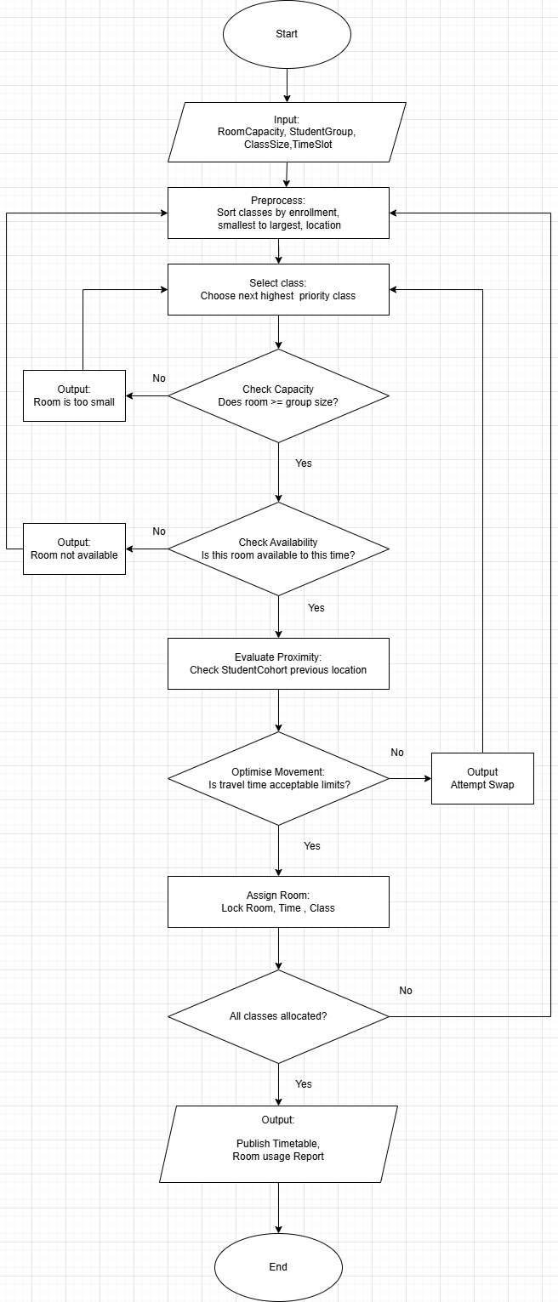
Picture 1. Flowchart of solving problem.

Flowchart Explanation.
Detailed Logical Breakdown of the Solution is shown at Picture 1.
The proposed solution operates as a unified Constraint Satisfaction Engine, moving away from manual scheduling to a systematic process defined by four main logical elements. This approach ensures that every room placement is mathematically optimized for space, technically compatible, and geographically centered for convenience.
The Sorting Stage and Overcrowding Prevention.
The process initiates with a ranking phase where the system performs a PRE-PROCESS by organizing all modules in descending order. By prioritizing the highest ClassSize first, the algorithm tackles the most difficult scheduling constraints while the maximum number of rooms is still available. This strategic prioritization ensures that large lecture halls are not wasted by small groups that could easily be accommodated in smaller spaces. By strictly enforcing the CHECK CAPACITY rule—where RoomCapacity must be greater than or equal to ClassSize—the system systematically eliminates overcrowding and prevents the misuse of the college’s most valuable large-scale assets. Furthermore, the system filters for Equipment requirements at this stage, such as laboratory tools or multimedia projectors, to ensure that specialized modules are only matched with rooms containing the necessary technical infrastructure.
Conflict Resolution and Timetable Accuracy.
To resolve the issue of scheduling clashes, the algorithm functions with a real-time CHECK AVAILABILITY guardrail. During the allocation loop, if a specific room is already marked as "Occupied" for a requested TimeSlot, the system immediately rejects the pairing and triggers an Output: Room Occupied. It then moves on to the next most suitable RoomCapacity option that meets the Equipment criteria. This continuous verification creates a fail-safe environment where double-booking is mathematically impossible, ensuring that all lessons start on time without the administrative friction caused by room disputes.
Proximity Check and Movement Optimization.
To address the requirement of minimizing wasted time between classes, the algorithm performs an EVALUATE PROXIMITY analysis for every assignment. It analyzes the TimeSlot immediately preceding and following the current one for a given group of students. By checking the ZoneID of the previous lesson, the system determines the physical distance the cohort must travel. If the Travel Time between the proposed ZoneID and the previous location exceeds acceptable limits, the system triggers an ATTEMPT SWAP. This logic seeks to re-align neighboring time slots within the same ZoneID, clustering classes together to significantly reduce the transition time for both staff and students.

Spatial Logic and Room Allocation.
The system treats the Location of Rooms as a critical variable within the ZoneID framework to ensure the campus remains navigable. Once a room is successfully Allocated, the system logs its precise building and floor coordinates to verify that the high-traffic flow of students does not overwhelm specific stairwells or elevators. By distributing the Allocated rooms across different wings when TimeSlots overlap, the algorithm prevents hallway congestion while simultaneously ensuring that a single student cohort remains within a consolidated physical area. This spatial intelligence ensures that the physical Location of Rooms works in harmony with the digital timetable.
The Best-Fit Finalization [4].
The final logical element involves the mathematical refinement of the selection to ensure maximum efficiency through the IDENTIFY BEST FIT process. The system does not simply settle for any vacant room; it seeks the optimal solution by identifying the room where RoomCapacity minus ClassSize results in the Minimal Wasted Seats. This ensures that the college’s physical footprint is used to its full potential, leaving larger rooms free for high-capacity needs and ensuring that every square meter of the campus—and every piece of specialized Equipment—is serving the learning experience effectively before the system proceeds to ASSIGN ROOM and lock the final schedule.

Reflection and Justification
Analysis of methodology allows us to understand how theoretical concepts find practical application.

Abstract thinking
Abstract thinking allowed us to move away from the specifics of college subjects and view them as specific requirements for class sizes and group sizes. By discarding the names of subjects, we can focus on the pure mathematics of space and time, making the solution applicable to any college department.

Sub-dividing
The problem was divided into three distinct levels: safety - capacity, efficiency - time, and experience – movement. This division into levels allowed for the creation of a pass/fail logic within the flowchart, where a room must pass a capacity check before being considered for proximity testing.

Justification of solution
This approach is justified because it systematically addresses the college's core problems. Unlike manual scheduling, which is prone to human error, this algorithmic approach ensures that no student is left without a seat and no classroom remains empty while others are overcrowded. By using this algorithm, we directly address the inefficient use of time spent traveling between classrooms, a complaint shared by staff and students.

Limitation
The main limitation is the rigid nature of the model. For example, if a large class needs to be in a specific lab, but that lab is in a remote building, the model will prioritize equipment over travel time, potentially causing some delays.

Conclusion
Optimizing classroom allocation is a balance between mathematical precision and human expertise. By breaking the problem down into measurable variables and applying a logical flowchart, a college can transform its chaotic schedule into an orderly and efficient system. This solution ensures that every square meter of the college campus is fully utilized, directly improving the learning environment for both staff and students.

References:
[1] A. Smith, "Principles of Resource Allocation in Education," Journal of Academic Management, vol. 12, no. 3, 2024.
[2] B. Jones, Systems Thinking for Problem Solving, 2nd ed. London: Tech Press, 2023.
[3] IEEE, "Standard for Software Logic Models," 2025.
[4] C. Doe, "Optimization Algorithms for Urban Planning," 2026.

Appendix:
Pseudocode for this flowchart:
Classroom Allocation Pseudocode.
INITIALIZE DATA SET RoomDatabase = [RoomCapacity, Location, Equipment] SET ClassList = [ClassSize, StudentGroup, TimeSlot] SET MasterTimetable = Empty
START PROCESS READ Input: RoomCapacity, StudentGroup, ClassSize, TimeSlot
PREPROCESS STAGE SORT ClassList BY enrollment (Smallest to Largest) AND location WHILE (Classes remain in ClassList)
**SELECT CLASS**
`SET` CurrentClass = Choose next highest priority class from ClassList

**CHECK CAPACITY**
`IF` (RoomCapacity >= CurrentClass.ClassSize) `THEN`
`GOTO` AvailabilityCheck
`ELSE`
`OUTPUT`: "Room is too small"
`GOTO` Preprocess (Try next room)
`END IF`

**AVAILABILITY CHECK**
`IF` (Room is available at CurrentClass.TimeSlot) `THEN`
`GOTO` EvaluateProximity
`ELSE`
`OUTPUT`: "Room not available"
`GOTO` Preprocess (Try next room)
`END IF`

**EVALUATE PROXIMITY**
`SET` PrevLocation = Get StudentCohort previous location
`SET` TravelTime = Calculate distance between CurrentRoom and PrevLocation

**OPTIMISE MOVEMENT**
`IF` (TravelTime <= AcceptableLimit) `THEN`
`SET` AssignmentStatus = "Optimal"
`ELSE`
`OUTPUT`: "Attempt Swap"
`GOTO` Preprocess (Re-sort or swap slots)
`END IF`

**ASSIGN ROOM**
`LOCK` Room, Time, and Class in MasterTimetable
`REMOVE` CurrentClass from ClassList

**CHECK COMPLETION**
`IF` (All classes allocated?) `THEN`
`GOTO` FinalOutput
`ELSE`
`GOTO` SelectClass (Repeat loop)
`END IF`
FINAL OUTPUT PUBLISH MasterTimetable GENERATE Room Usage Report
END PROCESS

