Project Management
Module code: LCBB5005
Student name: Alice-Ana-Maria Casota
Student ID: 2117333

Coursework: Essay (Project Plan)

Contents
Introduction 4
2. Overview of Hinkley Point C Project 4
2.1 Project description, goals, and benefits 4
3. Budget analysis 5
3.1 Factors contributing to cost overruns 5
3.2 Financial implications 6
4. Time analysis 7
4.1 Causes of project delays 7
4.2 Impact on the overall project 7
5. Quality assessment 8
5.1 Evaluation of project quality 8
5.2 Consequences of quality issues 8
6. Stakeholder analysis 9
6.1 Stakeholder engagement and communication 10
6.2 Influence on project outcomes 10
7. Risk factors and mitigation 10
7.1 Identification of project risks 10
7.2 Risk assessment and management strategies 11
8. Critical evaluation of project plan 11
8.1 Assessment of initial project plan 12
8.2 Identifying weaknesses and gaps 12
8.3 Key factors leading to overruns and delays 12
9. Recommendations 13
Conclusion 14
Reference list 15

List of Figures
Figure 1- Hinkley Point C Project (BBC, 2022) 4
Figure 2- Cost breakdown of Hinkley Point C (Lawson, 2022) 6
Figure 3- Timeline (Rabe and Gippner, 2017) 7
Figure 4- Project plan of Hinkley Point C Project (BBC, 2022) 11

List of Table
Table 1- Stakeholders Analysis (Author) 9
Table 2- Risk factors (Author) 10

Introduction
With a projected cost of between $25 and $26 billion, the UK's Hinkley Point C Project is a world first in the construction of a nuclear power station (BBC, 2022). The major goal of the Somerset-based project is to create low-carbon electricity, enough to power about 6 million homes, while also boosting the UK economy and creating new jobs. The project, which involves the construction of two European Pressurised Reactors (EPR), is an important step towards the country's goal of reducing carbon emissions and adopting more sustainable energy alternatives (EDF, 2015). However, major difficulties, such as cost overruns and construction delays, have plagued the project. To understand what went wrong and how to prevent it in the future, this critical evaluation dives deep into the project's core features like money, schedule, quality, stakeholders, and risk factors.

2. Overview of Hinkley Point C Project

2.1 Project description, goals, and benefits
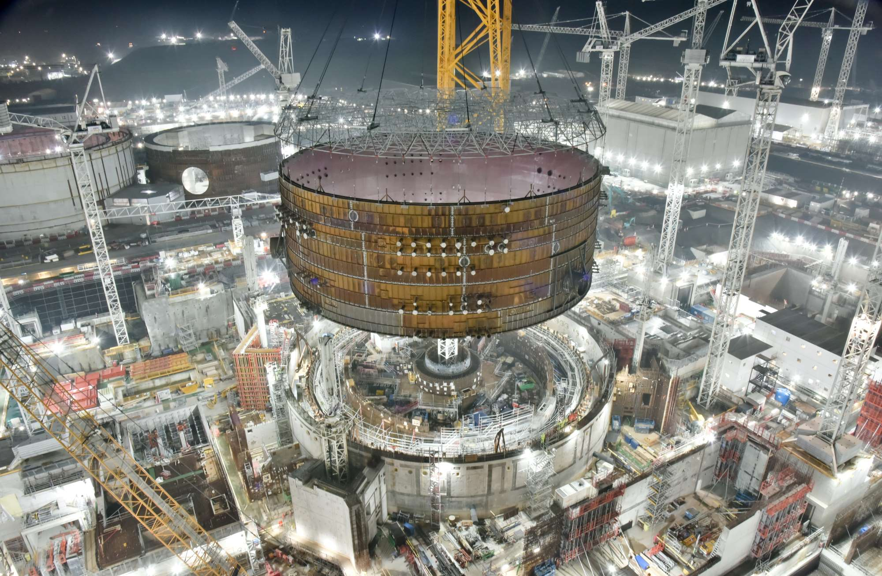
Figure 1- Hinkley Point C Project (BBC, 2022)

Somerset, United Kingdom is home to the Hinkley Point C Project, a partnership between EDF Energy and China General Nuclear Power Group (CGN) (Rabe and Gippner, 2017). It will be a watershed moment in the revival of the UK's nuclear power industry as it plans to build a 3.2-gigawatt nuclear power station to supply low-carbon electricity to almost 6 million homes (Gov.uk, 2023). The project's key objectives are twofold: contributing to the UK's carbon emissions reduction goals by offsetting 9 million tons of CO2 annually through its two EPR reactors over 60 years, and creating economic benefits by generating 25,000 jobs and offering up to 1,000 apprenticeships. Additionally, it aims to bolster the domestic nuclear industry by directing 64% of its construction value to UK companies. With a budget of £25–£26 billion, Hinkley Point C is the costliest nuclear power project in the world and a major investment in the UK’s energy infrastructure (Lawson, 2022). The use of fossil fuels can be decreased, and energy security can be improved, by doing this. In addition, the job openings created by the project help people acquire new abilities, which in turn promotes creativity in the energy industry.

3. Budget analysis
The budget for the massive and intricate Hinkley Point C Project has received a great deal of scrutiny. The original price range for this project was between £25 and £26 billion (NS Energy, 2023). As the work continued, however, it became clear that the true expenses were much greater. Cost estimates and actual expenditures may differ depending on the project's current development level; however, it is clear that significant budget overruns have occurred.

3.1 Factors contributing to cost overruns
The cost overruns at Hinkley Point C have been caused by several sources. First, there have been unforeseen obstacles and engineering difficulties due to the complexities of building a nuclear power station on such a huge scale (Reuters, 2022). Because additional time, money, and effort were needed to overcome the technical challenges posed by these complications, construction costs have gone up. Second, construction costs may have risen because of changes in safety laws and standards that arose during the building. The cost of making such changes to a project can quickly build up. Costs will rise as a direct result of construction delays. Increased labour costs, longer project schedules, and more money spent on administration and logistics are all common results of delays (Smyth, Lecoeuvre and Vaesken, 2018).
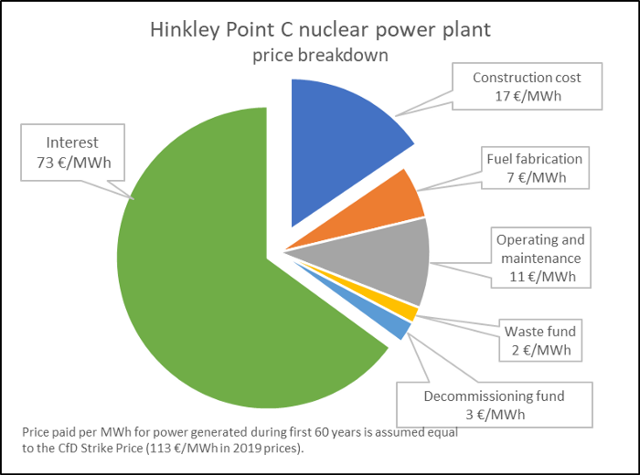
Figure 2- Cost breakdown of Hinkley Point C (Lawson, 2022)

3.2 Financial implications
Cost overruns have major repercussions on the budget. The budget for the project is being stretched thin, and the added expenses may have wider economic consequences as well. There may be consequences for energy customers, investors, and the government if the project's budget grows (Bodansky, 2010). As these costs are often passed on to the end-users, the additional financial burden may eventually result in higher electricity rates for consumers. The financial viability and returns on investment of the project may be impacted by cost overruns. The government's ability to allocate resources to other programmes and initiatives may also be affected by the rising expenditures.

4. Time analysis
Adherence to the intended timeframe is critical to maintaining project efficiency and cost-effectiveness, especially in large-scale building projects like Hinkley Point C, where time management is crucial (Amdrews and Folger, 2012). However, significant time has been added to the project after it was originally expected to be finished. The construction process would have followed a strict timeline, as described in the project's original concept. There have been setbacks at various points because of the unforeseen difficulties and technical issues inherent in the development of a nuclear power facility.
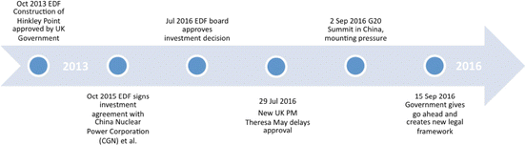
Figure 3- Timeline (Rabe and Gippner, 2017)

4.1 Causes of project delays
- The completion of the Hinkley Point C Project has been pushed back for many reasons. It can take a long time for a project of this size and possible environmental impact to receive the requisite regulatory licences and permits. Any glitches in the regulatory process can push back the entire schedule.
- Second, unexpected technical issues and engineering hurdles have arisen during construction, as is the case with any major infrastructure project (Mavrokefalidis, 2023). It has taken more effort and resources than expected to resolve these problems.
- In addition, there have been coordination difficulties due to the large number of contractors and subcontractors working on the construction, which could cause bottlenecks and delays.

4.2 Impact on the overall project
The Hinkley Point C project delays have far-reaching consequences.
- To begin, a delay in construction can cause ripple effects across the project schedule and may even extend the expected completion date. This, in turn, threatens the project's capacity to meet its low-carbon electricity delivery deadlines to the grid, and thereby the UK's energy transition objectives (Watt, 2017).
- Second, one could end up spending more money if one is delayed. Costs like labour, equipment rentals, and utilities tend to creep up as projects drag on, putting more pressure on already tight budgets. There may be fewer new employment and fewer opportunities for apprenticeships produced as a result of delays in the project's overall efficiency and productivity. Implementing efficient mitigation measures is crucial to addressing time-related difficulties.
This may entail utilising lessons acquired from prior nuclear projects, boosting communication and coordination among stakeholders, and generally better project management practices (Weinfass, 2023). Delays can be avoided and problems can be solved more quickly if risks are identified and managed proactively at the outset.

5. Quality assessment
For a nuclear power plant like Hinkley Point C to run smoothly and safely, quality control measures must be strictly adhered to at all times. To guarantee that the project's infrastructure and equipment adhere to safety standards and industry best practices, the project would have set rigorous quality expectations and compliance requirements.

5.1 Evaluation of project quality
The materials utilised, the building methods, and the observance of safety regulations are only some of the features of the Hinkley Point C Project that must be evaluated to determine its overall quality. There should have been quality assurance checks during construction to make sure everything is up to code (Somerset Council, 2023). It is possible to gain insight into the project's conformance to the defined quality standards by analysing data from quality assurance inspections, material testing findings, and compliance reports.

5.2 Consequences of quality issues
A nuclear power plant cannot afford to have any quality issues. Safety issues, broken machinery, and inefficient operations can result from even the smallest deviations from the norms. The rework that may result from fixing quality problems will add time and money to the project. Inadequate quality control may also endanger the project's long-term performance and safety, leading to the need for expensive retrofits or modifications down the road (Bodansky, 2010).

6. Stakeholder analysis
A stakeholder analysis is essential for understanding the interests, influence, and potential impact of various individuals and organizations involved in the Hinkley Point C Project. Key stakeholders in this project include:
Table 1- Stakeholders Analysis (Author)
- EDF Energy and China General Nuclear Power Group (CGN) | As the primary developers and investors, their primary interest lies in the project's successful completion and return on investment (Verdict Media Limited, 2013).
- UK Government | The government has a vested interest in the project's success, given its strategic significance for the country's energy security and low-carbon energy goals.
- Local community | Nearby neighbours are stakeholders who are worried about the project's potential negative effects on the environment and society.
- Energy consumers | The general public represents a significant stakeholder group with interests in affordable and sustainable energy supply (Amdrews and Folger, 2012).
- Environmental groups | The project's compliance with environmental standards and its possible influence on the local ecosystem is under constant surveillance by environmental advocacy groups.

6.1 Stakeholder engagement and communication
Involving and communicating with stakeholders effectively is crucial for meeting their needs and addressing their concerns. To keep stakeholders aware of the project's development and answer any inquiries or difficulties, it is important to establish frequent updates, public discussions, and transparent communication channels. The efficiency of the project's stakeholder engagement initiatives can be determined by collecting and analysing data on stakeholder interactions, feedback, and the resolution of problems (Lawson, 2022).

6.2 Influence on project outcomes
The project's outcomes may be greatly affected by the opinions of many stakeholders. When the government and the community back a project, it is easier to get the necessary permissions for regulations and the project moves along more quickly (Murray and Holbert, 2020). However, delays, legal issues, and reputational hazards can result from disagreement or resistance from key players, especially environmental groups or local communities.

7. Risk factors and mitigation

7.1 Identification of project risks
To reduce risks and prevent delays in the Hinkley Point C Project, it is crucial to identify and manage potential risks. The following are examples of potential risk factors:
Table 2- Risk factors (Author)
- Technical Risks: Complex engineering, unexpected geological conditions, and faulty equipment are only a few of the issues that can arise during the building of a nuclear power plant (Irvine, 2011).
- The potential for delays in obtaining permits and approvals, changes to safety criteria, or legal challenges are all examples of regulatory risks.
- Threats to a company's financial stability are due to factors such as unforeseen expenses, fluctuating material costs, or other economic factors (Amdrews and Folger, 2012).
- Potential negative consequences on the environment and the need to follow stringent environmental regulations are examples of environmental risks.

7.2 Risk assessment and management strategies
To properly prioritise and assess the possible impact of each risk factor, a thorough risk assessment should have been performed. To properly deal with these risks, the project team would have established risk management procedures (Bodansky, 2010). For instance, the team may have performed in-depth feasibility studies, hired seasoned engineering specialists, and incorporated best practices from earlier nuclear building projects to reduce technical risks. The team would have been proactive in its engagement with the appropriate authorities, would have followed all applicable safety protocols, and would have prepared for the possibility of delays due to regulatory issues.

8. Critical evaluation of project plan
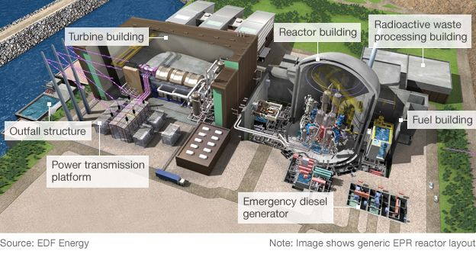
Figure 4- Project plan of Hinkley Point C Project (BBC, 2022)

8.1 Assessment of initial project plan
When the original plan for the Hinkley Point C Project is analysed critically, its strengths and shortcomings become apparent. The strategy displayed haughty goals to supply the UK's energy requirements, cut carbon emissions, and boost the economy. It is encouraging that the original strategy identified key stakeholders and took their needs into account (EDF, 2015). However, the proposal may not have accounted for all of the difficulties that would be present when building a nuclear power station of this size. It is possible that the original cost and time estimates did not take into account all of the possible risks and uncertainties because they were based on overly optimistic assumptions.

8.2 Identifying weaknesses and gaps
The project blueprint has several weaknesses and gaps. Estimated cost and completion time are the most important. The project plan may have overlooked technical issues, legal restrictions, and market changes, causing cost overruns and delays. It is also possible that stakeholders were not satisfied with the methods used to involve and inform them.

8.3 Key factors leading to overruns and delays
According to the facts and analysis from the preceding sections, the following are the main causes of cost overruns and delays in the Hinkley Point C Project:
- Technical Challenges: The complex engineering requirements and unanticipated geological conditions may have led to construction delays and increased costs (Mavrokefalidis, 2023).
- Regulatory Processes: Delays in obtaining permits and approvals, as well as changes in safety regulations, could have impacted the project's progress (Reuters, 2022).
- Stakeholder Engagement: Inadequate stakeholder engagement and communication may have resulted in opposition and resistance, leading to delays and legal challenges.
- Risk Management: Insufficient risk assessment and management strategies may have left the project vulnerable to unexpected events and their associated costs.

9. Recommendations
To address the current challenges faced by the Hinkley Point C Project, the following remedial actions are recommended:
- Comprehensive risk management: Determine what might go wrong by conducting a thorough risk assessment. Create thorough strategies for mitigating risk and backup plans to resolve any problems that may develop when the project is being carried out (Watt, 2017).
- Enhanced stakeholder engagement: Improve interaction and dialogue with the government, communities, and environmental groups who have a vested interest in the issue. Respond quickly and openly to concerns, and solicit input actively to ensure that stakeholder voices are heard and considered.
- Revision of project plan: Check the project schedule and budget again to make sure they are reasonable. The risk of future overruns and delays can be reduced if the revised plan takes into account prospective technological challenges and changes in regulatory requirements (Weinfass, 2023).
- Lesson sharing and collaboration: Encourage nuclear professionals to work together and share information to learn from each other's mistakes and successes. The effective execution of future endeavours can be improved by learning from past successes and the difficulties experienced by others.
- Technological advancements: Maintain a level of technological acuity in nuclear power plant building. Streamline the building process and cut expenses by adopting cutting-edge engineering innovations (NS Energy, 2023).
- Investment in the skilled workforce: The building of nuclear power plants requires a highly trained and specialised crew. It is possible to assure a skilled staff that can handle the intricacies of such projects by providing training and apprenticeship opportunities.

Conclusion
In conclusion, the Hinkley Point C Project represents an important step in the United Kingdom's efforts to reduce carbon emissions and move towards more sustainable energy. Reflecting the nation's dedication to clean energy solutions is the massive undertaking to create low-carbon electricity for millions of homes and boost economic growth. The problems with the project, such as cost overruns and construction delays, have been brought to light by the critical review. To overcome these obstacles, one will need a risk management strategy that anticipates problems, stakeholder involvement at every level, and a flexible project plan that accounts for the unexpected. The success rate of future nuclear power plant projects can be raised by the use of effective risk mitigation measures, improved communication with stakeholders, and the adaptation of project plans to account for potential impediments. The UK and the global nuclear energy sector can move closer to a sustainable, low-carbon future and meet their climate change ambitions by learning from the mistakes made at Hinkley Point C and using the lessons learnt.

Reference list
Amdrews, A. and Folger, P. (2012) Nuclear Power Plant Design and Seismic Safety Considerations. CreateSpace.
BBC (2022) Hinkley Point C delayed by a year as cost goes up by £3bn. BBC News. [online] 20 May. Available at: https://www.bbc.com/news/uk-england-somerset-61519609.
Bodansky, D. (2010) Nuclear energy : principles, practices, and prospects. New York: Springer.
EDF (2015) Hinkley Point C. [online] EDF Energy. Available at: https://www.edfenergy.com/energy/nuclear-new-build-projects/hinkley-point-c.
Gov.uk (2023) Hinkley Point C: Value for Money Assessment. [online] Available at: https://assets.publishing.service.gov.uk/government/uploads/system/uploads/attachment_data/file/621400/Detailed_value_for_money_assessment.pdf.
Irvine, J.M. (2011) Nuclear power : a very short introduction. Oxford ; New York: Oxford University Press.
Lawson, A. (2022) Boss of Hinkley Point C blames pandemic disruption for £3bn delay. [online] the Guardian. Available at: https://www.theguardian.com/uk-news/2022/may/20/hinkley-point-c-nuclear-power-station-edf-delayed-covid-costs-rise.
Mavrokefalidis, D. (2023) Concerns mount over delays and rising costs at Hinkley Point C. [online] Energy Live News. Available at: https://www.energylivenews.com/2023/06/06/concerns-mount-over-delays-and-rising-costs-at-hinkley-point-c/.
Murray, R.L. and Holbert, K.E. (2020) Nuclear energy : an introduction to the concepts, systems, and applications of nuclear processes. Oxford ; Cambridge, Ma: Butterworth-Heinemann.
NS Energy (2023) Hinkley Point C Nuclear Power Station - NS Energy. [online] Nsenergybusiness.com. Available at: https://www.nsenergybusiness.com/projects/hinkley-point-c-nuclear-power-station-uk/.
Rabe, W. and Gippner, O. (2017) Perceptions of China’s outward foreign direct investment in European critical infrastructure and strategic industries. International politics, 54, pp.468-486.
Reuters (2022) EDF to announce new cost increase, delay for Hinkley Point nuclear plant. Reuters. [online] 28 Mar. Available at: https://www.reuters.com/business/energy/edf-announce-new-cost-increase-delay-hinkley-point-nuclear-plant-2022-03-28/.
Smyth, H., Lecoeuvre, L. and Vaesken, P. (2018) Co-creation of value and the project context: Towards application on the case of Hinkley Point C Nuclear Power Station. International Journal of Project Management, 36(1), pp.170–183.
Somerset Council (2023) Hinkley Point C. [online] www.somerset.gov.uk. Available at: https://www.somerset.gov.uk/business-economy-and-licences/major-developments/hinkley-point-c/.
Verdict Media Limited (2013) Hinkley Point C Nuclear Power Station - Power Technology | Energy News and Market Analysis. [online] Power Technology | Energy News and Market Analysis. Available at: https://www.power-technology.com/projects/hinkley-point-c-nuclear-power-station/.
Watt, H. (2017) Hinkley Point: the ‘dreadful deal’ behind the world’s most expensive power plant. [online] the Guardian. Available at: https://www.theguardian.com/news/2017/dec/21/hinkley-point-c-dreadful-deal-behind-worlds-most-expensive-power-plant.
Weinfass, I. (2023) EDF reveals ‘increasing risk’ of Hinkley delays and budget overruns. [online] Construction News. Available at: https://www.constructionnews.co.uk/civils/edf-reveals-increasing-risk-of-hinkley-delays-and-budget-overruns-09-06-2023/ [Accessed 23 Jul. 2023].

