NAME: Adebomi Oluyinka Salu
STUDENT NUMBER: 1809923
MODULE: LCMB7001
TITLE: Marketing Management Assessment 2
LECTURER: Tushara Balendran
SUBMISSION DATE: Friday 14th January 2022
WORD COUNT: 2000 words or Equivalent

TABLE OF CONTENT

- INTRODUCTION 3
- PESTLE: EXTERNAL ANALYSIS OF BURBERRY 4-7
- PORTER’S FIVE FORCES 7-10
- SWOT ANALYSIS 10-12
- ADVANTAGES AND DISADVANTAGES OF SWOT ANALYSIS 13
- SEGMENTATION, TARGETING AND POSITIONING 13-15
- THE MARKETING MIX STRATEGY 15-18
- CONCLUSION 18
- RECOMMENDATIONS USING ANSORP MATRIX 18-19
- REFERENCES 20-22

INTRODUCTION
The marketing department plays a crucial role in the effectiveness and survival of a company in the current competitive world. Companies are not unsusceptible to challenges like rising expectations of consumers, increasing brand awareness and competitiveness, being able to manage information, and the steady rise of digitalisation. Those that can achieve sustainable competitive advantage with their brands due to an efficient and effective marketing strategies and processes and with the aid of business models or framework become a cut above others. They also possess a differentiated value proposition, an important factor in the success of their brand.
This report will be conducting a situational analysis of Burberry which includes the external and internal factors with the aid of framework and models. Focus will be on applying environmental tools like PESTEL model, Porter’s Five Forces Model and SWOT analysis to the chosen company. Also, this report will be determining the Segmentation, Targeting and Positioning for the company. In addition, the report will find out the Marketing Mix Strategy utilised for producing the desired response from their target market. Recommendations will be suggested because of the findings from the analysis.
The first section is the application of PESTEL to conduct an external analysis of Burberry to determine whether the external factors in the model are favourable or unfavourable to Burberry’s marketing strategy. Next section will be applying the Porter’s Five Forces to identify the attractiveness of the strategy in terms of the five competitive forces to determine whether they are high, medium, or low and why. The third part will present a SWOT analysis indicating a simple internal and external analysis which are opportunities and threats, strengths, and weaknesses facing Burberry. In addition to this part is the critical analysis of using one of the above-mentioned situations analyses with the focus on SWOT.
The strategy section will be exploring Segmentation, Targeting and Positioning (STP) process, and the Marketing Mix to understand Burberry’s marketing strategy. Lastly, is the conclusion and recommendations to develop a desired strategy for the future.

PESTLE: EXTERNAL ANALYSIS OF BURBERRY
Definition: PESTEL is one of the analytical tools that helps to keep organisations responsive to macro-environmental changes to and capture opportunities and reduce threats by examining these factors; Political, Economic, Social-Cultural, Technological, Legal, and Environmental (Whittington, et al., 2020). In specific terms as defined by Hill (2020), It is a strategized framework or tool used mostly by marketers in examining and analysing macro environmental factors which impacts their organisation’s overall progress and success in the competitive market. The Monash Business School in Australia from their Marketing dictionary sees the macro environment as external forces that cannot be controlled which are economic, demographic, technological, natural, social, and cultural, legal, and political. This influences decision making and impacts on the performances of a company. Fig. 1 below shows a diagrammatic representation of PESTEL Analysis.
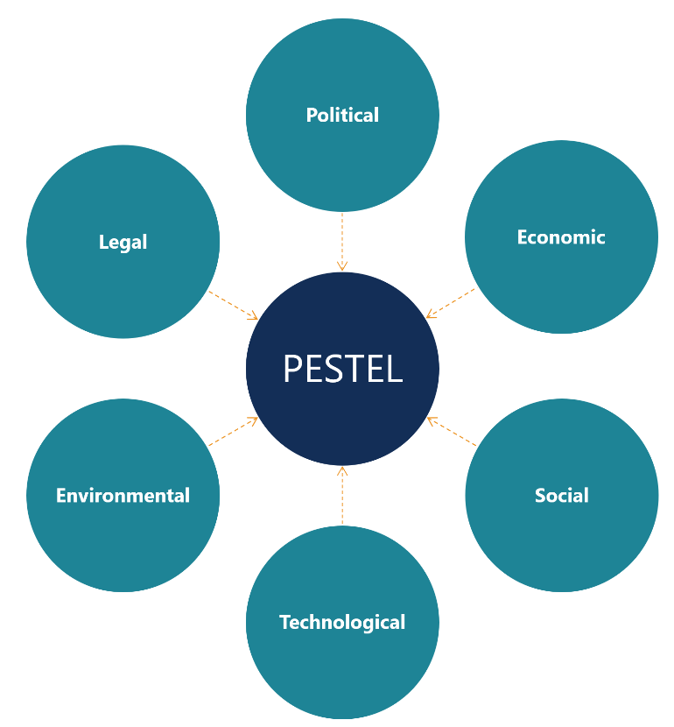
Fig. 1 Overview of PESTEL Analysis (Source: Corporate Finance Institute)
Political and Legal: Political and legal factors have been pulled together because the political environment in a country is guided by the legal system that exists which is why both will be regarded as one. These factors have been both favourable and unfavourable to Burberry for different reasons depending on the country Burberry is conducting its business. Looking at this from the British perspective, the enforcement of Brexit rules has caused sales of luxury products to EU countries to swiftly decline which has a damaging effect on luxury fashion industry (Butler, 2021). In effect, Burberry’s sales in the EU countries have seen a decline. Also, the impact of ending VAT-free shopping period for tourists coming into U.K. following the Brexit transition has been a threat to sales, in addition to adding cost of complying to the new post-Brexit rules and regulations (Rojas, 2021). International trade has been hit considerably because of Brexit and as such it is the main political event which has created these uncertainties due to the legal implications which has made these factors unfavourable to Burberry.
Economic: Although Burberry sales have seen a return to pre-pandemic levels as the younger consumers make purchases of the brand, it is reported that due to constant emergence of new variant of the coronavirus, growth in sales remain uncertain. Despite the total revenue up until September 2021 were £1.2bn up 38% year on year and like-for-like store sales rose by 6%, shares have decreased by 5% on the FTSE 100 (Jolly, 2021). Additionally, the growing concern of Covid-19 and its effects on the global economy has resulted in a volatile and uncertain climate which has led to a downside scenario for the Burberry brand (Burberry, 2020/21). This scenario is seen as a severe but plausible downside due to the situation of the British economy downturn because of the pandemic. Therefore, the economic factor is seen as unfavourable to Burberry as a company.
Social and Cultural: The impact of Covid-19 on consumer behaviour with the changing trends in society has in one sense been a mixture of favourable and unfavourable with the latter taking precedence. It has been a threat because of the lockdown caused by the pandemic as stores were forced to shut down for a considerable period in which sales were lost. There were no reasons for consumers to buy fashion products because all social gathering and meetings of people were banned to curtail the spread of the virus. It did not matter the demography, geography or psychography of the consumers that Burberry was targeting at that period.
Contrary to this however, many people taking up walking as exercise to remain healthy during the lockdown because of gym closure also led to slightly higher sales in the Burberry Heritage Trench Coats which has remained favourable to the brand with demand from consumers. Customers can browse the newly updated Burberry website to take advantage of home delivery service provided. In addition, and most importantly, Burberry is widely recognised and loved by consumers that there is a growing community on some social media like Facebook, Twitter, and YouTube, dedicated to the brand. Burberry has used its social media marketing strategy successfully by repositioning itself from a “stodgy nonentity” into a major trendsetter amongst other luxury brands in efforts to broaden their reach, appeal to younger consumers and thereby improve their revenue stream (Phan, et al., 2011).
Equally important is how Burberry was able to bounce back from being associated with the ‘chavs’ into a respected quality brand it is currently recognised. The revitalisation of the brand was done by using aggressive communication strategy with integrated marketing communication (IMC) in advertisements on social media platforms and launching ‘Burberry Porsum’ a high-end range of products to emphasise the British Heritage (Phan, et al., 2011).
Although the Covid-19 pandemic set about a decline in sales to Burberry, it has currently been doing well post-pandemic due to a new designer named ‘Riccardo Tisci’ to revitalise the brand who has gathered a new younger consumer for Burberry. For these reasons, the social-cultural factors are more favourable to the Burberry brand (Reuters, 2021).
Technology: Technological growth have become one of Burberry’s strong opportunities amongst its competitors hence it is favourable as the company has transformed itself as a long-time innovator by embracing the digital world. A statement by the Chief Executive Officer of Burberry states that: “We have transformed the in-store experience and launched industry-leading digital innovations that embody our values of creativity and forward thinking. As a result, we have attracted a new luxury customer with strength across key regions for luxury market growth” (Gobbetti, 2020/21).
Burberry has invested in research and development which is evident in many of the company’s environmental projects in addition to the growth in technology. For instance, a collaboration between Burberry, Asos and British Fashion Council in a vital project for unlocking growth for fashion and creative industries; in which £80m was made available (Santamaria, 2018). This R&D project enabled nine clusters of fashion hubs and University of Leeds worked closely with Burberry, The Royal College of Arts and British Fashion Council to embrace digital technology in the design process thereby reduce lead times and waste.
Furthermore, the social media sights create opportunities to engage customers by practising relationship marketing. As can be seen with the launch of the Burberry App which provides augmented reality experience to customers by allowing them to design a 3D virtual sculpture of some of Burberry’s pocket bag, placing them in real-life settings to show the look in customer’s homes (Burberry, 2021). This is evidence of Burberry continuously pushing the boundaries with innovative technology.
Environmental: The environmental factors are favourable regarding Burberry for a variety of reasons. Burberry has a well-established commitment to sustainability rooted in the belief that the challenges the fashion world is faced with need to be tackled for future growth; and also dedicated to empowering social progress and reducing their environmental footprints (Burberry, 2021). Other commitment to the environment by Burberry could also be seen in their commitment to support global conservation efforts with its biodiversity strategy in restoring and regenerating nature which helps to slow down global warming, being part of the transition to 1.5-degree centigrade pathway as part of the Paris Agreement (Burberry, 2021).
In conclusion, the factors that are favourable are: Environmental and Technological; with Economic seen as unfavourable. Political and Legal together with Social-cultural factors falls into the category on both favourable and unfavourable. Environmental scanning could be defined as a continuous and accurate analysis of the external and internal environment of an organisation for identifying strength, weaknesses, opportunities, and threats which could influence the present and future strategies (Bhasin, 2019). In the same way, environmental analysis is also the process of appraising all the external and internal elements which could influence the performance of an organisation (Jargons, 2021). Therefore, if scanning and analysis are practised, Burberry could become more proactive rather than reactive.

PORTER’S FIVE FORCES
The Porter’s five forces model is an analysis of the current competitors of a company with the intention of judging the attractiveness of the industry. It determines the right time to introduce a product into the industry in terms of profitability or the right time for exiting the industry because of the competitiveness of the market. These are determined by five forces which are: Industry rivalry, Threat of new entry, bargaining power of buyers, Threat of substitutes and Bargaining power of suppliers as shown in the diagram in Fig.2. An analysis of Burberry immediate environment, indicating whether these forces which affects the decision making and performance are high, medium, or low.

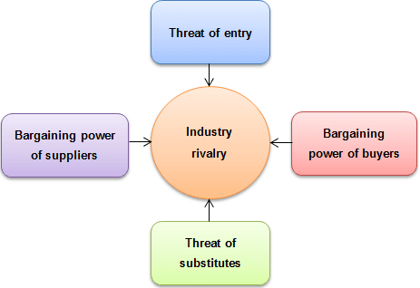
Fig 2. Porter’s Five Forces (Source: Strategic Management Insight)

Industry rivalry: The level of rivalry of Burberry within its competitors in the luxury fashion brand in the U.K. is high. This is because the current competitors that Burberry is competing with in the U.K. are companies like Channel, Michael Kors of the Capri Holdings Limited, and Ted Baker to mention a few. These competitors and many others have as big a share in the luxury market as Burberry have despite being in the luxury category because they are all vying for the same consumers of luxury goods. In July 2021, Statista, a statistic portal for market research and data published some of their findings regarding the top 10 luxury brand’s total revenue for year 2020 in the U.K in which Burberry positions in the third place amongst those mentioned, as shown below:
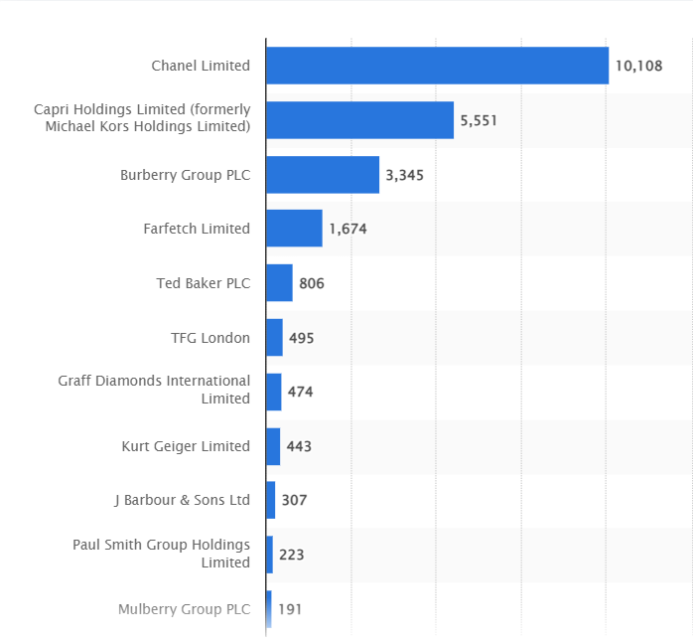
Fig 3 Top 10-11 U.K. luxury brand in revenue in million U.S. dollars 2020 (Source: Statista)
This figure shows that Channel ranked first with revenue of over 10b (billion) and Burberry coming third with a total revenue of just over 3b U.S dollars. It shows the big difference in Channel profits and Burberry profits. Some of the other reasons why the threat of industry rivalry is high could be seen in the focus that all these companies are putting into differentiating themselves from their rivals. Focusing on enhancing boosting customer experience in-store, personal shopping assistants online and in-store, personalised items to customer’s choice, and using technology to boost customer interaction all contribute to gaining a competitive edge over competitors. The fierce competition amongst these rivals makes the industry rivalry in the luxury market high especially in the global market as also shown in Fig. 4 below:
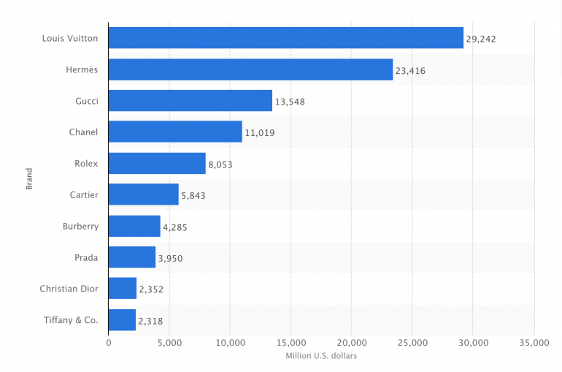
Fig 4. Global luxury brands in revenue as at 2017 (Source: Statista)

Threat of new entrants: The treat of new entrants that might affect Burberry is low. This is because Burberry has created barriers against new entrants in many ways. For instance, Burberry has a very strong brand name which have been in existence for many decades. The brand is recognised globally with the iconic and seasonal designs which is protected by its intellectual property (Burberry, 2020). Another reason is Burberry’s financial resources is high which means smaller rivals would not be able to afford to finance research and developments as well as the technology innovations that Burberry excels. Similarly, Burberry is a member of the FTSE100 index and listed on the London stock exchange because of investing their finances appropriately for effective growth and shareholder value (Burberry, 2020).
Bargaining power of suppliers: The bargaining power of suppliers is low-medium. Burberry is highly committed to their various suppliers and craftspeople all over the world who are central to the business and devoted to nurturing and preserving their skills which enhances their livelihoods and wellbeing (Burberry, 2021). One of the ways of enabling control is when Burberry decided to acquire one of their suppliers who is a leather goods business from an Italian supplier partner CF&P to enable greater control over cost, delivery, quality, and sustainability of the leather goods (Weissman, 2018). On the other hand, this kind of move could become risky if the responsibility of managing the suppliers acquired becomes too much. Burberry however has relative control because most of their products are produced at Burberry-owned manufacturing sites in the U.K. and Italy. Raw materials used are mostly leather, cotton and cashmere which the company ensures will be traceable by year 2025 (Burberry, 2021).
Bargaining power of the buyer: The bargaining power of the buyers is medium. The reason for this medium level is because as much as the brand has its dedicated consumers amongst a niche market, the company has started using their innovative technology to reach the younger and wider market who are able to analyse the benefits of owing a Burberry bag to that of a Channel bag. This makes the market easy for buyers to switch their loyalty easily as well as maintain the loyalty from the niche consumers. Burberry is fighting back to gain the upper hand however by the introduction of personalised relationship rather than functional with the customers as this increase’s customer retention (Hobbs, 2016). Hence because some customers would not want to switch whilst some don’t mind switching makes the level of the bargaining power of the buyers to be medium.
Threat of substitutes: The threat of substitutes for Burberry brand is high. There are many substitutes in the market for Burberry. For example, brands like Zara, H&M, Guess, Next, Aquascutum, Boden, Cos, Alex Mill and Asos, to mention a few. People who could not afford the prices for a Burberry product might consider these other brands to fulfil their wants and desires. With the large number of substitutes, the level of threat is high.
In summary, the forces creating the greatest threat to Burberry can be found in threat of substitutes and industry rivalry. Bargaining power of buyer is medium, bargaining power of suppliers’ swings between medium to low and threat of new entrants is low.

SWOT ANALYSIS
SWOT analysis is a framework used in extracting critical external strength and weaknesses and internal opportunities and threats facing a company (Kotler, et al., 2008). A group of other authors explains that SWOT provides a broad overview of a company’s strength and weaknesses surveyed within an analysis of strategic abilities and opportunities and treats surveyed within an analysis of the environment (Johnson, et al., 2014).
SWOT ANALYSIS FOR BURBERRY BRAND:
STRENGTHS:  - Strong heritage legacy: The brand is rooted in the heritage and principles of the founder, Thomas Burberry with a strong focus on quality, craftmanship, creativity and innovation. The brand is driven by cutting edge technology fuelled with creativity in their 165 years of brand history (Burberry, 2021).  - Structured operating model: Burberry operates under an organised strategy which is shaped by region, channels, and the allocation of products to the right channel.  - Innovative marketing strategy: Burberry excels in great digital innovative advertisements especially online on social media platforms. This makes the brand have prominence all over the world through its reach.  - Financial advantage: Burberry is listed on the London stock exchange and member of the FTSE100 (Burberry, 2021).  - Wide distribution network: Burberry trades through a network of their own stores and franchises and with online partners.  - Intellectual Property (IP): Burberry is protective of their brand therefore has a strong safeguard for their IP and is protected across the world it trades. | WEAKNESSES:  - Fierce competition: Burberry faces fierce competition from other luxury brands globally. The brand also faces a threat from other substitutes in customers substituting the brand with products from other stores that do not cost as much.  - Lagging customer loyalty: The decrease in customer loyalty was blamed on wider economic conditions and trading in traditionally lucrative Asian market which has affected footfall negatively (MarketingWeek, 2016).  - Luxury brand ubiquity: Burberry has suffered in its brand becoming ubiquitous when the company licenced all products to be sold in outlet stores at low discounts (Walker, 2018). This was reinforced by Angela Ahrendts the CEO of Burberry in 2018 by this statement “In luxury, ubiquity will kill you”.  - Negative knowledge: Burberry’s association with the ‘chavs’ became negative for the brand a few years ago.
OPPORTUNITIES:  - Investment in research and development (R&D): Burberry has the finances to invest in R&D to retain brand heat. Evident in creating new ways of reaching customers through live streaming and remote selling especially in South Korea and Mainland China (Burberry, 2020).  - Strategy for growth: Burberry has a good strategy for growth with the brand. For instance, Vogue announced the opening of Burberry’s new flagships store in Sloane Square London in July 2021. This is so they could meet the growing demands of customers. Also, there are plans for three more flagship stores to be opened in the next year in Bond Street, London; Rue Saint-Honoré in Paris and Plaza 66 in Shanghai (Marketline, 2021).  - Increase digital presence: Especially in the current covid-19 pandemic period, Burberry has seized the opportunity to respond quickly by adapting their business with digital strength (Burberry, 2020). | THREATS:  - Bargaining power of customers: Customers have medium-high bargaining power because of change in fashion trends and substitute brands/stores.  - Strict Political and legal restrictions: Subject to Brexit and Covid laws and regulations, Burberry’s daily operations are bound to be affected as many other businesses as possible.  - Threats from other luxury brands.

ADVANTAGES AND DISADVANTAGES OF SWOT ANALYSIS
SWOT analysis is a situation analysis model used as a planning tool by companies and organisations so that their goals, functions, and plan of action, can be aligned to the operational environment. As much as it is widely used for the advantages, there are also shortcomings to the model when used. Importantly, factors that make up strengths and weaknesses in a SWOT analysis for a company are relative and not absolute (Kotler, et al., 2008). Thus, one of the advantages is that it is a simple four-box framework which at the same time could become a disadvantage because it could be oversimplified with insufficient data (CIPD, 2021). In addition to the advantages as indicated by CIPD, managers or leaders in charge of the strategy in a company can understand strength and weaknesses to help develop strategic thinking and growth. Future business opportunities can be realised through a SWOT analysis as well as predict business threats thereby put together a plan of action to minimise or eliminate these threats.
An important unfavourable aspect of using SWOT analysis is found only relating the strengths to critical success factors having excluded a list of all features of the company. However, too long a list could also cause a lack of focus and a company unable to differentiate important factors (Kotler, et al., 2008). Sometimes data collected could become unfounded through speculative or questionable information and through a fast pace of change in the business environment the company operates (CIPD, 2021). In summary, for SWOT analysis to be an effective tool, it needs to be done frequently.

SEGMENTATION, TARGETING AND POSITIONING
SEGMENTATION: Market Segmentation is the process in which segments of the market is identified and a large customer base is categorised into groups of existing and impending customers (Camilleri, 2018). Kotler, et al. (2008) explains it further that through market segmentation, large divergent markets can be divided into smaller segments for the purpose of easy, efficient, and effective reach with products and services matching their unique needs. The major factors used in the segmentation of customer markets are categorised into geographic, demographic, psychographic and behavioural segmentation. Geographic segmentation is when the market is divided into different geographical parts such as cities, countries, nation, and regions; demographic segmentation is based on age, gender, income, race, education, marital status, and occupation whilst psychographic segmentation is based on personalities and lifestyle of consumers (Kotler, et al., 2020). Added to these is behavioural segmentation which is the division of consumers into categories based on attitudes, knowledge, and use of the brand.
In the case of Burberry, the company uses a combination of geographic, demographic, and psychographic segmentation for different reasons like developing a profile of their kind of consumers, allocation of stores and or even direct marketing, in their marketing mix strategy. As reported in Burberry’s 2021 strategic report, despite Covid-19 having a significant effect on luxury market profits with a 60% year-on-year decline in Earnings Before Interest and Taxes (EBIT) in the luxury market, regional performances have varied in with staggered recovery shaped by economic recovery policies and consumer confidence. Burberry’s strategy is to put their resources into geographical locations in Asia, Americas, Europe, and the Middle East. Although there was decline at the start of 2020, Mainland China started recovering with a +45% year-on-year growth due to the robust local economy, government stimulus packages helping the Americas customers, and less impact of covid on luxury goods in the Middle East (Burberry, 2020/21). In addition, Burberry stores are situated in cities in the U.K. like London, Edinburgh, and Glasgow, and big cities in Asia and the Middle East.
Burberry’s demographic segmentation covers a wide range of age 0-24 months, 3-14 years, and mostly between 20-45+ years; wide range of products for men and women with high income category due to the high prices of their products. There is also a niche segment of customers depending on their social class whose loyalty are with the Burberry brand. Furthermore, Burberry’s psychographic segmentation have taken shape over social media platforms like Facebook and Instagram and the members or followers are based on their activities, interests, opinions, and lifestyle. Burberry also uses the geo-demographic segmentation in allocating their stores in specifically affluent areas where the higher earners live like their store in Sloane Square and Regent Street in London.
Therefore, a typical Burberry brand consumer is a child or adult, man, or woman within the age of 20-45 of middle to high income earners, high-class groups which constitutes of ordinary people, celebrities and social media influencers interested in Burberry’s heritage products.
TARGETING: Targeting is the process where each market segment is gauged according to their attractiveness for entry selection strategy (Kotler, et al., 2008). Burberry utilizes mostly undifferentiated marketing strategies and sometimes use differentiated in collaboration with concentrated marketing in their marketing mix. For instance, for undifferentiated marketing, most of their brand promotions is done in form of a short film with YouTube their chosen media platform. The most current advertisement using IMC is a short film in collaboration with “Are You Happy. Are You?” which has over 5m views to date (Are You Happy. Are You? 2021). This promotion has a mixture of a child with her mother, black men and women featuring and also laying emphasis on mental health. Burberry also have promotions mainly for men fragrances on Television which is an example of differentiated with a combination of concentrated marketing for a small niche of customers.
Therefore, Burberry’s target market are men, women, and children of ages 4-45, different cultural backgrounds, gender, and ethnicity, including celebrities.
POSITIONING: Positioning is the final stage of target marketing specifying the position the brand wishes to occupy in the consumer’s mind taking into consideration the competitor’s products and services (Camilleri, 2018). It is not what the company does to their brand or product, it is what is done to the mind of the consumers which is the brand image in the minds of the customer that is positioning. The major positioning themes are Benefit positioning, User positioning, and Competitive positioning, with celebrity endorsements included as important especially for luxury brands. Kotler et al, (2020, p.51) defines positioning as “arranging for a product to occupy a clear distinctive and desirable place relative to competing products in the minds of target consumers”.
Burberry’s brand image in their customers mind is firstly the signature checks associated with their iconic trench coats, bags and scarves, and the classic English styles associated with their brand ambassadors like Marcus Rashford, Kate Moss, Naomi Campbell, and Emma Watson. Burberry focuses on Benefit positioning with emphasis on high quality products that lasts very long by investing in quality raw materials, whilst reducing, reusing, and recycling wastes produced (Burberry, 2021). Similarly, Burberry uses History/Parentage positioning with a combination of celebrity endorsements positioning because the customer places the brand high above other brands due to the historical heritage of the founder Thomas Burberry. In addition to this, examples of celebrity endorsements are Romeo Beckham (son of David Beckham the former footballer) is associated to Burberry, James Corden and Julie Walters (of the musical drama Billy Elliot) are all associated with Burberry as faces of Burberry. The brand is positioned as one for the younger consumer group who loves quality products associated with British heritage.

THE MARKETING MIX STRATEGY
Definition: Marketing mix is “the set of tactical marketing tools, product, price, place and promotion that a firm blend to produce the response it wants in the target market” (Kotler, et al., 2020, p. 51). This definition was mostly recognised at a period when companies did not realise the importance of services (customer service) as pivotal to brand development therefore limited to the 4Ps. Eventually, the 7Ps was created to include people, process, and physical evidence, and 8Ps to include partners. The 7Ps or 8Ps is recognised to work well for multichannel companies for attaining online capacity (Hanlon, 2021). For Burberry being a product brand, the 4Ps as shown in Fig. 5 will be discussed with their existing marketing strategy.
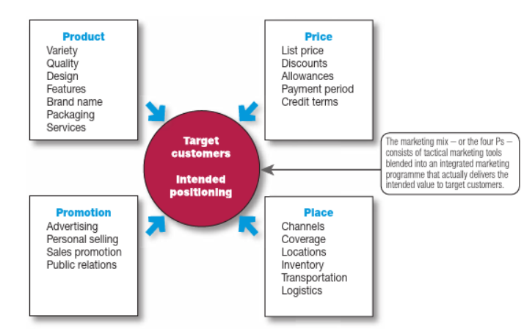
Fig 5. The 4Ps of Marketing Mix (Source: Principles of Marketing by Kotler et.al, 8th edition)
PRODUCT: Burberry’s strategy in terms of branding their products is based on a combination of line extension with introduction of new check colours, lining the inside of their trench coats with the iconic check rather than on the outside, and introducing different shapes and styles of accessories like bags, scarfs, in different colours to attract different target market. This strategy of line extension is used by companies as a leverage to brand equity as well as trying to minimise cost (Kirmani, et al., 1999). Although Burberry uses line extension, the company also utilizes line stretching (downward stretch) as a strategy for protection of the brand and upward stretch for existing customers looking for new features, higher prestige, and quality which the brand provides.
Central to Burberry’s products are the outwear, trench coats, jackets, signature bags, leather products and perfumes with the affordable accessories being their products for entry level customers. It also includes Women and Men clothing including outerwear Jackets and Coats, T-shirts and Knitwear, Bags, Scarves, Jewellery, Accessories including Belts, Hats, Gloves, Wallets, Umbrellas, and Sunglasses, Fragrances, Beauty products, Shoes and Gifts items.

PRICE: Burberry business is anchored in luxury and with the vision to leveraging this strong luxury offer to their customers, their product prices reflect this vision with the use of high-quality leather materials, and high-quality gabardine for outerwear products. For example, a men’s monogram motif cotton T-shirt cost £350 whilst the long Kensington Heritage Trench Coat cost £1650. This is a form of price skimming where high prices are charged in line with the quality of products offered which must not be compromised. The global marketing team in Burberry work to have a consistent pricing strategy all over their global stores to eliminate differential pricing or price discrimination.
PLACE: Burberry currently has about 459 stores located globally as of March 2021 as reported by Statista Research Department. The company use a combination of direct and indirect channel of distribution as shown in Fig 6.
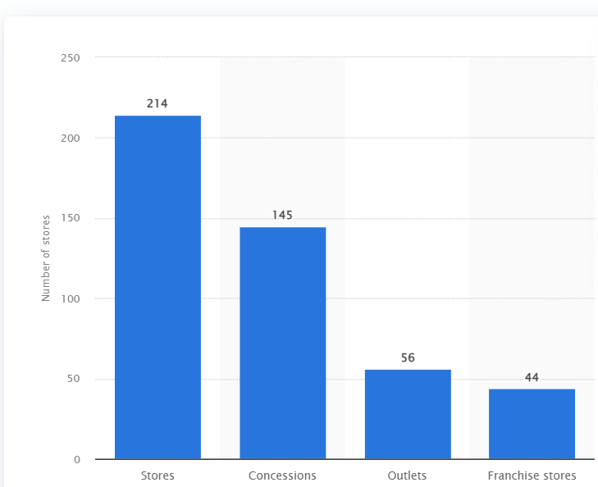
Fig 6. Burberry’s number of stores worldwide (Source: Statista)
It is evident from Fig.6 that Burberry store’s strategy combines direct distribution and indirect distribution with 214 Stores, 145 Concessions, 56 Outlets and 44 Franchise stores. As can be seen in their direct operation, franchised, online and through wholesale partners however use product and distribution expertise partners for their beauty and eyewear, building a connection with consumers through their innovative and stimulative content and experiences (Burberry, 2020/21).
PROMOTION: In terms of promotions, Burberry has merged integrated marketing communication (IMC) with digital innovation which is evident in their promotional advertisements in the past years, and more innovation continues to grow. In the same way that there are several Burberry brand short films in association with current issues in the world being showcased on YouTube. Advertisements on TV for the brand’s men perfume is an example. The most recent brand experience unveiled by Burberry is in Korea with “A New Immersive Brand Experience”. This inspirational pop-up is happening across the globe with the one in Jeju Island, Korea showcasing the brand’s latest outwear silhouettes as reported by the ‘Retail & Leisure International (RLI) online news website. The experience provides customers and visitors to the pop-up with cinematic films by three artists Cao Yuxi, Lia Jiayu, and Maotik where digital and the outdoor collides, and in the available products like the iconic trench coats, water resistant gabardine and the new revolutionary gabardine (RLI, 2021). In effect, Burberry is using a combination of advertising on TV and social media platforms, sponsorships like the ‘Tour de France cycling team’ and their partnership with Marcus Rashford in helping children and youth develop literacy skills, to mention a few.

CONCLUSION
In conclusion, the marketing department of every company and organisation plays a significant and crucial role with the marketing activities and their contribution to the business profitably and with the intension of adding value to the brand. A marketing executive must emphasise growth for the brand and recommend strategies for continued growth. Understanding the external and internal factors together with the strength, weaknesses, opportunities for growth and threats influencing the brand leads to understanding of the brand value. It important to understand Burberry’s strategy of segmentation, targeting a positioning the luxury brand; together with what the marketing or promotional mix strategy so that appropriate recommendations could be suggested.

RECOMMENDATIONS
To find out the future marketing strategies for Burberry, it is suggested that the Ansoff matrix is applied. The Ansoff Matrix was developed in 1957 by Igor Ansoff an Applied Mathematician, used as a strategic marketing management planning tool for the future growth of a business and for protection against different measure of risks (Clarissia, 2019). In simple terms, it enables marketers a simple and productive way of analysing different options for taking strategic decisions and being aware of risks involved. There are four strategic choices in the matrix as seen in Fig. 7 which are: Market Development, Product development, Market Penetration and Diversification. These choices vary in risks depending on the strategic choice

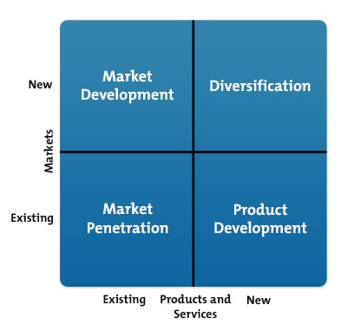
Fig 7 Ansoff Matrix (Source: Oxford Learning lab)
Burberry could apply this matrix to gain new perspectives to enable their luxury business to grow further than it is currently growing. The Burberry brand seem to be developing and growing positively with Market penetration and Product development. With market penetration, the brand is already promoting and selling their current products to their already established customers through their different promotional strategies. The company’s product development strategy also is targeting their existing customers with new reformed products.
Therefore, the recommended strategy would be to introduce their luxury brand into new markets especially as the company is financially resourced and diversify into new market with new products; and enable diversification of new products into new market is recognised as the riskiest of all the four strategies in the Ansoff matrix (Ryan, 2021).

REFERENCES
Are You Happy. Are You? 2021. [Film] Directed by Atdhe Trpca. U.K.: s.n.
Bhasin, H., 2019. Environmental Scanning – Importance Of Environmental Scanning. [Online]
Available at: https://www.marketing91.com/environmental-scanning/
[Accessed 22nd December 2021].
Burberry, 2020/21. Burberry Strategic Report. [Online]
Available at: https://www.burberryplc.com/content/dam/burberry/corporate/oar/2021/pdf/Burberry_2020-21_Strategic_repor
[Accessed 26th December 2021].
Burberry, 2020. Burberry Annual Report 2019/2020, s.l.: Burberry.
Burberry, 2021. Annual Report 2020/2021, London: Burberry.
Burberry, 2021. Burberry Ethical Trading. [Online]
Available at: https://www.burberryplc.com/en/responsibility/communities/ethical-trading.html
[Accessed 23rd December 2021].
Burberry, 2021. Burberry News. [Online]
Available at: https://www.burberryplc.com/en/news/brand/2021/burberry-creates-augmented-reality-pocket-bag-experience.htm
[Accessed 22nd December 2021].
Burberry, 2021. Business Model. [Online]
Available at: https://www.burberryplc.com/en/company/business-model.html
[Accessed 26th December 2021].
Burberry, 2021. Communities. [Online]
Available at: https://www.burberryplc.com/en/responsibility/communities.html
[Accessed 12th December 2021].
Burberry, 2021. TRANSPARENCY IN THE SUPPLY CHAIN AND MODERN SLAVERY STATEMENTS. [Online]
Available at: https://uk.burberry.com/legal-cookies/transparency-in-the-supply-chainmodern-slavery-statements/
[Accessed 23rd December 2021].
Butler, S., 2021. From fashion to farming: how Brexit is hitting Britain's trade, The Guardian: s.n.
Camilleri, A., 2018. Market Segmentation, Targeting and Positioning. In Travel Marketing, Tourism Economics and the Airline Product, Switzeland: Springer.
CIPD, 2021. Advantages and disadvantages of using SWOT analysis, s.l.: CIPD.
Clarissia, M. S., 2019. A Study on Ansoff Matrix Technique: As a Growth Strategy and an Adaptive Learning Technique Adopted in the leading Brand of Products. A Journal of Composition Theory, 10(9), pp. 1494-1506.
Gobbetti, M., 2020/21. Burberry Strategic Report: Chief executive Officer's Letter, London: Burberry.
Hanlon, A., 2021. How to use the 7Ps Marketing Mix. [Online]
Available at: https://www.smartinsights.com/marketing-planning/marketing-models/how-to-use-the-7ps-marketing-mix/
[Accessed 27th December 2021].
Hill, A., 2020. What is PESTLE, PESTEL or PEST Analysis?. [Online]
Available at: https://mychartguide.com/what-is-pestle-pestel-or-pest-analysis/
[Accessed 20th December 2021].
Hobbs, T., 2016. Burberry admits its customer loyalty is ‘lagging’ and marketing needs ‘rebalancing. [Online]
Available at: https://www.marketingweek.com/burberry-admits-customer-loyalty-is-lagging-and-marketing-needs-rebalancing-as
[Accessed 23rd December 2021].
Jargons, B., 2021. Environmental Analysis. [Online]
Available at: https://businessjargons.com/environmental-analysis.html
[Accessed 22nd December 2021].
Johnson, G. et al., 2014. Exploring Strategy Text and Cases. 10th ed. Harlow: Pearson.
Jolly, J., 2021. Burberry reports slow sales growth as Covid impact persists, s.l.: The Guardian.
Kirmani, A., Sood, S. & Bridges, S., 1999. The Ownership Effect in Consumer Responses to Brand Line Stretches. Journal of marketing, 63(1), pp. 88-101.
Kotler, P., Armstrong, G., Harris, L. C. & He, H., 2020. Principles of Marketing. 8th ed. Harlow: Pearson.
Kotler, P., Armstrong, G., Wong, V. & Saunders, J., 2008. Principles of Marketing. 5th ed. Harlow: Pearson.
MarketingWeek, 2016. Burberry admits its customer loyalty is ‘lagging’ and marketing needs ‘rebalancing. [Online]
Available at: https://www.marketingweek.com/burberry-admits-customer-loyalty-is-lagging-and-marketing-needs-rebalancing
[Accessed 26th December 2021].
Marketline, A., 2021. Burberry Group Plc, s.l.: Marketline.
Phan, M. C. T., Thomas, R. & Heine, K., 2011. Social Media and Luxury Brand Management: The Case of Burberry. Journal of Global Fashion Marketing, 2(4), pp. 213-222.
Reuters, C., 2021. UK’s Burberry names Versace boss Akeroyd as CEO. [Online]
Available at: https://www.cnbc.com/2021/10/20/uks-burberry-names-versace-boss-akeroyd-as-ceo.html
[Accessed 22nd December 2021].
RLI, 2021. Burberry Unveils New Immersive Brand Experience. [Online]
Available at: https://www.rli.uk.com/burberry-unveils-new-immersive-brand-experience/
[Accessed 27th December 2021].
Rojas, J.-P. F., 2021. Burberry warns of impact of axing VAT-free shopping on UK sales, s.l.: Sky News.
Ryan, E., 2021. The Ansoff Matrix: How You Can Use It to Strategize Your Business Growth [blog]. [Online]
Available at: astcapital360.com/blog/ansoff-matrix/
[Accessed 28th December 2021].
Santamaria, B., 2018. Burberry, Asos join 'first-of-its kind' R&D programme for UK fashion industry. [Online]
Available at: https://ww.fashionnetwork.com/news/Burberry-asos-join-first-of-its-kind-r-d-programme-for-uk-fashion-indust
[Accessed 22nd December 2021].
Walker, C., 2018. When Brand Familiarity Breeds Risk: The Curse of Negative Knowledge. GFK Marketing Intelligence Review, 10(1), pp. 24-28.
Weissman, R., 2018. Burberry will acquire its supplier for 'greater control. [Online]
Available at: https://www.weforum.org/agenda/2015/04/do-you-understand-your-companys-knowledge-assets/
[Accessed 23rd December 2021].
Whittington, R. et al., 2020. Exploring Strategy. 12th ed. Harlow: Pearson.

