  - University of Wales Trinity St. David
  - School of Engineering
  - Motorsports Engineering BEng
  - Advanced Engine Design

Con-rod Accelerations, forces

and displacements

  - Oliver Duane
P151457
  - 2019

Abstract

This report looks at some of the accelerations, forces and displacement of a con-rod in a Ford 1.6 naturally aspirated engine.
The forces on the con-rod are calculated from the masses, crank angle and cylinder pressure data, then the safety factor determined using the material’s data. Alongside the standard con-rod results, there are calculated results for an engine modified with a titanium con-rod.
The main part of the report consists of eight tasks, sequentially progressing through the stages of analysing performance to enable engine development.

Contents
- Intro 1
- Supplied data 1
- Tasks: 2
A.Calculate peak gas forces 2
B.Graph inertia loads of piston on con-rod at 6000 rpm 4
C. & D. Calculating highest net compressive and tensile forces on con-rod 7
E.Calculate maximum compressive and tensile stresses on con-rod shank using minimum cross-sectional area 8
F. Calculating nominal static safety factors (relative to UTS) for both compressive and tensile loads using results from E. 8
G.Calculating con-rod strain using results of E. and a simplified rectangular beam model 9
H.Calculating strain of a titanium con-rod and significance to engine operating clearances 10
I. Graph inertia, gas and net instantaneous torque, and calculate average net torque 10

Table of Figures
Figure 1: Constant data 1
Figure 2: Variable data 1
Figure 3: Con-rod material UTS and Bore Area 2
Figure 4: Average gas cylinder pressures 3
Figure 5: Maximum cylinder gas forces at 6000rpm 4
Figure 6: Acceleration and inertia forces at 6000rpm, parallel to cylinder 5
Figure 7: Con-rod angle 6
Figure 8: Piston inertia load on the con-rod at 6000rpm 7
Figure 9: Tensile and compressive forces on con-rod 8
Figure 10: Instantaneous torque on crankshaft 12

Intro

The Ford 1.6 engine is subjected to a variety of internal forces that result in engine vibration and rotation:
- The heavy crank shaft and cam shafts rotate, thereby creating rotational inertia which resists changes in speed and results in a torque to the engine block. It is balanced so does not cause vibration;
- The pistons move linearly with high accelerations due to the rapid changes in direction, but spend more time at the bottom end (due to con-rod and crank geometry) and therefore have a higher acceleration (and therefore force) at the top-end;
- The top-end of the con-rod moves linearly while the bottom end follows the circular path of the crank’s rotation. This results in oscillating rotational inertia of the bottom-end, combined with oscillating linear inertia with high acceleration of the top-end. The CoG of the con-rod follows an elliptical path relative to the block;
- Although the valves have a relatively low mass, they oscillate with high accelerations and jerk.
The engine is limited in speed and power by the inertia of the many moving parts in it. The result of multiple masses moving at high speed in a variety of motions is:
- Complex vibration of the engine block;
- Fluctuating loads on components;
- Energy dissipation through friction.
The force produced by the inertia of these components increases exponentially with speed (F = ma = mω²r), and so reducing their masses is an effective way of reducing vibration and component loads. (Ferguson & Kirkpatrick, 2001)
When reducing the masses of components, care must be taken to maintain adequate strength so that they do not break. The main steps in this process are:
- Calculating the maximum forces;
- Determining the safety factor;
- Selecting a material with suitable properties;
- Accounting for the property differences of materials, and the effect changes of temperature have on those properties;
- Accounting for flaws in the material structure due to poor quality materials;
- Optimising the shape to use minimal material (within the constraints of the manufacturing processes) while withstanding the forces and safety margin for the specified lifespan.

Supplied data

Two types of data were supplied, constant (Figure 1.) and varying (Figure 2.).
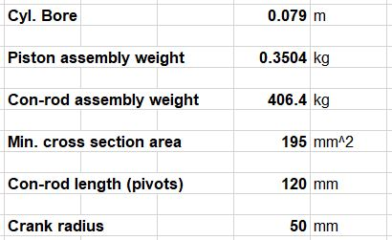
Figure 1: Constant data
The varying data consisted of various measurements taken at each degree for two rotations of the crank, or one complete 4-stroke cycle, at several different engine speeds.
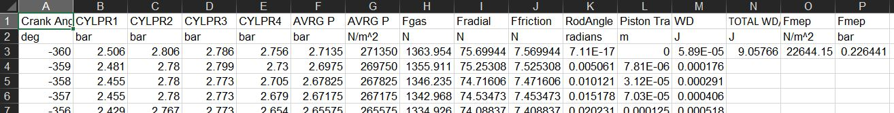
Figure 2: Variable data
Bore area was calculated and some typical UTS figures determined (Figure 3.).
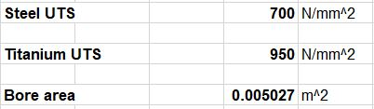
Figure 3: Con-rod material UTS and Bore Area

Tasks:

Calculate peak gas forces

Pressure = Force / Area
so:
Gas Force pushing piston down = Gas Pressure x Area of cylinder bore.
Fig. shows that the highest gas forces are produced at the highest measured engine speed, 6000 rpm.

Figure 4: Average gas cylinder pressures
Figure 4. shows an approximate 4% variance of maximum gas forces between cylinders at 6000 rpm.

Figure 5: Maximum cylinder gas forces at 6000rpm
To find the peak gas pressure, and therefore the peak gas forces acting on the piston, the maximum pressure reading was found in the supplied data. It is in cylinder 3 at 18 degrees of crank angle, engine speed of 6000 rpm (or 628 rads/sec), with a pressure of 97.5 bar and 49kN of gas force acting on the piston.

Graph inertia loads of piston on con-rod at 6000 rpm

The piston inertia force acting along the path of the piston can be calculated by multiplying piston mass by piston acceleration. $$Piston Inertia Force=Piston Mass x Piston Acceleration$$

The piston mass data was supplied. The acceleration was calculated from the change in piston velocity divided by the change in time:
$$Piston Acceleration= Δ Piston Velocity / Δ Time$$

Piston velocity was calculated by the change in position divided by the change in time:
$$Piston Velocity= Δ Piston Distance / Δ Time$$

The time period between data points depends on engine speed. The time taken for one degree of crank rotation (the time period between data points) was found using the following formula:
$$Seconds per degree=\frac{1s}{360°\left(\frac{rpm}{60s}\right)}$$

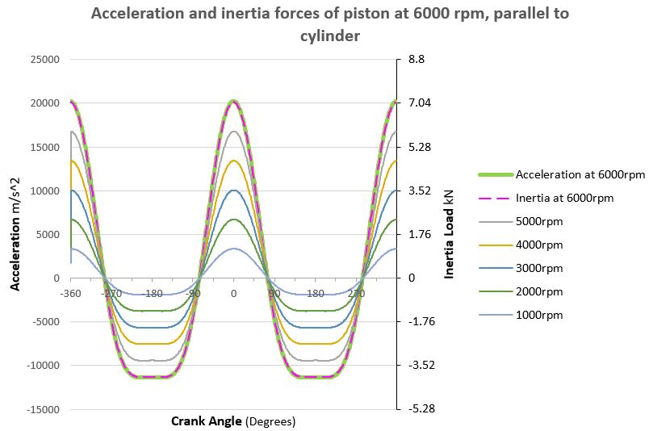
Figure 6: Acceleration and inertia forces at 6000rpm, parallel to cylinder
From Fig. the following information was determined:
- Piston inertia is directly proportional with piston acceleration, as piston inertia is a product of the variable acceleration and the constant mass;
- Acceleration and inertia increase proportionally with engine speed;
- At TDC the piston acceleration causes a tensile load on the con-rod;
- At around 76 degrees there is momentarily no piston inertia load on the con-rod as the inertia load changes from one direction to the other;
- At BDC the piston inertia causes a compressive load on the con-rod.
However, when the angle of the con-rod differs to the direction of gas force, the cylinder wall provides an additional lateral force. The resultant force along the con-rod was calculated using trigonometry:

Figure 7: Con-rod angle

Figure 8: Piston inertia load on the con-rod at 6000rpm

C. & D. Calculating highest net compressive and tensile forces on con-rod

To calculate the net force, gas force, piston inertia force and con-rod angle must be considered:

$$Net force on Conrod = \frac{Piston inertia force-Gas force }{Cos(Conrod angle)}$$
- Positive gas force compresses (imparts a negative force on) the con-rod.
- Positive piston inertia force stretches (imparts a positive force on) the con-rod.
The resulting curve is shown in Figure 9. Tensile loads are positive and compressive loads are negative.

Figure 9: Tensile and compressive forces on con-rod

The net force on the conrod (as seen in Figure 9.) is only subjected to tensile load (peaking at 5.75kN) during the second half of the exhaust stroke and the first half of the intake stroke. During the compression and combustion strokes the gas force is greater than the inertia force. The net compressive force peaks at -41.45kN at 18 degrees of C.A.
The gas force at this point, however, is reduced by the opposing piston inertia. (Heywood, 1988)

Calculate maximum compressive and tensile stresses on con-rod shank using minimum cross-sectional area

Using measurements taken from the same type of con-rod, the minimum cross sectional area was calculated. The compressive and tensile stresses were then calculated by dividing the con-rod force by the minimum cross-section area. The stress is the same for both steel and titanium.
$$Max. stress = \frac{Max. net force }{Min. cross section area}$$

$$Max. net compressive force \left(C.A. = 18 degrees\right) =-41.5 kN$$

$$Max. net tensile force (C.A. = -352 degrees)=5.75kN$$

$$Minimum cross section area =195mm^2$$
Max. compressive stress:

$$\frac{-41.5 kN}{195 mm^2}= -213 N/mm^2$$
Max. tensile stress:

$$\frac{5.75 kN}{195 mm^2}= 29.5 N/mm^2$$

Calculating nominal static safety factors (relative to UTS) for both compressive and tensile loads using results from E.

The static safety factors for nominal compressive or tensile loads are found by dividing the UTS of the conrod material by the maximum compressive or tensile load.

$$Nominal static safety factor=\frac{UTS}{Nominal stress}$$

$$Nominal compressive stress=-213 N/mm^2$$

$$Nominal tensile stress=29.5 N/mm^2$$

Production engine, Steel con-rod | Modified engine, Titanium con-rod
$$UTS=750 N/mm^2$$  Compressive static safety factor:  $$\frac{750}{-213}= -3.52$$  Tensile static safety factor:  $$\frac{750}{29.5}= 25.4$$ | $$UTS=650 N/mm^2$$  Compressive static safety factor:  $\frac{650}{-213}= -3$.05  Tensile static safety factor:  $$\frac{650}{29.5}= 22$$

Calculating con-rod strain using results of E. and a simplified rectangular beam model

The maximum strain ($ε$) caused by gas pressure and inertia loadings is calculated by dividing the maximum net stress ($σ$, 213 N/mm^2) by the Youngs modulus ($E,$) of the con-rod material.
$$Strain ε=\frac{Stress σ}{Youngs modulus E}$$
$Compressive stress σ=213 N$/mm^2
$Tensile stress σ=29.5 N$/mm^2

Production engine, Steel con-rod | Modified engine, Titanium con-rod
$Youngs modulus E$ = $2 x {10}^{5}$  $$Compressive strain ε=\frac{213}{\begin{aligned}2 x {10}^{5} \\ \end{aligned}}$$  $$= 1.065 x {10}^{-3}$$  or  0.1065 %  $$Tensile strain ε=\frac{29.5}{2 x {10}^{5}}$$  $$= 1.475 x {10}^{-4}$$  or  0.01475 % | $Youngs modulus E$ = 1.13$x {10}^{5}$  $$Compressive strain ε=\frac{213}{\begin{aligned}1.13 x {10}^{5} \\ \end{aligned}}$$  $$= 1.885 x {10}^{-3}$$  or  0.1885 %  $$Tensile strain ε=\frac{29.5}{1.13 x {10}^{5}}$$  $$= 2.611 x {10}^{-4}$$  or  0.02611 %

Calculating strain of a titanium con-rod and significance to engine operating clearances

The proposed Titanium con-rod for the modified engine has the following characteristics:
- Lower modulus of elasticity than Steel i.e. more flexible - Under compression this is not so important, but under tension the con-rod elongates 77% more than steel (0.226mm for titanium compared with 0.128mm for steel) and therefore could collide with the top of the cylinder or the valves, especially with increasing engine speed.
- Higher UTS -. more stress can be withstood – Gas pressures and engine speed could be increased, weight could be removed from the con-rod, while still maintaining the factor of safety;
- Nearly half the weight of steel – less inertia counteracting the power stroke.

Graph inertia, gas and net instantaneous torque, and calculate average net torque

The instantaneous torque was calculated by multiplying:
- The crank force;
- Sin of the angle between the crank and con-rod;
- The crank radius.

Figure 10: Instantaneous torque on crankshaft
The mean average net torque was calculated by dividing the sum of data readings (one for each degree of crank rotation) by the number of readings. Each cylinder was calculated to produce 71.4Nm, giving a total of 285.5Nm for all four cylinders.

Bibliography
Ferguson, C. R. & Kirkpatrick, A. T., 2001. Internal Combustion Engines. Second ed. New York: John Wiley & Sons, Inc..
Heywood, J. B., 1988. Internal Combustion Engine Fundamentals. First ed. USA: McGraw-Hill, Inc..

