Module Title:
Understanding and Engaging Stakeholders

Module Code: - LCLM 5001 C1
Assignment: Individual Report

Student Name: - Mihaela Amisculesei

Student Number: - 2411946

Lecturer’s Name: - Eric Osei

Table of contents
1.0 Introduction: Holiday Inn and the Stay Smart+ Initiative 4
2.0 Situational Analysis: SWOT and PESTLE 4
SWOT Analysis 5
PESTLE Analysis 6
3.0 Identification and Categorisation of Key Stakeholders 7
Internal Stakeholders 7
External Stakeholders 7
4.0 Stakeholder Roles, Responsibilities, and Analytical Frameworks 8
RACI Matrix for Stay Smart+ Launch 8
Stakeholder Power/Interest Grid 9
Stakeholder Roles, Benefits, and Challenges – Table 2 10
Communication Plan: Stay Smart+ Global Launch 11
5.0 Stakeholder Engagement Process and Conflict Management (The 4C's Model) 17
Managing Conflict 19
6.0 Evaluation of Impact and Recommendations 19
Impact of Stakeholder Engagement on Business Performance 19
Recommendations for Future Stakeholder Engagement 20
7.0 Conclusion 21
Reference List 22

Executive Summary
This report outlines the stakeholder engagement strategy for the global launch of "Stay Smart+," a new AI-driven and sustainability-focused customer experience service for Holiday Inn. The project aims to integrate personalised travel planning and eco-friendly amenities across selected international markets within six months. As Project Manager, this report identifies and categorises key internal and external stakeholders critical to the launch's success. Utilising frameworks such as stakeholder theory, the Power/Interest Grid, and a RACI Matrix, the report justifies tailored engagement strategies to foster collaboration and commitment across diverse cultural contexts. The analysis critically evaluates the benefits, challenges, and ethical considerations inherent in managing these relationships, applying the 4C's model to propose a conflict resolution process. Finally, the report evaluates the impact of robust stakeholder engagement on business performance and provides strategic recommendations to ensure the Stay Smart+ initiative achieves its objectives of enhanced brand differentiation and operational excellence.

1.0 Introduction: Holiday Inn and the Stay Smart+ Initiative
InterContinental Hotels Group (IHG) is one of the world's leading hotel and hospitality companies, with a portfolio of well-recognised brands, including Holiday Inn and Holiday Inn Express. With over 4,000 Holiday Inn-branded hotels globally, it is a cornerstone of the mid-scale to upper mid-scale accommodation market, serving both leisure and business travellers (IHG, 2026). The brand has a significant presence in major urban centres, including London and Birmingham, where it competes on service consistency, location, and value. As part of IHG's broader strategy, which focuses on operational efficiency and brand relevance (IHG, 2026), Holiday Inn continually evolves to meet changing guest expectations.
In this context, the company is preparing to launch "Stay Smart+," a premium customer experience service. This six-month global project integrates three core components:
- AI-Driven Guest Interaction: Implementing an AI concierge and chatbot for 24/7 guest requests, personalised local recommendations, and seamless service recovery.
- Personalised Travel Planning: Using guest data to pre-empt needs, offering tailored itineraries, and integrating with loyalty programmes to reward individual preferences.
- Sustainability-Focused Amenities: Introducing in-room sustainability features (e.g., digital guides to reduce paper waste, refillable dispensers) and offering guests carbon-offset options for their stay, aligning with IHG's "Journey to Tomorrow" ESG commitments (IHG, 2026).
This ambitious project requires the seamless cooperation of diverse stakeholders. As the appointed Project Manager, this report details the strategic approach to identifying, analysing, and engaging these key players. The objective is to ensure that Stay Smart+ is not only successfully launched but also effectively adopted, creating a distinct competitive advantage for Holiday Inn in its local and international markets.

2.0 Situational Analysis: SWOT and PESTLE
To contextualise the Stay Smart+ launch, a situational analysis of Holiday Inn within the IHG group is essential. This appraisal identifies the internal and external factors that will influence the project's trajectory.

SWOT Analysis
SWOT analysis is a strategic planning framework used to evaluate the Strengths, Weaknesses, Opportunities, and Threats involved in a project, organization, or business venture (Ghazinoory et al., 2011). It serves as a situational analysis tool that identifies internal factors (strengths and weaknesses) and external environmental factors (opportunities and threats) to help managers match an organization's resources and capabilities to the competitive environment (Gürel & Tat, 2017).
The components are typically defined as follows:
- Strengths: Internal attributes and resources that support a successful outcome.
- Weaknesses: Internal attributes and resources that work against a successful outcome.
- Opportunities: External factors the entity can capitalize on or use to its advantage.
- Threats: External factors that could jeopardize the entity's performance or goals (Helms & Nixon, 2010).
Table 1 shows the Strengths, Weaknesses, Opportunities and Threats of Holiday Inn.

Table 1
Strengths  - Vast global scale and distribution of IHG (IHG, 2026).  - Strong brand recognition and loyal customer base (IHG Rewards).  - Proven operational expertise and established franchise network. | Weaknesses  - Potential for brand dilution between Holiday Inn and Holiday Inn Express (Warislohner, 2025).  - Inconsistent service delivery across franchise-owned versus corporate-managed properties.  - Legacy IT infrastructure in some hotels, which may complicate AI integration.
Opportunities  - Growing demand for hyper-personalisation and contactless technology in travel.  - Increasing consumer preference for sustainable and responsible brands (Font and Lynes, 2018).  - Leveraging AI to improve operational efficiency and reduce labour costs. | Threats  - Aggressive competitive moves from Hilton and Marriott (Warislohner, 2025).  - Economic uncertainty and cost-conscious consumers impacting leisure travel spend (Warislohner, 2025).  - Data privacy regulations and guest scepticism regarding AI data usage.

PESTLE Analysis
- Political: Geopolitical instability and changing travel regulations can impact international travel volumes. IHG's global footprint requires navigating diverse political landscapes.
- Economic: While IHG has shown resilience, US RevPAR has faced challenges (Warislohner, 2025). The launch must provide clear ROI for hotel owners. Major events like the FIFA World Cup 2026 present a significant short-term economic opportunity to drive adoption.
- Social: There is a social shift towards "experiential travel" and sustainability. Guests expect technology to enhance, not replace, human interaction. The "de-skilling" of service must be managed carefully to avoid guest dissatisfaction.
- Technological: The rapid advancement of generative AI makes the Stay Smart+ vision feasible but also raises the risk of rapid obsolescence. Cybersecurity and seamless integration with existing Property Management Systems (PMS) are critical challenges.
- Legal: Compliance with global data protection laws (GDPR in the UK/EU, CCPA in California) is paramount for the AI-driven personalisation features. Accessibility standards must also be met.
- Environmental: IHG's commitment to ESG goals (IHG, 2026) aligns with the sustainability amenities of Stay Smart+. However, the environmental impact of increased technology use (e.g., energy for data centres) must be considered.

SMART Objective for Stay Smart+:
- by 31 January 2027 (six months post-full launch),
- achieve a 15% increase in Guest Satisfaction Scores (GSS) related to "personalisation" and "technology" in pilot hotels,
- secure commitment from 80% of franchise owners in target markets to implement the full Stay Smart+ suite.

3.0 Identification and Categorisation of Key Stakeholders
Effective stakeholder engagement begins with systematic identification. Drawing on stakeholder theory (Freeman, 1984), which posits that organisations must consider all groups who can affect or are affected by their actions, the stakeholders for Stay Smart+ are categorised as internal and external.

Internal Stakeholders
- Product Development Team: Responsible for the technical architecture of the AI tools and sustainability features.
- Marketing & Sales Department: Tasked with crafting the value proposition, promoting Stay Smart+ to guests, and training sales teams for corporate accounts.
- Hotel General Managers (GMs) & Operations Staff: The end-users of the system within each hotel, responsible for day-to-day execution.
- IHG Executive Team: Holds budgetary authority and strategic oversight, measuring project success against corporate goals.
- IT & Data Security Team: Ensures system integration, data privacy compliance, and cybersecurity.
- Human Resources (HR): Manages the change process, including staff training and updated job descriptions.

External Stakeholders
- Hotel Owners/Franchisees: Independent business owners who license the Holiday Inn brand. They must invest in the new technology and adopt the operational changes (Donaldson and Preston, 1995).
- Guests (Existing and Target): The end-users whose experience and data are central to the Stay Smart+ value proposition.
- Suppliers & Technology Partners: Third-party vendors providing AI software, IoT devices for rooms, and sustainable amenity products.
- Local Communities: In various international markets, communities will be impacted by the hotel's sustainability practices and tourism flows (Barakat and Wada, 2021).
- Regulatory Bodies: Government agencies and industry associations that set standards for data privacy, health & safety, and environmental claims.
- Online Travel Agencies (OTAs): Partners like Expedia, whose relationship with the hotel may evolve as direct bookings are incentivised through personalised offers.
Figure 1 is a Stakeholder Map

Fig. 1
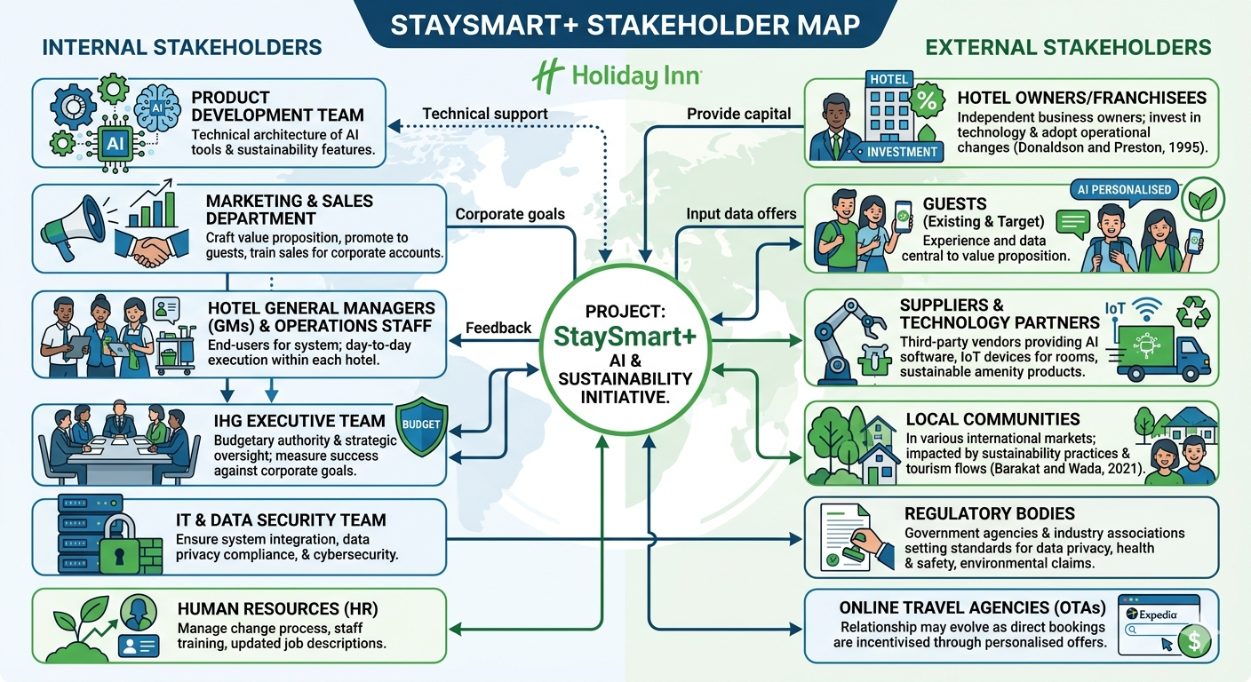

4.0 Stakeholder Roles, Responsibilities, and Analytical Frameworks
To manage this complex network, a structured approach using a RACI Matrix and a Power/Interest Grid is required. These frameworks clarify roles and prioritise engagement efforts (Eden and Ackermann, 2013; Jacka and Keller, 2009).

RACI Matrix for Stay Smart+ Launch
This matrix clarifies who is Responsible (doer), Accountable (approver), Consulted, and Informed for key project deliverables (Jacka and Keller, 2009).
Deliverable / Activity | Product Dev. | Marketing | Hotel GMs | Hotel Owners | IT Security | IHG Exec.
Develop AI Software | R | I | I | I | C | A
Create Launch Marketing Plan | I | R | C | C | I | A
Install & Test In-Hotel Tech | C | I | R | A | C | I
Approve Owner Funding | I | I | C | A | I | C
Ensure Data Privacy Compliance | C | I | I | I | R | A
Train Hotel Staff | I | C | R | I | - | I

RESPONSIBLE
ACCOUNTABLE
INFORMED
CONSULTED

Stakeholder Power/Interest Grid
Based on the model used in project management (Eden and Ackermann, 2013), this grid helps prioritise engagement.
- High Power, High Interest (Manage Closely): IHG Executive Team, Hotel Owners/Franchisees. Their buy-in is non-negotiable for funding and rollout.
- High Power, Low Interest (Keep Satisfied): Regulatory Bodies, Major Technology Partners. They require compliance and contractual updates but not daily communication.
- Low Power, High Interest (Keep Informed): Hotel GMs and Operations Staff, Guests, Local Communities. Their feedback is vital for iteration, and their satisfaction determines success.
- Low Power, Low Interest (Monitor): General suppliers, secondary competitors. Minimal engagement is required.
Figure 2 shows a graphic of stakeholder power and interest.

Fig. 2
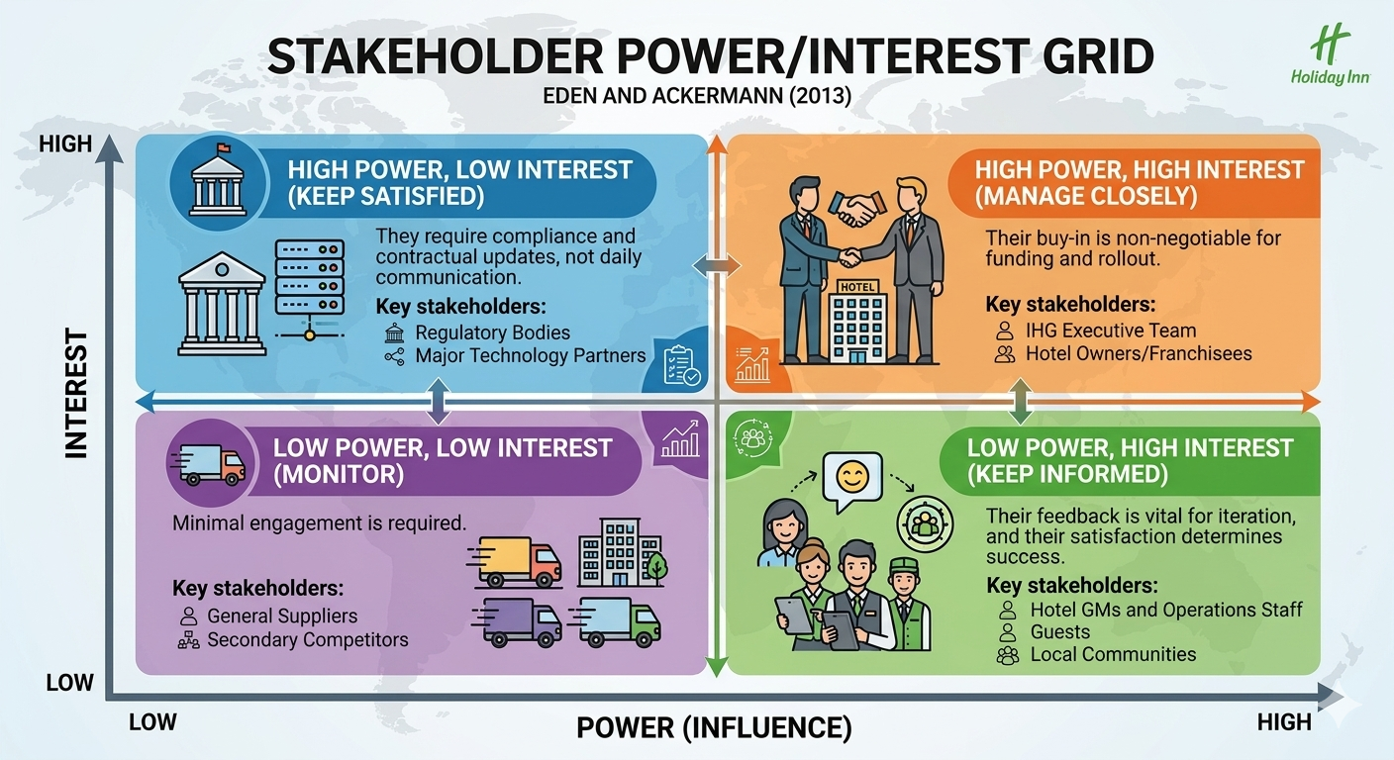

Stakeholder Roles, Benefits, and Challenges – Table 2
Table 2
Stakeholder | Key Role in Stay Smart+ | Benefits They Bring | Potential Challenges They Face
Product Development Team | Build and test the AI platform. | Technical expertise; innovation capability. | Scope creep; integration with legacy hotel systems.
Hotel Owners | Fund and authorise implementation in their properties. | Capital; local market knowledge; operational control. | ROI concerns; resistance to additional operational complexity; short-term franchise agreements (Donaldson and Preston, 1995).
Hotel GMs & Staff | Implement and use the system daily. | On-the-ground insight; direct guest interaction. | Inadequate training; fear of technology replacing jobs ("de-skilling"); increased workload during transition.
Guests | Use the service and provide data. | Real-world feedback; data to fuel personalisation. | Privacy concerns; frustration if AI fails to understand complex requests.
Local Communities | Recipients of sustainability efforts. | Social license to operate; potential for local partnerships. | "Greenwashing" accusations if sustainability claims are not genuine (Font and Lynes, 2018).

Communication Plan: Stay Smart+ Global Launch
This Communication Plan operationalises the 4C's model (Communication, Consultation, Collaboration, Commitment) as outlined by Story Inc. (2021) and is designed to ensure transparent, timely, and tailored information flow to all stakeholder groups (Project Management Institute, 2021). The plan follows best practices in stakeholder engagement (Freeman, 1984; Ashcroft, 2017) and is aligned with IHG's corporate communication protocols (IHG, 2025).
Communication Plan – Table 3

Table 3
What Information? | Target Audience | When? | Method of Communication | Provider
Project Vision & Strategic Rationale | IHG Executive Team; Hotel Owners; Global Marketing Team | Project initiation; Quarterly strategic reviews | Formal presentations; Board papers; Strategic roadshows (Donaldson and Preston, 1995) | Project Manager; IHG Chief Strategy Office
Technical Specifications & Integration Requirements | Technology Partners (AI Vendors); IT Security Team; Product Development Team | Weekly throughout development phase | Technical working groups; Shared project management software (Jira/Asana); API documentation portals (Buttle and Maklan, 2019) | IT Director; Product Development Lead
ROI Analysis & Business Case | Hotel Owners; IHG Executive Team; Investment Analysts | Pre-approval phase; Quarterly updates | One-on-one business reviews; Investor presentations; Dedicated owner portal (Wang, Yang and Chen, 2022) | Regional Operations Directors; Finance Business Partner
Operational Training & Process Changes | Hotel GMs; Operations Staff; Front-line Employees | 4 weeks pre-launch; Ongoing support | On-site training sessions; E-learning modules; "Pilot Hotel Network" peer forums (Bowie and Buttle, 2011) | HR Manager; Training Coordinator; Regional Operations Directors
Brand Guidelines & Marketing Assets | Global Marketing Team; Regional PR Teams; Hotel GMs | 6 weeks pre-launch; Ongoing | Global marketing portal; Campaign toolkits; Creative review sessions (Kotler, Bowen and Baloglu, 2022) | Global Brand Director; Marketing Manager
Guest-Facing Features & Benefits | IHG Rewards Members; Target Guests; OTAs | Pre-arrival (1 week); During stay; post-stay | In-app notifications; Email campaigns; In-room QR codes; Social media content (Martin and Murphy, 2017) | Marketing Manager; Digital Experience Team
Data Privacy & Compliance Updates | Local Communities; Environmental NGOs; IHG Executive Team | As required by law; Quarterly compliance reviews | Formal compliance reports; Regulatory filings; Industry association working groups (GDPR, 2018) | Legal Counsel; Data Protection Officer
Sustainability Impact & ESG Metrics | Local Communities; Environmental NGOs; IHG Executive Team | At launch; Bi-annually thereafter | Sustainability reports; Community open days; Local press releases; NGO partnership briefings (Font and Lynes, 2018; United Nations, 2015) | Sustainability Manager; Regional PR Team
Progress Updates & Milestone Achievements | All internal stakeholders (IHG employees, GMs, Owners) | Monthly; Ad-hoc for critical milestones | "Stay Smart+ Spotlight" newsletter; Intranet portal; Town hall webinars (Visme, 2025) | Project Coordinator; Internal Communications Team
System Performance & Technical Support | Hotel GMs; IT Support Teams; Technology Partners | Daily during rollout; Weekly ongoing | Real-time dashboards; Support ticketing system; Technical advisory calls (Christopher, Payne and Ballantyne, 2013) | IT Support Desk; Technology Partners
Conflict Resolution & Issue Escalation | Hotel Owners; GMs; Technology Partners | As conflicts arise | Mediated meetings; Formal escalation protocols; Collaborative problem-solving sessions (Freeman et al., 2010) | Project Manager; Regional Directors
Guest Feedback & Satisfaction Metrics | Product Development Team; Marketing Team; Hotel GMs | Weekly post-launch | NPS survey reports; social media listening tools; Review aggregation dashboards (Oliver, 2010) | Guest Experience Manager; Data Analytics Team
Competitive Intelligence & Market Positioning | IHG Executive Team; Global Marketing Team; Hotel Owners | Quarterly | Industry analysis reports; Competitor benchmarking; Market intelligence briefings (Warislohner, 2025) | Market Research Manager; Strategy Team
Loyalty Programme Integration | IHG Rewards Members; Loyalty Team; Hotel GMs | Monthly; At key campaign launches | Loyalty programme communications; In-app loyalty updates; Member-exclusive offers (Buttle and Maklan, 2019) | Loyalty Programme Manager; CRM Team
Supply Chain & Amenities Delivery | Hotel Suppliers; Procurement Team; Hotel GMs | Weekly during rollout | Supplier portal; Delivery tracking dashboard; Quality assurance reports (Clarkson, 1995) | Procurement Manager; Supply Chain Coordinator
Shareholder & Investor Communications | Investment Analysts; Shareholders; Financial Media | Quarterly; At major announcements | Earnings calls; Annual report; Investor roadshows; Regulatory announcements (IHG, 2025) | IHG Investor Relations; Chief Financial Officer
Local Community Impact Reporting | Local Communities; Regional Government; NGOs | Bi-annually | Community newsletters; Local media partnerships; Public meetings (Elkington, 1997; Yang, 2024) | Regional PR Manager; Sustainability Officer
Crisis Communication & Issue Management | All stakeholders (tiered based on impact) | Immediately upon issue identification | Emergency alerts; Press statements; Direct stakeholder calls; Social media monitoring (Pears and Shields, 2022) | Corporate Communications; Crisis Management Team
Post-Launch Review & Lessons Learned | All internal stakeholders; Key external partners | 3 months post-launch | Comprehensive review report; Stakeholder feedback workshops; Continuous improvement roadmap (Project Management Institute, 2021) | Project Manager; Quality Assurance Team
Celebration & Success Recognition | All project contributors; Hotel staff; Partners | At successful launch completion | Recognition events; Internal awards; Thank-you communications; Success story publications (Carroll and Shabana, 2010) | HR Manager; Project Manager; IGH Executive Team

This communication plan ensures that every stakeholder group receives tailored, timely information through channels they prefer, thereby fostering the transparency and trust essential for the successful launch of Stay Smart+. The plan will be reviewed monthly and updated based on stakeholder feedback and evolving project requirements (Freeman et al., 2010).

5.0 Stakeholder Engagement Process and Conflict Management (The 4C's Model)
As Project Manager, the process of engagement must be dynamic and structured to foster ownership and mitigate resistance. A synthesis of engagement principles (Christopher, Payne and Ballantyne, 2013; Ashcroft, 2017) can be achieved through the 4C's Model: Communication, Collaboration, Consultation, and Commitment (Story Inc., 2021). This process is not linear but a continuous cycle.

1. Communication (Building Awareness)
The first step is to establish clear, transparent, and tailored communication channels. For high-power stakeholders like Hotel Owners, this involves one-on-one business case presentations detailing ROI, payback periods, and support from IHG. For GMs and Staff, communication must address the "what's in it for me?" factor, framing the AI not as a replacement but as a tool to reduce mundane tasks and enhance their role as hospitality professionals (Ashcroft, 2017). A project newsletter, an intranet portal, and regular town hall webinars will be established. For Regulatory Bodies, formal communication will ensure compliance from day one. Crucially, all communication will be adapted for cultural and linguistic differences in international markets, respecting the principle that "one size does not fit all" (Barakat and Wada, 2021).
2. Consultation (Seeking Input)
Before finalising the product, a consultation phase is critical. This moves beyond informing to actively listening. Focus groups with frequent guests (IHG Rewards members) will be conducted to test the AI interface and privacy preferences. Workshops with GMs from pilot hotels in London and Birmingham will be held to gather feedback on operational workflows. This aligns with the Integrated Stakeholder Sustainability Management framework, which emphasises understanding diverse interests to build collaborative partnerships (Barakat and Wada, 2021). For the sustainability features, consultation with local community groups and environmental NGOs in key markets will validate the authenticity of the initiatives and mitigate the risk of being perceived as disingenuous (Font and Lynes, 2018).

3. Collaboration (Co-Creating Solutions)
Collaboration represents a deeper level of engagement (Christopher, Payne and Ballantyne, 2013). A "Stay Smart+ Owner Advisory Group" will be formed, consisting of a representative sample of franchisees from different regions. This group will collaborate on the final rollout schedule and provide input on the training modules. Similarly, a "Pilot Hotel Network" will be established where GMs from early-adopter hotels can share best practices and co-create troubleshooting guides for the wider group. This co-creation fosters a sense of ownership and transforms stakeholders from passive recipients into active partners.

4. Commitment (Securing Buy-In)
The goal is to secure stakeholder commitment. For owners, this means signing the contract to implement Stay Smart+. For staff, it means actively using the new tools and promoting them to guests. Commitment is secured by demonstrating that their input from the consultation and collaboration phases has been valued and incorporated. This is formalised through service level agreements (SLAs) with owners, updated job descriptions for staff, and public acknowledgment of their role in the launch materials.

Managing Conflict
Conflict is inevitable. The 4C's model provides a pathway for resolution. For example, a key conflict is likely to arise with Hotel Owners regarding the cost of the new technology versus the brand standard mandate. Using this model:
- Communication: The Project Manager would first listen to the owner's specific financial concerns, acknowledging the pressure on their margins.
- Consultation: We would then consult with the owner to explore alternative financing models, such as IHG-subsidised pilot programmes or tiered implementation packages.
- Collaboration: Together, we would work to identify the "minimum viable product" that meets brand standards while respecting their budget, perhaps by phasing the rollout of certain amenities.
- Commitment: This collaborative problem-solving builds trust, leading to a renewed commitment from the owner to proceed, albeit on a modified timeline. This approach, grounded in agency theory (Donaldson and Preston, 1995), aligns the interests of the principal (owner) and the agent (IHG) by finding a mutually acceptable solution.

6.0 Evaluation of Impact and Recommendations

Impact of Stakeholder Engagement on Business Performance
Effective stakeholder engagement is not merely a procedural exercise; it is a direct driver of business performance for the Stay Smart+ launch. Its impact can be evaluated across several dimensions:
- Financial Performance: Engaging hotel owners early to co-create the ROI model increases the speed of adoption, directly impacting the project's revenue targets. Conversely, failure to engage them can lead to pushback, delayed rollouts, and the underperformance of the entire initiative. As seen in IHG's broader strategy, maintaining owner satisfaction is crucial for financial health (IHG, 2026).
- Guest Satisfaction & Loyalty: By consulting with guests during the design phase, Stay Smart+ is more likely to deliver features that genuinely enhance their stay, leading to higher GSS scores, improved online reviews, and increased loyalty programme engagement. This directly counters the risk of brand dilution (Warislohner, 2025).
- Operational Efficiency: Collaborative planning with GMs and operations staff ensures that the AI tools are intuitive and genuinely improve workflow, rather than creating friction. This leads to higher staff adoption rates and can deliver the intended labour savings by automating routine inquiries. This addresses the operational challenges identified in industry trends (Warislohner, 2025).
- Brand Reputation and Risk Management: Engaging with local communities and ensuring regulatory compliance protects the brand's social license to operate and mitigates legal risks. Proactive consultation on sustainability features builds authentic ESG credentials (Font and Lynes, 2018), differentiating Holiday Inn from competitors and appealing to the values-driven traveller.

Recommendations for Future Stakeholder Engagement
To build on the foundation laid for Stay Smart+ and institutionalise best practices, the following recommendations are made:
- Establish a Permanent Stakeholder Advisory Panel: Move beyond project-specific engagement by creating a permanent panel comprising franchise owners, GMs, and guests. This panel would meet bi-annually to review IHG's strategic initiatives, providing a continuous feedback loop and fostering long-term collaboration (Christopher, Payne and Ballantyne, 2013).
- Develop a Differentiated Engagement Model for International Markets: While the core frameworks are global, the "how" of engagement must be localised. In markets like China, where relationship-building (guanxi) is paramount, face-to-face consultation with owners and government bodies is more critical than digital communication (Yang, 2024). A toolkit of culturally adaptable engagement strategies should be developed.
- Implement a Digital Stakeholder Relationship Management (SRM) Platform: To manage the complexity of global stakeholders, invest in an SRM platform. This would allow the project team to track engagement history, map stakeholder sentiment in real-time, and tailor communications, ensuring that no stakeholder group, especially those with lower power but high interest, is neglected (Ashcroft, 2017).
- Formalise Conflict Resolution Protocols: Based on the 4C's model, develop a formal, tiered conflict resolution protocol. This would provide a clear pathway for escalating and resolving disputes with owners or other key partners, ensuring conflicts are managed constructively and transparently rather than becoming adversarial.
- Integrate Stakeholder Feedback into Product Roadmaps: Formally link the output of stakeholder consultation and collaboration to the product development lifecycle. When a stakeholder's suggestion is not implemented, a formal response explaining the rationale should be provided. This closes the feedback loop and demonstrates that their input is genuinely valued, reinforcing commitment (Freeman, 1984).

7.0 Conclusion
The successful launch of the Stay Smart+ initiative for Holiday Inn hinges on the meticulous and strategic engagement of its diverse stakeholders. As this report has demonstrated, a structured approach grounded in stakeholder theory (Freeman, 1984) is not an optional extra but a fundamental prerequisite for success. By systematically identifying internal and external parties—from the IHG executive team and hotel owners to guests and local communities—and analysing their power, interest, and influence through tools like the RACI Matrix (Jacka and Keller, 2009) and Power/Interest Grid (Eden and Ackermann, 2013), a project manager can prioritise efforts and allocate resources effectively.
The application of the 4C's model (Story Inc., 2021) provides a dynamic and ethical framework for navigating the complexities of a global launch. Through transparent Communication, genuine Consultation, inclusive Collaboration, and a relentless focus on securing Commitment, potential conflicts—particularly with cost-conscious hotel owners—can be transformed into opportunities for co-created solutions. This process not only mitigates risk but also builds the trust and alignment necessary for rapid adoption.
Ultimately, the impact of this engagement flows directly to the bottom line. It enhances financial performance by securing owner buy-in, drives guest satisfaction through co-designed features, and strengthens brand reputation through authentic sustainability practices (Font and Lynes, 2018). By adopting the recommendations to establish permanent advisory structures, localise engagement strategies, and leverage digital SRM tools (Ashcroft, 2017), Holiday Inn can ensure that the spirit of collaboration embedded in the Stay Smart+ launch becomes a lasting competitive advantage, solidifying its position in the evolving hospitality landscape.

Reference List

Ashcroft, J. (2017) The relational lens: understanding, measuring, and managing stakeholder relationships. Cambridge: Cambridge University Press.
Barakat, S. and Wada, E.K. (2021) Stakeholder theory in the hospitality and tourism literature: a systematic review, Journal of Hospitality and Tourism Insights, 4(5), pp. 678-702.
Bowie, D. and Buttle, F. (2011) Hospitality marketing: principles and practice. 2nd edn. Oxford: Butterworth-Heinemann.
Buttle, F. and Maklan, S. (2019) Customer relationship management: concepts and technologies. 4th edn. Abingdon: Routledge.
Carroll, A.B. and Shabana, K.M. (2010) The business case for corporate social responsibility: a review of concepts, research and practice, International Journal of Management Reviews, 12(1), pp. 85-105.
Christopher, M., Payne, A. and Ballantyne, D. (2013) Relationship marketing: creating stakeholder value. Saint Louis: Taylor and Francis.
Clarkson, M.B.E. (1995) A stakeholder framework for analysing and evaluating corporate social performance, Academy of Management Review, 20(1), pp. 92-117.
Donaldson, T. and Preston, L.E. (1995) The stakeholder theory of the corporation: concepts, evidence, and implications, Academy of Management Review, 20(1), pp. 65-91.
Eden, C. and Ackermann, F. (2013) Making Strategy: The Journey of Strategic Management. London: SAGE Publications.
Elkington, J. (1997) Cannibals with forks: the triple bottom line of 21st century business. Oxford: Capstone Publishing.
Font, X. and Lynes, J. (2018) Corporate social responsibility in tourism and hospitality, Journal of Sustainable Tourism, 26(7), pp. 1027-1042. Available at: https://doi.org/10.1080/09669582.2018.1488856.
Freeman, R.E. (1984) Strategic management: a stakeholder approach. Boston: Pitman.
Freeman, R.E., Harrison, J.S., Wicks, A.C., Parmar, B.L. and de Colle, S. (2010) Stakeholder theory: the state of the art. Cambridge: Cambridge University Press.
GDPR (2018) *General Data Protection Regulation (EU) 2016/679*. Available at: https://gdpr-info.eu/ (Accessed: 5 March 2026).
Ghazinoory, S., Abdi, M. and Azadegan-Mehr, M. (2011) SWOT methodology: a state-of-the-art review for the past, a framework for the future, Journal of Business Economics and Management, 12(1), pp. 24–48. doi: 10.3846/16111699.2011.555358. Cited by 74
Gürel, E. and Tat, M. (2017) SWOT ANALYSIS: A THEORETICAL REVIEW, Journal of International Social Research, 10(51), pp. 994–1006. doi: 10.17719/jisr.2017.1832.
Helms, M.M. and Nixon, J. (2010) Exploring SWOT analysis – where are we now? Journal of Strategy and Management, 3(3), pp. 215–251. doi: 10.1108/17554251011064837. Cited by: 2422
IHG (2025) Statement re shareholder engagement and outcome, Investegate, 20 August. Available at: https://www.investegate.co.uk/announcement/rns/intercontinental-hotels-group--ihg/statement-re-shareholder-engagement-and-outcome/9066286 (Accessed: 5 March 2026).
IHG (2026) IHG Annual Report and Financial Statements 2025. Available at: https://www.ihgplc.com/en/investors/annual-report (Accessed: 5 March 2026).
Jacka, J.M. and Keller, P.J. (2009) Business Process Mapping: Improving Customer Satisfaction. 2nd edn. Hoboken: John Wiley & Sons.
Kotler, P., Bowen, J.T. and Baloglu, S. (2022) Marketing for hospitality and tourism. 8th edn. Harlow: Pearson Education.
Martin, K.D. and Murphy, P.E. (2017) The role of data privacy in marketing, Journal of the Academy of Marketing Science, 45(2), pp. 135-155. Available at: https://doi.org/10.1007/s11747-016-0495-4.
Oliver, R.L. (2010) Satisfaction: a behavioural perspective on the consumer. 2nd edn. Abingdon: Routledge.
Pears, R. and Shields, G. (2022) Cite them right: the essential referencing guide. 12th edn. London: Bloomsbury.
Project Management Institute (2021) A guide to the project management body of knowledge (PMBOK guide). 7th edn. Newtown Square: Project Management Institute.
Story Inc. (2021) *The 4 c's: connection, consultation, collaboration & co-creation*. Available at: https://www.storyinc.co.nz/blog/the-4-cs-connection-consultation-collaboration-amp-co-creation (Accessed: 5 March 2026).
United Nations (2015) Transforming our world: the 2030 agenda for sustainable development. A/RES/70/1. New York: United Nations.
Visme (2025) How to create a stakeholder engagement plan (+ templates). Available at: https://visme.co/blog/stakeholder-engagement-plan/ (Accessed: 5 March 2026).
Wang, D., Yang, M. and Chen, G. (2022) Stakeholder engagement in sustainable tourism: a systematic review and research agenda, Tourism Management Perspectives, 42, 100967. Available at: https://doi.org/10.1016/j.tmp.2022.100967.
Warislohner, F. (2025) The 2026 Hospitality outlook: the year of segmentation and "The Float". Available at: https://www.linkedin.com/pulse/2026-hospitality-outlook-year-segmentation-2l5lc (Accessed: 5 March 2026).
Yang, M. (2024) Developing a stakeholder engagement framework for international hotel chains managing hotel environmental sustainability in China. DHTM thesis. Hong Kong Polytechnic University. Available at: https://theses.lib.polyu.edu.hk/handle/200/13476 (Accessed: 5 March 2026).

