Assignment Title: HTML & CSS Web Development
Student Name: Aleksandr Badger
Student Number: 2308404
Course: Software Development
Module Name: Introduction to Web and Database Concepts (ACCA4023)
Date: 08/01/2025

Table of Contents
Introduction 2
Requirements 3
Implementation 4
Validation 6
HTML 6
CSS 6
Evaluation 7
Evaluation of my website 8
Search Engine Optimisations 8
Accessibility 8
Appendices 11
Index.HTML 11
Events.html 13
Contact.html 15
History.HTML 17
LearnWelsh.HTML 19
Styles.css 23

Introduction
This report covers the creation of a website of my choosing, it’s requirements such as it’s purpose, it’s intended audience and more. It will also cover how it conforms to WCAG 2.1 and Web standards by evaluating and validating its contents and code, as well as the implementation of these standards, tools and the needs of it’s users.

Requirements
My website is about the city of Swansea and its culture, the purpose of it is to help inform those who are intending to visit Swansea, or simply want to learn more about its history and people. It aims to teach visitors about some local history, the Welsh language and local events in the area.

Implementation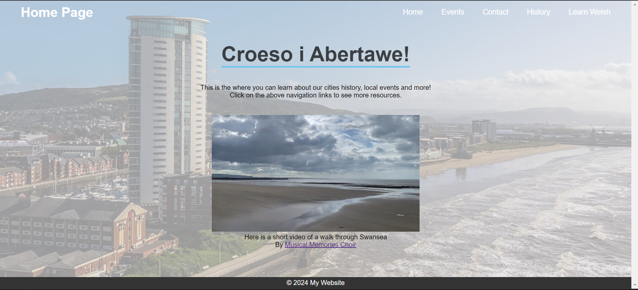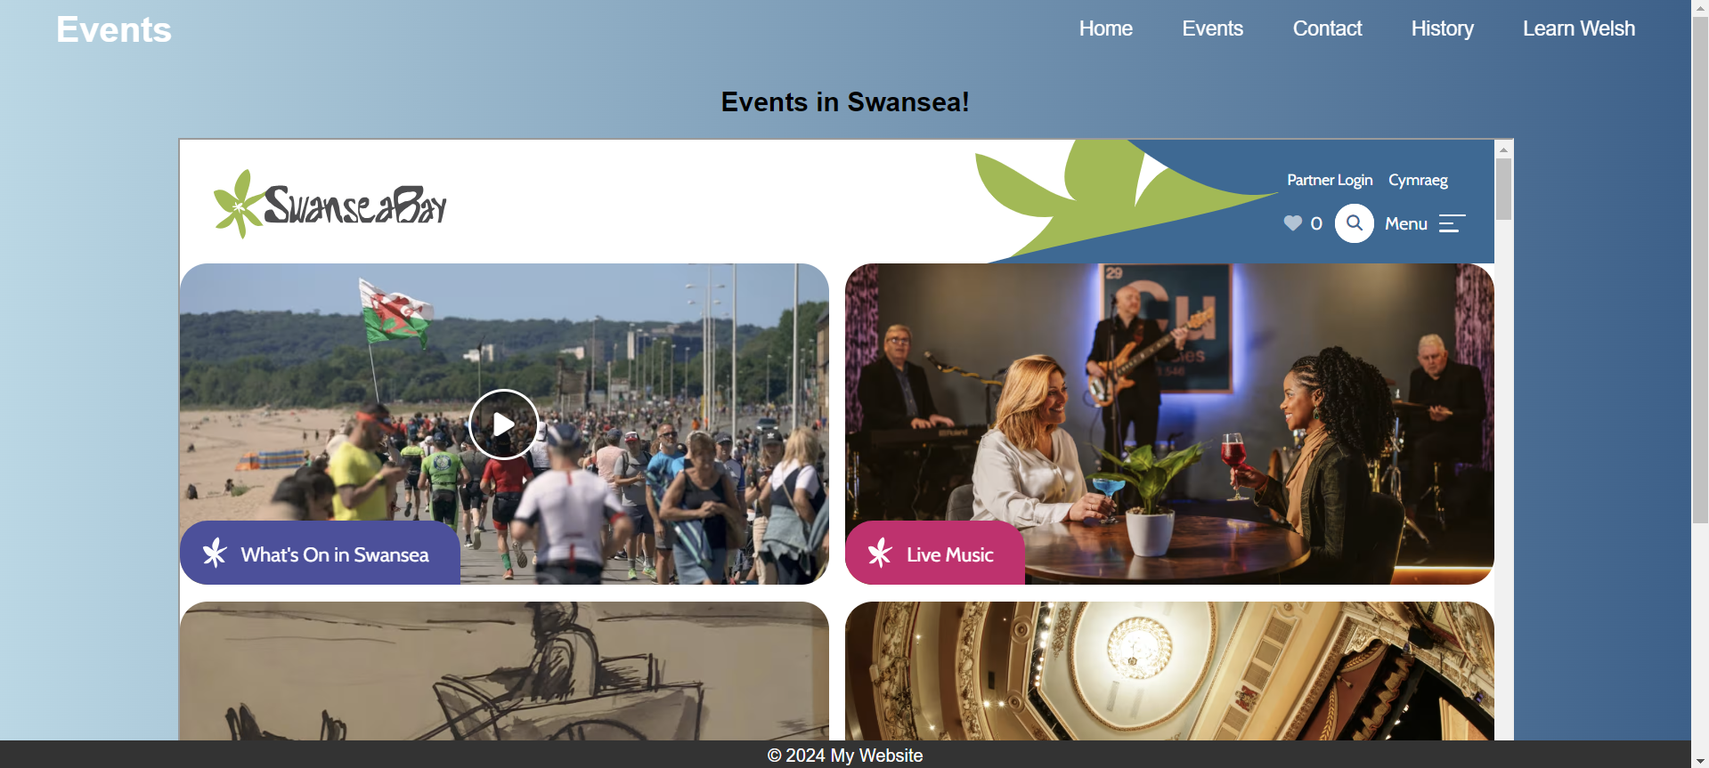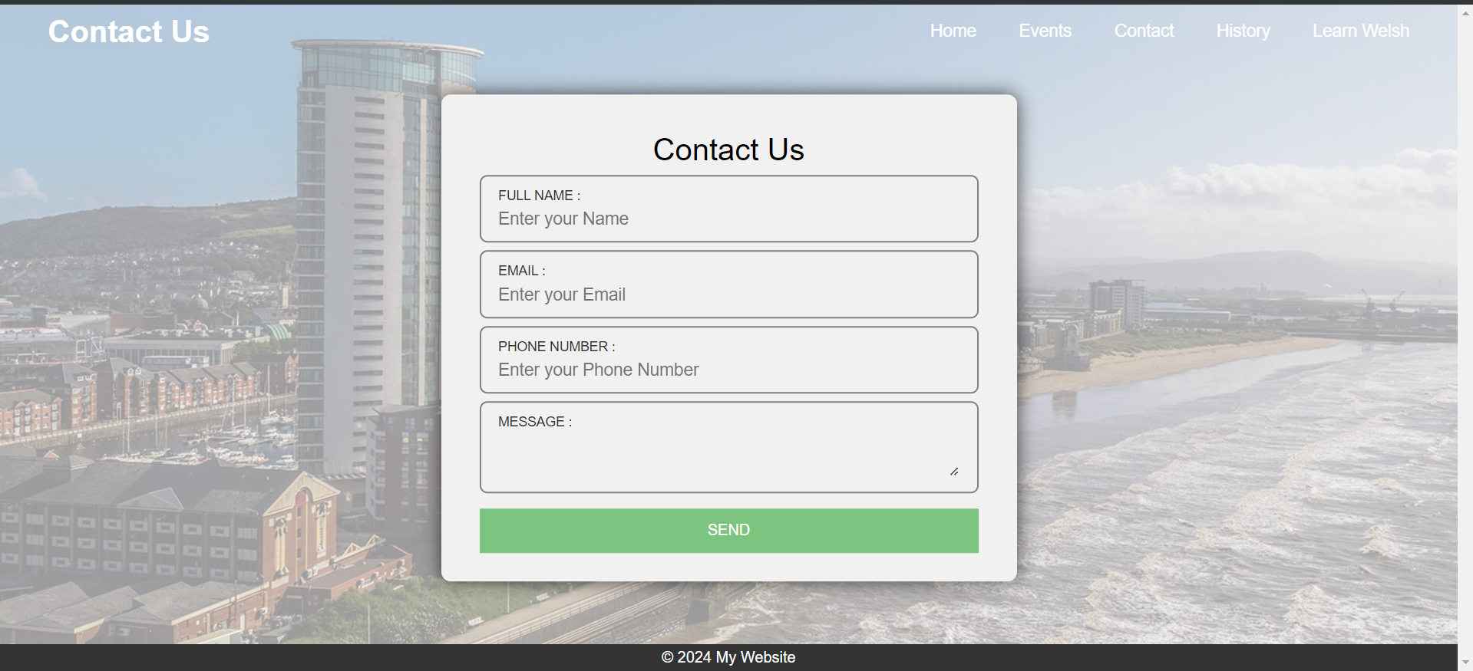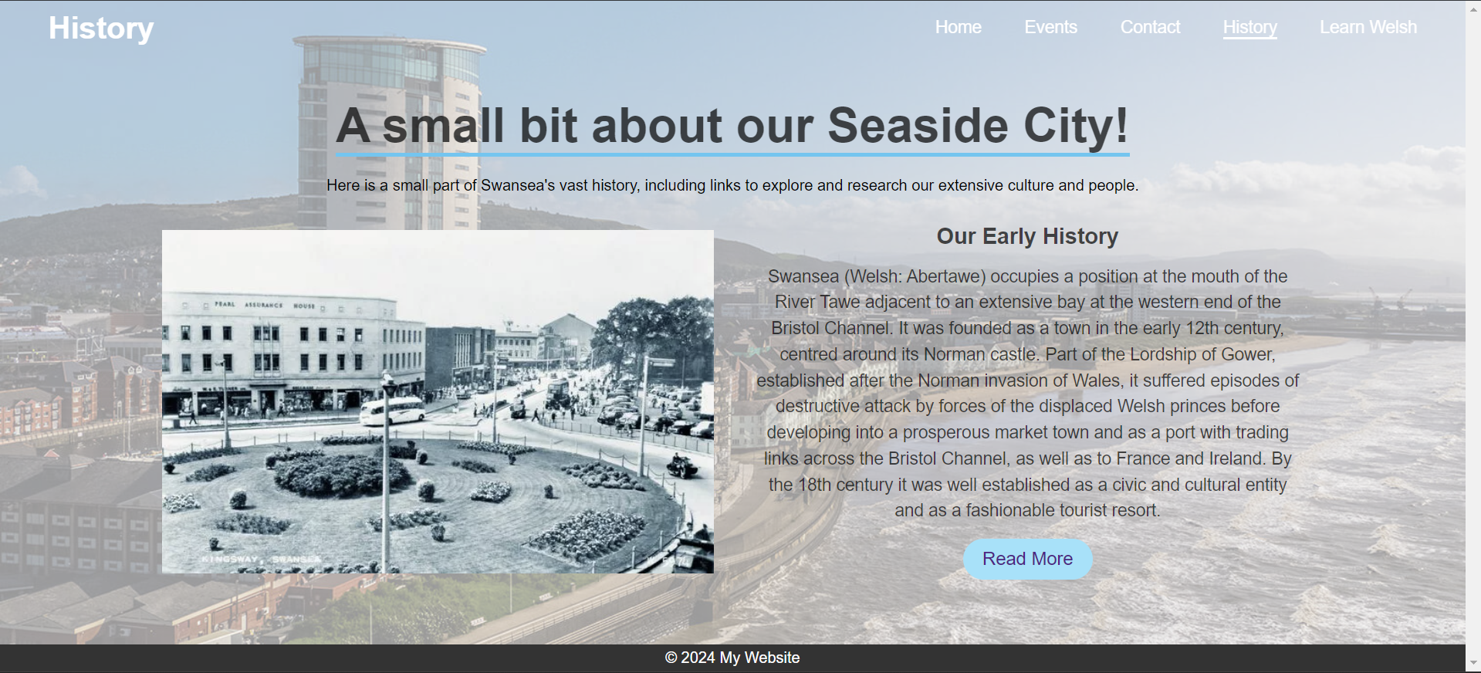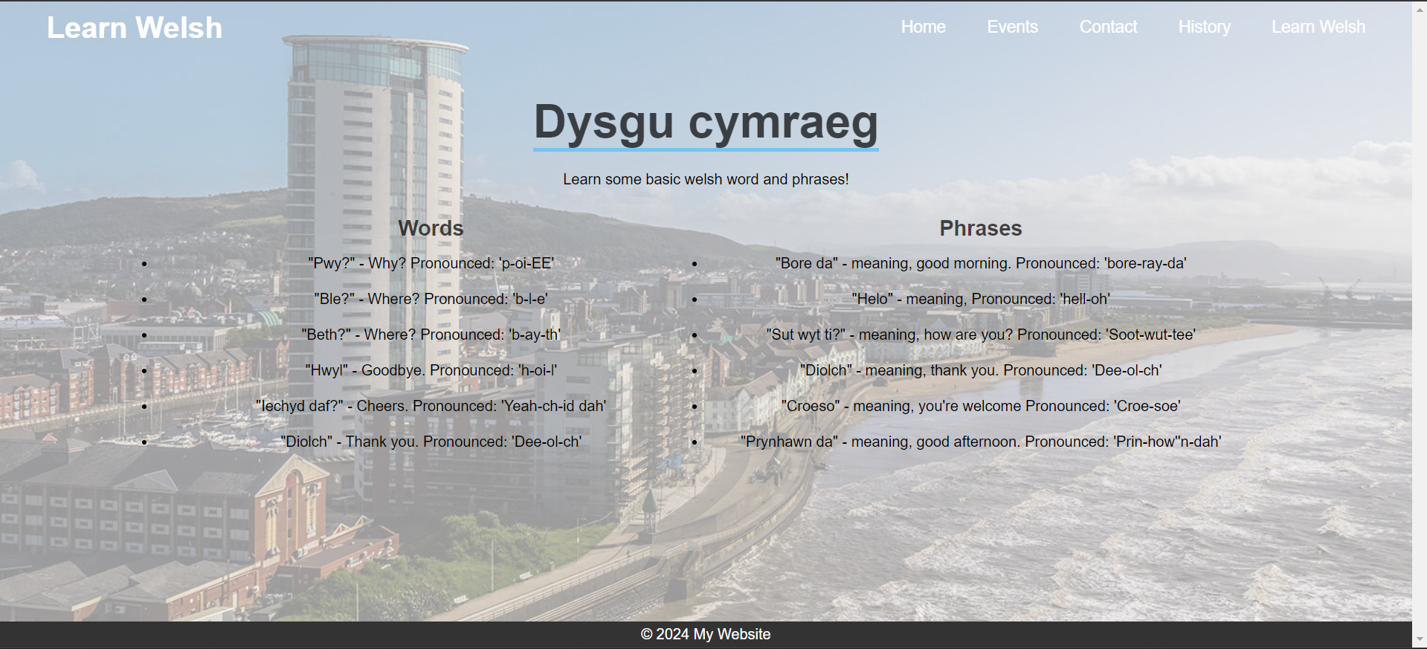

Validation

HTML
When inputting my Home Page into the validator, it highlights 2 potential issues in my code, the first being a trailing slash on void elements, however this is harmless and is automatically input by Visual Studio.
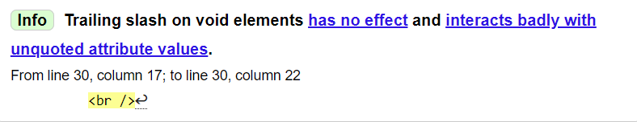
The second error was that on line 31, column 17, the element p1 is a child of the element div. The solution to this would be to move p1 outside of the element div in this specific context, however, as this does not cause any damage or issues within the website, it has been left untouched.
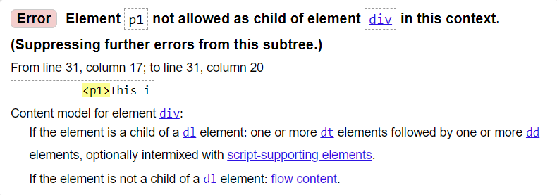

CSS
When entering the stylesheet into the CSS validator, it returns two errors.
The first error being a parse error in the “nav ul li” style, however, as this sheet is deprecated, it has been left untouched, but the fix for this would be either removal, or to simply add a semi colon at the end to close the line.
The second error is within the .swanseaBackground style, where there is a value error within the position, as it is “center”, when that is not a valid position as it is overwritten by a “position: fixed” in .swanseaBackground::before. To fix this, this can simply be removed, or left alone as this does not effect anything.
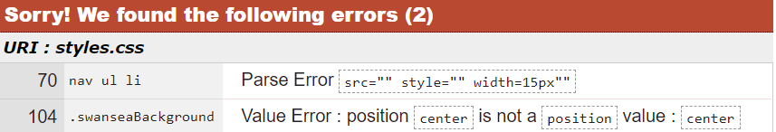

Evaluation
- Website Usability
Website usability refers to the ease of use of your website, such as how the quickly and painlessly the user can achieve their goal within your website (assuming they’re using it for its intended purpose), such as finding a specific word in a dictionary online, in this case ease of use would make it so that there is a search function for words [1].
One study researched and explored the relationships among these dimensions and their impact on users' purchase intentions and behaviours. The findings highlight the critical role of usability in enhancing e-commerce success and provide guidelines for developing better websites. This research offers tools for both web developers to improve design and researchers to assess usability's effects on consumer behaviour [2].
- Website Accessibility
Website accessibility refers to how accessible your website is to as many potential users as possible, including those with disabilities and impairments, such as the deaf or cognitively impaired [3].
This study identifies important factors of website accessibility among 210 national tourism websites using Web Content Accessibility Guidelines. It finds that there are common issues in navigation, adaptability and compatibility with assistive technologies, such as foot pedals and text-to-speech. It concludes that these websites should include stricter regulations for enhancing accessibility, with key areas being text alternatives, adaptable content and user-friendly navigation [4].
- Search Engine Optimisations
Search Engine Optimisations (SEOs) are how web developers optimise their websites via multiple strategies, so that they rank higher, and therefore appear closer to the first search page, on search engines, such as Google. This is an extremely effective marketing strategy as your website will be the first one user see, and so they’re more likely to view and use your website [5].
This study delves into SEO techniques and categorises them into white-hat and black-hat approaches, and further highlights the importance of on-page and off-page techniques. The paper emphasises advancements like Mhits AND Aggregate PageRank for improved accuracy. The study urges developers to adapt to new and evolving search engine technologies and highlights SEOs important role in enhancing visibility, user engagement and competitiveness with other websites [6].

Evaluation of my website

Search Engine Optimisations
My website has an easy to use and navigate design, being very clear about what hyperlinks take you where, ensuring the content on each page has enough spacing and appropriate font sizes and choice, so that it is user friendly. My website aims to inform users about Swansea a small amount, while redirecting any further inquiries and thirst for knowledge to other websites, which are more appropriate.

My website could be improved in this regard by providing the user with more information on where to find what they are looking for, while providing more information and content about the topic itself, such as on the History page.

While I have included some basic SEO techniques, there are not many within my website and code. I have used HTML tags to ensure that the search engine can appropriately show my webpage with relevant searches, such as the <title> tag, which is how users and the search engine see my webpage, as shown below, alongside the meta tag.

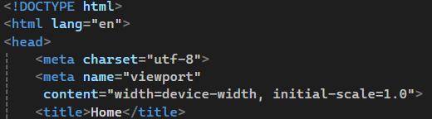

The website also utilises alt, lang and header tags, so in case of an image or video being unavailable, it will display alt text to the user to describe what should be there, as well as header tags to help separate text and enhance readability and so that the browser can sort which text is what language, and offer translation options.

The website could have better SEOs, by using tags, which give keywords to the website that correspond to certain words users will type in, for example, if the user is looking for cooking recipes, the tags would include “cooking”, “recipes”, so that the search engine can recommend the website to them.

Accessibility
To increase perceivability, I used Visual Studio extensions to enhance my webpage, as it allowed me to see changes in real time, so I could see if a colour didn’t contrast well, or if links were to hard to find and more.

Contrast checker also helped to ensure my text was readable and contrasted well with the background, as seen below.

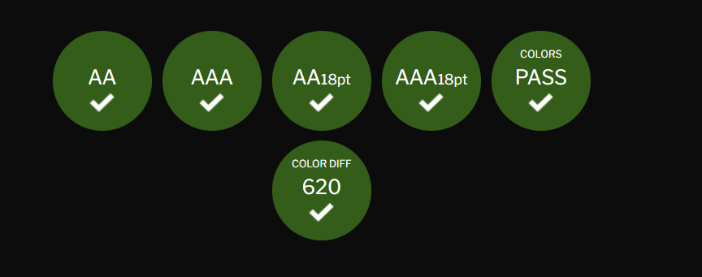

There are also images and videos included in the webpages to help engage and interact with the user.

To increase operability, the user face is very easy to navigate, having clearly defined names and hyperlinks to each page, so that users know can easily find what they are looking for. These are also in the same place per page, so that the user can easily find them again, also displaying what web page they are currently on in a larger font separated in the top left of the header.

To increase understandability, the font is the same across the web page including size and adequate spacing, ensuring that the font type is easy to read for those with disabilities. Hyperlinks in the header have an underlining effect when hovering over them to ensure the user recognises that it is a link, and that they are able to open it. Other hyperlinks are within coloured boxes that clearly state “Click Here”, so that the user recognises where to click.

The webpages are able to adapt to different resolutions and devices, so that it is easily accessible on different types of devices, such as mobile or laptops, and they adapt simultaneously as the screen changes size.
References
[1] L. Zappa. "Website usability | Common usability issues | Examples | Testing and benefits." https://userreport.com/blog/website-usability/ (accessed Jan 8).
[2] Y. Lee and K. A. Kozar, "Understanding of website usability: Specifying and measuring constructs and their relationships," Decision Support Systems, vol. 52, no. 2, pp.450–463, -01-01 2012. doi: 10.1016/j.dss.2011.10.004. Accessed: Jan 8, 2025, [Online]. Available: https://www.sciencedirect.com/science/article/pii/S0167923611001679
[3] Central Digital and Data Office. "Understanding accessibility requirements for public sector bodies." https://www.gov.uk/guidance/accessibility-requirements-for-public-sector-websites-and-apps. (accessed 08/01).
[4] T. Domínguez Vila, E. Alén González and S. Darcy, "Website accessibility in the tourism industry: an analysis of official national tourism organization websites around the world," Disabil.Rehabil., vol. 40, no. 24, pp.2895–2906, 2018. doi: 10.1080/09638288.2017.1362709. Available: https://doi.org/10.1080/09638288.2017.1362709
[5] A. Weiner. "What Is SEO? A Guide to Search Engine Optimization." https://www.wix.com/blog/what-is-seo (accessed Jan 9).
[6] D. Sharma, et al., "A Brief Review on Search Engine Optimization," 2019 9th International Conference on Cloud Computing, Data Science & Engineering (Confluence), 2019. doi: 10.1109/CONFLUENCE.2019.8776976.

Appendices

Index.HTML
<!DOCTYPE html>
<html lang="en">
<head>
<meta charset="utf-8">
<meta name="viewport"
content="width=device-width, initial-scale=1.0">
<title>Home</title>
<link rel="stylesheet" href="styles.css">
</head>

<body>

<header class="header">
<a href='#' class="logo">Home Page</a>

<nav class="navbar">
<a href="index.html">Home</a>
<a href="events.html">Events</a>
<a href="contact.html">Contact</a>
<a href="History.html">History</a>
<a href="LearnWelsh.html">Learn Welsh</a>
</nav>
</header>

<div class="swanseaBackground">
<main>
<div class="heading">
<h1 lang="cy">Croeso i Abertawe!</h1>

<br />
<p1>This is the where you can learn about our cities history, local events and more!</p1>
<p1>Click on the above navigation links to see more resources.</p1>
<br />
</div>
<video width="500" controls autoplay muted>
<source src="Videos/SwanMarina.mp4" type="video/mp4">
<source src="Videos/SwanMarina.mp4" type="video/mp4">
</video>
<p>
Here is a short video of a walk through Swansea<br>By
<a href="https://www.youtube.com/watch?v=J6IPlOxkpYM" target="_blank">
Musical Memories Choir
</a>

</p>

</main>
</div>
<footer>
<p>© 2024 My Website</p>
</footer>
</body>
</html>

Events.html
<!DOCTYPE html>
<html lang="en">
<head>
<meta charset="utf-8">
<meta name="viewport"
content="width=device-width, initial-scale=1.0">
<title>Events</title>
<link rel="stylesheet" href="styles.css">
</head>

<body style="background: linear-gradient(to right, lightblue, #1F618D)";>

<header class="header">
<a href='#' class="logo">Events</a>

<nav class="navbar">
<a href="index.html">Home</a>
<a href="events.html">Events</a>
<a href="contact.html">Contact</a>
<a href="History.html">History</a>
<a href="LearnWelsh.html">Learn Welsh</a>
</nav>
</header>
<main>
<h2 lang="en">Events in Swansea!</h2>
<br />
<iframe src="https://www.visitswanseabay.com/whats-on/" width="1200" height="800">Your browser does not support iframes. </iframe>

</main>
<footer>
<p>© 2024 My Website</p>
</footer>
</body>
</html>

Contact.html
<!DOCTYPE html>
<html lang="en">
<head>
<meta charset="utf-8">
<meta name="viewport"
content="width=device-width, initial-scale=1.0">
<title>Contact Us</title>
<link rel="stylesheet" href="styles.css">
</head>

<body>

<header class="header">
<a href='#' class="logo">Contact Us</a>

<nav class="navbar">
<a href="index.html">Home</a>
<a href="events.html">Events</a>
<a href="contact.html">Contact</a>
<a href="History.html">History</a>
<a href="LearnWelsh.html">Learn Welsh</a>
</nav>
</header>

<div class="swanseaBackground">
<main>
<div class="contact-form">

<h1>Contact Us</h1>

<div class="txtb">
<label>Full Name : </label>
<input type="text" name="" value="" placeholder="Enter your Name">
</div>

<div class="txtb">
<label>Email : </label>
<input type="text" name="" value="" placeholder="Enter your Email">
</div>

<div class="txtb">
<label>Phone Number : </label>
<input type="text" name="" value="" placeholder="Enter your Phone Number">
</div>

<div class="txtb">
<label>Message : </label>
<textarea></textarea>

</div>
<a class="btn">Send</a>

</div>
</main>
</div>

<footer>
<p>© 2024 My Website</p>
</footer>
</body>
</html>

History.HTML
<!DOCTYPE html>
<html lang="en">
<head>
<meta charset="utf-8">
<meta name="viewport"
content="width=device-width, initial-scale=1.0">
<title>History</title>
<link rel="stylesheet" href="styles.css">
</head>

<body>

<header class="header">
<a href='#' class="logo">History</a>

<nav class="navbar">
<a href="index.html">Home</a>
<a href="events.html">Events</a>
<a href="contact.html">Contact</a>
<a href="History.html">History</a>
<a href="LearnWelsh.html">Learn Welsh</a>
</nav>
</header>

<div class="swanseaBackground">
<main>
<div class="heading">
<h1>A small bit about our Seaside City!</h1>
<p1>Here is a small part of Swansea's vast history, including links to explore and research our extensive culture and people.</p1>
</div>
<div class="container">
<section class="about">
<div class="about-image">
<img src="Images\oldSwansea.jpg" alt="Image of Old Swansea pre-war.">
</div>
<div class="about-content">
<h2>Our Early History</h2>
<p>Swansea (Welsh: Abertawe) occupies a position at the mouth of the River Tawe adjacent to an extensive bay at the western end of the Bristol Channel. It was founded as a town in the early 12th century, centred around its Norman castle. Part of the Lordship of Gower, established after the Norman invasion of Wales, it suffered episodes of destructive attack by forces of the displaced Welsh princes before developing into a prosperous market town and as a port with trading links across the Bristol Channel, as well as to France and Ireland. By the 18th century it was well established as a civic and cultural entity and as a fashionable tourist resort.</p>
<a href="https://www.swansea.gov.uk/localhistory" class="read-more">Read More</a>
</div>
</section>
</div>

</main>
</div>
<footer>
<p>© 2024 My Website</p>
</footer>
</body>
</html>

LearnWelsh.HTML
<!DOCTYPE html>
<html lang="en">
<head>
<meta charset="utf-8">
<meta name="viewport"
content="width=device-width, initial-scale=1.0">
<title>History</title>
<link rel="stylesheet" href="styles.css">
</head>

<body>

<header class="header">
<a href='#' class="logo">Learn Welsh</a>

<nav class="navbar">
<a href="index.html">Home</a>
<a href="events.html">Events</a>
<a href="contact.html">Contact</a>
<a href="History.html">History</a>
<a href="LearnWelsh.html">Learn Welsh</a>
</nav>
</header>

<div class="swanseaBackground">
<main>
<div class="heading">
<h1>Dysgu cymraeg</h1>
<p1>Learn some basic welsh word and phrases!</p1>
</div>
<div class="container">
<section class="about">
<div class="about-content">
<h2>Words</h2>
<ul>
<li>
"Pwy?" - Why?
Pronounced: 'p-oi-EE'
</li>
<li>
"Ble?" - Where?
Pronounced: 'b-l-e'
</li>
<li>
"Beth?" - Where?
Pronounced: 'b-ay-th'
</li>
<li>
"Hwyl" - Goodbye.
Pronounced: 'h-oi-l'
</li>
<li>
"Iechyd daf?" - Cheers.
Pronounced: 'Yeah-ch-id dah'
</li>
<li>
"Diolch" - Thank you.
Pronounced: 'Dee-ol-ch'
</li>

</ul>
</div>
<div class="about-content">
<h2>Phrases</h2>
<ul>
<li>
"Bore da" - meaning, good morning.
Pronounced: 'bore-ray-da'
</li>
<li>
"Helo" - meaning,
Pronounced: 'hell-oh'
</li>
<li>
"Sut wyt ti?" - meaning, how are you?
Pronounced: 'Soot-wut-tee'
</li>
<li>
"Diolch" - meaning, thank you.
Pronounced: 'Dee-ol-ch'
</li>
<li>
"Croeso" - meaning, you're welcome
Pronounced: 'Croe-soe'
</li>
<li>
"Prynhawn da" - meaning, good afternoon.
Pronounced: 'Prin-how''n-dah'
</li>

</ul>
</div>
</section>
</div>

</main>
</div>
<footer>
<p>&copy; 2024 My Website</p>
</footer>
</body>
</html>

Styles.css
/* General body styling*/
* {
margin: 0;
padding: 0;
box-sizing: border-box;
font-family: "Poppins", sans-serif;
}

html {
overflow-y: scroll;
}

body {
min-height: 100vh;
padding: 60px;
}
/* Header Styling*/
.header {
position: fixed;
top: 0;
left: 0;
width: 100%;
background-color: transparent;
display: flex;
padding: 10px 50px;
justify-content: space-between;
z-index: 100;
align-items: center;
}

ul li {
margin-bottom: 20px;
}

.logo {
font-size: 32px;
color: #fff;
text-decoration: none;
font-weight: 700;
}

/* Navigation Menu*/
.navbar a {
position: relative;
font-size: 18px;
color: #fff;
font-weight: 500;
text-decoration: none;
margin-left: 40px;
}

.navbar a::before {
content: '';
position: absolute;
top: 100%;
left: 0;
width: 0;
height: 2px;
background: #fff;
transition: .3s;
}

.navbar a:hover::before {
width: 100%;
}

nav ul li {
display: inline;
margin: 0 10px;
img src="" style="" width=15px""
}

nav ul li a {
color: white;
text-decoration: none;
}

/* Main content styling */
main {
padding: 20px;
text-align: center;
}

/* Footer Styling */
footer {
background-color: #333;
color: white;
text-align: center;
padding: 5px;
position: fixed;
bottom: 0;
left: 0;
width: 100%;
}

imgtag {
text-align: center;
color: cornflowerblue;
padding: 1px;
}

.swanseaBackground {
display: grid;
position: center;
z-index: 1;
}

.swanseaBackground::before {
pointer-events: none;
background-image: url('Images/swansea.jpg');
background-position: center;
background-size: cover;
background-repeat: no-repeat;
content: '';
position: absolute;
inset: 0;
opacity: 0.4;
z-index: -1;
}

/*Keeps video opacity at max*/
video {
opacity: 1;
}

/*Contact Form and Us Page*/
.contact-form{
width: 85%;
max-width: 600px;
background: #f1f1f1;
position: absolute;
top: 50%;
left: 50%;
transform: translate(-50%, -50%);
padding: 30px 40px;
box-sizing: border-box;
border-radius: 10px;
text-align: center;
box-shadow: 0 0 20px #000000b3;
font-family: "Poppins", sans-serif;
}

.contact-form h1{
margin-top: 10px;
font-weight: 200;
}

.txtb{
border:2px solid gray;
margin: 8px 0;
padding: 12px 18px;
border-radius: 8px;
}

.txtb label{
display: block;
text-align: left;
color: #333;
text-transform: uppercase;
font-size: 14px;
}

.txtb input,.txtb textarea{
width: 100%;
border: none;
background: none;
outline: none;
font-size: 18px;
margin-top: 6px;
}

.btn{
display: inline-block;
background: #50C878;
padding: 14px 0;
color: white;
text-transform: uppercase;
cursor: pointer;
margin-top: 8px;
width: 100%;
}

/*History Page*/

.heading{
width: 90%;
display: flex;
justify-content: center;
align-items: center;
flex-direction: column;
text-align: center;
margin: 20px auto;
}

.heading h1{
font-size: 50px;
color: #000000b3;
margin-bottom: 25px;
position: relative;
}

.heading h1::after {
content: "";
position: absolute;
width: 100%;
height: 4px;
display: block;
margin: 0 auto;
background-color: #1ec7f4;
}

.heading p{
font-size: 18px;
color: #000000b3;
margin-bottom: 35px;
}

.container{
width:90%;
margin:0 auto;
padding:10px 20px;
}

.about{
display: flex;
justify-content: space-between;
align-items: center;
flex-wrap: wrap;
}

.about-image{
flex:1;
margin-right: 40px;
overflow: hidden;
}

.about-image img{
max-width: 100%;
height: auto;
display: block;
transition: 0.5s ease;
}

.about-image:hover img{
transform: scale(1.2);
}

about-image:hover img{
transform: scale(1.2);
}

.about-content{
flex:1;
}

.about-content h2{
font-size: 23px;
margin-bottom: 15px;
color: #000000b3;
}

.about-content p{
font-size: 18px;
line-height: 1.5;
color: #000000b3;
}

.about-content .read-more {
display: inline-block;
padding: 10px 20px;
background-color: #88e3fc;
font-size: 19px;
text-decoration: none;
border-radius: 25px;
margin-top: 15px;
transition: 0.3s ease;
}

.about-content .read-more:hover {
background-color: #88e3fc;
}
@media screen and (max-width: 768px){
.heading{
padding:0px 20px;
}
.heading h1{
font-size: 36px;
}
.heading p{
font-size: 17px;
margin-bottom: 0px;
}
.container{
padding:0px;
}
.about{
padding:20px;
flex-direction: column;
}
.about-image{
margin-right: 0px;
margin-bottom: 20px;
}
.about-content p{
padding: 0px;
font-size: 16px;
}
.about-content .read-more{
font-size: 16px;
}
}

