Name: Suad Issa
Student Number: 2422333
Module: Professional Development in Health & Social care
Module code: LCHS4009
Lecturer: Olubukola Adegbite
Assignment Title: Personal Development Portfolio

Table of Contents
Task 1 of 4 3
Task 2 of 4 5
Task 3 of 4 6
(a) SWOT Analysis 6
(b) Personal Development Plan (PDP) 8
Task 4 of 4 10
References 13
Appendices 14
Appendix 1: Job Advertisement 14

Task 1 of 4
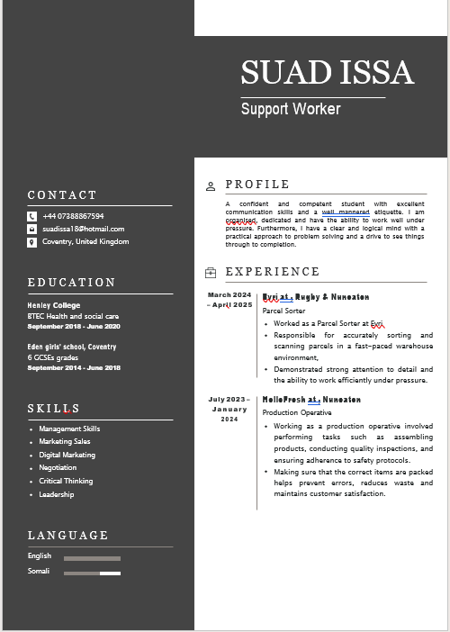
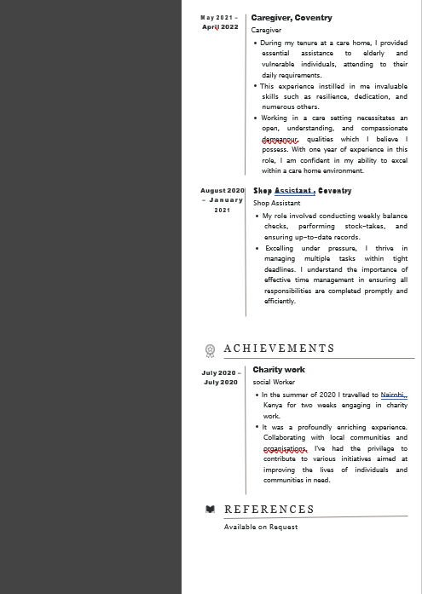
Figure 1: CV

Task 2 of 4
It is my application to work as a Support Worker in Christ the King Residential Care Homes. My intention is to support vulnerable adults and make a positive impact as I am confident that I can make a significant impact on the lives of people needing social assistance due to their vulnerability. My career objective is to enhance my skills and to work on my abilities in delivering person-centred care. I also aim to advance professionally as a part of an environment of professional, supportive and structured care.
My BTEC in Health and Social Care has given me a good understanding of safeguarding, patient care, and professional ethics. My studies have helped me gain a balance of the need to uphold dignity, secrecy, and respect towards people with a wide range of needs. The knowledge has equipped me to adhere to the standards of care, conform to policies and offer safe and effective support in accordance with organisational needs.
My practice experience in a setting of a care home has helped me to foster holistic exercise of my expertise I have learnt in health and social care. I assisted people in need, older individuals and vulnerable people in their day-to-day activities. I was also deemed to be responsible so that they can experience a comfortable, safe and nurturing environment. These actions have allowed me to build my resilience, patience, and have a compassionate attitude which is crucial in supporting a person with varying needs. My experience also includes conducting charitable projects in Nairobi, which allowed me to function closely with varied communities that helped me become more culturally aware and adaptable to various environments. These experiences are close to the duties in the role, such as assisting people, encouraging independence, and ensuring positive relationships.
I also have effective communication skills which were used effectively and professionally in my experience in a call centre where I dealt with customer inquiries. Being a shop assistant enhanced my organisational and time management capabilities which enabled me to work effectively when I was under pressure. Besides, my experience in care gives evidence of my compassionate character, which allows me to establish trusting relationships and to support people with empathy and understanding.
I also think that I can be a good applicant to this position because of my related experience, high work ethic and keen desire to provide the highest-quality care. I am also highly interested in enhancing my skills with the hands of training and professional development opportunities offered in your organisation. I believe that I will be able to positively serve your team and at the same time make sure that service users are well, have dignity, and independence [See Appendix 1].

Task 3 of 4

(a) SWOT Analysis
Strengths | Weaknesses
- The experiences I have gained working with elderly patients have helped me understand how to support their daily needs.  - It`s a very good communication skill that has been developed and enhanced through my work in a call centre. I used to answer call inquiries to resolve any issues and communicate under pressure which is quite significant when communicating with the service users and any other employee.  - I have an understanding, compassionate and caring personality which enables me to establish a trusting relationship with the vulnerable people in my professional settings of social care and these provide me with the scope to offer holistic emotional and physical support.  - I am very organised and would work well under pressure as it has been proven during past roles and also have the ability to organise time and prioritise things in a busy caring environment. | - My BTEC in Health and Social Care does not make much of the more professional qualifications like NVQ Level 3 and that would only render me less competitive as compared to the higher positions.  - The area that my clinical training focuses on is more specialised like medication administration or people with complex health conditions and needs further expansion.  - My practice of handling individuals with challenging behaviour is still at its infancy and I will be required to be exposed more to easily handle such cases in the future by myself.  - I have noted that my lack of confidence when speaking in front of an audience must be enhanced, and this may influence my performance when someone comes up to my group or team members.
Opportunities | Threats
- The help workers offering the UK health and social care industry are highly desired that render significant employment chances and long term career (Careshowlondon, 2026).  - I am also exposed to other training opportunities such as NVQ Level 3 and the constant professional development programmes that will assist me in becoming more equipped in terms of knowledge and skills.  - The career advancement as a senior care leader in a social care team, or specialisation cones are apparent with 1.71 million vacancies and the professionals are subjected to future career development (Skillsforcare, 2025).  - The utility of my skills having speciality in the social domain will also allow me to become able to work in the areas of mental health, disability support and behaviour management. It will not only make me more employable but also capable of working in various care settings. | - The competition for the job of support worker is especially vivid among the applicants for jobs of higher qualification and experience (Locke et al., 2022).  - Care work may be emotionally exhausting because of physical and emotional labour of assisting the struggling members of society (Umubyeyi et al., 2024).  - This is significant because, even though such a policy might be neglected, the law and other policies of regulations must not be neglected too, hence it may be extremely harmful in the pursuit to fail.  - Work-life balance and work satisfaction are then subjected to them unless the problem of workload, work shifts and pressures in the workplace is adequately dealt with.
Table 1: SWOT Analysis
(Source: Self-Developed)

(b) Personal Development Plan (PDP)
Goal | Actions | Time Frame | Resources Needed | Monitoring and Evaluation
Enhance communication and confidence (associated with deficiency in communication confidence and speaking before the audience) | Get involved into regular speaking practice, use communication workshops, and get more active in terms of communicating with service users and colleagues in the working situation. | 6 months | Online communication courses, training inside the workplace, supervisor and peer feedback will serve as the indicator of progress | It will be monitored by the changes in self-perception and the rise in confidence in the everyday communication and team discussions.
Gain a Level 3 Health and Social Care qualification (associated with the weakness of limited formal qualifications) | Getting myself enrolled in the NVQ Level 3 course, attending classes, obtaining study materials, tutor support, financial resources where needed and others | 2 Years | Pseudo-work, mentoring by experienced employees, theoretical learning in the care environment | It will be evaluated in terms of supervisor-reported feedback, the self-assessed level of confidence in managing complex situations and the skills to use the necessary care methods in a situation where they are not supervised.
Improve presentation and engagement skills (related to feedback: speak louder, do not read of the slide, engage the audience) | Presentations preparedness, developing confidence techniques, and conducting rehearsals in front of peers or mentors to build confidence. | 6 Months | Sessions of practice, obtaining evaluation from lecturers in the form of feedback and peers, access to presentation tools and reading materials | It will be monitored by the improvement of delivery style, voice projection, and audience engagement
Table 2: Personal Development Plan
(Source: Self-Developed)

Task 4 of 4
Description
My presentation on the assessment of the understanding of component 1 of LCHS4009 was about the Communication in health and social care practice, during which I was expected to be able to display my knowledge of the essential concepts and reiterate them to my lectuere. I created a series of slides with the help of PowerPoint and planned my information to make it concise and understandable. Overall in this evaluation I have developed the sections to explain the topic and tried to address all the important points in the specified amount of time I had. In this evaluation, I made sure that I completed all the tasks related to this assignment following the deadlines. However, the presentation was mostly reading off the slides instead of speaking naturally.
Feelings
Right from the beginning of the presentation, I was quite nervous and anxious and this was because I put too much pressure on myself. I was afraid of making some mistakes and forgetting things. In the moments when my nervousness was not at its best, it distracted my confidence, and I had to read more of the slides. Towards the end of the presentation, I couldn't help but feel a sense of relief and I also learned I could have done better. The feedback enabled me to know my strengths and areas that I have to work on.
Evaluation
The content and preparation were one of the positive things in my presentation. My slides were properly structured and the information that I gave was pertinent and logically arranged. I made sure I mentioned the necessary points and was able to show that I had a rudimentary grasp of the subject. There were however various things that had to be done better. Another piece of feedback was to speak louder, as the lecturer had difficulty hearing me at times. I was also overly dependent on reading off the slides and that interfered with my capacity to express myself naturally.
Analysis
The problems discussed in my presentation were predominantly caused by a lack of confidence and nervousness. Since I did not have much confidence in myself in my delivery, I relied on the use of reading off the slides as some sort of support. My lack of practice also became a factor of performance in that I was not entirely comfortable delivering the content without using written work. At the time it comes to health and social care roles the importance of communication as the professionals involved in these fields have to communicate effectively and confidently with the service users, families, as well as with work colleagues (O'Toole, 2024). The areas of weakness that I now have in the field of communication might impact my performance ability in these roles, and that is why I need to enhance these communication skills.
Conclusion
This experience has helped me understand the learning on the importance of good communication and engagement skills. It is essential to introduce good content however the ability to convey the information clearly and confidently is also important. I also understood that preparation should include practising delivering as well as making of the slides. In the reflection, I have been helped to understand what I need to undertake to emerge more effective in an academic and professional setting.
Action Plan
I will also focus on the development of communication and presentation skills since it is a method of improving my performance. I will also practice speaking loudly and clearly and my training will be through making a presentation every time. I will break them down to bullet points instead of full sentences because I will not need to read out of my slides and also I will preview myself. Another way through which I will monitor my progress is through lecturer feedback, and continue to boost my confidence in the long run. In order to comply all these actions, it will take around 6 months in total for me while my long term actions to be followed as per the PDP plan I have developed.

References
Careshowlondon (2026) Health and Social Care Industry Demand: Is It a Good Career in 2025? Available at: https://www.careshowlondon.co.uk/edition-17/health-social-care-industry-demand-good-career-2025 (Accessed 12 March 2026)
Indeed (2026) Support Worker. Available at: https://uk.indeed.com/jobs?q=Support+Worker&l=London&mna=&gclsrc=aw.ds&aceid=&gad_source=1&gad_campaignid=23317320197&gbraid=0AAAAADe30jNGxMboe6Yd2_xCoyarqbGDH&gclid=Cj0KCQjwpv7NBhCzARIsADkIfWw1RYWMkVK7erCR7h1e_oKO05luDzgGEN0zsf7vnlp8uqy0ckQPm-caAhVEEALw_wcB&from=mobRdr&utm_source=%2Fm%2F&utm_medium=redir&utm_campaign=dt&vjk=7227a5d39d45f953 (Accessed 21 March 2026)
Locke, R., McGinty, M., Ramirez, G.G. and Sellers, K. (2022) ‘Attracting new talent to the governmental public health workforce: strategies for improved recruitment of public health graduates’, Journal of Public Health Management and Practice, 28(1), pp.1-9. Available at: https://doi.org/10.1097/PHH.0000000000001336
O'Toole, G. (2024) Communication-E-Book: Core Interpersonal Skills for Healthcare Professionals. Elsevier Health Sciences.
Skillsforcare (2025) The state of the adult social care sector and workforce in England. https://www.skillsforcare.org.uk/Adult-Social-Care-Workforce-Data/workforceintelligence/Reports-and-visualisations/National-information/The-State-of-report.aspx (Accessed 12 March 2026)
Umubyeyi, B., Leboul, D. and Bagaragaza, E. (2024) ‘“You close the door, wipe your sadness and put on a smiling face”: a qualitative study of the emotional labour of healthcare professionals providing palliative care in nursing homes in France’, BMC Health Services Research, 24(1), p.1070. Available at: https://doi.org/10.1186/s12913-024-11550-7

Appendices

Appendix 1: Job Advertisement
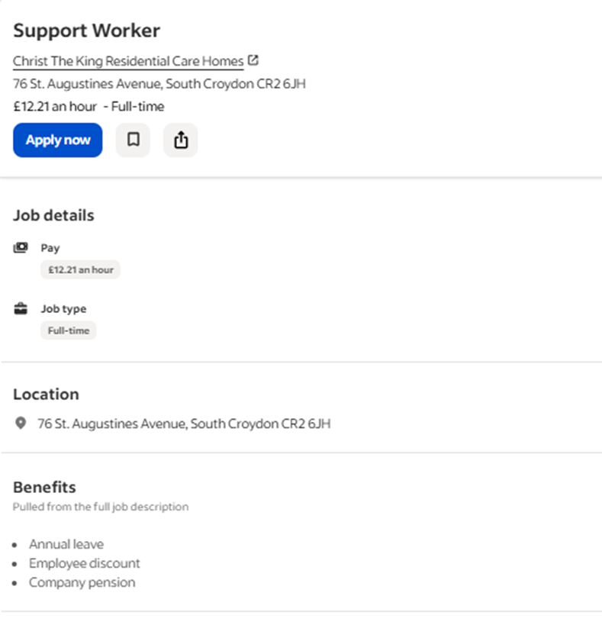
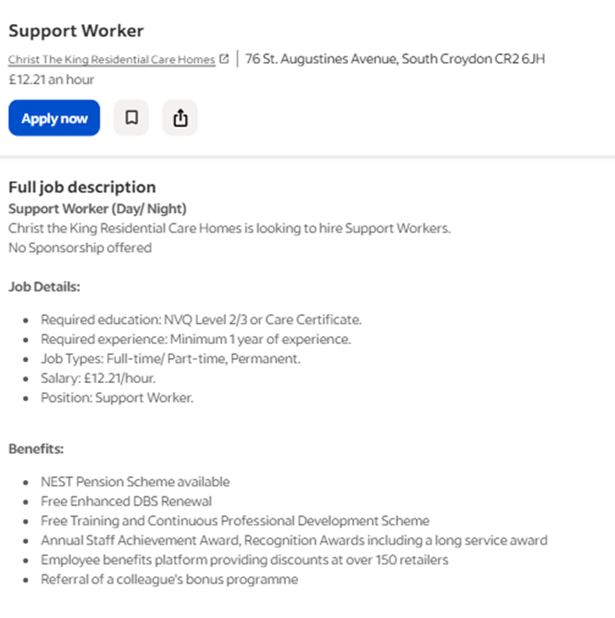
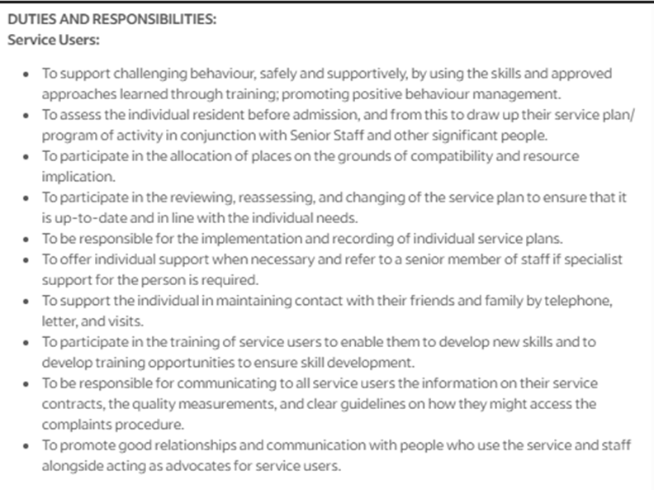
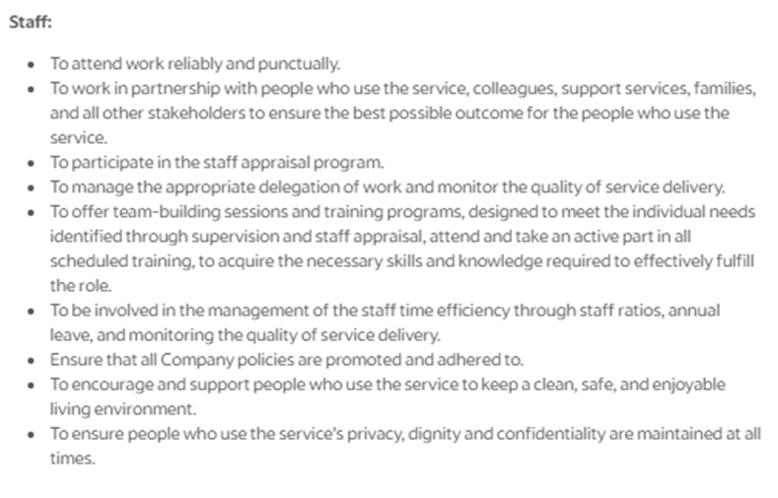
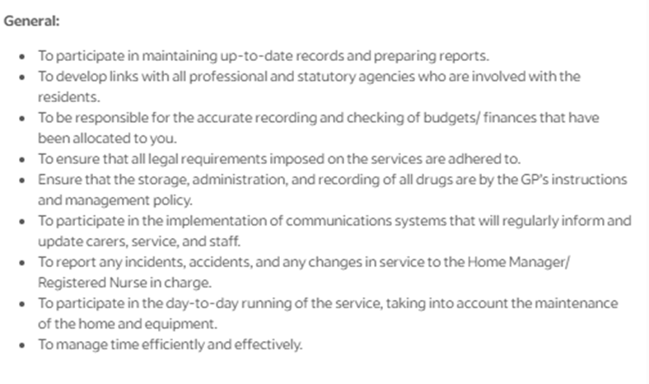
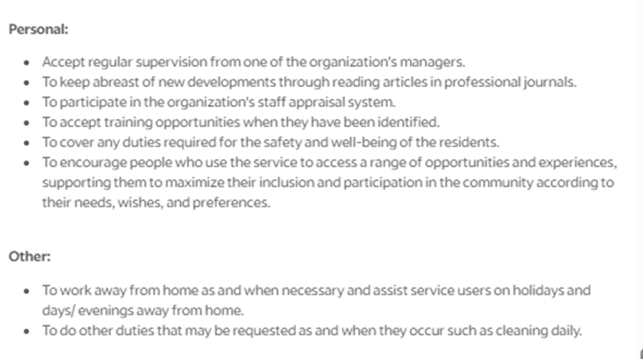
(Source: Indeed, 2026)

