
Skills for the Workplace
Module Assignment Submission
Student Name: | Medi-Bethan Williams
Student Number: | 2025488
Module No: | BMSK4007
Module Title: | Digital Skills and Personal Branding

Statement of Confirmation of Authenticity
By the act of making this submission, the student declares that this is the work of the student named above. The work has not, in whole or in part, been knowingly presented elsewhere for assessment, or where assessment has been built on a previous assessment, this has been identified. Where materials have been used from other sources it has been properly acknowledged. If this statement is untrue, the student acknowledges that an assessment offence has been committed.
Attention is drawn to the plagiarism and unfair practice policies of both the University and of ILM.
Permission for ILM to use this script
ILM uses learners’ submissions – on an anonymous basis – for assessment standardisation. By submitting, both the centre and the learner agree that ILM may use this script on condition that identifying information is removed. However, if you are unwilling to allow ILM use this script, please refuse by ticking the box: □

Table of Contents
What has been the impact of 21st Century Technologies on the modern workplace? 3
Evaluate the appropriate use of modern technologies and social media in the workplace generally 3
Explore the use of modern technologies and social media in own workplace 6
How can Personal branding help YOU? 8
Your LinkedIn Profile to promote your Personal Brand 9
Evaluate the value of other social media platforms to enhance networking and career prospects 10
Examine the impact of Personal Branding on your own employability 11
Discuss personal and professional security and safety online. 11
References 12
Appendix 1 14

What has been the impact of 21st Century Technologies on the modern workplace?

Evaluate the appropriate use of modern technologies and social media in the workplace generally
Many types of technology form an integral part of the workplace in the 21st century such as Telephones, PC’s ipads, Mac computers all very different from previous technology such as Fax machines, dial-up modems and typewriters.
Companies need for this technology is for business need, transformational need of the business to adapt, for efficiency or for shared access to information, widening networks, business opportunities, and employability opportunities. The introduction of the internet in the 1990s and the development of mobile phones in the 21st century became common accessories. Not all embraced the use of technology (Armstrong and Casement 2000) indicated that technology should be avoided as it may hinder children from having peer interaction and impact negatively on their emotional development as well as social development.
With ranges of modern technology, being used in particular software and social media platforms, it also critical that companies explore the best software and cloud-based technology to support their individual business needs. A number of equipment offers limited storage and does not offer a complete firewall on personal data or company files; therefore, additional protected storage is paramount to ensure data protection and restricted access. As mentioned in (Casserly, no date) it makes little sense to store everything on phones and computers w
When cloud links can be shared, which in turn, can limit the pressure of attachments on emails which clogs up the email storage.
Companies in this current day utilise cloud-based technology to reduce costs on server backup and costs of maintaining their own servers through additional staffing such as IT technicians. Cloud-based technology for storage prevents data breaches and data loss. It is merely a hard drive based on the cloud in the form of a backup of files. With files changes within MP4’s and PDF, the demand on storage is considerable dependant on company size. A number of cloud-based storage technology is available such as Google Drive and Microsoft one drive and Dropbox. A number of these offer some storage free of charge but offer further increase at a cost. As outlined in (Ellman, Lee and Jin, 2018) a number of companies charge per minute or per month for bespoke packages, whilst other charge a fee for a combination package, it is vital that companies research the appropriate package to meet their business need and budget. This can offer companies greater storage and protection and will result in cost-efficiency.
In the article it states “In 2015 Amazon Web Services share of the worldwide market was 31%, followed by Microsoft (9%), Google (4%.)” The table below shows the changes between 2017 and 2018. Shares drop due to increased providers with Google dropping into fourth place. (Gartner Says Worldwide IaaS Public Cloud Services Market Grew 31.3% in 2018, 2018).

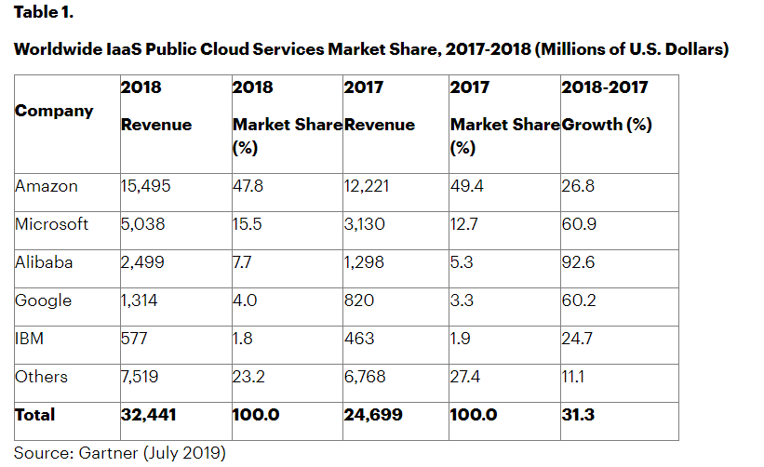
Skype (standing for Sky Peer to Peer) founded in 2003, was for a many was the leading form of connecting with others across the world. (Cowling, no date). Advancement of technology and competitiveness of companies such as Google, Facebook and Apple have also created various adaptations or own versions in many formats showing the sophistication of advancement in technology since 2003. Having expanded their range, they offer services such as Zoom, Microsoft Teams and What’s App.
Each of these services allow us to connect with each other virtually. Over the last twelve months, we have seen service delivery for many companies adapt to online working provision. In my own workplace, we have chosen to utilise Microsoft Teams, giving us an opportunity to instant message individuals, Meet in an online face to face manner, add Microsoft meeting to calendars through links and sync Microsoft 365 with our calendars and emails. The use of Microsoft 365 allows you to create settings to show your availability online, such as available, busy, offline and in a call. Unfortunately, in my workplace, it does not seem to stop individuals from contacting you throughout meetings, or when you are showing as “offline” as you are working on report with a deadline. Whereas, if you were in the office it is unlikely that you would be disturbed during a meeting or whilst you were hidden away meeting a deadline for a report. Invariably means I am answering messages during meetings and loosing train of thought whilst completing reports. For effectiveness, I have created staff surgeries within my calendar daily between certain identified times, to allow for such interruptions.
Other forms of technology that is used is social media. The use of such technology has evolved over the years in a work context and can be used to reach stakeholders of your business. Giving you opportunities to reach a wider network is also a form of promoting your product and is widely used for branding and marketing.
As indicated in (8 Best Social Media Platforms for Business: Your Ultimate Guide, 2021) there are over 65 forms of social media platform that can be exploited by companies to benefit their business. The advantages of using such portals range from linking with customer, greater branding awareness, increase your search engine optimisation, increase income opportunity and increase your network community. As outlined in the article the top 8 are Facebook; Instagram; Twitter; Linkedln; YouTube; Reddit; Pinterest and Quora. Outlined here in the article is how Facebook has increased income through advertising and in 2019/2020 had earned a staggering 78.9 billion dollars in the twelve-month before the final fiscal period of 2020. This indicates the magnitude and influence social media has drawn on companies to advertising through their portal over the past years.
Companies can utilise the platform to increase their target audience. Whilst many advertising products on Facebook are popup adverts, companies can also create pages for their companies for which customers or people with interests in their branding can like, share and be kept up to date of their promotions, new products and services. Raising the companies profile on a much wider geographical scale if not globally. This in turn can increase customer base and increase income. The downside of the use of this app can be the disadvantage of personal control if the app is suspended in any way. As in recent weeks where this has been the case, the costs to business as indicated in (Facebook’s six-hour outage costs an estimated $79m in ad revenue loss, no date) is in excess of 79 million dollars in total. The use of Facebook can be costly and needs consistent management.
Instagram, became as such overnight success in 2010, a younger audience than that of Facebook frequents an app that allows you to show images of goods or products gives high visibility to followers however depending on the business target audience in the main. In my workplace, as a college, we use both, as we deliver education to both adults and to 16-19 year olds. It allows us to market our successes and showcase case studies and market our brands to a wide range of audiences. Again, the downside this needs constant management and vigorous posting to keep actively engaged. This tool is only as wide as the followers you have and these can be difficult to obtain, as individuals need to know of you to follow you.
Whilst there is “Twitter” that allows for daily quotes and promotion again offering the same pros and cons as with the above applications, the other social media application used predominantly by professional individuals is LinkedIn.com. This has transformed the way in which companies seek and recruit employees and develop networks. Companies can utilise this application as a tool for strengthening their business-to-business interaction. LinkedIn can allow company individuals to establish greater link with peers from other companies, expanding knowledge transfer, and marketing of products but can also be used to find professionals that can assist in creating connections to individuals who can support their business in developing solutions to overcome barriers or that can complement their product base to reach wider networks. This can be done by endorsing an individual, acknowledging their work service having primary and secondary contacts. As a company that delivers across the UK and locally, my workplace encourages the use of LinkedIn to promote ourselves and our brand, which in turn allows for wider market potential. It also shows the calibre of the professionals they employ which heightens the calibre of their branding.
In context, there is a need for business to ensure that the correct provision is used to enable the service provision to be secure, within budget, user friendly and practical. Essentially, the continuity of service provision including expansion of provision through marketing and networking is key to the stability of the business and the use of modern technology can affect positively in the main, on supporting the service provision. However, a number of the software applications need to have Wifi access to enable the company to access the files. In my workplace, the provision was also made to be able to access our own desktop/network through remote access that gave us flexibility but even then when working from home you will need WIFI to connect your computers to desktop. In conclusion, WIFI is critical to accessing the software explored.

Explore the use of modern technologies and social media in own workplace
Within my workplace, we have over the past twelve months due to the pandemic. As an education establishment, it was paramount to continue delivery throughout lockdown, therefore we implemented procedures to overcome the challenges including ensuring the resource provision was adequate to continue a quality service.
Reflecting on the research undertaken within this report, I recognise the need for the correct technology be identified for business needs. Modern technologies plays a large part following the pandemic and has informed a new way for our business to conduct its day to day practices. (de Lucas Ancillo, del Val Núñez and Gavrila, 2020) states that the workplace will not remain the same in practice following the pandemic, and significantly the recreation of service will need to include as key elements, work, technology and safety as part of the transformation.
My workplace has adapted with a number of technologies. All staff were given laptops which gives flexibility of delivery being remote or in the workplace. Software was installed onto the equipment to allow for direct contact, indirect contact, virtual meetings, calendar synchronisation and shared documentation and files. This provision chosen by my workplace was in the form of Microsoft 365. This software includes the majority of Microsoft packages such as Word, Excel, PowerPoint and Microsoft teams.
One noticeable change over the past few years within my workplace is the use of social media. Not only from a perspective of marketing and creating wider networks but the use to promote good practice and successes.
The use of Facebook and Instagram within my workplace helps us promote up and coming courses as well as funding opportunities individuals can access to support them to undertake the course. As an education provider that delivers widely throughout the UK and internationally it broadens the communication we have with our stakeholders. (Figure 1).

Figure 1. Stakeholder mapping – Gower College (Medi 17/10/21)
Difficulties for us within the workplace, is the varying degree of information needing to be communicated with the stakeholders and the frequency. The use of Facebook is only used as a broad tool within my workplace as a reflection on achievements and as an advertising tool to grow participation in courses, of course which will increase footfall and revenue. Using such a platform allows the college to market to a target audience wider than just their mailing contact lists. However, this is not seen as a stakeholder communication conveyancer. Facebook has a limited use of character space and is in the public domain and therefore confidential stakeholder information would not be appropriate to be conveyed in this manner. Therefore, the use of Facebook benefits them only in widening their audience and possibility of increased participation. (Log in to Facebook, no date)
As for relating information to stakeholder these are currently performed by the use of technology such as Microsoft Teams. The benefit to the company in respect of these can be seen as a cost efficiency measure. This is through the reduction in travel costs to different campuses, Welsh Government Offices and to businesses. Whilst this is an efficiency, this is not without its flaws, it is dependent on WIFI signal and as a location in particular my department is hidden within some dense woodland, frequently fails. From a customer service point of view this is not ideal nor professional in an outward facing manner. I do however, feel that the lockdown during Covid 19 has allowed for an understanding that these things may happen when using technology in the way we do currently for service delivery.
Instagram is a relatively new social media platform used by my workplace, again used in the same vein as that of their Facebook application, widening the ability to reach wider audiences. This is dependent on following and those who follow you. The organisation has their own accounts branded as Gower College Swansea you need to search for them in order to follow them and only works if you are interested or know about them. (Login • Instagram, no date)
Equally, Gower College has a twitter account and utilises this to promote events they are at or hosting. Often “tweeting” their whereabouts. This can have an obvious impact on their networks in particular as they are required invariably to use # at the beginning of an event, which tags the company, or event they are attending/hosting. I feel this works better for my workplace in showcasing their diversity rather than merely a college that delivers to 16 – 19 year olds. We have a broad range of provision which includes business development supporting business with their workforce development, developing new courses in line with business need and regional demand, influencing curriculum change as well as community engagement and public used facilities such as the theatre, sports centre and our hair and beauty provision which is also open to the public. We rarely market these on the other platforms and feel that the college could benefit from the use of Facebook and other social media platforms in order to maximise their potential for income generation. (https://twitter.com/gowercollegeswa, no date)
As a college are particular form of wider advertising, marketing and branding is reliant on the use of the college website and that of internal newsletters. This does not offer an external facing wider public exposure and it then becomes reliant on staff and words of mouth to distribute this information.

How can Personal branding help YOU?

Creating on online vision or presence of yourself effectively on online identity, can have both a positive and negative effect.
Boys and Ellison (2007) describe social networking sites (SNS) as “web-based services that allow individuals to (1) construct a public or semi-public profile within a bound system, (2) articulate a list of other users with whom they share a connection and (3) view and traverse their list of connections and those made by others within the system”. This all true and can be used as an advantage to further your own opportunities in raising your brand and profile, share connections to maximise network opportunities and also by discussing products with other in the form of marketing.
From a positive perspective, creating a profile for your brand on SNS can increase your publicity, marketing, advertising, employability, social status and increase product sales and income. The negativity that comes with this is the fact that the use of sites such as Facebook, Instagram and LinkedIn are all in public domain. It is a wise move to always remember this when creating a profile. Ensuring a professional and positive outward image of yourself in critical.
Creating a personal brand will include your skills, your expertise, values and beliefs, when beginning my career in Coleg Sir Gar I was privileged to represent the college due to my branding and expertise in the area of business development, by being interviewed for “Wedi 3” a welsh chanel four programme and introduced a local business expert. I believe this came about due to my successful business values and beliefs in local businesses being entrepreneurial and my career in supporting businesses to evolve, innovate and improve through opportunities available to them to expand their product and brand. Of course this is all related to your personal brand, therefore, my professionalism played a large part in been chosen and given the opportunity to do this. I also believe that the endorsement from other memebers on Linedln also contributes to enhancing your personal brand.

Your LinkedIn Profile to promote your Personal Brand
Below is a link to my own Likedln profile and shows my presence on the social media site, together with a screen shot of my endorsements by others.
https://www.linkedin.com/in/medi-bethan-williams-90476379/
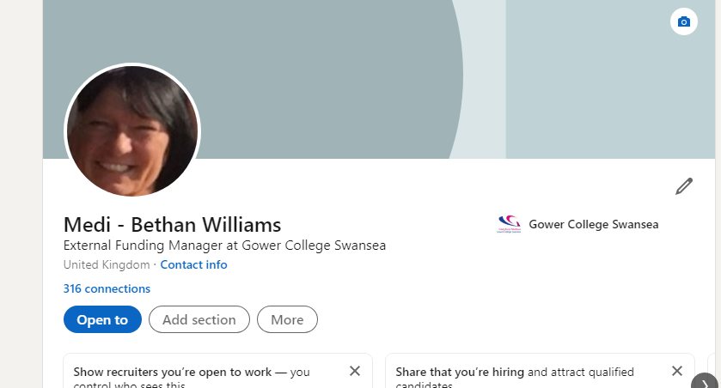

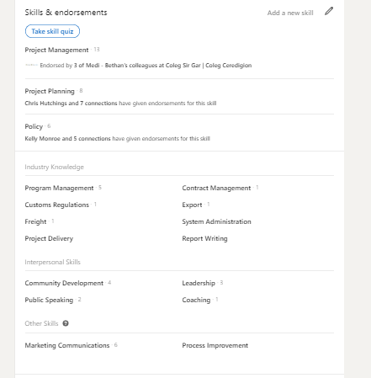

Evaluate the value of other social media platforms to enhance networking and career prospects
There is a number of platforms that we can promote our branding that allow us to enhance our networks and career prospects, not only that of LinkedIn.
Facebook is also a platform that can also support your personal brand. It is critical that a professional approach is used to build your professional brand; however, this can be different from your personal account. In my instance, I work in an education establishment where we are led by professional bodies and any throw away comment or remark can bring the company into disrepute. As we are governed and need to be affiliated with the Education Workforce Council. Any complaint based on a comment or unprofessional behaviour can be investigated and you can be brought in front of the committee to be reprimanded in the same way as a court hearing. (Hearing outcomes,no date). Whilst this is the down side of personal professional brand from my perspective, there is also a very positive opportunity for me to promote my success and can also broaden my networking opportunity. Other opportunities are that individuals can see your progression in career pathways and also contact you in respect of advice or even vacancy opportunities.
Instagram, is a platform, used mainly by younger people, highlighting short brief images or videos. This can be a versatile tool to reach a younger target audience, promoting your brand. It can also have a positive influence on the younger generation by way of identifying with your posts, seeing a positive outward appearance and your career journey. An example of this is where you set out in a administrative role and then progress up the ladder to become a manager, this can impact positively on those that follow you on the application.
All mentioned platform of social media are an outward facing communicative tool that is in the public domain, one should be mindful what is posted from a professional perspective in case of misinterpretation or an unprofessional post.

Examine the impact of Personal Branding on your own employability

The social media screening articles states that 70% of employers screen candidates on social media sites whilst recruiting personnel (Social Media Screening in Recruitment, no date) and around 43% use it in respect of checking on current employees. Depending on your profile, this can impair your employability prospects. As outlined in (The 10 Biggest Personal Branding Mistakes People Make, no date) it is important not to be fake, oversell yourself, overselling yourself, never underestimate the opportunity of collaboration.
All of the above can limit your employability chances. (Social Media Screening in Recruitment, no date) It was revealed in 2017 that a huge 36% of UK Employers rejected candidates based on their Facebook, Instagram, Twitter or LinkedIn profiles. This highlights the importance of maintaining a professional outward facing brand that captures you personality, beliefs and behaviours, skills and expertise.

Discuss personal and professional security and safety online.

One of the most important regulations that has come into play since 2018 is the new GDPR regulations outlined in (Information Commissioner's Office, 2019), This indicates the guidelines on dealing and saving personal data. In particular, the way in which companies handle personal date on a day-to-day basis. For example, in my workplace, we will send information for projects through encrypted files or password protected files. In respect of students we now are not allowed to store them for more than two years and where possible avoid the use of storage, if it can be shown and verified that the relevant documentation to prove right of abode for example has been seen examined and verified.
Despite the exit of the UK from the EU it is still affecting businesses. It can also be checked and investigated for breach, which can cause a financial penalty if the company, for failure to adhere to the guidance. For example, you may send an email without thought to a colleague in respect of a student’s name date of birth and unique learner number as you work in the same company, however, this must be encrypted as you are in breach of sharing unprotected personal data.
From a company perspective it is now prohibited to send promotional emails direct unless you have prior permission, this is why social media platforms can assist in the promotion of company brands, marketing and networking.

References
8 Best Social Media Platforms for Business: Your Ultimate Guide (2021) OptinMonster. Available at: https://optinmonster.com/best-social-media-platforms-for-business/#quora (Accessed: 16 October 2021).
Armstrong, A. and Casement, C. (2000) The child and the machine: how computers put our children’s education at risk, Open WorldCat. Beltsville, Md.: Robins Lane Press. Available at: https://www.worldcat.org/title/child-and-the-machine-how-computers-put-our-childrens-education-at-risk/oclc/43615849 (Accessed: 18 October 2021).
Boyd, D. M. and Ellison, N. B. (2007) “Social Network Sites: Definition, History, and Scholarship,” Journal of Computer-Mediated Communication, 13(1), pp. 210–230. doi: 10.1111/j.1083-6101.2007.00393.x.
Casserly, M. (no date) Store your photos, files and videos in the cloud for free, Tech Advisor. Available at: https://www.techadvisor.com/test-centre/internet/best-cloud-storage-3614269/. Accessed 16/10/21.
Cowling, J. (no date) A Brief History of Skype - the peer to peer messaging service, content.dsp.co.uk. Available at: https://content.dsp.co.uk/history-of-skype. Accessed 16/10/21
de Lucas Ancillo, A., del Val Núñez, M. T. and Gavrila, S. G. (2020) “Workplace change within the COVID-19 context: a grounded theory approach,” Economic Research-Ekonomska Istraživanja, pp. 1–20. doi: 10.1080/1331677x.2020.1862689.
Ellman, J., Lee, N. and Jin, N. (2018) “Cloud computing deployment: a cost-modelling case-study,” Wireless Networks.
Facebook’s six-hour outage costs an estimated $79m in ad revenue loss (no date) The Drum. Available at: https://www.thedrum.com/news/2021/10/05/facebook-s-six-hour-outage-costs-estimated-79m-ad-revenue-loss. Accessed 16/10/21
Gartner Says Worldwide IaaS Public Cloud Services Market Grew 31.3% in 2018 (2018) Gartner. Available at: https://www.gartner.com/en/newsroom/press-releases/2019-07-29-gartner-says-worldwide-iaas-public-cloud-services-market-grew-31point3-percent-in-2018. Accessed 16/10.21
Hearing outcomes (no date) www.ewc.wales. Available at: https://www.ewc.wales/site/index.php/en/fitness-to-practise/hearing-outcomes.html (Accessed: 24 October 2021).
https://twitter.com/gowercollegeswa (no date) Twitter. Available at: https://twitter.com/gowercollegeswa?lang=en (Accessed: 17 October 2021).
Information Commissioner's Office (2019) Guide to the General Data Protection Regulation (GDPR), Ico.org.uk. ICO. Available at: https://ico.org.uk/for-organisations/guide-to-data-protection/guide-to-the-general-data-protection-regulation-gdpr/.
Log in to Facebook (no date) Facebook. Available at: https://en-gb.facebook.com/GowerCollegeSwansea/ (Accessed: 17 October 2021).
Login • Instagram (no date) www.instagram.com. Available at: https://www.instagram.com/gowercollegeswansea/?hl=en (Accessed: 17 October 2021).
Social Media Screening in Recruitment (no date) Working Solutions. Available at: https://www.workingsolutions.co.uk/blog/social-media-screening-in-recruitment.
Social Media Screening in Recruitment (no date) Working Solutions. Available at: https://www.workingsolutions.co.uk/blog/social-media-screening-in-recruitment#:~:text=According%20to%20a%202018%20CareerBuilder (Accessed: 24 October 2021).
The 10 Biggest Personal Branding Mistakes People Make (no date) Business 2 Community. Available at: https://www.business2community.com/branding/the-10-biggest-personal-branding-mistakes-people-make-02270076.

Appendix 1

Linkedln Profile


