Assignment 1 – Usability Engineering



Student Name: Morgan Lloyd
Student Number: 296463
Contents
1. Introduction 3
2. Task Analysis & User Requirements 16
3. Paper Prototype 20
4. Application of human factors 28
5. Heuristic Evaluation – My design 32
6. Heuristic Evaluation – Classmates Design 32
7. Software prototype 35
8. Evaluation of Adobe XD 44
9. Evaluation of techniques 45
References 46

- Introduction

The selected task for this project is to design a prototype interface for accessing the covid pass as part of the Welsh Government Covid Pass. Accessing the pass involves two main processes:

- Login
- Registration

  - Registration

Currently, the registration process requires the user to submit an email to link the account as shown below.
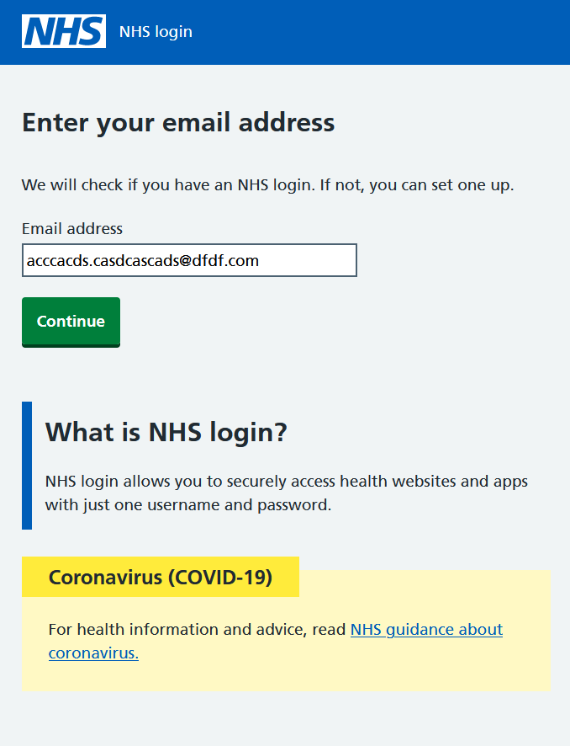[1]

After that users are given a list of required details for registration including name, date of birth and postcode.
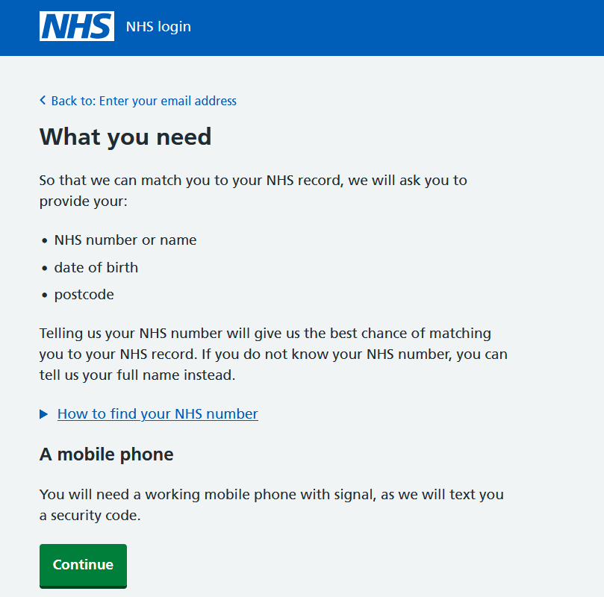

[1]

The third step is for users to create a password and to agree to the terms of use.
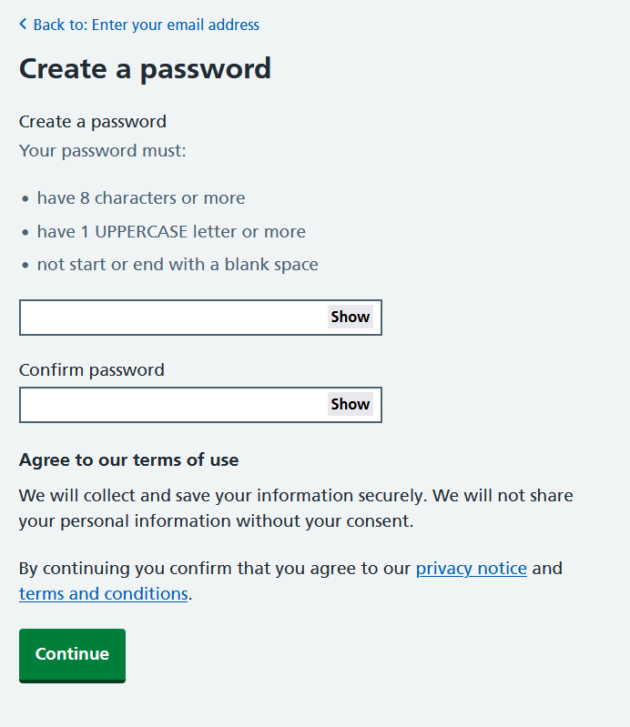
[1]

The next stage of registration is to provide a mobile number.
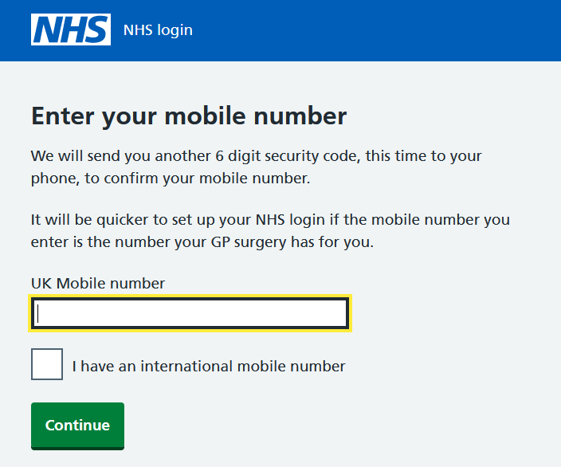
[1]

The next stage requires you to confirm the mobile by entering a security code.

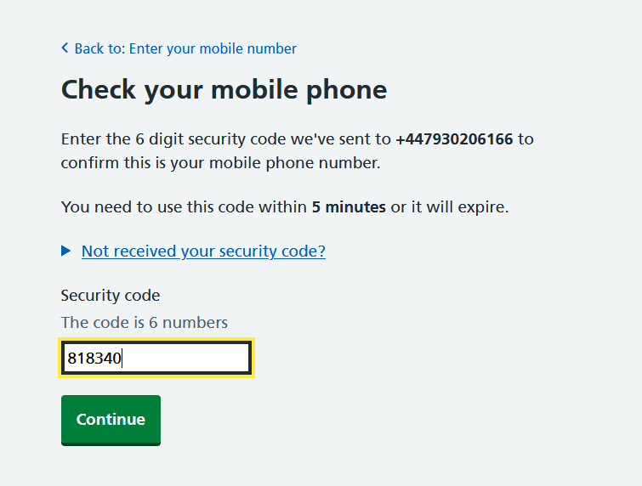
[1]

The system then asks if you know your NHS number for quicker retrieval and record matching.
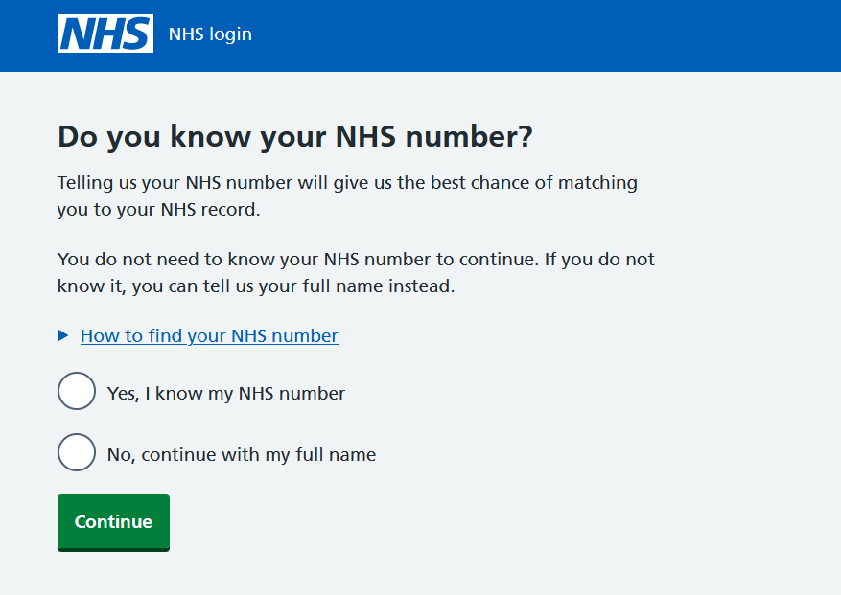

[1]

If the NHS number is unknown, you must provide a full name for identification purposes along with your date of birth and postcode.
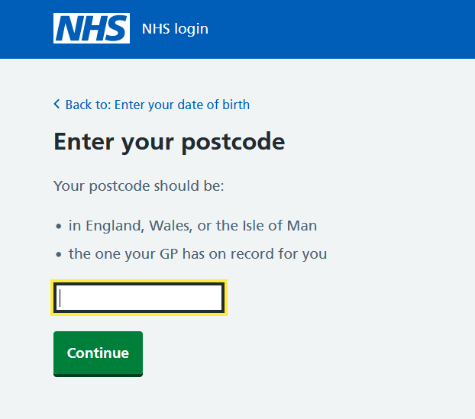
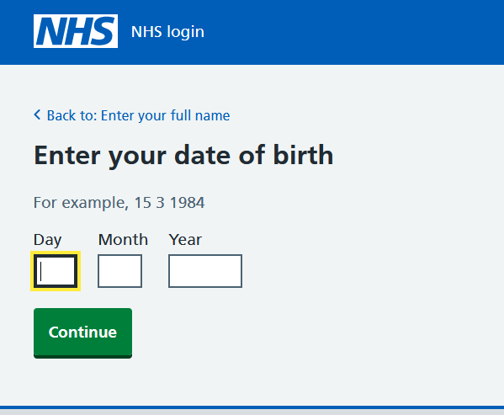
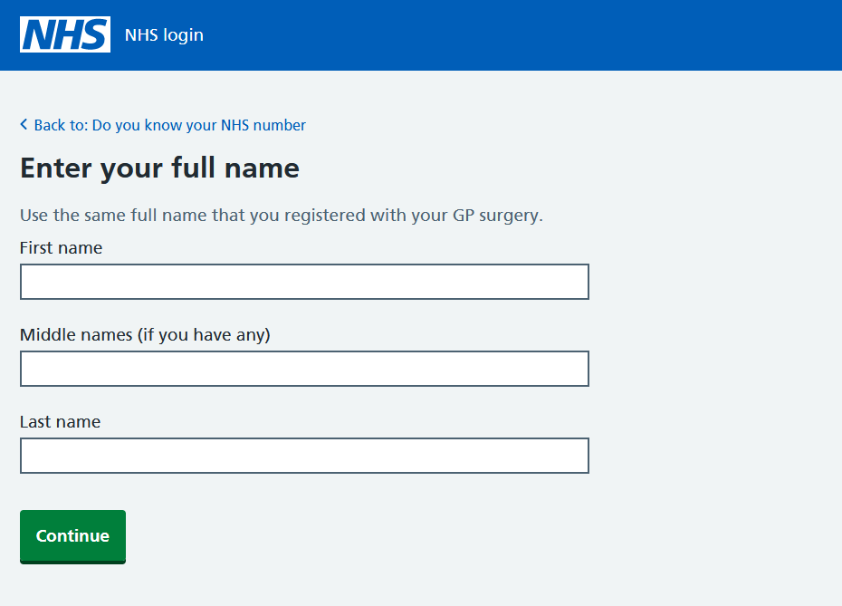

[1]

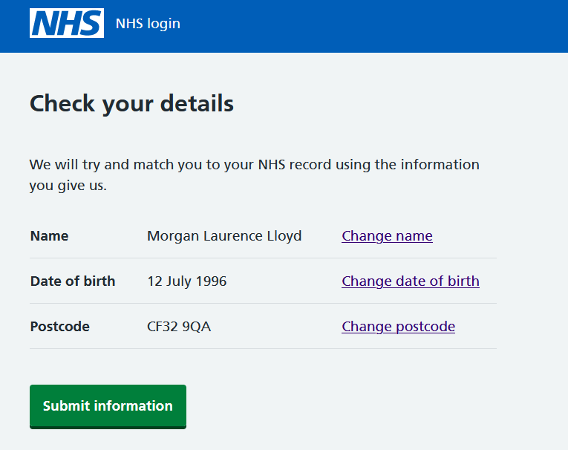
After providing identification data you must confirm they are correct and the NHS system will try and match a record.

[1]

Confirmation of the terms and conditions relating to personal data provided.
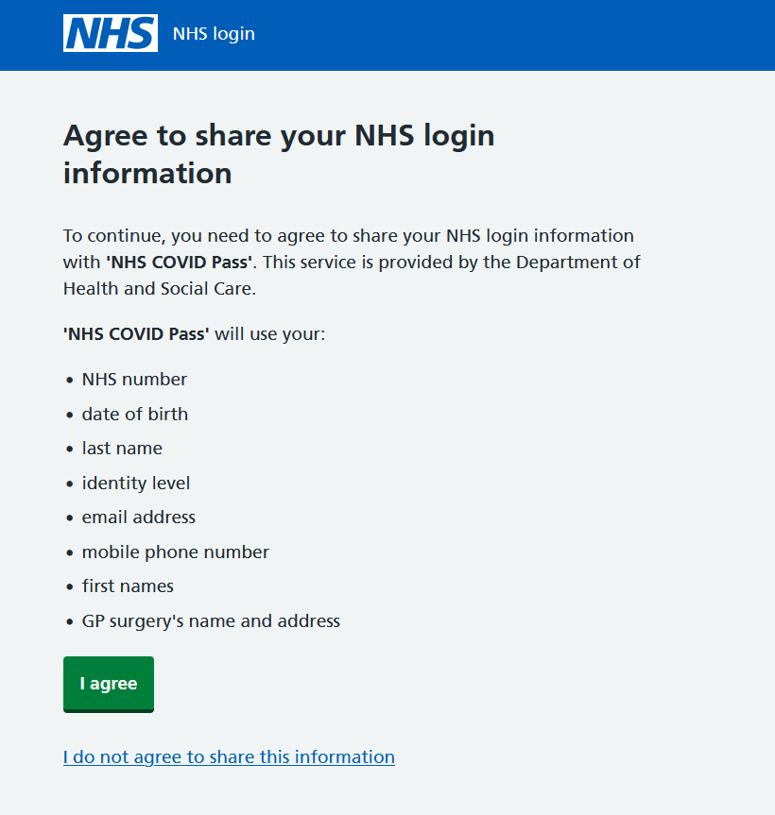
[1]

Access the covid pass using the domestic link which provides a QR code for the covid pass which can be downloaded as a PDF or email.

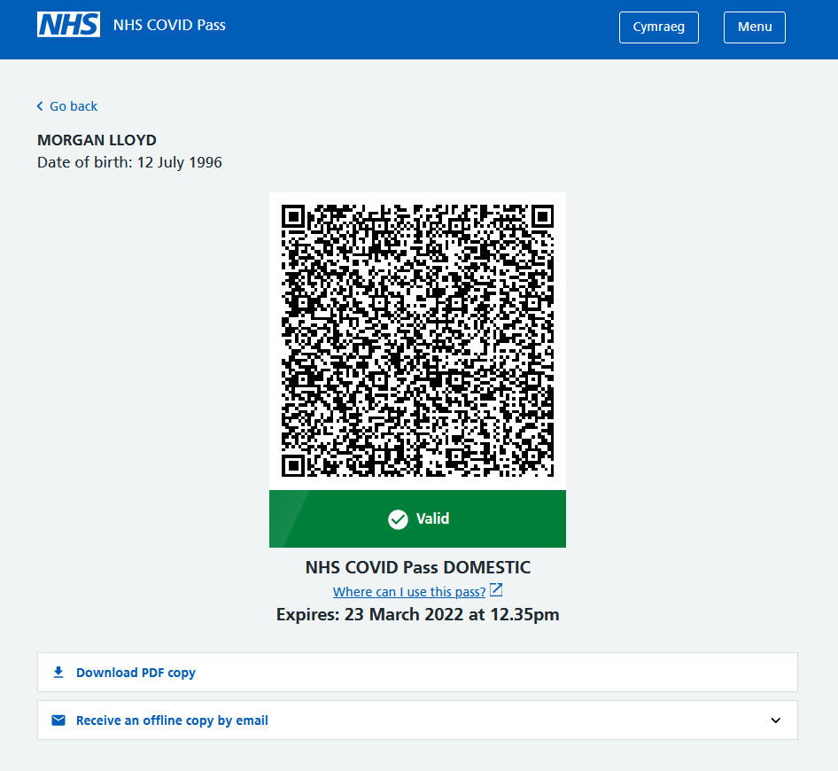

[1]

  - Login
For the login process, you start with an email address to identify your account to the NHS.
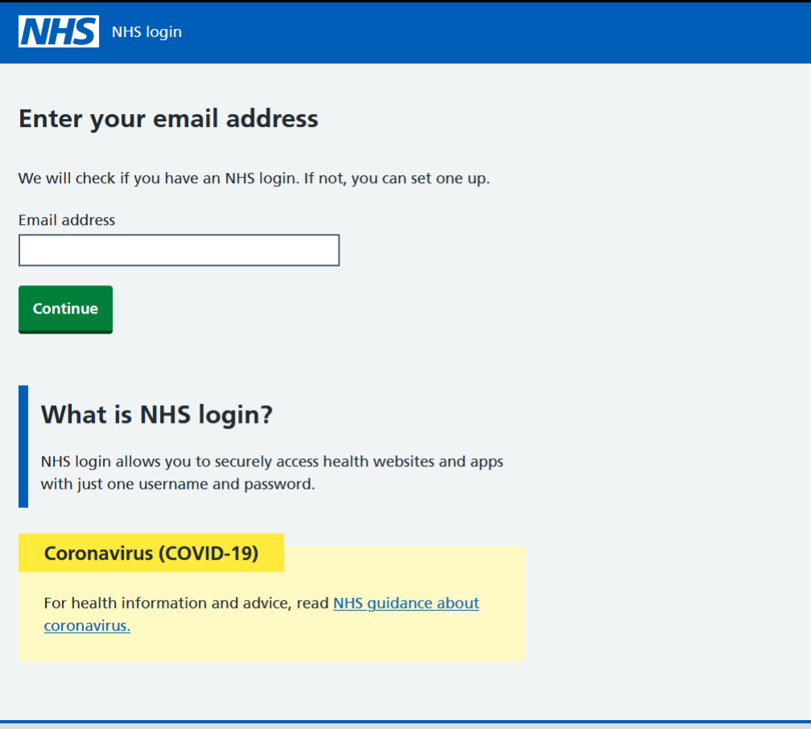
[1]

The second stage is to confirm the account is correct and matches the NHS login.
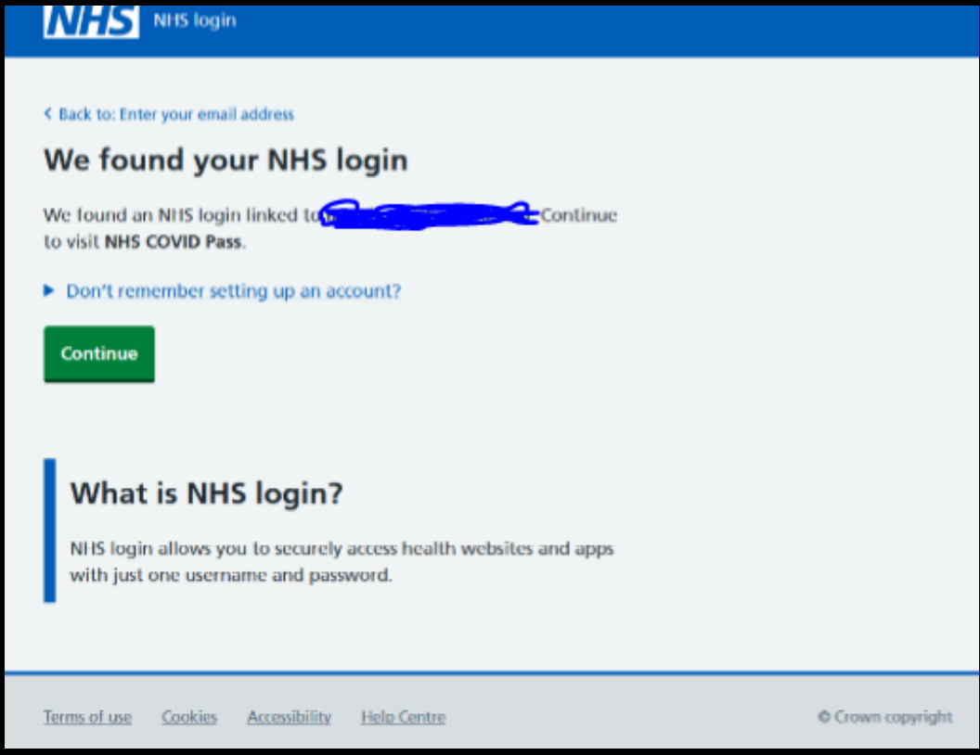
[1]

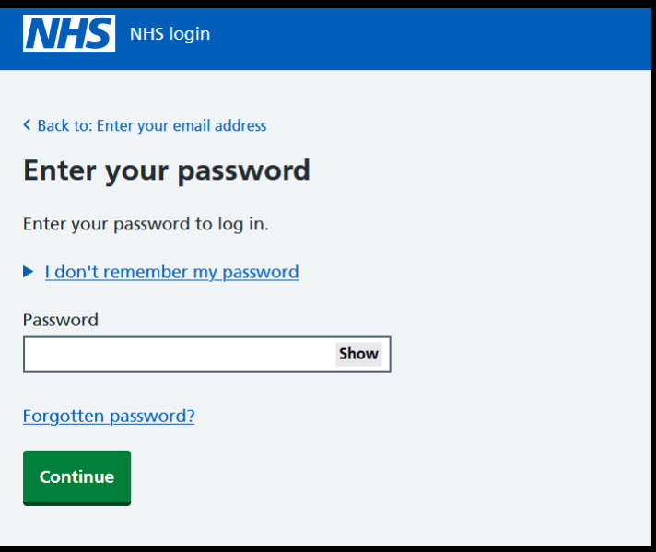
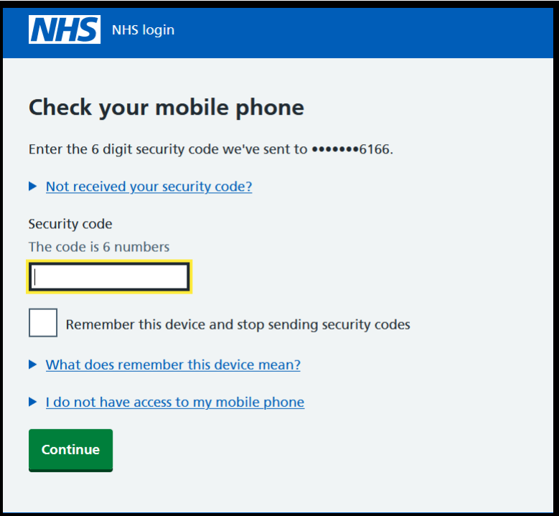
After confirming the account, the user must enter a password that they specified in the registration. Link reset password is available. After this, the user is then required to enter a security code which is sent to their mobile phone.

[1]

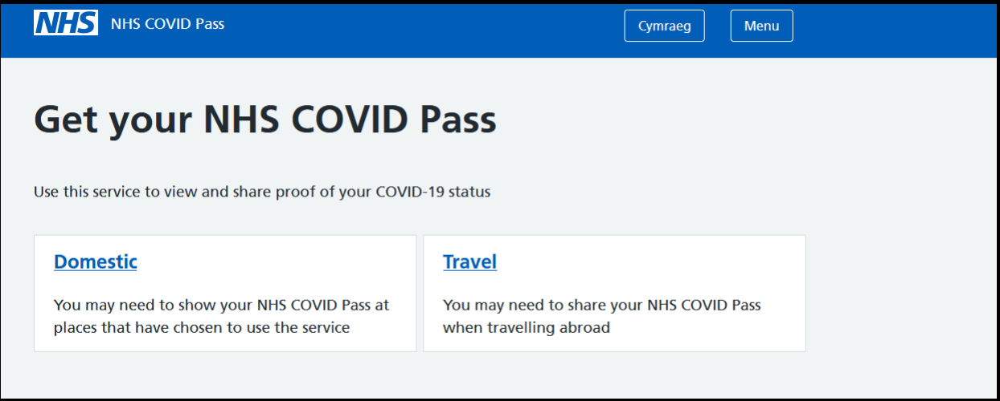
After logging in the user can then access the pass using either the domestic or travel links depending on the covid pass required for their travel or venue destinations.

[1]

- Task Analysis & User Requirements

I will be utilising hierarchical task analysis to determine which tasks and sub-tasks are required for the users. Task analysis is used to determine user requirements, specifically, actions that the user takes to complete a task. Additionally, it gives insights into the systems processes and user needs. [2]

I will be taking in user feedback via an interview to locate frustrations or concerns that users are currently experiencing with the current system. I will use this feedback to determine the required tasks.

The target user group for this system is technically anyone from ages 12 and up as per the current Welsh Government website [3]. However, for this task, I will be exploring the requirements of an adult between the ages of 18-55.

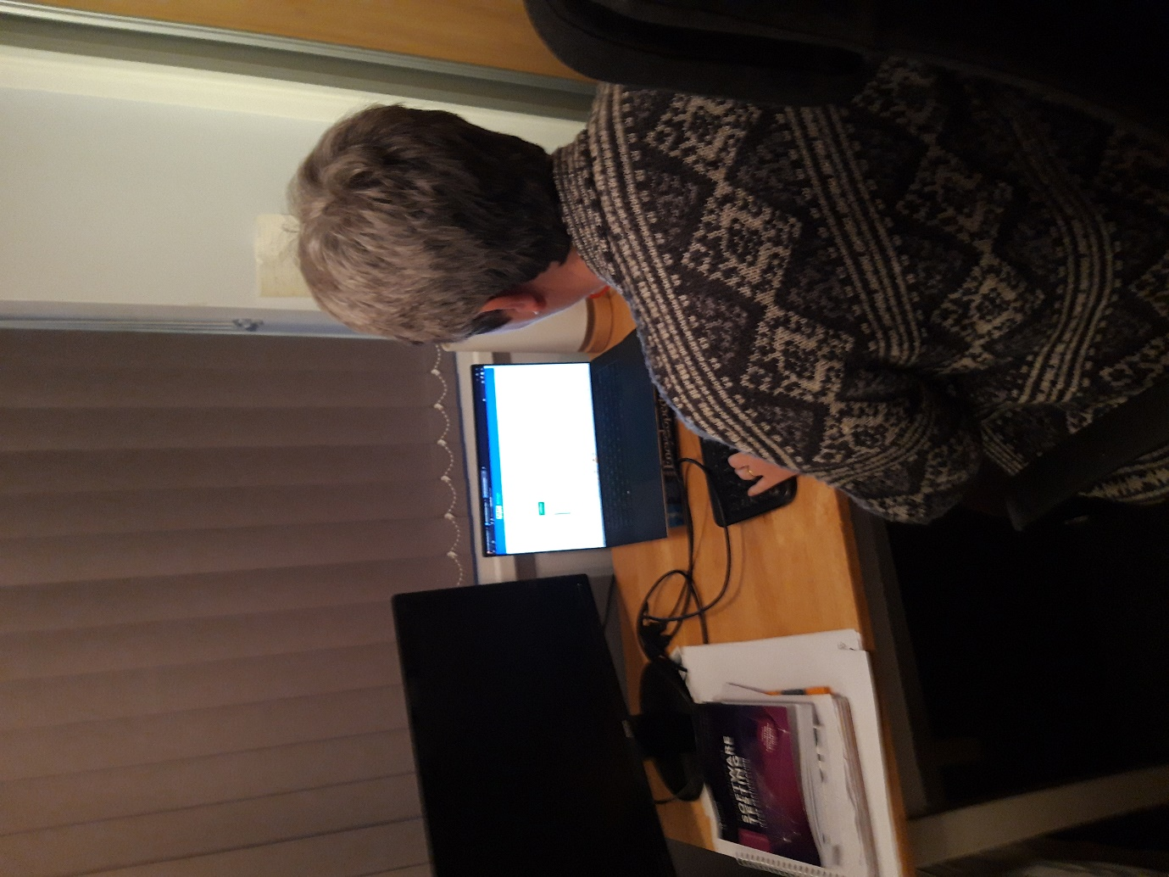

Interview questions

While using the system did you experience any frustrations? If so can you please explain your frustration?

I found the registration and login confusing at the beginning as it isn’t clear which path you are going down. I also found it long-winded to fill in the date of birth, name and postcode on separate forms. The NHS number I didn’t have and would be better if I could go straight to the other section.

Do you have any suggestions for further improvement for the system?

Found the text messy in some areas. Unclear when you start registering or logging in so clear buttons or titles for that. I would also change the forms so you can enter quicker in some areas such as when entering personal details. Perhaps an area where you can go straight to entering details if you don’t have the NHS number.

Task analysis

From the user interview responses and the current system, there are three main goals or tasks for the user of the system:

- Registration
- Login
- Pass access
Registration
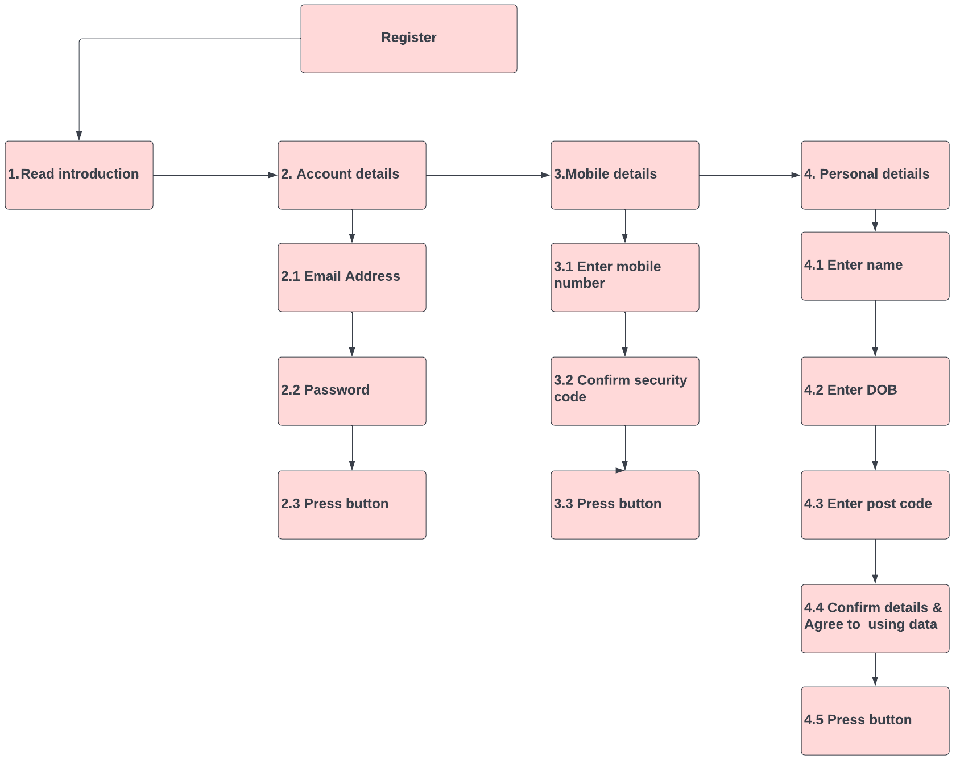
Below is the registration process which involves 4 main tasks which include introduction, account details, mobile details and personal details. Some of these tasks have sub-tasks as shown below.

Login
Below is the login task analysis. The process involves two main tasks which are entering the email and password and confirming the user via mobile details.

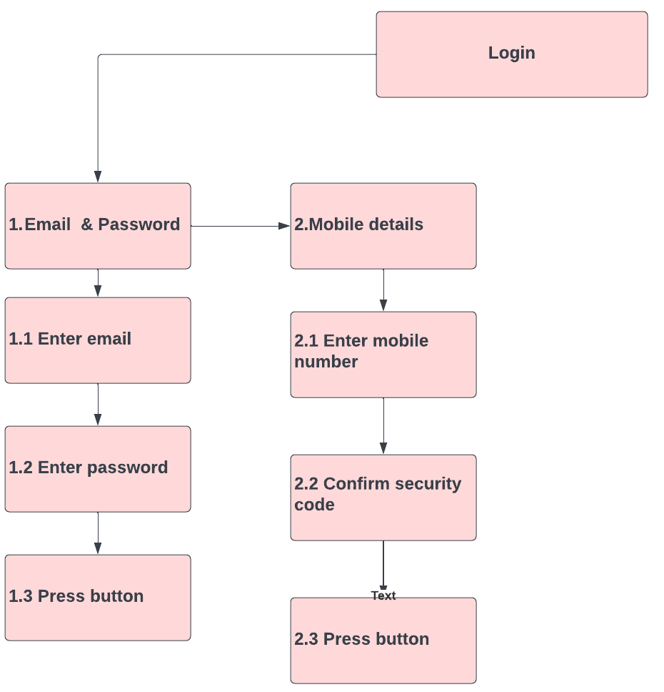

Pass Access
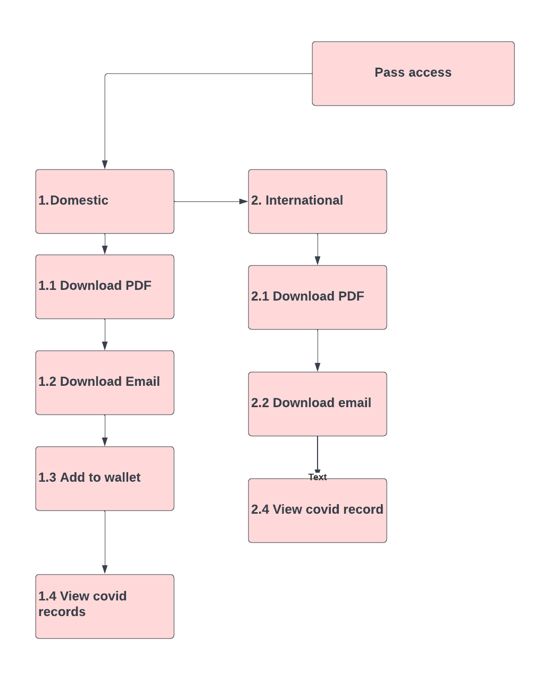
Below are the tasks for the pass access which comes after registration or login. Two main tasks include either domestic or international.

- Paper Prototype
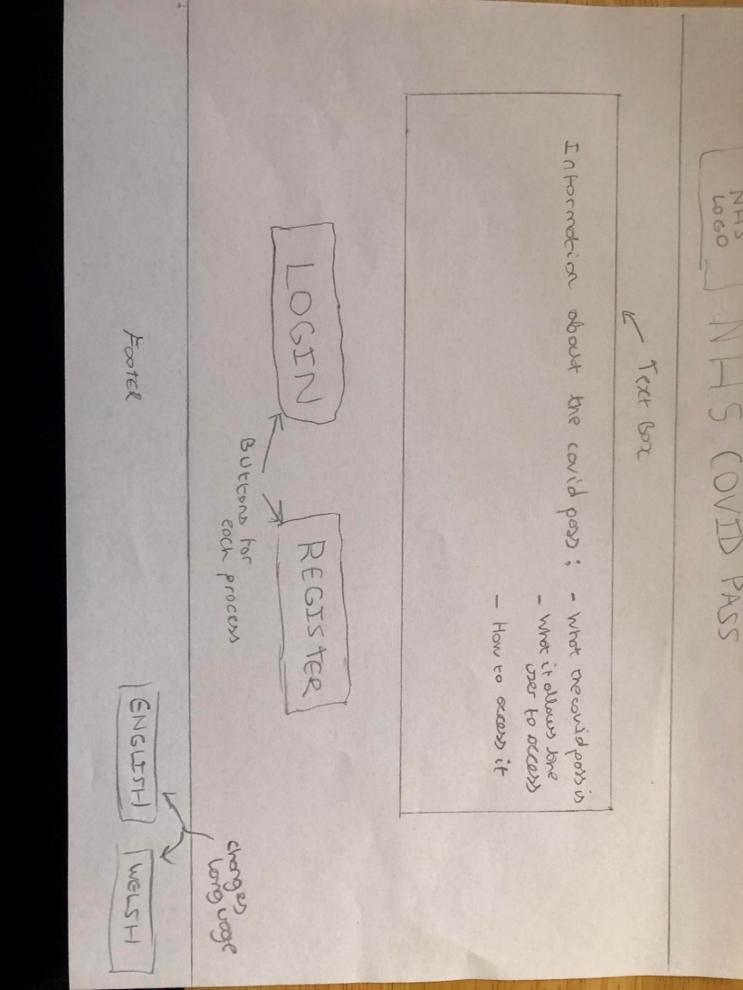
Below I will be showing the paper prototype of the NHS covid pass system. Specifically, I will be showing the registration, login and pass access processes. The first process of a user will be to either login or register as shown below.

Registration – Step 1
The first step of registration is the account details. The user is required to enter their email, password and confirm password.
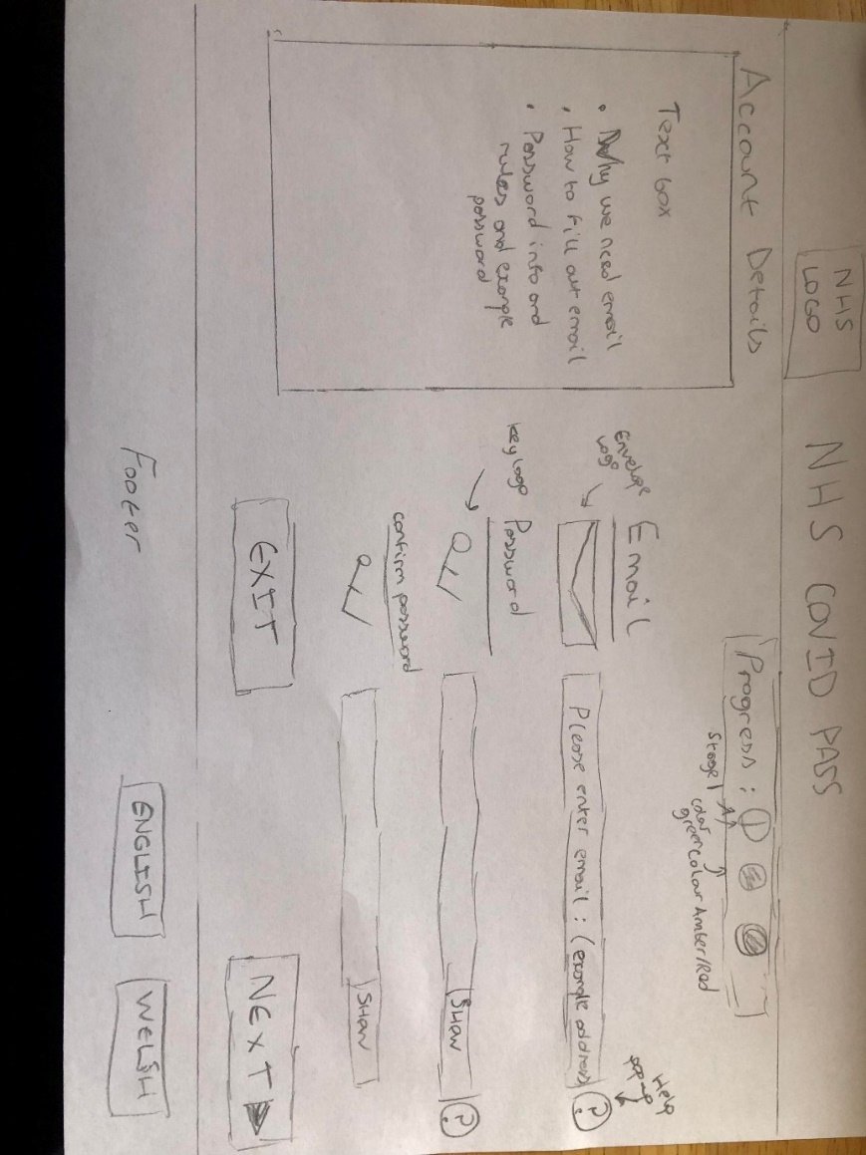

Registration – Step 2
The second step of registration is the mobile details. The user is required to enter their mobile number and confirm a security code.

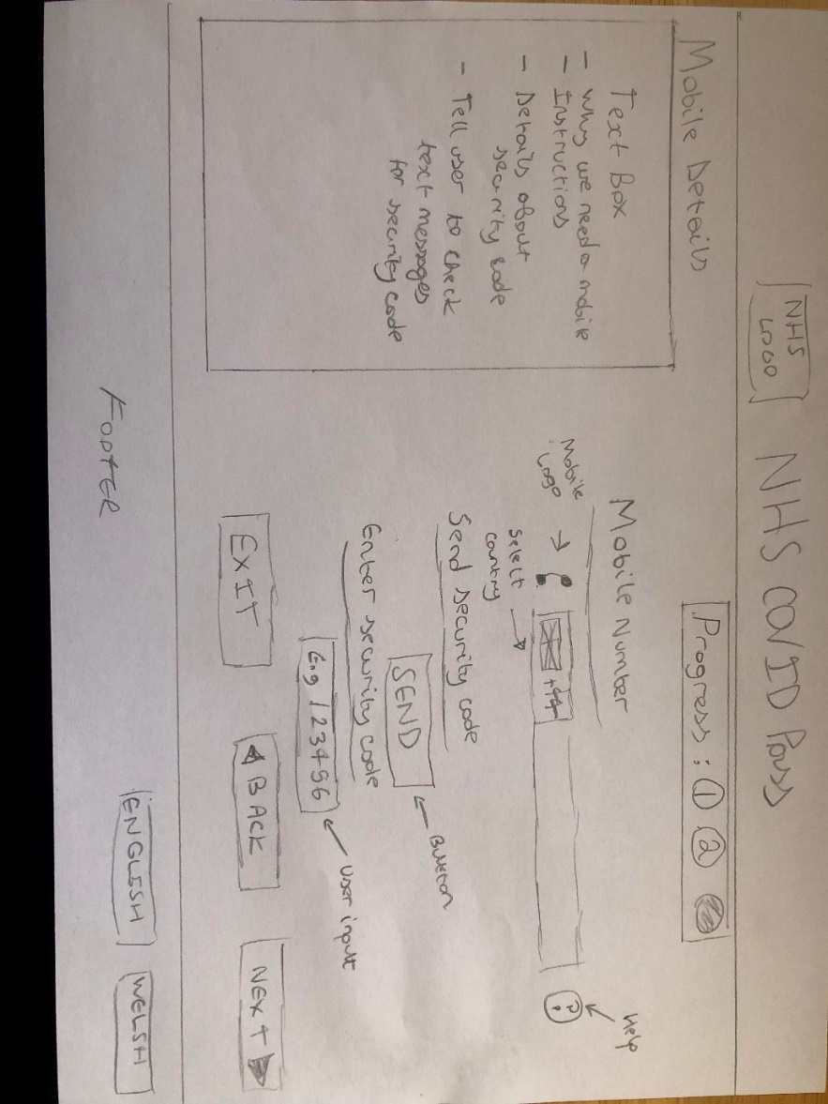
Registration – Step 3
The final stage of registration is the personal details. The user enters their name, date of birth and postcode.
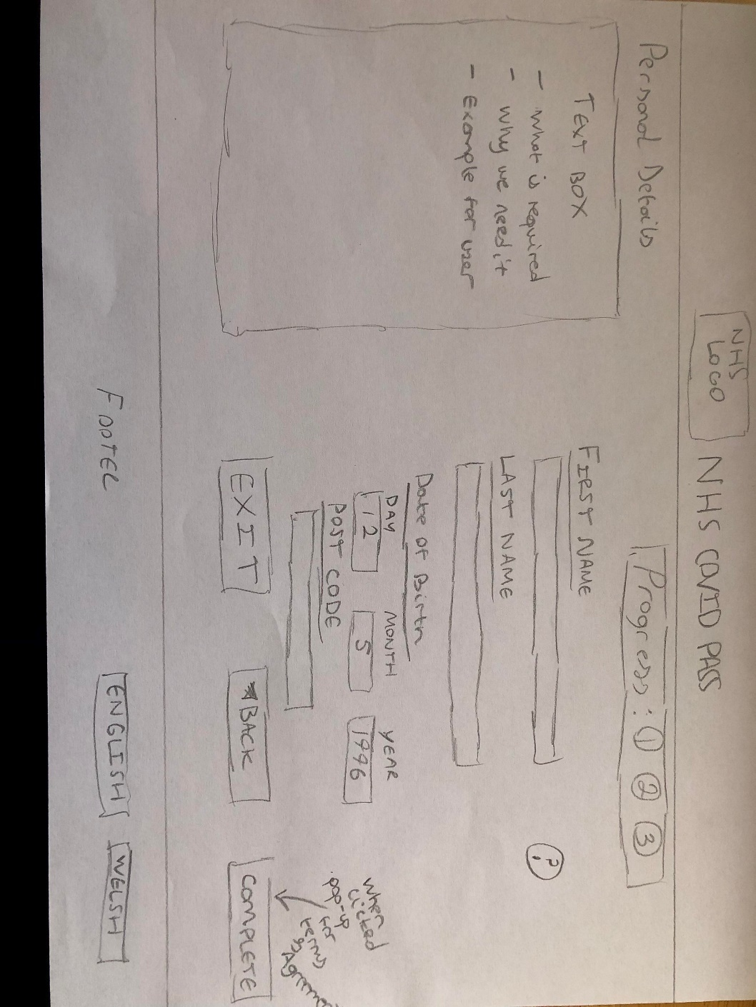

Login – Step 1
This is the first stage of the login process. Email and password entry fields are located in the middle with appropriate symbols.

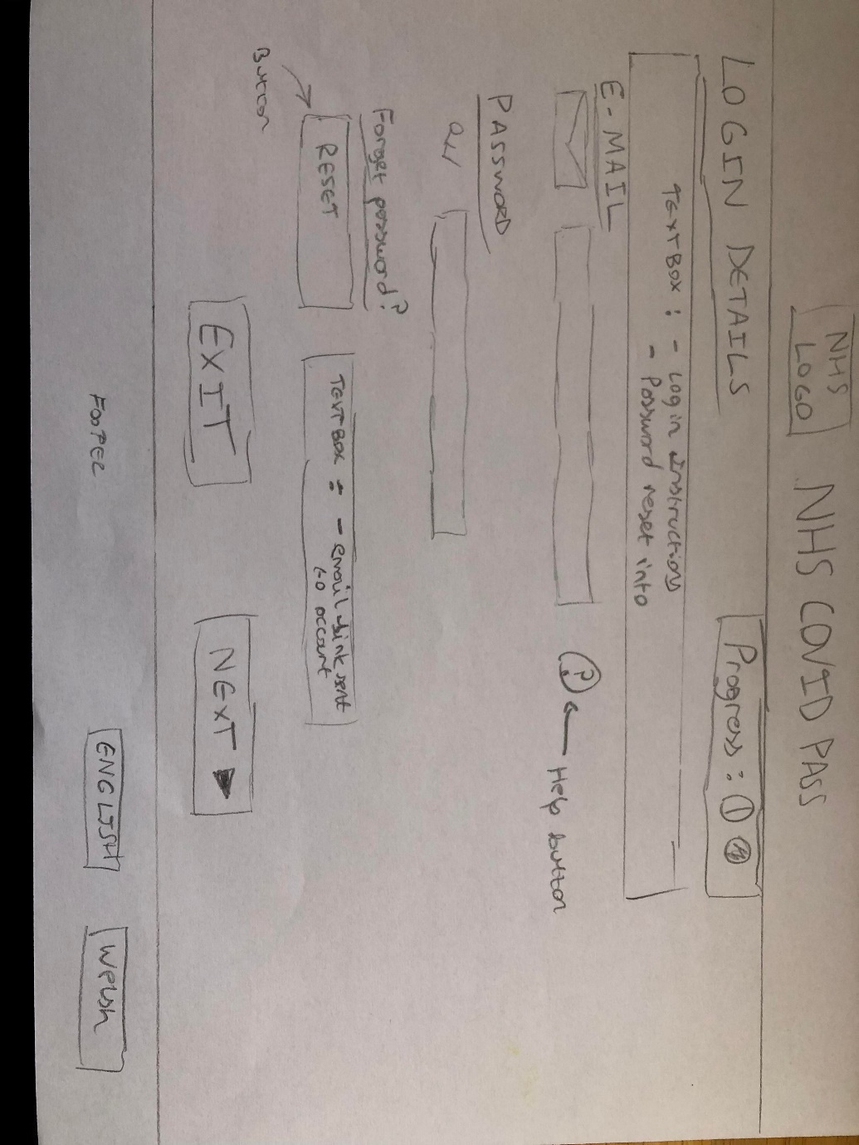

Login – Step 2
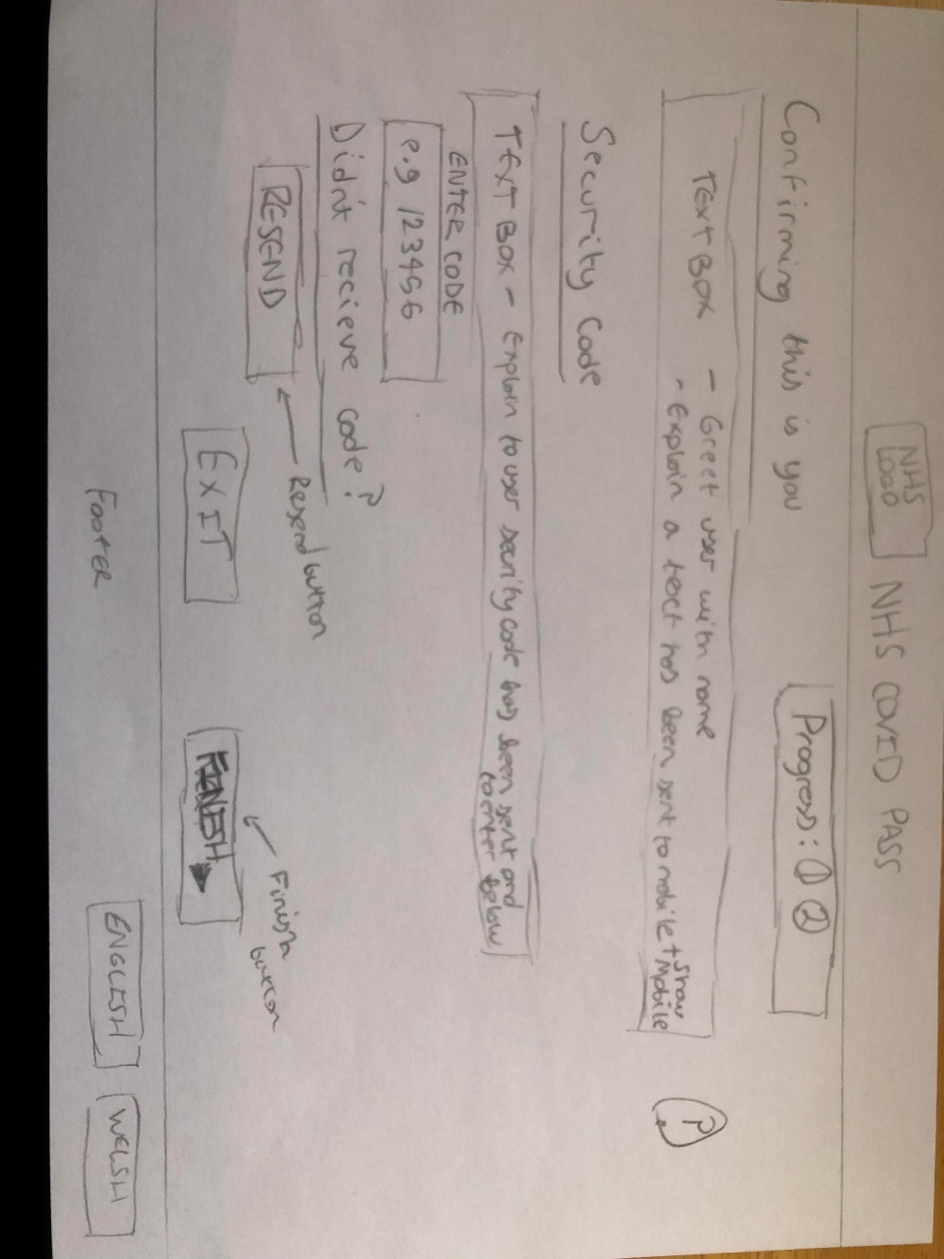
In the middle is another text box telling the user to locate the security code along with the entry field. Additionally, a resend button is available. Exit and finish button at the bottom for appropriate actions.

Pass access – Step 1
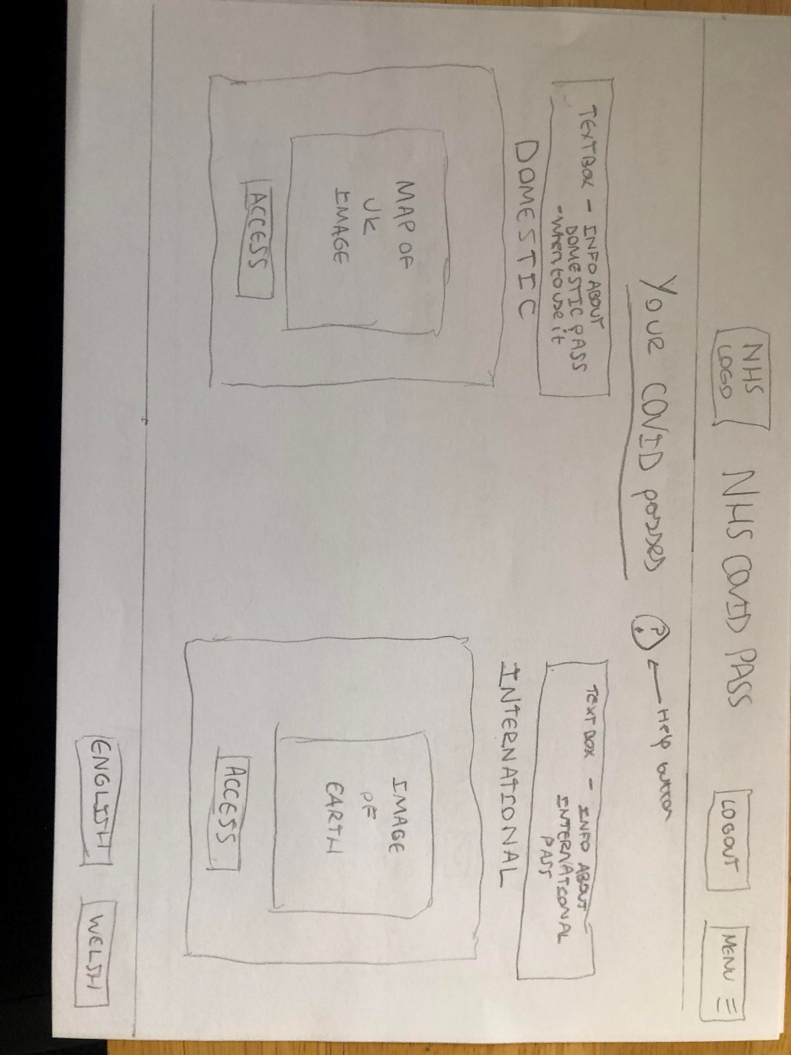
This is the pass access that is available after login and registration. The page has logout and menu features at the top.

Pass access – Step 2
Below is the final page of the processes. On the left is the details of the vaccination for the user and in the middle is the QR code. On the right is the download functions.
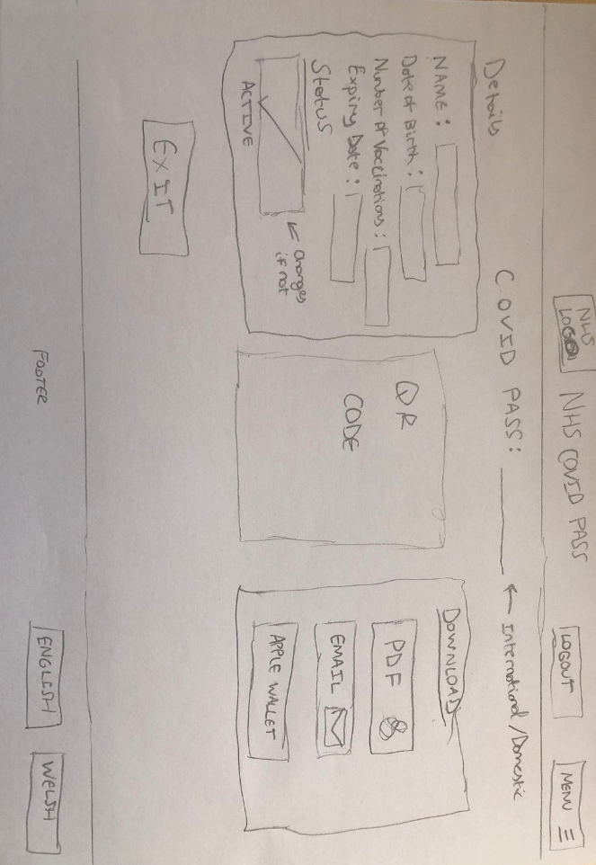

- Application of human factors
Below I will be detailing the human factors applied to the design. I will be covering:
- Gestalt’s principles of perception.
- Human memory
- Affordances
- Interface Metaphors

Gestalt’s principle of proximity
According to researchers, the law of proximity means items that are placed nearby appear to be in a group from the user’s perspective. This is important to inform users of specific actions or items within the design. For example, in my design, I grouped buttons relating to the downloading of the PDF together as shown below. [4]
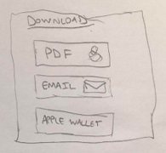

Gestalt’s principle of similarity
The principle of similarity is observed when items on the screen or typography are similar forming a perception of being seen as a whole. This principle is observed in relation to the text boxes on the screen in my design compared to the underlined titles. The user is drawn to the dissimilar title rather than the grouping of text making it easier to distinguish important items on the screen such as the heading.[4]
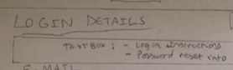
Dissimilar title compared to text

Gestalt’s principle of symmetry
The principle of symmetry is important for the user to quickly access information. If the symmetry on the screen is off the user will perceive it to be incomplete thus causing the user to try to figure out what needs to be corrected rather than quickly retaining the purpose of direction. Below shows symmetry in the design as shown by the obvious alignment pattern and not making the user work to figure out what is needed to be done. [4]
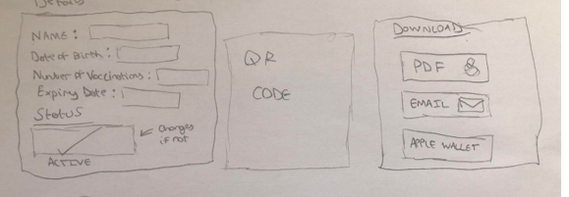

Gestalt’s principle of closure
The principle of closure is about open shapes causing users’ visual perceptions to view that shape or image to be imperfect. This is an issue as it serves as a form of disruption for the user as they will need to actively figure out via reasoning what is trying to be shown. Below is my design, I have used exclusively formed shapes to avoid any disruption to the user. [4]

Human memory
In the design, the user needs to use their short-term memory when entering the security six-digit security code from their text message. Long-term memory is used when accessing the account such as remembering their password.
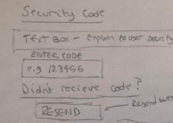
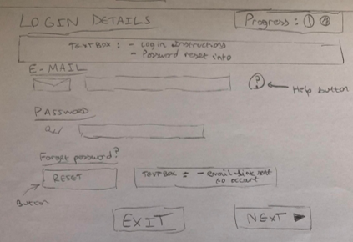
However, it is usually better for the user experience of the user to present them with the required information than to rely on the memory of the individual as it is quicker. This is one of Jakob Nielsen’s heuristic rules called ‘recognition rather than recall’. Additionally, it is one of Schneiderman’s rules called ‘reduce short-term memory load’.[5]
Affordances
Affordances are interaction possibilities for a user or actor in their environment which could be physical such as a mouse or keyboard. Additionally, it could be interacting with objects on the screen such as buttons or input fields located in the design. Norman suggests that clues are a part of affordances to guide the user on how to use them. For example, in my design, a user can perform actions on a variety of buttons or input fields and clues that are a part of those actions could be the descriptive text describing the action such as ‘exit’. [6]


Interface Metaphors
An interface metaphor is a way of presenting an object or symbol from the real world and using it in a computer interface such as using a bin to mean deletion. [7] This can help users understand the meaning of an action or process within the system with ease. In my design, I use the question mark symbol to guide users if they need help.
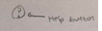

- Heuristic Evaluation – My design
To assess my design another student performed a heuristic evaluation to gauge the usability of the prototype. The prototype was assessed against Nielsen’s ten heuristics of user interface design found below.
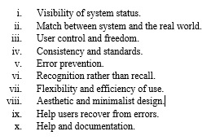

[8]

A copy of the evaluation can be found in Appendix A. Below I will be summarising the weaknesses and strengths of the design.
Issues with the visibility of the system were observed. Particularly the lack of error messages and feedback for users when completing processes. However, good visibility with the process due to the buttons for moving through the process as well as the progress bar highlighting the stages.
The system generally showed clarity throughout matching the real world. However, the overuse of text boxes on the login page needs to be fixed as well as renaming the button from finish to next as the process isn’t fully finished. The user control was also highlighted as an issue due to no way to return to the home page but overwise no problems.
The help and documentation, recognition rather than recall and consistency heuristics all scored perfectly with no need for improvement. However, error prevention and helping users recover needs to be improved as there is currently no facility within the design for these purposes. Aesthetic minimalism needs to be improved as overuse of similar text is used which is ruining the usability along.

- Heuristic Evaluation – Classmates Design
Below is the heuristic evaluation of a class member’s design using Nielsen’s [8]. The design can be viewed in Appendix B for reference. The evaluation uses a scale for each heuristic along with the reasoning. The scale can be found below:
1 = No usability issue
2 = Cosmetic problem only
3 = Minor usability problem low priority
4 = Major problem; high priority; fixing is recommended
5 = Unusable, must be fixed before release.

- Visibility of system status – 1

Reasoning

Excellent use of visibility. Steps are available for the user to highlight where they are in the process. Loads of feedback for users for errors and completion of tasks as well.

- Match between system and the real world – 2

Reasoning

Excellent choice using the flags to select the users’ language at the beginning. However, for the mobile entry field perhaps a selection of flags for country code would be more appropriate. The correct language is used throughout with no complex terminology relating to IT.

- User control and freedom – 5

Reasoning

Moving through the process is simple and also moving backwards with the buttons. However, you cannot exit the application clearly. You cannot clearly see an option to login into the system from the start, it looks like you have to go through registration again. Registration for COVID passes for international travel requires facial registration. However, perhaps for people staying in the UK this process of facial scanning is not required.

- Consistency and standards – 1

Reasoning

Highly consistent design no improvement can be made.

- Error prevention – 3

Reasoning

Excellent error messages. However, one issue is with the maximum file size error. It would be more appropriate to keep the user on the page rather making them redirect back and restart the process. Perhaps just using an alert would be better.

- Recognition rather than recall – 1

Reasoning

Actions are all clear as well as for instructions on how to do things. Appropriate use of chunking with security code to help with short-term memory.

- Flexibility and efficiency of use – 5

Reasoning

No way to exit the process. No way to access the login without entering a specific URL. Create a login button on the home page to resolve. No way to exit the process either during operation. Add in exit buttons.

- Aesthetic and minimalist design – 1

Reasoning

An excellent design that is consistent throughout an appropriate amount of text for the user and does not repeat. No improvement is possible.

- Help user recognise, diagnose and recover from errors – 3

Reasoning

My only complaint is that there is no way to reset the user password on the login screen. Otherwise, error messages are detailed and easy to understand.

- Help and documentation – 3

Reasoning

There are no help guides or buttons throughout the design. Even though the designs show clear instructions some users will encounter difficulty so adding in help sections somewhere on the screen would improve the design.

- Software prototype

Home page

Below is the home page which can be accessed throughout by clicking on the NHS logo. Two paths are available login and register. Language selection is found on the bottom with flags as suggested in the evaluation feedback.

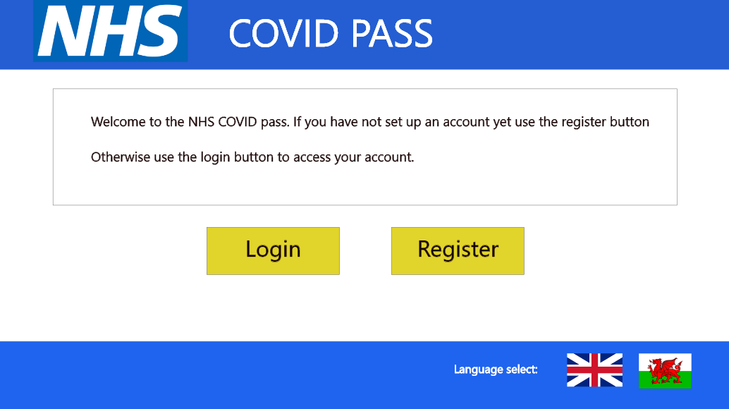

Loading page & Success Page

Below are the loading and success pages. Throughout the next stages, these pages are used after each stage when processing input and so will be described once here. Both pages inform the user of correct functionality and offer system visibility, feedback and error determination that the old system failed in the evaluation.

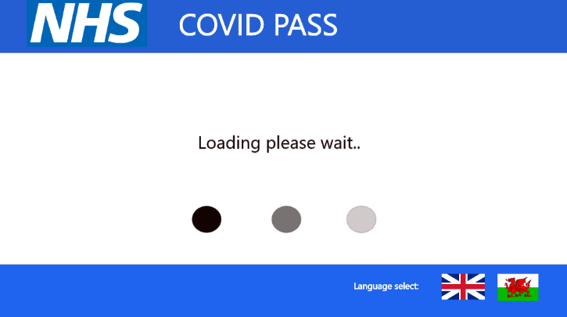
Registration – Step 1

Below is the account details stage of registration. Not much has changed from the paper prototype except the clarity of the text which was a minor error in the evaluation. Users can visualise the progress of registration at the top right and can exit or progress using the buttons.

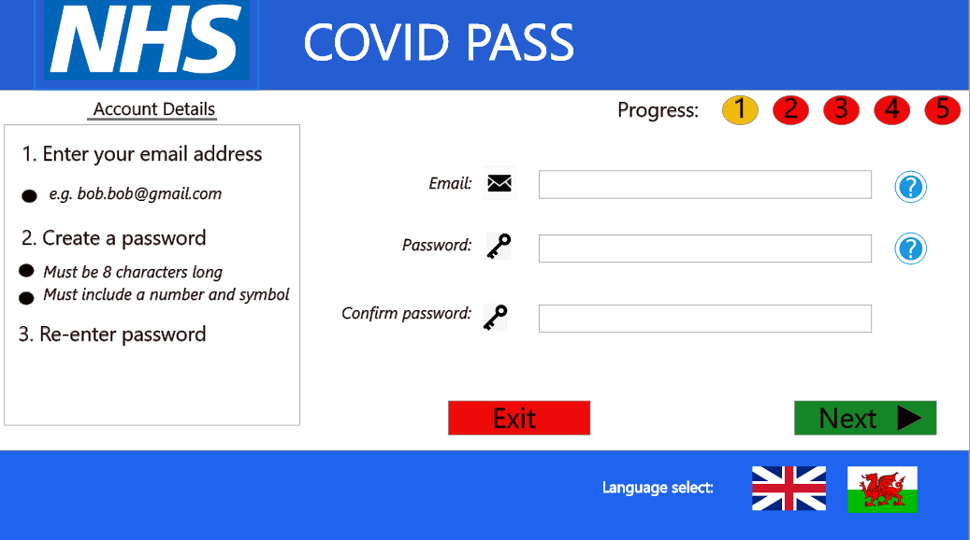

Registration – Step 1 error

Below is an error page for the account details page. This corrects the heuristics relating to errors found in the original design.
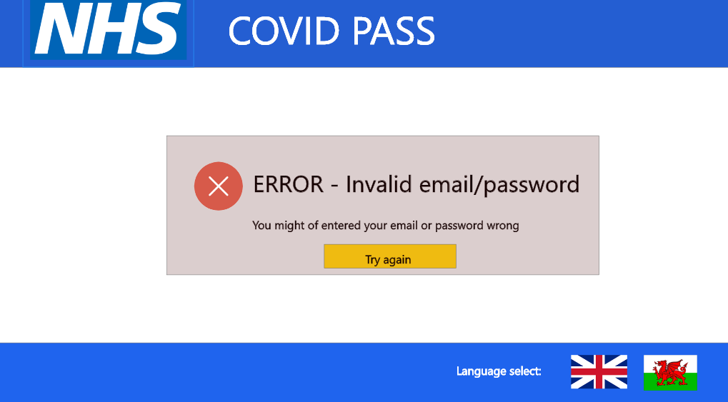

Registration – step 2
Below is the mobile details registration page. Nothing has been changed compared to the original design. The progress bar at the top changes colour to show user progress. Users can now move back if needed.
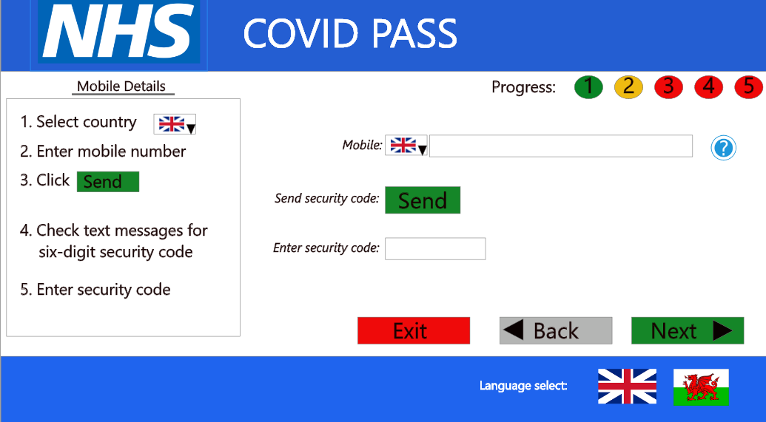

Registration – step 2 error
Error page for incorrect security code correcting the error heuristics. Users can retry if needed.
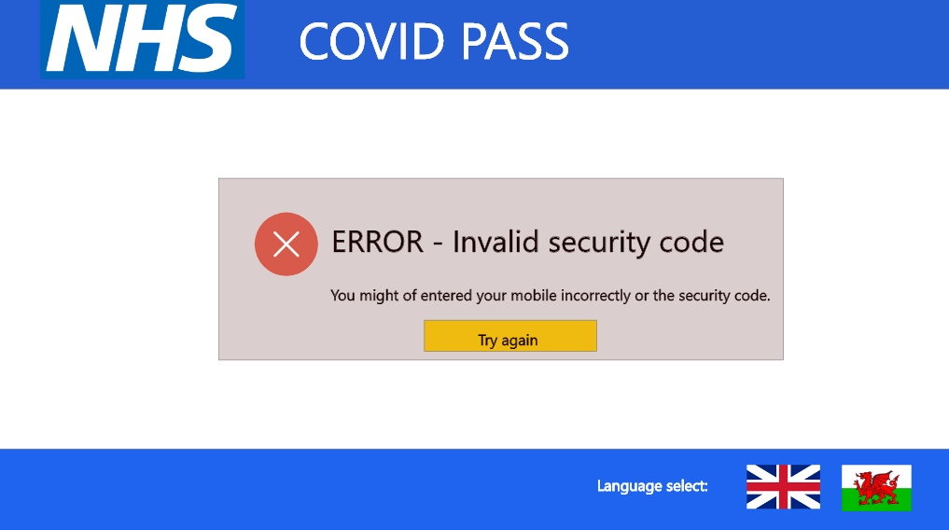

Registration – step 3
Stage 3 personal details. Changes have been made to the text reducing the amount to facilitate readability. The inclusion of the address line has been made as it was missed in the original research.
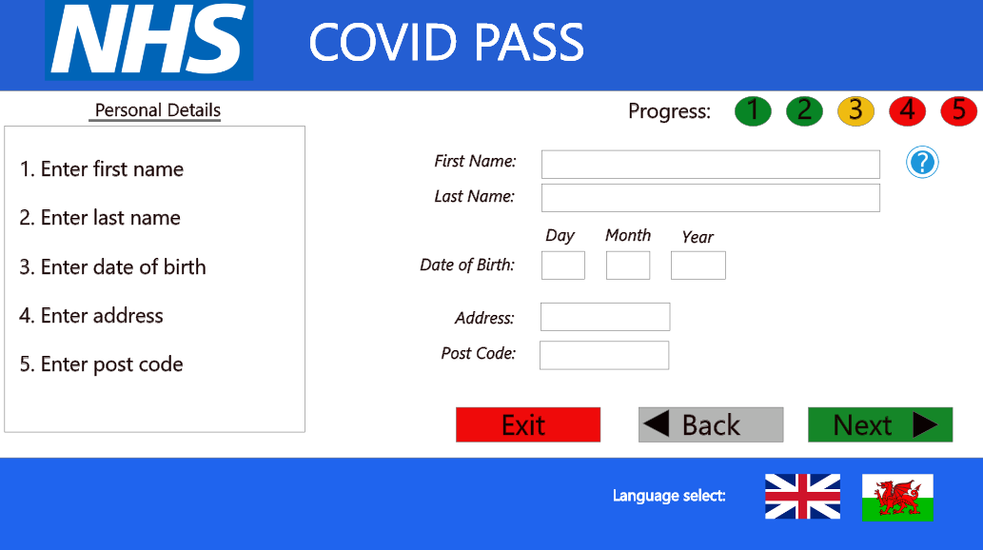

Registration – step 3 error
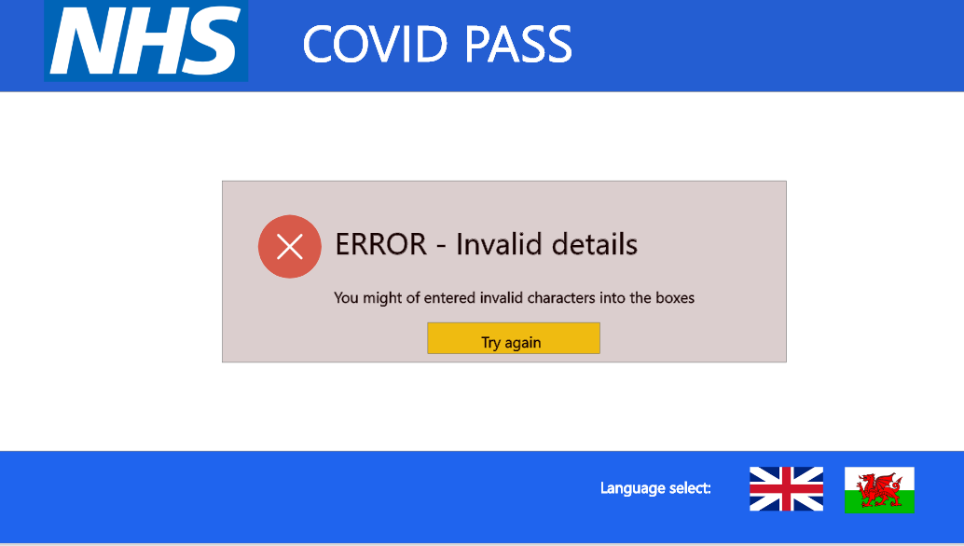

Registration – step 4
New page for uploading identification which was missed in the research. However, is now clear from observing this page on requirements.[7] New affordance is used by allowing the user the ability to drag a photo.
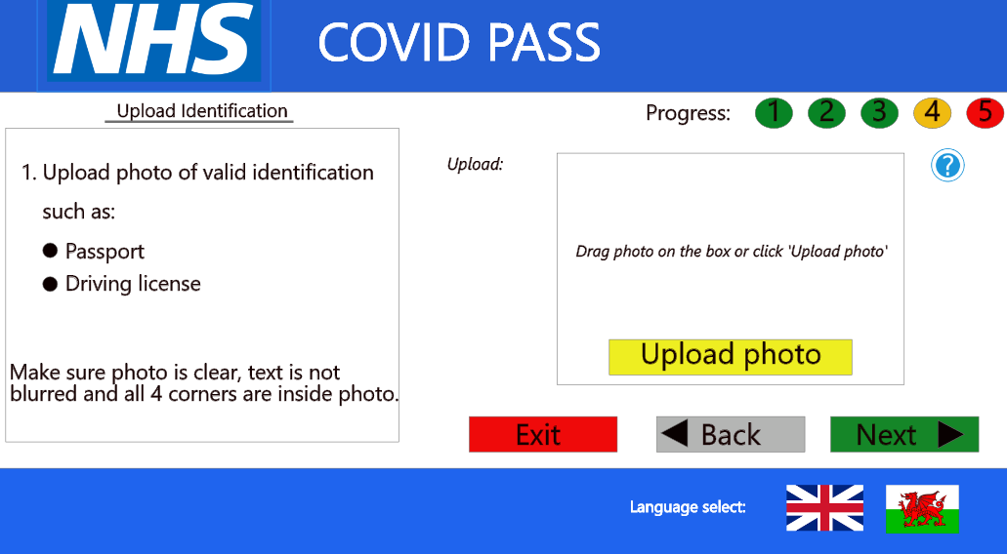

Registration – step 4 error
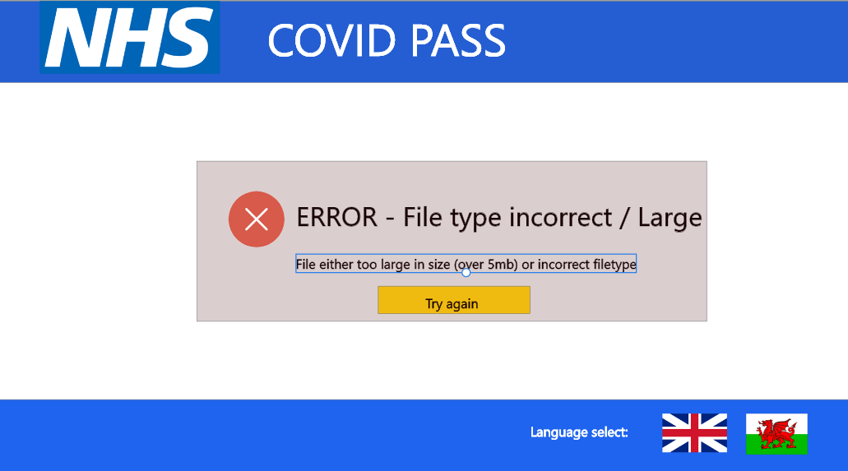

Registration – step 5
Another new stage compared to the original design. From this Welsh government page, it is clear now that facial scanning is needed as was not evident going through the government design.[7] A new affordance is used for the user as they need to position themselves with the design. When the scan is successful the user is automatically redirected to the covid pass page.
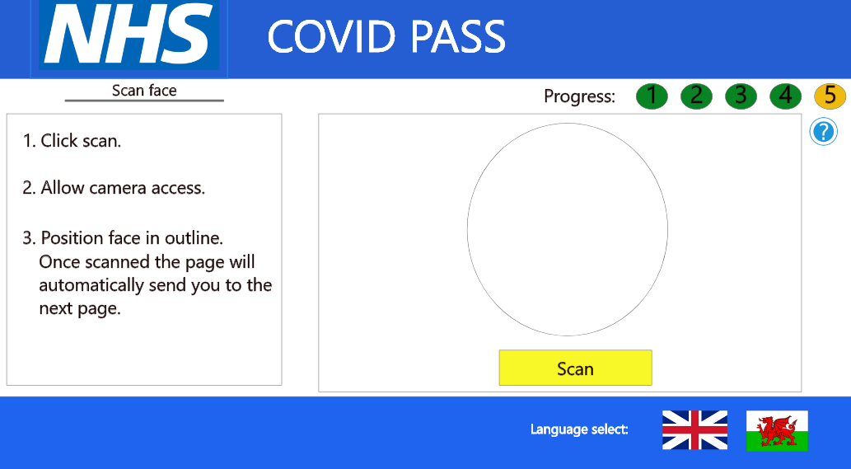
Registration – step 5 error
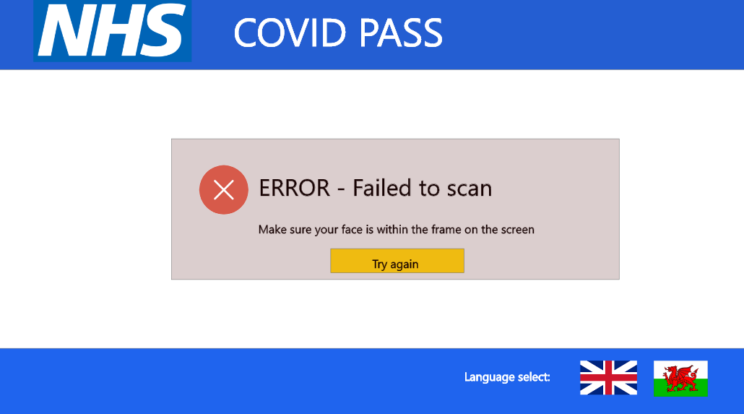

Login – step 1
This is the login details page where the user enters their email and password. Compared to the original the text box has been reduced to increase the aesthetic and minimalistic design. The box surrounding the reset password section has been removed to satisfy the issues in the evaluation.
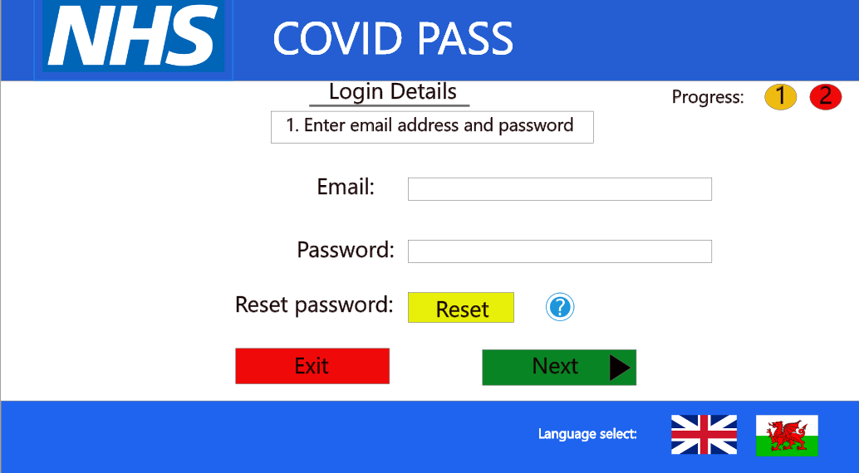

Login – step 2
This is the final stage of the login process. Compared to the original the text boxes have been reduced as per recommendations in the evaluation. Users can perform actions for navigating and sending security code again.
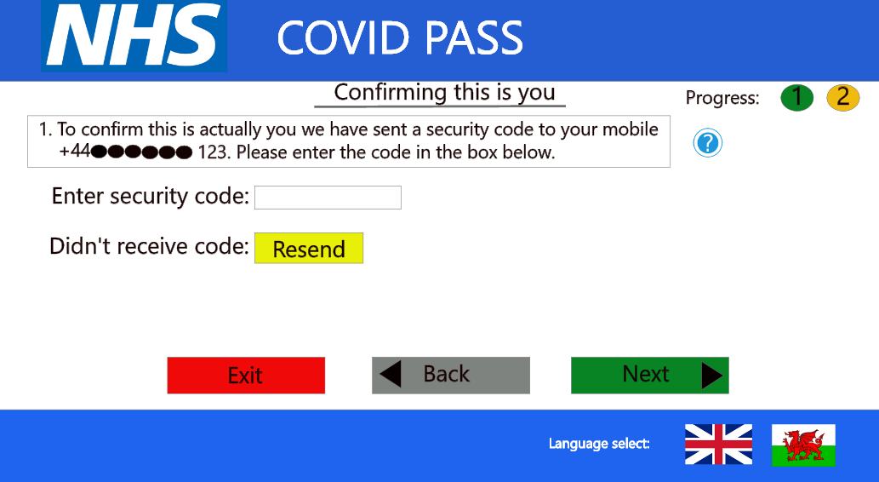

Login error 1
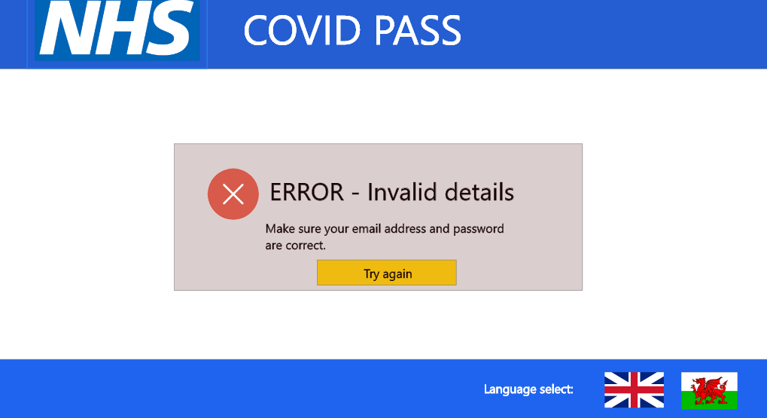
Login error 2
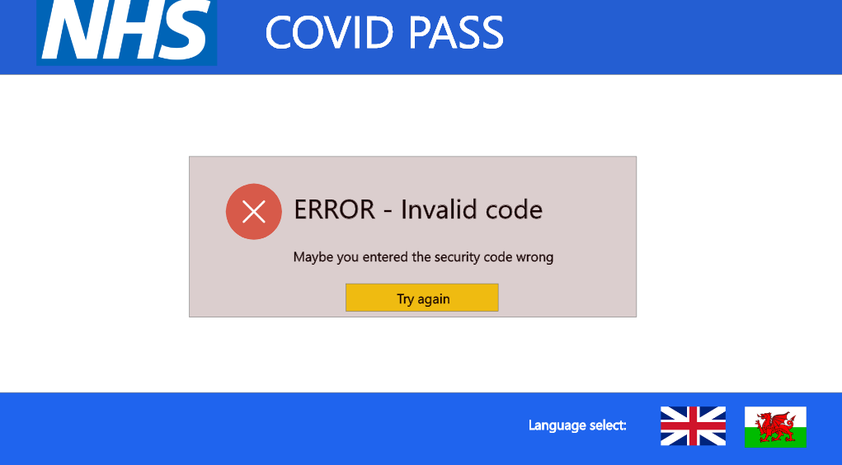

Covid pass
Below is the covid pass page. Users can log out, exit and download the pass. The design has removed apple pay and replaced It with SMS to facilitate better accessibility for users as per recommendation in the evaluation.
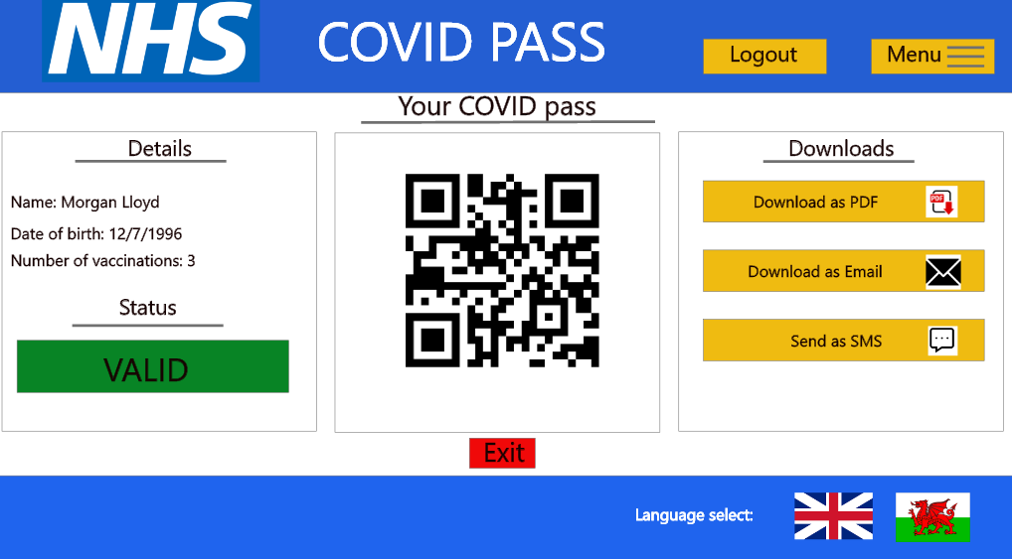

- Evaluation of Adobe XD
The selected tool for the prototyping of this design was Adobe XD. From using this tool it is clear it has advantages for producing accurate interfaces. One of these advantages is the way it displays the alignment of objects to allow you to accurately position with the correct spacing which allows you to quickly create symmetry quickly. The diagram below shows this positioning. Another advantage is the ability to select the correct display resolution for the intended device making the prototype scale realistic. The final benefit is that you can create components that allow you to reuse common items such as buttons speeding up development.
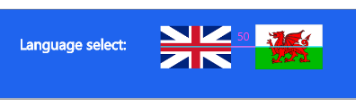
However, some disadvantages were experienced such as the lack of underline text options which forced me to use a line shape to create the same effect. Additionally, I found the cropping tool hard to use and locate as it is not obvious on the first try which slowed down the prototyping. Overall I think the tool is very effective for rapid prototyping due to the advantages stated earlier.

- Evaluation of techniques
Throughout the stages of the design, I have used multiple usability engineering techniques such as task analysis, human factors and walkthrough evaluations. The task analysis provided great insight into the requirements of the target audience of the pass and the issues they experienced using the old system. Using these insights led to a reduction in the task numbers condensing areas by combining steps such as email and password registration into one page. However, this technique did not result in the most useful changes in my design as it is difficult to encompass all aspects of usability using just task analysis.
Human factors was another technique used. Factors such as Gestalt’s rules of perception, affordances and interface metaphors were applied in the design. I think they certainly improved the design by reducing the memory load on the users and relying on recognition rather than recall. Additionally, it allowed the design to be more minimalistic by reducing the text needed.
The walkthrough provided the greatest benefit to my design. Areas such as error prevention and feedback were missed in my first paper prototype which would have been missed without the evaluative walkthrough. My system also improved as the walkthrough feedback showed I missed vital stages such as face scanning and document uploading sections. Further refinement was done on certain pages removing unnecessary text boxes as shown below. Overall, the walkthrough technique caught the most design flaws and provided greater feedback and updates for the final design.
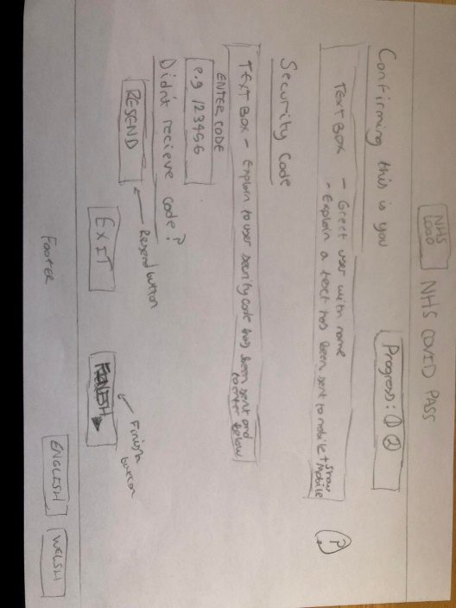

References
- NHS COVID Pass - NHS [Internet]. covid-status.service.nhsx.nhs.uk. [cited 2022 Mar 25]. Available from: https://covid-status.service.nhsx.nhs.uk

- Maguire M, Bevan N. User Requirements Analysis. IFIP Advances in Information and Communication Technology. 2002;133–48

- Get your NHS COVID Pass [Internet]. GOV.WALES. [cited 2022 March 25]. Available from: https://gov.wales/get-your-nhs-covid-pass

- Smith-Gratto K, Fisher MM. Gestalt Theory: A Foundation for Instructional Screen Design. Journal of Educational Technology Systems. 1999 Jun;27(4):361–71.

- Designing for fun | ACM Interactions [Internet]. interactions.acm.org. [cited 2022 March 25] Available from: https://interactions.acm.org/archive/view/september-october-2004/designing-for-fun1

- Mcgrenere J, Ho W. Affordances: Clarifying and Evolving a Concept [Internet].[cited 2022 March 25] Available from: http://graphicsinterface.org/wp-content/uploads/gi2000-24.pdf

- Barr P, Biddle R, Noble J. A taxonomy of user-interface metaphors. Proceedings of the SIGCHI-NZ Symposium on Computer-Human Interaction - CHINZ ’02. 2002;

- Nielsen J. Heuristic Evaluation Ten Usability Heuristics [Internet]. Available from: https://pdfs.semanticscholar.org/5f03/b251093aee730ab9772db2e1a8a7eb8522cb.pdf

Appendix A
The severity of usability issues is determined using the following 0 to 4 rating scale. Please give each heuristic a rating and a reason for your choice.
1 = This is not a usability issue
2 = Cosmetic problem only: only fix if more time is given
3 = Minor usability problem: low priority issue
4 = Major usability problem: high priority issue, fixing it is critical
5 = Usability catastrophe: this must be fixed before the product can be launched

- Visibility of system status: 4

- Reasoning for rating: However, there is not much feedback given throughout the whole process, there is no error pages or success pages to make the user aware if their details have gone through correctly, especially once the complete button is clicked, do they go straight into the logging in process or do they have to wait for their details to be confirmed?

- Match between system and the real world: 4

- Reasoning for rating: Familiar words and phrases have been used with no jargon. However, there is a slight confusion with the login page, why has an email link been sent to the account, what is the purpose of this? As it has the next button to be able to move on. Also, on the progress 2 login page, why is there 2 text boxes saying the same thing about a message sent to them? Is there any need for the first text box to say this? One last thing, again with the progress 2 login page, shouldn't the finish button be the next button to take them onto the Covid pass?

- User control and freedom: 3

- Reasoning for rating: There is no way to get back to the home/start page if needed.

- Consistency and standards: 1

- Reasoning for rating: The system is fairly simple to go through and is consistent throughout the whole process.

- error prevention: 5

- Reasoning for rating: There are no error message screens throughout the design.

- Recognition rather than recall: 1

- Reasoning for rating: It doesn't require the user to remember information from one part of the interface to the next which is a good thing. The steps on what the user has to do are clear also.

- Flexibility and efficiency of use: 2

- Reasoning for rating: The only thing missing which has already been mentioned above is a way to get to the home page. Other than that, the system seems to be flexible.

- Aesthetic and minimalist design: 4

- Reasoning for rating: As mentioned previously, on the progress 2 login page, there are 2 text boxes saying the same thing about a message sent to them? Is there any need for the first text box to say this? This seems irrelevant. Also, to download the Covid pass, there is an option for 'apple wallet' but a lot of people don't have this so again this seems irrelevant as only a minority would be able to use that option. You could change that to an SMS message instead. Both the domestic and travel pass prove that the person has been vaccinated and both last the same number of days so don't see the need in having two of them, it just requires more clicking in and out for the user. Why not just have the one Covid pass that covers everything. But that is my opinion and not a priority.

- Help users recognize, diagnose, and recover from errors: 5

- Reasoning for rating: There are no error message screens throughout the design as mentioned above, displaying no way for the user to recognise, diagnose and recover from an error.

- Help and documentation: 1

- Reasoning for rating: Plenty of help and documentation has been provided throughout the entire process.

- Any recommendations? Add a home button or the logo to take the user home.
You have a postcode field for the user to fill in but no address field, surely the system would need to know the users address too?
You are also missing a field for the user to input their NHS number which is needed to collect their vaccination records for the Covid pass as well as a photo upload and face scan for identification to prove that it is that person.

Appendix B



