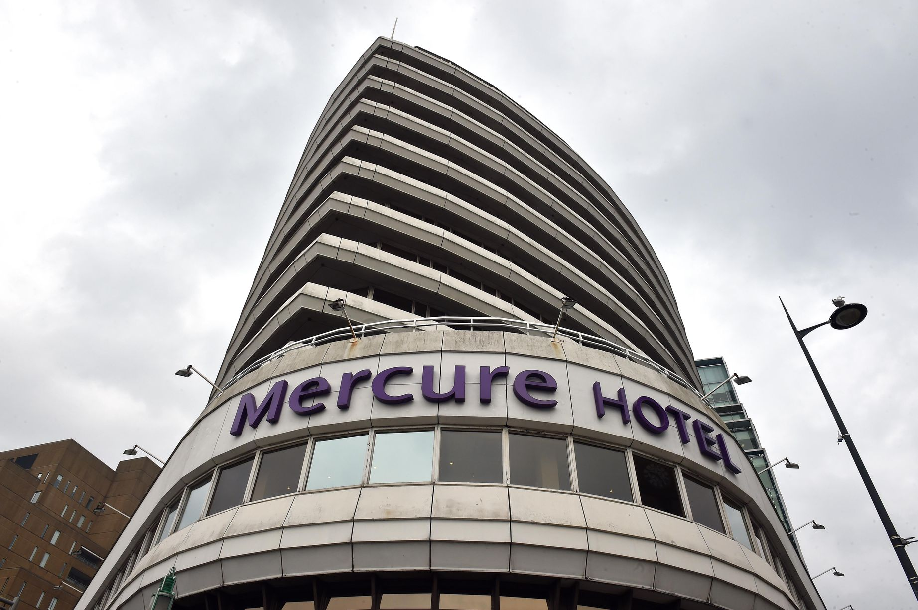  Student Learning Log  Front Office | Alexandra Boata, 2014200  Managing Hotel Administration, BMIH6004  Lecturer’s: Dr Jayne Griffith-Parry, Robyn Griffiths

Contents

Personal and Vocational development 2
Operational Tasks 2
Department software systems 4
Review 5
Organisational Issues 5
Conclusion 6
References 7

Personal and Vocational development

The goals of this log are to provide a brief overview of the Front Office Department's responsibilities and its primary operations at the Mercure hotel.
The Mercure Atlantic Tower hotel was assigned by the university to complete my internship. The hotel is located in Liverpool, surrounded by beautiful views which are represented by the river and the royal Liver building. The hotel is structured on 12 levels and is offering to their guests 225 rooms (Mercure, 2023).
The rooms are divided into privileged, twin rooms, and double rooms with a rate between £56-£117 per night.
The placement at Mercure Atlantic Tower hotel in Liverpool offers me the possibility to undertake the role of a supervisor within the organisation, this offers me the opportunity to learn and develop new skills within the hospitality industry. I enjoy my self being able to observe the issues that may occur in the hotel and in the meantime to make think of a solution to come up with ideas about how the business can run successfully (Baum, 2002).
Thru the months spent and departments allocated I can say that I receive this as a chance to reflect on my decisions about which department will fit me to work after I will graduate. The answer is simple, I enjoy working with the guests and dealing with their preferences therefore this is the reason that the department in which I would like to work in the future is the front office (Cord and Clements,2010).
The placement has been set for 16 hours per week for ten weeks, and I can state that over this period I managed to complete the gaps that existed before the beginning of the internship.

Operational Tasks

Opted to start with the front office, where I spent four weeks. I was interested in starting with this department because I wanted to understand exactly how the operations are working concerning their guests as well as to learn the functionality of the Opera system. In my opinion, it is crucial to first understand how the services are sold and promoted to the guests for them to book a room or an event in the hotel.
This is the primary section of the hotel where guests encounter it for the initial time. A front office department's key tasks are to manage reservations, registration, check-in, check-out, bill settlement, overnight monitoring, managing guest records, keeping the front office data, organizing quality service, and level of satisfaction (Jawabreth et al, 2022).
The front desk's major function is to get guests into accommodations quickly, professionally, and correctly. Registering guests requires processing unique bookings, allocating the appropriate rooms while maintaining room requests, and getting the payment method (Front Office, 2023).
Because the Reception Department of Mercure Hotel is open 24 hours a day, it is separated into three teams, each team has a shift set for eight hours per day.
For the task to be completed efficiently and effectively, there must be a flow of information between each schedule and the personnel in each sector.
As guests are checking in and out of the hotel, as well as when they are staying there, the Reception Department should be able to provide them with fast and welcoming services, which I noticed that sometimes, especially during the weekend when is the busiest time, the queue is long and the guests are getting upset because they need to wait too long to be checked-in, this issues is creating basically because of the short staff or probably the incorrect rota which is created every month.
One way of dealing with the issue is to establish a suitable strategy for hotel occupancy and to begin looking for recruitment to provide quality services to their guests ( Jolly, Self and Gordon, 2020). However, Van de Wagen and Goonetilleke, (2015), think that training and briefings might be customized to provide an additional benefit to the front office crew to be prepared to assist a large number of visitors when they are checking in or out.
Another recommendation would be to establish a digital platform at the front office that would allow guests to check in and out using detection and recognition, which would assist to accelerate the procedure and boost guest engagement (Xu et al, 2021).
As the hotel uses a digital platform, every operation to change rooms results in a revision and may take time to adjust. If a room is ready to be offered to clients (Empty Cleaning) or not, the Reception Department can provide correct information about that condition as soon they are checking the Opera system, but in case the self-check-in and out will be implemented this will aim to speed up the process for the reception team and therefore for their guests ( Oh, Jeong and Baloglu, 2013).
James, the supervisor that offered me the training in reception, said that is important always to register all the guests' concerns or even employees in the Log sheets, where the manager can see and assess the problem.
For example, the Logbook may contain information about a guest that is required to have a taxi at a certain hour in the morning, or in case of a disabled guest that requests assistants while checking out the next day. But could also include information about employees that are calling in sick and are missing from work (Cuic, Bilic and Brajkovic, 2022).
One of the key duties of the reception section is to welcome visitors or handle check-ins. This department assists with registration, and they can proceed to their rooms (Mondal, 2023).

Department software systems

Opera is the platform used by the hotel for guests registrations. At first impression, it appears complicated and hard to understand, but I was impressed to see how quickly I learned to complete the check-in, which is more difficult than the check-out, where the guests just throw the room keys.
James was really helpful and well-prepared to assist me in understanding every aspect of the reception.
Surprisingly, arranging a stay through websites like Booking.com, Expedia, Hotels4U, and Thomas Cook is even cheaper than calling or emailing the hotel directly. If a guest wants to book a room directly from the front desk, the receptionist will use Resawed to provide the guest with information about the costs, rooms available, and options.

Review

During these weeks spent at the hotel, I felt that I was part of the Mercure team. Nicola Boniface the manager who guided me all this time, appointed James as the receptionist to offer me the training and the wonderful experience spent in the front office.
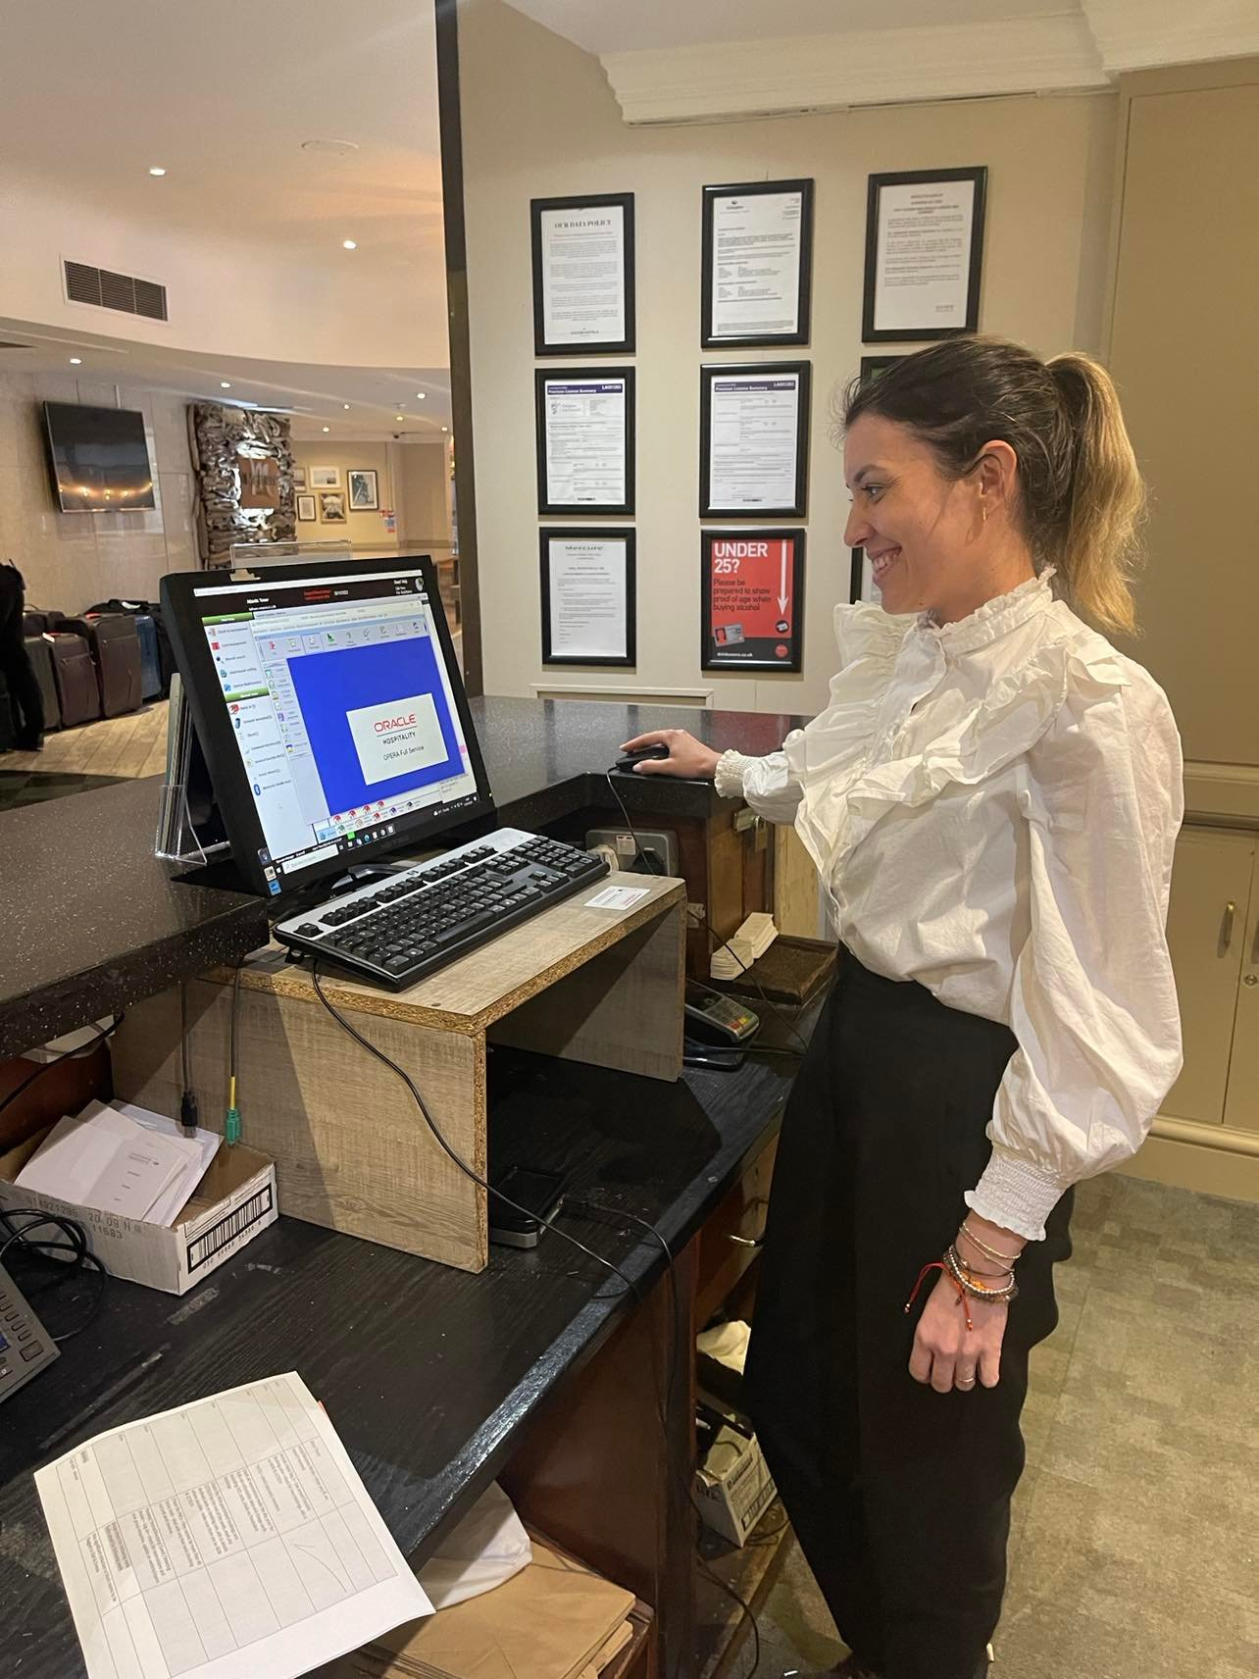
(self-creation)

Organisational Issues

Technical issues are the most common and are generated by hotel amenities or equipment that is not operating correctly, for example, a malfunctioning heating system, a lightbulb issue, or TVs.
The guests are complaining about these problems always, in my opinion, these issues could be avoided if the housekeeping will check the rooms before placing them as inspected, therefore if they will notice that something goes wrong or is not working let the maintenance team know as soon as possible to be able to fix in time before the guest's arrival.
Noticed that on Sundays when the hotel is busy, the maintenance team are not working, therefore if a complaint comes to the front office, the receptionist will need to deal with this and fix the problem. In this case, the receptionist is offering to the guest to move the room, by upgrading it and this is affecting the profitability of the hotel because the guest is not paying anything extra for it. In my opinion, as I mentioned to the front office team is necessary to have a person responsible for the maintenance even during the weekend time.

Conclusion

Being a member of the front office staff, I was able to see the true issues that management and employees may face with their guests. It has been a delight to be surrounded by all of the personnel who have provided me with all of the knowledge I needed to reach my objective of becoming confident, ready to assist in any scenario, and adaptable in comprehending the demands of the guests.

References

Baum, T., (2002) ‘Skills and training for the hospitality sector: a review of issues’, Journal of vocational education & training, 54(3), pp. 343–364.
CORD, B. and CLEMENTS, M., (2010) Pathway for student self-development: A learning orientated internship approach. Australian Journal of Adult Learning, 50(2), pp. 287-307.
Čuić Tanković, A., Bilić, I. and Brajković, I. (2022) ‘Internal communication and employee satisfaction in hospitality’, Management, 27(1), pp. 1–16. Available at: https://doi.org/10.30924/mjcmi.27.1.1.
Front Office Department, (2023) Front Office Department Introduction, Operations and Functions. Available at: https://setupmyhotel.com/train-my-hotel-staff/front-office-training/743-front-office-introduction-operations-functions.html (Accessed: March 5, 2023).
JAWABREH, O., MASA'DEH, R., AL FAYOUMI, T. and BAREYA, A., 2022. CUSTOMER SATISFACTION TOWARDS COMMUNICATION SKILLS OF FRONT OFFICE STAFF AT THE HOTEL (CASE STUDY FIVE STARS HOTELS IN AQABA). Geo Journal of Tourism and Geosites, 44(4), pp. 1312-1318.
Jolly, P.M., Self, T.T. and Gordon, S.E. (2020) ‘Attracting hospitality recruits: the benefit of benefits’, Journal of human resources in hospitality & tourism, 19(1), pp. 1–22. Available at: https://doi.org/10.1080/15332845.2020.1672243.
Mercure Liverpool Atlantic Tower Hotel, (2023) all.accor.com. Available at: https://all.accor.com/hotel (Accessed: March 5, 2023).
Mondal, B.D., (2023) Hotel Front Office Department: Importance, functions, duties, Hotel Management Tips. Available at: https://www.hotelmanagementtips.com/hotel-front-office-department/ (Accessed: March 4, 2023).
Oh, H., Jeong, M. and Baloglu, S. (2013) ‘Tourists’ adoption of self-service technologies at resort hotels’, Journal of business research, 66(6), pp. 692–699. Available at: https://doi.org/10.1016/j.jbusres.2011.09.005.
Van der Wagen, L. and Goonetilleke, A. (2015) Hospitality Management, Strategy and Operations. Pearson Australia: Australia
Xu, F.Z., Zhang, Y., Zhang, T., Wang, J., (2021) ‘Facial recognition check-in services at hotels’, Journal of hospitality marketing & management, 30(3), pp. 373–393. Available at: https://doi.org/10.1080/19368623.2020.1813670.

