Title Page:

Matthew Coleman (2306158)

Higher National Diploma:Computing (Software Engineering)

L4 - Computer Architecture and Operating Systems (ACCA4022)

Table of Contents - 1
Introduction - 2

Key functionality of operating systems. 2-6
-Functionality in windows. 2-4
-Functionality in Linux Ubuntu. 5-6

Use of Commands. 7-24
-Windows Powershell commands. 7-15
-Linux Bash CLI commands. 16-24

Scripting. 25-30
-Windows scripting. 25-27
-Linux scripting. 28-30

Conclusion. 30

References. 31-33

Introduction.
Operating systems are a cornerstone of modern technology and how Firmware and software interact with one another. I have been asked to make a paper to explore this further and to become more familiar with the subject matter. I will primarily be looking at Windows and Linux ubuntu in this paper.

Key functions of general operating systems.

What is a general purpose operating system and what function does it perform.[1]”An Operating System acts as a communication bridge (interface) between the user and computer hardware.” This allows for the User to be able to interact with the device's physical hardware through its GUI or command line and make use of these resources when they run other programs on the system. The main functionality of a operating system is to [2] “handles the launch and management of every application” this is usually in the form of time sharing/scheduling the CPU. [3]which can be done in many ways some examples are round robin, first come first serve, priority scheduling and there are many other ways to go about this.

Functionality in windows.

[4]Windows is one of the most popular operating systems in the world so I will show you some of its core functionality. [5] the examples that i will be showing for windows are 1.“Start menu”, 2.“File explorer”, 3.“Task manager”, 4.“Taskbar”

- [5]The screenshot below is of the “Start menu” GUI the purpose of which is to help the user get to their most frequently used and pinned application for quick access.
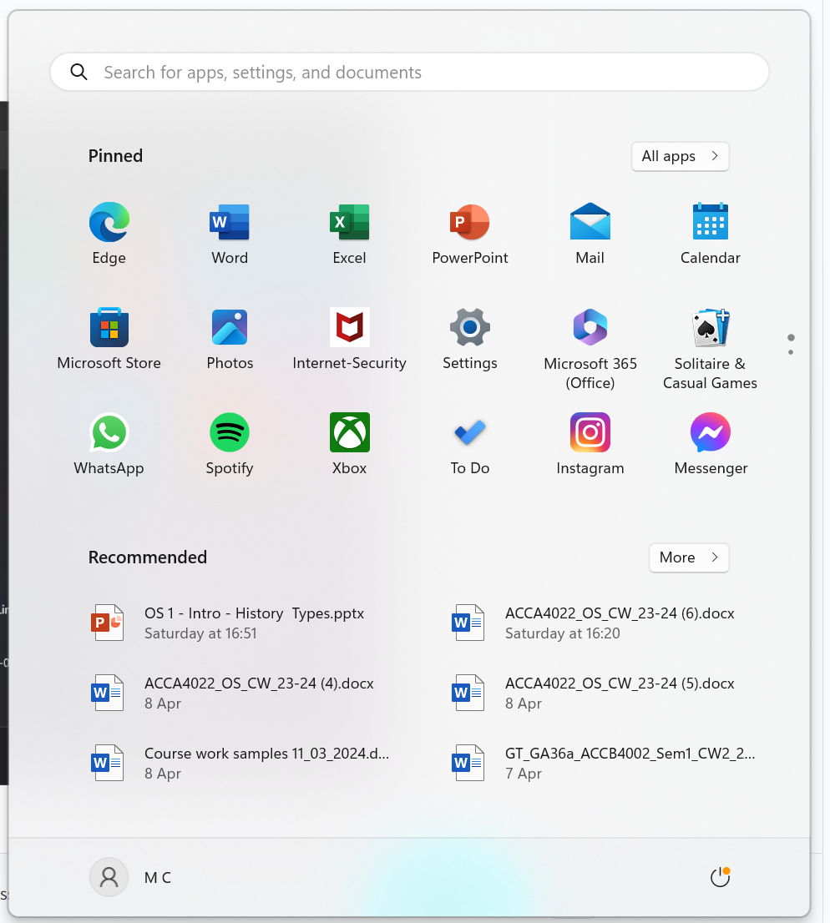[6]

- [5]The screenshot below is of the “File explorer”. This is a GUI implementation to make it easier for the user to search for files on a device if they are unfamiliar with the command line.
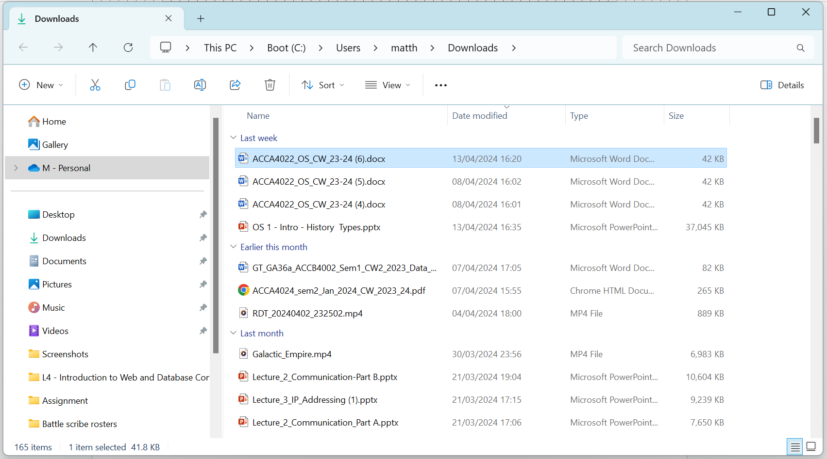[6]

- [5]The screenshot below is for the “Task manager”. This is another GUI to show the user what applications are currently running on their device and also how many resources each one is currently using.
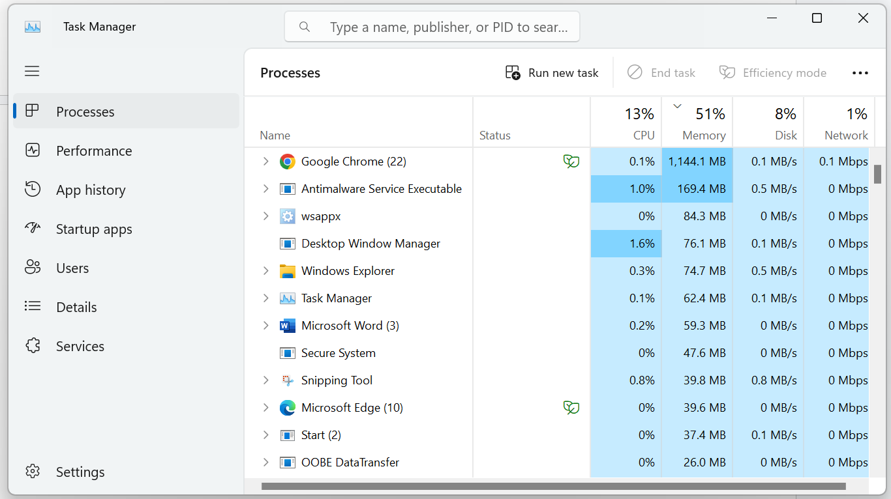[6]

- [5]The screenshot below is for the “Taskbar” This is one of the main components that make up the windows GUI as it allows the user to quickly navigate between specific currently running or pinned applications.
[6]

Functionality in linux.

[7]Outside of personal use linux dominates the OS market when it comes to managing network infrastructure such as servers and databases, [8] primarily for its security and reliability. We will be looking at Ubuntu’s(a version of linux) functionality 1. “Cisco’s home” 2. “Terminal” 3. “Panel”

- The screenshot below is for “Cisco’s home” which functions as a GUI display of a device's files rather than just using the command line(Terminal). Primarily for users who are more familiar with windows systems.
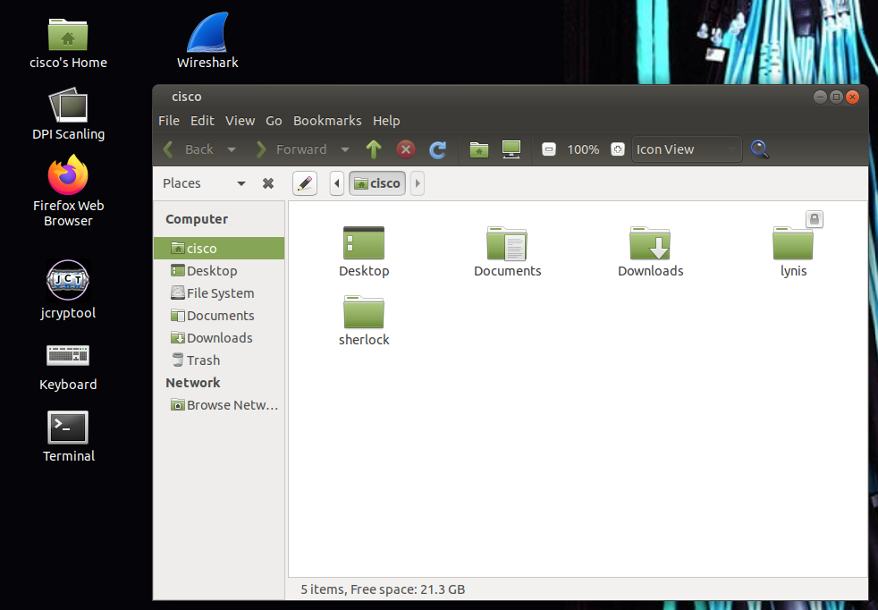[6]

- The screenshot below is for the “Terminal”. This is a non GUI way for the user to interact with the device through commands entered into it. Some prefer it due to less graphical noises and resources required to display it.
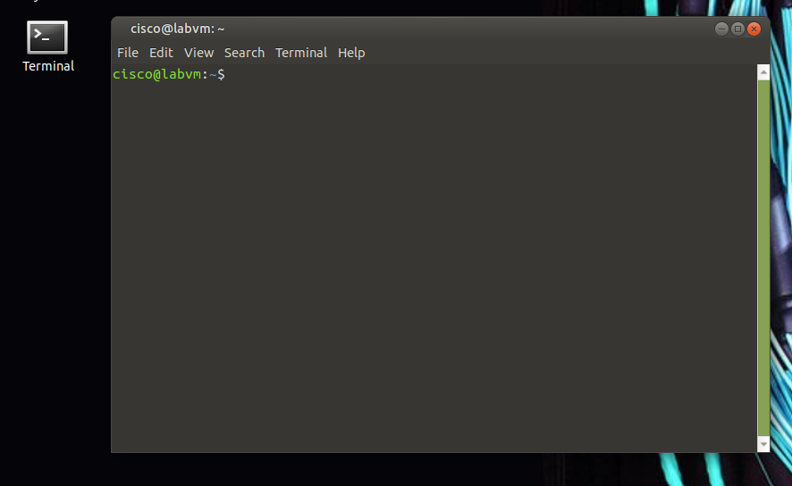
[6]

- The screenshot below is for the “Panel”. It function in a very similar way to the “Taskbar” in windows as it is there to provide a intuitive GUI for the user to quickly navigate through running applications.
[6]

Windows Powershell commands.
What is windows powershell and CLI/command line, [9] “PowerShell is a cross-platform task automation solution made up of a command-line shell”. Its purpose is to standardize CLI commands across the OS ecosystem as it works with the most commonly used desktop OS [10] being Windows, Linux and MacOS.
As for what a CLI/command line is, it's [11]”a software mechanism you use to interact with your operating system using your keyboard.”. This is opposed to a GUI [12]”interfaces typically feature visual elements like buttons and menus, rather than just text fields.”.
An added benefit of using command line is it can be used [13]”to automate processes that require repetitions.”, this allows the user to streamline their work as well as remove human error between those repetitions.
Now lets looks at some of the basic commands you will need to get familiar with when using Powershell.[14] 1.”Get-Command”, 2.”Get-Help”, 3.”Set-ExecutionPolicy”, 4.”Get-Service”, 5.”ConvertTo-HTML”, 6.”Get-EventLog”, 7.”Get-Process”, 8.”Clear-History“, 9.”Format-Table“, 10.”Format-List”.
- [14]“Get-Command” will bring up the library of Commands available for you to use.[6]
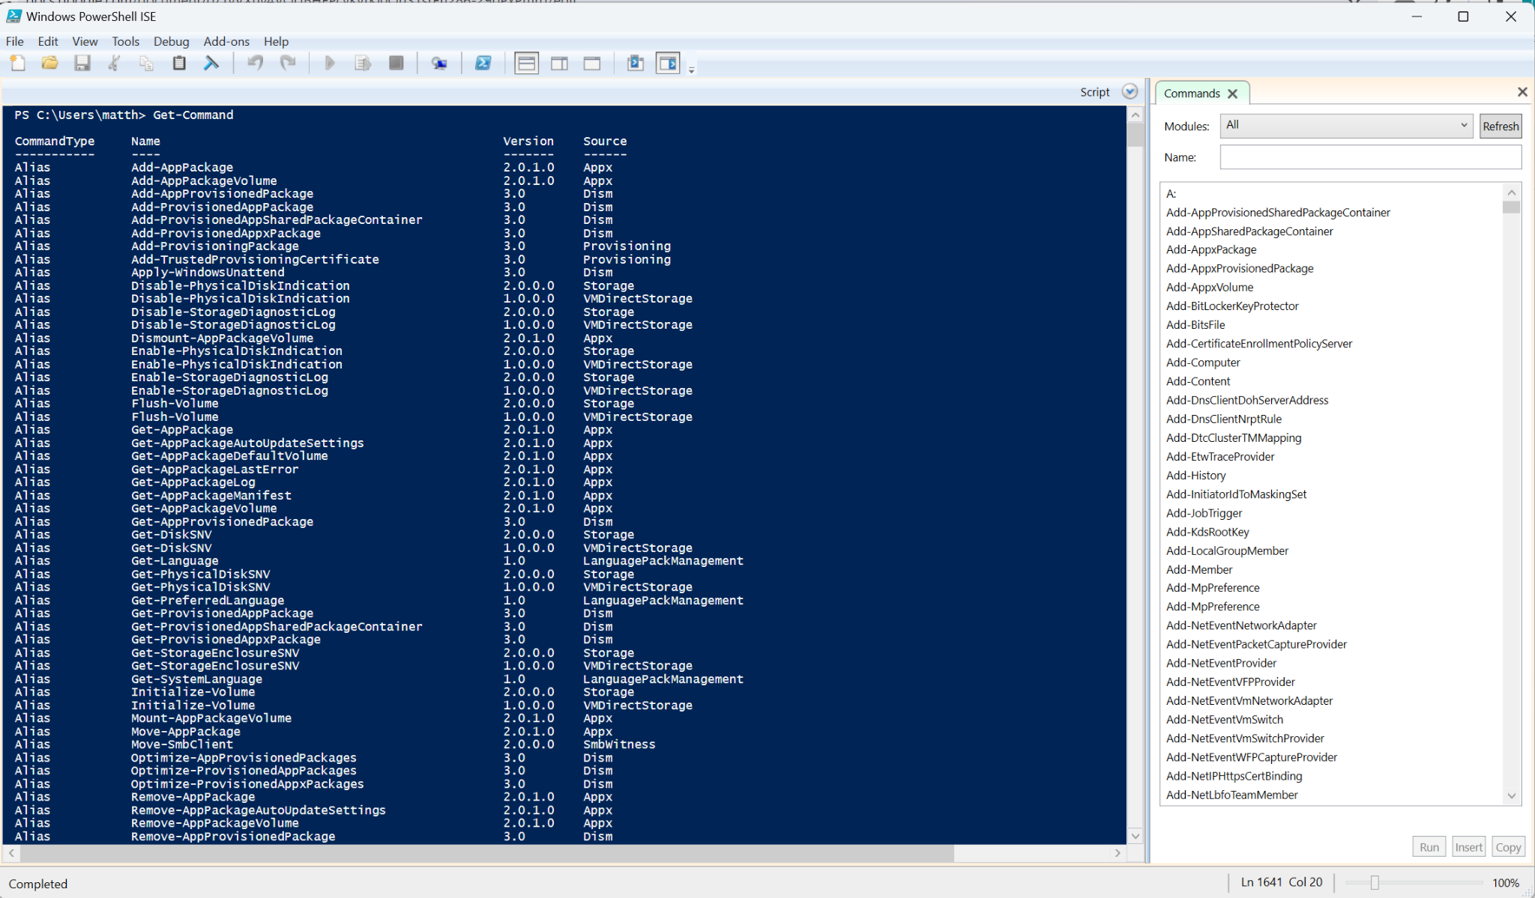

- [14]“Get-Help” Will bring up a list of online microsoft resources to help you learn how to make best use of powershell.[6]
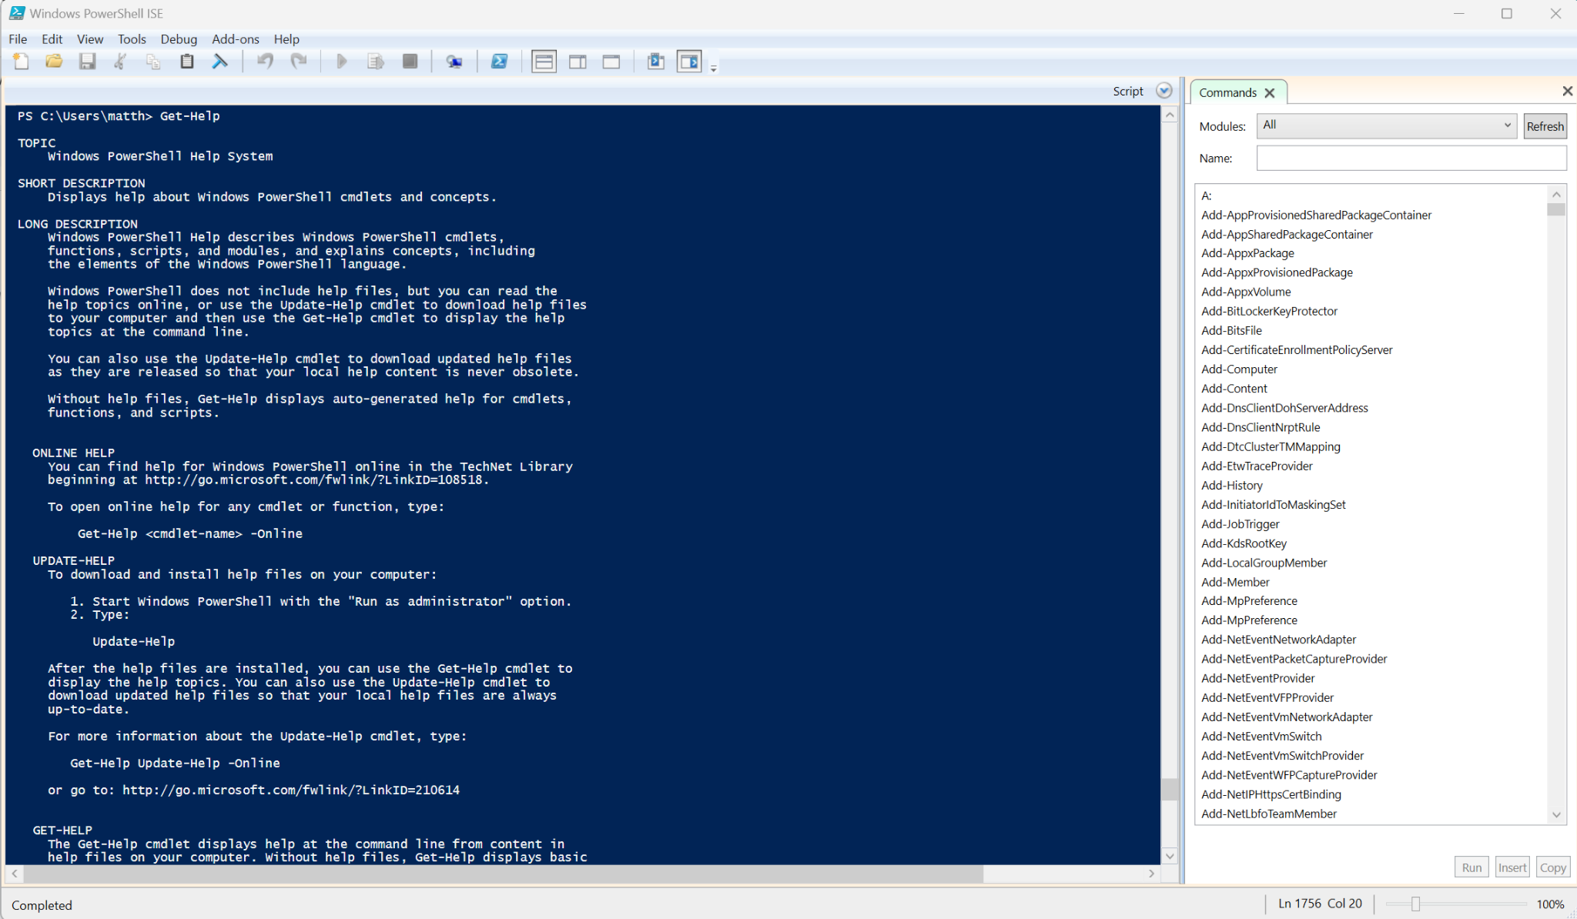

- [14]“Set-ExecutionPolicy” allows you to set the security parameters when it comes to running scripts in powershell. There are 4 security settings however my default is set to where no scripts will run to prevent malware being run.[6]
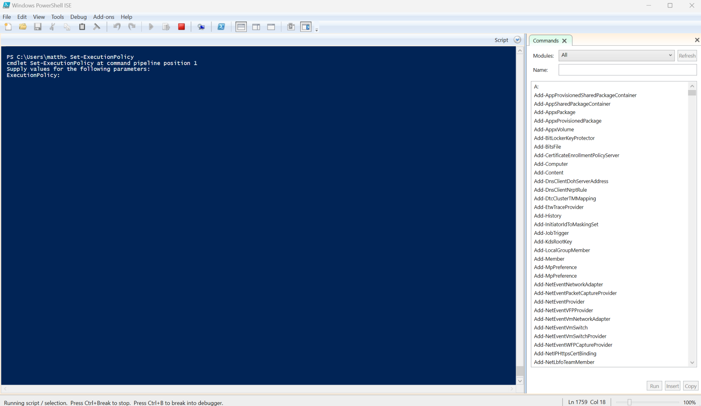.

4.[14]”Get-Service” will come back with a list of all the services and applications with their states installed on a system.[6]
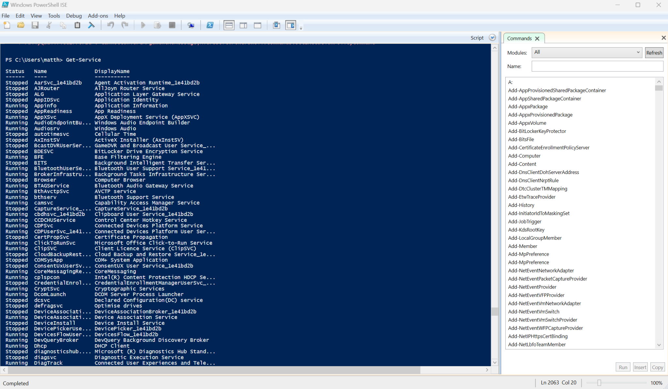

5.[14] “ConvertTo-HTML” if you need to extract data and export it in a more handleable format like HTML the full command bellow[14] “get-alias | convertto-html > aliases.htm” this also requires a file waiting to receive said data. [6]
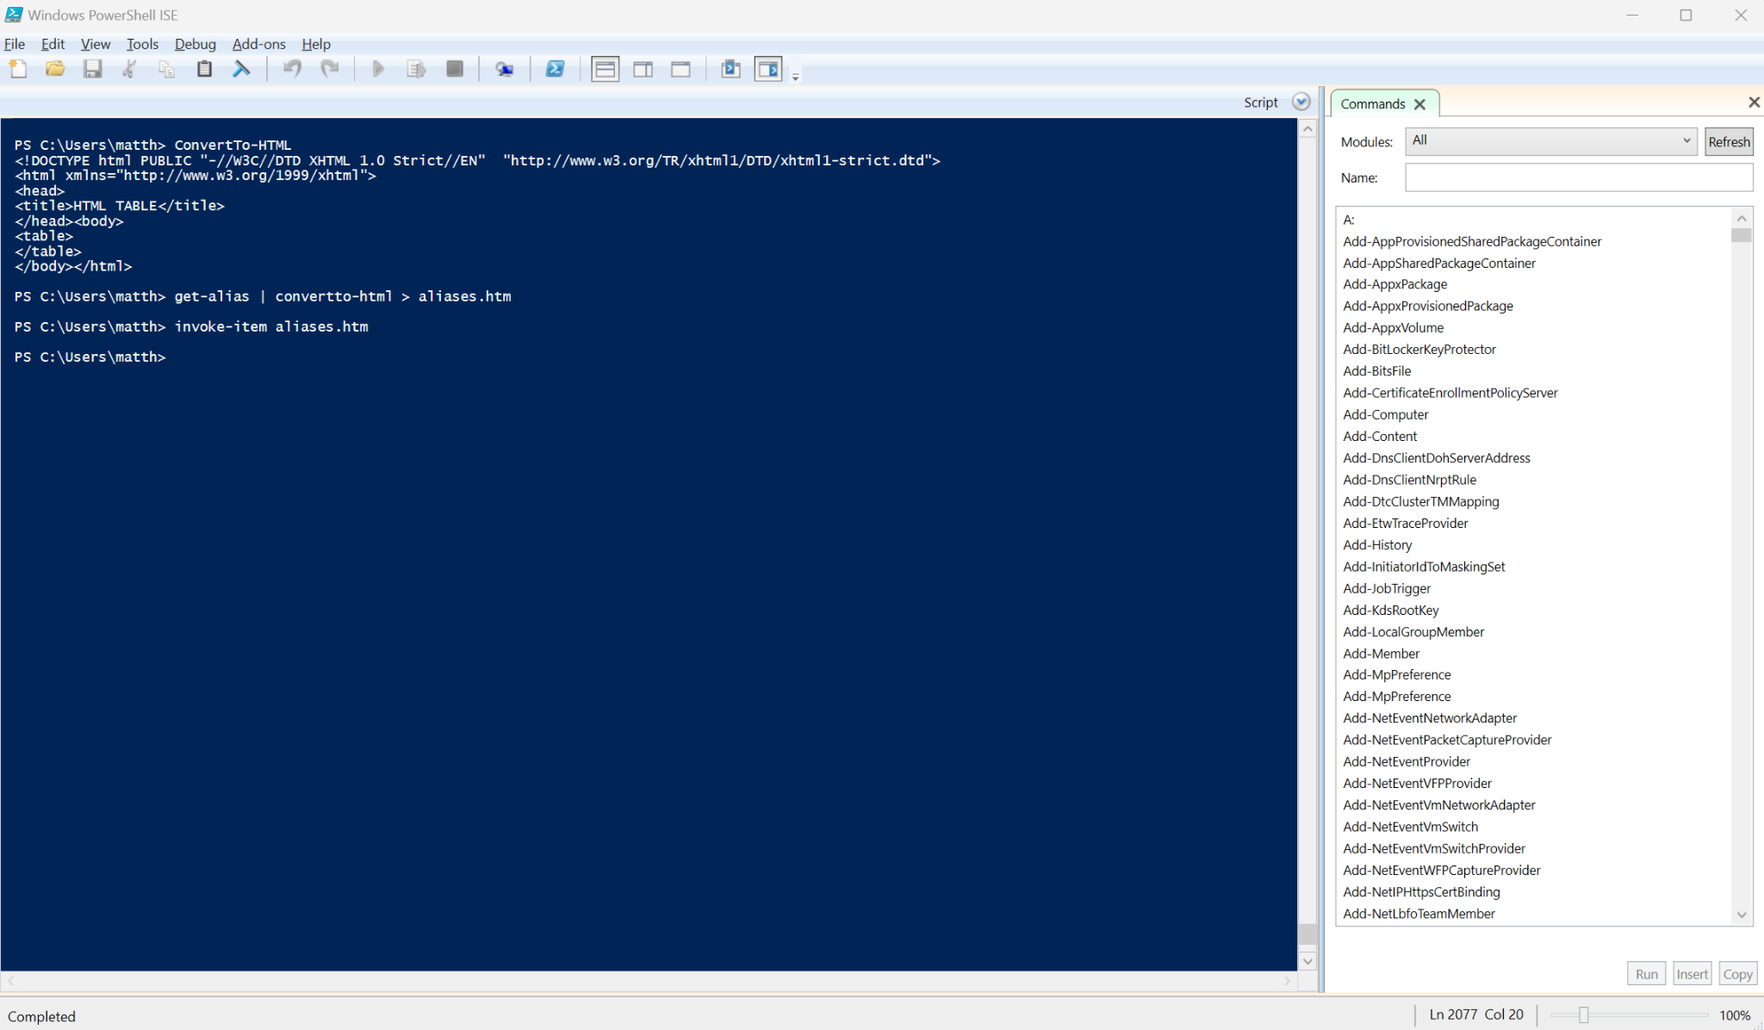
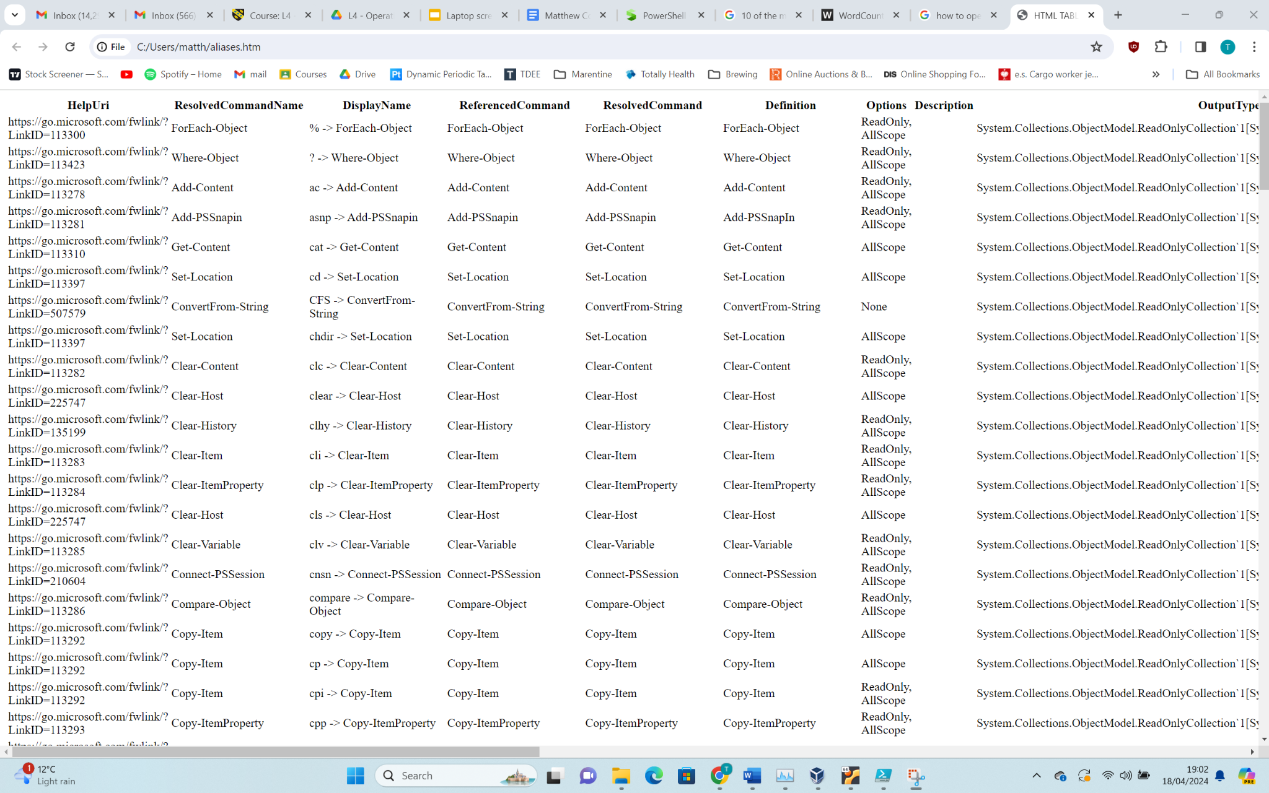
6. [14]“Get-EventLog” will then ask you which log you would like to view. For example I have used “Get-EventLog -Log "Application" to view the applications log.[6]
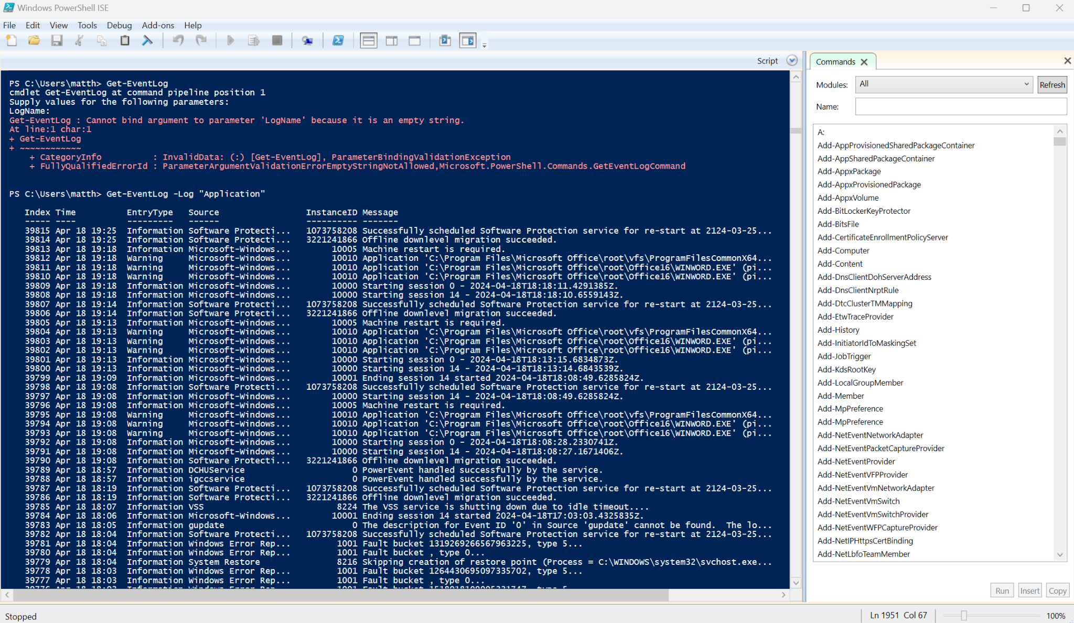

7. [14]”Get-Process” will give you a list of the processes which are currently running on a device not unlike task manager. Commands can also be given to stop specific processes.[6]
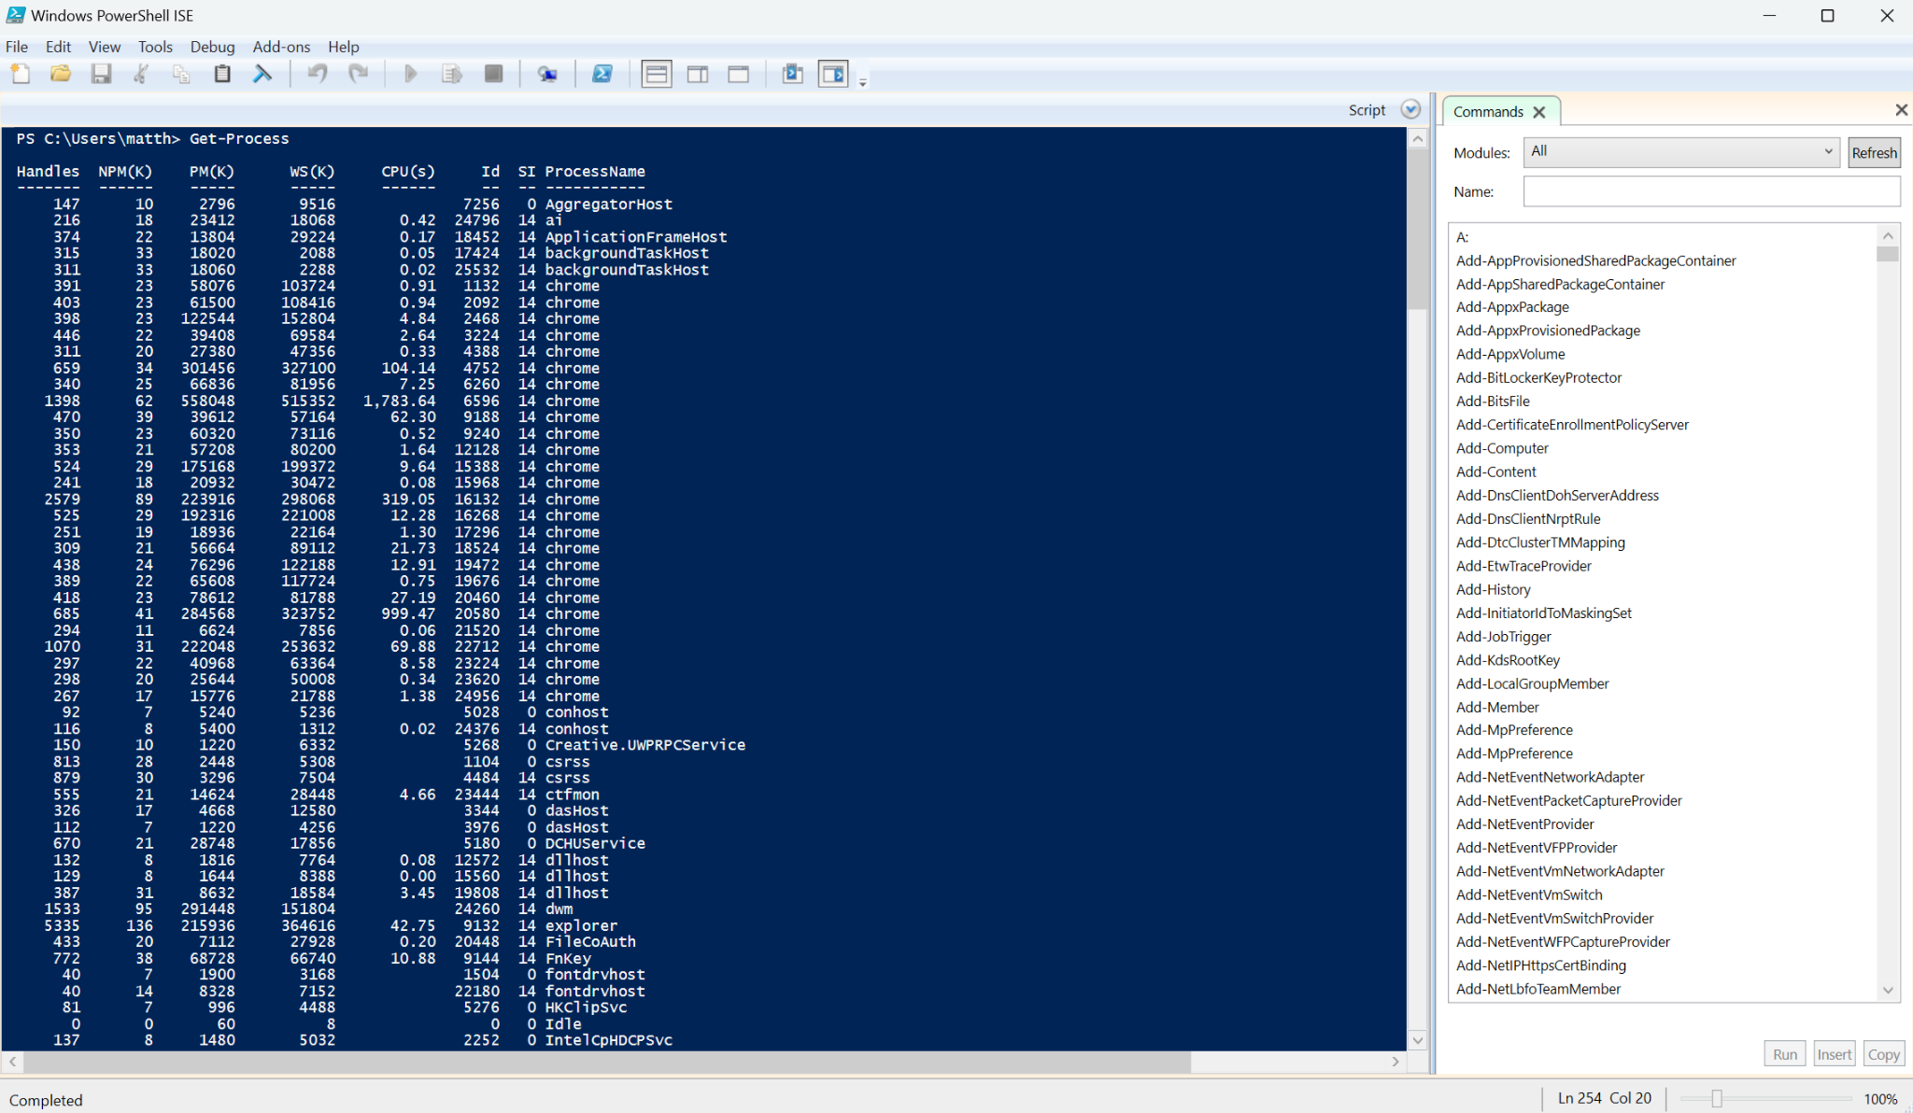

8. [14]”Clear-History“ will simply just clear your command search history.[6]
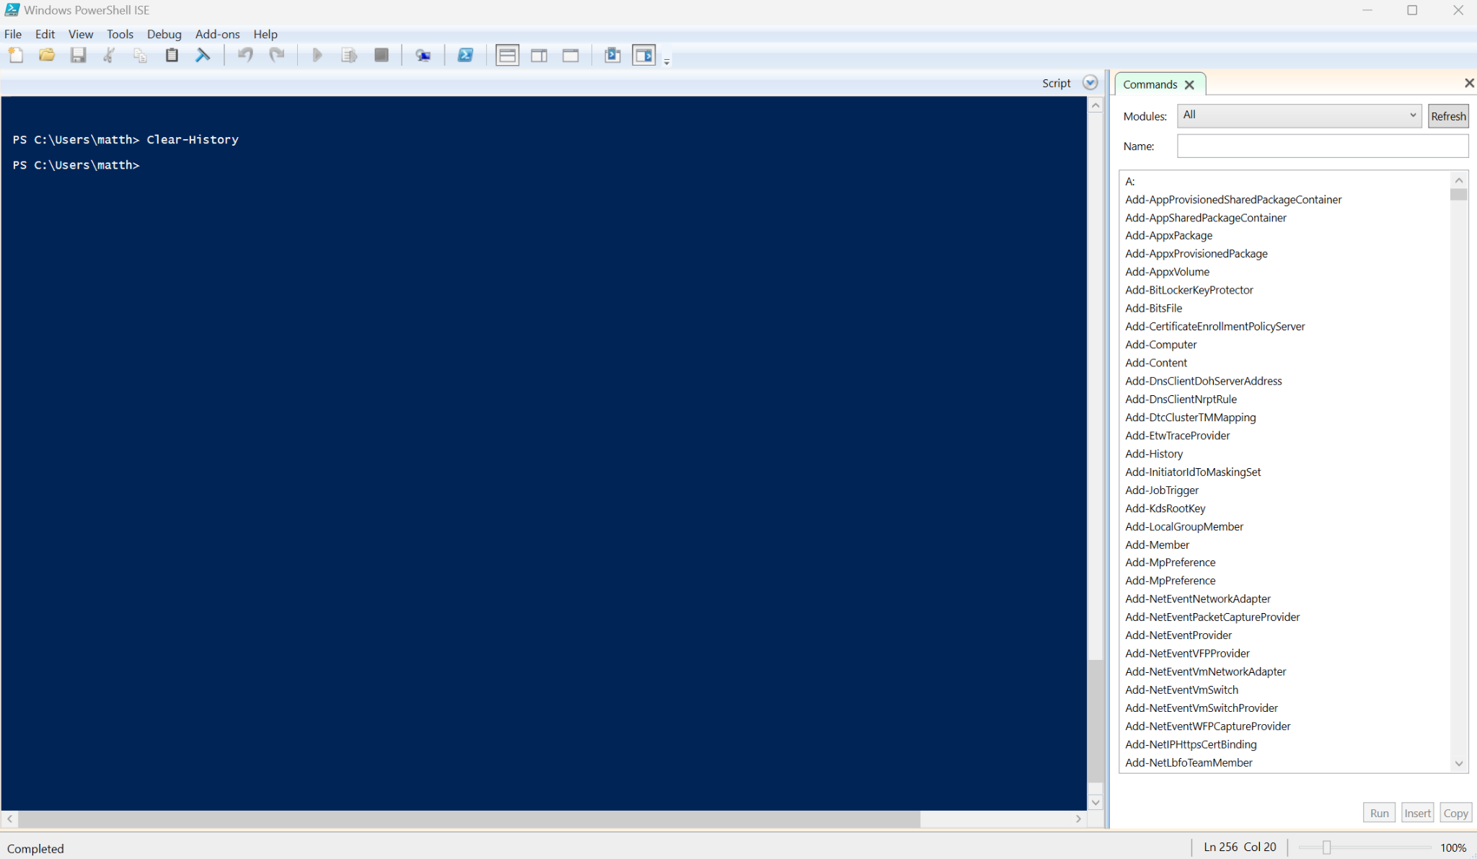
9.[14] ”Format-Table“ is a way to make an output more readable to the user by formatting it into a table. For example “Get-Process | Format-Table -Property Name, CPU, Memory -AutoSize”[6]
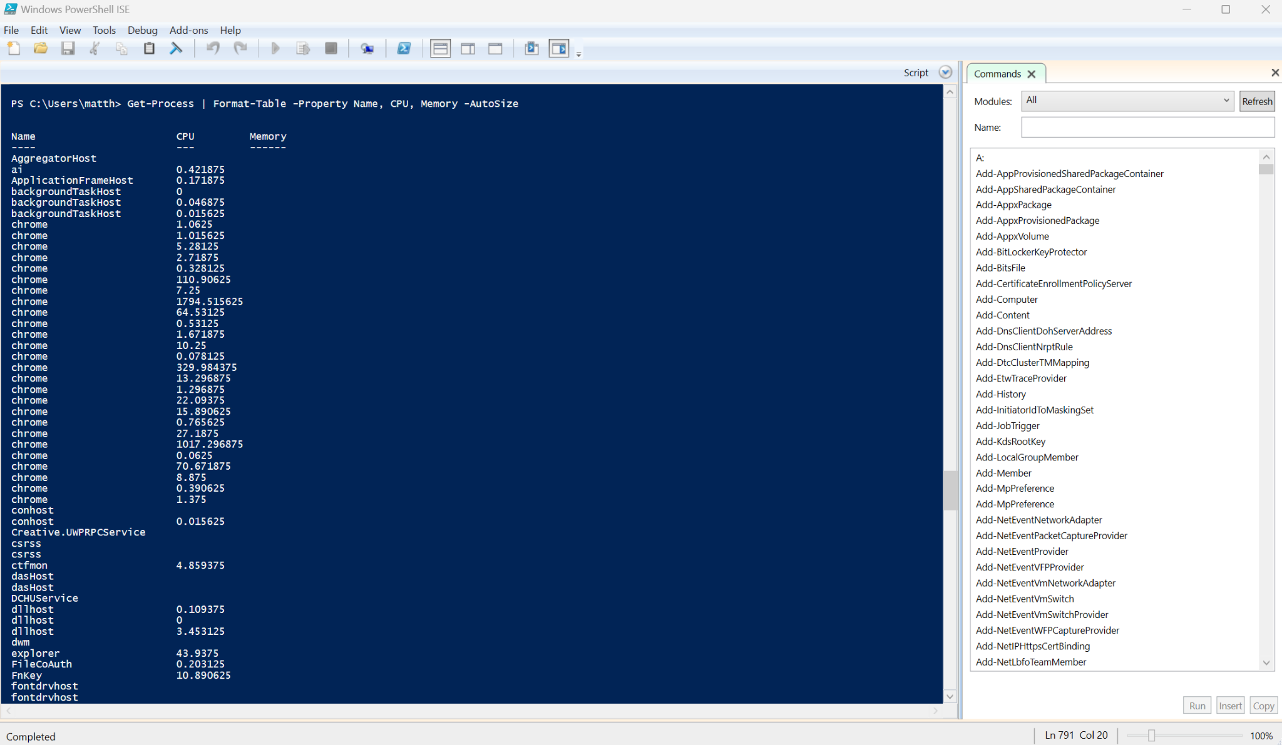

10.[14] ”Format-List” Is similar to “Format-table” as it is just another way to represent the information in the powershell window and is used in tandem like this “Get-Service | Format-List”.[6]
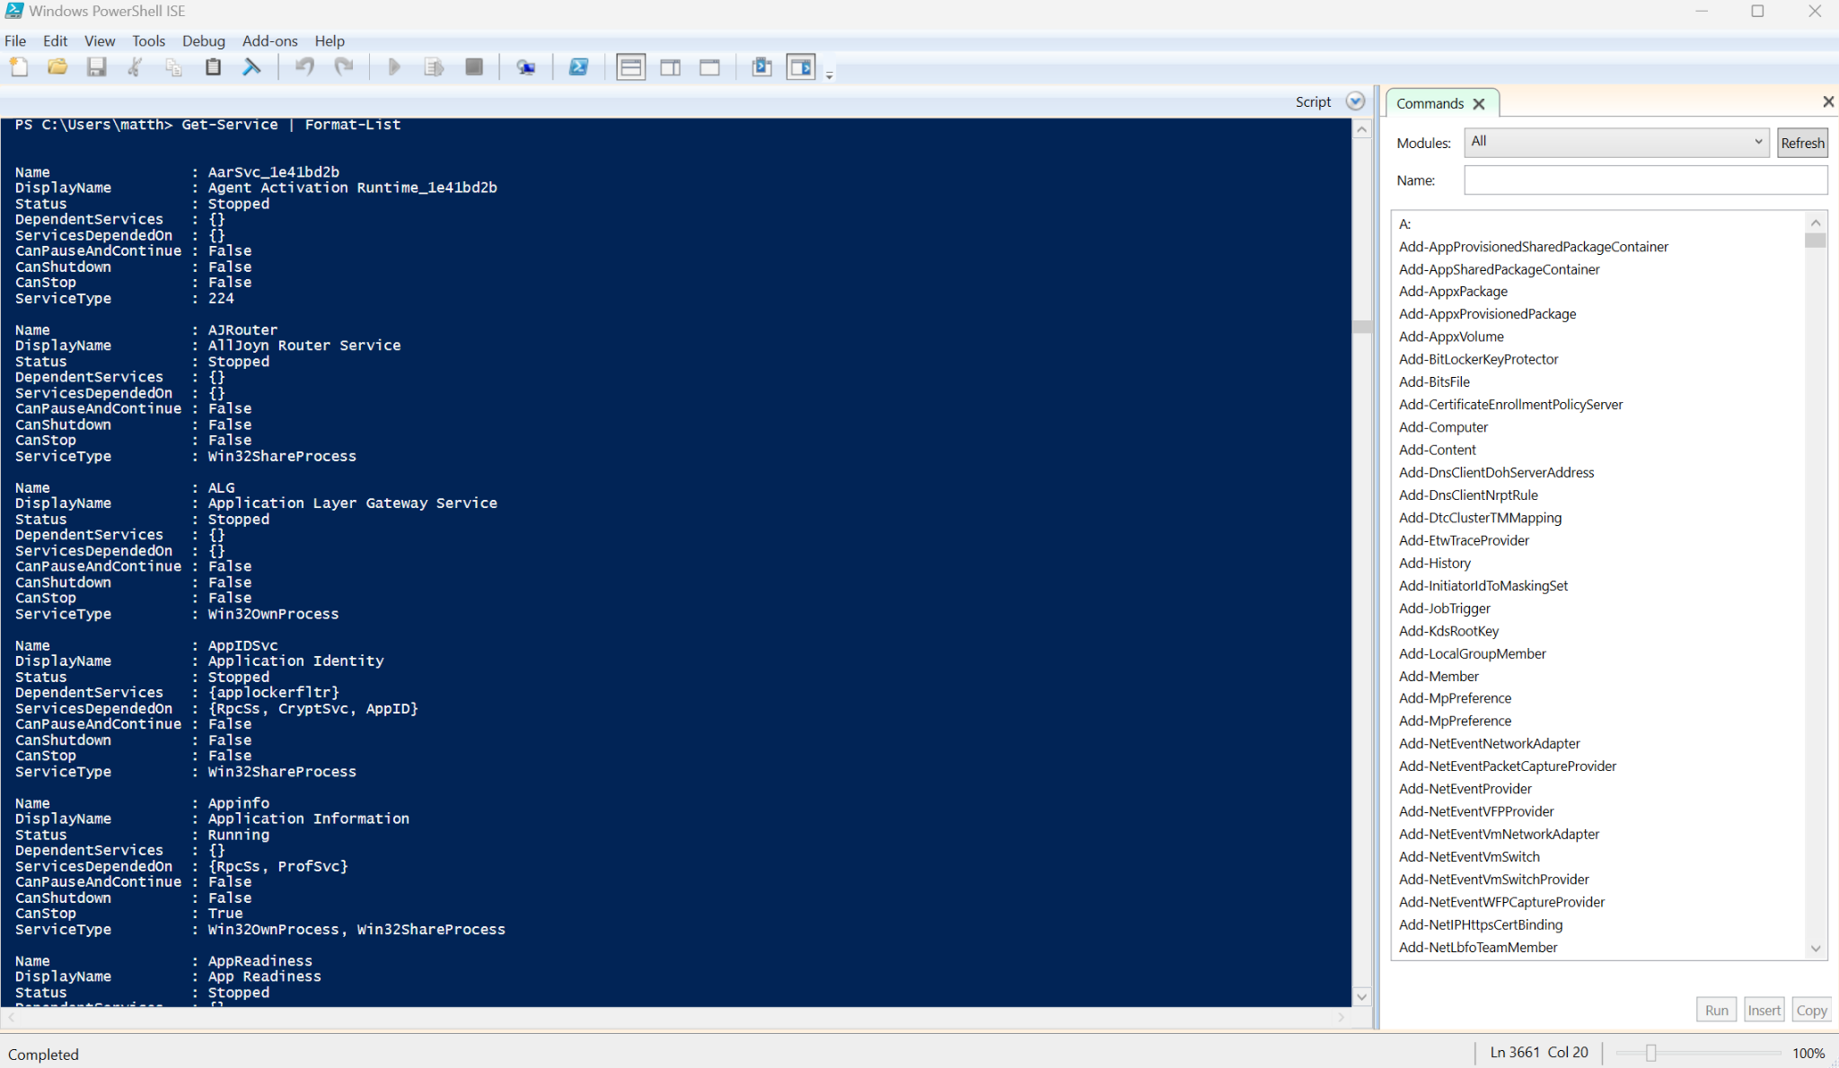

Linux Bash CLI commands.

To start things off, what is Bash?[15]”Bash (Bourne Again Shell) shell is an enhanced version of the Bourne shell distributed with Linux and GNU operating systems.” [16] In the same way that powershell is specialized for Windows, Bash is the CLI for Linux systems.

[17] Even though many prefer powershell as it has a more orthodox approach to its syntax and that it has an edge with how much control it gives you over a windows OS system, many will still choose to pick up Bash. This is because any Linux based system will be able to run it and many popular OS’s use Linux as a starting point.[18]Much like windows powershell, Bash is also a scripting language which gives the user the option to write and implement scripts of their own to speed up their work flow.

[19] A limitation of Bash as it is purely a CLI appears to be that data from commands has to be piped between them via strings which can reduce the capabilities of the tool in some conditions. This does not seem to be as much of an issue when it comes to powershell. So when using commands be aware of the data/type you are handling.

Now that the groundwork has been laid out let's look at some of the commands that are commonly used in Bash.(**note powershell is used in some instances to show a more readable response populated with data**) [20] 1.”ls”, 2.”pwd”, 3.”cd”, 4.”mkdir”, 5.”rm”, 6.”cp”, 7.”mv”, 8.”touch”, 9.”file”, 10.”cat”.

- ”Ls” Is used to show a directory’s contents and display them.[6]
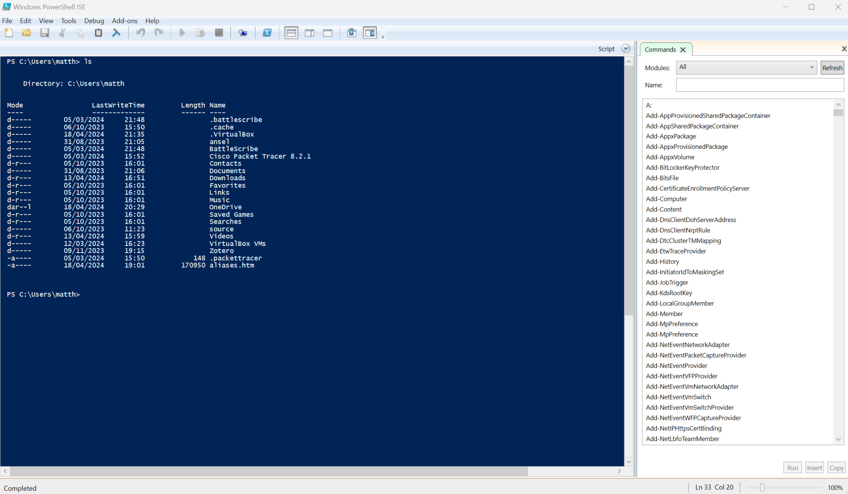

- ”Pwd” Will show you the current working file directories Path.[6] 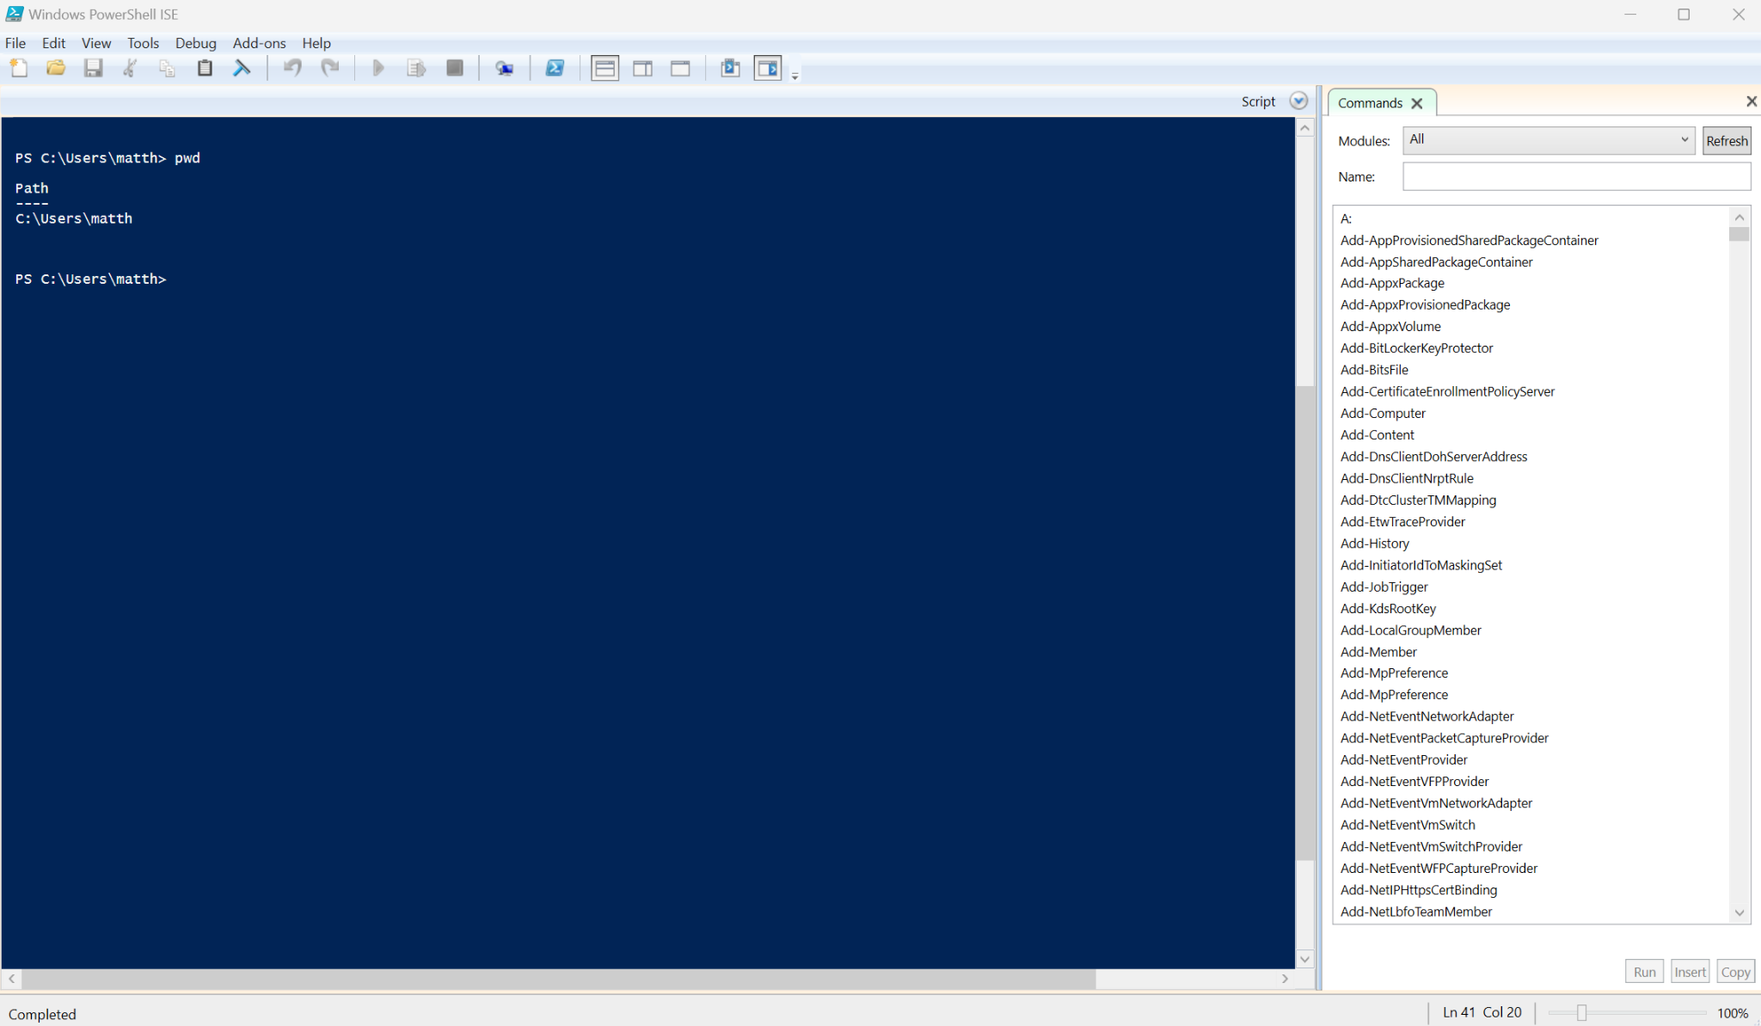

- “Cd” Is used to change the directory.[6]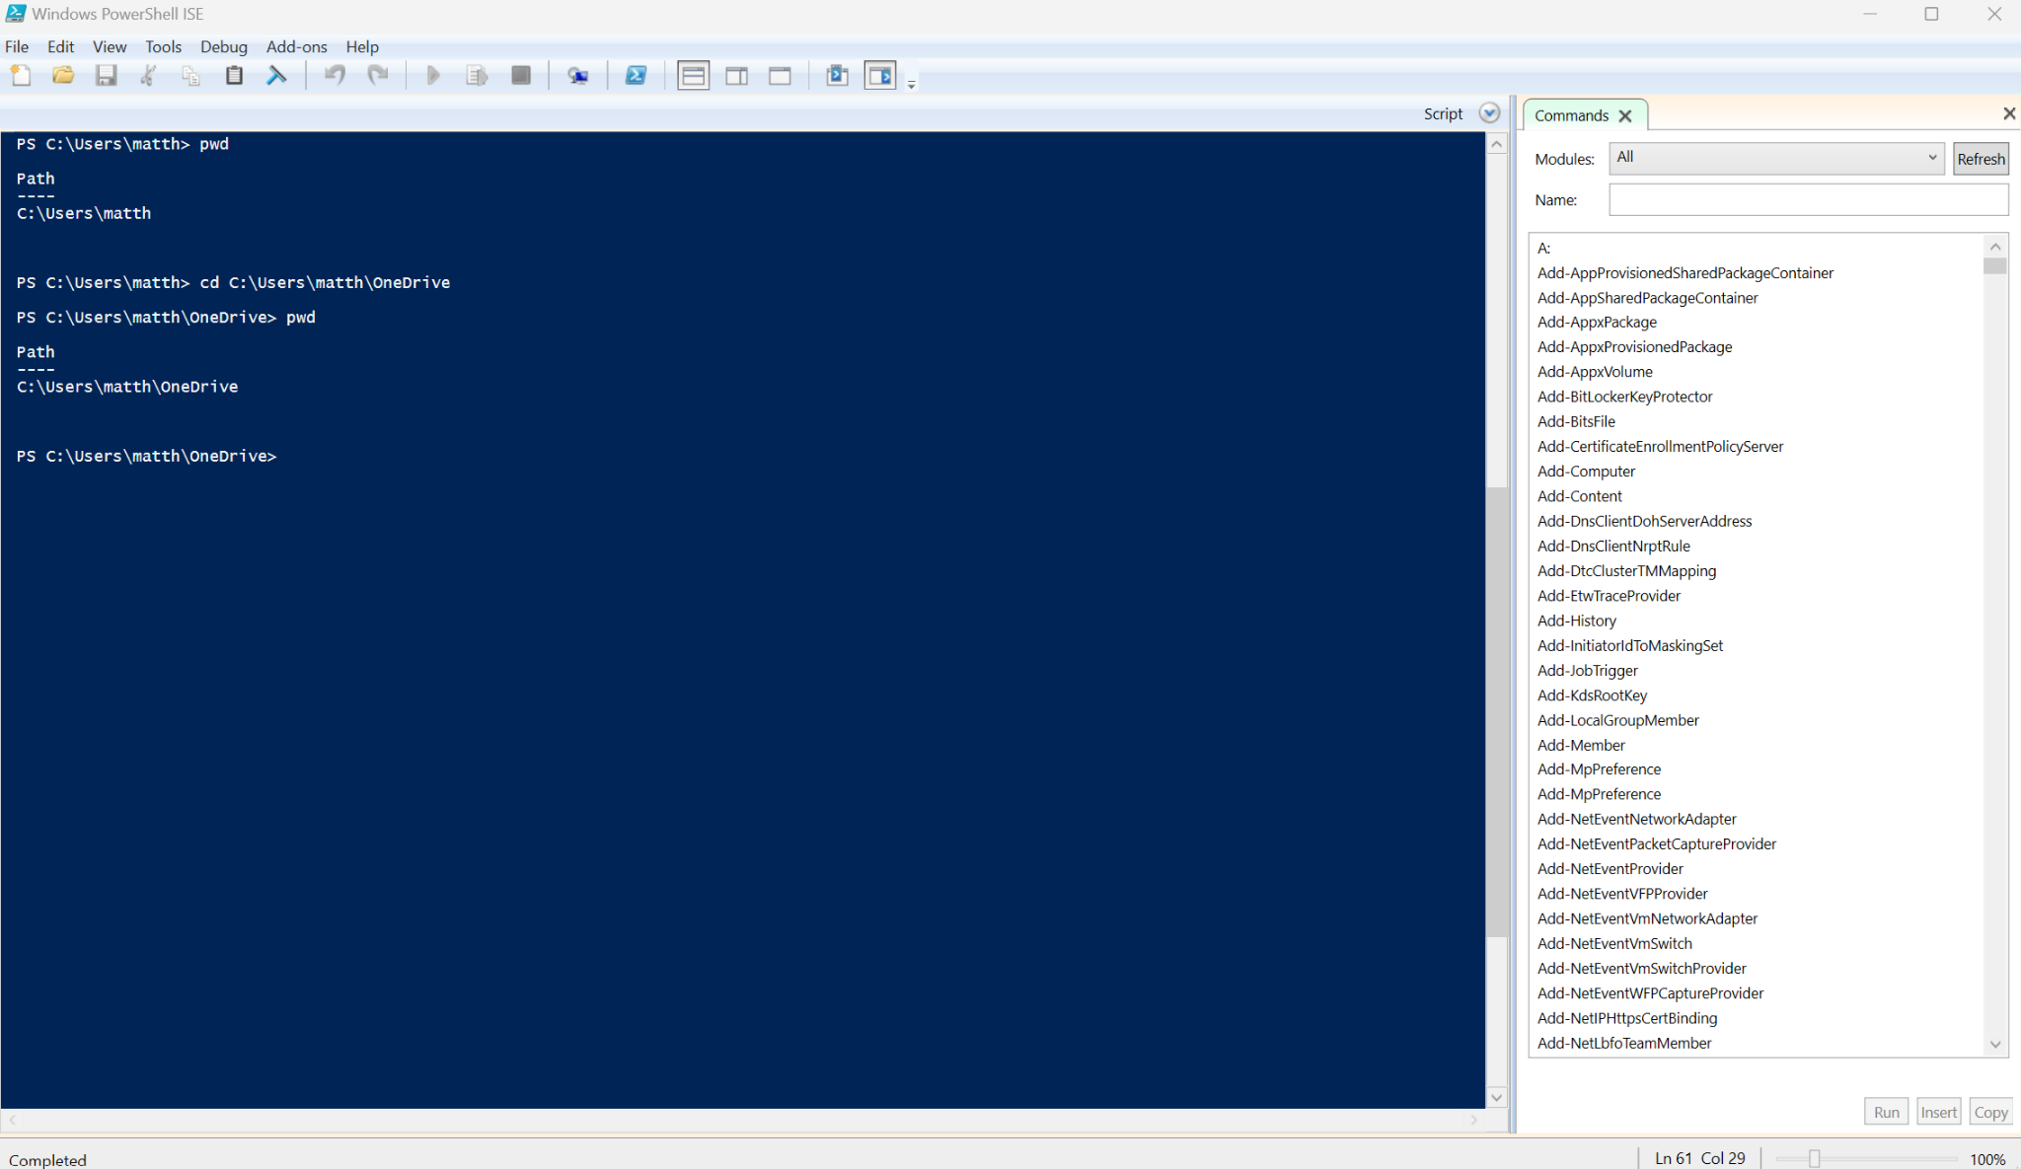

- “Mkdir” Is used to create a new directory. [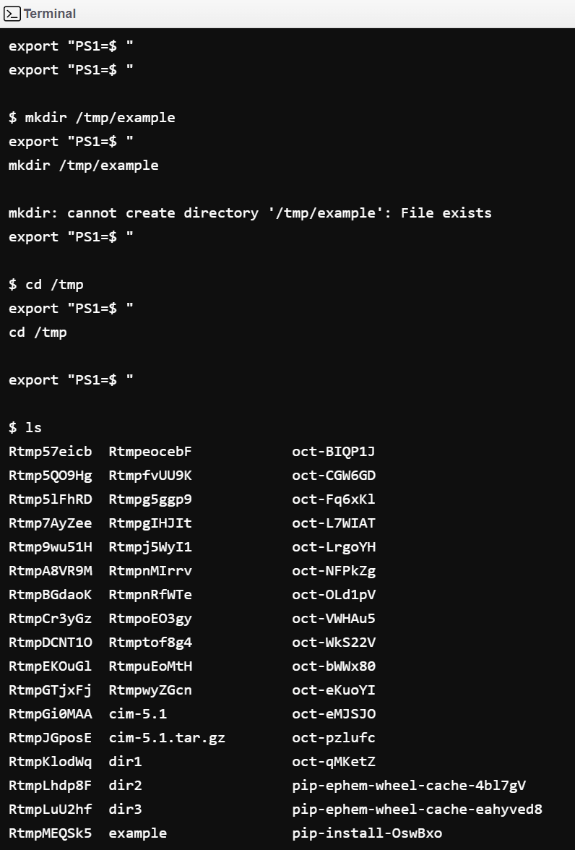

- ”rm” is used to delete a file by name.[6]
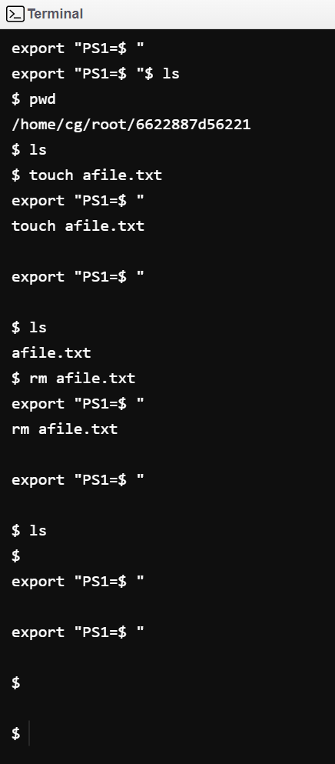

- “Cp” Is used to copy and paste a file to a specified location.[6]
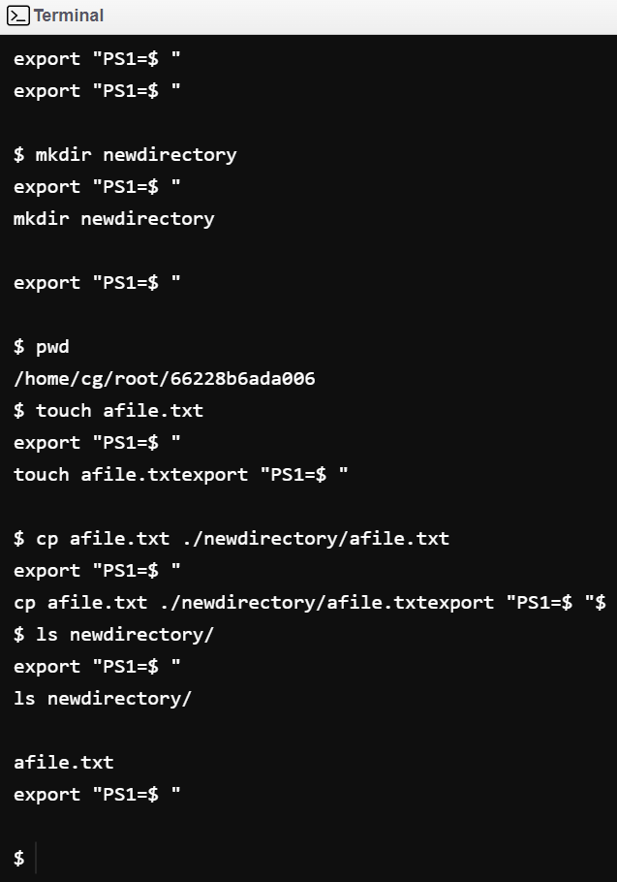

- ”Mv” Is used to move a file to other locations without copying. [6]
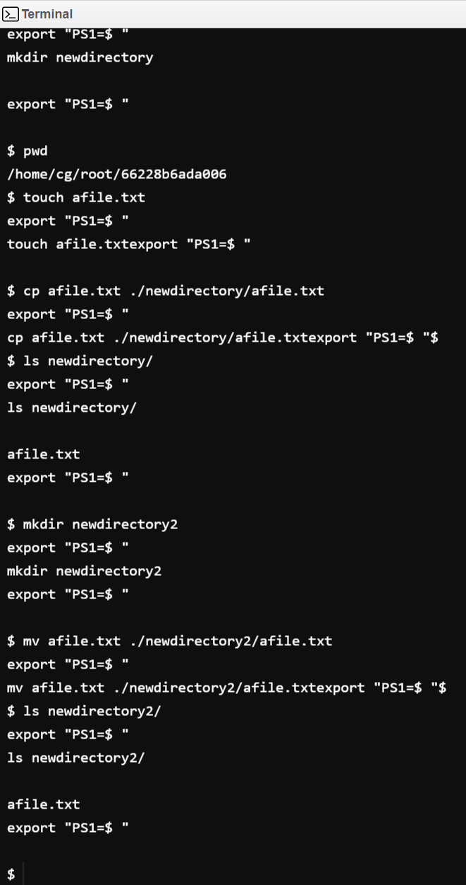

- ”Touch” Is used to create files. It is also represented in previous screenshots.[6]
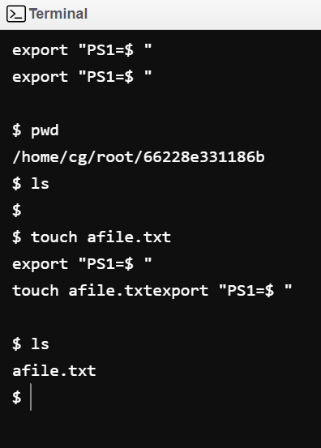

- ”File” I used to determine a file's type (**in this case it is completely empty**).[6]
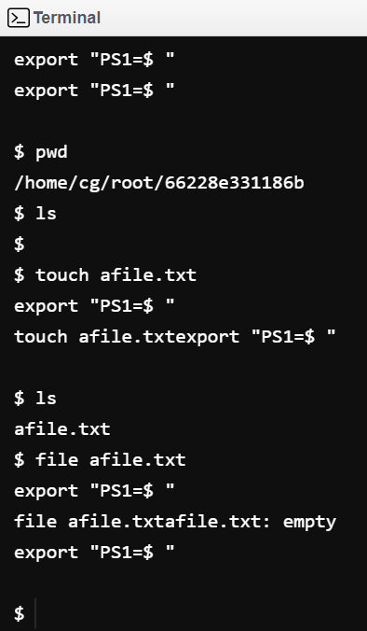

- ”cat” it takes a files content, organizes it and presents it as a standard output
(*note test file is empty so nothing is displayed*)[6]
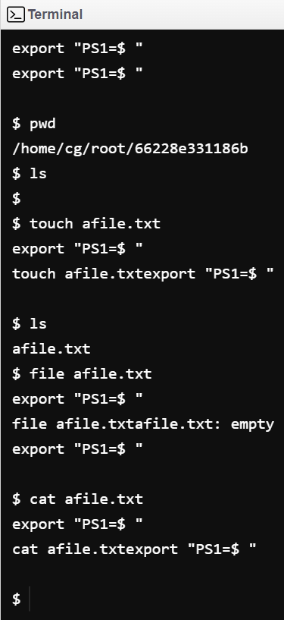
Windows Scripting.

As a quick refresh as to what scripting is[21] a form of programming mainly utilized to speed up the process of completing tasks especially repetitive tasks. Most people interact with them via their GUI’s backend.[22] When it comes to Windows Power shell and its scripting language capabilities it seems to be very streamlined especially for the Windows OS systems and Microsoft products. One of the key ways this was achieved was through making all inputs and outputs .Net objects so that they don't have to be converted to different file types like HTML.

Some examples are [23] Amazon’s AWS which thanks to the .Net usability/functionality power shell and CLI commands can be used to streamline and automate your AWS service management. Another is [24] Google cloud where they also make use of Powershell scripting primarily for the production of reports and breaking down large data sets going as far as being able to manipulate your Google cloud resources from the command line.

Moving on to the actual syntax of powershell’s scripting, thanks to its backing it has some rather nice quality of life features.[25] Some of the main ones are being task based, so it makes use of already pre-existing commands and thus scripts so those with any prior experience adapt smoothly. Consistent standardized design, commands and system data stores use common naming syntax as well as data types so data can be piped directly between them. Due to powershell being open source the whole user experience can be customized to be a bespoke fit for its individual use cases.

Thanks to the nature of being open source there are now many library extensions that you can now add to your powershell.[26] being modularised helps a lot as the user can simply enable and disable the required libraries and or organize them into their separate packages depending on what the job/task is at hand.

Now that's all said and done, here is a simple “Hello World” example of writing and executing a script.

1.You will need to create a new file to hold your scripts.[6]
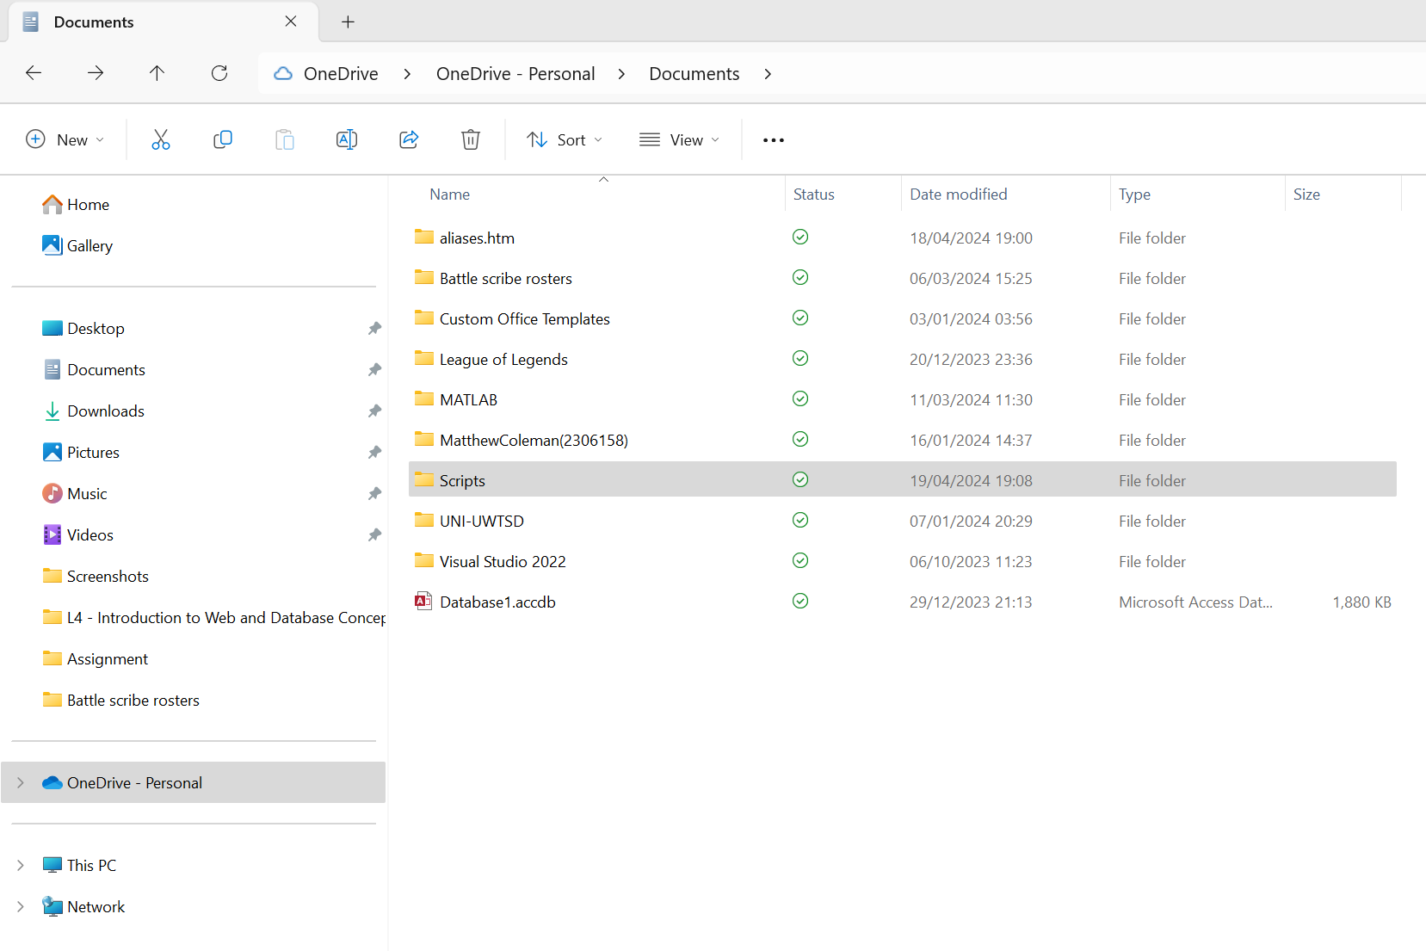

2. Make your script file, thai will be a text file where we change the “.txt” to “ps1” [6]
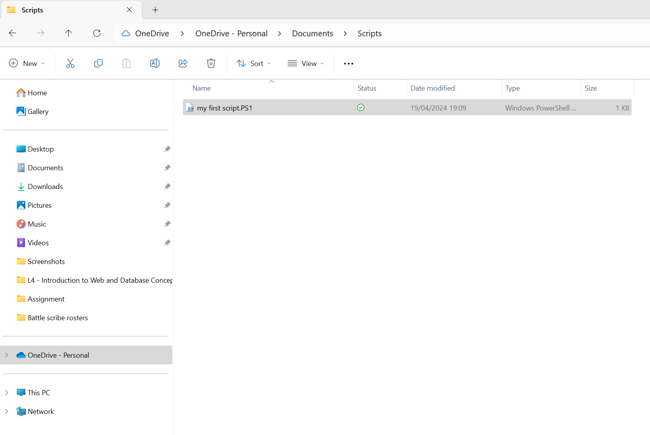

3.Now open your script file and enter ( write-host "Hello, World" ) this is a command which will write back its contents to the terminal.[6]
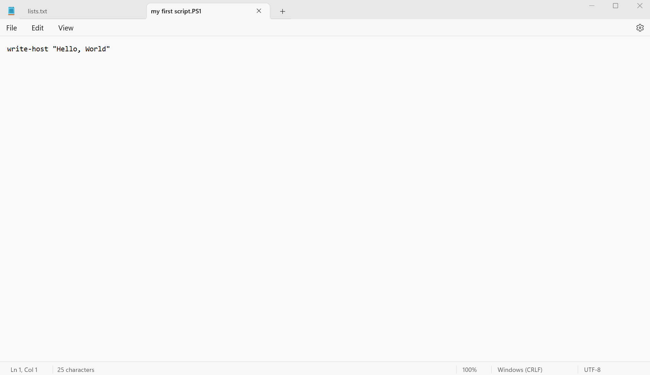

4.It is time to now run your script like so.(If this is you first time running a script on powershell you will need to change your execution policy as by default it is set to restricted meaning no scripts will run).[6]
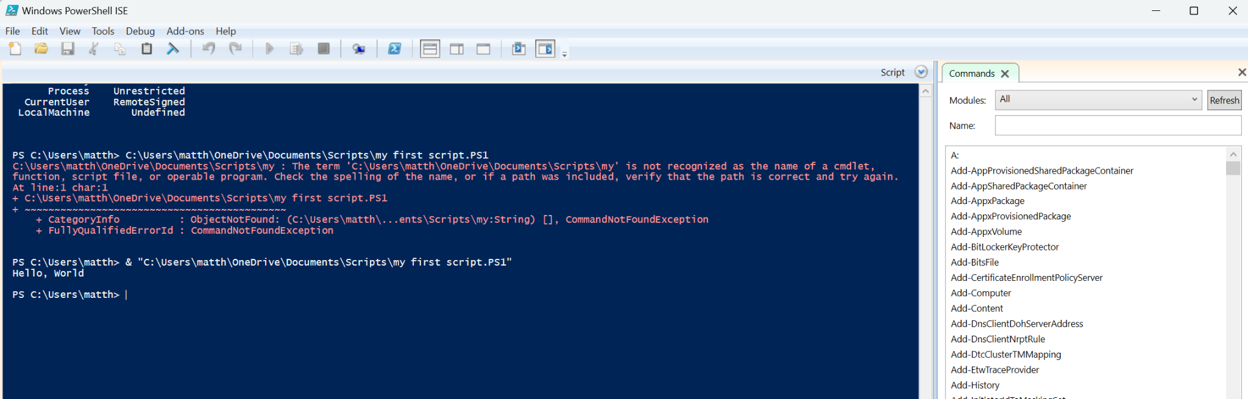

Linux Scripting.

[27]Bash is the scripting language that Linux OS uses as it is based upon the Bourne shell. A pretty important aspect of the Bourne again shell is that its scripts and commands are backwards compatible. [28]Going back to familiarity, Bash is similar to powershell in that it is a command line interpreter scripting language, which can be used in a similar fashion to automate a lot of your task processes.

[29]Let's go over some of the main features of Bash and what makes it so popular. Unsurprisingly it gives you the ability to customize your keys allowing you to create command line shortcuts to more easily navigate your directories or repeat common commands. But there is also a built-in navigation command known as the directory stack so you can navigate via “pushing(pushd)” and “popping(popd)” your way through the stack as needed. [30] A neat feature of Bash which greatly improves efficiency is that it has launch file capability meaning that upon launching the terminal these can be run to set up an environment near immediately.

Now lets look at Bash’s scripting.[31]You can easily identify a Bash script by the fact that its file name will end in a “.sh” and alternatively just ”sh”. [32] All scripts start with whats referred to as “shebang” and occurs on the first line the exact she bang looks like this “#!” the “#” is in reference to the shell and “!” for bash as to indicate which interpreter to use while reading the script.

With that all said and done lets create a simple Bash script for “Hello world”.
- First we need to create the script file and to do so we will be using “Touch”[6]
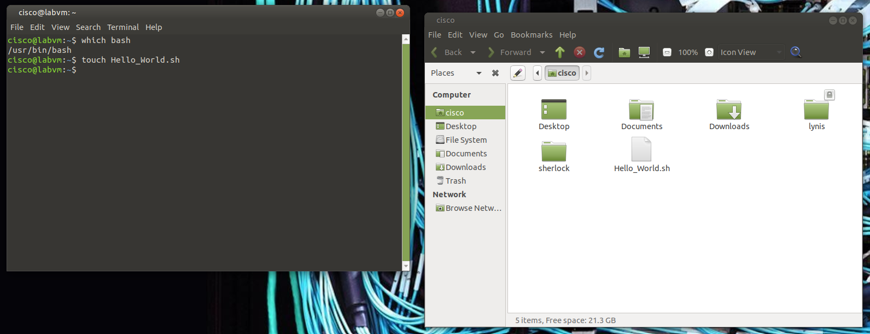

- The next step is to locate the pathway to your shell on this device via “which bash” as this will be needed when we write the first line of the script.[6]
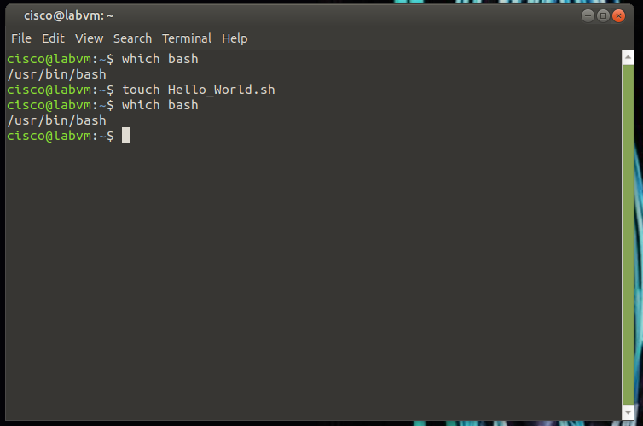

- Once we have that we can now write the bash script in the file. We will be using “echo” to write back to the terminal like so. Take note of the “#! /usr/bin/bash” at the top to indicate the start and the interpreter.[6]
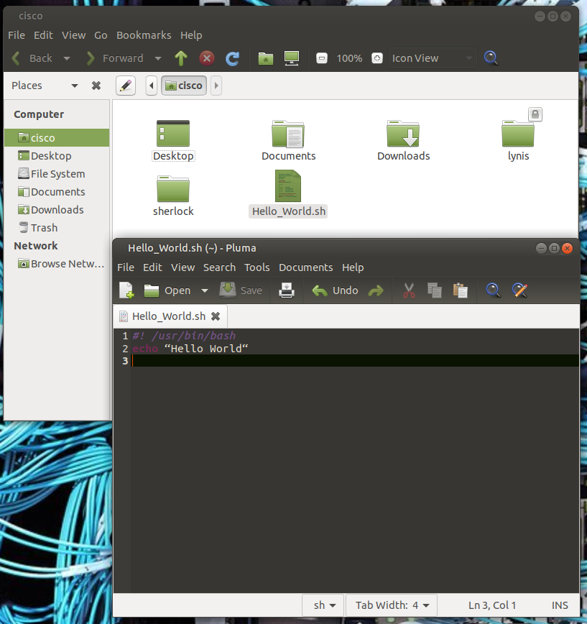

- After that we can now run the bash file by entering “bash” and then the script file name.Bear in mind the “bash” is case sensitive as you can see.[6]
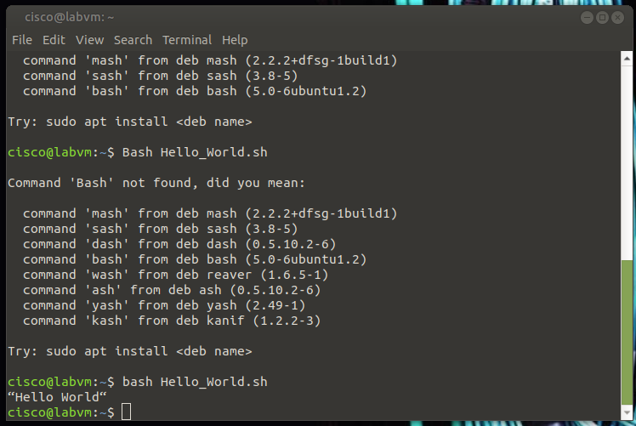

Conclusion

Operating systems are extremely useful for providing a way for the user to interact with the hardware of the device. More specifically there is a large variety in the ways that it can be done either through GUI or Command line but more often than not it is a mixture of both, trying to leverage the best aspects of each.While also being tailored enough to fit nearly any users preferences (soft features (GUI or command line balence) as compared to hard features like powershells .Net standardization). Scripts are also something that I need to look into further as they are the key to any real efficiency gain when it comes to using a device and or process.

References

[1] GeeksforGeeks .[Online] available at :
https://www.geeksforgeeks.org/functions-of-operating-system/ (14/04/2024)

[2] Techtarget .[Online] available at :
https://www.techtarget.com/whatis/definition/operating-system-OS (14/04/2024)

[3] GeeksforGeeks .[Online] available at :
https://www.geeksforgeeks.org/cpu-scheduling-in-operating-systems/ (14/04/2024)

[4] statcounter .[Online] available at :
https://gs.statcounter.com/os-market-share (17/04/2024)

[5] Scaler topics .[Online] available at :
https://www.scaler.com/topics/features-of-windows-operating-system/ (17/04/2024)

[6] Matthew John Coleman .[Online] available at :
https://docs.google.com/presentation/d/1wHsZ2ZogPuyZb-bLKU9FX0fOD8ls2cL2Icds0qpa-44/edit?usp=sharing (17/04/2024)

[7] Logic monitor .[Online] available at : https://www.logicmonitor.com/blog/9-reasons-linux-is-a-popular-choice-for-servers#:~:text=For%20businesses%20and%20organizations%20that,often%20the%20platform%20of%20choice.
(17/04/2024)

[8] Linkedin .[Online] available at :
https://www.linkedin.com/pulse/why-linux-still-vital-industry-kanika-jindal-9zppc/ (17/04/2024)

[9] Microsoft .[Online] available at :
https://learn.microsoft.com/en-us/powershell/scripting/overview?view=powershell-7.4 (18/04/2024)

[10] GitHub .[Online] available at :
https://github.com/PowerShell/PowerShell (18/04/2024)

[11] AWS-Amazon .[Online] available at :
https://aws.amazon.com/what-is/cli/ (18/04/2024)

[12] Lenovo .[Online] available at :
https://www.lenovo.com/gb/en/glossary/what-is-a-gui/ (18/04/2024)

[13] Spiceworks .[Online] available at :
https://www.spiceworks.com/tech/devops/articles/what-is-powershell/ (18/04/2024)

[14] Stackify by nitro .[Online] available at :
https://stackify.com/powershell-commands-every-developer-should-know/ (18/04/2024)

[15] PhoenixNap .[Online] available at :
https://phoenixnap.com/kb/bash-commands#:~:text=The%20Bash%20(Bourne%20Again%20Shell,directories%2C%20and%20different%20data%20types. (18/04/2024)

[16] javatpoint .[Online] available at :
https://www.javatpoint.com/powershell-vs-bash-shell#:~:text=1.,of%20the%20Linux%20operating%20system. (18/04/2024)

[17] The Windows Club .[Online] available at :
https://www.thewindowsclub.com/powershell-vs-bash-explained-which-one-is-better (18/04/2024)

[18] SQAUSH .[Online] available at :
https://www.squash.io/evaluating-the-benefits-of-bash-scripting-in-linux/#:~:text=Benefits%20of%20Using%20Bash%20Scripting,-Bash%20scripting%20offers&text=By%20writing%20a%20script%2C%20you,need%20to%20be%20performed%20regularly. (18/04/2024)

[19] CBTNuggets .[Online] available at :
https://www.cbtnuggets.com/blog/certifications/microsoft/powershell-vs-bash-whats-the-difference (18/04/2024)

[20] Hostinger tutorials .[Online] available at :
https://www.hostinger.co.uk/tutorials/linux-commands (18/04/2024)

[21] Coralogix .[Online] available at :
https://coralogix.com/blog/what-is-scripting/ (19/04/2024)

[22] Microsoft .[Online] available at :
https://learn.microsoft.com/en-us/powershell/scripting/overview?view=powershell-7.4 (19/04/2024)

[23] AWS- Amazon .[Online] available at :
https://aws.amazon.com/powershell/ (19/04/2024)

[24] Google - Google cloud .[Online] available at :
https://cloud.google.com/powershell/ (19/04/2024)

[25] Tutorials point .[Online] available at :
https://www.tutorialspoint.com/powershell/powershell_scripting.htm (19/04/2024)

[26] site core powershell extensions .[Online] available at :
https://doc.sitecorepowershell.com/modules (19/04/2024)

[27] O’reilly .[Online] available at :
https://www.oreilly.com/library/view/learning-the-bash/1565923472/pr01s02.html (19/04/2024)

[28] Unstop .[Online] available at :
https://unstop.com/blog/what-is-bash (19/04/2024)

[29] Linux Simply .[Online] available at :
https://linuxsimply.com/bash-scripting-tutorial/introduction/features-of-bash/ (19/04/2024)

[30] Geeksforgeeks .[Online] available at :
https://www.geeksforgeeks.org/bash-script-features/ (19/04/2024)

[31] Freecodecamp .[Online] available at :
https://www.freecodecamp.org/news/shell-scripting-crash-course-how-to-write-bash-scripts-in-linux/#:~:text=A%20bash%20script%20is%20a,it%20using%20the%20command%20line. (19/04/2024)

