APPENDIX 3 | Layout for Declaration/Statements page to be included in Higher Degree Dissertation

DECLARATION

This work has not previously been accepted in substance for any degree and is not being concurrently submitted in candidature for any degree.

Signed |  | (Candidate)
Date

STATEMENT 1
This thesis is the result of my own investigations, except where otherwise stated. Where correction services have been used, the extent and nature of the correction is clearly marked in a footnote(s).

Other sources are acknowledged by footnotes giving explicit references. A bibliography is appended.

Signed |  | (Candidate)
Date

STATEMENT 2
I hereby give consent for my thesis, if accepted, to be available for photocopying and for inter-library loan, and for the title and summary to be made available to outside organisations.

Signed |  | (Candidate)
Date

Candidates on whose behalf a bar on access has been approved by the University, should use the following version of Statement 2:

I hereby give consent for my thesis, if accepted, to be available for photocopying and for inter-library loans after expiry of a bar on access approved by the University of Wales on the special recommendation of the Member Institution concerned.

Signed |  | (Candidate)
Date

SUMMARY OF DISSERTATION
APPENDIX 4 | Summary of Dissertation

Title | Mr.
Surname | Mohammed
Forename(s) | Shiraz Hussain
Institution | Oxford graduate online school
Degree Sought | MBA Topup
Title of Dissertation | : Determining factors of shoppers loyalty to branded retail shops (sainsburyTesco and Asda)in UK
Summary: The aim of the research was to analyse the influence of economic crisis on the determining factors of shopper loyalty to the branded retail grocery stores in the United Kingdom. With a cross sectional study conducted on the customers of Tesco, Sainsbury and Asda based on the determinants of customer loyalty mainly atmosphere, store layout, uniqueness of store, convenience of store, value of products, price of products, familiarity with layout, service quality, brand image and loyalty schemes.
Methodology with a positivist philosophy, deductive approach and quantitative strategy utilised a structured questionnaire to collect data from 90 customers selected on a random basis from the three different stores of three branded retail stores -- Sainsbury, Tesco and Asda. The data was analysed with the help of a comparison method considering the perceptions about different aspects relating to customer loyalty for the three different retail stores.

The data analysis has conclusively indicated that under economic crisis consumers value perception is changing and hence the attitudinal and behavioural loyalty would be significantly dependent on the ultimate price paid by them for the products. This would also involve the shopping trips to the retail store, brand image which reduces perceived risk and the loyalty schemes or customer retention programs which are providing tangible benefits to the customers. The data analysis has indicated that convenience or location of the store, brand image, price of the products, value perception and loyalty scheme are the factors which are having most influence on customer loyalty under difficult economic conditions.

Determining factors of shopper loyalty to branded retail shops (Sainsbury, Tesco and Asda) in UK

Abstract
The aim of the research was to analyse the influence of economic crisis on the determining factors of shopper loyalty to the branded retail grocery stores in the United Kingdom. With a cross sectional study conducted on the customers of Tesco, Sainsbury and Asda based on the determinants of customer loyalty mainly atmosphere, store layout, uniqueness of store, convenience of store, value of products, price of products, familiarity with layout, service quality, brand image and loyalty schemes.
Methodology with a positivist philosophy, deductive approach and quantitative strategy utilised a structured questionnaire to collect data from 90 customers selected on a random basis from the three different stores of three branded retail stores -- Sainsbury, Tesco and Asda. The data was analysed with the help of a comparison method considering the perceptions about different aspects relating to customer loyalty for the three different retail stores.
The data analysis has conclusively indicated that under economic crisis consumers value perception is changing and hence the attitudinal and behavioural loyalty would be significantly dependent on the ultimate price paid by them for the products. This would also involve the shopping trips to the retail store, brand image which reduces perceived risk and the loyalty schemes or customer retention programs which are providing tangible benefits to the customers. The data analysis has indicated that convenience or location of the store, brand image, price of the products, value perception and loyalty scheme are the factors which are having most influence on customer loyalty under difficult economic conditions.

Table of Contents
Abstract 2
Chapter 1 Introduction 6
1.1 Scope/rationale of the project 7
1.2 Limitations 8
1.3 Research problem 8
1.4 Aim of research 9
1.5 Objectives of research 9
1.6 Research questions 10
Chapter 2 Literature review 11
2.1 Definitions and concepts of loyalty 11
2.2 Characteristics of loyalty 11
2.3 Different phases of loyalty 12
2.4 Loyalty towards organisations 13
2.5 Shop loyalty theories 14
2.6 Determining factors of shopper loyalty 16
2.6.1 Effect of store on loyalty 17
2.6.2 Perceptions of value 20
2.6.3 Image of the store on shopper loyalty 20
2.6.4 Consumers income as a determining factor 21
2.7 Shopper loyalty model 22
2.8 Conclusion of literature review 24
Chapter 3 Methodology 26
3.1 Introduction 26
3.1.1 Aim of research 26
3.1.2 Objectives of research 26
3.1.3 Research questions 27
3.2 Research methodology 27
3.3 Research philosophy 28
3.3.1 Positivist research philosophy 28
3.3.2 Interpretivist research philosophy 29
3.3.3 Rationale for adopting research philosophy 29
3.4 Approach to research 30
3.4.1 Rationale for adopting deductive method 30
3.5 Strategy of research 31
3.5 Research design 32
3.5.1 Population of research 32
3.5.2 Sample of research 33
3.5.3 Development of sample 33
3.5.4 Data collection from sample 34
3.5.5 Pilot study of questionnaire 35
3.5.6 Primary data collection 35
3.5.7 Analysis of primary data 35
3.5.8 Ethical aspects of research 36
Chapter 4 Data presentation and analysis 37
4.1 Introduction 37
4.2 Atmosphere 38
4.3 Store layout 40
4.4 Uniqueness of store 42
4.5 Convenience of store 44
4.6 Value of products 47
4.7 Price of products 49
4.8 Familiarity with layout 51
4.9 Service quality 54
4.10 Brand image 56
4.11 Loyalty schemes 58
Discussion 61
Conclusions 66
References 68
Appendix 74
Questionnaire 74

Chapter 1 Introduction
The following report is the culmination of the research conducted on the determining factors of shopper loyalty to branded retail shops, where three branded retail shops and their customer’s perspectives were considered. These are Sainsbury, Tesco and Asda which are the three foremost branded grocery retailers in the United Kingdom. The consideration of the study was customer loyalty and the contributing factors towards developing loyal customers. Profitability of an organisation has several functions and customer loyalty is an important aspect of the revenues and profitability (Baker et. al. 2002). Consequently much attention has been received from the research circles and practitioners about the various elements of customer loyalty and the studies have contributed to models, concepts and practical ideas to develop loyal customers.
Another aspect of the present study is that it is conducted in the backdrop of the economic crisis which has engulfed the United Kingdom. Although there are signs of recovery, various sections of the economy continue to fluster. The study being a horizontal/cross-sectional (with three branded grocery retail chains) offers a unique viewpoint from the customer perspective those factors that are affecting them with regards to their shopping behaviour. One of the main reasons for venturing towards a horizontal/cross-sectional study was the research gap found by the author. Taking a variety of studies on customer loyalty it can be seen that most of them have a longitudinal perspective or the data is collected over a period of time from the same segment of customers. These longitudinal studies assessing the development of customer loyalty and the contributing factors towards loyalty, rather than comparing the changes due to a certain significant economic factor (recession). The current study, horizontal in nature is focusing on customer loyalty and the contributing factors towards customer loyalty at a particular point of time; nevertheless focusing on different sections of the customers (customers of three retail chains) and in the backdrop of the economic crisis.

1.1 Scope/rationale of the project
The scope of the research is the analysis of the determining factors of shopper loyalty to branded retail shops in the United Kingdom. The most prominent branded grocery retail chains are Tesco, Sainsbury, Asda, along with others such as Morrison's. A cross-section of the main branded grocery retail chains have come under the scope of the study mainly because they would be catering to a majority of the consumer market. Furthermore the case study has under its scope, a cross-section of different customer segments. Additionally the scope of the study is the evaluation of the data in an environment of economic crisis and hence the changes in customer shopping characteristics which would have an influence on shopper loyalty.
The rationale for the research is based on the author's experience and observations along with the consideration of future possibilities. During the period of time the author was in the United Kingdom, especially under the economic crisis, there was a noticeable shift in the purchasing pattern of some of the customers known to the author. Through observations, the author found that the shopping pattern of customers for even several of the most essential items in day-to-day life, such as grocery and household articles have changed. There have also been differences in the store formats, business models and new products in the retail stores. One of the finest examples is the low-cost own branded products by the major retailers, even though they have been rolling out these products for a few years, during the recession period, Tesco and Sainsbury were introducing their own branded products in every segment. Moreover the researcher found that consumers are increasingly looking for best price, even at the expense of certain quality, mainly because of the effect of economic crisis. Prior to the research, the author has developed an understanding of such interactions and indeed it is to be noted that such observations have not had anyeffect on collecting data developing conclusions.
Another important rationale for the present study is the interest in branded retail industry. The author, being from India has the opportunity to enter into a career in the branded retail industry, which is flourishing in India. It is expected that the Indian government would give opportunity for foreign branded retail chains such as Tesco and Wal-Mart to operate in the country, although the repercussions and the negative effects of such monopolistic branded retail chains will have on the economy is evident from the examples in the United Kingdom. Nevertheless the author feels that such a situation is eventual and with the possibility of the retail branded industry improving; the author would like to enter into a career in the industry. In such a situation, it would be hugely beneficial if there is significant understanding of the operations of branded retail chains. Hence the rationale for the present research is also from the motivation of the author to analyse the consumer purchase behaviour, the characteristics of loyalty and the consequent business models and strategies to be adopted by branded retail chains.

1.2 Limitations
The present research has the limitations that it is restricted to a particular geography as it was not possible to conduct the study on the customers from different geographies sections and hence the sample is developed from the restricted geography. This has limited the inclusion of various demographic segments of customers from the United Kingdom; nevertheless since the research is conducted in London with myriad demographic segments, closely representing the population in the whole of United Kingdom, the limitations have been largely reduced and generalisations can be grown from the research.

1.3 Research problem
The recession has had an effect on the spending capacity and purchase behaviour of consumers (Baker et. al. 2002). The economic crisis has had a serious effect on purchasing patterns due to the reduced spending capacity and this could have an effect on repurchase behaviour of consumers. Loyalty towards an organisation or a brand has two dimensions -- attitudinal loyalty and behavioural loyalty. Attitudinal loyalty is the beliefs and ideas, in a positive manner held by the customer towards the brand or the organisation and behavioural loyalty is actions based on attitudinal loyalty or their recurrent repurchasing from the same organisation or of the same brand.
It has been suggested by Miranda et. al. (2005) the loyalty would not be affected by competitor’s actions and even significant external considerations such as price and quality. The customers take pains to seek out those products and organisations to which they are loyal to (Yun and Good 2007). However the economic crisis might have an effect on the behaviour of consumers as more and more people would be searching for lower-priced products and hence the value of the products and from the organisation. The research problem is the impact of economic crisis on consumer behaviour and shopper loyalty to established branded chain retail grocery shops in the United Kingdom. The following study is analysing the problem of changing consumer behaviour that has an influence on the determining factors of shopper loyalty due to the economic crisis. A cross-sectional study of three branded chain retail stores is conducted.

1.4 Aim of research
The aim of the research is to analyse the influence of economic crisis on the determining factors of shopper loyalty to branded retail grocery stores in the United Kingdom. A cross-sectional study is conducted to collect data from customers of three different grocery retail branded stores located north of London.

1.5 Objectives of research
- To critically analyse the consumer behaviour and characteristics of customer loyalty
- To identify the determining factors of shopper loyalty to branded grocery retailing chains in the United Kingdom.
- To investigate the influence of economic crisis on consumer loyalty to branded grocery retail shops in the United Kingdom.

1.6 Research questions
The research has provided answers to the following research questions and has been elaborated in the present report.
- What are the determining factors of consumer loyalty to branded grocery retail stores in the United Kingdom customer
- What is the influence of economic crisis on the determining factors of customer loyalty to branded grocery retail stores in the United Kingdom?

Chapter 2 Literature review

2.1 Definitions and concepts of loyalty
Analysing the different definitions provided by researchers and authors it is clear that it is very complex concept. Even if wide-ranging definitions have been put forward, none of them captures the essence in its fullest. Loyalty can be considered to be having two different attributes mainly a very intense attitude (beliefs and ideas) which has a relative nature complimented by repeated repurchases (Miranda et. al. 2005). The arguments of Shannon and Mandhachitara (2008) is along similar patterns which includes the commitment of the customer to repurchase a brand, product or from a company over the future period of time, in spite of influence of the several negative situations ranging from competitors marketing effort and the inability to access the product, brand or the company. Another definition provided by Baker et. al. (2002) indicates that loyalty can be evaluated as an investment or personal sacrifice from the part of the customer to improve the relationship to that of the brand or company. Considering all of these definitions, a simpler and much supple definition of loyalty can be provided which could constitute of a long-term adherence towards a brand or company and in turn the customer receiving value out of this relationship in the form of quality and price.

2.2 Characteristics of loyalty
Turner and Wilson (2006) have evaluated the different categories and characteristics of consumer loyalty from the previous research studies conducted by other authors and have indicated that consumers positive attitudes in a relative manner to that of a product or company and the consequent repeated purchases is dependent on different stages of loyalty. These are latent loyalty, spurious loyalty, no loyalty and attitudinal loyalty. Under latent loyalty, the beliefs and attitudes of the customer to the product or the company are strong; but are not associated with repeated repurchases (Sivadas and Prewitt 2000). There is a preference of the consumer towards one brand or company, but this is not converting into actions favourable to the customer or even the company because of the reasons ranging from price, accessibility and even a desire to switch and experiment with other products.
On the other hand under spurious loyalty, the consumer does not have a level of relative positive attitude towards the product or company; nevertheless exhibit repeated repurchase. Under spurious loyalty, the repeated repurchase is a consequence of again situational factors such as price of the product or the company, accessibility and availability. No loyalty is a condition where the customer does not have any kind of attitude or exhibits repeated repurchases. The customer exhibits experimentation and switching from one product brand to another and does not form any kind of relative attitude.

2.3 Different phases of loyalty
Studies of customer loyalty have attributed the development of loyalty to the different phases. The development of loyalty of customers towards the brand or company is a gradual process and the relative positive attitude development along with the repeated repurchase behaviour strengthens as the customer goes through these phases (Miranda and Kónya 2008). The first phase is cognitive loyalty stage where there is a preference for the particular brand or company among the alternatives. As per Bellizzi and Bristol (2004) cognitive loyalty is dependent on the information and experience of the customer. Nevertheless under the stage of cognitive loyalty, the customer has a preference to switch and experiment with other products.
The next stage of loyalty is affective (Turner and Wilson 2006) and is dependent on consumer's experience and perception towards the brand or company. It is during this stage that consumers develop the relative attitudes about the brand or company and there is a lesser level of switching behaviour and increasing repeated repurchase as. The third stage is conative loyaltywhere there is a significant improvement in repeated repurchaseconsequent to improved relative attitude (Wright and Sparks 1999). Nevertheless Waarden (2008) considers that even under conative loyalty stage, where it is considered that a positive relative attitude has been created, along with a commitment to develop the relationship with the brand or the organisation: there is a level of switching or an intention to experiment.
Contrary to this Allaway et. al. (2006) evaluates the conative loyalty stage is when the organisation is also benefiting due to the commitment shown by the customer towards the brand of the company and the positive preference towards the brand resulting in positive word of mouth. Hence conative loyalty also can be considered at the stage where absolute loyalty has been created. It is in the action loyalty that customer exhibits the specific characteristics that can be defined under the perspective of "consumer loyalty" to a brand or company where the positive relative attitude is converted into actions of the repeated repurchase, the commitment and intention of the repeated repurchase (Hoffman and Lowitt 2008). Under the action loyalty stage, the organisation and the customer is benefited as the frequency of purchases and the amount of purchases on the brand for the company increases.

2.4 Loyalty towards organisations
Some of the limitations of the conclusions and the analysis of the previous sections is stemming from the fact that most of the research studies have been conducted on consumer loyalty towards brands or product. Even some of the studies have considered the loyalty towards particular type of services provided by organisations. Nevertheless the study is in the area of loyalty towards the store, which does not provide any particular service as in the case of hospitality companies. The study conducted by Herstein and Jaffe (2007) have contributed much in the way for understanding and analysing loyalty of consumers towards the retail establishments and indeed has characterised store loyalty as a consistent revisiting pattern articulated over the future time periods towards the particular store out of the available and accessible ones. Loyalty towards store is again characterised by Shannon and Mandhachitara (2008) as the derivation of the psychological process by way of analysing the possible alternatives in making decisions contributing to a level of commitment towards a particular store.
Another study by Bellizzi and Bristol (2004) considering loyalty towards chain stores have indicated that many customers are inclined to patronise a specific brand of retail stores out of the available ones and there is a positive attitude formed which contributes to the future intentions to revisit the specific brand. As indicated in several sections previously, loyalty towards a particular shop would be developed through the formation of positive attitudes,intentions for revisiting and actual revisiting pattern. As in the case of loyalty towards a product or a brand, loyalty towards particular retail shops and branded chain retail shops would also be dependent on the positive attitudes (attitudinal loyalty) and repeated patronage (behavioural loyalty).
A study evaluating the different types of loyalty towards products and brands in a quantitative manner has considered that loyalty can be either long-term or short-term with the short-term loyal consumers having the propensity to switch, whereas the long-term loyalty consumers having the propensity to indulge in word of mouth marketing for the organisation. From the studies of Herstein and Jaffe (2007), (even though not considering loyaltyto particular shop or branded chains), the conclusion that loyalty of customers would have to be evaluated based on intensity of commitment and repurchase behaviour, rather than the actual level of purchases and the incremental purchases made by the customer would be important as this is supported by other researchers such as (Turner and Wilson 2006).

2.5 Shop loyalty theories
Several theoretical and conceptual models have been developed by researchers to analyse loyalty of consumers towards products, brands and organisations. Specific studies relating to the loyalty of consumers towards the retail shops have provided valuable theories, especially focusing on the limitation of resources (Wong and Sohal 2003). An important consideration by Duke (1989) to understand shop of loyalty to retail shops is the structure of the retail shops in a particular country, along with the considerations of geography and cultural aspects. While these can be included as macro-level functions, Rafiq and Fulford (2005) have moved a step further to introduce the micro-level characteristics which ranges under the headings of social and psychological aspects.
It is from these analyses that Ou et. al. (2011) developed the model of resource limitation and have characterised store loyalty as a function of resources available with the consumer. The study states that many consumers do not have any specific loyalty towards the particular store, or branded store and the positive attitudes and actual repurchase behaviour is mainly emanating from the lack of resources ranging from finances, transportation (accessibility) and time (availability). The consumers are patronising one particular store over a specific store brand mainly because they are unable to travel long distances and there is lack of time availability, which would seem to provide specific loyalty towards a particular store which is easily accessible and available (Humby et. al. 2008).
Nevertheless there are other research studies seemingly providing contradictory conclusions to the limited resources theory by suggesting that modern retail formats are able to develop certain kind of loyalty mainly based on the aspect of "convenience". The suggestion by Sengupta (2008) is based on the findings that consumers are being loyal to large format retail stores mainly because of the convenience that such shops offer to them in terms of availability of all kind of items under one roof. The researcher has termed this function as coming under "discretion"; nevertheless when considering from the perspective of customers, is adapting to the situation rather than developing any kind of loyalty. Yet the convenience offered by large scale retail formats can provide an explanation to consumer's loyalty towards such a particular store or even store brand.
Apart from the specific studies conducted by researchers outside of loyalty, one specific topic is very relevant to understand consumer's purchase behaviour. According to Hirschman (1970) consumers that are having resource limitations indulge in "cherry picking" to ensure they are getting better value for the resources spent. Such kind of customers would be switching stores and there is no loyalty from them to any kind of store formats, store location or even brands. The price sensitivity of customers contributes to cherry picking behaviour and in the context of the present research is necessary to be analysed as the recession and the economic crisis would be contributory to price sensitivity among the consumers. As evidently pointed out by Allaway et. al. (2006) economic conditions can change the consumer behaviour and make them more price sensitive which would make the previously loyal shoppers to indulge in cherry picking and hence being sensitive to the opportunities available from several shops rather than specific ones.
A quantitative study conducted on consumer's to analyse the value gained from cherry picking behaviour have contradicted the value benefits derived from such mainly based on the conclusions that the opportunity time lost in cherry picking for shopping from multiple shops is negating any kind of additional value gained from low prices (Herstein and Jaffe 2007). Consumers are losing time and even generating expenses for visiting more number of stores than one to ensure they get a better price for their money spent; but at the same time is losing time and money on transportation which could have been used otherwise for productive purposes.

2.6 Determining factors of shopper loyalty
While the previous section evaluated the different theories relating to general consumer loyalty and specific loyalty to retail stores, it is necessary to identify the contributing factors towards loyalty and especially to retail stores. Many of the previous studies have indulged in identifying those determinants and there are many such determinants that have been conclusively proven as having an important contribution to developing the loyalty towards the retail stores. The several research studies, analysed in the previous sections providing the different aspects of loyalty have identified customer satisfaction, location of the stores (Kent2003), the range of items available in the store (Wright and Sparks 1999), promotions and offers, the frequent purchase/loyalty programmes of the shops (Miranda and Kónya 2008), appearance, layout and atmosphere in the store as intently important (Hoffman and Lowitt 2008). Furthermore there are minor functions contributing to store loyalty such as the value of the products in the store (Wong and Sohal 2003), the quality of service offered by the employees of the store (Humby et. al. 2008).
There could be several determinants depending upon the various dimensions, but Rocereto (2007) have attributed that the main determinants of shopper loyalty can be divided into three basic elements. These are the environment within the shops, the perception of quality and price. It can be seen that most of the above-mentioned determinants of shopper loyalty can be classified into these three things. Nevertheless modern retail store formats, as identified from the theory of loyalty due to convenience has considered the determinants of availability of the products, availability of parking and modern functions such as self-checkout (Lawfer 2003). Furthermore the study that considered that consumer loyalty is mainly dependent on convenience have provided that the availability of product delivery, guarantee of price of quality, method of payments and other types of conveniences offered by the store (restaurants, pharmacies, parking and so on) as having important contribution to shopper loyalty. It can be seen that there are innumerable determinants that can affect the shopper loyalty and hence it is difficult to be studied as a whole.Hence it is necessary to identify and consider the most important ones, especially in light of the objectives of the present research.

2.6.1 Effect of store on loyalty
Retail stores as per Thain and Bradley (2012), similar to other organisational setups and atmosphere can develop positive attitudes in the minds of the customer. Similar to the positive attitude developed by the brand, the stores can be designed to provide certain emotional response. Particular retail shops operating in different formats adoptspecific type of designs to capture the attention of specific customer segments and thereby develop positive attitude from them. The study by Pooler and Pooler (2003) has conclusively proven the importance of store affects which is similar to the branding effects on loyalty. The effects of the store are the atmosphere within the shop, the layout, the value of the products available, and the quality of the products (Sivakumar 2007). Apart from this Wong and Sohal (2003) have also considered that the familiarity of the store layout for the customer would also have important functions. It is seen that most of the stores have a way of positioning their products and this contributes to certain level of familiarity particularly in the branded retail stores. Most of the branded retail stores are arranging their products in a specific function and hence even changing the particular store, but coming under the particular brand would contribute to familiarity.
On the other hand there are also studies which provide certain inconclusive and even contrary positions to that of the importance of effect of store on consumer loyalty. The majority of the stores are operating in the same format and having layouts very similar to each other; the uniqueness and atmosphere within the stores of competitors have diminished. Hence it has been suggested by Yavas and Babakus (2009) that in-store environment, layout and design do not have a significant effect on shopper loyalty. On the other hand the design of the store, its layout and appearance contribute to behavioural loyalty as per (Guenzi et. al. 2009).
The in-store entertainment and other type of convenience of the restaurants, coffee shops, automated teller machines, and play areas for children and so on are providing a level of shopping experience even in grocery shops. Similarly the different types of store layouts and other designs, in store offers and promotions are also contributing to store effects which differentiate the competitors and hence contributing to shopper loyalty. It has also been considered by Guenzi et. al. (2009) that the brand appeal of the store has an important contribution to retail store loyalty.
Specific elements within the store environment have been considered by Kerr (2009) as contributing to shopper loyalty. Many shops are now trying to attract and entertain the customers by providing several conveniences to ensure that they are spending more time at the shops, purchasing more products. The importance of other types of convenience is pertinent here especially coffee shops, children's play areas, automated teller machines, in-store restaurants and so on. Other type of attraction factors such as specific promotions has also been employed by large retail stores (Hoffman and Lowitt 2008). Nevertheless such kind of in-store atmosphere can also have an effect on consumer perceptions as there is increasing crowd in the shops that contributes to negative perceptions. The atmosphere within the store can affect the senses of the customers, these are the internal lighting, design, layout, and music, colours which especially have an effect on the visual and olfactory senses, and hence important to be considered when analysing shopper’s attitudinal and behavioural loyalty (Thain and Bradley 2012).
The design of the stores and particular atmosphere that creates a positive emotional response has received much importance in the recent research studies, which seems to have been particularly successful for service-based organisations. The concept of appealing to the senses of the customers have been utilised by many organisations and the design of the physical environment has been identified by Yavas and Babakus (2009) and Findlay and Sparks (2008) as contributing to the development of positive emotional response. It has been stated by Kerr (2009) that providing a shopping experience is important for attracting the customers and the store layout is designed to increase the convenience for the customers. Nevertheless Byrom et. al. (2001) have considered that consumer's emotional response to the in store atmosphere can either be based onenjoying the shopping experience or avoiding the crowded stores. There are many consumers who have a discomfort to shopping and even those elements which are considered as developing positive emotions such as music, colour and lighting could be affecting some of the consumers in a negative manner. Hence in store atmosphere, which cannot be changed for the particular customer preferences, would have an effect in different directions.

2.6.2 Perceptions of value
The perceptions of value, either in terms of money or quality canensure repeated patronage (Richardson 1997). Although consumer loyalty theories have suggested that price should not be a consideration as attitudinal and behavioural loyalty would be dependent on other factors rather than price and even quality. In other words the consumer who is price sensitive would not be loyal to the product or a brand and hence not to the store, but to the value offered by the store (Wong and Sohal 2003). This would mean that the current strategy of providing offers and product promotions by reducing the price of many of the modern branded retail stores would be attracting only price sensitive customers and do not contribute to any kind of loyalty over the long-term. Nevertheless Gogos (2003) have evidently concluded that customers evaluate the cost accrued and the benefits received and this is one of the initial stages of developing loyalty.
When analysing the different phases of loyalty it was considered that consumer's develop absolute loyalty through different attitude formation phases andevaluation phases before moving on to affective loyalty or attitudinal loyalty. Hence the ability of the store to attract the consumers based on value perception would be an initial stage for developing the actual behavioural loyalty (Rafiq and Fulford 2005). In other words the stores which are meeting the consumer's expectation of value in terms of price and quality would be able to improve the repeated purchases. Although it has been identified that loyalty formation is initially through the attitudinal development which is followed by behavioural loyalty, the in-store loyalty programmes, offers and promotions are indeed providing the reverse effect. In other words loyalty programmes and offers are developing behavioural loyalty, from which consumers evaluate the costs and benefits which contributes to positive emotional responses and attitudinal loyalty.

2.6.3 Image of the store on shopper loyalty
The image of the shop can be defined as a set of perceptions held by the customers about the shop or the brand. The tangible and intangible factors associated with shops especially branded retail shops have a consequent effect on the value perceptions (Burt 2000). Similar to brands, the retail stores also projected certain image and shopping in particular retail stores is characterised as projecting a particular social image for the customers (Baltas1997). In other words similar to the purchase and use of brands, shopping a particular retail store brands is indicative of the social class and hence an image projection to. Moreover it has been considered by Burt (2000) that the image of the store has an effect on other evaluative dimensions such as the perception of value and quality of the products available. Hence the brand image of the store is very similar to the product brand image and would have an important effect on shopper loyalty. Indeed many of the retail shops operating under a brand have a particular image that is representative of the value and quality of the products available within.
The positioning of the store in the form of the brand provides the level of attitude and emotional response formation which should be having an important effect on shopper loyalty (Huddleston et. al.2009). Similar to the effect that a product brand has on consumer loyalty, the image of the store and hence the brand association of the store would have significant effect and hence is a significant determining factor of shopper loyalty.

2.6.4 Consumers income as a determining factor
Consumption is dependent on economic conditions and the income of consumers would have an effect on the type of shopping and hence the attitudes and behaviours (Byrom et. al. 2001). Higher income customers are spending more and lower income customers would be spending less. There are studies attributing importance of income on loyalty towards products and brands. Nevertheless it has been found that the level of consumers have a different effect on loyalty towards the shop than other factors. It is seen that consumers with lower income has the tendency to do the shopping at particular stores and on the contrary with higher discretionary income the switching behaviour increases (Richardson 1997). While it can be considered that lower discretionary spending capability would be contributing to cherry picking, the actual practice of cherry picking itself is able to develop certain kind of loyalty, especially behavioural loyalty. Nevertheless Sivadas and Prewitt (2000) have identified that such kind of cherry picking emanating from lower discretionary spending is only a response rather than any kind of loyalty.The level of discretionary spending would be contributing to the value perception of the customers and hence could determine the shopping decision or choice of shops (Gogos 2003).

2.7 Shopper loyalty model
The previous section provided several determining factors or determinants of consumer shopper loyalty to specific retail shops and even retail branded shops. Many models have been developed to identify those determining factors and their influence on consumer loyalty. Nevertheless the author feels that model developed by Baker et. al. (2002) is an apt representation of almost all of the main determining factors. Most of the determining factors are coming under the store environment, which is leading to the choice of two. The further elements of consumer loyalty are from within the store itself or rather the perceptions gained from the store that contributes to the repeated repurchase intentions. Hence the model actually identifies that the store environment is able to attract the customers and develop certain kind of initial attitudes which is the initial phases of loyalty development (Rowley 2000). Furthermore the same model contributes the level of loyalty improvements through the perceptions gained by the shoppers during the time within the store especially from the value perceptions. The consumers hence move through the different phases of loyalty and the ultimate behavioural and attitudinal loyalty is developed when the repurchase intentions are strong (behavioural loyalty) along with a positive value perception (attitudinal loyalty). The model is shown in the below figure.
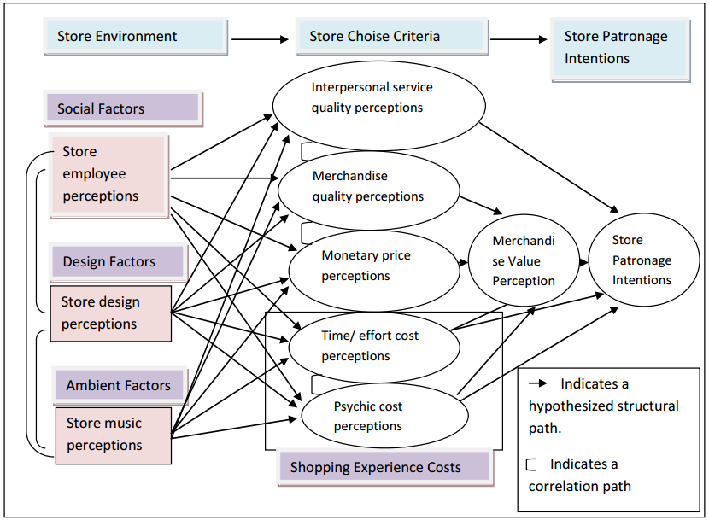
Figure 1 - Conceptual model of consumer loyalty towards retail store
Source - Baker et. al. (2002)
The above conceptual model developed by Ilonen et. al. (2011) has been conceived from the different factors that were considered as the determinants contributing to shopper loyalty. The in-store environment, especially those factors which can have an effect on the attitude formation such as the social factors, in-store design and the store environment would be contributing to the choice of the particular store. Furthermore the choice of the particular store would be providing positive emotional response in the form of service quality offered by the employees of the store, the value perceptions, the impact of time and effort spent and the overall shopping experience. All these would be contributory to the overall value perception which has been identified by Kaul et. al. (2010) as an important determinant of repeated patronage. The repeated patronage intentions as per the model are mostly based on the value perceptions and hence the model indicates that the behavioural loyalty would be based on the positive emotions gained by the customers from the initial store environment to that of the store criteria choice factors. The above model has been taken as the basic conceptual framework for analysis in the present research, which includes almost all of the main determinants of consumer loyalty as has been analysed in the previous sections. The above model is particularly suitable for analysis as it is capturing almost all of the dimensions which have been analysed in the previous sections.

2.8 Conclusion of literature review
When analysing the determining factors of shopper loyalty, it was necessary to begin from the concepts and characteristics of loyalty along with the different phases of loyalty. When analysing the specific determining factors it has been found that there are aspects which contributes to attitudinal loyalty and that contributes to behavioural loyalty. There are some elements which provide positive emotional response that contributes to attitudinal loyalty and the strengthening of attitudinal loyalty would be the actual development of behavioural loyalty or in other words repeated repurchase intentions and the following actions. Several aspects of consumer loyalty would mean that the different determinants have different effect on consumer's attitude and behaviour. Nevertheless the main determinants are the store environment, the layout and design which provide certain level of emotional response and contributes to the choice of the store. The further development of attitudinal loyalty and behavioural loyalty would be dependent upon the value perceptions especially those related to quality and price. It is when the consumers gain significant value perceptions while purchasing at a particular retail store, that there is an improvement in attitudinal loyalty and furthermore the behavioural loyalty. The model developed by Baker (2002) have aptly captured almost all the elements and the determining factors of shopper loyalty to retail store brands and hence can be considered as the conceptual model that can be used for analysing the aspects of shopper loyalty. Hence this model which is depicted in the previous figure would be utilised to develop questionnaire for collecting the data from the customers of the three retail stores-Tesco, Sainsbury and Asda. Furthermore the hypothesised structure path indicating the contribution of different determining factors towards attitudinal and behavioural loyalty development would be used to analyse the actual data collected from the customers.

Chapter 3 Methodology

3.1 Introduction
Any research will have a methodological framework which constitutes of the research design along with the fundamental elements of the research that is shaping knowledge. This chapter provides the fundamental factors that are applying to the present research mainly the considerations of the philosophy of research, research approach, research strategy. Further to this, the section also goes into the details of the various elements of research design that could have been utilised and the rationalisation of those practical elements of research design that have been applied. These would be in the areas of recognising the population, developing a sample from the population, developing the data collection instrument and the method of data analysis used. The essential contribution of this chapter is to provide the method used by the researcher in collecting the data to answer the research questions. Before proceeding further, it is pertinent to remind about the aim, objectives and research questions.

3.1.1 Aim of research
The aim of the research is to analyse the influence of economic crisis on the determining factors of shopper loyalty to branded retail grocery stores in the United Kingdom. A cross-sectional study is conducted to collect data from customers of three different grocery retail branded stores located north of London.

3.1.2 Objectives of research
- To critically analyse the consumer behaviour and characteristics of customer loyalty
- To identify the determining factors of shopper loyalty to branded grocery retailing chains in the United Kingdom.
- To investigate the influence of economic crisis on consumer loyalty to branded grocery retail shops in the United Kingdom.

3.1.3 Research questions
- What are the determining factors of consumer loyalty to branded grocery retail stores in the United Kingdom customer
- What is the influence of economic crisis on the determining factors of customer loyalty to branded grocery retail stores in the United Kingdom?
The above research questions are being tackled in the present report and hence the focus of the present research is to develop the methodologies where the determining factors of consumer loyalty to the three branded grocery retail stores in the United Kingdom is considered. Further the analysis section contributes to the influence of those determining factors of customer loyalty, especially in an environment of economic crisis. Hence the data collection should consider the environment of economic crisis when analysing the determining factors of consumer loyalty.

3.2 Research methodology
Any research is used to develop knowledge in a systematic manner. Most of the research studies in the areas of business management are of practical value as they are providing certain knowledge in the practical realm that can be applied to the business environment in which the study is being conducted (Burns and Burns 2008). The present research is being conducted in the marketing area, especially focusing on consumer loyalty to the branded retail chain stores. Since the nature of the research is to develop practical applications that can be implemented in the business environment, it is necessary to put more focus on the practical implications and hence the collection and analysis of data would have to be considered from this point of view. Nevertheless any research would follow certain pattern and in the present research the author has adopted the model developed by Saunders (2003) in the form of the research onion. The research onion modelhas in it the various aspects of the research such as the philosophy, approach, strategies, methods, time horizons and other pertinent details. The research onion model developed by Saunders (2003) is provided in the below figure. The structure of the chapter is in the form of the research onion.

3.3 Research philosophy
A philosophical point of view is necessary for any research according to Crowther and Lancaster (2012) as a study is conducted to develop knowledge in a specific area. Nevertheless the knowledge development would be dependent on several factors and one of them as per Chapman (2005) is the viewpoint of the researcher about the world. According to Walliman (2010) the researcher can have a strictly scientific frame of mind and can consider knowledge as strictly emanating from social reality that can be recognised and characterised. On the other hand knowledge can also be based on abstract definitions and interpretations provided to the social reality which is another viewpoint (Jackson 2010). Hence the viewpoint adopted by the researcher contributes to the kind of knowledge developed which is an important aspect of any research. Accordingly there are several subdivisions in the research philosophy and these are positivism, interpretivism, realism and epistemology. For the purposes of this research, positivism and interpretivism are analysed in detail and the rationale for choosing one (Positivism) is given subsequently.

3.3.1 Positivist research philosophy
The research philosophy of positivism is considered by individuals who feel that the knowledge can be developed only based on the reality in the social world that can be observed and quantified (Laurel 2003). The data gained from strict scientific methods used in the research can provide concepts and generalisations. Most positivist research studies utilise a very strict scientific method in the areas of data collection and analysis and hence utilise a mainly quantitative strategy which would be discussed subsequently. Important element of a positivist research is the development of hypothesis which is then tested with the help of the data collected. In the present research hypothesis is in the form of the research question as given previously.

3.3.2 Interpretivist research philosophy
The research philosophy of interpretivism considers the knowledge is not specific to the data that can be observed and quantified (Kothari 2009). An individual who considers an interpretation of the data or information which can be observed can go in depth into the subject, although such kind of interpretations may not be truly valid for every kind of situation. In other words the rules and generalisations can be very specific and hence not globally generalised. According to Rugg and Petre (2006) interpretivist form of research philosophy is used when the particular research subject has to be studied in detail and when the researcher has an important role to play in identifying and interpreting the social reality. Many interpretivist research studies utilise qualitative methods, although quantitative studies have also been conducted (Chapman 2005).

3.3.3 Rationale for adopting research philosophy
The present research is considering the determining factors of shopper loyalty to branded retail shops (Sainsbury, Tesco and Asda) from the customers of United Kingdom. It is necessary to adopt a scientific method and the social reality about factors that are determiningconsumer’s loyalty to the branded retail is not open to interpretation. Any kind of interpretations performed on the perceptions of customers about their loyalty and those factors influencing their loyalty would invalidate the generality of such research. Moreover the researcher has to be unbiased in this particular study and the perceptions of customers about their mentality towards the branded retail stores have to be studied. A quantitative method/research strategy has to be adopted (which is discussed subsequently) in order to determine the shopper loyalty. The qualitative study, although would provide in-depth details about the determining factors might not be sufficiently generalisable to the customers of United Kingdom as a whole. All these factors contributed to the adoption of the positivist research philosophy for the present research.

3.4 Approach to research
Approach to research would be mainly based on the consideration of previous studies, the utility value, the concepts and theories, the situation of study, the nature of the Hypothesis and the research questions and so on. In other words the research approach according to Zikmund et. al., (2012)can be based on two elements. One is the existence of previous concepts, theories and hypothesis which can be utilised for the present research. Such kind of study is called deduction where the pre-existing concepts are utilised for the collection of data and its analysis to develop generalisations. In deduction Bryman and Bell (2007) states the formulation of hypotheses, the development of variables from the theoretical and conceptual models, the data collection and analysis of data contributing to generalisations as the main functions. The other approach to research is to concentrate entirely or mostly on data collected from the respondents of the subjects of the study to develop theories and concepts, although in the subsequent stage pre-existing concepts and ideas can be utilised (Hair et. al., 2011). Such type of research is considered as induction where the importance is given to the data collected rather than the utilisation of previous concepts, theories and models.

3.4.1 Rationale for adopting deductive method
The present research is trying to understand and investigate the determining factors of shopper loyalty to branded retail shops in the United Kingdom. Consumer loyalty has been studied in much detail and various theoretical and conceptual frameworks and models have been already developed. The validity and reliability of these models have already been discussed in the literature review and one particular model has been selected for further processing with the help of data to be collected from the respondents of the study. The present research is not trying to develop a model which would involve the determining factors and its influence on customer loyalty. On the other hand the pre-existing theories and concepts are the underlying framework of the present research. Hence it is necessary to adopt a deductive method where the identified models, frameworks and theories are used for the collection of data to particularly investigate the influence of determining factors of consumer loyalty to the branded retail shops in the United Kingdom. The general models are based on customer loyalty and have been studied considering various industries, whereas the present research is focusing on the branded retail shops in the United Kingdom and the customers of United Kingdom. Hence the deductive approach uses the model identified in the literature review to understand the influence of the determining factors on the customers of United Kingdom for the branded retail chain shops.

3.5 Strategy of research
The strategy of research would involve the practical consideration of the processes involved in the research (Bajpai 2003). One main consideration would be the type of data to be collected and the type of analysis, which according to Saunders et. al., (2003) would depend upon the generalisations and even the subject of the study. In the present research the subject of the study is consumer loyalty. Consumer loyalty can be studied from the perspective of customers which would provide better generalisations and especially in the present case the determining factors of consumer loyalty when considering the branded retail chain shops had to be studied. In such a situation, it is necessary to get data from a large number of customers of branded retail chain shops. One reason for including the three different chain retail shops in the United Kingdom (Sainsbury, Tesco and Asda) is the in-depth analysis required on the determining factors. All these considerations would come when considering the strategy of research.
The strategy of research can be divided into quantitative and qualitative. In quantitative research, data collected is numericaland the analysis methods are scientific (Cooper and Schindler 2006). On the other hand qualitative method involves the collection of subjective data (Sekaran and Bougie 2010). As detailed in the previous paragraph, the research requires large amount of data from the customers especially about their attitudes and behaviour to the retail chain shops that are determined by several factors as analysed in the literature review. A range of determining factors were considered in the literature review and to cover this it is necessary to collect data in a numerical fashion. Moreover a large number of respondents from three different chain retail shops had to be studied which again necessitatesa strategy which takes less time, but provides more data or sufficient data that can be used for generalisations. As indicated in this paragraph itself, quantitative research strategy provides numerical data which is easy for analysis and can be collected in a much lesser/shorter time frame. On the other hand qualitative data has the advantage that it gives in-depth details about the subject of the study or in this case those factors that are affecting customer loyalty to the branded retail chain shops in the United Kingdom.
There are several reasons for choosing quantitative strategy, it is also necessary to invalidate a qualitative strategy for the present research. The present research does not require a deeper understanding of influencing factors of customer loyalty, but only a cursory understanding of those factors alone. Much more research has gone into the analysis of the determining factors and since the present research is conducted in an environment of economic crisis, it is assumed that the moderating factors or those determining factors could be time sensitive. Hence this time sensitivity necessitates the collection of data which is not in depth, but provides an outer covering or outer layer about consumer perceptions towards loyalty. Taking on these considerations, the researcher has adopted a strategy of quantitative data collection and analysis.

3.5 Research design
Research design involves the practical aspects of research mainly identification of the population and its characteristics, development of the sample, the development of the data collection instrument and the various methods to be used for data collection and analysis. These are the aspects that are covered in the following sections.

3.5.1 Population of research
The research is conducted on the customers of the branded retail chain shops -- Sainsbury, Tesco and Asda. Hence the population of the research would be the customers of these three chain retail shops and all over the United Kingdom. Hence the characteristics of this population closely resemble the characteristics of the total population of United Kingdom as almost all the individuals in the country could be a customer of any of these three chain retail shops or any other chain retail shops operating in their vicinity. Nevertheless it is to be reasonably assumed that the characteristics of the population of the present research would be closely mimicking that of the characteristics of the population of the country.

3.5.2 Sample of research
It is not possible to study the perspectives of the entire population and hence the sample. A sample is the subset of the population (Sekaran and Bougie 2010) which has the characteristics of the population and hence such a study of the sample would be providing a reasonable understanding of the population (Saunders et. al., 2003). A sample is adopted due to the impracticality and a necessity of studying the entire population which is the present scenario. There are several methods of sampling. The main two types are probability and nonprobability approach. The probability approach according to Kothari (2009) is to develop a statistically precise sample from the population or in other words characteristics of the population and sampling can be defined to a certain extent (Bryman and Bell 2007). In a nonprobability sampling, the characteristics of the sample may not be defined to the certain precision as that of a probability approach. Although probability sampling approach would be able to improve the validity and reliability, there are cases when the probability approach cannot be developed. The present research is one such scenario and a nonprobability sampling approach is adopted. Nevertheless even within the nonprobability sampling, the researcher has gone on for a random development of the sample from the customers of the three branded retail chain shops.

3.5.3 Development of sample
It was initially determined that a practical sample would constitute of equal number of respondents from the three branded retail chain shops. It was also determined that in order to improve the validity and reliability from the perspective of the subjects involved, it is necessary to collect data from different areas of the country as far as possible. Due to the limitations of the researcher in moving to another part of the country, it was decided to collect data from different parts of London, which would provide a sample that is reasonably close to the characteristics of the population of the entire country. Hence the researcher selected three retail shops of Sainsbury, Tesco and Asda at three different locations. Therefore a total of nine retail shops were selected out of which there were three each from Sainsbury, Tesco and Asda. Further the researcher decided to collect data from 10 random respondents for these three retail chain shops from three different places. Altogether a total of 90 customers were involved in the sample. These 90 customers consist of 10 each from Sainsbury, Tesco and Asda located at Barking, Enfield and Heathrow areas. The approach to the development of the sample was a random method where the researcher approached the customers coming out of the retail chain shops at different locations. The method used for the collection of data with the help of the data collection instrument is provided below.

3.5.4 Data collection from sample
Once the determination of the way in which the sample was to be developed, it was necessary to consider the instrument for data collection. The researcher had already finalised on a quantitative method and within the quantitative method of primary data collection, it was necessary to finalise on the specific type. After a lot of consideration, the researcher concluded the survey using a structured self-completed questionnaire would be appropriate. Such a survey would be able to collect data from the customers in an easy manner within a short period of time.
The researcher then focused on the various theories and concepts especially those determining factors of shopper loyalty considering the effect of store, perceptions of value, image of store and consumer characteristics. From all these aspects and the several models analysed in the literature review about the shopper loyalty model, a completely structured questionnaire was developed. The structured questionnaire utilise a five point Likert scale for a range of sentences. The sentences analysed the perceptions of the customers about the aspect of the store, value perceptions, image and consumer characteristics. The consumers were asked to provide the response on a five point Likert scale for each of the sentence.

3.5.5 Pilot study of questionnaire
In order to ensure the reliability and validity of the survey, an initial pilot study was conducted on 10 customers. These 10 customers involved to 3 of Tesco, 3 of Sainsbury and 4 of Asda. All these 10 customers were known to the researcher and were close associates. The survey instrument was provided to the respondents of the pilot study and once they completed the pilot study, an interview was taken about the survey instrument or the questionnaire itself. It was found that some of the sentences were vague and others were open ended. It was also found that there were too many questions in the initial survey. After the pilot study, the researcher further modified the survey instrument to improve the validity and reliability. The researcher also analysed the data collected from the pilot study respondents to ensure that the data would indeed provide answers to the research question.

3.5.6 Primary data collection
Once the survey instrument was pilot tested, the researcher proceeded to data collection. The researcher, as mentioned in the section under sampling, approached the potential respondents (customers of the three chain retail shops at different places) and provided an overview of the objectives of the research. A consent statement was also developed which was provided to the respondents and after the consent was taken, the survey questionnaire was provided. The respondents completed the survey by themselves. The survey took two weeks to complete (last two weeks of August 2013). The researcher was able to collect the responses of 10 customers of Tesco, Sainsbury and Asda located at Enfield, Barking and Heathrow.

3.5.7 Analysis of primary data
The analysis of the data collected from the total 90 respondents of the study was conducted with the help of scientific and mathematical methods. Microsoft Excel was used as the main tool for analysing the numerical data. Initially the researcher proceeded with the conversion of the Likert scale to the numerical format after which several calculations were performed and compared with each other. A comparison method was adopted where the perceptions of customers were analysed with each other. In other words the perceptions of customers of Tesco, Sainsbury and Asda each of the variables identified as determining factors were compared to identify the strengths of each. The average and the variance in the data were also calculated for each of the three retail stores. From this analysis, the researcher proceeded to evaluate the determining factors of shopper loyalty by taking into consideration secondary data.

3.5.8 Ethical aspects of research
Any research would involve several aspects related to ethics. The present research was conducted in a purely professional manner and according to the ethical foundations of the University. The researcher ensured that there is no harm to the respondents due to the participation. No personal data was collected from any of the respondents. The data collected from the respondents were numerical in nature and hence cannot be identified or related to any of the respondents. Furthermore the questionnaire was completed and the researcher took no part in the completion of the questionnaire by any of the respondents and hence the data collected is completely unbiased.

Chapter 4 Data presentation and analysis

4.1 Introduction
This chapter provides the analysis of the data collected from the customers of Sainsbury, Tesco and Asda stores. The chapter provides the behavioural and attitudinal loyalty dimensions of customers towards each of the factors that determine the loyalty to each of the retail store brands. The consumers perceptions of responses were collected with the help of a five point Likert scale and the data about their perceptions are calculated by taking the percentage of response to each of the Likert scale factor and considering both behavioural and attitudinal loyalty. The behavioural loyalty is analysed based on whether the consumers would be purchasing for using the services of the same store and attitudinal loyalty is analysed with the help of consumer's positive or negative response about the particular characteristics.

4.2 Atmosphere
 |  | Atmosphere motivating patronage (Behaviour) | Atmosphere refreshing (Attitude)
Sainsbury | Strongly approve | 18 % | 10 %
Sainsbury | Approve | 28 % | 16 %
Sainsbury | Neither approve nor disapprove | 24 % | 38 %
Sainsbury | Disapprove | 16 % | 18 %
Sainsbury | Strongly disapprove | 14 % | 18 %
Tesco | Strongly approve | 26 % | 20 %
Tesco | Approve | 34 % | 26 %
Tesco | Neither approve nor disapprove | 16 % | 20 %
Tesco | Disapprove | 12 % | 22 %
Tesco | Strongly disapprove | 12 % | 12 %
Asda | Strongly approve | 34 % | 28 %
Asda | Approve | 42 % | 36 %
Asda | Neither approve nor disapprove | 12 % | 18 %
Asda | Disapprove | 8 % | 12 %
Asda | Strongly disapprove | 4 % | 6 %
Table 1 - Atmosphere as a dimension of behavioural and attitudinal loyalty

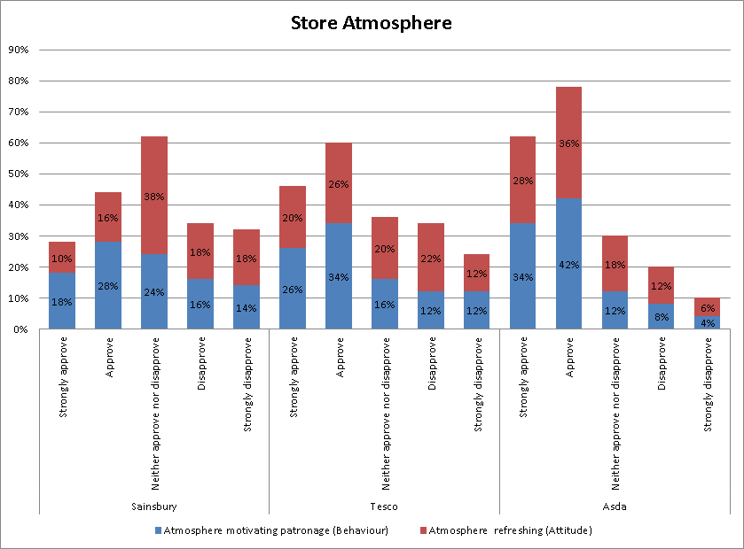
Figure 2 - Atmosphere as a dimension of behavioural and attitudinal loyalty
When considering the above table and figure and the responses of the consumers by taking atmosphere as motivating their repurchases (behavioural loyalty) and again analysing their attitude towards the store brand (attitudinal loyalty), it can be seen that Asda has the best store atmosphere which is able to capture consumer loyalty, but is closely followed by Tesco. While a majority of the customers of Asda has given a strong approval about store atmosphere being able to capture behavioural and attitudinal loyalty, in the case of Tesco, the atmosphere is able to capture behavioural loyalty, but not attitudinal loyalty to the same extent. While in the case of Asda the total number of respondents who have indicated their strong approval and approval about store atmosphere contributing to behavioural loyalty and attitudinal loyalty are 76 % (for behavioural loyalty) and 64 % (for attitudinal loyalty). The number of customers who have given similar responses in the case of Tesco is 60 % (for behavioural loyalty) and 46 % (for attitudinal loyalty). It should also be pertinent to note that 20 % of the customers have indicated their neither approval no disapproval in the case of atmosphere of Tesco store contributing to their attitudinal loyalty. In the case of Sainsbury, a large majority of customers have given their neither approval any disapproval for both attitudinal and behavioural loyalty (24 % and 38 % respectively). This would indicate that the store atmosphere in Asda is much better than that of Tesco and Sainsbury and is able to capture both behavioural and attitudinal loyalty.

4.3 Store layout
 |  | Store layout motivating patronage (Behaviour) | Store layout refreshing (Attitude)
Sainsbury | Strongly approve | 14 % | 8 %
Sainsbury | Approve | 26 % | 12 %
Sainsbury | Neither approve nor disapprove | 16 % | 32 %
Sainsbury | Disapprove | 24 % | 30 %
Sainsbury | Strongly disapprove | 20 % | 18 %
Tesco | Strongly approve | 18 % | 14 %
Tesco | Approve | 32 % | 16 %
Tesco | Neither approve nor disapprove | 16 % | 28 %
Tesco | Disapprove | 20 % | 26 %
Tesco | Strongly disapprove | 14 % | 16 %
Asda | Strongly approve | 26 % | 22 %
Asda | Approve | 38 % | 34 %
Asda | Neither approve nor disapprove | 14 % | 20 %
Asda | Disapprove | 14 % | 14 %
Asda | Strongly disapprove | 8 % | 10 %
Table 2 – Store layout as a dimension of behavioural and attitudinal loyalty
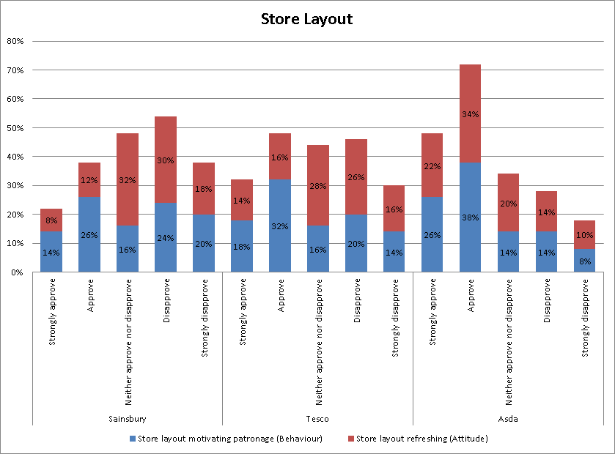
Figure 3 -Store Layoutas a dimension of behavioural and attitudinal loyalty
Layout of the store can motivate the consumers to come back to the same store which also can provide a positive attitude. Many retail stores now design their stores to ensure that the customers find the products easily as well as to increase the retention and engagement with the products. When considering store layout as a dimension that is contributing to behavioural and attitudinal loyalty, the customers of Asda seems to indicate positive response. In other words store layout of Asda is contributing to positive behavioural and attitudinal loyalty. On the other hand behavioural loyalty of customers or the customer's motivation to come back to Tesco store is strongly is strongly influenced by store layout; however the same has not been converted to a positive attitude which is the same case with that of Sainsbury. Sainsbury seems to be faring poorly from the consumer's perspective about store layout; although it is able to induce certain level of behavioural loyalty; but many customers of Sainsbury do not have a positive attitude towards the store layout. It is seen that a majority of the customers have responded either negatively (48 %) or given a neutral opinion (32 %) to the question about store layout giving a positive attitude in the case of Sainsbury. A similar number, although slightly reduced is seen in the case of consumer responses from Tesco. On the other hand in the case of Asda, a majority of the customers have a positive opinion about store layout as motivating their repurchase intentions and also developing positive attitude.

4.4 Uniqueness of store
 |  | Uniqueness of store motivating patronage (Behaviour) | Uniqueness of store refreshing (Attitude)
Sainsbury | Strongly approve | 6 % | 6 %
Sainsbury | Approve | 14 % | 16 %
Sainsbury | Neither approve nor disapprove | 44 % | 40 %
Sainsbury | Disapprove | 22 % | 20 %
Sainsbury | Strongly disapprove | 14 % | 18 %
Tesco | Strongly approve | 12 % | 12 %
Tesco | Approve | 20 % | 22 %
Tesco | Neither approve nor disapprove | 34 % | 30 %
Tesco | Disapprove | 22 % | 20 %
Tesco | Strongly disapprove | 12 % | 16 %
Asda | Strongly approve | 20 % | 24 %
Asda | Approve | 30 % | 34 %
Asda | Neither approve nor disapprove | 14 % | 18 %
Asda | Disapprove | 18 % | 14 %
Asda | Strongly disapprove | 18 % | 10 %
Table 3as a dimension of behavioural and attitudinal loyalty

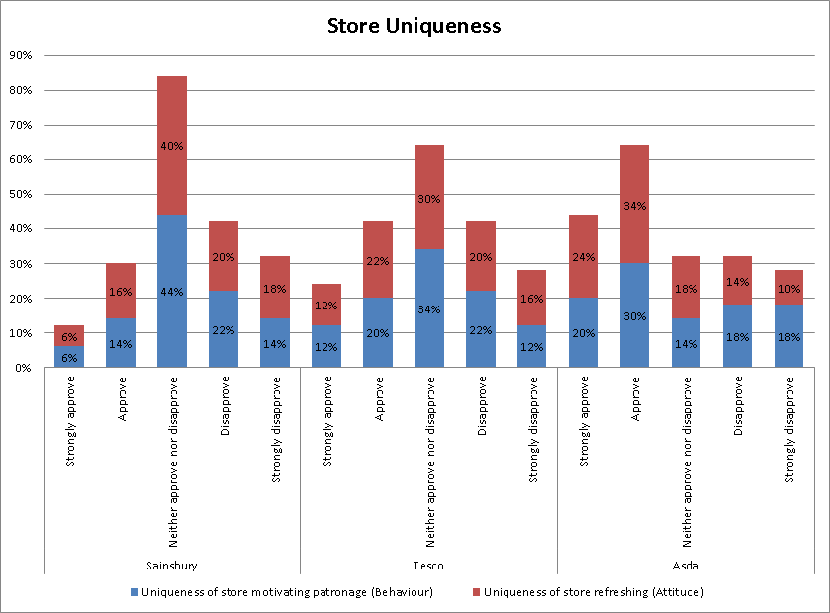
Figure 4as a dimension of behavioural and attitudinal loyalty
Store uniqueness can be considered from the perspective of uniqueness of merchandise as well as the differentiation from the other stores. Two out of the three retail store brands seems to have followed a similar pattern in the stores with same kind of products and little differentiation which seems to be the reason for many consumers’ neutral opinion or response towards store uniqueness as a factor contributing to behavioural and attitudinal loyalty. The highest level of neutral response is for the customers from Sainsbury with 40 % and 44 % for attitudinal and behavioural loyalty respectively. In the case of Tesco the same values are 34 % and 30 %. Since a large majority of the customers of both Tesco and Sainsbury are indicating their neutral opinion about uniqueness of store one can conclude that uniqueness is not an important variable that is affecting consumer loyalty to these stores. Another consideration that would be pertinent to the present data from the customers would be the analysis that both Tesco and Sainsbury do not have any uniqueness in their stores and hence the customers are not identifying uniqueness as a motivating factor in repurchases intentions or positive attitude formation.
However there are some customers especially in the case of Asda indicates that uniqueness of the story is an important factor in their loyalty to the store. A significant level of positive response is evident from the customers of Asda indicating its uniqueness as a contributor to both attitudinal and behavioural loyalty. The numbers of customers who have provided positive responses are significantly higher than that of Tesco and Sainsbury which would indicate that Asda stores are unique and this is an important factor contributing to store loyalty of customers to Asda.

4.5 Convenience of store
 |  | Convenience of store motivating patronage (Behaviour) | Convenience of store refreshing (Attitude)
Sainsbury | Strongly approve | 28 % | 2 %
Sainsbury | Approve | 38 % | 8 %
Sainsbury | Neither approve nor disapprove | 12 % | 32 %
Sainsbury | Disapprove | 12 % | 46 %
Sainsbury | Strongly disapprove | 10 % | 12 %
Tesco | Strongly approve | 20 % | 24 %
Tesco | Approve | 30 % | 34 %
Tesco | Neither approve nor disapprove | 18 % | 16 %
Tesco | Disapprove | 16 % | 12 %
Tesco | Strongly disapprove | 16 % | 14 %
Asda | Strongly approve | 18 % | 12 %
Asda | Approve | 26 % | 24 %
Asda | Neither approve nor disapprove | 26 % | 26 %
Asda | Disapprove | 18 % | 22 %
Asda | Strongly disapprove | 12 % | 16 %
Table 4- Convenience as a dimension of behavioural and attitudinal loyalty
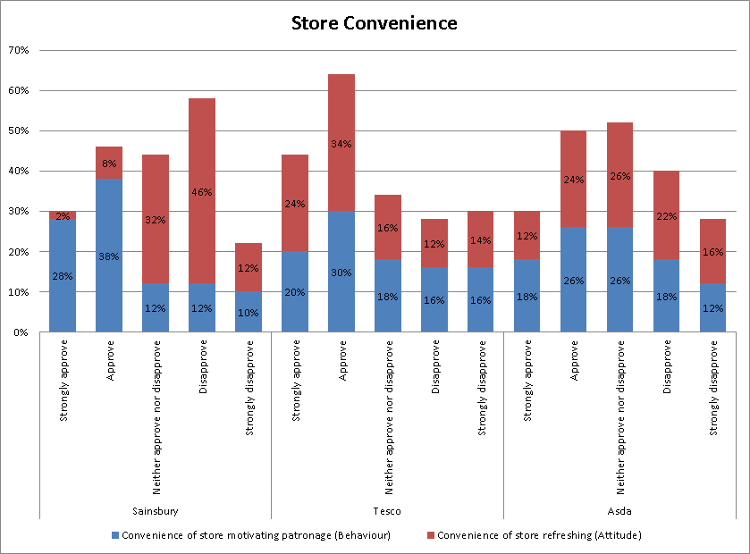
Figure 5- Convenience as a dimension of behavioural and attitudinal loyalty
Contradictory results are emanating from the consumer response towards the question of convenience motivating patronage as well as attitude. While in the case of Sainsbury, there is significant level of repurchase intentions due to the convenience of the store, the attitude formed towards this convenience aspect is negative. In the case of Tesco, both behavioural and attitudinal loyalty is relevant when the data is considered or in other words consumers are evaluating convenience of Tesco stores as a motivator for the repurchases and developing positive attitude. In the case of Asda, the level of convenience offered by the stores is not enabling the customers to develop repurchase intentions or positive attitude.
When going in-depth into the data, it can be seen that a majority of the customers who have provided the data for Sainsbury have provided their positive response towards the factor of convenience as a motivator in patronage. A total of 66 % of the customers have given their strong approval or approval to the sentence which indicates that customers are patronising Sainsbury stores mainly because of a convenience factor. However when considering the attitude for the customers towards the Sainsbury, there is a rather negative implications with roughly 32 % giving a neutral response and 58 % giving a negative response towards convenience as a contributor to attitude formation. The reason for such a contradictory stance would be the considerations that convenience as a practical factor rather than an attitudinal factor. Sainsbury stores are located in the town centres and hence accessible to where majority of the population. Nevertheless there seems to be a negative attitude towards the accessibility factor for the Sainsbury stores.
When considering the case of Tesco stores and the data, there is a large number of customers who have indicated their positive intentions about repurchase based on convenience and attitude development in a positive manner. In the case of Tesco hence one can say that convenience of the stores is an important factor that is contributing to repurchase intentions and positive attitude or both behavioural and attitudinal loyalty. In the case of Asda, there is a large neutral opinion (26 % each) and negative opinion about the convenience of the stores. Many of Asda stores are located out of the town centres and are bigger stores than Tesco and Sainsbury. The convenience factor from the perspective of accessibility to the stores is limited because the customers would have to travel. On the other hand as the store layout and model has a large number of products under one store this is another factor that can define convenience. Nevertheless a majority of the customers have taken the concept of convenience based on accessibility and in this case Tesco seems to have gained the upper hand due to their location and gaining both behavioural and attitudinal loyalty from the customers. In the case of Sainsbury the behavioural loyalty is developed which is devoid of attitudinal loyalty.

4.6 Value of products
 |  | Value of products motivating patronage (Behaviour) | Value of products refreshing (Attitude)
Sainsbury | Strongly approve | 16 % | 4 %
Sainsbury | Approve | 18 % | 10 %
Sainsbury | Neither approve nor disapprove | 24 % | 32 %
Sainsbury | Disapprove | 18 % | 32 %
Sainsbury | Strongly disapprove | 24 % | 22 %
Tesco | Strongly approve | 20 % | 12 %
Tesco | Approve | 24 % | 16 %
Tesco | Neither approve nor disapprove | 24 % | 24 %
Tesco | Disapprove | 16 % | 30 %
Tesco | Strongly disapprove | 16 % | 18 %
Asda | Strongly approve | 30 % | 22 %
Asda | Approve | 38 % | 28 %
Asda | Neither approve nor disapprove | 18 % | 16 %
Asda | Disapprove | 10 % | 20 %
Asda | Strongly disapprove | 4 % | 14 %
Table 5- Value of products as a dimension of behavioural and attitudinal loyalty

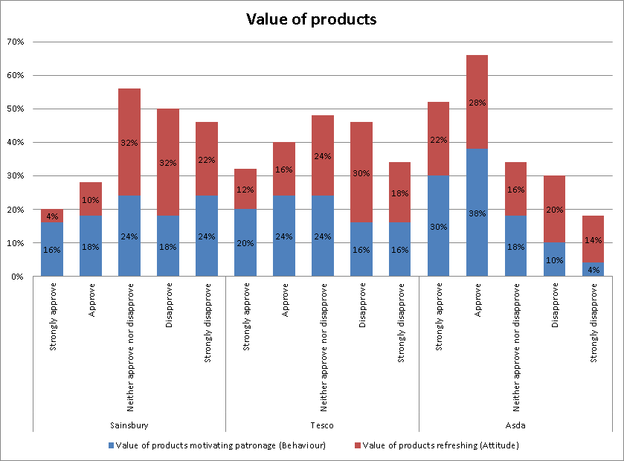
Figure 6 - Value of productsas a dimension of behavioural and attitudinal loyalty
Large format stores would be able to have large number of products differentiated in terms of value. Small format stores would not be able to stock a large variety of the same product category. Both Tesco and Sainsbury, although having larger store formats, a vast majority are small scale located at the town centre. Asda on the other hand is a large format store, but located outside the town centre and hence able to stock a large variety of products in the same category. Based on the value perception, the customers seem to patronise Asda stores again with a positive attitude towards the store brand. When considering behavioural loyalty based on the value of products, strong approval is provided by 30 % and approval provided by 38 % with neutral and negative response is very marginal in the case of Asda. When considering attitudinal loyalty, strong approval is provided by 22 % and approval provided by 28 %, although there seems to be a larger negative opinion on the neutral and the negative side. When contrasting the responses towards behavioural and attitudinal loyalty in the case of Asda, it seems that customers are gaining value in a practical sense and hence developing behavioural loyalty or repurchase intentions; however the value perspective is diminished by the inconvenience factor and hence affecting attitudinal loyalty.
When considering both Tesco and Sainsbury, there seems to be negative opinion about the value of products especially in the case of Sainsbury. It would be particularly pertinent to note that behavioural loyalty is evident in the case of Tesco with a total of 44 % of the customers indicating their positive response towards the question for Tesco, while in the case of Sainsbury this is 34 %. Nevertheless the attitudinal loyalty is diminished significantly in the case of Sainsbury and higher in the negative and neutral side. 32 % have a neutral response with a combined 54 % on the negative side about the question towards attitude formation considering value of products of Sainsbury. In the case of Tesco, the same numbers are 24 % (neutral) and 48 % (negative response) towards attitude formation. On the other hand Tesco has managed to develop certain behavioural loyalty or repurchase intentions based on value of products. On the whole Asda seems to provide value to the customers and hence gaining behavioural and attitudinal loyalty at the same time, while Tesco seems to game certain level of behavioural loyalty but lacking in the area of attitudinal loyalty. The case of Sainsbury, behavioural loyalty is evident although marginal and contrasting the attitudinal loyalty is clearly negative.

4.7 Price of products
 |  | Price of products motivating patronage (Behaviour) | Price of products refreshing (Attitude)
Sainsbury | Strongly approve | 4 % | 10 %
Sainsbury | Approve | 6 % | 16 %
Sainsbury | Neither approve nor disapprove | 38 % | 26 %
Sainsbury | Disapprove | 34 % | 32 %
Sainsbury | Strongly disapprove | 18 % | 16 %
Tesco | Strongly approve | 14 % | 14 %
Tesco | Approve | 22 % | 20 %
Tesco | Neither approve nor disapprove | 18 % | 18 %
Tesco | Disapprove | 26 % | 28 %
Tesco | Strongly disapprove | 20 % | 20 %
Asda | Strongly approve | 22 % | 28 %
Asda | Approve | 36 % | 38 %
Asda | Neither approve nor disapprove | 16 % | 12 %
Asda | Disapprove | 12 % | 16 %
Asda | Strongly disapprove | 14 % | 6 %
Table 6 - Price of productsas a dimension of behavioural and attitudinal loyalty

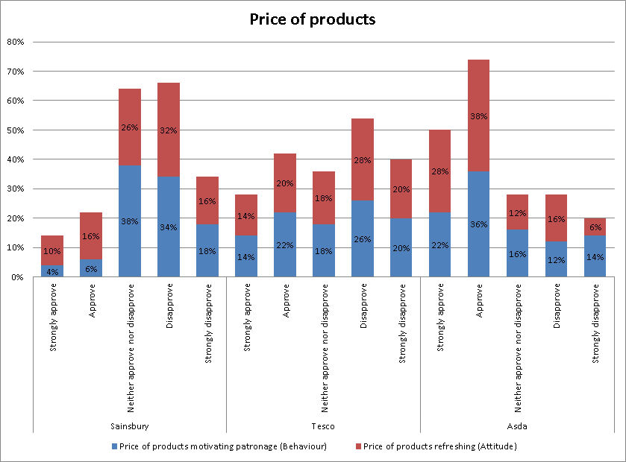
Figure 7- Price of products as a dimension of behavioural and attitudinal loyalty
In the case of the price of products, Asda with the larger store formats seems to be gaining better behavioural and attitudinal loyalty from the customers. On the other hand in the case of Sainsbury, both behavioural and attitudinal loyalty is negative. In the case of Tesco, there is also a large level of negative response towards both behavioural and attitudinal loyalty, but not to the same extent as that of the customers of Sainsbury. Overall when considering the data, Asda stores seems to provide better pricing of products to the customers and hence evoking behavioural and attitudinal loyalty. A majority of the customers have developed behavioural loyalty towards Asda (58 %) and in the case of attitudinal loyalty is even higher with the response rate of 66 %. Strong negative or neutral response is evident in the case of Sainsbury for both behavioural and attitudinal loyalty when considering price as a factor. The neutral response in the case of behavioural loyalty is 38 %, attitudinal loyalty is 26 % for Sainsbury, and negative response is totally 52 % (behavioural loyalty) and 48 % (attitudinal loyalty). In the case of Tesco, there is again strong disapproval, but not to the same extent as that of Sainsbury. 46 % of the customers are indicating their negative response to their repurchase intentions based on price at Tesco and a similar number of customers are again indicating their negative attitude formation towards the price. Overall one can say that customers are not patronising Sainsbury due to its price factor. In the case of Tesco there is some level of attitudinal loyalty formation; however this is not very strong. Asda is providing better priced products to the customers and hence evoking both attitudinal and behavioural loyalty.

4.8 Familiarity with layout
 |  | Familiarity with layout motivating patronage (Behaviour) | Familiarity with layout refreshing (Attitude)
Sainsbury | Strongly approve | 28 % | 32 %
Sainsbury | Approve | 42 % | 42 %
Sainsbury | Neither approve nor disapprove | 12 % | 14 %
Sainsbury | Disapprove | 10 % | 6 %
Sainsbury | Strongly disapprove | 8 % | 6 %
Tesco | Strongly approve | 26 % | 36 %
Tesco | Approve | 36 % | 44 %
Tesco | Neither approve nor disapprove | 18 % | 6 %
Tesco | Disapprove | 12 % | 8 %
Tesco | Strongly disapprove | 8 % | 6 %
Asda | Strongly approve | 12 % | 8 %
Asda | Approve | 18 % | 14 %
Asda | Neither approve nor disapprove | 28 % | 38 %
Asda | Disapprove | 32 % | 24 %
Asda | Strongly disapprove | 10 % | 16 %
Table 7- Familiarity with layout as a dimension of behavioural and attitudinal loyalty
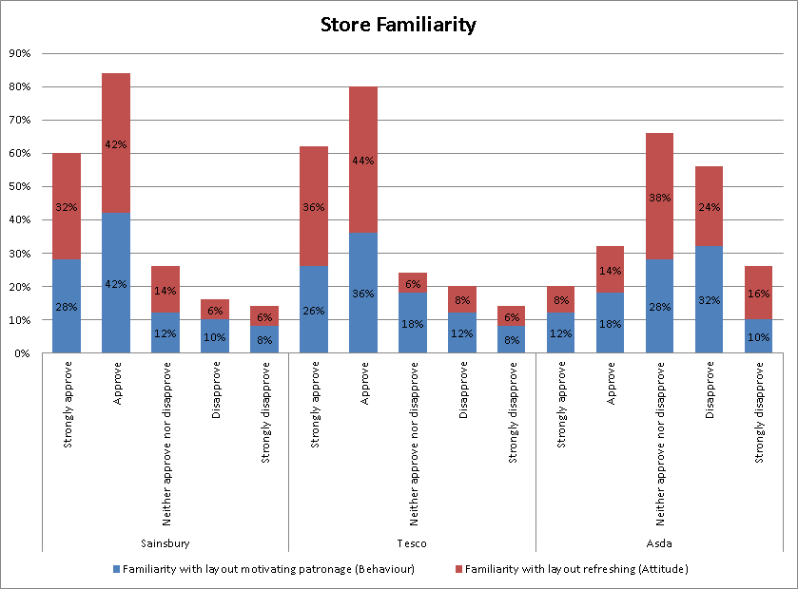
Figure 8- Familiarity with layout as a dimension of behavioural and attitudinal loyalty
Larger store formats are complicated whereas smaller store formats are easy for the customers from the perspective of finding their products easily. A majority of Sainsbury and Tesco stores are smaller formats whereas Asda as indicated previously is a large format with a large number of products. Familiarity with the store layout is an important factor that can motivate the customers to come back to the store and develop positive attitude. This aspect is pertinent from the data gained from the customers about store familiarity contributing to behavioural and attitudinal loyalty. The smaller store formats such as Sainsbury and Tesco is able to gain both behavioural and attitudinal loyalty due to the store familiarity gained by the customers. However in the case of Asda, there is a large neutral or negative response about store familiarity that is a contributing factor towards attitudinal and behavioural loyalty.
In the case of Sainsbury, the combined positive response towards attitudinal loyalty is 70 % with behavioural loyalty even higher at 74 %. Similarly in the case of Tesco the behavioural loyalty due to store familiarity is that 62 % and attitudinal loyalty is even higher than that of Sainsbury at 80 %. In the case of Asda, there is a large neutral response and again a similar negative response to store familiarity. 20 % and 30 % of the customers are providing a neutral response to the questions about behavioural characteristics and attitudinal characteristics in the case of store familiarity. Similarly the responses on the negative side to both dimensions are 42 % and 40 % respectively. The data gives rise to the conclusions that smaller store formats provides for better store familiarity which is evidently contributing to better behavioural and attitudinal loyalty and in particular case since Asda is having larger store formats, is unable to gain behavioural and attitudinal loyalty. On the other hand both Tesco and Sainsbury due to the smaller sized formats is enabling the customers to easily access the products, hence providing a convenience factor, and ensuring behavioural and attitudinal loyalty to the store brands.

4.9 Service quality
 |  | Service quality motivating patronage (Behaviour) | Service quality provided refreshing (Attitude)
Sainsbury | Strongly approve | 2 % | 2 %
Sainsbury | Approve | 6 % | 6 %
Sainsbury | Neither approve nor disapprove | 48 % | 32 %
Sainsbury | Disapprove | 32 % | 38 %
Sainsbury | Strongly disapprove | 12 % | 22 %
Tesco | Strongly approve | 4 % | 6 %
Tesco | Approve | 12 % | 18 %
Tesco | Neither approve nor disapprove | 34 % | 30 %
Tesco | Disapprove | 26 % | 30 %
Tesco | Strongly disapprove | 24 % | 16 %
Asda | Strongly approve | 6 % | 8 %
Asda | Approve | 16 % | 22 %
Asda | Neither approve nor disapprove | 28 % | 34 %
Asda | Disapprove | 26 % | 18 %
Asda | Strongly disapprove | 24 % | 18 %
Table 8 - Service quality as a dimension of behavioural and attitudinal loyalty

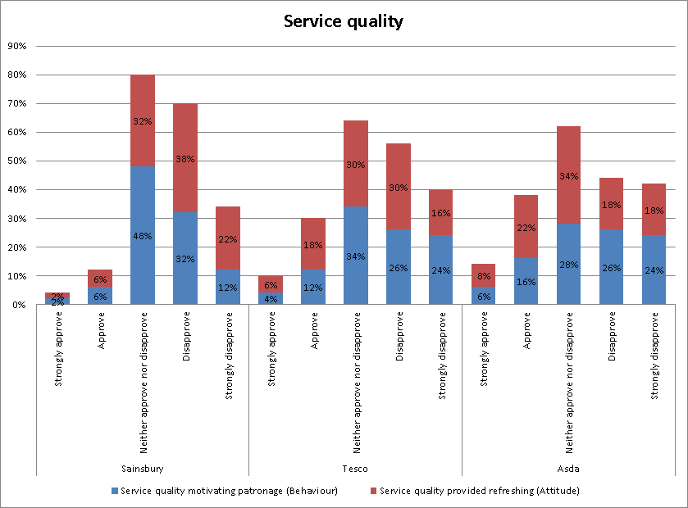
Figure 9- Service quality as a dimension of behavioural and attitudinal loyalty
Service quality can be considered as the service provided by the employees of the store to the customers. Many of the retail stores have moved into self-service concept where there is negligible contact between the employees and the customers. Even the checkout and payment for the products purchased at the store are being automated. This self-service concept is enabling the stores to reduce the employee cost as well as other operational costs. When considering the data from the consumers, service quality from the perspective of many customers are negative and are contributing to negative attitudinal and behavioural loyalty for all the three stores. Tesco and Sainsbury have implemented automated checkout facilities at almost all of their stores and this is evident in the case of customer responses about service quality as a contributor to behavioural and loyalty to the stores. Very strong negative response or disapproval is evident in the case of Sainsbury followed by Tesco and Asda.
In the case of Sainsbury, the neutral responses to both behavioural and attitudinal characteristics are 48 % and 32 % respectively. The combined negative responses towards service quality in contributing to behavioural and attitudinal loyalty are 44 % and 60 %. In the case of Tesco the neutral response is 34 % and 30 % respectively for behavioural and attitudinal loyalty and negative responses to the same dimensions are 50 % and 46 % respectively. A similar level of negative response is also evident in the case of Asda. On the whole one can say that none of the store brands is providing service quality through its employees due to the lack of contact between the customers and the employees. The customers themselves have to find the products they want and even pay for them at the automated checkout which is reducing the level of service quality expectations. This is contributing to negative attitudinal and behavioural loyalty from the customers of all the three store brands.

4.10 Brand image
 |  | Brand image motivating patronage (Behaviour) | Brand image refreshing (Attitude)
Sainsbury | Strongly approve | 26 % | 26 %
Sainsbury | Approve | 38 % | 38 %
Sainsbury | Neither approve nor disapprove | 12 % | 10 %
Sainsbury | Disapprove | 16 % | 14 %
Sainsbury | Strongly disapprove | 8 % | 12 %
Tesco | Strongly approve | 24 % | 26 %
Tesco | Approve | 36 % | 34 %
Tesco | Neither approve nor disapprove | 8 % | 12 %
Tesco | Disapprove | 16 % | 16 %
Tesco | Strongly disapprove | 16 % | 12 %
Asda | Strongly approve | 28 % | 32 %
Asda | Approve | 36 % | 38 %
Asda | Neither approve nor disapprove | 6 % | 12 %
Asda | Disapprove | 12 % | 8 %
Asda | Strongly disapprove | 18 % | 10 %
Table 9 - Brand imageas a dimension of behavioural and attitudinal loyalty

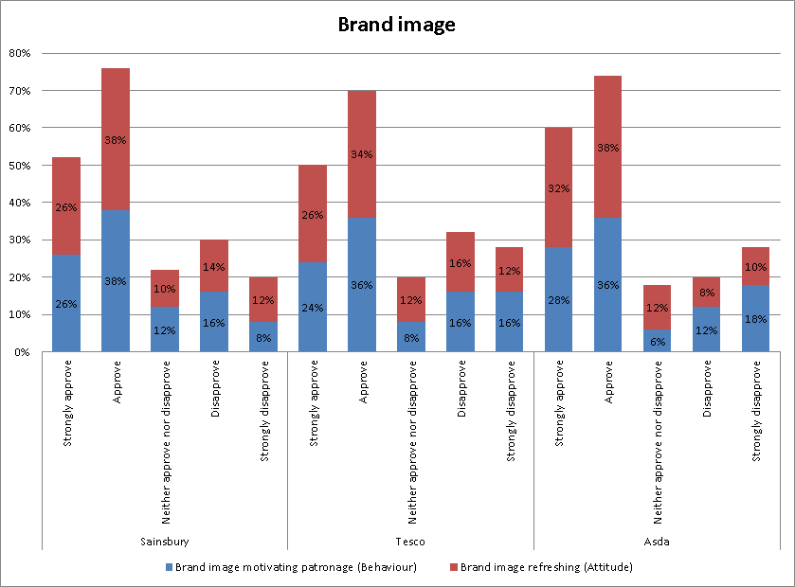
Figure 10- Brand image as a dimension of behavioural and attitudinal loyalty
Brand image of the store is an important factor that can contribute to loyalty, both behavioural and attitudinal. The three stores identified and involved in the survey -- Sainsbury, Tesco and Asda are having high brand value and brand image in the United Kingdom. Although Tesco is the largest, when considering the data collected from the customers of the three branded stores, it seems there is no significant deviation between the three. However it is very clear that brand image is an important factor that is contributing to both behavioural and attitudinal loyalty as is evident from the responses of the customers.
In the case of Sainsbury, as with the two other branded retail stores, there is high attitudinal and behavioural loyalty from the customers. The number of customers who have indicated that they would be visiting Sainsbury store for the repurchases based on the brand image of the store is 64 % and at the same time the attitudinal loyalty due to brand image is 62 %. In the case of Tesco the responses are 62 % and 60 % respectively whereas in the case of Asda is 64 % and 70 % respectively. Although there is a slight increase in the level of the number of customers who have indicated that Asda's brand image is contributing to higher behavioural and attitudinal loyalty, the level of responses from the customers of other two branded retail stores are no less insignificant and in different from that of Asda. On the whole one can say that the brand image of all the three retail stores is indeed a contributor to both behavioural and attitudinal loyalty.

4.11 Loyalty schemes
 |  | Loyalty scheme motivating patronage (Behaviour) | Loyalty scheme refreshing (Attitude)
Sainsbury | Strongly approve | 36 % | 36 %
Sainsbury | Approve | 42 % | 42 %
Sainsbury | Neither approve nor disapprove | 8 % | 6 %
Sainsbury | Disapprove | 12 % | 12 %
Sainsbury | Strongly disapprove | 2 % | 4 %
Tesco | Strongly approve | 34 % | 34 %
Tesco | Approve | 46 % | 42 %
Tesco | Neither approve nor disapprove | 6 % | 8 %
Tesco | Disapprove | 8 % | 12 %
Tesco | Strongly disapprove | 6 % | 4 %
Asda | Strongly approve | 34 % | 34 %
Asda | Approve | 42 % | 40 %
Asda | Neither approve nor disapprove | 8 % | 12 %
Asda | Disapprove | 8 % | 8 %
Asda | Strongly disapprove | 8 % | 6 %
Table 10 - Loyalty schemes as a dimension of behavioural and attitudinal loyalty

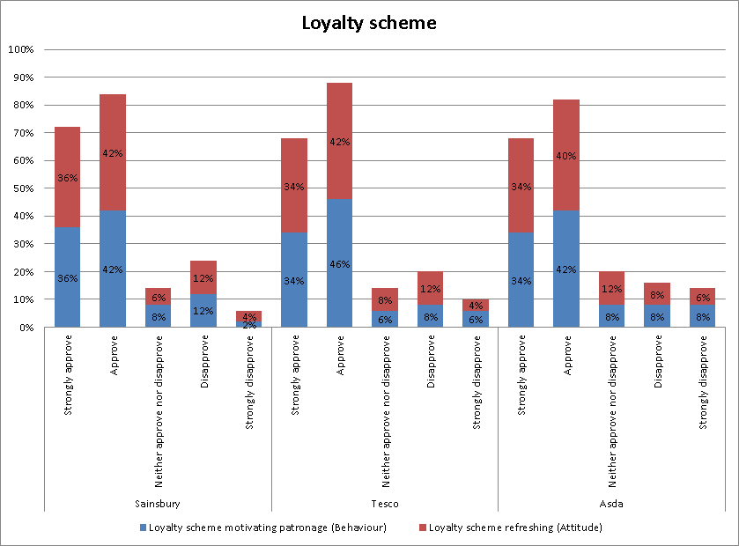
Figure 11 - Loyalty schemesas a dimension of behavioural and attitudinal loyalty
A majority of the retail stores have introduced loyalty schemes or customer retention programs where the customers are benefited while they are purchasing more number of products of from the retail store. Although Tesco has pioneered this concept and has been considered as quite successful, the other two also have introduced their own loyalty schemes. The data collected from the customers about loyalty schemes would also indicate that it is an important contributor to both behavioural and attitudinal loyalty. Although Tesco's loyalty scheme is considered superior in the market than that of others, the level of response received from the customers of the three retail stores do not indicate any kind of differentiation and a superior effect for Tesco. A majority of the customers of all the three retail stores have indicated that they are having repurchase intentions and attitudinal loyalty to the retail store brands considering the loyalty schemes. Even the number of customers who have responded for both attitudinal and behavioural loyalty dimensions and characteristics are not very different from each other.

Discussion
Main consideration of the data collection process was to identify customer loyalty and the contributing factors towards developing loyal customers for three branded retail shops -- Sainsbury, Tesco and Asda. Since the present research study has been conducted in the backdrop of economic recession, although with signs of recovery, the horizontal/cross sectional study was able to provide the current mentality and those determining factors of customer loyalty and the contributing factors at the currenteconomic conditions. Moreover since three different retail chain stores are taken into consideration, which are catering to a majority of the grocery market in the United Kingdom, the main determinants of consumer loyalty has been clearly established from the data collected. Furthermore the noticeable shift in the purchasing pattern of the customers has been considered in the data collected and is clearly evident when analysing the data. The final objectives of investigating the determining factors of shopper loyalty to branded grocery retail chains and the influence of economic crisis on consumer loyalty to branded grocery retail shops is the main objective of the present chapter.
While the definitions and characteristics of customer loyalty has been clearly provided in the literature review, it is pertinent to mention here that consumers positive attitudes in a relative manner to that of a product or company can be considered as loyalty which has the consequence of repeatedly purchases (Waarden 2008); nevertheless dependent on the involvement of both behavioural and attitudinal loyalty (Shannon and Mandhachitara 2008). Furthermore it was also understood that there could be latent loyalty, spurious loyalty and no loyalty,dependent upon different characteristics of the customer and that of the product or the service (Turner and Wilson 2006).
While several aspects that contributes to customer loyalty was also evaluated, it was found that in the case of retail stores there could be different factors coming into play when comparing customer loyalty in the case of branded products (Bellizzi and Bristol 2004). While convenience, accessibility, availability, discretion (Findlay and Sparks 2008), purchase behaviour, economic conditions, price, quality (Kerr 2009) and so on were analysed, at the end a framework was developed in the literature review which considered 10 aspects or determinants of customer loyalty to a retail store. These factors involve the environment within the store ranging from social factors, design factors and ambient factors which have an effect on the store choice criteria and further on the patronage intentions (Hoffman and Lowitt 2008). Once the fundamental framework was developed, the questionnaire was designed to collect data from the customers of Tesco, Sainsbury and Asda.
Taking the overall analysis, it is clear that many customers are positive to different aspects of customer loyalty and furthermore they find that these aspects are more relevant and evident in the case of Asda, followed by Tesco and then by Sainsbury. When taking the overall analysis, one can clearly identified the level of loyalty to different branded retail stores. The customer's loyalty to Asda and Tesco are almost the same level considering their positive perceptions to different attributes of loyalty factors.
In the case of store atmosphere, Asda gains both behavioural and attitudinal loyalty and when considering the present economic climate, it is more pertinent to note that Asda has much more number of products under their stores than many Tesco stores which are in different formats. However Asda has only one type of format with a superstore structure which involves a large number of products. In the case of store layout as well, consumers positive preference towards the layout of Asda which is followed by Tesco is clearly evident; however it is to be noted here that many customers are also favourable to the store layout of Sainsbury. Hence store layout seems to have evoked different responses from the customers although Asda has gained the upper hand when considering the data.
When considering the uniqueness of the store, Sainsbury seems to have better contribution to customer's positive perception with Asda and Tesco following a similar pattern in the stores with same kind of products and little differentiation. Many customers have a neutral opinion towards the similarity of the pattern of the stores and the type of products available. In the present market conditions, customers would be looking forward to different type of products with different price tags and hence uniqueness would be a main factor in the current economic situation (Burt 2000).
Convenience is also an important factor that has an effect on consumer's loyalty to the store. In the case of Sainsbury there is significant level of repurchase intentions due to the convenience of the store; nevertheless the attitude formed toward this convenience aspect is negative. In the case of Tesco as well both behavioural and attitudinal loyalty is relevant when the data is considered or in other words consumers are evaluating convenience of Tesco stores as a motivator for their repurchases. Convenience in the present condition of economic crisis would mean less financial outgo on shopping trips. Asda which has located the stores outside the city centres and hence requiring the customers to travel to the store would be having less convenience and hence having an effect in a negative manner. The data which indicates that consumers have positive attitude towards Sainsbury and Tesco stores which are located near their homes and houses hence is a clear indication of changing behaviour of consumers due to the economic crisis.
Under the current economic conditions, the value of the products would be an important factor along with pricing (Gogos 2003). Large format stores would be able to have large number of products differentiated in terms of value (Kent 2003). Both Tesco and Sainsbury, although have large store formats, a vast majority of them are small scale located at the town centres which is contributing to convenience, but is limiting the range of products and hence the value derived from the shopping trips to these stores. Asda on the other hand is a large store format, but located outside the town centre and hence able to stock a large variety of products in the same category and hence necessarily would be having products in different pricing categories. Nevertheless as indicated before, the convenience is limited in the case of Asda and a negative factor whereas value of the products and the pricing range would mean that Tesco and Sainsbury would be able to improve the customer loyalty. The data in fact suggest that customers have strong passenger attitude towards Asda due to the value and the range of products within its stores, whereas in the case of convenience, Tesco and Sainsbury is generating loyalty.
Familiarity with store layout is important factor that can motivate the customers to come back to the store and develop positive attitude (Lawfer 2003). This aspect is pertinent from the data gained from the customers of the three different retail stores. The smaller store formats are able to gain both behavioural and attitudinal loyalty due to the store familiarity gained by the customers and hence both Tesco and Sainsbury is thumping as the in the case of store familiarity. However store familiarity is not a very relevant factor when considering the present economic conditions.
Service quality can be considered as the service provided by the employees of the store to the customers and many retail stores have moved into a self-service concept where there is negligible contact between the employees and the customers (Miranda and Kónya 2008). Even the checkout and the payment for the products purchased at the store are being automated (Rafiq and Fulford 2005).The self-service concept is enabling the stores to reduce employee cost as well as other operational cost (Rocereto 2007) service quality from the perspective of many customers are negative contributing to negative attitudinal and behavioural loyalty for all the three branded retail stores. Tesco and Sainsbury have implemented automated checkout facilities at almost all of the stores and this is evident in the case of customer responses about service quality as a contributor to behavioural and attitudinal loyalty to the stores.
Brand image of the store is an important factor that can contribute to loyalty (Sengupta 2008). The three branded retail stores have a high brand appeal and image in the United Kingdom. Although Tesco is the largest, customers of three branded retail stores have provided no significant difference between the three when considering the effect of service quality and customer loyalty. Nevertheless brand image is an important factor under present economic conditions as customers would be attracted to the brand which they feel would be providing value and a range of products (Shannon and Mandhachitara 2008).
Finally loyalty scheme which provides tangible price reductions and benefits to the customers would be considerably relevant factor in the present economic conditions (Turner and Wilson 2006). A majority of the retail stores have introduced loyalty schemes or customer retention programs where the customers are benefited while they are purchasing more number of products from the retail store (Sengupta 2008). Tesco has pioneered this concept and it has been quite successful in this whereas the other two - Sainsbury and Tesco also have their own loyalty scheme. The data collected from the customers about loyalty schemes would also indicate that it is an important contributor to both behavioural and attitudinal loyalty. The majority of the customers of all the three retail stores have indicated that they are having repurchase intentions and attitudinal loyalty to the retail store brands considering the loyalty schemes. It is very pertinent in the present economic conditions as the loyalty schemes are providing tangible benefits and price reductions to the customers and hence the better the loyalty scheme the better the customer loyalty, although it could only be behavioural loyalty (Kerr 2009).
Overall when considering the data one can say that convenience, value of products, price of products, brand image and loyalty scheme are the main factors that would be relevant in the present economic conditions and determine customer loyalty. Although other factors such as atmosphere, store layout, uniqueness of store, familiarity with layout and service quality are also determinants, the importance of the other factors is because they are affecting the financial outgo or the price of the products.

Conclusions
The recession has had an effect on spending capacity and purchasing behaviour of consumers. The economic crisis has had a serious effect on purchasing patterns due to the reduced spending capacity and this could have an effect on repurchase behaviour of consumers. The repurchase behaviour or the loyalty towards an organisation might have changes during the economic crisis or during austerity. The economic crisis would lead more people to search for low priced products and hence more value of the products and from the organisation. The aim of the research was to analyse the influence of economic crisis on determining factors of shopper loyalty to branded retail grocery stores in the United Kingdom. A cross sectional study was conducted to collect data from customers of Tesco, Sainsbury and Asda.
The literature review provided 10 determinants of customer loyaltymainly atmosphere, store layout, uniqueness of store, convenience of store, value of products, price of products, familiarity with layout, service quality, brand image and loyalty schemes. The research methodology involved a positivist philosophy with a deductive approach and quantitative strategy. The sample of research involved customers from Sainsbury, Asda and Tesco and were developed through a random selection approach. A total of 90 customers were selected with 10 customers each from three different stores of the three retail branded stores - Sainsbury, Tesco and Asda. The three stores of Sainsbury, Tesco and Asda were located at Barking, Enfield at Heathrow. The data was collected from a structured questionnaire which includes all the aforementioned aspects relating to customer loyalty and the analysis of the data was conducted based on a comparison of perceptions of the customers of three different retail stores.
The outcome of the data analysis indicates that when considering economic crisis, consumers evaluate the value condition of the products and the ultimate price to them. Hence the convenience of location of the store would be an important factor along with the price of the products and the ultimate value of the products. The brand image of the store would also have significant importance for customers. Moreover loyalty scheme is the factor which can provide financial benefits to the customers and indeed develop loyalty.
Considering these entire factors one can say that under the economic conditions the price and the ultimate value of the products would be able to generate more customer loyalty. The customers would be shopping around for better priced products; however the convenience aspect would mean that they would be shopping near to their residence locations which would again mean that the smaller stores of Tesco and Sainsbury would be generating more customer loyalty than the Asda stores located outside the city centres. On the contrary one can also say that customers would be loyal to those stores which are near to them and hence convenient for them which is also reducing their ultimate price outgo.
The value of the products would be dependent upon the range of products available within the store and hence the larger store formats would be able to command more customer loyalty. The larger store formats would be able to stock different products with different price ranges from which the customers can choose based on their financial capabilities and hence the larger store formats such as Asda and the ones by Tesco which are located outside the city centres would be able to command loyalty. The price of the products available at the retail stores would be a significant determinant of customer loyalty. Finally the brand image of the store and the loyalty scheme of the store would also have significant relevance on customer loyalty. The brand image reduces the perceived risk of the customers and the loyalty schemes provides tangible benefits and motivates them to come back to the same store.

References
Allaway, A.W., Gooner, R.M., Berkowitz, D. and Davis,L., (2006). Deriving and exploring behavior segments within a retail loyalty card program, European Journal of Marketing, 40 (11/12), 1317 – 1339
Bajpai, N., (2003). Business Research Methods. India: Pearson Education India
Baker, J., Parasuraman, A., Grewal, D. and Voss, G.B., (2002). The influence of multiple store environment cues on perceived merchandise value and atomic intentions, Journal of Marketing, 65, pages 121
Baltas, G., (1997). Determinants of store brand choice: a behavioral analysis, Journal of Product & Brand Management, 6 (5), 315 – 324
Bellizzi, J.A. and Bristol, T., (2004). An assessment of supermarket loyalty cards in one major US market, Journal of Consumer Marketing, 21 (2), 144 – 154
Bryman, A. and Bell, E., (2007). Business Research Methods. 2nd ed. Oxford University Press: New York.
Bryman, A. and Bell, E., (2011). Business Research Methods. 3rd ed. Oxford University Press: New York.
Burt, S., (2000). The strategic role of retail brands in British grocery retailing, European Journal of Marketing, 34 (8), 875 - 890
Burt, S., (2000). The strategic role of retail brands in British grocery retailing, European Journal of Marketing, 34 (8), 875 – 890
Byrom, J., Hernández, T., Bennison, D and Hooper, P., (2001). Exploring the geographical dimension in loyalty card data, Marketing Intelligence & Planning, 19 (3), 162 – 170
Chapman, S., (2005). Research Methods, 3rd ed. UK, Routledge
Cooper, D.R. and Schindler, P.S., (2006). Business Research Methods. 9th ed. New York: Tata McGraw-Hill Education
Crowther, D. and Lancaster, G., (2012). Research Methods, UK, Routledge
Duke, R.A., (1989). A Structural Analysis of the UK Grocery Retail Market, British Food Journal, 91 (5), 17 – 22
Findlay, A. and Sparks, L., (2008). “Switched”: store-switching behaviours, International Journal of Retail & Distribution Management, 36 (5), 375 – 386
Gogos, P., (2003). Back to Basics When Minding the Store, Handbook of Business Strategy, 4 (1), 275 – 279
Guenzi, P., Johnson, M. D. and Castaldo, S., (2009). A comprehensive model of customer trust in two retail stores, Journal of Service Management, 20 (3), 290 – 316
Herstein, R. and Jaffe, E.D., (2007). Launching store brands in emerging markets: resistance crumbles, Journal of Business Strategy, 28 (5), 13 – 19
Hirschman, A.O., (1970) Exit, Voice, and Loyalty: Responses to Decline in Firms, Organizations, and States, Volume 25, Harvard University Press
Hoffman, J.L. and Lowitt, E.M., (2008). A better way to design loyalty programs, Strategy & Leadership, 36 (4), 44 – 47
Huddleston, P., Whipple, J., Mattick, R.N. and Lee, S.J., (2009). Customer satisfaction in food retailing: comparing specialty and conventional grocery stores, International Journal of Retail & Distribution Management, 37 (1), 63 – 80
Humby, C, Hunt, T. and Phillips, T., (2008) Scoring Points: How Tesco Continues to Win Customer Loyalty, 2nd edition, Kogan Page Publishers
Ilonen, L., Wren, J., Gabrielsson, M. and Salimäki, M., (2011). The role of branded retail in manufacturers' international strategy, International Journal of Retail & Distribution Management, 39 (6), 414 – 433
Jackson, S.L., (2010). Research Methods: A Modular Approach, 2nd ed. California: Cengage Learning
Kaul, S., Sahay, A. and Koshy, A., (2010). Impact of initial-trust-image on shopper trust and patronage intentions: A study of young, male apparel shoppers in India, International Journal of Retail & Distribution Management, 38 (4), 275 – 296
Kent, T., (2003). 2D23D: Management and design perspectives on retail branding, International Journal of Retail & Distribution Management, 31 (3), 131 – 142
Kerr, B., (2009). Shopping for loyalty: an executive's wish list, Journal of Consumer Marketing, 26 (1), 49 – 51
Kothari, C.R., (2009). Research Methodology: Methods and Techniques, 2nd ed. Kolkata: New Age International
Laurel, P., (2003). Design Research: Methods and Perspectives, Massachusetts: MIT press
Lawfer, M.R., (2003) Why Customers Come Back: How to Create Lasting Customer Loyalty
Miranda, M., Konya, L. and Havrila, I., (2005). Shoppers' satisfaction levels are not the only key to store loyalty, Marketing Intelligence & Planning, 23 (2), 220 – 232
Miranda, M.J. and Kónya, L., (2008). Are supermarket shoppers attracted to specialty merchandise rewards?,Marketing Intelligence & Planning, 26 (1), 43 – 59
Ou, W.M., Shih, C.M., Chen, C.Y. and Wang, K.C., (2011). Relationships among customer loyalty programs, service quality, relationship quality and loyalty: An empirical study, Chinese Management Studies, 5 (2), 194 – 206
Pooler, J.A and Pooler, J., (2003) Why We Shop: Emotional Rewards and Retail Strategies, Greenwood Publishing Group
Rafiq, M. and Fulford, H., (2005). Loyalty transfer from offline to online stores in the UK grocery industry, International Journal of Retail & Distribution Management, 33 (6), 444 – 460
Richardson, P. S., (1997). Are store brands perceived to be just another brand?,Journal of Product & Brand Management, 6 (6), 388 – 404
Rocereto, J.F., (2007) Consumer Self-concept and Retail Store Loyalty: The Effects of Consumer Self-concept on Consumer Attitude and Shopping Behavior Among Brand-specific and Multi-brand Retail Stores, Drexel University
Rowley, J., (2000). Loyalty kiosks: making loyalty cards work, British Food Journal, 102 (5/6), 390 – 398
Saunders M., Lewis, P. and Thornhill, A., (2003). Research Methods for Business Students. 3rd ed. Delhi. Pearson Education India
Saunders M., Lewis, P. and Thornhill, A., (2009). Research Methods for Business Students. 5th ed. Pearson Education: Harlow.
Sekaran, U. and Bougie R., (2010). Research Methods for Business: A Skill Building Approach. 5th ed. Chichester: John Wiley & Sons
Sengupta, A., (2008). Emergence of modern Indian retail: an historical perspective, International Journal of Retail & Distribution Management, 36 (9), 689 – 700
Shannon, R. and Mandhachitara, R., (2008). Causal path modeling of grocery shopping in hypermarkets, Journal of Product & Brand Management, 17 (5), 327 – 340
Sivadas, E. and Prewitt, E.J., (2000). An examination of the relationship between service quality, customer satisfaction, and store loyalty, International Journal of Retail & Distribution Management, 28 (2), 73 – 82
Sivakumar, A., (2007) Retail Marketing, Excel Books India
Thain, G and Bradley, J., (2012) Store Wars: The Worldwide Battle for Mindspace and Shelfspace, Online and In-store, 2nd edition, John Wiley & Sons
Turner, J.J. and Wilson, K., (2006). Grocery loyalty: Tesco Clubcard and its impact on loyalty, British Food Journal, 108 (11), 958 – 964
Waarden, l.M., (2008). The influence of loyalty programme membership on customer purchase behaviour, European Journal of Marketing, 42 (1/2), 87 – 114
Walliman, N., (2010). Research Methods: The Basics, UK, Taylor & Francis, 2010
Wilson, J., (2010). Essentials of Business Research: A Guide to Doing Your Research Project. Los Angeles: SAGE Publications Ltd.
Wong, A. and Sohal, A., (2003). Assessing customer-salesperson interactions in a retail chain: differences between city and country retail districts, Marketing Intelligence & Planning, 21 (5), 292 – 304
Wong, A. and Sohal, A., (2003). Service quality and customer loyalty perspectives on two levels of retail relationships, Journal of Services Marketing, 17 (5), 495 – 513
Wright, C. and Sparks, L., (1999). Loyalty saturation in retailing: exploring the end of retail loyalty cards?,International Journal of Retail & Distribution Management, 27 (10), 429 – 440
Yavas, U and Babakus, E., (2009). Retail store loyalty: a comparison of two customer segments, International Journal of Retail & Distribution Management, 37 (6), 477 – 492
Yun, Z.S. and Good, L.K., (2007). Developing customer loyalty from e-tail store image attributes, Managing Service Quality, 17 (1), 4 – 22
Zikmund, W.G., Babin, B.J., Carr, J.C. and Griffin, J., (2012). Business Research Methods. 9th ed. Ohio: Cengage Learning

Appendix

Questionnaire
- Atmosphere inshop is encouraging me to visit the same shop
1 | 2 | 3 | 4 | 5
Strongly approve | Approve | Neither approve nor disapprove | Disapprove | Strongly disapprove

- Atmosphere within the shop is stimulating and giving good sensation
1 | 2 | 3 | 4 | 5
Strongly approve | Approve | Neither approve nor disapprove | Disapprove | Strongly disapprove

- Shop layout is encouraging me to visit the same shop
1 | 2 | 3 | 4 | 5
Strongly approve | Approve | Neither approve nor disapprove | Disapprove | Strongly disapprove

- Shop layout is stimulating and giving a good sensation about the shop
1 | 2 | 3 | 4 | 5
Strongly approve | Approve | Neither approve nor disapprove | Disapprove | Strongly disapprove

- Uniqueness of the shop is encouraging me to visit the same shop
1 | 2 | 3 | 4 | 5
Strongly approve | Approve | Neither approve nor disapprove | Disapprove | Strongly disapprove

- Uniqueness of the shop is refreshing and giving a good feeling about the shop
1 | 2 | 3 | 4 | 5
Strongly approve | Approve | Neither approve nor disapprove | Disapprove | Strongly disapprove

- Uniqueness of the merchandise is encouraging me to visit the same shop
1 | 2 | 3 | 4 | 5
Strongly approve | Approve | Neither approve nor disapprove | Disapprove | Strongly disapprove

- Uniqueness of the merchandise is refreshing and giving a good feeling about the shop
1 | 2 | 3 | 4 | 5
Strongly approve | Approve | Neither approve nor disapprove | Disapprove | Strongly disapprove

- Value of the products is encouraging me to visit the same shop
1 | 2 | 3 | 4 | 5
Strongly approve | Approve | Neither approve nor disapprove | Disapprove | Strongly disapprove

- Value of the products is refreshing and giving a good feeling about the shop
1 | 2 | 3 | 4 | 5
Strongly approve | Approve | Neither approve nor disapprove | Disapprove | Strongly disapprove

- Price of the products is encouraging me to visit the same shop
1 | 2 | 3 | 4 | 5
Strongly approve | Approve | Neither approve nor disapprove | Disapprove | Strongly disapprove

- Price of the products is refreshing and giving a good feeling about the shop
1 | 2 | 3 | 4 | 5
Strongly approve | Approve | Neither approve nor disapprove | Disapprove | Strongly disapprove

- Familiarity with the layout is encouraging me to visit the same shop
1 | 2 | 3 | 4 | 5
Strongly approve | Approve | Neither approve nor disapprove | Disapprove | Strongly disapprove

- Familiarity with the layout is refreshing and giving a good feeling about the shop
1 | 2 | 3 | 4 | 5
Strongly approve | Approve | Neither approve nor disapprove | Disapprove | Strongly disapprove

- Service quality provided by the staff is encouraging me to visit the same shop
1 | 2 | 3 | 4 | 5
Strongly approve | Approve | Neither approve nor disapprove | Disapprove | Strongly disapprove

- Service quality provided is refreshing and giving a good feeling about the shop
1 | 2 | 3 | 4 | 5
Strongly approve | Approve | Neither approve nor disapprove | Disapprove | Strongly disapprove

- Brand image of the shop is encouraging me to visit the same shop
1 | 2 | 3 | 4 | 5
Strongly approve | Approve | Neither approve nor disapprove | Disapprove | Strongly disapprove
- Brand image of the shop is refreshing and giving a good feeling about the shop
1 | 2 | 3 | 4 | 5
Strongly approve | Approve | Neither approve nor disapprove | Disapprove | Strongly disapprove

- Loyalty scheme of the shop is encouraging me to visit the same shop
1 | 2 | 3 | 4 | 5
Strongly approve | Approve | Neither approve nor disapprove | Disapprove | Strongly disapprove

- Loyalty scheme of the shop is refreshing and giving a good feeling about the shop
1 | 2 | 3 | 4 | 5
Strongly approve | Approve | Neither approve nor disapprove | Disapprove | Strongly disapprove

