Case study
Rhyd-y-Car Terrace, 08/01/26

Ben Davies [2521920]
Fundamentals of Construction Technology.

Contents
Introduction 2
1805 House 2
1855 House 3
1895 House 4
1925 House 5
1955 House 6
1985 House 7
Conclusion 8
Reference page 9
Part 2 10

Introduction
Rhyd-y-Car Terrace is a row of six workers’ houses originally built near Merthyr Tydfil in the late eighteenth century to house the ironworkers employed at the Crawshay ironworks. The St Fagans Museum explains that “These houses were originally located at Rhyd-y-car, Merthyr Tydfil, close to the ironworks owned by Richard Crawshay.” (Museum Wales, 2024). According to St Fagans, “the terrace was moved stone by stone from Rhyd-y-Car and rebuilt at the museum in 1952” (St Fagans, 2024). Each house is interpreted to represent domestic life during six different years: 1805, 1855, 1895, 1925, 1955, and 1985. This allows the terrace to be used as a chronological study of how materials, construction methods, household comfort, and social expectations changed over nearly two centuries. Instead of comparing different buildings, the terrace provides a controlled example where the same building form is shown under different conditions, making changes easier to identify and explain.
This report examines each house focusing on:
- Windows and doors
- Wall coverings (internal and external)
- Roof coverings
- Eaves and rainwater goods
- Floor coverings
- Internal joinery
The aim is to not only describe the construction differences, but to explain why these changes occurred, linking construction decisions to cost, availability, practicality, climate, maintenance, public health knowledge and cultural expectations of comfort.

1805 House
The 1805 House shows the earliest phase of the terrace, where the priority was basic shelter using materials that were locally available and affordable. The windows are small multi-paned timber casement windows, as glass was expensive to produce in large sheets at the time, and the front door is a simple vertical plank timber door, chosen for durability rather than appearance. Both windows and door were painted brown originally, however, were showing signs of being weathered and abandoned. This again demonstrates that the cost that the cost of upkeep was too high and therefore not treated as a priority. Internally, the walls are coated with lime plaster and finished with a limewash, a breathable surface that allowed moisture to escape through the solid stone walls, which Riley and Cotgrave (2018) highlight as essential in early construction. Externally, the stone is also limewashed, offering minor weather protection. The roof is covered with heavy stone slates, laid slightly irregularly, reflecting local quarry sourcing and hand-laid craftsmanship. At eaves level, the detailing is minimal, although cast iron guttering is present, likely due to the proximity of the ironworks where these parts were manufactured cheaply. As seen in my photograph taken during the site visit (2025), the floor is made of stone flagstones laid directly on compacted ground, which is durable but very cold underfoot, showing that long-term comfort was not a priority. Above, the floor joists are exposed, further demonstrating the priority of basic shelter and cost saving, which can also be seen in the author’s photograph taken during the site visit (2025).
Overall, the 1805 house reflects a period where housing for workers was constructed to meet basic shelter and practicality, with minimal decorative finish. The use of limewash, exposed structure and stone flooring shows that function, durability and local material availability outweighed comfort. Riley and Cotgrave (2018) note that breathable lime-based finishes were essential for moisture control, which aligns with what is seen here. The 1805 house therefore demonstrates a subsistence level of domestic comfort, which would have been typical of early industrial working-class housing for that period.

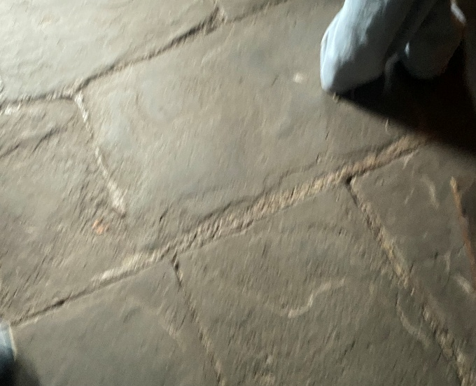
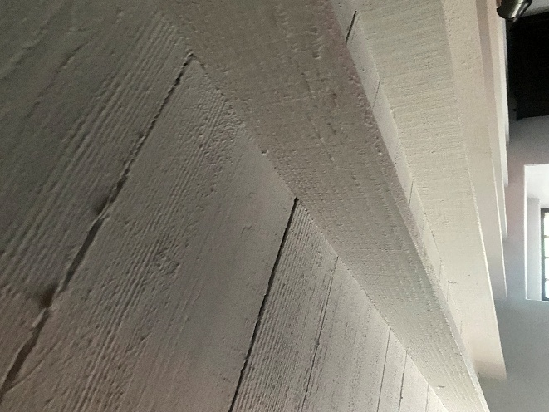

1855 House
The 1855 house remains very similar to the 1805 home, showing that working-class construction changed only gradually over the early nineteenth century. The windows are still timber casements, and the panes are still the same size as well. The front door remains a simple timber plank door. Both windows and door were again painted brown which again suggests the basic standards for a working home at the time were indeed basic. Internally, the walls continue to use lime plaster and limewash, as breathable finishes were still essential before the introduction of damp-proof courses. Riley and Cotgrave (2018, p.45) explain that “lime-based finishes allow moisture to evaporate naturally,” which meant they continued to be used widely through the nineteenth century. Externally, the stone walls remain unrendered, suggesting appearance was still secondary to function. The roof continues to use heavy stone slates, and the eaves retain cast-iron gutters, which were a product of the local iron industry. The flooring is again stone flags, with the floor joists exposed above, which is again confirmed by the author’s own photo’s showing both the flag stone flooring and exposed floor joists.
These continuities show that construction was driven by tradition, limited income and availability of local materials. Chudley and Greeno (2014, p.22) note that builders tended to “persist with familiar materials where cost constraints were strong,” which explains why the 1855 house looks almost unchanged from its earlier form. Small improvements such as smoother plastering reflect slow increases in domestic pride, but affordability remained the main influence on material choice.

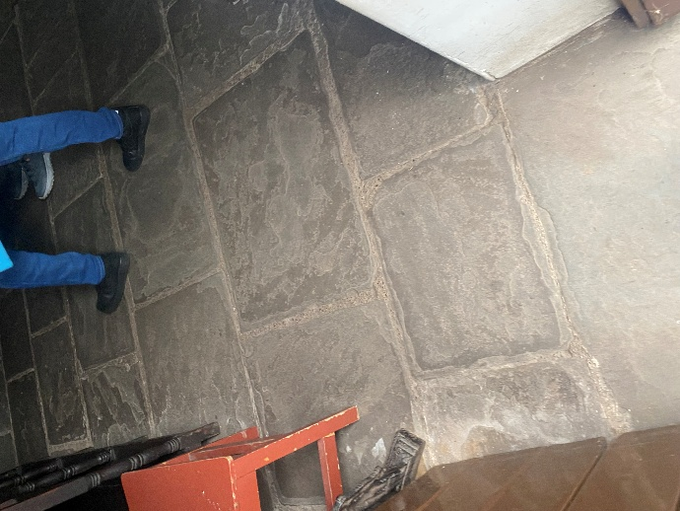
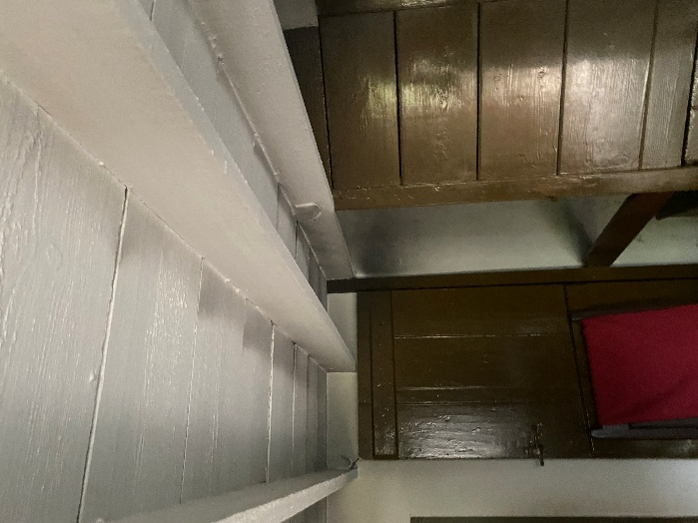

1895 House
By 1895, industrial development had brought noticeable changes in domestic interiors, especially in decorative finishes. The windows now contain larger, clearer glass panes thanks to mass-production methods, as seen in the St Fagans Virtual Tour (2024). The most significant change is the introduction of wallpaper, which becomes affordable during the late Victorian era and is widely used to decorate working-class homes. The external stone remains mostly unrendered, but the interior surfaces show greater interest in appearance. The roof is now covered in Welsh slate, more uniform and lighter than stone, and widely distributed across Wales due to improved rail transport. Chudley and Greeno (2014, p.145) state that “the expansion of rail transport made slate the dominant roofing material across the UK”. Floor coverings remain stone flags, but a small rug appears at the hearth, introducing the first affordable comfort in the home. The floor joists above are still exposed, showing that decorative improvements were superficial rather than structural.
The 1895 house reflects rising aspiration, comfort and identity within working-class households. Decorative wallpaper allowed families to personalise the home, while improved glass and slate became accessible through industrial mass production. The small hearth rug indicates an increasing desire for warmth and comfort in central living spaces. These changes support the pattern identified by Riley and Cotgrave (2018), who note that domestic improvements during this period were influenced by “industrial supply, affordability and changing expectations of home life” (p.73).
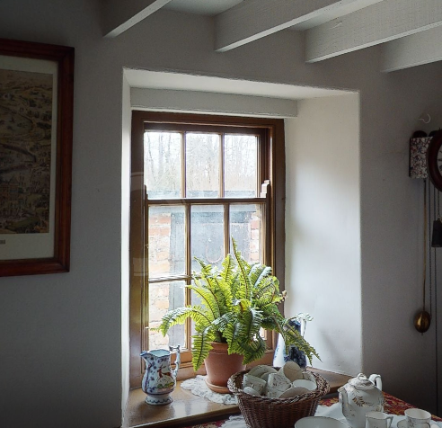

1925 House
By 1925, the influence of hygiene, affordability and modern materials becomes clear. Windows now include small opening top-lights, improving ventilation into the home. Walls continue to feature wallpaper, but in lighter colours and washable finishes reflecting a focus on cleanliness. The roof remains Welsh slate, still the standard for durable pitched roofs. Cast-iron gutters are still present, though slightly more refined in profile. The most notable change is the introduction of a linoleum strip over the stone floor in the main walkway. This can be seen in my own photograph from the visit (2025). Linoleum was considered easy to clean and warmer underfoot than stone. As Riley and Cotgrave (2018, p.102) note, “the early twentieth century saw internal finishes selected increasingly for ease of maintenance and hygiene.” The upper floor joists remain exposed.
The 1925 house demonstrates how public health knowledge and practicality influenced material selection. Hygienic finishes, cleaner wall coverings and inexpensive floor coverings such as linoleum responded to broader social pressures. Chudley and Greeno (2014) explain that new manufactured products gradually entered working-class homes as they became cheaper and easier to install. The 1925 house shows a transitional period between tradition and modernity, where durability remained important, but hygiene and comfort were becoming priorities.
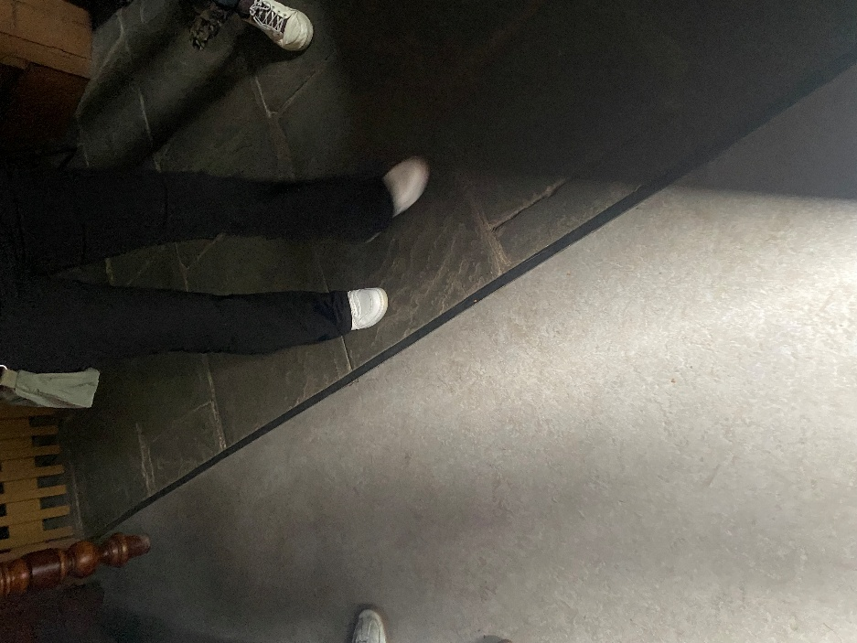

1955 House
The 1955 house displays much clearer improvements in comfort, decoration and quality. The windows are now factory-produced timber casements, offering better insulation and more refined appearance. One of the most visible external changes is the introduction of smooth render applied over the stone walls, a cream finish associated with mid-twentieth-century modernisation. Another noticeable change is the introduction of a more stand out colour choice for the windows, doors and gutter/ downpipe, which shows that decorative finish had become a priority. The roof now uses uniform slate-profile tiles, which were easier to install, lighter, and mass-produced. Cast-iron gutters remain but are painted to protect from rust. Internally, the most significant change is the replacement of stone floors with a herringbone timber floor, covered almost entirely by a large, patterned rug. This creates a major shift in acoustic comfort, thermal comfort and domestic appearance. For the first time, the ceiling is fully plastered, concealing the joists and giving the room a more finished appearance.
These changes reflect post-war improvements in living standards and the growing cultural importance of the home. Chudley and Greeno (2014, p.201) observe that “post-war housing placed greater emphasis on comfort, finish and modern materials,” which corresponds with the shift seen at Rhyd-y-Car. Decorative standards rise noticeably, and the use of manufactured joinery and rendered walls reflects new construction norms that prioritised appearance, maintenance and insulation.

1985 House
The 1985 house represents modern domestic expectations, where comfort, uniformity and low-maintenance materials become the standard. Windows are now softwood casements, selected for affordability and reduced upkeep. The front window has 3 panes, when compared to the first of the houses it shows how far manufacturing has come over nearly two centuries. The external walls are smooth-rendered and painted pink, reflecting modern aesthetic preference rather than structural need. Which again shows the importance for aesthetics and the want for colour at the time. The roof uses machine-made concrete or composite tiles, which Chudley and Greeno (2014, p.179) describe as “durable, economical and suited to large-scale housebuilding.” The rainwater goods are now uPVC, replacing cast iron because they are cheaper, lighter and require almost no maintenance. Internally, the floors are fully carpeted, demonstrating the expectation of warmth throughout the home. Ceilings are plasterboard, with mass-produced internal joinery that reflects late twentieth-century standardisation.
The 1985 house shows the result of two centuries of construction development, where priorities have shifted from survival to comfort, convenience and efficiency. Material selection is influenced as much by maintenance and cost-effectiveness as by structural performance. Standardised products dominate domestic construction, and the home reflects modern expectations shaped by mass production and consumer preference.

Conclusion
Across the six houses of Rhyd-y-Car Terrace, the progression from 1805 to 1985 demonstrates clear shifts in materials, construction methods and expectations of comfort. Early homes emphasised durability and practicality, relying entirely on local materials such as stone slate, limewash and simple timber joinery, as well as the cast iron items produced at the ironworks. By contrast, later houses incorporated manufactured products, decorative finishes such as wallpaper and colour on external paint, new roofing materials and improved ventilation. The changes reflect wider trends in construction technology, public health awareness, industrial production and evolving social expectations. The terrace therefore provides a clear, controlled case study showing how domestic buildings adapt across time to changing economic, technological and cultural conditions.

Reference page
Chudley, R. & Greeno, R. (2014) Building Construction Handbook. 10th ed. London: Routledge.
Museum Wales (2024) Rhyd-y-Car Terrace. Available at: https://museum.wales/collections/historic-buildings/29/Rhyd-y-car-Terrace/ (Accessed: 8 January 2026).
Riley, M. & Cotgrave, A. (2018) Construction Technology 1: House Construction. 4th ed. London: Red Globe Press.
St Fagans (2024) Rhyd-y-Car Terrace Interpretation. St Fagans National Museum of History.
St Fagans Museum (2024) Rhyd-y-Car Terrace Virtual Tour. National Museum Wales. Available at: https://museum.wales/learning/activity/401/Virtual-Tour-of-Rhyd-y-car-Homes-through-Time-/ (Accessed: [24/11/2025]).

Part 2
The following section presents three hand-drawn sketches illustrating typical domestic construction methods from different periods. The sketches are shown in chronological order: pre-1900, 1950’s, and post 2000.



