Name: Abuobyda Radi
Student Number: 1605618
Module Title: Researching and Analyzing Data
Module Code: EMPL4012
Lecturer Name: DIOLA PIJLHOUT

Working from home why?
Introduction
Teleworking or working from home is something different from working from an office. In this report, I will consider the advantages and disadvantages of working from home compared to working from an office. I will collect information from different academic resources to compare and contrast different views to draw a conclusion.
Why working from home?
Dr Jill Miller, the research advisor from the Chartered Institute of Personal and Development said “Employers need to adapt to the changing nature of work and this starts with recognizing that working life can exist outside of the four walls of an office environment.” (Owen, 2018).
Many think that working from home is paramount, they can timetable themselves. When working from home, one need not to get stress, writing a report is easier to do away from meetings, it is considered a good option to work and look after your own child and save travel cost and time to travel can be spent working, When working from home, after completing assigned tasks, one can also other private wok, such as paying bills, getting a haircut, exercising as well as being parent ( Shulman, 2018). It was also pointed out by Barton, that agrees with Shulman, in that working from home can help to look after two years children while working (Barton, 2018). Barton also pointed out that working from is beneficial and that it increases happiness and productivity. When employees work from home, organizations can also save money in rent, gas, electricity.
According to the independent news more than four million British workers have chosen to work from home. Other research shows a flow of 800,000 workers joining home workers over the past years. According to the national work from home day, the government indicated about 4.2 million are working from home and this is 3.4 more compared to 2005. The statistics from the office of National office of statistics also revealed that the proportion of people working from home is now account for 13.7 % of the workforce, this was 12% in 2005. Northern Ireland has the lowest employees (9%) working from home, while South West of England has 18.3% workers that work from home. In type of work, 7% are in retail compared to 17.7% in jobs that relate to Information and Communication Technology (ICT) sector, mostly in computer programming and desk support. There are 60% of home workers that are men and they are mostly self-employed. Research also shown that more top managers are working from home than in the office, the ratio is 1:5, this shows that because they are having a better balance between work and life (Owen, 2018).
According to the guardian newspaper, the number of people shifting to work from home is reaching high record, during the first quarter of 2014, this was 13.9%, compared to 1.3 in 1998, Fig (1) in appendix (A ) shows steady increase of home worker from March 1998 – 2014. What do they do and how do they do it? Was explained (Sedghi, 2018.)
About 35% of employees working from home are professionals, 23.5% working in skills trade, 14.8%, this means many of workers are high skilled workers. High skills workers use technology to carry out their work. Using ICT is more productive and less in cost to carry out professional work at home instead of wasting time in travel. Fig (2) Appendix (A) shows that skilled workers occupying the highest percentage while sales and customer’s services showing 2.2% which need face to face services and some jobs cannot be done remotely.
In Fig (3), Appendix (A), in UK, for 2013 analysis, south-west show the highest while the lowest was in Kingston (5.2%)
A case study for Paul Wilson who was initially working for someone and now running a business in Newcastle. When Paul heard about ‘Work Wise’ about organizations promoting home working, he started to find out the benefits of working from home. Paul found out that considering the daily travelling shows a considerable saving in time and cost. Paul felt he was more productive, there was less distraction compared to working in an office, about working from home he said “It’s a very independent and autonomous way of working”. Paul is now running his own business in Newcastle, and the people he employs are working from home and they are all happy working from home (Owen, 2018)

.

.

Why work from office?
Working from office is considered important, as employees cannot do all aspects of their works away from their office (Barton, 2018). According to Esther Canonical research for 514 employees, many employees who work from home did not receive training on how to do their jobs effectively, (Barton, 2018).
Employers prefer staff to work in the office rather from home, and this is mainly due to the lack of mutual trust that remains one of the biggest barrier for allowing staff to work from home. According to Frances O’Grady, the TUC general secretary, some organizations are happy and encourage home working as it improves productivity and retention of staff but many are still afraid to allow their staff to work from home.
Some employees have argued that the primary reason that some workers prefer to work from home is that it saves travelling time, but others argued that working at an office gives them time in the morning to think about the day at work and gives them time on the way back to switch from work mode (Seroter, 2018), this is good as far as stress is concerned. There is also a similar good argument concerning health, interpersonal skills and wellbeing. Physical activity, for example walking around in the office is good to help maintain weight. Taking to colleagues face to face instead of just using technology for work and pleasure (Seroter, 2018).
Working in office is flexible, easier to communicate with each other, easier to manage employees and can increase innovation (TechRepublic, 2018)
Pros and cons,
Working from home, one is free as when to start and when to finish, no travelling cost, wearing what we want, no manager looking over our shoulders and married people can look after their children as well as working
Working from home, means to be self-disciplined, self-motivated and minimum time for outside pleasure. At office, one cannot escape from office for pleasure

.

Conclusion
The interest of home working is driven towards the promotion of flexible working hours, the comfort ability of being at home, the appeal of now being able to work from home for a reputable company without necessarily having the negatives attached to being self-employed first to enjoy the benefits of working at home, and the ability to still fulfil other personal duties and engage in personal hobbies whilst working.
Working from home provides flexible working schedules and its becoming common for many organizations. Organizations have adopted hot desking that is fewer desk compared to the number of staff, by encouraging remote working, many organizations are now saving money. But, working from home is not as simple as just opening a computer and get down with work, training is needed. Organizations need to do meetings through video conference and provide training by other means. It has been recommended that employees who work from home are to prepare for the day as they would for working in the office (take shower, get dressed). Statistical analysis shows that there is an increased interest in the work force to work from home especially in retail and ICT.
The benefits for working from home mainly stem from being able to manage your own time. This allows people to work according to their own needs and wants. They can build a schedule which allows them to get the work they need done as well as still having time to spend with family and loved ones, engaging in personal activities or even household chores. They can build a comfortable working environment which suits them and one which they feel can stimulate their work mode. However, one of the major drawbacks is that working from home causes a blurred line between home and work and meshing the two together can cause immense stress for the employee.
Working from an office however is good for self-discipline as there is a defined start and end time which encourages a rigid routine with minimal flexibility for certain exceptions such as doctors’ appointments. Adhering to this routine means the employee must practice strict self-discipline. It also helps employees build a rapport with their team and managerial staff. This in turn could prove more rewarding in the long term and result in higher chance of promotion for those working in an office. This is as the manager will be able to visually see day in and day out which staff have been performing well, have shown great dedication, team work and good attendance and punctuality – all of these are harder to assess with employees working from home. One of the main drawbacks with working from the office is cost particularly with relation to travel. Traveling costs can weigh a hefty amount financially and cause a dent in an employee’s monthly salary.

Reference
- Shulman, A. (2018). Alexandra Shulman on working from home: it's not an adequate alternative. [Online] the Guardian. Available at: https://www.theguardian.com/money/2013/mar/02/alexandra-shulman-working-from-home [Accessed 10 Jan. 2018].
- Barton, E. (2018). Working from home may actually hurt your career. [online] Bbc.com. Available at: http://www.bbc.com/capital/story/20170418-how-working-from-home-ruins-everything [Accessed 10 Jan. 2018].
- Owen, J. (2018). Over four million Britons favor working from home. [online] The Independent. Available at: http://www.independent.co.uk/news/uk/politics/over-four-million-britons-abandon-workplace-in-favour-of-working-from-home-says-study-10298480.html [Accessed 11 Jan. 2018].
- Sedghi, A. (2018). Proportion of people working from home reaches record high. [Online] the Guardian. Available at: https://www.theguardian.com/news/datablog/2014/jun/04/proportion-of-employed-working-from-home-reaches-record-high [Accessed 11 Jan. 2018].
- Seroter, R. (2018). 6 Reasons Why Working at the Office Is Much Better Than Working Remote. [online] Richard Seroter's Architecture Musings. Available at: https://seroter.wordpress.com/2015/07/27/6-reasons-why-working-at-the-office-is-much-better-than-working-remote/ [Accessed 11 Jan. 2018].
- TechRepublic. (2018). 10 reasons why working in the office work beats telecommuting. [online] Available at: https://www.techrepublic.com/blog/10-things/10-reasons-why-working-in-the-office-work-beats-telecommuting/ [Accessed 11 Jan. 2018].

Appendix A

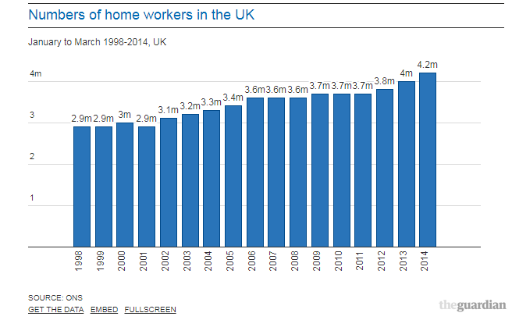
Fig (1) number of home workers (1998-2014)

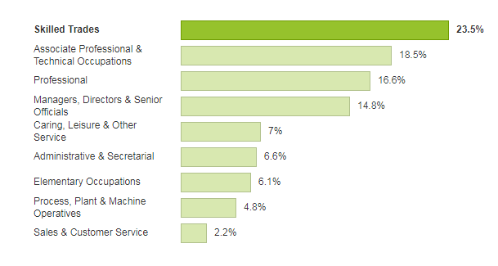

Fig(2) % of home workers and non-home workers in each occupation group

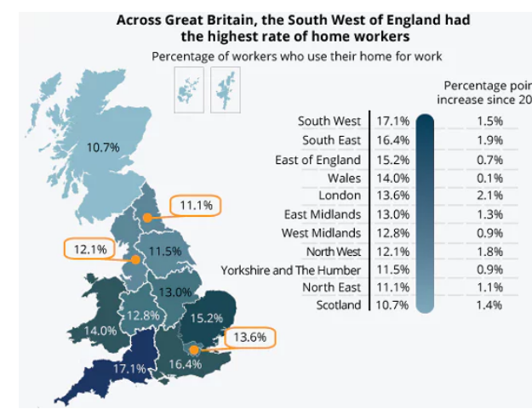

Fig (3) Across UK The south-west had the highest home working rate in 2013

