PROJECT MANAGEMENT  Assignment 1 | STUDENT NAME: OANA ELIESCU  STUDENT ID NUMBER: 1809525  MOODLE TITLE: LCBB5005 PROJECT MANAGEMENT  ASSIGNMENT TITLE: PROJECT OF A BUILDING CONSTRUCTION  LECTURER’S NAME: DR NANDISH PATEL

Table of Contents
INTRODUCTION 2
BUSINESS CASE 2
SMART OBJECTIVES 3
WBS 4
ACTIVITY LIST 6
ACTIVITY SCHEDULLING 10
BUDGET MODELLING…………………………………………………………………………………………………………………..12
CASH FLOW STATEMENT………………………………………………………………………………………………………….….14
PROJECT EXECUTION CHALLENGES………………………………………………………………………………………………15
CONCLUSION……………………………………………………………………………………………………………………………….16
REFERENCES………………………………………………………………………………………………………………………………..17

INTRODUCTION
Project Management can be defined as the process of applying different processes, skills, methods and knowledge in order to achieve particular objectives of a project. It is an important part of a project because it makes sure that right outcomes are delivered (Chawla and et. al., 2018). The project is to construct a building for a client as they are facing issues with space at their workplace. Managing the different activities in the project effectively will help in completing the project effectively and deliver the same on time. Effective project management will help the project manager in make informed decisions and also ensure that the final output which is delivered is on time without any delays. Also, the project manager will be able to ensure an efficient use of the different resources.

Business Case
Business Problem
The business problem is that the client is facing issues with space within their workplace and want to shift some of the workforce to a new workplace. This is because the employees are not able to work effectively and cannot concentrate on their jobs. For this, they want to get constructed a new building so that the business processes can be carried out effectively.
Benefits
A new workplace building will help in increasing the motivation level of employees and reduce their existing levels of stress. They will be able to put in better efforts in getting the tasks done which are assigned to them. This will lead to an increase in the performance as well as productivity of the company (Delisle, 2019). With a limited workforce in the new workplace, the employees will support and encourage each other.
Stakeholder Analysis
It can be defined as the process of identifying the different stakeholders of the company before initiating a project and grouping them based on their levels of interest, participation and power. A stakeholder analysis is explained below :
High Power, High Interest – These are the most important stakeholders and they should always be given priority because they possess high interest as well as high power in the project (Stakeholder Analysis, 2020). Stakeholders included in this category are the owner of the project, general manager and director.
High Power, Low Interest – These stakeholders possess high power in the project and thus, should be kept satisfied. And since they have a low interest, they should not be over-communicated because this can lead them to lose their interest. Examples include customers, investors and sponsors.
Low Power, High Interest – Stakeholders who come in this category should be kept informed and followed up with regularly (Layton and Ostermiller, 2017). This is done in order to make sure that they are not facing any problems. Stakeholders included in this category include employees and suppliers.
Low Power, Low Interest – This is the last category of stakeholders and they should be informed about the project only periodically. Examples include security guard, cleaners and so on.

Communication Plan
The different stakeholders of the project will be communicated from time to time. This will be done in order to keep them informed about the progress of the project. A communication plan is described below :

Stakeholder Name | Engagement | Channel | Frequency
Owner, General Manager and Director | Manage Closely | Meetings, E-mails, Personal check-ins | Daily
Customers, Investors and Sponsors | Keep Satisfied | Top of the line e-mails | Monthly
Employees and Suppliers | Keep Informed | Written notes | Weekly
Security Guard and Cleaners | Monitor | Newsletters | Monthly

Smart Objectives
The main objective of undertaking this project is to construct a new workspace building for the employees (Martens and Carvalho, 2017). This is being done in order to increase the productivity as well as performance levels of the employees so that they become more competitive. To complete the project within 6 months in associated cost of £50,000 in order to expand business operations.

The project will help the company in managing their employees in an effective way and ensuring that there is an increase in their overall levels of productivity. Also, the goal is to make sure that the employees work productively and are able to build strong working relationships.

Work Breakdown Structure

WBS
A Work Breakdown Structure can be defined as a structure where in a complex project is broken down into easy and manageable tasks. It is usually used for projects, programs etc. in order to deliver the project in an effective manner (McKevitt, Carbery and Lyons, 2017). The primary purpose of a work breakdown structure is to reduce different complicated activities. A project manager can easily allocate different tasks to the team members with the help of the same. The work breakdown structure mainly ensures that all members of the project are on the same page and focus on completing the tasks effectively. Not only this, it helps in organising the work of all the team members into different sections that are manageable. There are many benefits of developing a work breakdown structure. For example, it allows the project manager to develop a schedule for the project in an effective manner.
Not only this, it can also be used to identify any potential risks that can be associated with the project. In context to the project chosen for this report, the construction of the building will involve different activities. Heavy tasks will be broken down into easy and understandable tasks. The tasks will be divided into three categories, so that it is easy for the project members to understand the same and work on them effectively (Niknazar and Bourgault, 2017). Also, the project manager will be able to monitor the different activities in an efficient manner and ensure that the desired outcome is achieved. Finally, an effective work breakdown structure can help in completing the project in an effective and efficient way. The three stages in which the building will be constructed : Initiation, Planning and Execution and Control.

Construction of Building

Execution and Control
Initiation
Planning

Official paperwork
Column casting and
construction of walls
Miscellaneous work

Roofing
Excavation and
foundation
Plastering

Fixing doors, windows,
electrical and plumbing works

Tiles laying and painting

Activity List
Different activities will be involved in constructing a building for a workplace. An explanation of the same is described below -

Initiation Stage
- Official paperwork – This is the initial requirement of constructing any building. The paper work for this project will include preparation of drawings, estimating the cost of material and the approval of drawings from the client (Owusu, Chan and Shan, 2019).
- Excavation and foundation – The process of excavation is usually carried for the construction of a building and should be based on the drawings because the lengths as well as widths are defined in them. On the other hand, in the foundation work, different processes which are included are compacting the ground, shuttering and footing concrete.
Planning Stage
- Column casting and construction of walls – This process involves fixing the shuttering and then concrete is poured. After 24 hours, the shuttering is removed and curing is done (Portny, 2017). Once this is done, the walls are constructed using bricks, cement and wood.
- Roofing – In this stage, the roofing of the building is done, and this is an important stage wherein the workers are supposed to keep a check on the details.
- Plastering – After slab pouring, form work is removed, and the plastering process begins. Enough time is given for the plaster to dry so that it gains enough strength. All of the external walls of the building are plastered.
- Fixing doors, windows, electrical and plumbing works – Once this is done and the plaster dries, the doors as well as windows are fixed. Both doors as well as windows made up of wood are used. First the frames are fixed and later on, the doors and windows are put in to place.
- Tiles laying and painting – Tiles are laid in the kitchen area, where the employees can go and have refreshments. Tiles of granite, marble or epoxy are generally used.
Execution and Control
- Miscellaneous work – Once all of the work is done, there are various other tasks that need to be done (Rowe, 2020). This can include water proofing the terrace, false ceiling and installing the furniture within the workplace like chairs, tables etc.

Risk Management
It can be defined as the process which involves identifying risks, assessing them and controlling the different threats. While constructing a new building, there can be various threats that can have an impact on the overall performance of the project and the final outcome.

Risk Plan
It can be defined as the different techniques that can be used in order to identify the various risks as well as analyse their impact on the project (Silvius and et. al., 2017). By using this particular approach, the project manager can eliminate the risks that can have an impact on the overall progress of the project. Also, if the risks are identified in advance, the project manager will be able to save a lot of time as well as money.

Identifying Risk – A risk management plan can help in identifying the risks in an effective manner and also, adopt various measures to overcome them. In this, the project manager who is responsible for managing the construction process, will analyse the risks and develop strategies accordingly.

High quality of work – Effective management of risks will not only help in identifying the risks, but also plan and develop strategies to overcome them (Teo and Loosemore, 2017). This will help in saving a lot of time as well as using the available resources in an effective way.

Risk Register

Serial no. | Risk | Likelihood | Impact | Owner | Mitigation | Contingency | Weighting score (pre action) | Weighting score (post action )
1 | Lack of funds | High | High | Owner | This will include various strategies as they will help in overcoming the risk of funds. Various ways to mitigate the same will include avoiding any unnecessary costs and making sure that the available resources are used effectively. | A follow up plan will be developed to manage the project more effectively. | 8 out of 10 | 9 out of 10
2 | Lack of time | Medium | High | Project Manager | Developing a plan that will help in completing the project within the given time scale of 6 months. A project manager can also be hired. | Scheduling the project tasks effectively | 7 out of 10 | 8 out of 10
3 | Skilled Staff | Low | Medium | Project Manager | Trained staff members should be hired in order to make sure that all activities are completed on time and in an efficient way. | Experienced people will help in making sure that the project outcome matches the expectation of the client. | 8 out of 10 | 9 out of 10

Risk Priority Graph

Risk | High | Medium | Low
Lack of Funds
Lack of Time
Skilled Staff

Activity Scheduling
- Official paperwork
- Excavation and foundation
- Column casting and construction of walls
- Roofing
- Plastering
- Fixing doors, windows, electrical and plumbing works
- Tiles laying and painting
- Miscellaneous work

Gantt Chart
Gantt chart is a statistical tool which is in form of a chart and is effectively used in order to demonstrate the schedule of a project. It was developed in 1910. In current times modern times Gantt chart is effectively used to draw the relationship between various different activities and the current schedule status. In the following project the time required to complete the activities is 6 months (Turner, 2017). The Gantt chart demonstrate how the activities start and time required for each of these tasks. The project begins by getting approved for all the official paperwork an all the activities start thereafter as mentioned in the Gantt chart.

Critical Path
Critical path refers to a certain sequence of various stages which are determining the minimum time which is required to complete an operation. In the following report the critical path for the project of constructing a building is discussed. The critical path helps with a direction towards completion of various activities in the project. It also helps in estimating the maximum period by which the project will be completed. It also helps in identifying the correct sequence in which activities will be performed. This also provides with various other features such as total float that is the unused time in a critical path.
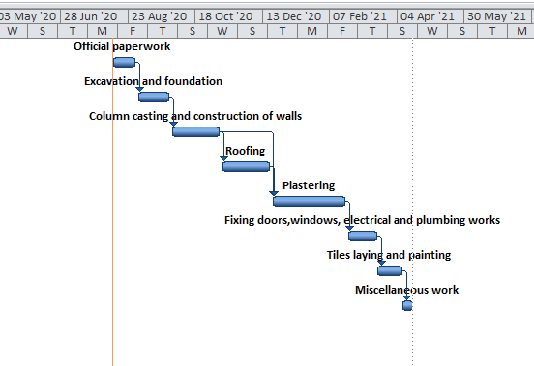
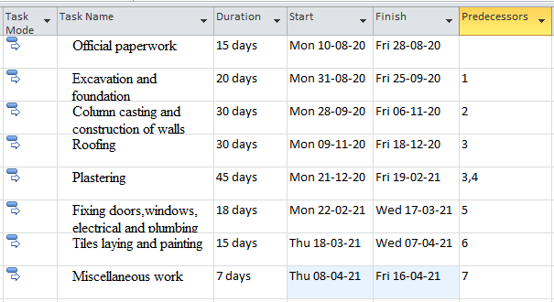

Budget Modelling
Budget discusses about the expenses or the amount of capital which will be required for a fixed period of time. Often the time included in a budget is for a year or until the activity for which it is created is finished such as the time when project comes to an end. The following budget consists of all the expenses including registration fee, notary fee, expenses of all the activities are mentioned separately in the budget along with a sum of expense which will be kept aside for miscellaneous expenses. Miscellaneous expense are those kind of expenses which are unforeseeable. No one can judge it beforehand therefore a reserve is kept for such expenses. The project manager often tries that the budget does not exceed from what is planned. Any deviation may be caused due to extra activities, increase in prices of raw materials or any mishap while the project is going on. However, project manager tries to avoid these incidents.

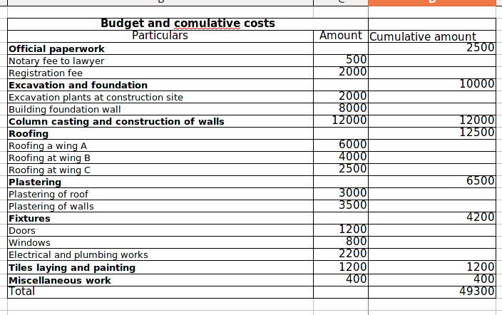

Cash Flow Statement
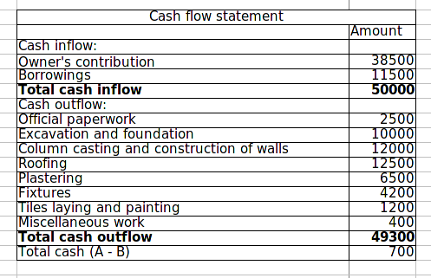
Cash flow statement is an important financial statement which provides information regarding cash inflows and outflows taking place in an organisation in certain fixed period of time. It helps in identification of the operating expenses which the organisation or in this case project will be requiring (Chawla and et. al., 2018). It is necessary to effectively understand the requirement and manage the capital for project. The major cash outflows will involve purchase of raw materials, payment to labour, tools and machineries etc. the capital expenses will include purchasing land, spending on machineries for excavation and so on.

Project Execution Challenges
While executing a project, there can be certain challenges which the project members can come across. In context to this project, there can be certain challenges which can affect the overall execution of the plan. For example, there can be a lack of funds as well as time. Also, if there are any issues in the budget, the project will not be completed in the given time frame. The team members should be skilled and experienced. If there is a lack of skilled employees, they will not understand the different activities and will fail to complete the assigned tasks on time. Therefore, it is important to manage the time by preparing a schedule so that the project members are engaged in their work and committed to it (Delisle, 2019). Frequent conflicts among the team members can also affect the overall productivity of the employees in a negative way. As a result, the overall output will be affected in an adverse manner. Therefore, these are some of the challenges that can come up during the execution of project, which is construction of building.

CONCLUSION
From the above report, it can be concluded that project management is one of the important components for a particular project. A project management plan can help in completing the project in an effective manner and in the given time frame. A work breakdown structure can be used in order to break down complex tasks into easy and manageable activities which are easy to understand as well as manage. A Gantt chart can be used to understand the time in which a particular task has to be completed. Therefore, project management is an essential part for completing a project.

REFERENCES
Books & Journals
Chawla, V. and et. al., 2018. The sustainable project management: A review and future possibilities. Journal of Project Management, 3(3), pp.157-170.
Delisle, J., 2019. Uncovering temporal underpinnings of project management standards. International Journal of Project Management, 37(8), pp.968-978.
Layton, M. C. and Ostermiller, S. J., 2017. Agile project management for dummies. John Wiley & Sons.
Martens, M. L. and Carvalho, M. M., 2017. Key factors of sustainability in project management context: A survey exploring the project managers' perspective. International Journal of Project Management, 35(6), pp.1084-1102.
McKevitt, D., Carbery, R. and Lyons, A., 2017. A profession but not a career? Work identity and career satisfaction in project management. International Journal of Project Management, 35(8), pp.1673-1682.
Niknazar, P. and Bourgault, M., 2017. Theories for classification vs. classification as theory: Implications of classification and typology for the development of project management theories. International Journal of Project Management, 35(2), pp.191-203.
Owusu, E. K., Chan, A. P. and Shan, M., 2019. Causal factors of corruption in construction project management: An overview. Science and engineering ethics, 25(1), pp.1-31.
Portny, S. E., 2017. Project management for dummies. John Wiley & Sons.
Rowe, S. F., 2020. Project management for small projects. Berrett-Koehler Publishers.
Silvius, A. G. and et. al., 2017. Considering sustainability in project management decision making; An investigation using Q-methodology. International Journal of Project Management, 35(6), pp.1133-1150.
Teo, M. M. and Loosemore, M., 2017. Understanding community protest from a project management perspective: A relationship-based approach. International journal of project management, 35(8), pp.1444-1458.
Turner, J.R. ed., 2017. Contracting for project management. Taylor & Francis.

Online
Stakeholder Analysis. 2020. [Online]. Available through:<https://www.productplan.com/glossary/stakeholder-analysis/>.

