
CertHE Computing Skills for Workplace
Module Name:
Computer Architecture and Operating Systems
Module Code:
ACCA4022
Student Name:
Hasnain Akhtar
Student ID:
2512913
Lecturer Name:
Md Shantanu Islam
Submission date:
24th July 2026

Contents
Introduction 4
Key functions of general Operating Systems 4
Task Management: 4
Application/Program Management: 4
File/Directory Management: 5
Device Management: 5
Security Management: 6
Use of Windows OS CLI commands 7
Example 1: 7
Example 2: 7
Example 3: 8
Example 4: 8
Example 5: 8
Example 6: 9
Example 7: 9
Example 8: 10
Example 9: 10
Example 10: 11
Use of Linux OS CLI commands 11
Example 1: 11
Example 2: 12
Example 3: 12
Example 4: 13
Example 5: 13
Example 6: 14
Example 7: 14
Example 8: 15
Example 9: 15
Example 10: 16
Use of Windows OS scripts 16
Example 1: 16
Example 2: 17
Use of Linux OS scripts 18
Example 1: 18
Example 2: 19
Conclusion 20
References 20
Appendices 21

Introduction
An operating system (OS) is the core software that enables a computer to function by managing hardware resources and providing services that allow applications to run efficiently. It acts as the interface between the user and the computer's hardware, ensuring that resources such as memory, storage devices and processors are allocated effectively. This report examines the key functions of modern operating systems, with particular focus on Microsoft Windows and Linux. It also explores the practical use of command-line interfaces and scripting to demonstrate how operating systems can be used to automate tasks and support effective system administration [1].

Key functions of general Operating Systems
Microsoft Windows is one of the world's most widely used operating systems, first released in 1985. It provides a graphical user interface (GUI) that enables users to manage hardware, software and system resources efficiently. Windows supports multitasking, device management and security, making it suitable for both personal and business computing environments [2], [3].

Task Management:
Task Management is a core function of the Windows operating system that allows users to monitor and control running applications, background processes and system performance. The Windows Task Manager provides real-time information on CPU, memory, disk and network usage, helping users identify resource-intensive applications and troubleshoot performance issues. It also enables users to end unresponsive processes, monitor system utilisation and manage startup applications, contributing to improved system stability and efficiency. These features help maintain smooth operation by ensuring that system resources are allocated effectively and unnecessary processes can be identified and managed when required [4].
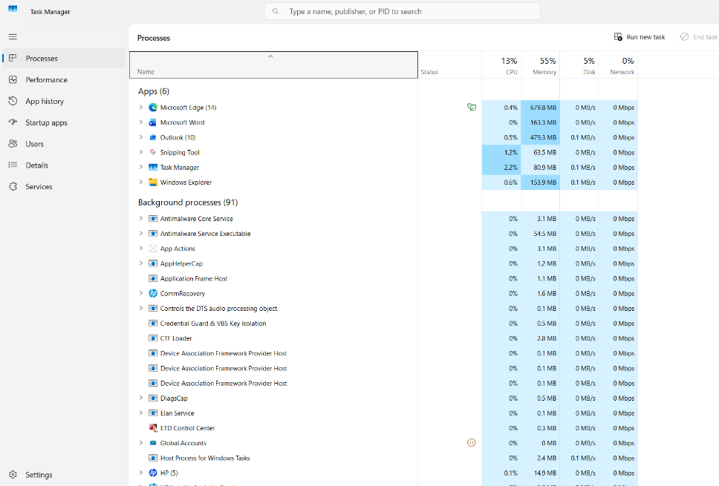
Figure 1: Task manager –

Application/Program Management:
Application management enables Windows to install, update, repair and remove software, ensuring that applications function correctly throughout their lifecycle. The Apps settings and Add or Remove Programs feature allow users to manage installed software, helping to free storage space, resolve software conflicts and maintain system performance. Windows also supports repairing compatible applications without requiring a full reinstallation, reducing downtime and improving reliability. Effective application management ensures that outdated or unnecessary programs can be safely removed while keeping essential software up to date, contributing to a stable and efficient operating system environment [5].

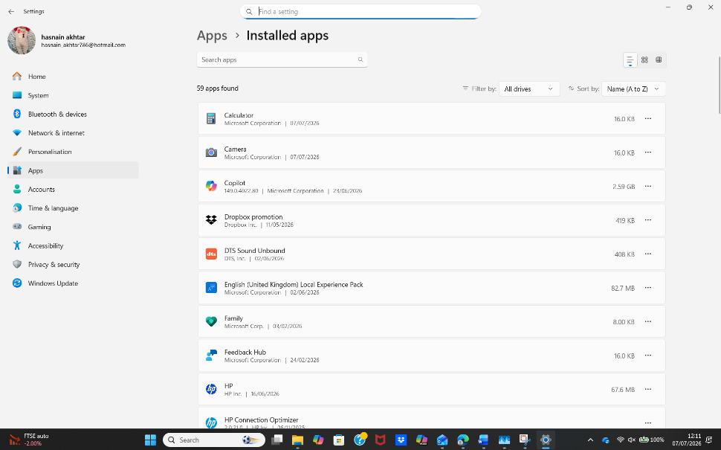
Figure 2: Add or remove programs

File/Directory Management:
File and directory management is a fundamental function of the Windows operating system, enabling users to create, organise, store and retrieve files efficiently. Windows uses File Explorer to provide a graphical interface for managing folders and files, allowing users to copy, move, rename and delete items with ease. The operating system also controls file permissions and supports file systems such as NTFS, which help maintain data integrity and secure access to stored information. Effective file management improves organisation, reduces the risk of data loss and allows users to locate information quickly, increasing overall productivity and system efficiency [6].

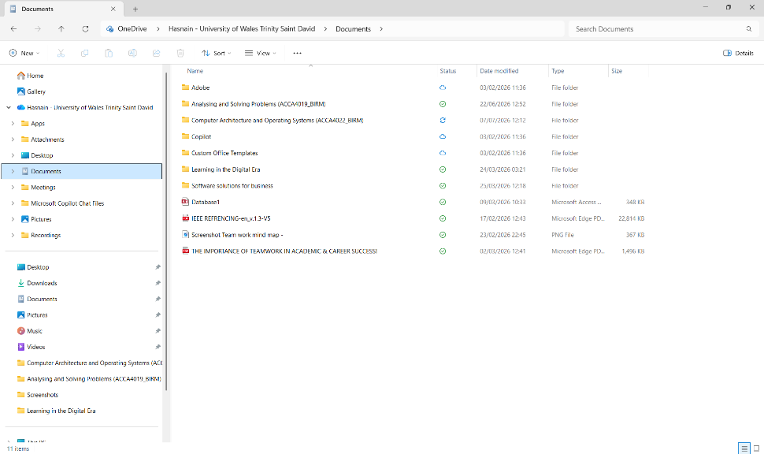
Figure 3: File manager

Device Management:
Device management is an essential function of the Windows operating system that enables hardware devices to communicate effectively with the computer. Using Device Manager, Windows detects, configures and monitors connected hardware such as printers, storage devices, graphics cards and network adapters. It also allows users to install, update, roll back or uninstall device drivers, helping to resolve compatibility issues and maintain system stability. If a hardware fault occurs, Device Manager provides diagnostic information that assists with troubleshooting and identifying the source of the problem. Effective device management ensures reliable hardware performance, improves compatibility and contributes to the overall efficiency of the operating system [7].
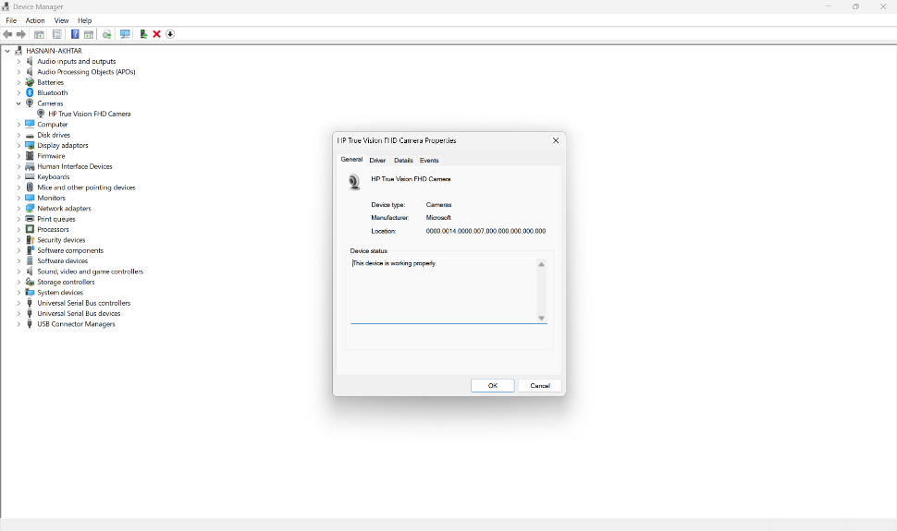
Figure 4: Device manager – Cameras –

Security Management:
Security management is a fundamental function of the Windows operating system that protects users, applications and data from unauthorised access and cyber threats. Windows uses security features such as user authentication, access permissions, encryption and firewall protection to safeguard system resources. Access control ensures that users are only granted the permissions necessary to perform their authorised tasks, reducing the risk of accidental or malicious activity. Regular security updates and the implementation of appropriate security controls help protect the operating system against emerging vulnerabilities, maintaining the confidentiality, integrity and availability of information while improving the overall security and reliability of the system [8].

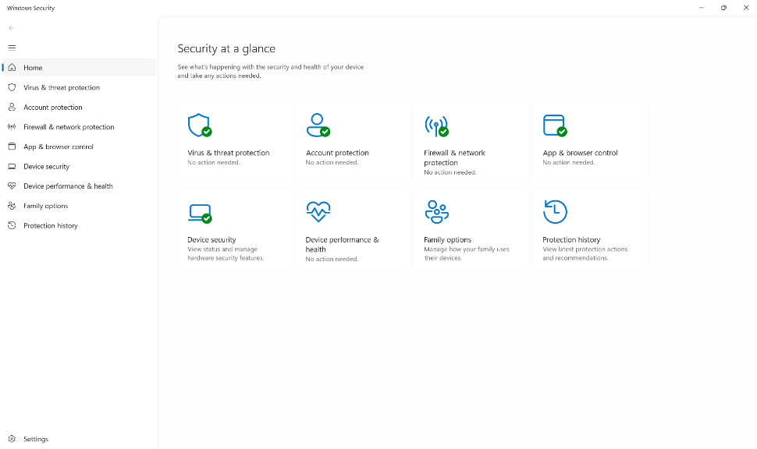
Figure 5: Window security overview

Use of Windows OS CLI commands
The Windows Command Line Interface (CLI), commonly accessed through Command Prompt (CMD), enables users to interact with the operating system by entering text-based commands rather than using a graphical interface. It is widely used by system administrators and IT professionals to perform file management, troubleshoot issues and automate routine tasks efficiently. The following section demonstrates several fundamental Windows CLI commands and their practical applications [9], [10].

Example 1:
The DIR command displays the files and folders within the current directory. The output lists file names, sizes, modification dates and subdirectories, allowing users to quickly view and verify the contents of a selected location in Windows Command Prompt [11].
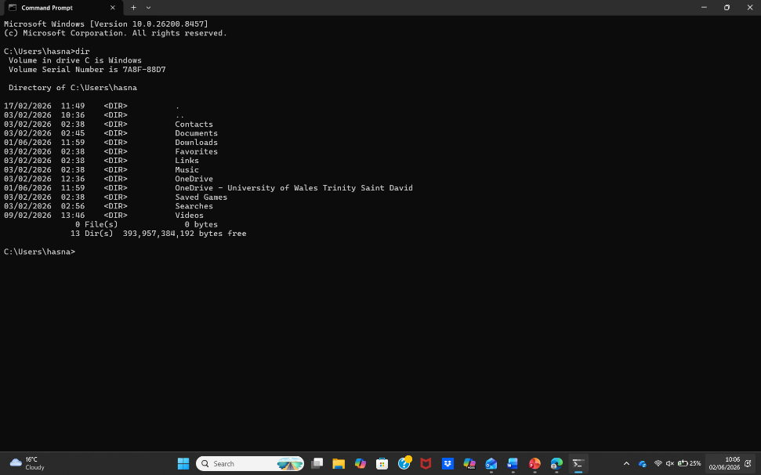
Figure 6: Command prompt - (DIR – Directory command).

Example 2:
The CD (Change Directory) command is used to navigate between folders within the Command Prompt. The output displays the new directory path, confirming that the current working location has changed successfully, allowing users to access files and execute commands in different directories [12].
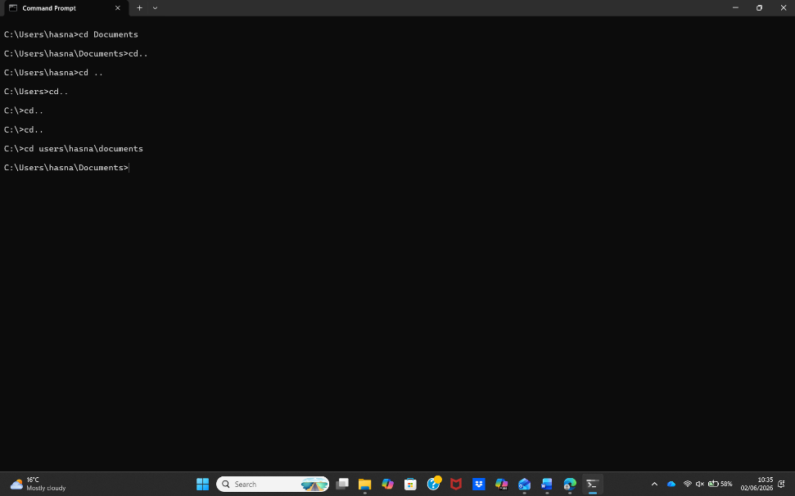
Figure 7: Command prompt - (CD).

Example 3:
The MKDIR (Make Directory) command creates a new folder within the specified location in Command Prompt. The output displays the newly created directory, confirming that the folder has been successfully added and is available for storing files or creating further subdirectories [13].
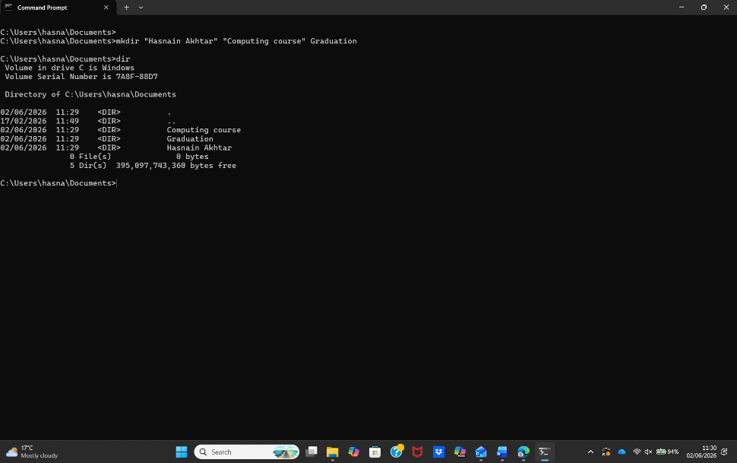
Figure 8: Command prompts - MKDIR – (Creating folders).

Example 4:
The RMDIR (Remove Directory) command deletes an empty folder from the current directory. The output confirms that the specified directory has been removed successfully, helping users organise storage by eliminating unnecessary folders and maintaining a tidy file structure [14].
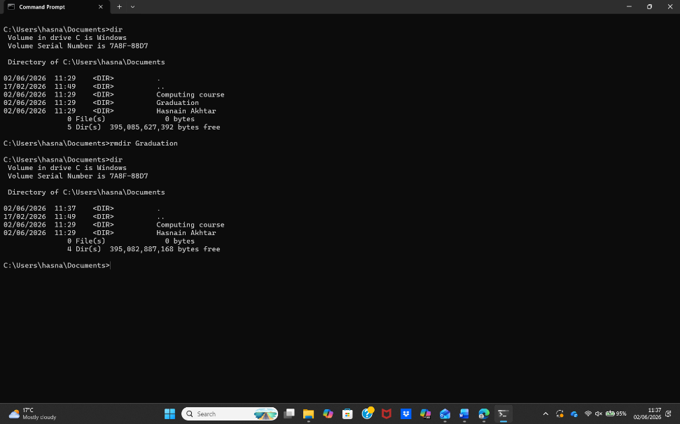
Figure 9: Command prompts - RMDIR (Deleting folder).

Example 5:
The RENAME (REN) command changes the name of an existing file or folder without altering its contents or location. The output confirms the item has been renamed successfully, allowing users to organise directories more effectively and maintain a clear, meaningful file structure [15].
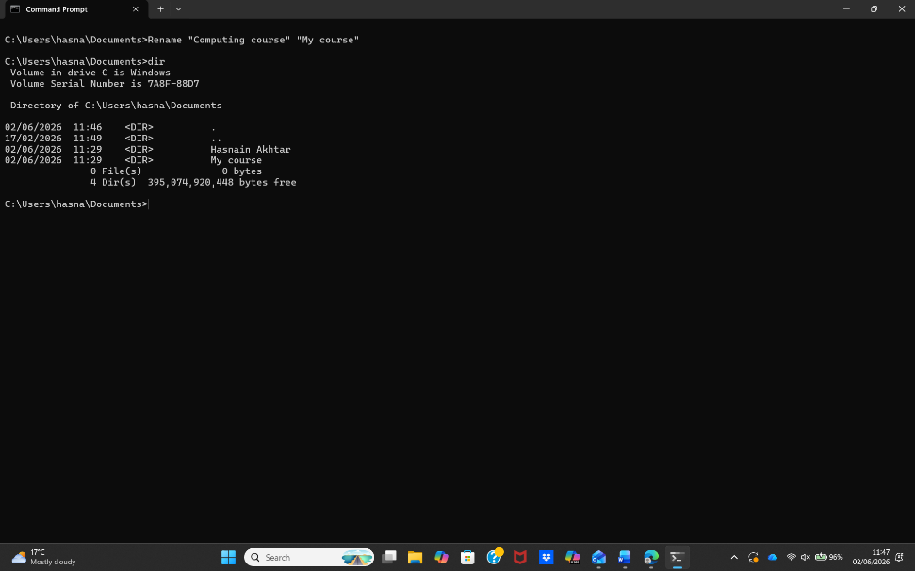
Figure 10: Command prompts - RENAME (Re-naming folders).

Example 6:
The IPCONFIG command displays the computer's current TCP/IP network configuration, including the IP address, subnet mask and default gateway. The output allows users to verify network settings, diagnose connectivity issues and confirm that the system is correctly configured for network communication [16].
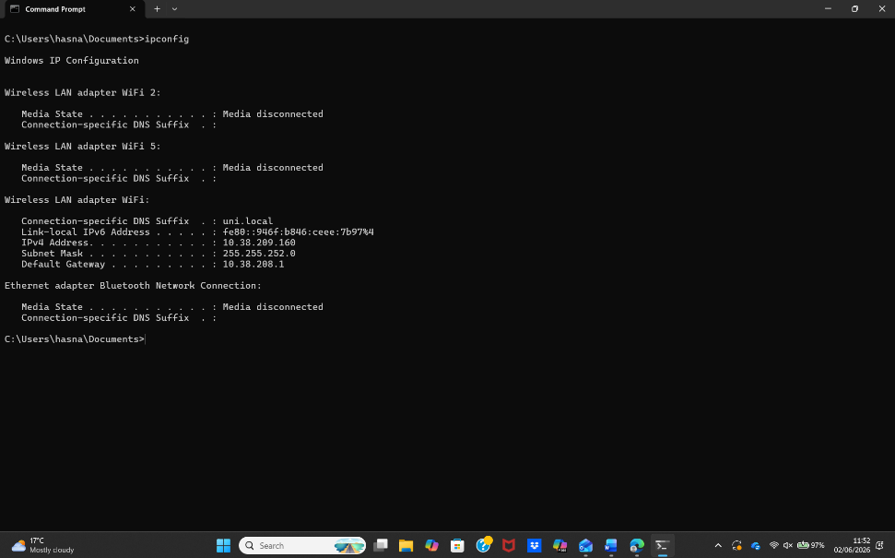
Figure 11: Command prompt – IPCONFIG – (Computer configuration).

Example 7:
The NETSTAT command displays active network connections, listening ports and network statistics on the computer. The output helps users monitor network activity, troubleshoot connectivity issues and identify established connections, providing valuable information for network management and diagnostics [17].
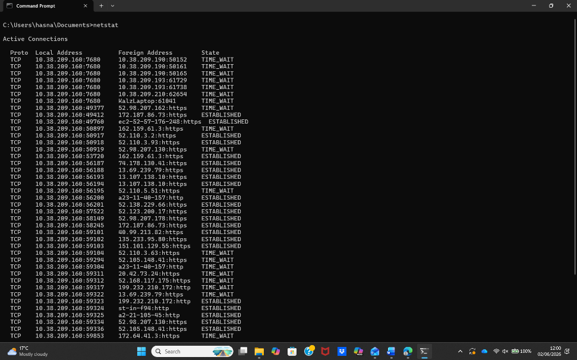
Figure 12: Command prompt - NETSTAT - Showing network connections

Example 8:
The SYSTEMINFO command displays detailed information about the computer, including the operating system version, processor, installed memory, network configuration and system boot time. The output enables users to verify system specifications, diagnose issues and gather important information for system administration and troubleshooting [18].
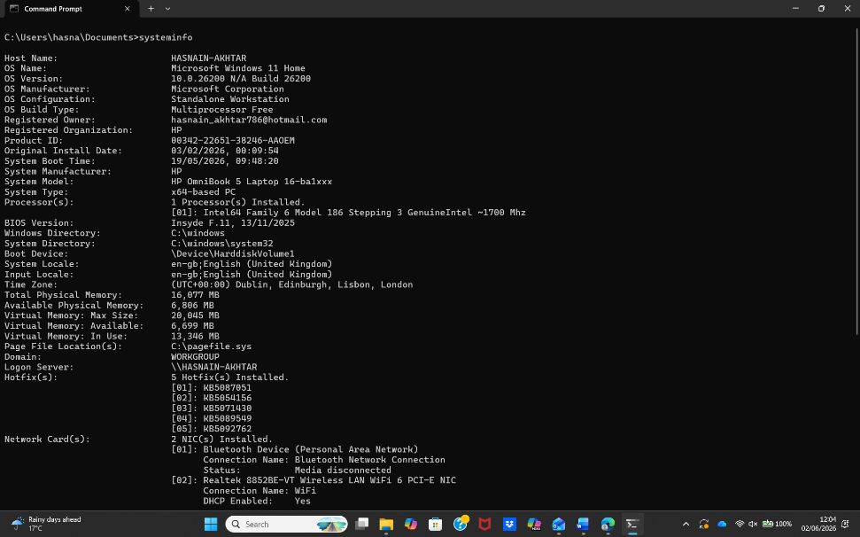
Figure 13: Command prompt – SYSTEM INFO -

Example 9:
The TASKLIST command displays all currently running processes and applications on the computer. The output provides information such as process names, process IDs (PIDs) and memory usage, enabling users to monitor system activity and identify active programs for troubleshooting or management purposes [19].
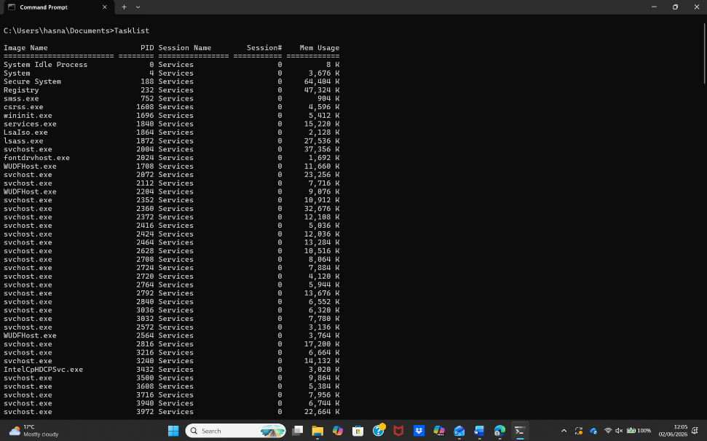
Figure 14: Command prompt – TASKLIST –

Example 10:
The PING command tests network connectivity between the computer and another device by sending Internet Control Message Protocol (ICMP) echo requests. The output displays response times, packet loss and connection status, helping users diagnose network communication and connectivity problems [20].
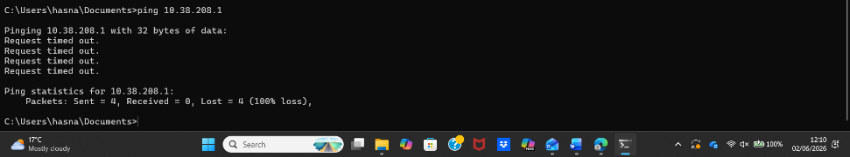
Figure 15: Command prompt – PING –

Use of Linux OS CLI commands
Linux provides a powerful Command Line Interface (CLI) that allows users to interact directly with the operating system by entering text-based commands. Unlike a graphical interface, the Linux CLI enables users and system administrators to manage files, configure the system, monitor networks and perform administrative tasks efficiently. It is widely used because commands can be executed quickly, combined into scripts and automated to simplify repetitive tasks [21], [22].

Example 1:
The pwd (Print Working Directory) command displays the full path of the current working directory. The output confirms the user's current location within the Linux file system, helping ensure that subsequent commands are executed in the correct directory [23].
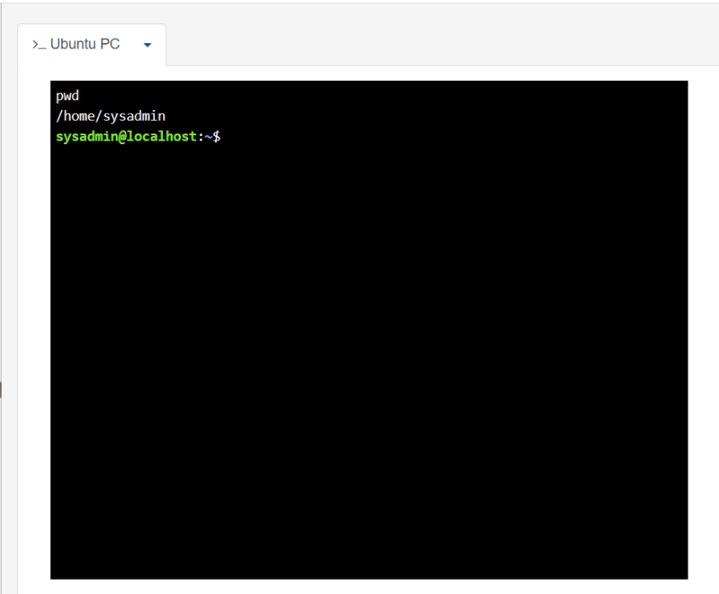
Figure 16: PWD –

Example 2:
The su (Switch User) command allows a user to change to another user account, including the root administrator account after entering the correct password. The output confirms that the active user has changed successfully, providing access to administrative privileges where authorised [24].
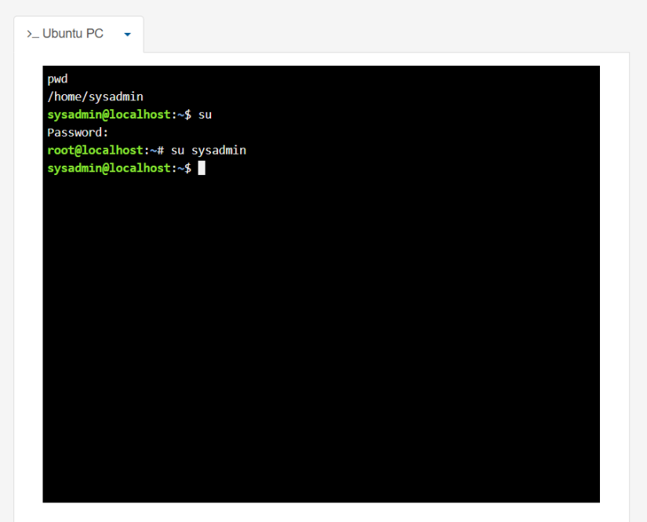
Figure 17: SU – ROOT USER

Example 3:
The ls command lists the files and directories contained within the current location. In the screenshot, the ls -l option displays additional information such as file permissions, ownership, file size and modification dates, making it easier to manage files efficiently [25].
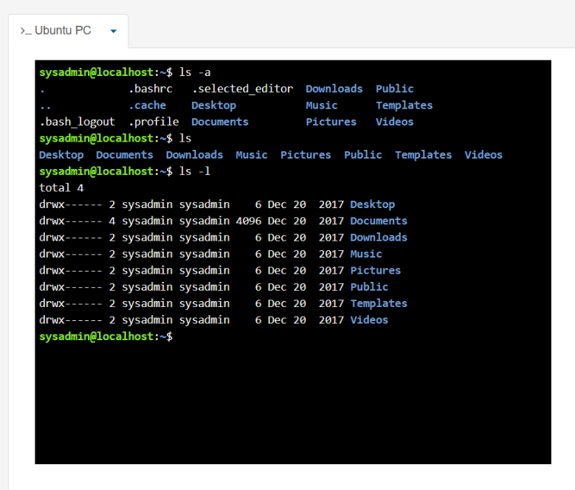
Figure 18: LINUX - ls

Example 4:
The cd (Change Directory) command is used to move between directories within the Linux file system. The output confirms that the current working directory has changed to the Desktop folder, allowing files and folders in that location to be accessed and managed [26].
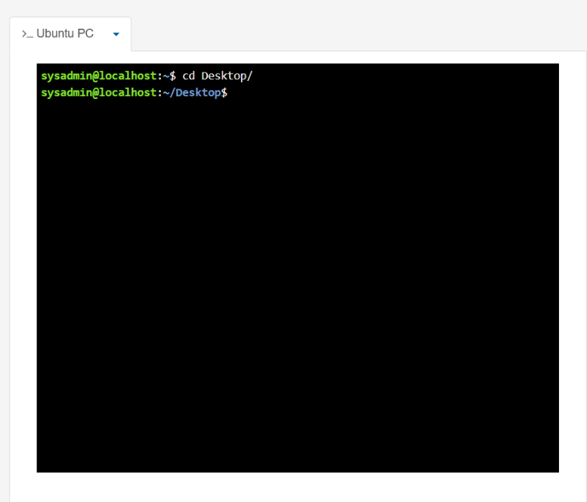
Figure 19: LINUX – cd – Desktop

Example 5:
The mkdir (Make Directory) command creates a new directory called new within the current location. Running ls afterwards confirms that the folder has been created successfully, allowing it to be used for organising files and storing data [27].
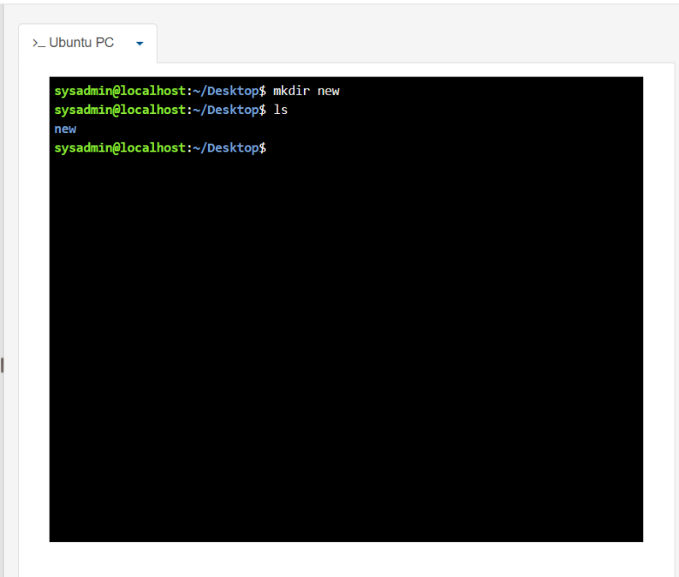
Figure 20: LINUX – mkdir (creating folder – NEW)

Example 6:
The rmdir (Remove Directory) command deletes an empty directory from the current location. In the screenshot, the folder named new is removed successfully. The output confirms that the directory has been deleted, helping users keep the file system organised by removing unnecessary empty folders [28].
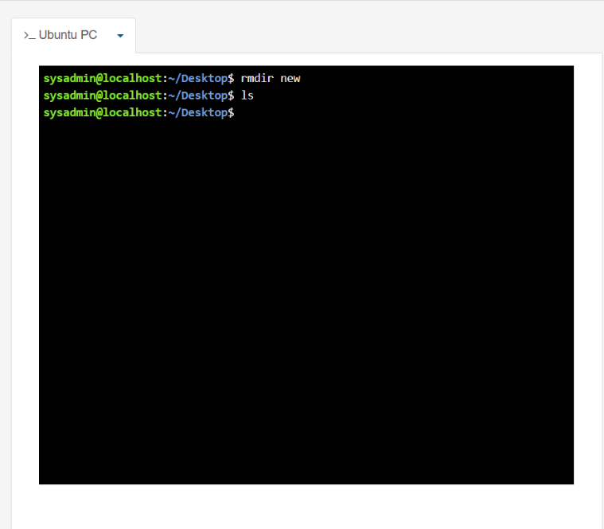
Figure 21: LINUX – rmdir new (delete folder ”new”)

Example 7:
The touch command creates a new empty file if it does not already exist. In the screenshot, the command creates a file named new. The output confirms the file has been added to the current directory, allowing users to store information or edit the file later using a text editor [29].
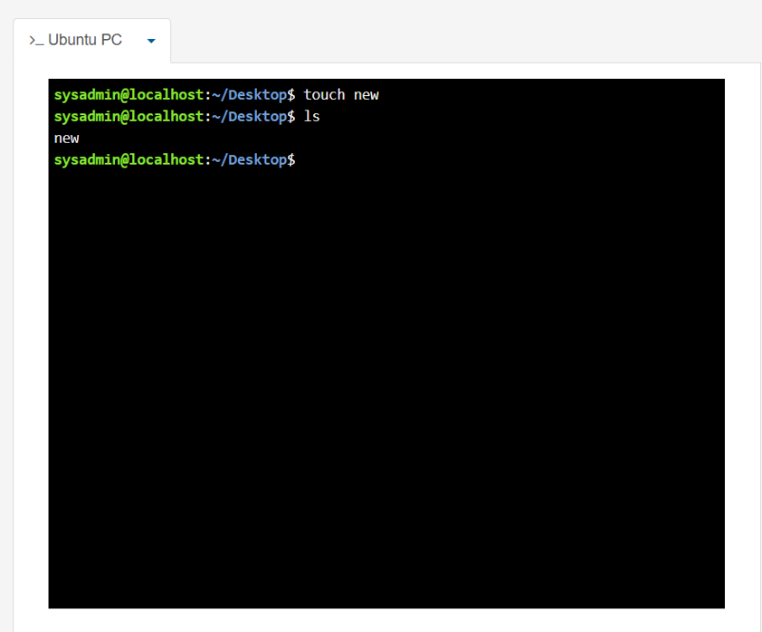
Figure 22: LINUX – touch new ( create a file)

Example 8:
The echo command writes text to a file using the > redirection operator. In the screenshot, the command stores the word "hello" in the file named new. The output confirms that the text has been written successfully, allowing the file to store simple data or messages [30].
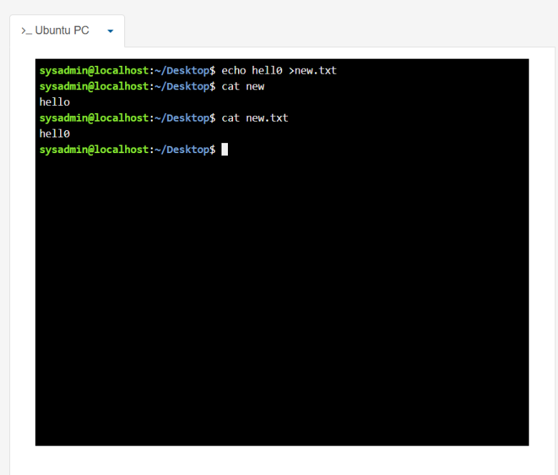
Figure 23: LINUX – echo hello >new (writing “hello” in new file)

Example 9:
The ifconfig command displays the network configuration of the system, including details such as the IP address, network interface and transmission statistics. The output enables users to verify network settings and troubleshoot connectivity issues by checking the current network configuration [31].
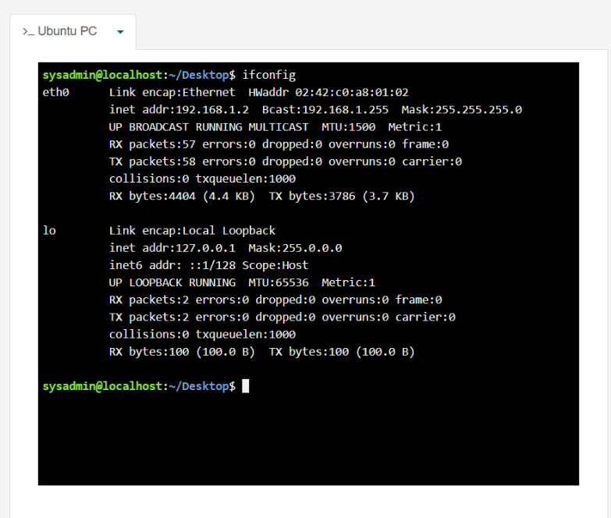
Figure 24: LINUX – ifconfig – (Internet configuration)

Example 10:
The whoami command displays the username of the currently logged-in user, while the date command shows the current system date and time. The output confirms the active user account and system time, providing useful information for system administration and troubleshooting tasks [32] [33].
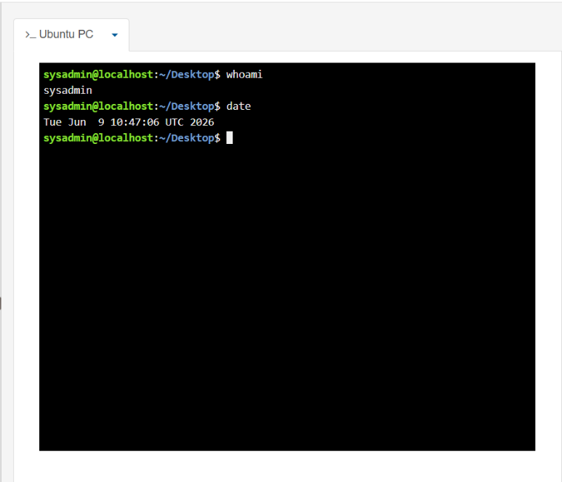
Figure 25: LINUX – whoami and date – (see which user logged into and date)

Use of Windows OS scripts
Batch scripting uses .bat or .cmd files to automate tasks in the Windows Command Prompt by running a sequence of commands. Batch scripts can perform calculations, process user input, manage files and repeat commands automatically, helping users save time and reduce manual work when carrying out routine administrative tasks [34], [35].

Example 1:
Figure 26 shows a Windows Batch script created in Notepad++ that asks the user to enter two numbers and then adds them together. The script uses the set /p command to collect input from the user and store the values in variables. In Batch scripting, variables are used to store data that can change while the program is running, and variable names should begin with a letter. The set /a command performs the mathematical calculation by adding the two values together. In programming, the equals sign (=) is used to assign a value to a variable rather than showing that two values are equal. As shown in Figure 27, after the user enters both numbers, the Command Prompt displays the calculated result. This example demonstrates how Batch scripts can combine user input, variables and arithmetic operations to automate a simple calculation in Windows [34], [36].

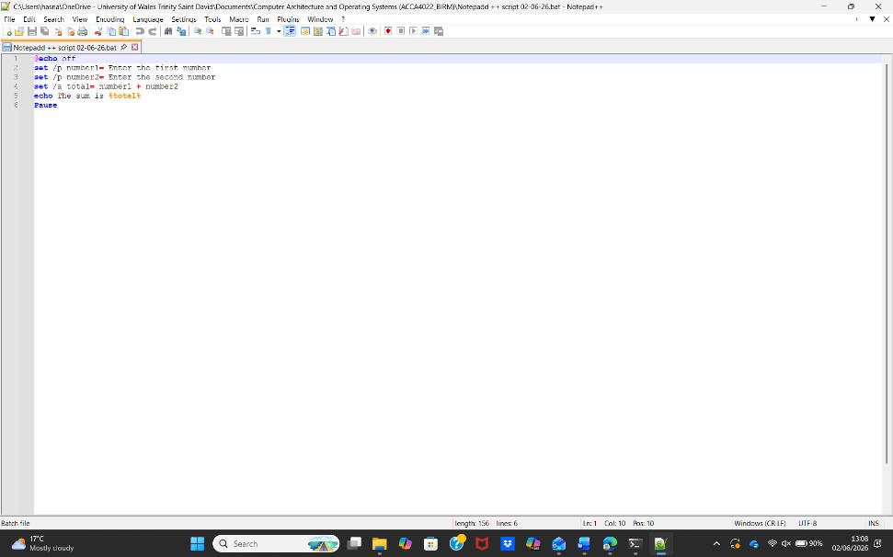
Figure 26: Notepad ++ Script -(Simple calculation of 2 numbers) - INPUT
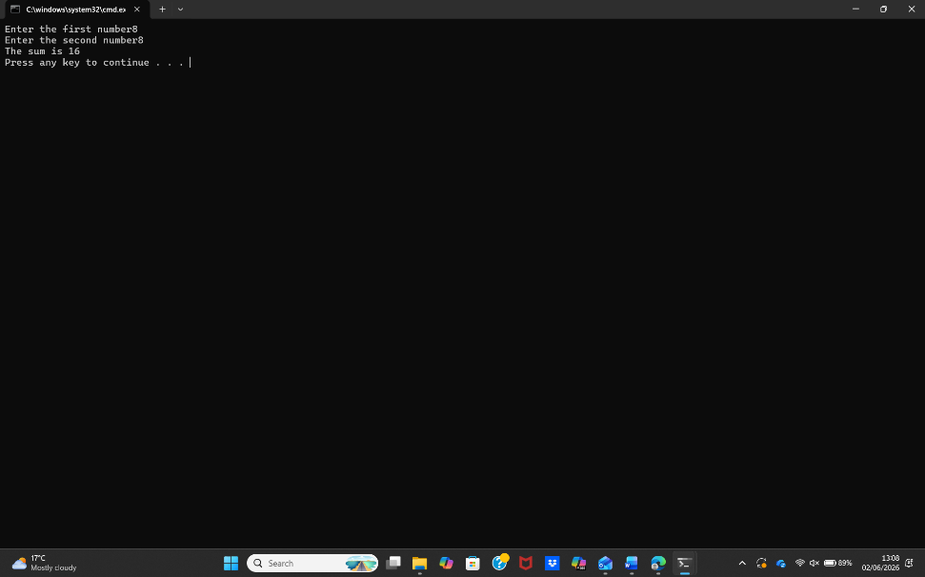
Figure 27: Notepad ++ Script (Simple calculation of 2 numbers) - OUTPUT

Example 2:
Figure 28 shows a Windows Batch script written in Notepad++ that asks the user to enter their age before checking whether they are old enough to vote. The script uses the set /p command to accept the user's input and store it in a variable. It then uses an IF...ELSE statement to compare the age entered with the minimum voting age. Conditional statements allow a program to make decisions based on whether a condition is true or false. If the user enters an age of 18 or over, the program displays a message confirming that they are eligible to vote. Otherwise, it informs the user that they are not old enough. Figure 29 shows the output produced after the script has been executed. This example demonstrates how Batch scripts can use variables, user input and decision-making statements to automate simple tasks and provide different outputs depending on the information entered by the user [34], [37].

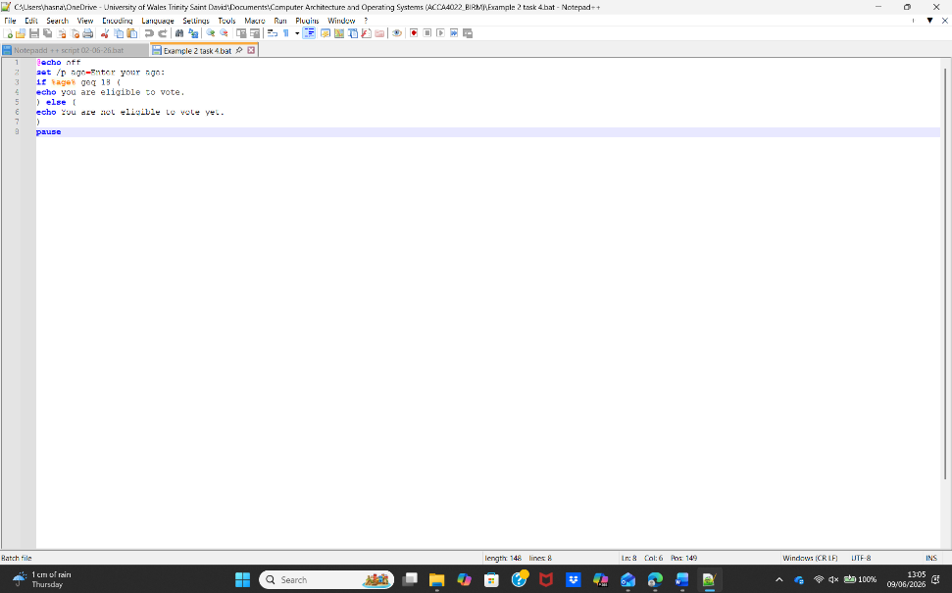
Figure 28: Notepad ++ Script - (Simple calculation of 2 numbers for voting) - INPUT
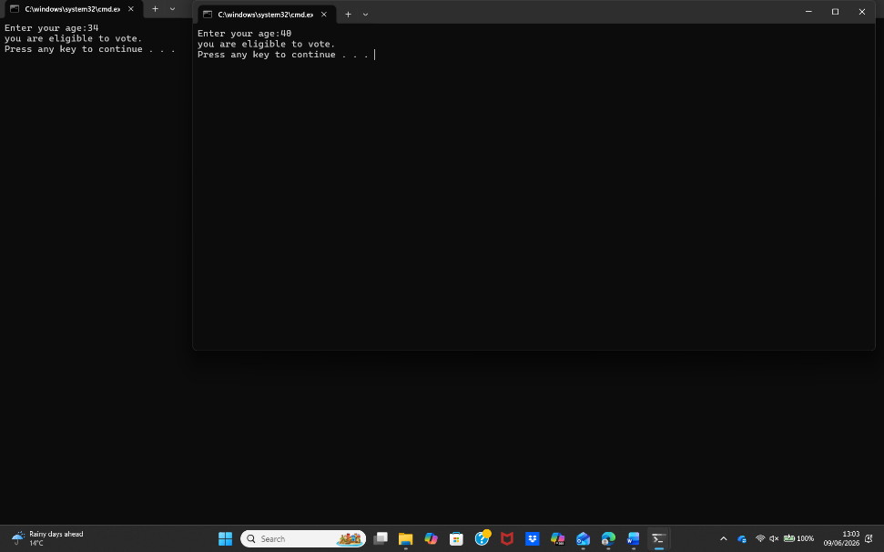
Figure 29: Notepad ++ Script - (Simple calculation of age for voting) - OUTPUT

Use of Linux OS scripts

Bash scripting is used to automate tasks in Linux by storing commands in a single .sh script file that can be executed by the Bash shell. Bash scripts can manage files, process user input, perform calculations and automate system administration tasks, helping users complete repetitive work more efficiently [38], [39].

Example 1:
Figure 30 shows a Bash script created in the Linux terminal to calculate the sum of two numbers entered by the user. The script uses the read command to collect user input and store the values in variables. It then performs the calculation using arithmetic expansion before displaying the result with the echo command. When the script was first executed, an error occurred because there was an unnecessary space between sum and $ in the output statement. This prevented the variable from being displayed correctly. After removing the space so that the variable was written as $sum, the script was tested again and produced the correct result, as shown in Figure 31. This example demonstrates the importance of testing and debugging Bash scripts, as even a small typing mistake can stop a program from working as expected [38], [40].

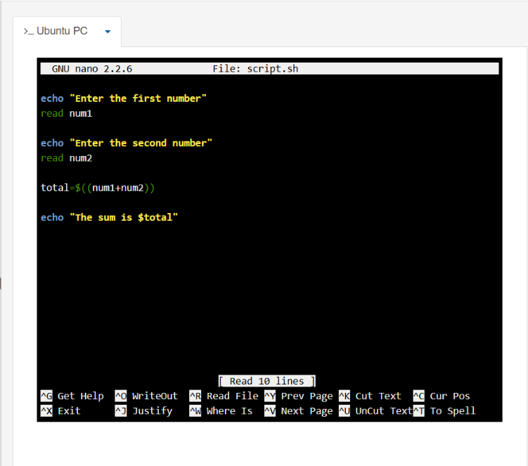
Figure 30: LINUX – creating script
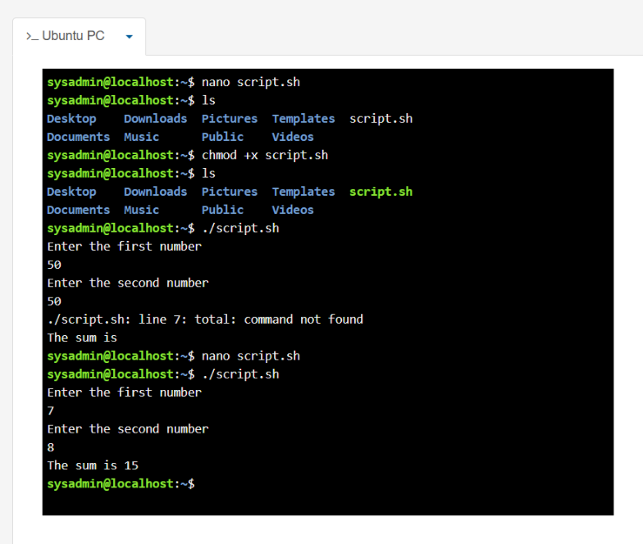
Figure 31: LINUX – OUTPUT – Running the script – made error in script by leaving a space between “sum $” so I deleted the space and re tested and it worked with > “sum$”

Example 2:
Figure 32 shows a Bash script named loop.sh being created using the nano text editor in Linux. The script contains a loop that repeatedly executes a set of commands, demonstrating how Bash scripting can automate repetitive tasks without requiring the user to enter the same command multiple times. When the script was first executed, Linux was unable to recognise the file because it had been saved with two extra letters in the filename. This prevented the script from running correctly. After identifying the mistake, the file was renamed to the correct filename and tested again. As shown in Figure 33, the corrected script executed successfully and produced the expected output. This example demonstrates the importance of using the correct file names when running Bash scripts and highlights how testing and correcting errors is an essential part of developing and troubleshooting Linux scripts [38], [41].
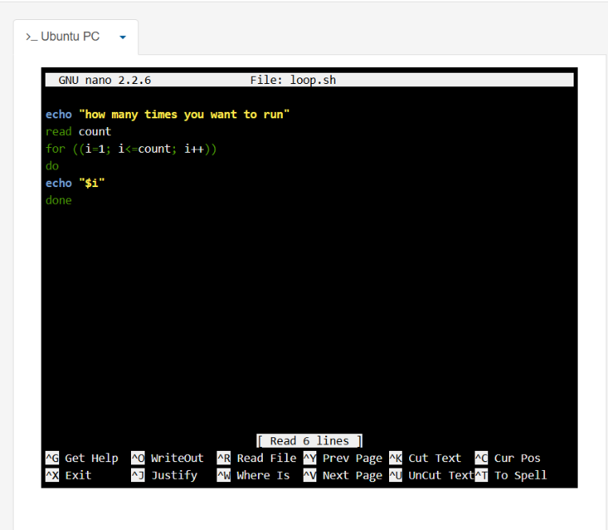
Figure 32: LINUX – INPUT – (nano loop.sh)
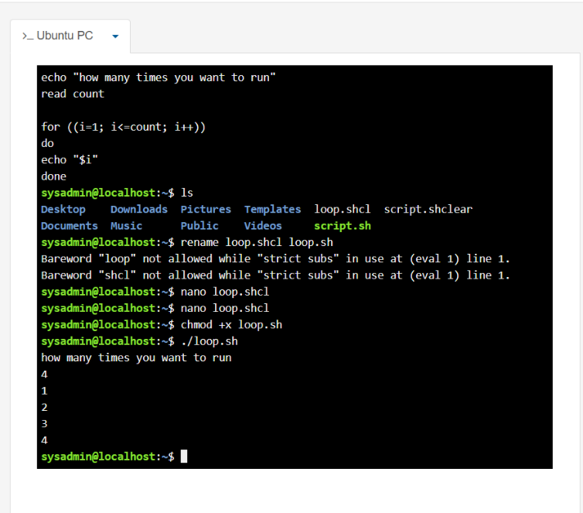
Figure 33: LINUX – Script – Output of loop – I saved the file incorrectly with extra 2 letters hence why it did not recognise, I rectified this by re-naming and it worked correctly.

Conclusion
This report improved my understanding of operating systems, command-line interfaces and scripting in both Windows and Linux. Completing the practical tasks helped me learn how commands and scripts can automate everyday tasks, manage files and solve simple problems. It also showed the importance of testing, identifying errors and correcting them to produce the expected results.

References
[1] J.-C. Franchitti, “6.1 What Is an Operating System?,” in Introduction to Computer Science. Houston, TX, USA: OpenStax, Nov. 13, 2024. [Online]. Available: https://openstax.org/books/introduction-computer-science/pages/6-1-what-is-an-operating-system. [Accessed: 23-Jul-2026].
[2] J.-C. Franchitti, “6.1 What Is an Operating System?,” in Introduction to Computer Science. Houston, TX, USA: OpenStax, Nov. 13, 2024. [Online]. Available: https://openstax.org/books/introduction-computer-science/pages/6-1-what-is-an-operating-system. [Accessed: 23-Jul-2026].
[3] J.-C. Franchitti, “6.2 Fundamental OS Concepts,” in Introduction to Computer Science. Houston, TX, USA: OpenStax, Nov. 13, 2024. [Online]. Available: https://openstax.org/books/introduction-computer-science/pages/6-2-fundamental-os-concepts. [Accessed: 23-Jul-2026].
[4] Microsoft, “Troubleshoot processes by using Task Manager,” Microsoft Learn, Feb. 12, 2026. [Online]. Available: https://learn.microsoft.com/en-us/troubleshoot/windows-server/support-tools/support-tools-task-manager. [Accessed: 23-Jul-2026].
[5] Microsoft, “Fix problems that block programs from being installed or removed,” Microsoft Support, n.d. [Online]. Available: https://support.microsoft.com/en-us/windows/deployment/install-upgrade/fix-problems-that-block-programs-from-being-installed-or-removed. [Accessed: 23-Jul-2026].
[6] Microsoft, “About File Management,” Microsoft Learn, Jan. 7, 2021. [Online]. Available: https://learn.microsoft.com/en-us/windows/win32/fileio/about-file-management. [Accessed: 23-Jul-2026].
[7] Microsoft, “Using Device Manager,” Microsoft Learn, Apr. 23, 2025. [Online]. Available: https://learn.microsoft.com/en-us/windows-hardware/drivers/install/using-device-manager. [Accessed: 23-Jul-2026].
[8] Joint Task Force, Security and Privacy Controls for Information Systems and Organizations, NIST Special Publication 800-53, Rev. 5. Gaithersburg, MD, USA: National Institute of Standards and Technology, Sep. 2020, updated Dec. 10, 2020. [Online]. Available: https://csrc.nist.gov/pubs/sp/800/53/r5/upd1/final. [Accessed: 23-Jul-2026].
[9] Microsoft, “Command-line syntax key,” Microsoft Learn, Sep. 8, 2023. [Online]. Available: https://learn.microsoft.com/en-us/windows-server/administration/windows-commands/command-line-syntax-key. [Accessed: 23-Jul-2026].
[10] Microsoft, “Windows commands,” Microsoft Learn, Feb. 24, 2026. [Online]. Available: https://learn.microsoft.com/en-us/windows-server/administration/windows-commands/windows-commands. [Accessed: 23-Jul-2026].
[11] Microsoft, “dir,” Microsoft Learn, Feb. 3, 2023. [Online]. Available: https://learn.microsoft.com/en-us/windows-server/administration/windows-commands/dir. [Accessed: 23-Jul-2026].
[12] Microsoft, “cd,” Microsoft Learn, Nov. 1, 2024. [Online]. Available: https://learn.microsoft.com/en-us/windows-server/administration/windows-commands/cd. [Accessed: 23-Jul-2026].
[13] Microsoft, “mkdir,” Microsoft Learn, Feb. 3, 2023. [Online]. Available: https://learn.microsoft.com/en-us/windows-server/administration/windows-commands/mkdir. [Accessed: 23-Jul-2026].
[14] Microsoft, “rmdir,” Microsoft Learn, Feb. 3, 2023. [Online]. Available: https://learn.microsoft.com/en-us/windows-server/administration/windows-commands/rmdir. [Accessed: 24-Jul-2026].
[15] Microsoft, “ren,” Microsoft Learn, Nov. 1, 2024. [Online]. Available: https://learn.microsoft.com/en-us/windows-server/administration/windows-commands/ren. [Accessed: 24-Jul-2026].
[16] Microsoft, “ipconfig,” Microsoft Learn, Feb. 3, 2023. [Online]. Available: https://learn.microsoft.com/en-us/windows-server/administration/windows-commands/ipconfig. [Accessed: 24-Jul-2026].
[17] Microsoft, “netstat,” Microsoft Learn, Nov. 1, 2024. [Online]. Available: https://learn.microsoft.com/en-us/windows-server/administration/windows-commands/netstat. [Accessed: 24-Jul-2026].
[18] Microsoft, “systeminfo,” Microsoft Learn, Feb. 3, 2023. [Online]. Available: https://learn.microsoft.com/en-us/windows-server/administration/windows-commands/systeminfo. [Accessed: 24-Jul-2026].
[19] Microsoft, “tasklist,” Microsoft Learn, Feb. 3, 2023. [Online]. Available: https://learn.microsoft.com/en-us/windows-server/administration/windows-commands/tasklist. [Accessed: 24-Jul-2026].
[20] Microsoft, “ping,” Microsoft Learn, Nov. 1, 2024. [Online]. Available: https://learn.microsoft.com/en-us/windows-server/administration/windows-commands/ping. [Accessed: 24-Jul-2026].
[21] N. Lager, “How to access the Linux terminal,” Red Hat Blog, Apr. 12, 2022. [Online]. Available: https://www.redhat.com/en/blog/access-linux-terminal. [Accessed: 24-Jul-2026].
[22] M. Garrels, Introduction to Linux: A Hands-on Guide, rev. 1.27. The Linux Documentation Project, Jun. 6, 2008. [Online]. Available: https://tldp.org/LDP/intro-linux/html/intro-linux.html. [Accessed: 24-Jul-2026].
[23] Free Software Foundation, “pwd: Print working directory,” in GNU Coreutils Manual, ver. 9.11, Apr. 20, 2026. [Online]. Available: https://www.gnu.org/software/coreutils/manual/html_node/pwd-invocation.html. [Accessed: 24-Jul-2026].
[24] D. Garn, “How to manage users and groups in Linux,” Red Hat Blog, Oct. 14, 2021. [Online]. Available: https://www.redhat.com/en/blog/linux-user-group-management. [Accessed: 24-Jul-2026].
[25] Free Software Foundation, “ls: List directory contents,” in GNU Coreutils Manual, ver. 9.11, Apr. 20, 2026. [Online]. Available: https://www.gnu.org/software/coreutils/manual/html_node/ls-invocation.html. [Accessed: 24-Jul-2026].
[26] Free Software Foundation, “Bourne shell builtins,” in GNU Bash Reference Manual, ed. 5.3, May 18, 2025. [Online]. Available: https://www.gnu.org/software/bash/manual/html_node/Bourne-Shell-Builtins.html. [Accessed: 24-Jul-2026].
[27] Free Software Foundation, “mkdir: Make directories,” in GNU Coreutils Manual, ver. 9.11, Apr. 20, 2026. [Online]. Available: https://www.gnu.org/software/coreutils/manual/html_node/mkdir-invocation.html. [Accessed: 24-Jul-2026].
[28] Free Software Foundation, “rmdir: Remove empty directories,” in GNU Coreutils Manual, ver. 9.11, Apr. 20, 2026. [Online]. Available: https://www.gnu.org/software/coreutils/manual/html_node/rmdir-invocation.html. [Accessed: 24-Jul-2026].
[29] Free Software Foundation, “touch: Change file timestamps,” in GNU Coreutils Manual, ver. 9.11, Apr. 20, 2026. [Online]. Available: https://www.gnu.org/software/coreutils/manual/html_node/touch-invocation.html. [Accessed: 24-Jul-2026].
[30] Free Software Foundation, “echo: Print a line of text,” in GNU Coreutils Manual, ver. 9.11, Apr. 20, 2026. [Online]. Available: https://www.gnu.org/software/coreutils/manual/html_node/echo-invocation.html. [Accessed: 24-Jul-2026].
[31] Net-tools Project, “ifconfig(8)—Configure a network interface,” Linux Manual Page, Sep. 10, 2025. [Online]. Available: https://man7.org/linux/man-pages/man8/ifconfig.8.html. [Accessed: 24-Jul-2026].
[32] Free Software Foundation, “whoami: Print effective user name,” in GNU Coreutils Manual, ver. 9.11, Apr. 20, 2026. [Online]. Available: https://www.gnu.org/software/coreutils/manual/html_node/whoami-invocation.html. [Accessed: 24-Jul-2026].
[33] Free Software Foundation, “date: Print or set system date and time,” in GNU Coreutils Manual, ver. 9.11, Apr. 20, 2026. [Online]. Available: https://www.gnu.org/software/coreutils/manual/html_node/date-invocation.html. [Accessed: 24-Jul-2026].
[34] Microsoft, “Windows commands,” Microsoft Learn, Feb. 24, 2026. [Online]. Available: https://learn.microsoft.com/en-us/windows-server/administration/windows-commands/windows-commands. [Accessed: 24-Jul-2026].
[35] Microsoft, “Command-line syntax key,” Microsoft Learn, Sep. 8, 2023. [Online]. Available: https://learn.microsoft.com/en-us/windows-server/administration/windows-commands/command-line-syntax-key. [Accessed: 24-Jul-2026].
[36] Microsoft, “set (environment variable),” Microsoft Learn, Sep. 6, 2023. [Online]. Available: https://learn.microsoft.com/en-us/windows-server/administration/windows-commands/set_1. [Accessed: 24-Jul-2026].
[37] Microsoft, “if,” Microsoft Learn, Feb. 3, 2023. [Online]. Available: https://learn.microsoft.com/en-us/windows-server/administration/windows-commands/if. [Accessed: 24-Jul-2026].
[38] Free Software Foundation, GNU Bash Reference Manual, ed. 5.3, May 18, 2025. [Online]. Available: https://www.gnu.org/software/bash/manual/. [Accessed: 24-Jul-2026].
[39] Red Hat, “What is Bash?,” Red Hat, n.d. [Online]. Available: https://www.redhat.com/en/topics/linux/what-is-bash. [Accessed: 25-Jul-2026].
[40] Free Software Foundation, “Bash builtin commands,” in GNU Bash Reference Manual, ed. 5.3, May 18, 2025. [Online]. Available: https://www.gnu.org/software/bash/manual/html_node/Bash-Builtins.html. [Accessed: 25-Jul-2026].
[41] Free Software Foundation, “Looping constructs,” in GNU Bash Reference Manual, ed. 5.3, May 18, 2025. [Online]. Available: https://www.gnu.org/software/bash/manual/html_node/Looping-Constructs.html. [Accessed: 25-Jul-2026].

Appendices
Online Course name: NDG Linux Unhatched

Figure 34: Certificate of completion

