Training Programme
This report will outline the design, reasoning, implementation and evaluation of a personalised training programme which has been developed to meet the specific fitness targets and needs of a client. An initial consultation was carried out alongside a fitness assessment, which helped structure the programme around the client’s physical condition, fitness levels, lifestyle and goals. The aim of this training programme was to help the client improve their overall fitness and to help them lose weight so that they could complete their first half marathon in June and a second in October.
Rationale
The initial frequency of the programme was set at two training sessions per week, on top of the running session and Zumba class that they already did. One of the training sessions set was to be completed at home or in their own time. This was decided because the client stated in the initial assessment how they had a full-time job which meant they were on different campus’ and had a young family, so time was limited. By allowing the client to train in their own time, it meant that they could establish a routine which worked for them without feeling pressured or overwhelmed with guilt if a session was not completed on a day that was mutually agreed. It also meant that the client wouldn’t face burnout, which is a common barrier with novice exercisers with a busy weekly schedule (Bodywork and Movement Therapies, 2023). As the client became more conditioned to training twice a week, the frequency of training was increased to three times a week, which aligns with the American College of Sports Medicine (ACSM, 2021). The ACSM suggests that training two to three times a week is important for general fitness.
A RAMP warm up (raise, activate, mobilise, potentiate) was used in the programme at the start of every session for the full 12-week programme. The RAMP warm up was initially introduced by Jeffreys (2007) and was used in the clients’ programme because it prepares the body for the upcoming exercise. It does this by raising the heart rate, activating muscle groups and improving the mobility of joints. During the warm up, the Rate of Perceived Exertion (RPE) was set between 3-5, which is in the moderate bracket. The RPE was set at 3-5 because the aims of the warm up was to increase blood blow and heart rate without causing fatigue to the client (Patel et al. 2025). This remained the same for the 12 weeks because the aim of the war up stayed the same.
At the beginning of the programme, all the resistance training that was set was machine based and not free weights. This decision was made because the client was a beginner in the gym and had no experience lifting weights, but also because the client had a neural injury. Using machines provides a controlled movement and offers stability so that the client can learn the correct movement pattern and build initial strength (Gentil et al., 2017) but also allowed the client to understand and learn what movements aggravated the Sciatica injury. However, in weeks 5-8 some free weights were introduced so that the client could start to learn the movement patterns without the assistance of the machine. By weeks 9-12 more free weights were introduced because the client became more confident and more stable when lifting weights.
In the initial weeks of the programme, the cardiovascular training was set at 8 minutes. This was because setting shorter cardio sessions allowed for progression throughout the plan, but also provided a stimulus for adaptation, whilst minimising the risk of making the clients Sciatica worse. Gradually increasing the volume of cardiovascular training and intensity is supported by the ACSM guidelines because it helps develop adherence and reduce risk of injury in clients that are deconditioned or sedentary. The rowing machine was often used for warm ups and for light cardio because it’s off feet, low impact but is still a full body exercise that doesn’t put the body under lots of stress. Clarke et al (2023) discovered that it was the best machine for injuries involving nerves and the spine because it helps with spinal decompression and it helps strengthen the posterior chain without aggravating the sciatic symptoms.
In the first 4 weeks of the programme, the focus was to develop foundational strength and to learn the correct technique of exercises. The use of 3 sets of 8 was used initially because it is ideal for beginners because helps build strength and muscle size (Chandler et al., 2017). Having few reps also allows individuals to focus of technique which is essential in the early stages because it will help reduce risk of injury later in the programme (Gentil et al., 2017). In weeks 5 to 8, the programme progressed from 8 repetitions to 10 repetitions. This was set because one of the core principles for this programme was progressive overload which helps with hypertrophy and improved muscular endurance and work capacity (Ratamess, 2012). Progressive overload is when there is a gradual increase of stress placed on the body during a specific training and is used so that the body doesn’t get used to the workload and therefore doesn’t plateau (Schoenfeld, 2010). This can be done by increasing the weight, the number of repetitions, the number of sets or shortening the rest periods in between sets. In weeks 9-12 the reps increased to 12 but sets stayed the same at three. This was set because increasing the reps helps build muscles, improved muscular endurance but also helped improve the overall work volume.
To ensure structural balance and even development across all primary movement patterns, the plan included a variety of vertical pull, vertical push, horizontal pull, horizontal push, hinge, rotate and brace exercises. This structure ensures that all of the major muscle groups are working which prevents muscular imbalances that then lead to postural injuries (Boyle, 2016). Lat pull down was selected because it engages the latissimus dorsi and the mid to upper back, muscles which become weaker if sat at a desk, which the client did daily due to their job. Shoulder press was included because it targets deltoids and triceps which supports overhead stability and shoulder stability and strength. Bent over row was used because it strengthens the middle back which again is important for people who work at desks because it counters the forward shoulder posture. Finally, chest push was picked because it helps with functional upper body strength. These four exercises alone were chosen for the client based around their lifestyle and their goals. Russian twists and plank were inserted for brace and twist exercises. During the consultation, the client explained how they eventually wanted to be able to do shoulder taps, these exercises teach the fundamental movements of a shoulder tap by strengthening the core in Russian twists but learning how to brace during a standard plank. Unlike squats or deadlifts, the leg press machine supports the back and doesn’t carry load directly on the spine under vertical load. Vertical load can aggravate sciatica, so this exercise was included in the plan to avoid further pain. Leg press was also used because it is easier to limit how deep the knees bend. This is key because deep flexion and certain hip angles can pinch the sciatic nerve further, causing more discomfort (Smith and Brown, 2020).
A traditional training system was used because the client was a beginner. Traditional training systems are easy to follow, easy to gage how the client is finding the exercises, and it is low risk because the trainer is able to spot the client and demonstrate exercises (Baechle & Earle, 2008). Traditional systems are also the best way to add gradual progression such as adding weight or adding repetitions. This teaches the client how to track their progress and understand how the body can adapt and become stronger over a period.

Reflection
One of the major changes I had to make to the programme was changing the chest push machine exercise to the bench press using the Smith machine. I initially picked the chest push exercise because I thought it was a simple but effective way of learning the movement pattern and gaining some initial strength in the upper body. However, it became quite clear early on that the client struggled with the movement at full extension and would often over push and their back would come off the seat, causing the handles to bang together. This meant that the client was altering the way they were using the machine to stop the contact at the top so wasn’t fully engaging the pecs or triceps. After observing this and having a conversation with the client, I decided to change the exercise to a bench press on a Smiths machine which meant that there was still guidance throughout the movement, but it meant they could do the exercise without having any factors affecting it. Once I made the switch, the client was able to jump up the weights quickly which they later explained might have been down the fact that they already had good foundational strength due to playing netball at a high standard a few years ago. This experience alone developed my coaching skills and the ability to notice incorrect form and technique. It also helped my adaptability and observational skills because I had to make sure the client was happy with the new exercise and their form was correct.
Throughout the whole programme the client was extremely committed and dedicated to the process. They were really determined, even when they were faced with a challenge or when they were struggling. For example, walking lunges were a struggle for the client because they often struggled with knee pain which was linked to their weight. I always made it clear to the client that if it was too much or too hard that we could modify the exercise or even switch it to something else, but they consistently chose to push through and complete the exercise and said they felt extremely proud when they finished it each week. This however did mean that I had to keep a close eye on their form and coach more thoroughly which helped my coaching skills but also helped my motivational skills and empathy skills.
The client was always positive and fully involved in every session I brought to her. They were always fully engaged when I was demonstrating exercises and was always eager to ask questions and understand why it was important to do certain things during the exercise so that they could get the technique correct. A highlight of this programme has been the client’s reaction when we increased weights on certain exercises. It helped build their confidence and helped maintain motivation because they saw it as a sign of progress. The client’s overall attitude not only made sessions more productive but also made it more enjoyable for us both.
Looking back on the programme, I do believe the programme went to plan. The client responded well to the programme and the exercises set and said that they could feel themselves getting stronger and fitter. However, in hindsight, I would have liked to work with the client for a longer period and would have liked to see her complete their goal of a half marathon. I felt we developed a great trainer-client relationship, and it has been rewarding for us both. Overall, I have developed the knowledge and understanding of the importance of flexibility and communication as a trainer but also how important it is to develop a good relationship with the client whilst also developing my observational skills. This programme has been valuable both professionally and personally.

Reference list
American College of Sports Medicine (2021) ACSM’s Guidelines for Exercise Testing and Prescription. 11th ed. Philadelphia: Wolters Kluwer.
Baechle, T.R. & Earle, R.W., 2008. Essentials of strength training and conditioning. 3rd ed. Champaign, IL: Human Kinetics.
Bodywork and Movement Therapies. (2023). Barriers to exercise adherence: A scoping review. Journal of Bodywork and Movement Therapies, [online] Available at: https://www.sciencedirect.com/science/article/pii/S1360859222001231 [Accessed 15 Apr. 2025].
Boyle, M. (2016). New Functional Training for Sports. 2nd ed. Champaign, IL: Human Kinetics.
Chandler, C., Souza, M., and Smith, A., 2017. Effects of resistance training on muscle strength and hypertrophy in different rep ranges: A review of the literature. Journal of Strength and Conditioning Research, 31(2), pp. 321-329.
Clarke, I.C., Cady-McCrea, M., Lawlor, M.C., Rodenhouse, T.F., Puvanesarajah, V. and Mesfin, A., (2023). The Rowing Spine: A Review of Biomechanics, Injury, and Treatment. Journal of Clinical Orthopaedics, [online] Available at: https://doi.org/10.1016/j.jocl.2023.100123 [Accessed 15 Apr. 2025].
Gentil, P., Soares, S.R. and Bottaro, M., 2017. Resistance training with machines vs free weights: Impacts on muscle strength and hypertrophy in untrained subjects. Journal of Human Kinetics, 56(1), pp. 19-26.
Jeffreys, I. (2007). Warm Up Revisited – The “RAMP” Method of Optimising Performance Preparation. Professional Strength and Conditioning, 6, pp.12–18.
Patel, R., Smith, J., & Thompson, L. (2025). Comparing the effectiveness of the FIFA 11+ warm-up and conventional warm-up programs on RPE and performance metrics in professional athletes. Nature Scientific Reports.
Ratamess, N.A., 2012. ACSM’s Foundations of Strength Training and Conditioning. Philadelphia: Wolters Kluwer Health/Lippincott Williams & Wilkins.
Schoenfeld, B.J., 2010. The mechanisms of muscle hypertrophy and their application to resistance training. Journal of Strength and Conditioning Research, 24(10), pp.2857-2872.
Smith, J.A. and Brown, T.L., 2020. 'The role of controlled range of motion in rehabilitation for sciatica sufferers', Journal of Physiotherapy and Rehabilitation, 28(3), pp. 45–53.
Smith, J.A. and Doe, R.L. (2023) 'The impact of resistance training on lower back pain in overweight adults', Journal of Rehabilitation Medicine, 55(4), pp. 210–218.

Lifestyle assessment and client profile

Page 1 of 6

Learner’s name: Lauren Evans Date: 30/01/25

Client’s name |  |  |  | Age | Gender
Ffion Vardon |  |  |  | 37 | Female
Description of lifestyle, to include: family, occupation, hobbies etc.
Client works full time between 2 campus sites.

Has 2 young children.

Tries to run a couple times week before the children wake up in the morning.

Does a zumba class on a Saturday morning.

Description of present exercise and physical activity levels (apply FITT where appropriate) |  | Description of past exercise and physical activity levels (apply FITT where appropriate)
Currently runs at least once a week and a Used to play netball 3 times a week before
light intensity. having children.

Zumba once a week high intensity. Used to go to them gym a lot.

Used to run a lot more than she does now.

Clients activity likes and dislikes
Likes: |  |  | Dislikes:
Weights circuits.  Short sharp exercises  Trying new exercises |  |  | Nothing in particular
Client PAR-Q /PAR-Q + completed and informed consent explained: YES |  |  | Did the client answer YES to any PAR-Q/par-q + questions? NO
Analysis of PAR-Q/PAR-Q + response(s) and actions if applicable
Results from tests (physical measurements/assessments (as appropriate to client and goals) –
examples only given – not prescriptive – appropriate to client needs and goals)
Test | Results
Blood pressure | 123/88
Anthropometrics (tick method): height and weight  BMI  waist circumference waist to hip ratio | Height = 174cm  Weight = 137.2 kg

Body composition (tick method): callipers  bio-electrical impedance | ////
Cardiovascular fitness (tick method):  Astrand bike test Rockport walking test step test  Cooper 12 min walk/run  other machine based time tests (please specify) | ////
Range of movement (tick method): sit and reach test  visual assessment other (please specify) | /////
Muscular fitness (tick method): abdominal curl/sit-up test press-up test  estimation of 8-12 rep max other (please specify) | /////
Balance tests:  (specify below) | /////
Results analysis – list any considerations for the programme based on the above

Functional ability – list any areas of functional fitness (relevant to client lifestyle and goals) that need applying to the programme
/////
Posture and alignment – list any postural/alignment issues your client might have and how these will be addressed in the programme (refer to postural analysis record)
No postural issues or abnormalities

Client’s needs
Client’s readiness to participate (list the client’s general feelings towards starting a programme of
exercise and any possible obstacles)
Client said she is eager to get started, excited to see the progress and determined to see a difference.
SMART goals: Indicate below if another party other than the personal trainer and client is required for goal setting (please give a reason for their involvement)
Short-term (3 months) | Agreed review dates:
Lose weight so that running becomes easier. April

Medium-term (6 months) | Agreed review dates:
To run a half marathon June
Long-term (12 months) | Agreed review dates:
Enter, compete and finish a hyrox competition 2026
Barriers to achieving goals
Client has a busy schedule and does not always having access to a gym.
Strategies to overcome these barriers
Integrate the PT session into the client’s life and weekly schedule and make it adaptable so that a session can be done at home if needs be.
Identify any everyday activities the client incorporates into their lifestyle that could compliment a gym programme and assist them in achieving goals
Running once a week will help lose weight but also help their goal of running a half marathon. Zumba classes will also help the client lose weight and will help add variety to the week.

Postural analysis record

Learner’s name: Lauren Evans Date: 30/01

Client name: Ffion Vardon Date: 30/01

Postural assessment notes and screening (can include a copy of postural assessment records or photographs detailing client’s posture)
Area of the body | Observation (static/dynamic) | Comments/recommendations
Head / neck (cervical spine) | No obvious differences
Shoulders, scapulae and Thoracic spine | No obvious differences

Pelvis and lumbar spine | No obvious differences  Not an observation but client has  sciatica
Knees, feet and ankles | No obvious differences

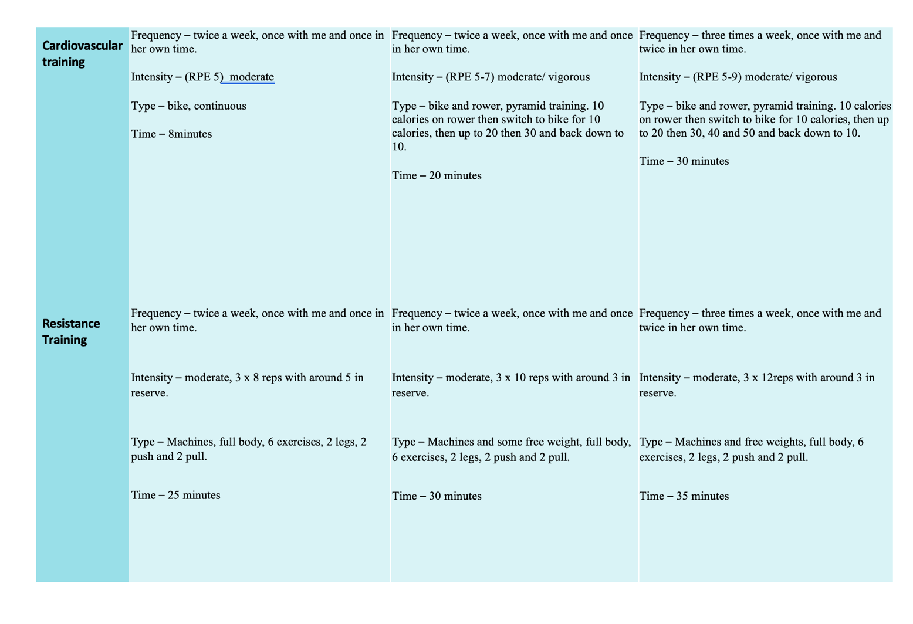
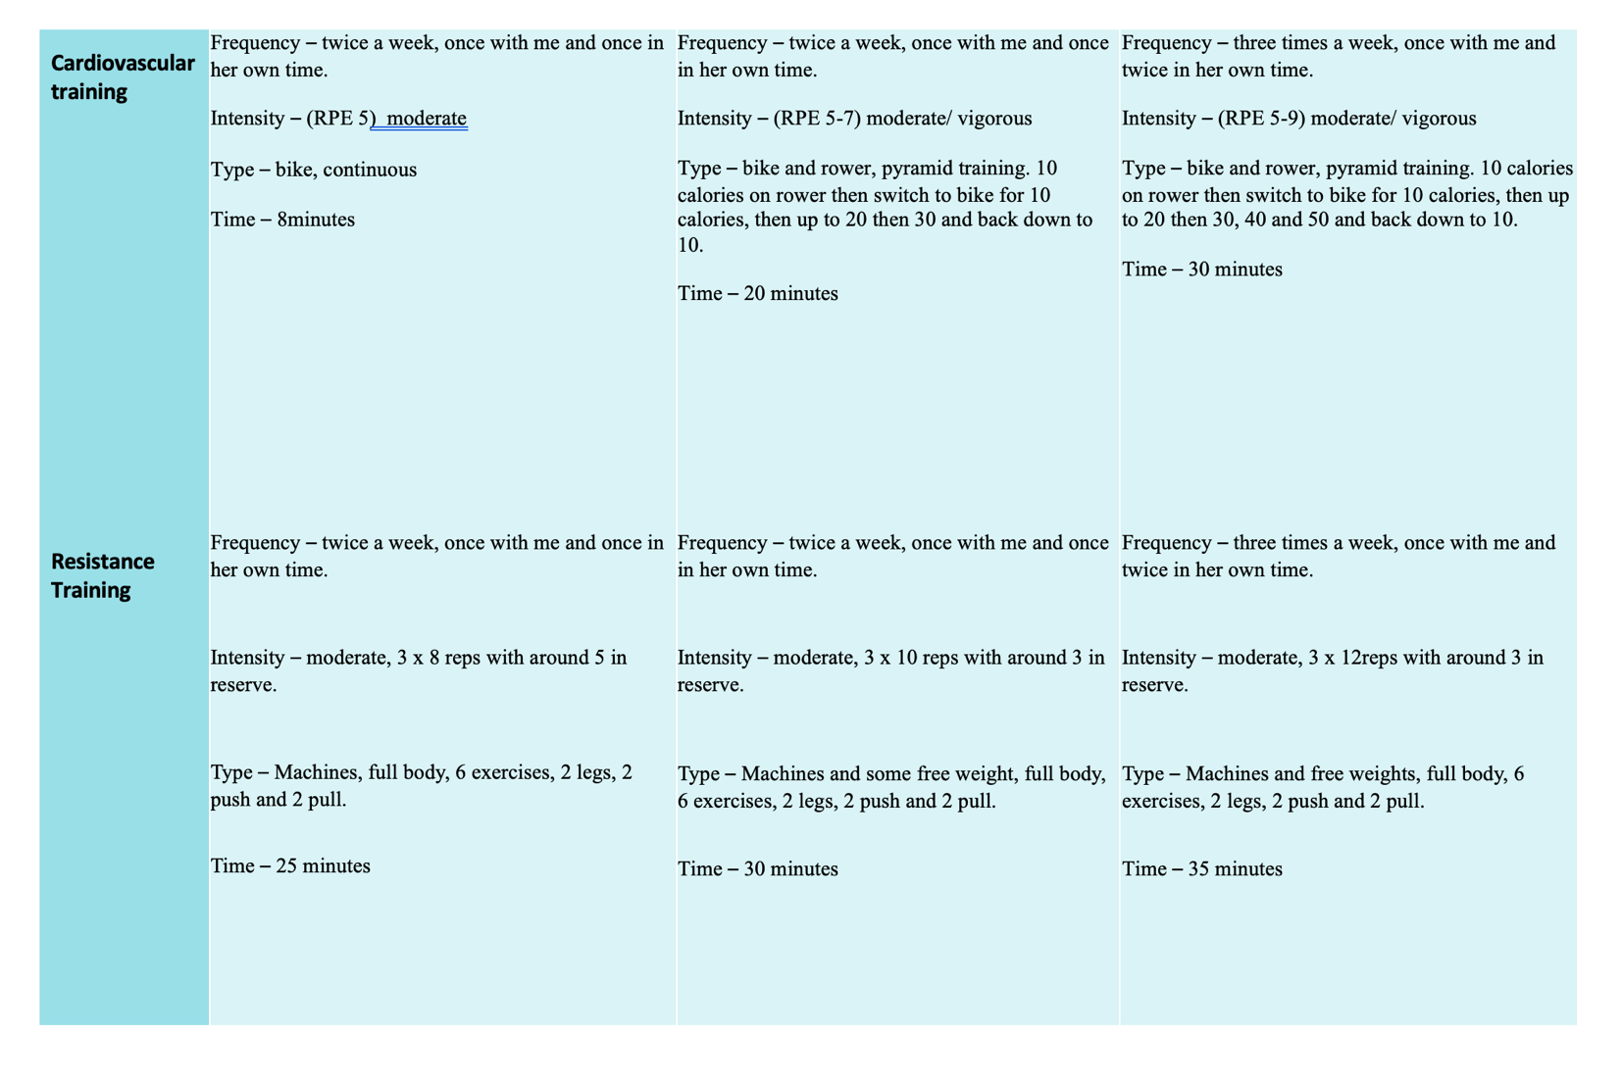
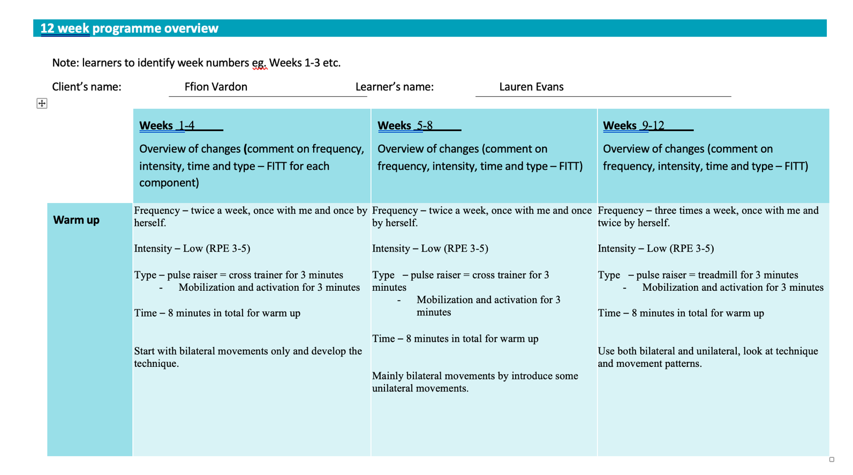

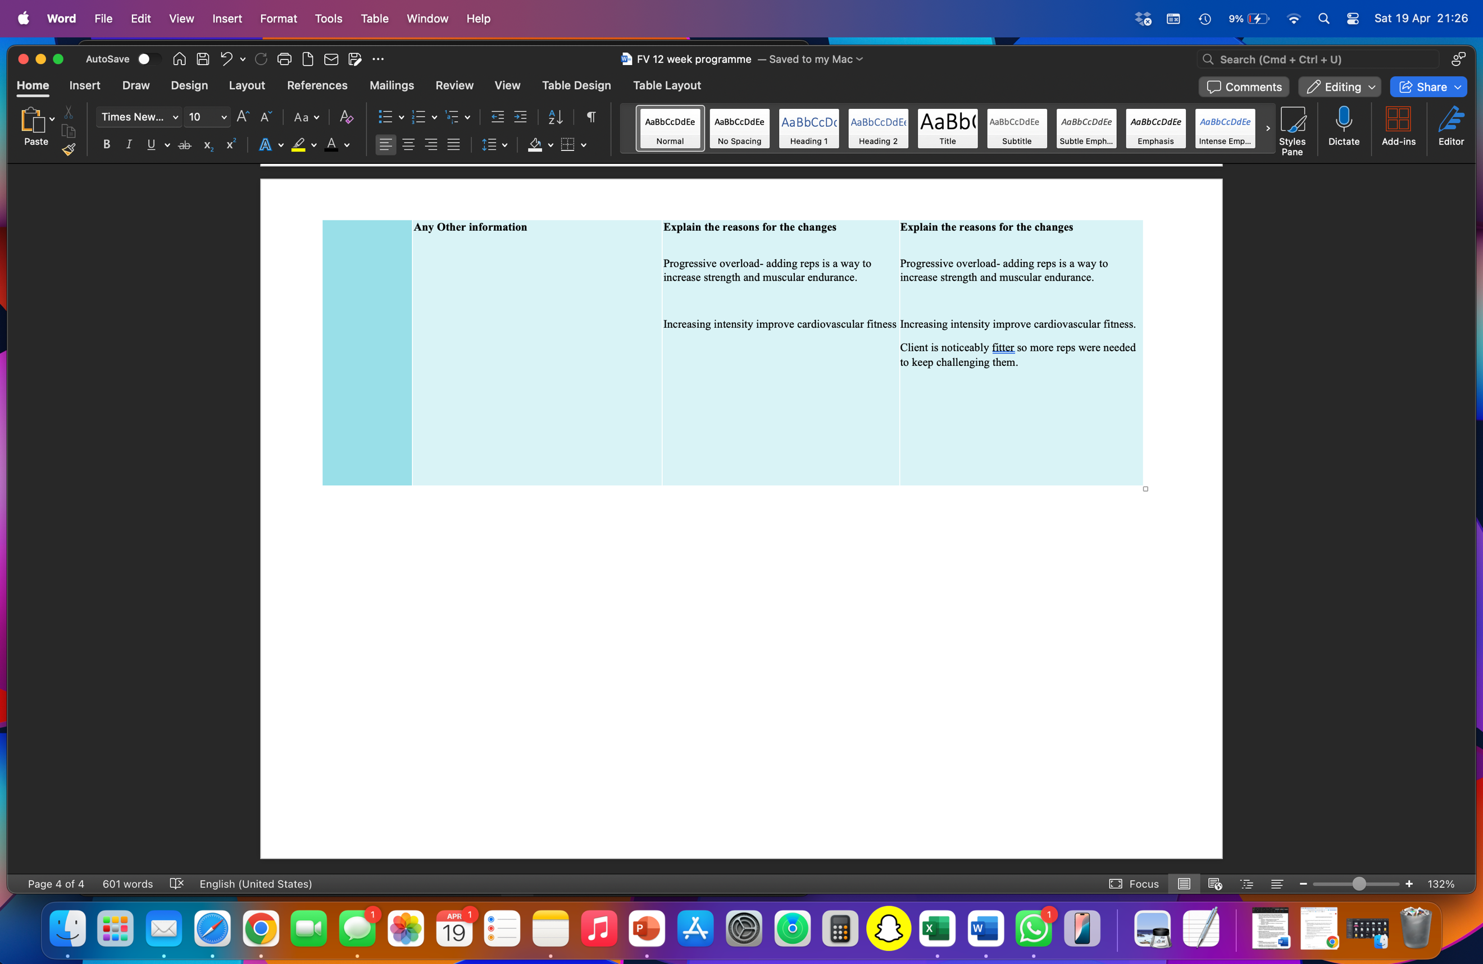
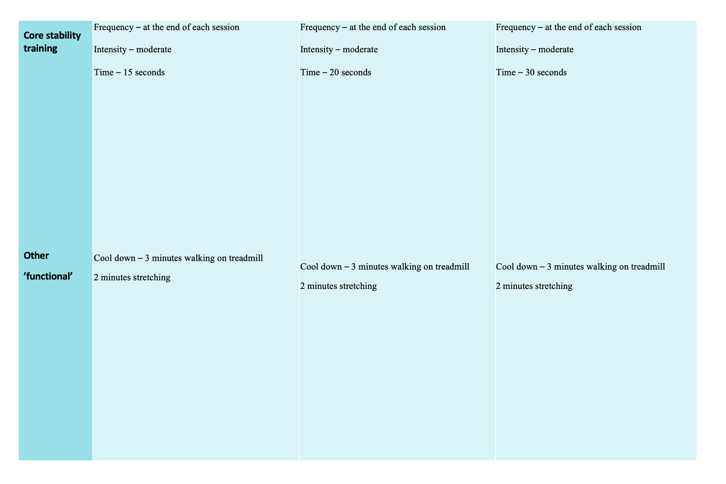

Individual session plans (detailed sessions)

Session plan (x3 detailed sessions)

Client’s name: Ffion Vardon Assessor’s name: Geraint Forster

Date: 3/2/25 Environment and resources: Gym

Warm up

Overview of content (including mobility, pulse raising and pre-stretch – where appropriate) | Equipment and duration | Level/speed | RPE/HR | Adaptation(s) or alternatives
Raise – treadmill  Activation – glute bridges  Mobilisation – walking lunge  - Leg+arm swings  Potentiate – body weight squat to box | 3 minutes  8 Reps  8 each side  8 reps | TBC | RPE 3-5  RPE 3-5  RPE 3-5  RPE 3-5 | Cross trainer  Hip thrusts  Standing knee and arm holds.  Kettlebell swings

Cardiovascular training 1

Equipment and approach | Programme timings | Level/speed | RPE/HR | Adaptation(s) or alternatives
Bike – continuous | 5 minutes | Light | RPE 5 | Treadmill

Resistance training

Exercise/machine | Resistance (kg/body weight) | Reps | Sets: rest | Training system | Adaptation(s) or alternatives
Lat pull down (vertical pull) | 20 kg | 8 | 3 sets  30 seconds | Traditional | Pull up with resistance bands
Shoulder press (vertical push | 10kg | 8 | 3 sets  30 seconds | Traditional | DB Press
Bent over single arm DB row (horizontal pull) | 6kg | 8 | 3 sets  30 seconds | Traditional | Bent over barbell row or seated cable row
Chest push | 10kg | 8 | 3 sets  30 seconds | Traditional | Push-ups or DB press
Leg press | 40kg | 8 | 3 sets  30 seconds | Traditional | Squat
Weighted lunge | 4kg | 6 on each leg | 3 sets  30 seconds | Traditional | Bulgarian split squat

Cardiovascular training 2

Equipment and approach | Programme timings | Level/speed | RPE/HR | Adaptation(s) or alternatives

Core stability training (as appropriate to client)

Core exercise(s) | Position | Length of hold :rest | Adaptation(s) or alternatives
Russian Twists holding 4kg  Shoulder taps or a plank | Sitting down  Prone but on hands | 15 seconds  15 seconds | Side crunch  Plank

Flexibility/mobility (as appropriate to client)

Muscle(s) stretched | Position | Type/ length of hold (static/dynamic/PNF) | Adaptation(s) or alternatives
Client has individual stretches

Individual session plans (detailed sessions)

Session plan (x3 detailed sessions)

Client’s name: Ffion Vardon Assessor’s name: Geraint Forster

Date: 11/3/25 Environment and resources: Gym

Warm up

Overview of content (including mobility, pulse raising and pre-stretch – where appropriate) | Equipment and duration | Level/speed | RPE/HR | Adaptation(s) or alternatives
Raise – treadmill  Activation – glute bridges  Mobilisation – walking lunge  - Leg+arm swings  Potentiate – body weight squat to box | 3 minutes  8 Reps  8 each side  8 reps | TBC | RPE 3-5  RPE 3-5  RPE 3-5  RPE 3-5 | Cross trainer  Hip thrusts  Standing knee and arm holds.  Kettlebell swings

Cardiovascular training 1

Equipment and approach | Programme timings | Level/speed | RPE/HR | Adaptation(s) or alternatives

Resistance training

Exercise/machine | Resistance (kg/body weight) | Reps | Sets: rest | Training system | Adaptation(s) or alternatives
Lat pull down (vertical pull) | 35 kg | 10 | 3 sets  30 seconds | Traditional | Pull up with resistance bands
Shoulder press (vertical push | 15kg | 10 | 3 sets  30 seconds | Traditional | DB Press
Bent over single arm DB row (horizontal pull) | 10kg | 10 | 3 sets  30 seconds | Traditional | Bent over barbell row or seated cable row
Chest push smith | 10kg each side of bar | 10 | 3 sets  30 seconds | Traditional | Push-ups or DB press
Leg press | 70kg | 10 | 3 sets  30 seconds | Traditional | Squat
Weighted lunge | 4kg | 10 on each leg | 3 sets  30 seconds | Traditional | Bulgarian split squat

Cardiovascular training 2

Equipment and approach | Programme timings | Level/speed | RPE/HR | Adaptation(s) or alternatives

Core stability training (as appropriate to client)

Core exercise(s) | Position | Length of hold :rest | Adaptation(s) or alternatives
Russian Twists holding 4kg  Shoulder taps or a plank | Sitting down  Prone but on hands | 30 seconds  30 seconds | Side crunch  Plank

Flexibility/mobility (as appropriate to client)

Muscle(s) stretched | Position | Type/ length of hold (static/dynamic/PNF) | Adaptation(s) or alternatives
Client has individual stretches

Individual session plans (detailed sessions)

Session plan (x3 detailed sessions)

Client’s name: Ffion Vardon Assessor’s name: Geraint Forster

Date: 8/4/25 Environment and resources: Gym

Warm up

Overview of content (including mobility, pulse raising and pre-stretch – where appropriate) | Equipment and duration | Level/speed | RPE/HR | Adaptation(s) or alternatives
Raise – treadmill  Activation – glute bridges  Mobilisation – walking lunge  - Leg+arm swings  Potentiate – body weight squat to box | 3 minutes  8 Reps  8 each side  8 reps | TBC | RPE 3-5  RPE 3-5  RPE 3-5  RPE 3-5 | Cross trainer  Hip thrusts  Standing knee and arm holds.  Kettlebell swings

Cardiovascular training 1

Equipment and approach | Programme timings | Level/speed | RPE/HR | Adaptation(s) or alternatives
Treadmill walking | 5 minutes | Light | RPE 5 | Bike

Resistance training

Exercise/machine | Resistance (kg/body weight) | Reps | Sets: rest | Training system | Adaptation(s) or alternatives

Cardiovascular training 2

Equipment and approach | Programme timings | Level/speed | RPE/HR | Adaptation(s) or alternatives
Rower+bike | Burn 10 calories on bike then switch over to rower and burn 10 calories, then switch back to bike and burn 20 calories then back to rower burn 20, then bike for 30 and rower for 30. Then work your work your way back down, so 20 calories on each machine and then 10. | At an easy speed, don’t burn yourself out. | 7

Core stability training (as appropriate to client)

Core exercise(s) | Position | Length of hold :rest | Adaptation(s) or alternatives

Flexibility/mobility (as appropriate to client)

Muscle(s) stretched | Position | Type/ length of hold (static/dynamic/PNF) | Adaptation(s) or alternatives
Client has individual stretches

Session review (3 implemented sessions)

Learner’s name: Lauren Evans

To be completed after each of the 3 implemented sessions.

Date | Session1: | 18/02/25 | Session 2: | 04/03/25 | Session 3: | 11/03/25
After my sessions, I received the following feedback from the client:
Session 1
The client said they really enjoyed it. They said they haven’t been worked that hard in ages and felt good after it. They said they’re really looking forward to our next resistance session and is eager to do the session by themselves.
Session 2
The client said they felt proud of themselves because they already jumped-up weights. They’ve gone to the gym more times than expected and have enjoyed doing the sessions so far. We switched the chest push exercise to bench press on the Smiths machine and they said they found it a lot more comfortable, and they wanted to stick with that machine from this week forward.
Session 3
The client said how they already feel considerably fitter and said they appreciated my enthusiasm during the session. They said they never normally enjoy cardiovascular training but enjoyed this session because it was made into a competition.
My sessions met the client’s needs in the following ways:
(comment on the effectiveness of your exercises, relationship with the client, how you communication style motivated the client and how well the programme matched the client’s needs and goals)
Session 1
In this first session we focused on learning the machines and the correct form so that the client gained confidence using them. I was clear and supportive whilst being encouraging throughout the session. We established a good rapport and found lots of things in common so that the client felt at ease and comfortable around me in the gym. The session matched the client’s level of knowledge and experience whilst pushing them and keeping them engaged.
Session 2
In this session I adapted the plan slightly. I changed one of the exercises to better fit the client as they were struggling with one of them. Whilst they were learning a new machine, I was enthusiastic and encouraging and I made sure we celebrated small wins so that it kept the client motivated towards her goals. The exercises are still targeting the clients’ goals without aggravating their injuries.
Session 3
This session focused on building cardiovascular fitness, starting with an enjoyable but competitive exercise, which not only matched their goals, but also met the client’s personality and their competitiveness. In this session I took part, and it was a competition between the two of us which helped with motivational communication to the client. The client worked harder as they were pushing to beat my time which meant it was meeting the client’s goal but also kept the session interesting.

With the information gathered from your client and your own evaluation of the sessions within the programme, explain how you will review the Personal Training programme and develop your own skills
Session 1
After this first session, I reviewed the clients performance levels but also their attitude and confidence towards all of the exercises. From this, I knew that I had to offer simple and clear demonstrations and instructions to build confidence early in the programme. I will continue to develop my communication skills, especially during times when the client needs encouraging, and also encouraging further clients who might be nervous or unsure about certain experiences or exercises in the gym.
Session 2
During this session, I swapped the chest push machine to bench press on the Smith machine. I had to quickly adapt which has highlighted to me the importance of flexibility in programming. Going forward, I want to develop the ability to identify errors in technique quicker and have a wider variety of alternative exercises so that I can give the client an option of which exercise or machine they would like to train on.
Session 3
In the third session, I noticed how the client adapted to the increase in intensity. This showed me the importance of increasing intensity throughout the programme to maintain motivation without causing fatigue. I plan to continue developing my skills in managing intensity and load throughout the programme and future programme. This will ensure that when I increase the intensity and duration of exercises that it is appropriate and enjoyable for the client and ensures it is relative to their aim and goals.

I (the client) agree with the above changes to personal training sessions and agree that they are appropriate to my needs.

Client’s signature: F.Vardon Date: 25/03.25

Learner’s signature: Lauren Evans Date: 25/03/25

Physical activity readiness questionnaire (PAR-Q)

Name: Ffion Vardon |  |  |  | Age: 37 |  |  |  | Gender: Female
Contact number: 074876543100 |  |  |  |  |  | Email: Ffion.vardon@uwtsd.ac.uk
Next of kin: James Vardon |  |  |  |  |  | Contact number: 07956664159
This PAR-Q is designed to help you to help yourself. Many benefits are associated with regular exercise, and completion of the PAR-Q form is a sensible first step to take if you are planning to increase the amount of physical activity in your life.
For most people, physical activity should not pose a problem or hazard.

The PAR-Q has been designed to identify the small number of people for whom physical activity might be inappropriate or for those who should seek medical advice concerning the type of activity most suitable for them. Common sense is your best guide for answering these questions.
1. Has your doctor ever said that you have a heart condition and that you should only do physical activity recommended by a doctor? | YES/NO
2. Do you feel pain in your chest when you do physical activity? | YES/NO
3. In the past month, have you had chest pain when you were not doing physical activity? | YES/NO
4. Do you lose your balance because of dizziness or do you ever lose consciousness? | YES/NO
5. Do you have a bone or joint problem (for example, back, knee or hip) that could be made worse by a change in physical activity? | YES/NO
6. Is your doctor currently prescribing drugs (for example, water pills) for your blood pressure or heart condition? | YES/NO
7. Do you know of any other reason why you should not do physical activity? | YES/NO

If you have answered YES to any of the above questions, then you are required to gain consent from your doctor before participating in the gym-based exercise programme.
If you have answered NO to all of the above questions and you have reasonable assurance of your suitability for:
A gym-based exercise programme – which will include; a warm up, cardiovascular training using equipment, fixed weights, using resistance machines, free weights, using dumbbells and barbells, body weight exercises and cool down stretches.
You are advised to postpone entry into the programme if you feel unwell or have a temporary illness. You must inform your gym instructor of any changes to your health status, whilst engaged in your training programme.

Client signature: Ffion Vardon |  | Date: 30/1/25
Witness signature: L.Evans |  | Date: 30/1/25

Informed consent
Informed consent form for exercise prescription
Programme objectives and procedures
I understand that the purpose of the exercise programme is to provide safe and individualised exercise to improve health and fitness. Exercises may include:
- Cardiovascular machine activities – treadmill walking or jogging, rowing, upright or recumbent cycling, stair climbing and other such activities
- Resistance training activities using resistance machines, free weights or body weight to improve muscular strength or endurance
- Cool down and flexibility exercises to improve movement around the joints and range of motion

Potential risks
The exercise programme is designed to place a gradually increasing workload on the cardiovascular and muscular systems and thereby improve their function. The reaction of the cardiovascular and muscular system to such exercise cannot always be predicted with complete accuracy. There is a risk of certain changes that might occur during or following the exercise. These changes could relate to blood pressure or heart rate.
Potential benefits
I understand that a programme of regular exercise has been shown to be beneficial. Some of these benefits include:
- A decrease in risk of heart disease
- A decrease in body fat
- Improved blood pressure
- Improvement in psychological function
- Improvement in aerobic fitness
The gym-based exercise programme has been explained to me and my questions regarding the programme have been answered to my satisfaction. I understand that I am free to withdraw at any time. The information obtained will be treated as private and confidential.

Signature of client: Ffion Vardon Date: 30/1/25
Witness signature: Lauren Evans Date: 30/1/25

