Modern Technology

Student’s Name: Petal Charmaine Jones
Student’s #: 1812740
Module #: BMSK 4003
Module Title: Digital Skills and Research Methods
Lecturer’s Name: Balenda Kandasary
Term 1

Table of Contents
Chapters Pages
Introduction 3
How modern technology can be used effectively within the workplace 4-5
How social media can be used 5-9
Conclusion 9
References 10-11
Appendices 12-14

Introduction
The purpose of this report is to write about the effectiveness of the use of modern technologies within the workplace.
Modern technology is the advancement of the old-style technology to the most recent technology which includes mobile telephones, where one can choose between network providers (Ramey, 2012). Transportation is also another form of advancement, where cashless journeys are introduced on the transport sector across the wider community
Technology can be defined as any old-style equipment that has been used in the work organisation, or for one personal use, this is ranging from an old-style computer, to a telephone.
Within every work organisations technology is very vital both to managers and employees. This is what they use to conduct their daily business by means of getting their workload sorted in an effective and efficient way. Technology has been used in organisations to ease the efficiency of processing customer queries such as those from emails, telephone conversations and social media interactions. Previously, without the assistance of technology, the processing of said queries could not be done before.

How modern technology can be used effectively within the workplace
Modern technology can be used for many different tasks, within the workplace. These tasks are as follows:
Internal Communication
This can be used to keep your workforce updated within the company by communicating with others without leaving your desk. These can be done through emails, text messages and web-based conference calling.
Digital Marketing
As indicated by Watson et al. (2002) cited by Sheth and Sharma (2005) the use of modern technology has increased over the decade, specifically the use of social media, with the increase use of social networking business have to figure out how to use this to their advantage specially to advertise their goods to present and prospective purchasers.
Within the digital marketing field, the CIPD uses customer relation management system (CRM), salesforce in order to gather intelligence on their customers, by emailing, segmented and target email of interest to them. On the other hand, by doing this as a company we are sending emails that our customers are interested in. CIPD offer products and services such as membership, training courses, conferences, text books, exhibitions and events. Cookies can also gather information of the customers whenever the customers try to create an account.
Social Media
By using social media this is the quickest way to get our messages across to our prospective customer. This also helps in generating a community of likeminded individuals, simply meaning you can create a forum of people all with the same interest discussing the same thing about your particular products and services. Social media also gather intelligence from the customers and help them with advice and training instantly because you can access the forum or the community from a smartphone wherever you are connected.
How social media can be used
The noticeable quality of web-based social networking has seen an uncommon climb over the earlier decade: LinkedIn rules the master long-extend casual correspondence fragment with in excess of 150 million selected people (LinkedIn About Us, 2012) with 21% developed some place in the scope of 18 and 21 years old (Socialnomics, 2011). Facebook is evidently one of the top visited locales (Alexa Internet Inc., 2011), attracting over an enormous part of a billion customers around the globe. Twitter immediately expanded generally speaking long-run relational correspondence and microblogging affirmation with in excess of 500 million customers (Twitter, 2012). Web based life can be utilized for advertising, correspondence and data gathering.
Marketing
Social media platforms can be used in marketing to elevate items and administrations to a larger audience to reach a bigger audience outside of followers, many companies used paid ads.
Web Pages, for example, Facebook and Twitter have changed the manner in which a few organizations consider promoting. A few associations are coordinating their forthcoming clients toward their pages more than they direct them to their own sites.
CIPD utilizes Facebook (see appendices figure 1) pages to market their products and services throughout the company to increase their impact. In service of their purpose they use research and agenda methods on core teams the eventual fate of work, the different and changing nature of the workforce and for the way of life and association of the work environment. This is how they use this platform for championing work and better work lives.
CIPD uses social media to advertise and highlight people and work, what is the meaning of work and how it takes place and the needs for work, technology developments and new ways of working. According Watson et al. 2002; Sheth & Sharma 2005 there are certain benefits as well as disadvantages using social media for marketing.
The chief benefit of social media in marketing is that it reduces expense and enhancing reach. Social media reduce expense in that business no longer have to print papers or send out distributors. Printing papers they would have to pay some amount of money but with social media it is less expensive as most of them are free.
Likewise, electronic elevating attracts firms to land at clients that may not be open because of passing and locational controls of existing course channels. Online life stages increase reach and abatement costs by giving three zones of favored condition to customers. The propelling firm can give incredible information to customers without human intervention. As written by Watson et al. 2002; Sheth and Sharma 2005, this is phenomenal over various sorts of contact considering the way that the degree of information that can be given is extensively more critical than in some other sort of correspondence.
Furthermore, and all the more significantly, the information can be given in a structure that customers can without quite a bit of a stretch methodology and appreciate. Electronic informal communication enables promoters to target groups and purchaser's needy site page area customers' near and dear interests and what their sidekicks like. With such "sharp" progressing, and publicizing, supports enough contact the individuals who are regularly animated by what they bring to the table. Besides, long range easy-going correspondence empowers verbal exchange to drive things past what progressing alone does (Hill, Provost and Volinsky, 2006). As the name proposes, electronic life is natural, and viable, two-way exchanges assume liability. Advertising changes in casual networks, with the accentuation put on working up long stretch associations that can change into more arrangements. Somebody must be able to screen every framework, respond to comments, answer questions and post information the customer respects critical (Barefoot and Szabo, 2010).
Communication
Social Media gives distinctive pathway so as to individuals to convey all through the world the fact of the matter is with the presentation of web-based systems administration it has been advance in an educational field in addition. Over the span of the ongoing 30 years correspondence has changed a great deal. Over the span of the latest 30 years the possibility of correspondence has encountered a liberal change and it is so far developing.
Email has furthermore altogether impacted the way where people with everything taken into account remain in contact. Communication are shorter and more dynamic than when letters were the standard and reaction time has stunningly lessened. Informing has made another framework for affiliation, one where the length of messages is shorter, and the style of the coordinated effort is continuously conversational. Proulx and Shepatin 2012 (cited to in Maund, Schriek and Tinkler, 2017) shares comparative perspectives. They expressed that innovation especially progressed and electronic advances engage relationship to occur and a great part of the time whether by content, Skype or Yik Yak. Especially when people are not in a comparable zone, a sentiment of affiliation is made through bestowed comprehension to advancement and media.
Besides, communicate advancements (see appendices figure 2) change these short impacts of correspondence from one-on-one trades to little news (or unintentional data) programs: which we can tune in 'at whatever point we need a strengthen or have a comment. Online specific instruments in like way can develop our awareness of the upgrades of our lord or social contacts. Twitter, for example, offers us an update of things individuals we know happen to do at a specific explanation behind time.
Social media can also be used to determine if one gets a job. Therefore, it is very important that one be careful of the things they post on social media. As potential employers can see, and this can reduce the chance of being employed. As indicated by Sheffield Hallam University (2014) web-based life can significantly upgrade your employability. Be that as it may, whenever utilized indiscreetly, online life can altogether harm your odds in the activity advertise. They went on to say that employability is not just about landing your next position. It is about your capacity to create and deal with a wonderful profession.
Through online life you get the opportunity to keep up your master character and make yourself known and clear for the right reasons. Right when you pursue a position, your potential administrator is likely going to filter for you online to find progressively about you, so the image you present is vital. Sheffield Hallam University (2014) encourage us not to leave anything recognizable that we would not require organizations to see when they examine for us.
Gathering Information
According to Poynter (2010) the web has been utilized as a mechanism for information assortment since around 1995, in spite of the fact that its quick development can for the most part be distinguished as being from 1999 onwards, and its authority as far as quantitative information assortment has just occurred throughout the most recent three years.
He argued that at first, the web, and online information assortment specifically, was viewed as just another methodology, with no critical ramifications for what the exploration was or what it implied. In any case, the web has prompted changes in the idea of research, both as far as trying the suspicions that used to support statistical surveying, (for example, testing hypothesis) and as far as opening up new conceivable outcomes, for instance using blog mining and online research networks.
Moreover, sites for example, LinkedIn (see appendices figure 3), Wink.com and Jobster.com are instances of business social affiliations, where individuals list their aristocrat data. This draws in extensive sifting for affiliation operators, zones, dynamic outlines, titles and claims to fame. Making an enthusiasm for such a pro social affiliation may make affiliation express data, for example, headcount, compensation, workers by work, direct telephone numbers and email addresses (Carpe, 2007). The systems help to find a potential data source and may even give his/her contact data. The data is given by the people utilizing the structure, and, as it were, they move affiliation express data that indisputably ought not be made open. This makes these structures amazingly all the even more captivating for a contender's strong getting staff, considering the route that regardless of perceiving conceivable individual data sources the system site itself can also go about as a major data source.
Conclusion
Every work organization is involved in the use of modern technology to get things done in due courses. Within CIPD technology help information to flow, it also shares information and improve the flow of information. Information at CIPD is stored at a central location in order for everyone to gain access. This structure makes the flow of information faster and easier.

References
Barefoot, D., and J. Szabo. (2010). “Friends with benefits: A social media-marketing handbook”. San Francisco: No Starch Press.
Carpe, D. (2007). How the Social Internet Simplifies Source Identification, Competitive Intelligence Magazine, (10)5, 2007, pp. 29-33.
Hill, S., Provost, F. & Volinsky, C. (2006). “Network-Based Marketing: Identify likely adopters via consumer networks”, Journal of Statistical Science, vol. 21, no.2, pp .256-276 DOI: 10.1214/088342306000000222
LinkedIn – About Us (2012). Press.linkedin.com. <http://press.linkedin.com/about> Accessed 31 December 2019
Maund, A. Schriek, M. and Tinkler, P. (2017). Certificate in Higher Education: Skills for the Workplace Student Yearbook. Sage Publications
Poynter, R. (2010). The handbook of online and social media research: Tools and techniques for market researchers. United Kingdom: Wiley.
Ramey, K. (2012). Modern technology advantages and disadvantages. [Blog].
Socialnomics. (2011). 100 Million on LinkedIn – Infographic by Country. <http://www.socialnomics.net/2011/03/28/linkedin-hits-100-million-breakdown-by-country-graphic/ErikQualman> | Accessed 31 December 2019
Sheffield Hallam University. (2014). Social Media and Employability. [online] Available at: https://sites.google.com/a/my.shu.ac.uk/shusome/employability
Sheth, J.N., Sharma, A. (2005). “International e-marketing: opportunities and issues, International Marketing Review”, vol. 22 no. 6, 2005 pp. 611-622
Twitter.com Site Info (2012). Alexa internet. http://www.alexa.com/siteinfo/twitter.com>
Accessed 31 December 2019
Watson, R.P., Leyland, F.P., Berthon, P. and Zinkham, G. (2002). “U-commerce: expanding the universe of marketing”, Journal of the Academy of Marketing Science, vol. 30 no. 4, pp. 333-47

Appendices

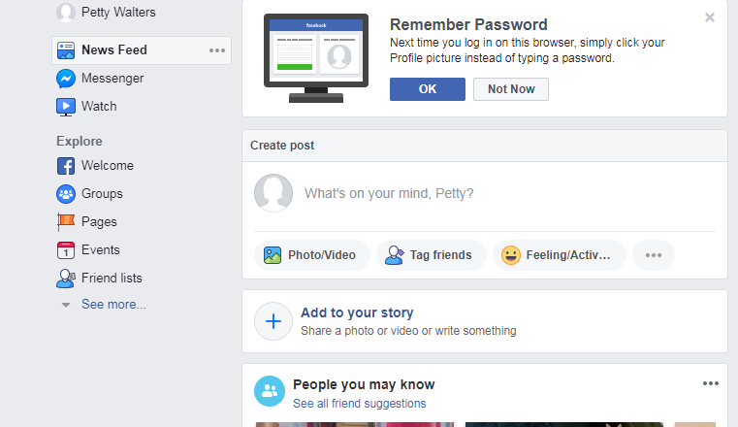
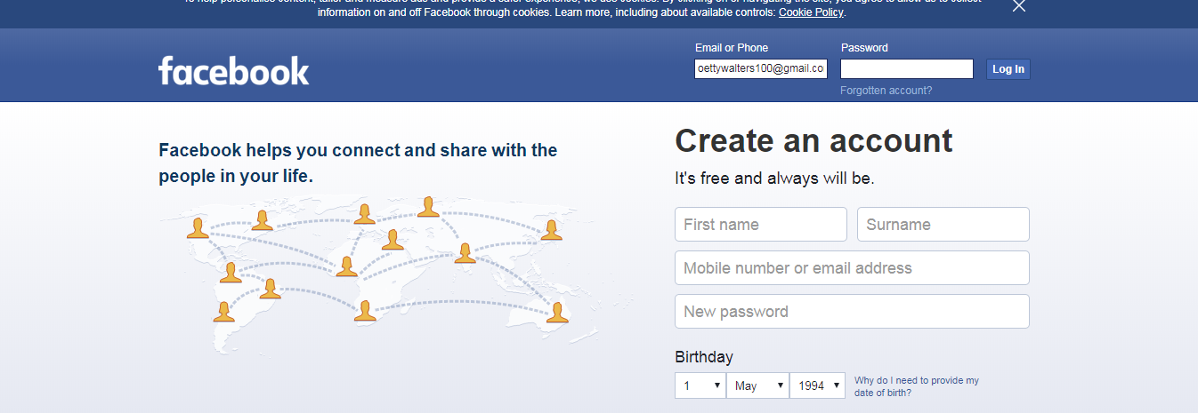

Figure 1: Facebook


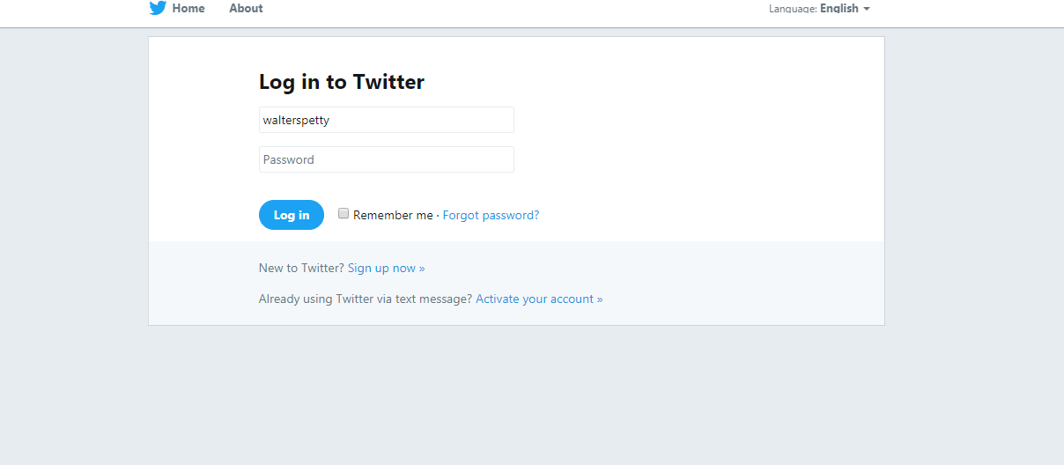

Figure 2: Twitter

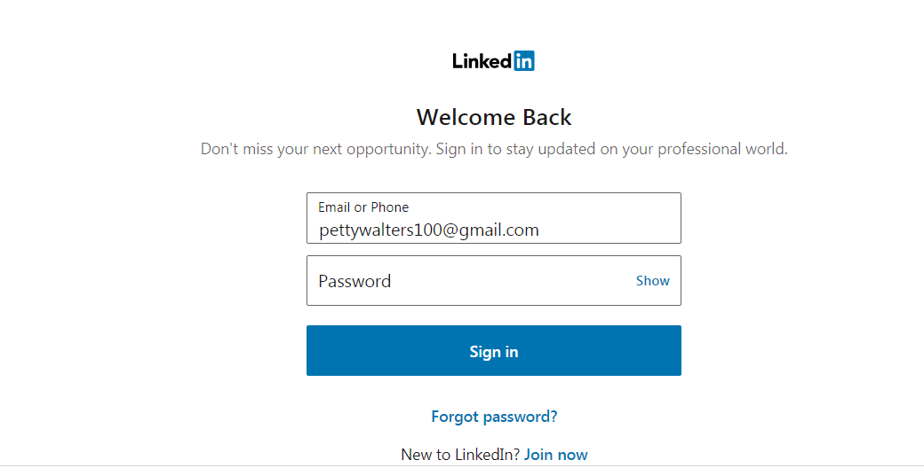
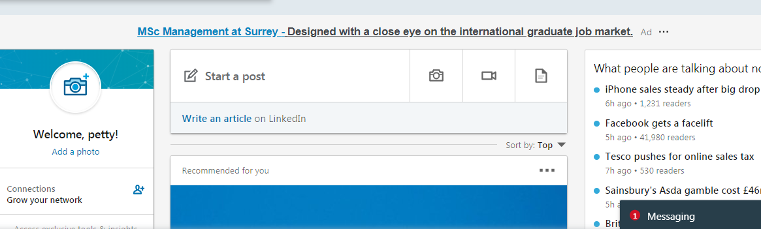

Figure 3: LinkedIn

