L4 - Learning in the Digital Era (ACCA4025)

L4 UCM Assignment 1

Sam Fenwick 2003537

Computer Animation

Table of contents

E- portfolio

Task 1- Written summary

Task 2- Mind map

Task 3- Video presentation

Task 4- Academic poster

E- portfolio

https://sam01fenwick.wixsite.com/digital-era
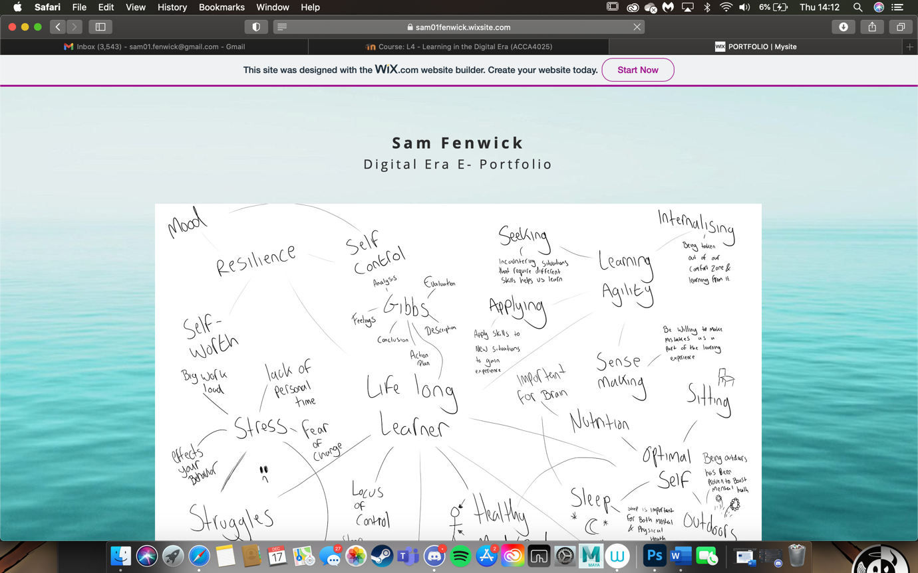

Task 1- Written summary

https://sam01fenwick.wixsite.com/digital-era

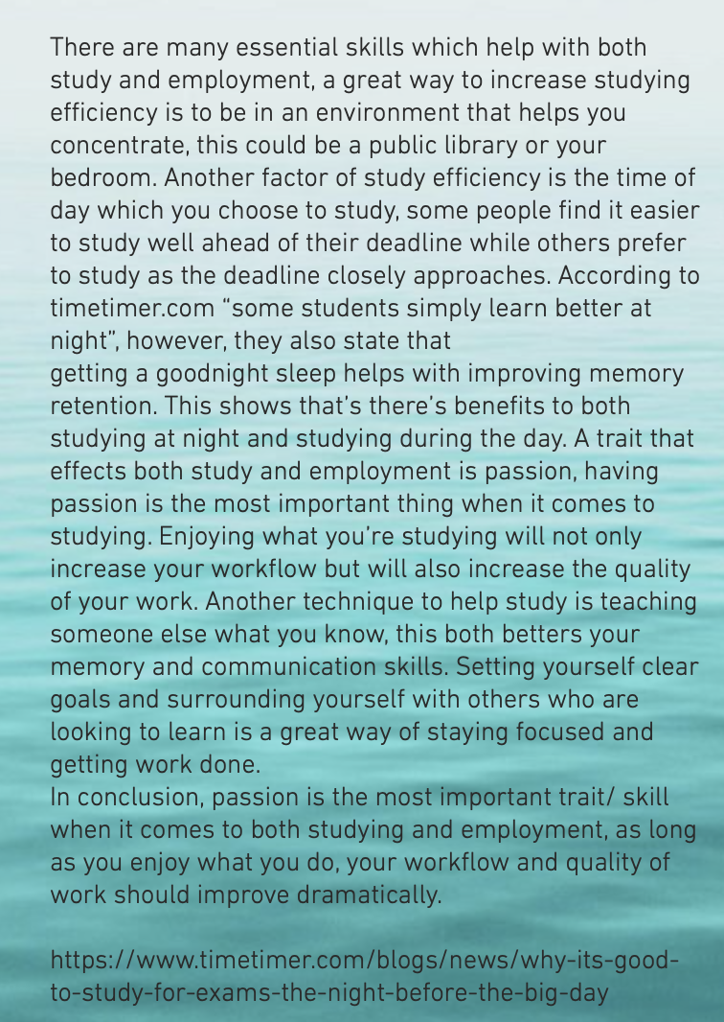
Task 2- Mind map

https://sam01fenwick.wixsite.com/digital-era

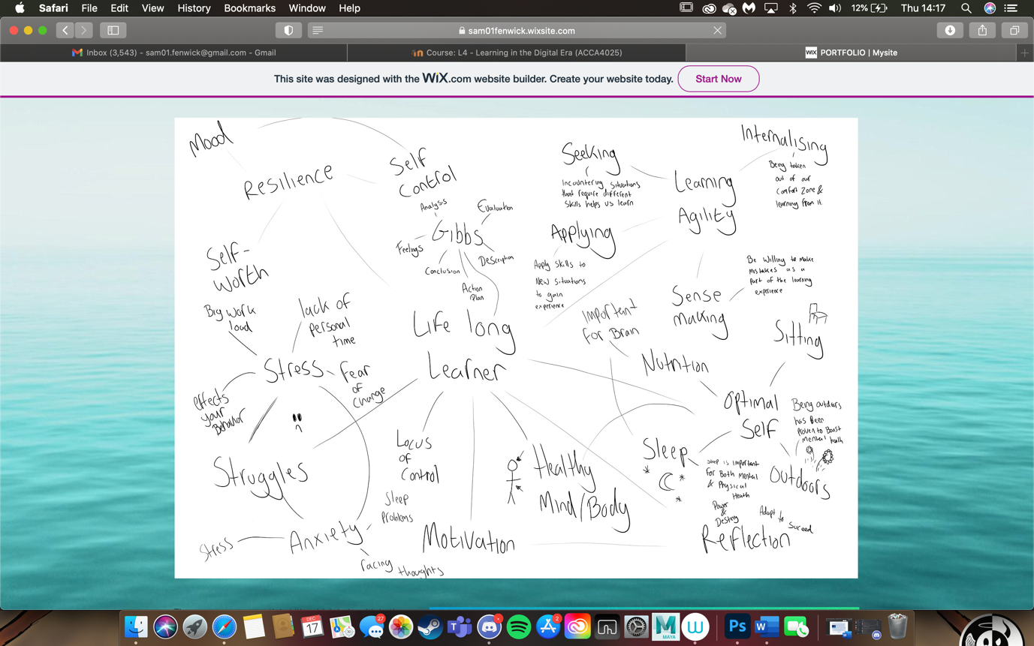
Task 3- Video Presentation

https://sam01fenwick.wixsite.com/digital-era

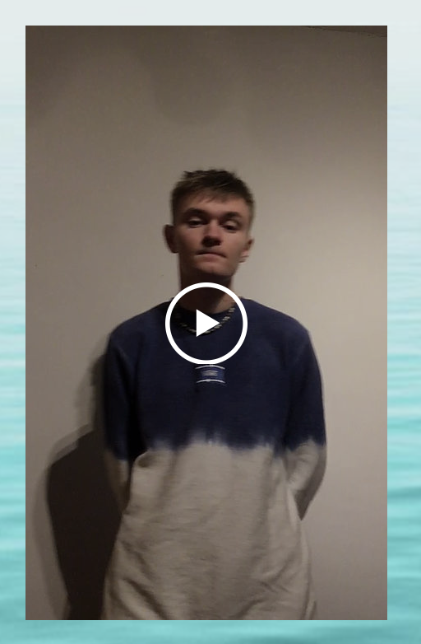
Task 4- Academic poster

https://sam01fenwick.wixsite.com/digital-era



