
50%
APPENDIX GA36b

LEVEL 5 ASSESSMENT SPECIFICATION

Student name: | Kaine Angus | Student ID number: | ANG12809789
Programme: | HND LEVEL 5
Module: | MECHANICAL PRINCIPLES
Module code: | M5X00926 | Contribution to Overall Module Assessment (%): | 50%
Lecturer: | EMILY NYATHI | Internal Verifier:
Assignment Title: | Power Transmission Systems | Word count (or equivalent):
Submission deadline: | 1/05/2020 | Return date of provisional marks & written feedback: | 8/05/2020
Submission method: | All written assessments, where practical and possible, must be submitted via Turnitin unless otherwise instructed by the Lecturer. (Please DO NOT put this assessment specification into Turnitin or it will match many similarities with other students’ submissions.)  Alternative submission method (if applicable):  Late submission of the assessment will result in a late penalty mark. Penalties for late submission: Up to one-week late, maximum mark of 40%. Over one week late, 0%. Only the Extenuating Circumstances Panel may approve a change to submission dates.
Academic honesty / referencing: | Academic honesty is required. In the main body of your submission you must give credit to authors on whose research and ideas your work is based. Append to your submission a reference list that indicates the books, articles, etc. that you have used, cited or quoted in order to complete this assessment.

Student FEEDBACK FORM

Generic Assessment Criteria | Marks available | Marks  awarded
1. Engagement with Literature Skills
.
You need to work on your referencing. In text referencing should match your reference list, and references should be in alphabetical order. You have engaged with very little relevant literature to the subject. |  | 11
 | 25 | 11
2. Knowledge and Understanding Skills

You did not complete objectives 1, 2 and 3 for Task 1. Your gear drive calculations are good. However, you made a few mistakes in applying your equations for calculating gear teeth in Q2ii. |  | 16
 | 30 | 16
3. Cognitive and Intellectual Skills

You hardly analysed the results from the belt drive friction experiment. You could have plotted graphs to help you with this, carried out some calculations using the given data and analysed the results, etc. However, you have demonstrated some good analytical skills in the task for gear drives. |  | 11
 | 25 | 11
4. Practical Application Skills

Your practical knowledge of gear trains is good. However, you need to improve on analysing given data, for example the belt drive experiment results could have been analysed and compared to real life applications. |  | 9
 | 15 | 9
5. Transferable Skills for Life and Professional Practice

You have good communication skills. You have also demonstrated that you have what it takes to take personal responsibility of your own work and to make your own decisions. However, keep on working on presenting your work in a neat and logical manor. | 5 | 3

Assessment Mark (Assessment marks are subject to ratification at the Exam Board. These comments and marks are to give feedback on module work and are for guidance only until they are confirmed. ) | Late Submission Penalties (tick if appropriate) |  | 50%
 | Up to 1 week late (40% Max) |  | 50%
 | Over 1 week late (0%) |  | 50%

Kaine Angus ANG12809789

Mechanical Principles
Power Transmission Systems
EMILY NYATHI

Contents

Task 1: 2
Summary 2
Introduction: 2
Background theory / research: 3
4
Equipment used in the experiment 4
Step by Step Procedure for the experiment: 5
Data Analysis and Calculations 6
Results: 6
Conclusion 7
Task 2 8
Task 2: 11
Problem solving 11
Bibliography 15

Task 1:

Summary
This report will determine the dynamic parameters of power transmission and rotating elements, where in task 1 it will show the constant angles of lap and its ratio. It will also verify the relationship of the following equation: 𝑇1/𝑇2= 𝑒𝜇𝜃, and determine the friction between a pulley and belt rig.
Task 2 will focus on gear trains and the mechanism with two or more gears, the ratio relative position of axis will also be covered in detail. Finally the report will cover gear speeds, torque, and number of teeth on a variation of gear types.

Introduction:
This report will cover an experiment for pulley systems where friction between the belt or the cable and the surface it is in contact with each other will be shown via test indicator. An example of friction is opening or closing roller shutter doors. In some applications these friction forces can be used to transform energy (power) from one source to another. For example, a belt driven system.
Friction is a force that opposes motion between two surfaces. There are two types of friction;
static and dynamic. Static friction is a force that must be overcome to start motion. Dynamic
friction, or kinetic friction, is a force that occurs between two moving surfaces and always acts
in the opposite direction to the motion. The magnitude of the force in the two types of friction
depends on the coe0cient of friction (CoF) between the two surfaces. The coe0cient of
friction is a value that is equal to the ratio between the maximal frictional force (Ff) that the
surface exerts and the force pushing the object toward the surface (mg). A CoF is only
apparent between two materials as without contact, there would be no friction.
Friction is a force that opposes motion between two surfaces. There are two types of friction;
static and dynamic. Static friction is a force that must be overcome to start motion. Dynamic
friction, or kinetic friction, is a force that occurs between two moving surfaces and always acts
in the opposite direction to the motion. The magnitude of the force in the two types of friction
depends on the coe0cient of friction (CoF) between the two surfaces. The coe0cient of
friction is a value that is equal to the ratio between the maximal frictional force (Ff) that the
surface exerts and the force pushing the object toward the surface (mg). A CoF is only
apparent between two materials as without contact, there would be no friction.
Friction is a force that opposes motion between two surfaces. There are two types of friction;
static and dynamic. Static friction is a force that must be overcome to start motion. Dynamic
friction, or kinetic friction, is a force that occurs between two moving surfaces and always acts
in the opposite direction to the motion. The magnitude of the force in the two types of friction
depends on the coe0cient of friction (CoF) between the two surfaces. The coe0cient of
friction is a value that is equal to the ratio between the maximal frictional force (Ff) that the
surface exerts and the force pushing the object toward the surface (mg). A CoF is only
apparent between two materials as without contact, there would be no friction.
Friction is a force that opposes motion between two surfaces. There are two types of friction;
Static and dynamic. Static friction is a force that must be overcome to start motion. Dynamic
Friction, or kinetic friction, is a force that occurs between two moving surfaces and always acts
in the opposite direction to the motion. The magnitude of the force in the two types of friction depends on the coefficient of friction (CoF) between the two surfaces. The coefficient of friction is a value that is equal to the ratio between the maximal frictional force (Ff) that the surface exerts and the force pushing the object toward the surface (mg). A CoF is only apparent between two materials as without contact, there would be no friction. (Ch-13, 2018)

This report will also provide an explanation and give examples of different types of gear trains such as the following:
- simple gear trains
- compound gear trains
- reverted gear trains
- epicyclical gear trains
Problem solving for gearing machine tools where the most effective and efficient gear type will be selected. A reference page will also be provided to give credit to the author of the information in bedded into the report.

Background theory / research:
As given in the lab sheet;
For a flat belt drive: 𝑇1𝑇2=𝑒𝜇𝜃
T1 = Tight side tension
T2 = Slack side tension
µ = Coefficient of friction
θ = Angle of lap (radians rad/s)
If a dependence of T1 is plotted against T2 for a constant angle of lap θ then a straight line should pass through the origin because 𝑒𝜇𝜃 is constant. 𝑇1𝑇2= 𝑒𝜇𝜃=𝑘 or T1 = k.T2
The slope k can be measured and it can yield a value for the coefficient of friction 𝜇.

𝑇1𝑇2= 𝑒𝜇𝜃=𝑘 ln k = 𝜇𝜃 = 𝜇=1𝜃ln𝑘 If ln 𝑇1𝑇2 is plotted against θ then the resulting curve should be a straight line that passes through the origin. The slope for this line equals µ: ln 𝑇1𝑇2=µ𝜃
Gear drives operate with a power efficiency significantly higher than any other mechanical drive, or any electrical, hydraulical or pneumatically power transmission according to (Jelaska, 2012), they have the widest use in transforming rotary motion from the prime mover to the actuator, and their importance is growing day by day.
Although efficiency is not the only criterion for choosing the type of transmission, the gear drive, due to its robustness and operational reliability, presents an inevitable component of most mechanical engineering systems. Gear drives are known to be highly demanding in design, manufacture, control and maintenance.
Mechanical power transmissions consist of units which, range from electrical, pneumatic and hydraulic types, transfer power from the prime mover to the actuator with the assistance of rotary motion. These units are called mechanical drives and are situated between the prime mover and the actuator. (Jelaska, 2012) shows that the mechanical drive driving shaft receives power P1 at speed of rotation n1 from the prime mover driven shaft, and the mechanical drive driven shaft supplies power P2 < P1 at speed of rotation n2 to the operational machine driving shaft.
The difference P1 P2 ¼ PL is called power loss and the ratio: h ¼ P2 P1 ¼ P1 PL P1 ¼ 1 PL=P1 is called efficiency. Their corrosion resistance and the functional ability of lubricant are also shown. “The importance of efficiency is raised to a power by the global lack of increasingly expensive energy and its value also decisively affects the price of the drive”. (Jelaska, 2012)
The second fundamental parameter of a mechanical drive is the transmission ratio defined as the ratio of its driving n1 and driven n2 shaft speeds of rotation or angular speeds: I ¼ n1 n2 ¼ v1 v2 : ð1:1Þ If I > 1 (n1 > n2) the mechanical drive is called an underdrive and its member is called a reducer. It reduces the speed of rotation and the transmission ratio is also called a speed reducing ratio.
The advantages offered by possible transmissions and drives are outlined in the below table:
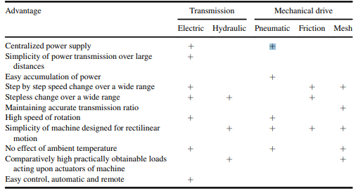

Figure 1 Advantages of transmission and mechanical drives (Jelaska, 2012)

Equipment used in the experiment

The following equipment was used:
- Belt friction rig
- Dial test indicator
- Weight carrier
- 2 – 24 kg weights

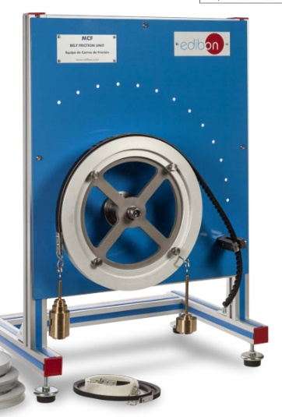
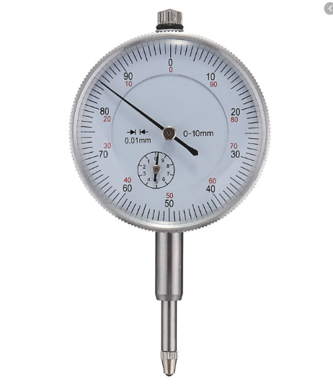
Figure 3 Dial test indicator
Figure 2 Belt friction rig with weight’s and carrier

Step by Step Procedure for the experiment:

Cantilever calibration:
- Turn angle of lap protractor to 0.
- Hang belt and weight carrier on cantilever with no weights attached.
- Set dial test indicator to 0.
- Measure the deflection of the cantilever for masses from 0 – 24kg with mass intervals of 3kg.
- Plot T₂ against deflection for the cantilever.
- Use the plot as a calibration curve to determine T₂ on the slack side against deflection.
Calibration prior to an experiment is extremely important as it gives confidence to the technician / operator that the results are in fact accurate and the scope for measuring errors are reduced as much as reasonably practical.

Constant angle of lap:
- Set lap θ to 90⁰, attach the belt and set the dial indicator to 0.
- Switch the pulley motor on.
- Measure the deflection for masses 0-20kg with mass intervals of 2kg.
- Using the calibration curve compute T₂ and plot T₁ against T₂.
- Calculate µ using first method in theory section.

Variable angle of lap:
- Attach belt and set the test indicator to 0.
- Attach 20kg to the belt.
- Switch pulley motor on.
- Measure deflection for angle of lap θ from 240⁰ to 10⁰.
- Determine T₂ for each angle with aid of the calibration curve.
- Plot $ln\frac{T1}{T2}$ against θ, rad.
- Record µ from the slope of the curve.

Data Analysis and Calculations

Results:

- Cantilever calibration
mass (kg) | 0 | 3 | 6 | 9 | 12 | 15 | 18 | 21 | 24
𝛿 | 0 | 15 | 30.5 | 45 | 60 | 75 | 90 | 104 | 118
T₂ = mg (N) | 0 | 29.43 | 58.86 | 88.29 | 117.72 | 147.15 | 176.58 | 206.01 | 235.44

(Table 1: Cantilever calibration results)

2.Constant angle of lap
mass (kg) | 0 | 2 | 4 | 6 | 8 | 10 | 12 | 14 | 16 | 18 | 20
𝛿 | 0 | 5 | 11 | 18 | 23 | 29 | 34 | 40 | 45 | 51 | 58
T₁ = mg (N) | 0 | 19.62 | 39.24 | 58.86 | 78.48 | 98.1 | 117.72 | 137.34 | 156.96 | 176.58 | 196.2
T₂ = k x δ | 0 | 9.94 | 21.868 | 35.784 | 45.724 | 57.652 | 67.592 | 79.52 | 89.46 | 101.388 | 115.304
(Table 2: Constant angle of lap results)

3.Variable angle of lap
Θ, deg | 240 | 220 | 200 | 180 | 160 | 140 | 120 | 100 | 80 | 60 | 40 | 20 | 10
Δ | 25 | 26 | 29 | 33 | 37 | 41 | 47 | 53 | 60 | 67 | 76 | 86 | 92
T_{2,} N | 49.7 | 51.69 | 57.65 | 65.60 | 73.56 | 81.51 | 93.44 | 105.36 | 119.28 | 133.2 | 151.09 | 170.97 | 182.9
Θ, rad | 4.19 | 3.84 | 3.49 | 3.14 | 2.79 | 2.44 | 2.09 | 1.75 | 1.4 | 1.05 | 0.7 | 0.35 | 0.17
$$\frac{T_{1}}{T_{2}}$$ | 3.95 | 3.80 | 3.40 | 2.99 | 2.67 | 2.40 | 2.10 | 1.86 | 1.64 | 1.47 | 1.30 | 1.15 | 1.07
$$ln\frac{T_{1}}{T_{2}}$$ | 1.37 | 1.34 | 1.22 | 1.10 | 0.98 | 0.88 | 0.74 | 0.62 | 0.49 | 0.39 | 0.26 | 0.14 | 0.068
(Table 3: Variable angle of lap results)

Conclusion

In conclusion the experiment was reasonably successful in that they allowed the group to obtain and calculate not just credible but some fairly accurate results. The limiting factor was the reliability of each reading.
For example, if there were some way of consistently placing the weights in a gentle fashion and not allowing the reading to be interrupted then the accuracy would have been improved. The lack of information on the provided materials also hindered progress, if the specifics of the materials used were known then a specific friction coefficient could be found. All in all, the results were reasonably accurate, so the experiments went well. Overall the coefficient of friction is influenced by the angle of contact between the belt and the pulley.
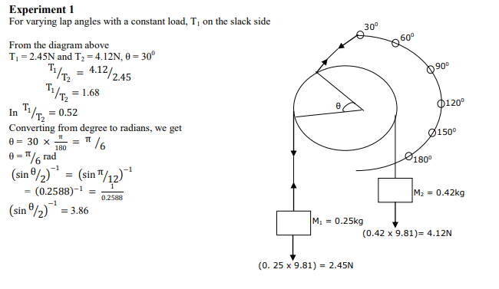

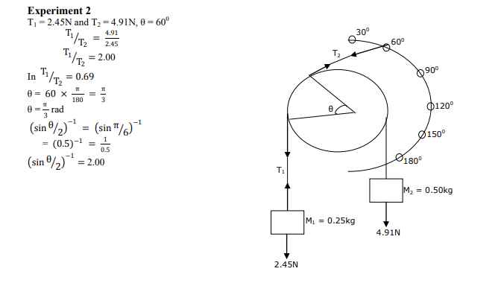
Figure 4 & 5:

(Tambari, 2015) Rope and Belt Friction experiment. For reference on varying lap angles with a constant load

Task 2

Simple Gear Train:
Simple gear train is where there is only one gear on each shaft, the gears are shown by their pitch circles. When the distance between the two shafts are small, the two gears 1 and 2 are made to mesh with each other to transmit motion from one shaft to the other. Since the gear 1 drives the gear 2 gear 1 is called the driver and the gear 2 is called the driven or even the follower. It may also be noted that the motion of the driven gear is opposite to the motion of the driving gear.
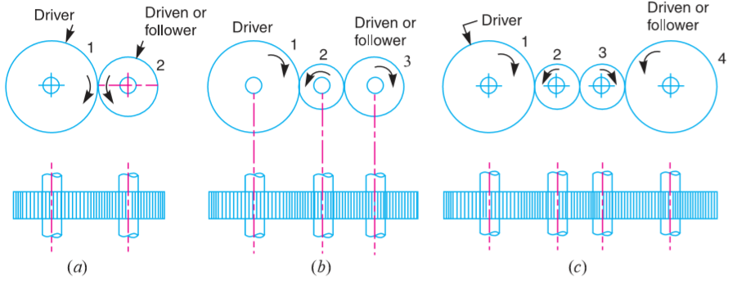
Figure 6 Simple gear train (Ch-13, 2018)

N1 = Speed of gear 1 (driver) in r.p.m
N2 = speed of gear 2 (driven) in r.p.m
T1 = Number of teeth on gear 1
T2 = Number of teeth on gear 2
Since the speed (velocity) ratio of the gear train is the ratio of the speed of the driver to the speed of the driven and ratio of speeds of any pair of gears in mesh is the inverse of their number of teeth, therefore:
Speed ratio = N1 / N2 = T2 / T1
It may be noted that the ratio of the speed of the driven to the speed of the driver is known as “train value” of the gear train.
Train value = N2 / N1 = T1 / T2, this shows that the train value is the reciprocal of speed ratio, and sometimes the distance between the two gears is large, the motion from one gear to another in such case may be transmitted by either of the following two methods:
- By providing the large sized gear
- By providing one or more intermediate gears

Compound gear train:
Compound gear trains involve several pairs of meshing gears. They are used where large speed changes are required or to get different outputs moving at different speeds. Gear ratios (or velocity ratios, VR) are calculated using the same principle as for simple gear trains, i.e. VR = number of teeth on the driver gear divided by the number of teeth on the driven gear.
However, the velocity ratio for each pair of gears must then be multiplied together to calculate the total velocity ratio of the gear train:
Total velocity ratio (VR) = VR1 x VR2 x VR3 x VR4, etc.
Gear ratio = No. of teeth on B / No. of teeth on A x No. of teeth on D / No. of teeth on C
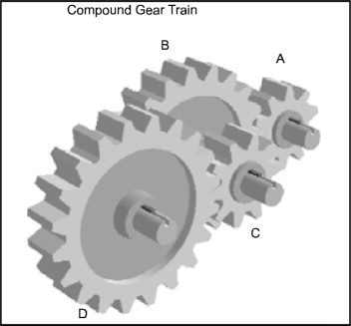
Figure 7: (N.Gokarneshan, 2013) Compound Gear train.

Reverted gear train:
When the axes of the first gear (first driver) and the last gear (driven) are co-axial, then the gear train is known as a reverted gear train as shown below in figure 8. Gear 1 (driver) drives gear 2 in the opposite direction since the gears 2 and 3 are mounted on the same shaft, therefore they form a compound gear and the gear 3 will rotate in the same direction as that of gear 2. The gear 3 drives the gear 4 in the same direction as of gear 1, and in a reverted gear train the motion of the first gear and the last gear is alike.
T1 = Number of teeth on gear 1
R1 = pitch circle radius of gear 1
N1 = speed of gear 1 in r.p.m.
T2, T3, T4 = number of teeth on respective gears
R2, R3, R4 = pitch circle radii of respective gears
N2, N3, N4 = speed of respective gears in r.p.m.
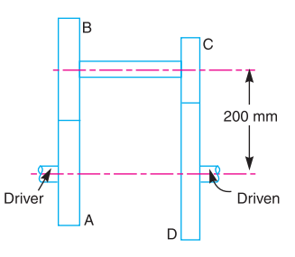
Figure 8 (Ch-13, 2018) Reverted gear train.

Epicyclic gear train:
In an epicyclic gear train, the axes of the shafts, over which the gears are mounted, move relative to a fixed axis. A simple epicyclic gear train is shown in Figure 9. Where a gear A and the arm C have a common axis at O1 about which they can rotate.
The gear B meshes with gear A and has its axis on the arm O2, about which the gear B can rotate. If the arm is fixed, the gear train is simple and gear A can drive gear B or vice versa, but if gear A is fixed and the arm is rotated about the axis of gear A (i.e. O1) then the gear B is forced to rotate upon and around gear A. Such a motion is called epicyclic and the gear trains arranged in such a manner that one or more of their members move upon and around another member are known as epicyclic gear trains. The epicyclic gear trains may be simple or compound and the epicyclic gear trains are useful for transmitting high velocity ratios with gears of moderate size in a comparatively lesser space.
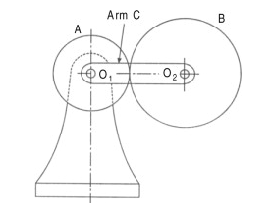
Figure 9: (Kumar, 2013) Epicycle gear train.

Task 2:

Problem solving

The gearing of a machine tool is shown in Figure 1 below. The motor shaft is onnected to gear A and rotates at 1000r.p.m The gear wheels B,C,D and E are fixed to parallel shafs rotating together. The final gear F is fixed on the output shaft. What is the speed of gear F?

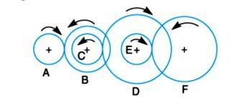

(Figure 10. Credit: GCS Assignment brief, 2020)

Below is a table showing the numbers of of teeth are given on each of the gears
Gear | A | B | C | D | E | F
No. of teeth | 20 | 50 | 25 | 85 | 28 | 65

$$Gear Ratio= \frac{Number of driven gear teeth}{Number of driver gear teeth}$$
Gear B:

$$\frac{50}{20}=2.5 \frac{1000}{2.5}=400 rpm$$
$$Gear B=400 rpm$$
Therefore, Gear C: Is on the same shaft as gear B and rotates at the same speed of 400 rpm.

Gear D:

$$\frac{85}{25}=3.4 \frac{400}{3.4}=117.65 rpm$$
$$Gear D=117.65 rpm$$
Gear D and E: Are located on the same shaft and rotate at 117.65 rpm

Gear F:$$\frac{65}{28}=2.32$$

$$\frac{117.65}{2.32}=50.71 r.p.m. Gear F=50.71 r.p.m.$$

- What type of gears are the best for applications that require speed reduction and torque multiplication?

Speed reducers are mechanical devices generally used for two purposes. The primary use is to multiply the amount of torque generated by an input power source to increase the amount of usable work. They also reduce the input power source speed to achieve desired output speeds. (Jelaska, 2012)
The selection and integration of speed reducers entails much more than simply picking one randomly. In most cases the maximum torque, speeds, and radial loads published cannot be used simultaneously. Proper service factors must be applied to accommodate a wide range of dynamic applications. And, once the appropriate speed reducer is selected, proper installation and maintenance are the keys to maximising life.
When a selected speed reducer or drive package is just too expensive for the application parameters, a different approach should be considered. Because all speed reducer types come in a variety of quality levels, it should be determined how much gearbox is really needed. However, you usually get what you pay for. There are several other “tricks” that can be implemented to reduce costs. (Ch-13, 2018)
One is to consider changing the mating drive components. Although most speed reducers can handle higher torque at lower speeds, the relationship is not linear. Instead of trying to get an entire speed reduction out of the gearbox and therefore the entire torque multiplication, a smaller reducer can be selected by getting some of the ratio and torque from less expensive pulleys or gears. For example, instead of choosing a 10:1 speed reducer driving a 1:1 belt, select a 5:1 reducer driving a 2:1 belt. The gearbox only has to do half the work.
- Two parallel shafts, about 800mm apart are to be connected by spur gears. One shaft is required to run at 360r.p.m and the other at 140r.p.m. Design the gears, given that the pitch is to be 25mm.

$$\frac{360}{140}=\frac{3.6}{1.4}=3.6:1.4$$

$$3.6+1.4=5 \frac{800}{5}=160$$

$$160×3.6=576 160×1.4=224$$

$$576+224=800mm$$

Now the distance between the gears has been made the radius of the gears is known. The number of teeth on each gear can now be calculated.

$$576×2=1,152mm Dia.$$

$$\frac{1,152}{25}=46 teeth on the 360 r.p.m. gear$$

$$224×2=448mm Dia. \frac{ 448}{25}=18 teeth on the 140 r.p.m. gear$$

A riverted gear train is to be designed such that its speed ratio is 12, as shown below. The module pitch of gears A and B is 3.13mm and of geras C and D is 2.5mm. What are the suitable numbers of teeth for the gears?

Speed ratio, NA/ND = 12; mA = mB = 3.125 mm; mC = mD = 2.5 mm
Let NA = Speed of gear A,
TA = Number of teeth on gear A,
rA = Pitch circle radius of gear A,
NB, NC, ND = Speed of respective gears,
TB, TC, TD = Number of teeth on respective gears, and
r B, r C , r D = Pitch circle radii of respective gears.
Since the speed ratio between the gears A and B and between the gears C and D are to be same, therefore:
NA / NB = NC = 3.464
Also the speed ratio of any pair of gears in mesh is the inverse of their number of teeth, therefore:
TB / TA = TD / TC = 3.464
We know that the distance between the shafts x = r A + r B = r C + r D = 200 mm
3.125 (TA + TB) = 2.5 (TC + TD) = 400
Therefore: TA + TB = 400 / 3.125 = 128
TC + TD = 400 / 205 = 160
TA + 3.464 TA = 128 or TA = 128
TA = 128 / 4.464 = 28.67
TB = 128 – 28 = 100
TC 3.464 = 160
TC = 160 / 4.464 = 35.84
TD = 160 – 36 = 124

Bibliography

Ch-13, 2018. Gear trains. s.l.:PDF Drive.
Chen, C., 2014. Epicyclic Gears. [Online]
Available at: https://www.sciencedirect.com/topics/engineering/epicyclic-gears
Jelaska, D., 2012. GEARS AND GEAR. Croatia: University of Split.
Friction – The Physics Hypertextbook. [online] Available at: https://physics.info/friction/ [Accessed 11 Nov. 2017]
Rahaman, M., Chowdhury, M. and Nuruzzaman, D. (2014). Experimental Investigation on Friction Coefficient of Engineering Polymers Sliding against Di-erent Counterface Materials. Advanced Materials Research, 903, pp.90-95.v. Luo, B., Li, L., Xu, M., Liu, H. and Xing, F.
Analysis of Static Friction Coefficient Between Work-piece and Rubber Belt in Sanding Wood-Based Panel. BioResources, 9(4)
Bolton, W. (1990). Engineering science.vii. Bolton, W. and Bolton, W. (2012)
Higher Engineering Science. Hoboken: Taylor and Francis.viii. Carvill, J. (2012). Mechanical Engineers Data Handbook. Elsevier Science

