Example:

Knowledge | (remembering and retaining)
Comprehension | (interpreting and understanding)
Application | (making use of)
Analysis | (taking part)
Synthesis | (putting together)
Evaluation | (judging and assessing)
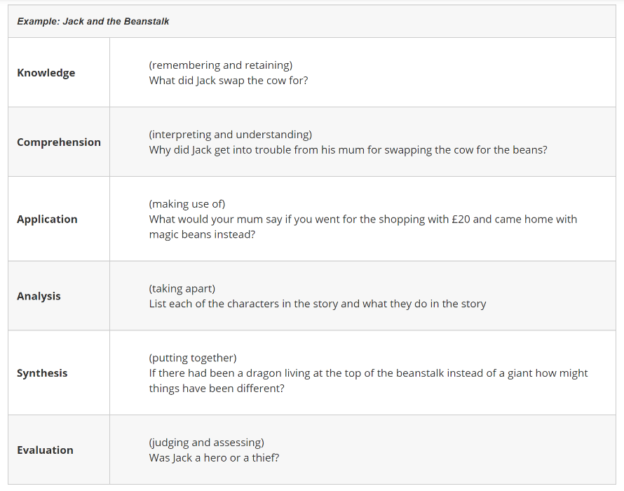
Bloom’s Taxonomy Task; Complete the table below using a story of your choice.

