Welsh Language Development Portfolio

Megan Harris

Student Number: 1900391

University of Wales Trinity Saint David

Welsh Lecturer: Helen Griffiths

Welsh Language Development Portfolio

Welsh Mini-Teach Lesson Plan………………………………………………………….Page 2-3

Welsh Mini-Teach Script and Prompts………………………………………………….Page 4

Welsh Mini-Teach PowerPoint………………………………………….……………….Page 5-6

Welsh Mini-Teach Resources…………………………………………………..……….Page 7

Welsh Mini-Teach Lesson Reflection…………………………………………….…….Page 8-9

Welsh Self Reflection……………………………..……..……………………………….Page 10

Welsh Nursery Lesson Plan….……………………………………………………….Page 11-12

Welsh Nursery Reflection……………….……………………………………………….Page 13

Welsh Nursery Evidence…………….……………….………………………………….Page 14

Welsh Year Six Welsh Marking………………………………………………..……….Page 15

Welsh Self Development……………….……………………………………………….Page 16

Welsh Mini-Teach Lesson Plan

Student-teacher | Megan Harris | Class: | Year Four
AoLE or Subject | Welsh Language Development | Date: | 25/02/2020
Lesson Focus: | To understand time and specific events using the Welsh Language
Meaningful links to Curriculum | Oracy: Learners should be given opportunities to reinforce Welsh syntax by the accurate use of a variety of vocabulary and sentence patterns  Oracy: Learners should be given opportunities to experience a variety of visual and written stimuli  Oracy: Learners should be given opportunities to work independently, in pairs, in groups and as a member of a class  Reading: Learners should be given opportunities to identify the characteristics of different genres in terms of organisation, structure and presentation
Meaningful links to:  Cross Curricular Responsibilities | Numeracy: Learners are able to tell the time to the nearest minute on analogue clocks  Numeracy: Learners are able to read hours and minutes on a 12 hour clock digital clock  Numeracy: Learners are able to estimate the number of minutes everyday activities take to complete
Personal Targets (Linked to QTS and identifed in weekly review)

Welsh Language Skills: On Track – There is a commitment to incremental development of personal skills in the use of Welsh Language.

Learning Objectives (focus on Learning- use accessible vocabulary):
The pupils will learn to: match a range of times using an analogue clock to every day activities

Success Criteria (clearly linked to each Learning Objective and related to the process and/or product of learning) | Assessment of Pupils’ Learning  Evidence  (What have the learners to say/write/do/produce – to demonstrate learning)
All – All pupils are able to identify the times on the clock and repeat them in Welsh  Most – Most pupils are able to match the written time to the analogue clock  Some – Some pupils are able to match the written and analogue time to the every day activity. | Questioning – to check understanding  Peer Assessment – do you agree with the answers?  Assessment for Learning – check the answers on the PowerPoint

Time | Activities/Methodology/Key Concepts  (Teacher’s Role – including key teaching points, differentiation strategies and key questions) | Pupil Tasks  (Pupils’ role –including differentiation, engagement in formative assessment and homework) | Resources  (Including Health and Safety requirement)
Opening phase (with links to prior learning) | Introduce the children into the lesson  Gain attention using the PowerPoint  Talk the children through the instructions of the lesson | Prepare for the lesson  Show attention is gained through co-operating with the PowerPoint | Welsh Lesson PowerPoint
Teaching & Core Learning | Use the PowerPoint to show how the resources are utilised  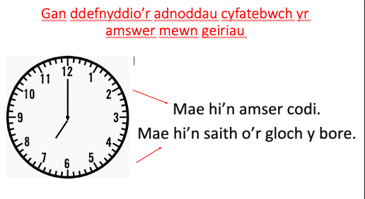 | Interact with the resources, read through the cards and understand how they are to be ordered i.e:  - Mae hi’n amser codi  - Mae hi’n saith o’r gloch y bore  Arrange the cards to match the clocks, the every day activity and the written time into an order where everything matches up | Welsh Lesson PowerPoint  Resources
Plenary | Display the correct answers on the board for the children to mark their answers | 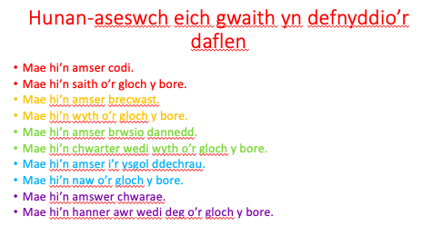  Use methods of Assessment for Learning to check your answers with the correct answers on the board | Welsh Lesson PowerPoint

Welsh Mini – Teach Script and Prompts

Introduce Yourself
Bore da Miss Harris ydw i.

Aims and objectives
Heddiw byddwn yn dysgu am amser – Today we are learning about the time

Check Well-Being of the children: Good Practice
Sut ydych hi heddiw? – How are you doing today?

Introduction to the session
Beth yw’r dyddiad heddiw? – What is the date?
Dydd Mawrth 25ain o Chwefror 2020 Dwy fil dauddeg – 2020

Welsh praise throughout
Da iawn, ardderchog, triwch eto/tria eto

Focus Question
Beth yw’r amser? – what is the time?
Faint o’r gloch yw hi? – what is the time?

Gaining Attention
Ydych chi’n barod? – are you ready?
Pwy sy’n barod? – who is ready?

 | Welsh | English
Introduce Yourself | Bore Da, Miss Harris ydw I | Good Morning, my name is Miss Harris
Aims and Objectives | Heddiw byddwn yn dysgu am amser | Today we will be learning about the time
Checking Well Being | Sut ydych hi heddiw? | How are you doing today?
Introduction to the Session | Beth yw’r dyddiad heddiw?  Dydd Mawrth 25ain o Chwefror  Dwy fil dauddeg | What is the date?  25th February  2020
Welsh Praise | Da Iawn  Ardderchog  Triwch Eto | Very Good  Fantastic  Try Again
Focus Question | Beth yw’r amswer?  Faint o’r gloch yw hi? | What is the time?
Gaining Attention | Ydych chi’n barod?  Pwy sy’n barod? | Are you ready?  Who is ready?

Welsh Mini-Teach PowerPoint

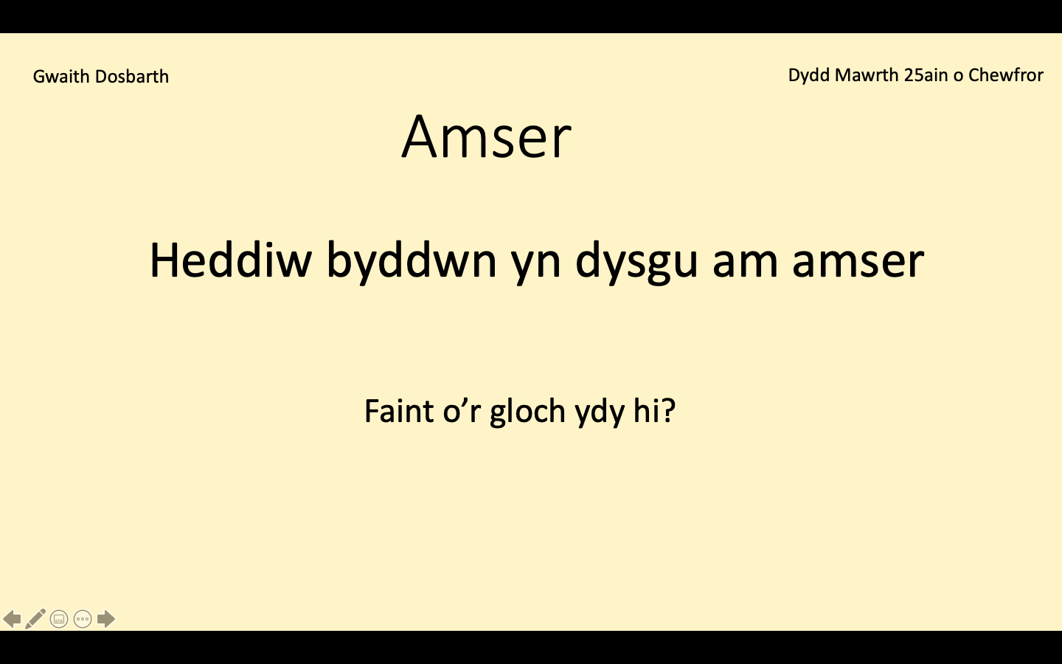
Slide One:

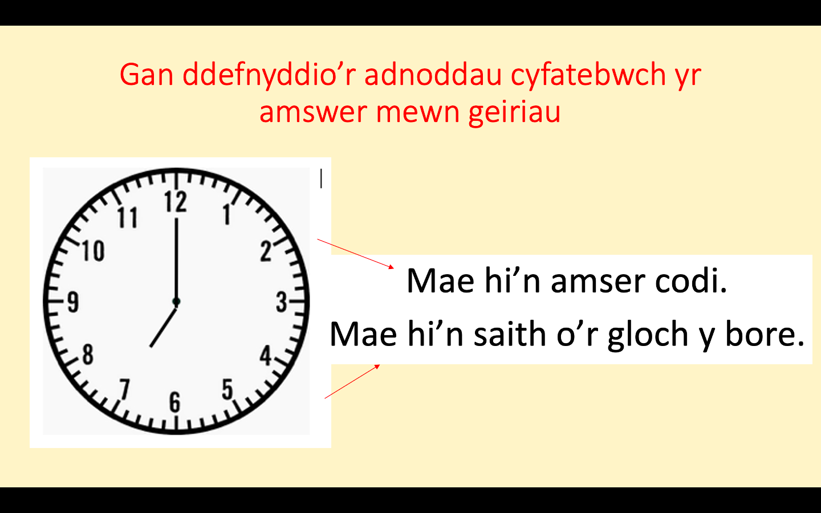
Slide Two:

Slide Three:

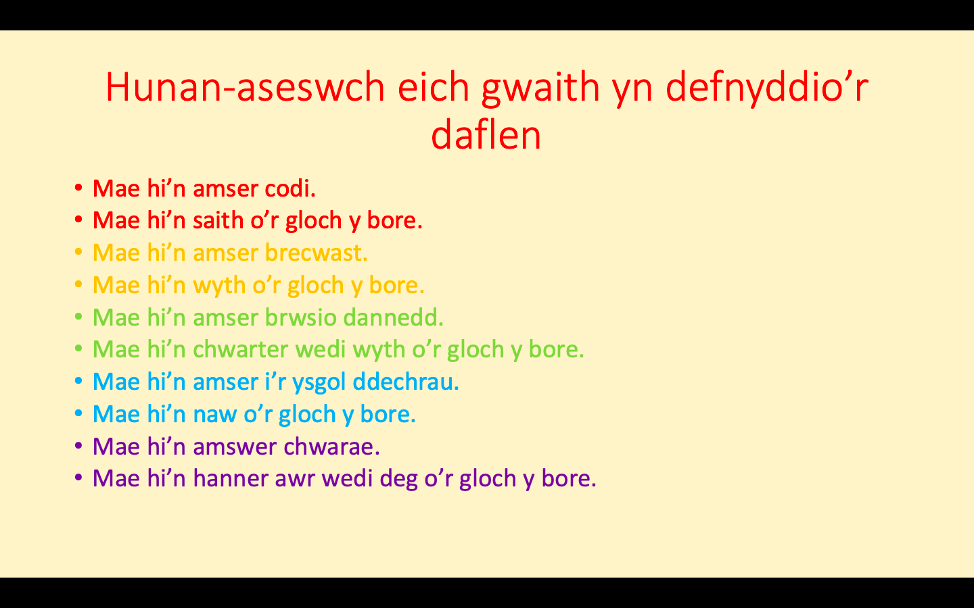
Slide Four:

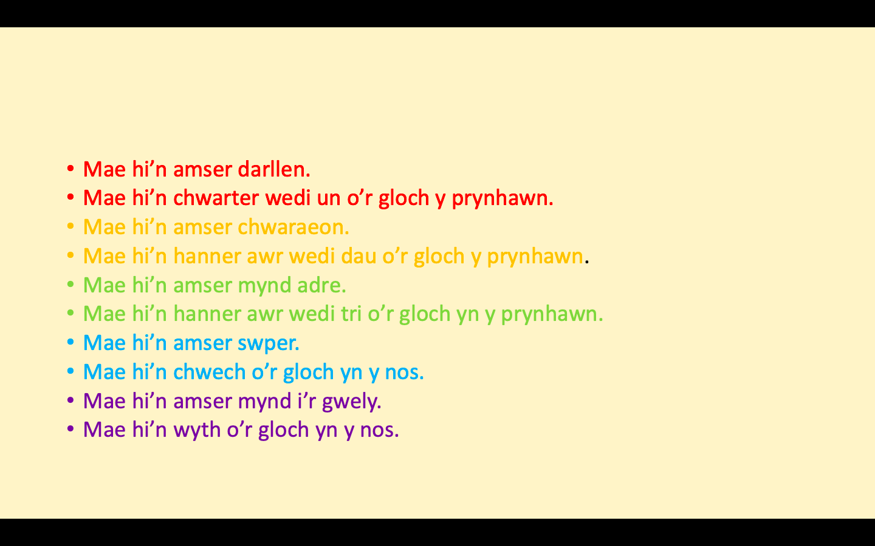

Welsh Mini-Teach Resources

Mae hi’n amser codi. Mae hi’n saith o’r gloch y bore.
Mae hi’n amser brecwast. Mae hi’n wyth o’r gloch y bore.
Mae hi’n amser brwsio dannedd. Mae hi’n chwarter wedi wyth o’r gloch y bore.
Mae hi’n amser i’r ysgol ddechrau. Mae hi’n naw o’r gloch y bore.
Mae hi’n amswer chwarae. Mae hi’n hanner awr wedi deg o’r gloch y bore.
Mae hi’n amser darllen. Mae hi’n chwarter wedi un o’r gloch y prynhawn.
Mae hi’n amser chwaraeon. Mae hi’n hanner awr wedi dau o’r gloch y prynhawn.
Mae hi’n amser mynd adre. Mae hi’n hanner awr wedi tri o’r gloch yn y prynhawn.
Mae hi’n amser swper. Mae hi’n chwech o’r gloch yn y nos.
Mae hi’n amser mynd i’r gwely. Mae hi’n wyth o’r gloch yn y nos.

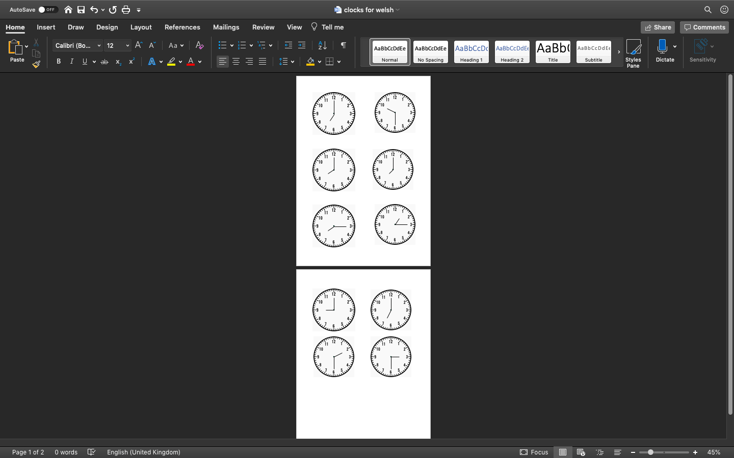

Welsh Mini-Teach Lesson Reflection

The Welsh Assessment saw the completion of a Welsh Language lesson plan, which was aimed at Year Four pupils. For the purpose of the Assessment, I conducted this Welsh Mini-teach activity with two other colleagues, identified throughout the writing as the ‘pupils’. The lesson was recorded by the university in order to demonstrate my level of Welsh Language Development. Prior to the Welsh Assessment within university, I had gained experience of using incidental Welsh throughout PTE1, through commands and praise. Along with this, I had taught a small selection of Welsh sessions to my pupils, in line with the Welsh Curriculum Framework. Through this, I was confident with the use of my limited Welsh understanding, but confident with what I had knowledge of.

The focus of the Welsh mini-teach was to understand the sentence pattern of ‘Mae hi’n ___ o’r gloch’ (It is ___ o’clock) and use prior knowledge to identify the correct clock, written time and everyday activity that was linked. The beginning of the lesson started by introducing myself and asking the pupils their name and how they were feeling today. By doing this, I believed it was essential to activate the prior knowledge of the pupils and make them feel welcomed into the learning environment. Before I began the activity, I brought up a PowerPoint that I had created. With this, the children were able to understand what the date was and respond to my question of ‘Beth wy’r dyddiad heddiw?’ (What is the date today?). Along with this, I set the aims and objectives of the activity, stating that ‘Heddiw byddwn yn dysgu am amser’ (Today we will be learning about the time). Following this, the activity was introduced to the children, showing them how the resources would be utilised through the PowerPoint. The activity was explained to the children throughout the use of Welsh Language ‘Gan ddefnyddio’r adnoddau cyfatebwch yr amser mewn geiriau’ (Match the activity and the time to the correct clock). Introducing the children into the activity was essential to activate their Welsh Language and prior knowledge, developing a sense of confidence within the children.

Throughout the activity, the pupils seemed comfortable with the level of challenge set for them during the activity. With this, it proved to me that I was aware of their prior knowledge to the activity, including the words and phrases used within the Welsh Language. The pupils worked well in pairs and displayed positive methods of collaborative learning. The children were capable of completing the activity, utilising the resources provided to them throughout. With this, the children were also able to interact with the PowerPoint, being able to recite the date to me and display their confidence and knowledge within the Welsh Language.

On a full reflection of the activity, I believe that the Welsh Mini-Teach was planned accordingly with the pupil’s prior knowledge taken into account. The vocabulary used was utilised and evidenced as suitable in regard to the age of the children and the skills displayed within the Welsh Language Curriculum. The implementation of language throughout the lesson ran smoothly, displaying confidence with my Welsh Language Development. I believe that I spoke smoothly and confidently throughout, pronouncing accurately and sticking at a steady place.

I believe that my effective practice was evidenced throughout the activity, using constant questioning and praise from the pupils in order to check their understanding. Through using the mechanism of positive reinforcement, the pupils were able to be motivated throughout the mini-teach activity, resulting in them completing the task. Along with this, effective practice was displayed where the prior knowledge of the pupils was taken into account. This allowed me to plan for the pupils, where I was aware of what they were capable of doing and what activities would challenge the pupils. Similarly, I was able to use Assessment for Learning during the activity, which I believe is a method of effective, good practice. Through this, I prepared the answers on the board for the pupils to utilise and mark their answers in order to take responsibility for their own learning.

Areas for my development would be to incorporate more Welsh into my lessons, which are not Welsh Development Lessons. I believe this would be through the use of incidental Welsh within my teaching and practice, in order to develop my Welsh Language skills along with those of the children within my class. With this, I believe that I could have prolonged the activity for the pupils, with more resources or a further written extension task in order to challenge the children to their full potential. With this, it would have allowed both myself and the children to understand potential for future development.

Welsh Self Reflection

Throughout my time on the PGCE course, I believe I have delved into the opportunity of further developing my Welsh Language Development. During the time at university, I have attended all Welsh Language sessions, developing a positive relationship with my lecturer and the peers within my class. With this, I have been able to seek advice, guidance and support from my lecturer and colleagues which has enabled me to progress in confidence and my accuracy of the Welsh Language. Becoming enriched with the Welsh Language has been identified through engaging in all set tasks within the Welsh sessions, alongside using Welsh Language Development apps such as DuoLingo.

Through using Welsh Language Development apps, I believe it has enticed me to focus on developing my language when out of the University setting. Due to being in a placement school where Welsh is at the centre of their ethos, aiming towards the ‘Siarter Iaith’ award, it was beneficial for me to become familiar with incidental Welsh to use within my teaching and around the school with other pupils and members of staff. Within my time in the classroom, I have always required children to answer the register in Welsh and respond to questions using as much Welsh as they possibly can. This includes asking to go to the toilet, asking for equipment or asking for further instructions. I believe that with children using Welsh positively throughout the classroom, it gave me the opportunity to develop my Welsh Language through utilising the knowledge of the children. Throughout my teaching, I have used Assessment for Learning, and Welsh praise to the children in their response to questions within the classroom. Along with this, I have always aimed to respond to children’s work using a Welsh comment, encouraging the children to respond to my comment in Welsh within their work.

My use of Welsh Language throughout placement has been commented on by my teachers and mentor, displaying my use and confidence. In terms of further Welsh Development, I will continue to become endorsed in Welsh throughout my own professional development. I will aim to do this through a range of online courses, along with endorsing myself into the resources provided by the university. This will allow me to build my confidence in the use of the language, becoming familiar with a different range of vocabulary.

Welsh Nursery Lesson Plan
Student-teacher | Megan Harris | Class: | Nursery ND/SD
AoLE or Subject | Welsh Language Development | Date: | 25.11.2019
Lesson Focus: | To answer a question about who they are
Meaningful links to Curriculum | Welsh Language Development: Use appropriate language in spontaneous and structured play activities and when conveying meaning.
Meaningful links to:  Cross Curricular Responsibilities | Language, Literacy and Communication: Oracy – Speak clearly enough to be understood by adults and peers  Language, Literacy and Communication: Listening – Listen and respond with growing attention  Language, Literacy and Communication: Collaboration and Discussion: Take part in activities alongside others.
Personal Targets (Linked to QTS and identifed in weekly review)
Different targets have been set for this week in line with the weekly review, in order to begin to gather further evidence to complete aspects of the Professional Learning Passport. I will aim to meet all targets under the ‘on track’ strand by the end of my professional practice. For this activity, the QTS standards which will be developed into targets are progression in learning, where I will reflect on each children's knowledge and understanding of the question in order to prepare for the next Welsh activity; assessment to support the progression in learning and Welsh Language Skills, where I will build on my own subject knowledge.
Progression in Learning: The student teacher demonstrates an understanding of how learning develops incrementally and tangentially, building on prior experience and learning, and plans for progress in learning based on this.
Assessment: The range of purposes and practices for assessment is understood and articulated
Welsh Language Skills: There is a commitment to incremental development of personal skills in the use of the Welsh language.

Learning Objectives (focus on Learning- use accessible vocabulary):
The pupils will learn to:
To ask the question ‘pwy wyt ti?’ and respond to the question.

Success Criteria (clearly linked to each Learning Objective and related to the process and/or product of learning) | Assessment of Pupils’ Learning  Evidence  (What have the learners to say/write/do/produce – to demonstrate learning)
***I can say who I am in a sentence  **I can repeat the sentence pattern to say who I am  *I know to say my name in response to the question | Children’s learning will be evaluated using peer assessment.  The children will be required to assess their peers answer using the thumb indicators.  Thumbs up- correct  Thumbs in the middle- almost there  Thumbs down- wrong

Time | Activities/Methodology/Key Concepts  (Teacher’s Role – including key teaching points, differentiation strategies and key questions) | Pupil Tasks  (Pupils’ role –including differentiation, engagement in formative assessment and homework) | Resources  (Including Health and Safety requirement)
Opening phase (with links to prior learning) | 1) To explain the activity to the children  2) Explain to the children the question and introduce it to them – encourage the children to repeat the question and answer – modelling speech  3) Read the book – Pwy wyt ti? - to the children, in order for them to become familiar to the question | Reiterate the question when it is said by the teacher as closely as you can  Read the book pwy wyt ti? With the teacher | Pwy wyt ti book
Teaching & Core Learning | 1) Put the children's photographs in the box  2) Play Beth sy yn y bocs with the children  3) Ask the children to say pwy wyt ti? To the child with the bag  4) Encourage the children to pick a photo from the bag and respond to the question (as the image they are holding) using the sentence pattern: _____ ydw I. | 1) Sing Beth sy yn y bocs with the teacher  2) Remove picture from the box  3) Respond to peers question of pwy wyt ti? With the name of the image using the sentence pattern  MAT Can you ask a friend who they are? Can you respond in a sentence to the question about who you are?  HA Can you respond in a sentence to the question about who you are independently?  MA Can you repeat a sentence to respond to the question about who you are?  LA Can you answer with your name to the question about who you are? | Box  Images of nursery children  IPad  Observation sheet  Pen
Plenary | Check understanding with pupils by asking each child the question for them selves | Respond to the question from the teacher individually in order to check understanding

Welsh Nursery Lesson Reflection

Evaluation of Pupil Learning

Evidence of Learning (including attitude to learning over time)) | During the activity, it was carried out in small groups of four or five. This is due to me being able to monitor and assess the children's understanding more efficiently in smaller groups. Each child's understanding will be monitored individually and recorded on the observation sheet provided. Due to the smaller groups, I was able to make notes on individuals and mark their differentiation they reached efficiently. This was easier to do due to the children being in smaller groups and myself being able to pay significant attention with each child.  With all children, independence, confidence and engagement will be monitored. However, this will be closely observed with the quieter, more withdrawn children in the classroom, alongside the children with English as an Additional Language and those with Speech and Language issues.  Children engaged with activity well, being able to pronounce the question. Two of the children with English as an Additional Language were able to respond to the question well and use the sentence pattern in order to support their other friends. One EAL Child struggled with the activity, and support was implemented through me adapting the lesson and asking for support from the More Able and Talented children within the group.
Next Steps for Progress | A few children within the activity needed support with their Speech and Language. One of these children was a child with English as an Additional Language. Due to this, I will observe ‘Teddy Talk’ sessions with this child and monitor how her language is progressing as my time in the placement class comes to an end.  Along with this, the children who struggled with their Speech and Language will receive interventions in order to develop confidence when talking to others and improve pronunciation within the activity.  Following the activity, I will plan more Welsh activities for the children to develop their Welsh Language Skills, which will provide an optimum opportunity for learning for the whole class.

Reflective Analysis of Teaching and Strategies For Development – including justification/rationale for pedagogical choices

Evidence of my Effective Practice | Throughout the activity, I said the question slowly and bit by bit for the children to say it back to me. Through this, the children were able to model my speech and pronunciation and I could evidence which children needed support with the pronunciation of the question.  I believe that the planned activity was significantly beneficial for the age group. Due to this, almost all children became familiar with the question and were able to meet the differentiated outcomes.  Certain children needed a reminder to say ‘ydw I’ on the end of the answer pattern. Through this, I was able to assess and monitor progress usefully on the observation sheet provided, in order to monitor progress when introducing the next Welsh question.  I encouraged the children to use their thumb indicator strategy for the peer and self-assessment within the group. For this, it justifies what I have learnt during university module lectures, where peer and self-assessment can be beneficial for children of all ages and indicates to the teacher who has gained knowledge and understanding of the activity.
Areas for my Development  Personal Targets for Progress | During the activity, I believe that if I was to use more praise it would encourage the children to become familiar with the positive reinforcement strategy of Skinner. I believe that I do praise children during the activity, but remembering to do it in Welsh for every child needs to be a focus of mine. I rewarded each child with a sticker at the end of the session, however, encouragement and positive reinforcement would be useful as I could link this to Professional Learning during my time at the university.  Further on in my practice, I will aim to plan more Welsh activities and use further incidental Welsh every day within practice in order to develop my Welsh Language Skills. With this, I can develop these skills and reflect and evidence this within my Professional Learning Journal.

Welsh Nursery Evidence
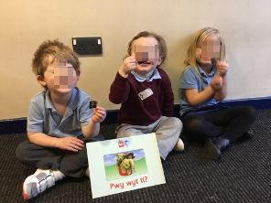
The images display evidence of the planned Welsh activity within my PTE1 nursery placement. The activity was suitable for the children to become endorsed in beginners sentence patterns within the Welsh language. The activity allowed the children to work collaboratively, developing confidence with ‘Pwy wyt ti?’ (Who are you?), which allowed the children to learn how to ask the question and respond to it. The children also became familiar with ‘Beth sy yn yr bocs?’ (What is in the box?) singing it as a group and picking out children’s faces. This allowed the children to ask the group whose image they were holding and respond using the correct name and sentence pattern.

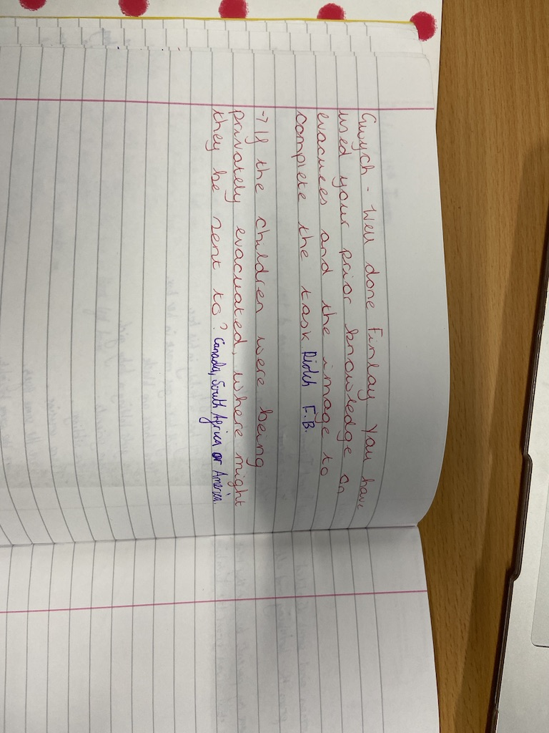
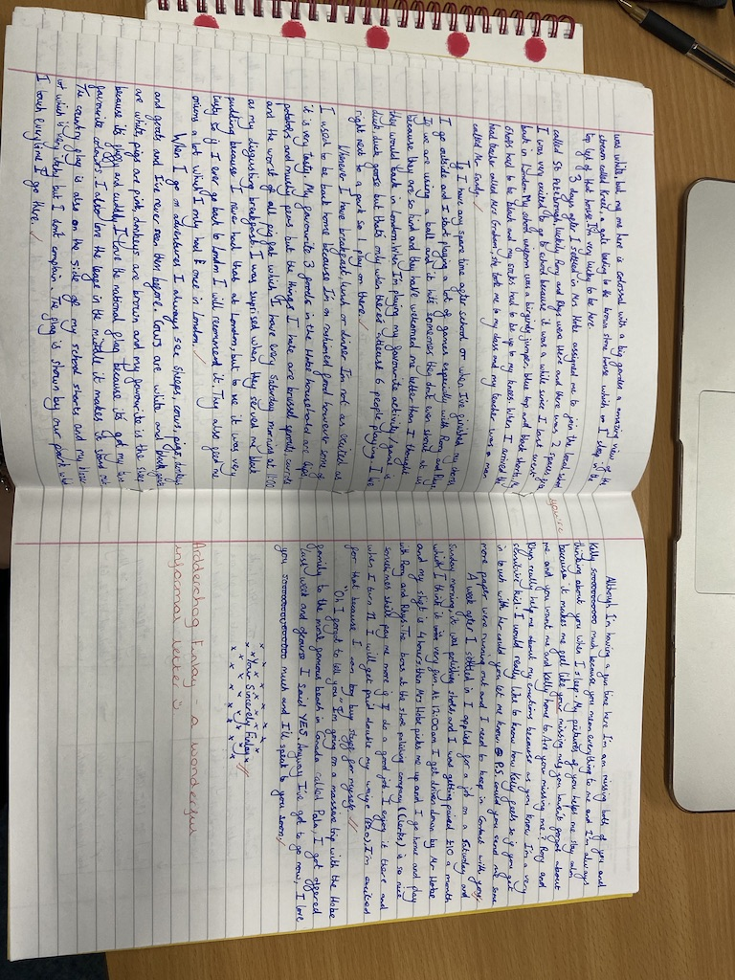
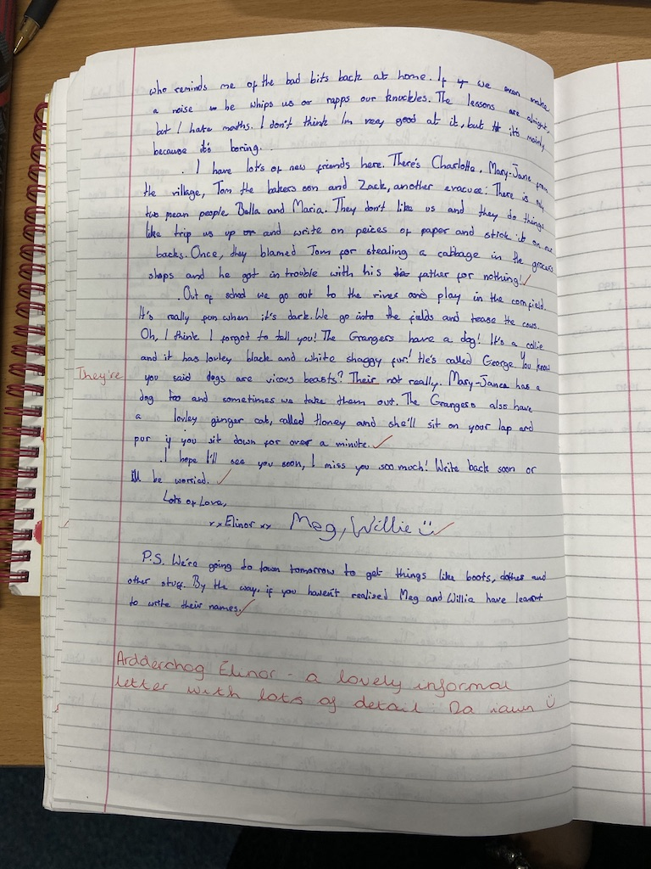
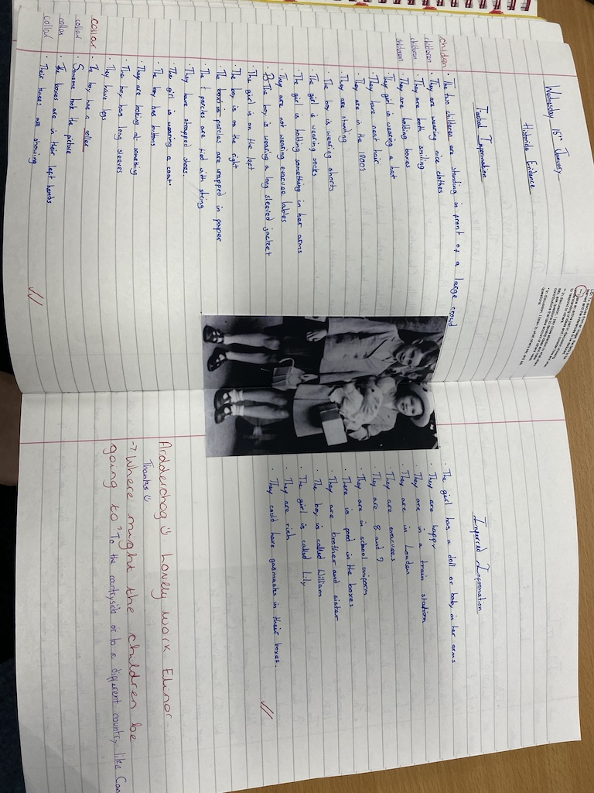
Welsh Year Six Marking

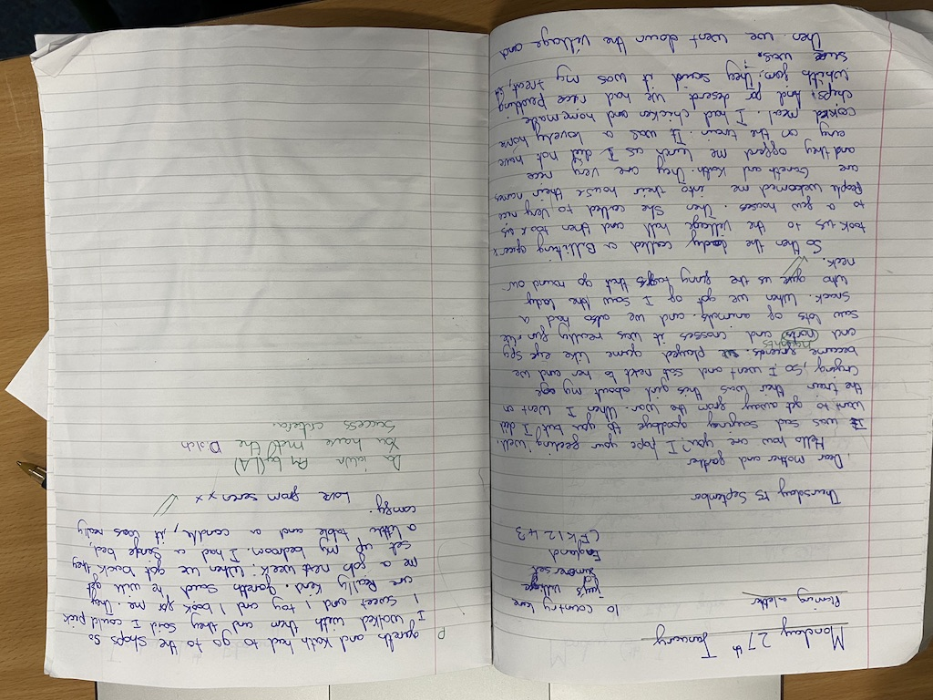
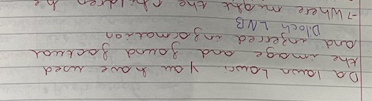
During my time on PTE1, I always marked the children’s books using a Welsh comment. The children were required to respond to the comment using a Welsh response, such as ‘diolch’ (Thank You). I believed that through using a comment within their marking, it provided an opportunity for the children to become familiar with Welsh vocabulary.

With the children seeing the comments in Welsh within their book, the children were able to become familiar with the marking codes and comments. The children have PIT Time (Pupil Improvement Time) every week in groups which allows them to respond and correct any marking or comments within their work. The children have marking code sheets for this which they utilise during this time. On the marking code sheets, there is a table full of Welsh response and commands/praise in order for the children to use within their work, within their comment response and during their peer/self assessment marking.

Welsh Self Development

Throughout my time in placement, I found it came naturally to use incidental Welsh throughout the classroom, the school learning environment, within my marking and in conversations with the children. My use of Welsh language was recognised and commented on within my assessments by my class teachers.

In aim of improving my Welsh Language Development, in further practice I will aim to observe and become familiar with how the language is used within other years groups so I can implement the language throughout different schools. I will continue to mark my work using a Welsh comment, praising children in Welsh and having conversations with children in Welsh.

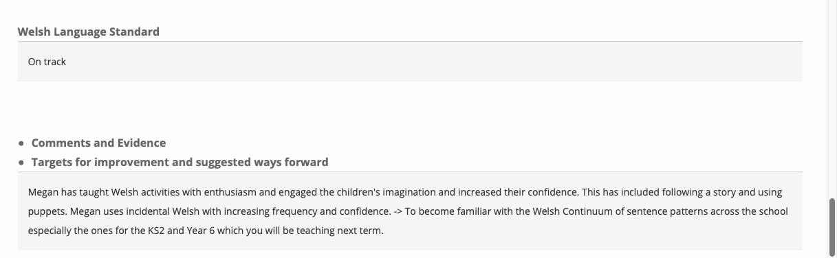
PTE 1 – Block One: Nursery

PTE 1 – Block Two: Year Six



