

(BMPS5007) contemporary issues in Public Services;
Design and Delivery: partnership working together and change management.

Charlotte Smith
Student Number - 1803955
Due - 08/11/2019
Final word count – 2,300

Within the public services, there is an area that needs to be governed by not only the police, fire service and ambulance, but in some cases, social services, child services and the government. These partnerships are a fundamental section of the public service safeguarding. Many of the issues within the 21st century are employment, education and crime (Statista, 2019); however, an issue that has continued to decrease in frequency is Child abuse and neglect.
In 2018 there were 2,960 (NSPCC, 2019) cases of child and young person’s abuse, of children on the child register, since 2014 this figure has decreased by 175 cases (NSPCC, 2019). There are many reasons that this could be the case, the creation of Young People Affected by Domestic Abuse (2011), All Wales Child Protection Procedures (2008) and Programme for Children and Young People (2015).
To understand the effect child abuse has on public services, there needs to be a basic understanding of the crime and causes. There are currently 12 types of abuse that a child can face these being; bullying and cyberbullying, child sexual exploitation, child trafficking, domestic abuse, emotional abuse, female genital mutilation, grooming, neglect, non-recent, online, physical and sexual abuse (NSPCC, 2019).
The first recorded case of child neglect in the case of Mary Ellen Wilson, born in 1864 in the Hell’s Kitchen of New York City. After the death, if her father, Mary's mother, was forced to work and boarded her daughter with a woman called Martha Score (Shelman & Lazoritz, 2003). As her financial situation worsened, Mary's mother was no longer able to make childcare payments, when this occurred, Martha turned a two-year-old Mary into the New York City Department of Charities. Mary was then placed in the care of Thomas and Mary McCormack (later Mary married Francis Connolly after Thomas’ death). During this time Francis and Mary moved to West 41st street, it was at this home that the neighbours noticed the mistreatment of young Mary, forcing her to do hard labour, she was repeatedly beaten, burned and cut (Shelman & Lazoritz, 2003).
When the couple then moved again the concerned neighbour contacted a local Methodist missionary, Angell Wheeler asking for the child to be watched. When Wheeler saw the state of Mary Ellen’s condition, she saw evidence of malnourishment, severe physical abuse and neglect (Shelman & Lazoritz, 2003).
Due to the period that this occurred, there was no legislation on child neglect. As a result, Mary Ellen’s case was taken on by the American Society for the Prevention of Cruelty to Animals (Shelman & Lazoritz, 2003). As a result of the neighbour’s testimony, Wheeler and the help of the Prevention of Cruelty to Animals Society, Mary Ellen’s case took to Supreme court in 1974.
During the hearing the offences covered where; regular and severe beatings, being forced to sleep on the floor, insufficient food, not provided with warm clothes to wear in cold weather, forbidden to go outside except at night in their yard and being locked in alone in a dark room (Shelman & Lazoritz, 2003). Mrs Connolly was sentenced to a year in jail, in the same year the New York Society for the Prevention of Cruelty to children was crated, the first of its kind.
From this first case of child neglect there have been significant there have been dramatic changed in the way that neglect protocols, acts and guidelines have changed. The Social Service and Well-being Act 2014 came into force in 2016, with the aims of providing a legal framework for improvement of the individuals well-being that need care and support.
The main aims of the act are, voice and control giving the individuals needs in the centre of care, enabling them to have a voice and control over the outcome of their well-being journey (Social Services and well-being Act 2014). Prevention and early intervention, this will increase the effectiveness of the service, in addition to creating a community first or grass roots feeling within the community. As well as this the well-being is a fundamental section for the service as the support people to achieve their own goals of well-being with a measure of success. In addition, the co-production of the service, between the individual and organisation will tailor the deliver and design of the plans.
Another key part of the initiative is to provide a level net protection of the individual starting at the community. If the induvial seeks further help the [partnerships that are made outside of the community such as government organisations, health serviced and other partners such as child service (Social Services and well-being Act 2014). This type of care can be referred to as the Continuum of Need or the windscreen pictured below.

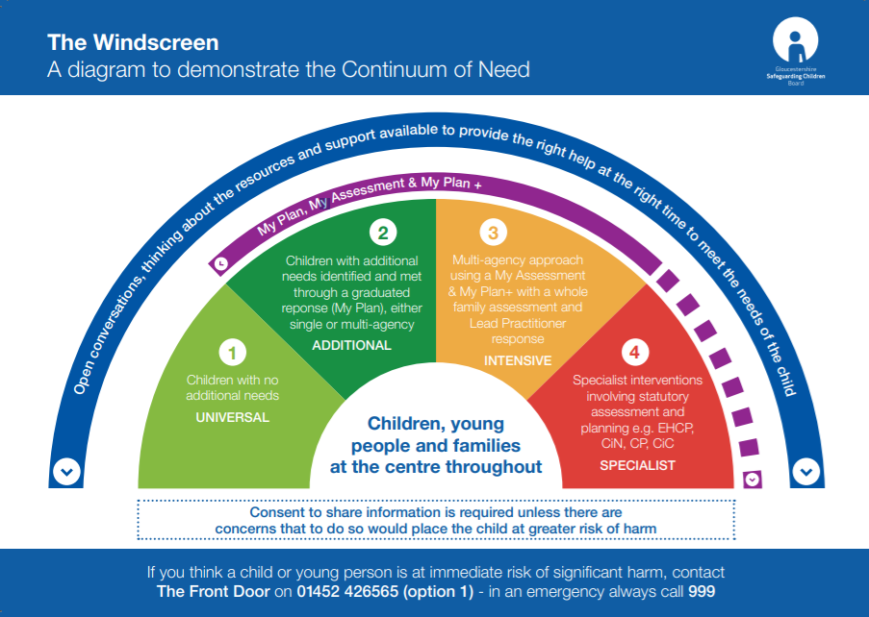
(Gloucestershire Safegaurding Children Board, n.d)

The aim of this ‘windscreen’ is promote multi agency working, providing tiers at which each team becomes involved as well as the standard of assessment the child will need to go through. For example, when applying a historical case to this diagram we can see at what stage each quarter would be covered. For each quarter there are types of care that a child will receive, universal is received by all, additional are extra services like additional help in school or mobility issues, this carries on into the intensive section. Finally the specialist section is where the child is in immediate need of care and protection.
In March2006 Baby Peter was born (BBC, 2013), in this stage of his life Peter would be in the light green section of the windscreen (Gloucestershire Safeguarding Children Board, n.d), meaning he will be receiving universal care, home visits from a mid-wife or health visitor for around 4 weeks after the baby is born. As this time no suspicions where raised Peter remained within the universal section seeking help from GP’s and other ordinary care.
November 2007 a GP for the family spotted bruises on the babies face and chest leading to the arrest of Connolly his mother (BBC, 2013). This stage of his life he would be moved directly to the amber stage or intensive due to the bruising on huis body at such a young age, following this he was removed form his mothers care for 5 weeks where he lived with a family friend with the case referred to the Commission for Social Care and Inspection (CSCI) (Gloucestershire Safeguarding Children Board, n.d).
Baby Peter was then admitted to North Middlesex Hospital with two black eyes bruises and swelling to the left side of his head, in April 2007 (BBC, 2013). This stage would move him into the severe stage of social care, as the Peter’s case was then further referred Ofsted for the inspection of the CSCI (Gloucestershire Safeguarding Children Board, n.d).
Peter remained would have then remained in the red section of the diagram until the day of his death at 17-months-old (Gloucestershire Safeguarding Children Board, n.d).
In a news report published by the Telegraph (Wardrop, 2010) Baby Peter was describes as being ‘failed’ by staff from every agency. There were many failures on behalf of many organisations regarding Peters case for example his GP for not reporting the first bruises to the police when he was just 6 years old, and the police for not investigating the matter sooner. Peter suffered more than 50 injured in 17 months regardless of the 60 visits from social services (Wardrop, 2010).
As a result of this injustice Ed Balls formed children’s sectary, release an investigation into the actions of those social workers. The review of the case concluded that baby peter deserved more from the services that were for protection, stating that the police, lawyers, social services and doctors should have stopped the issues ‘in its tracks’ at the first sight of any harm to Baby Peter.
Although had the Baby Peter case had arisen in the network the social service is today there may have been hope for Baby Peter. In 2007 there was a lack of Continuum of needs, the ability to put the child or family in the canter and surround them with specialists to help their situation.
However, this continuum of needs (The windscreen) did not exist when this case was in process. The main aim of the windscreen (Gloucestershire Safeguarding Children Board, n.d) is to provide a care-based system with the individual or the family at the centre, proving a protective ring of safeguarding.
Its can be seen that partnership plays a big role in family life for many people, however with any multi-agency initiative there are bound to be challenges and benefits of the workforce.
The three main challenges that face a partnership is, a difference of aims and values can lead to a differing agenda or end goal, this will almost affect every partnership within all practical aspects, such as negotiation, agreeing to share reward and poor performance, however many overcome this initial challenge (Heron & Orłowska, 2018).
Additionally, different capacity constraints, this related to the people themselves and their ability to work together, in a predetermined hierarchy of power every member knows their role. When including another organisation there will be a battle for power resulting in conflict.
As well as this, different ways of working will affect the partnership as there are many substantial ways in which a already predetermined team will work, by including another person or organisation this will force them to change their way of work, communication and project management (Heron & Orłowska, 2018).
(Heron & Orłowska, 2018).
From these initial challenges, the development of subordinate issues arises,
such as a lack of trust, poor transparency, agreeing who the lead partner is and differing terminology. If this confusion is there from the get-go, then it will prove difficult to have a partnership that helps the individual and works effectively.
However, three are many benefits to working in a partnership that prove the need for partnership within some organisations. Such as access to new locations that the original organisation may not have control over, better outcomes for those using the service a combined service has more to offer a person then one alone. As well as these, binding of existing skills will build the skill base of the organisation as well as gaining experience and knowledge for those who were not educated in the field to begin (Heron & Orłowska, 2018). In addition to risk sharing, added credibility and a shared infrastructure of assets.
Due to this there is a large gap or potential for partnership to form the basics of all public services organisations. Providing the public services with the ability to have long-term support and increase credibility, for example the partnership of the social services, the police and health service has created a centre of help for an individual or family in need. In addition to growing the quality of service provided by the partnership, one organisation can help in regard to one issue whereas in a partnership there are many bases covered as a result of the relationship (Heron & Orłowska, 2018).
Although, to prove this there needs to be evidence that the partnership is helping with the issue. For example, in the case of child neglect (NSPCC, 2019) there is a noticeable decrease in the amount of abuse cases recorded since 2014.
The aim for every social service worker is to keep the family together, through providing support, care and help. As of 2013 there were 68,00 children in the care of the local authority within England (Webb, 2014) and 5,765 within Wales. Within England in 2018 this figure rose to 73,00 (Ofsted, 2019) and 6,405 within Wales (StatsWales, 2013).
The below table is taken from the Child protection register statistics: Wales 2014-2018, each value has been rounded to the nearest 5 with anything under 5 marked with ‘*’.
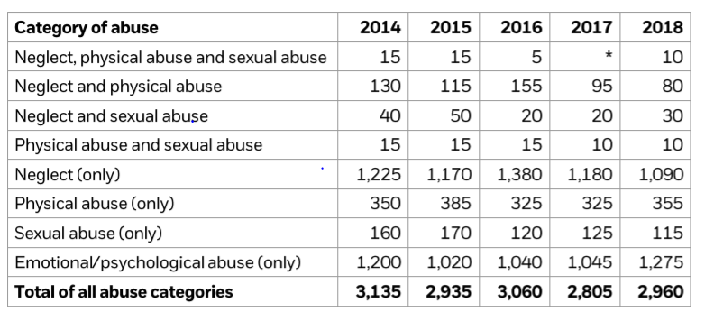 This table displays that changes that happened with regard to the frequency of child abuse cases within wale over a 4-year period. As you can see firstly, the overall number of cases has decreased, since the initial 3,135 in 2014 (NSPCC, 2019) to 2,960 this is a decrease of 175 as a percentage that is a decrease of 0.05% over 4 years. Along with this there is a documented change in the number of reports of neglect and physical abuse, from 2014-15 there was an increase of 25 cases however in 2018 this dropped dramatically by 75 reports (NSPCC,2019). During 2018 there was a slight overview of decrease within the child abuse categories.
However, is can also be seen that there are a number of categories of which saw a rise in cases. This can be due to the increased reporting of the crime due to awareness. For example, in 2015 the number of physiological abuses cases was 1,020 where last year the cases have risen to 1,275, currently there is no explanation for this, however the figure is set to go down, (NSPCC, 2019).
As partnership must be measured in efficiency, we must consider measuring the success rate of each partnership. In a letter to her colleagues, Julie Thomas (2019) stated that ‘Wales is seeing ‘excellent performance’ in terms of figures and practice with regard to child services. Giving examples of what can be measured by the council in terms of improvement for the Swansea area. If a report similar to the Report of the Cabinet Member for Children’s Services Child and Family Services Scrutiny Performance Panel was produced for each partnership to define its success and limitation, we would be able to determine which groups complete a task or service more efficiently.
Overall partnerships are a key service for Wales’ social services empire as we are the template for all social policies within Britain. Taking care back to the grass roots of the community and showing a non-judgemental way of helping people in difficult situations.

References
AWCPPRG (2008). All wales Child Protection Procedures. Welsh Assembly: Cardiff.
AWCPPRG (2011). Safeguarding Children and Young People Affected by Domestic Abuse All Wales Practice Guidance. 1st ed. Welsh Assembly: Cardiff.
BBC (2013). Timeline of Baby P case. [online] BBC: London. Available at: https://www.bbc.co.uk/news/uk-11626806 [Accessed 14 Oct. 2019].
Gloucestershire Safeguarding Children Board (2017). The Windscreen. [Graph] Glouster.
Heron, S. and Orłowska, P. (2018). PARTNERSHIPS May 2018 For Better Public Services. [online] GOV.UK : London. Available at: https://assets.publishing.service.gov.uk/government/uploads/system/uploads/attachment_data/file/715302/Partnerships_for_Better_Public_Services_2018.pdf [Accessed 14 Oct. 2019].
NSPCC (2019). Child Protection Register Statistics- Wales 2014-2018. [online] NSCPP: London. Available at: https://learning.nspcc.org.uk/media/1184/child-protection-register-statistics-wales.pdf [Accessed 14 Oct. 2019].
NSPCC (n.d.). Types of abuse. [online] NSPCC: London. Available at: https://www.nspcc.org.uk/what-is-child-abuse/types-of-abuse/ [Accessed 15 Oct. 2019].
Ofsted (2019). Children’s social care data in England 2017 to 2018: main findings. [online] GOV.UK: London Available at: https://www.gov.uk/government/publications/childrens-social-care-data-in-england-2018/childrens-social-care-data-in-england-2017-to-2018-main-findings [Accessed 13 Oct. 2019].
Shelman, E. and Lazoritz, S. (2003). Out of the Darkness; the True Story of Mary Ellen Wilson [online] Dolphin Moon Publishing: Florida. Available at: https://books.google.co.uk/books?id=qmtYdQ-BaIwC&printsec=frontcover#v=onepage&q&f=false [Accessed 16 Oct. 2019].
Statista Research Department (2019). Most important issues facing Britain 2019 | Statista. [online] Statista: Hamburg. Available at: https://www.statista.com/statistics/886366/issues-facing-britain/ [Accessed 15 Oct. 2019].
Stats Wales (2013). Children looked after at 31 March by local authority, gender and age. [online] Statswales: Cardiff. Available at: https://statswales.gov.wales/Catalogue/Health-and-Social-Care/Social-Services/Childrens-Services/Children-Looked-After/childrenlookedafterat31march-by-localauthority-gender-age [Accessed 15 Oct. 2019].
Stats Wales (2018). Children looked after at 31 March by local authority, gender and age. [online] Statswales: Cardiff. Available at: https://statswales.gov.wales/Catalogue/Health-and-Social-Care/Social-Services/Childrens-Services/Children-Looked-After/childrenlookedafterat31march-by-localauthority-gender-age [Accessed 14 Oct. 2019].
Thomas, J. (2019). Report of the Cabinet Member for Children’s Services Child and Family Services Scrutiny Performance Panel 28th August 2019 Monthly Performance Report – June 2019. [online] Swansea Council; Swansea. Available at: https://moodle.uwtsd.ac.uk/pluginfile.php/310406/mod_resource/content/1/Performance%20Monitoring%20June%202019.pdf [Accessed 14 oct. 2019]
Webb, A. (2014). Children's services aim to keep as many families as possible together. [online] the Guardian: London. Available at: https://www.theguardian.com/social-care-network/2014/jan/27/childrens-services-keep-families-together [Accessed 14 Oct. 2019].

Wardop, M. (2010). Baby P 'failed by incompetent staff from every agency'. [online] Telegraph: London. Available at: https://www.telegraph.co.uk/news/uknews/baby-p/8086957/Baby-P-failed-by-incompetent-staff-from-every-agency.html [Accessed 14 Oct. 2019)

Social Services and Well-being Act 2014

