

Personal Promotional Material

Mia Harries
Student Number: 2304406

BA (Hons) Computer Games Design
Personal Portfolio Development (ACCA6033)

10/05/2026

Contents
Employment Database 2
Personal Showreel 3
Business Card 4
Bibliography 6

Employment Database
Link to Excel: PPD Database.xlsx
Image of Databse:
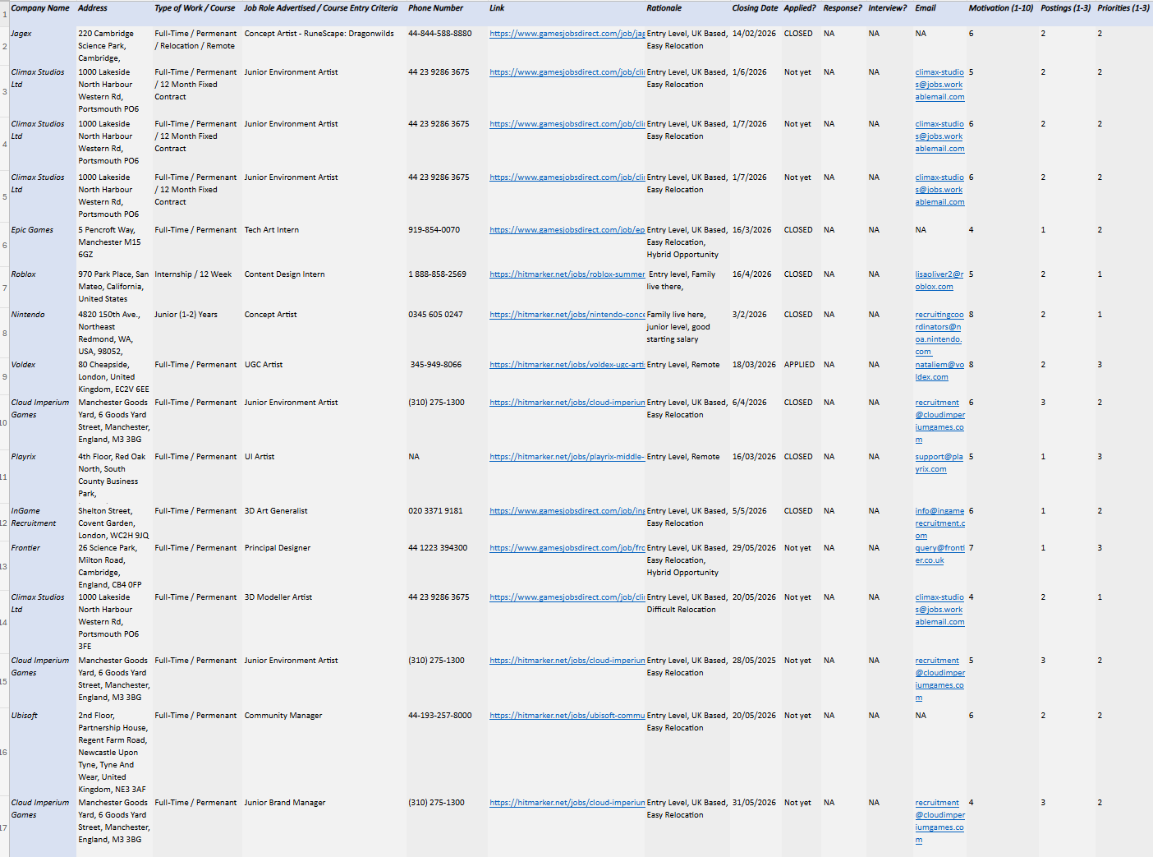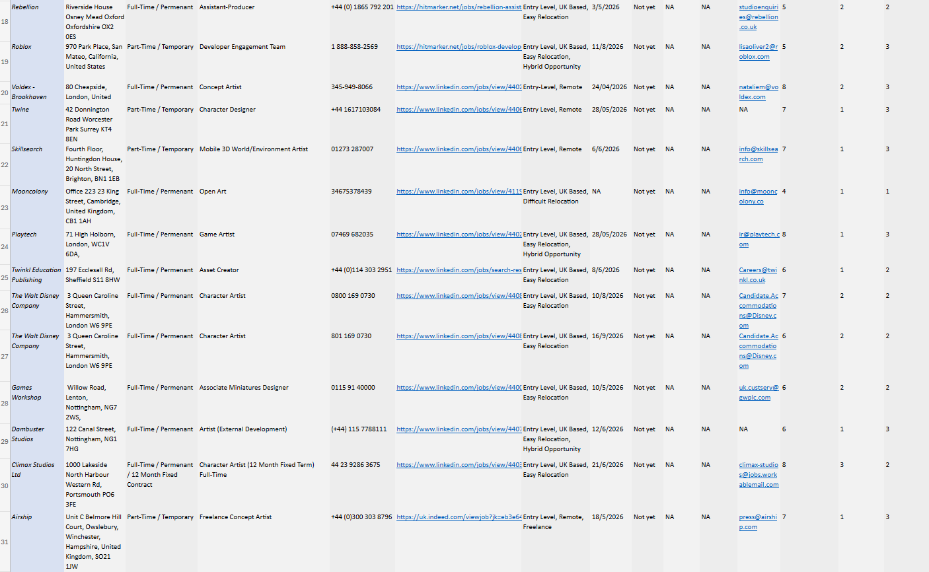

Personal Showreel
Video Link: https://youtu.be/ce20DsmVlA8


Business Card
Final Front Design to scale (8.8mm x 5.8cm 300DPI CMYK):
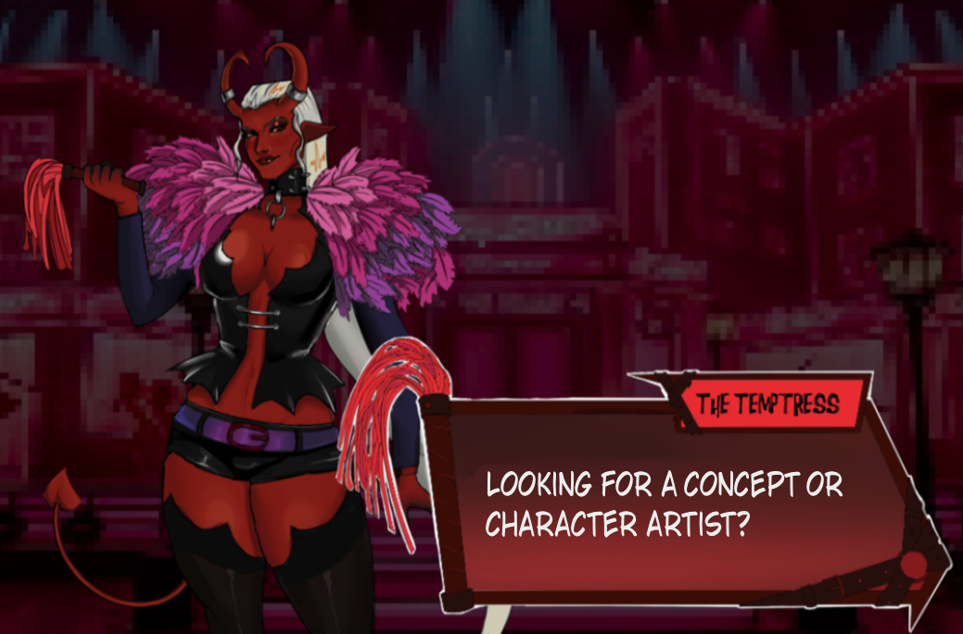
Final Back Design to scale (9.1mm x 6.1mm version available for print):
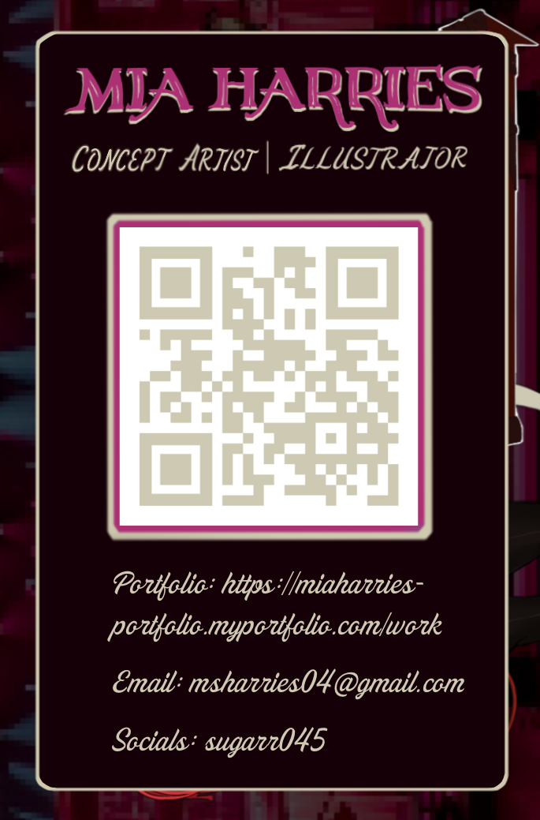

Initial Idea Variations:
These are the other ideas that I’d had when creating the initial business card, I really liked the second one because it does best in showing off some of my best work but it seemed to cluttered to be considered professional so the final design is much simpler than the initial ones.
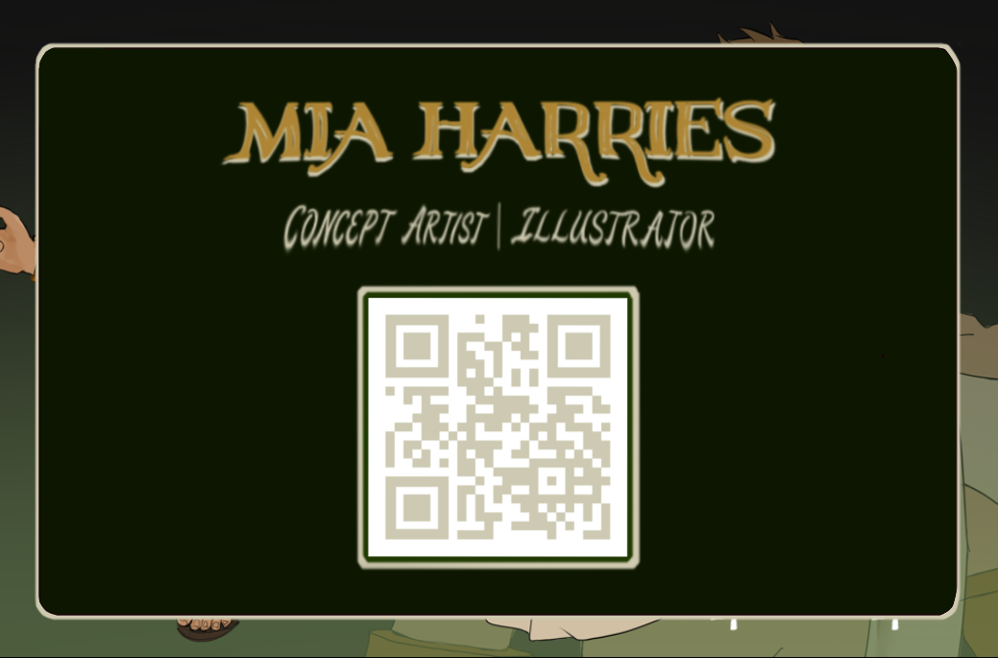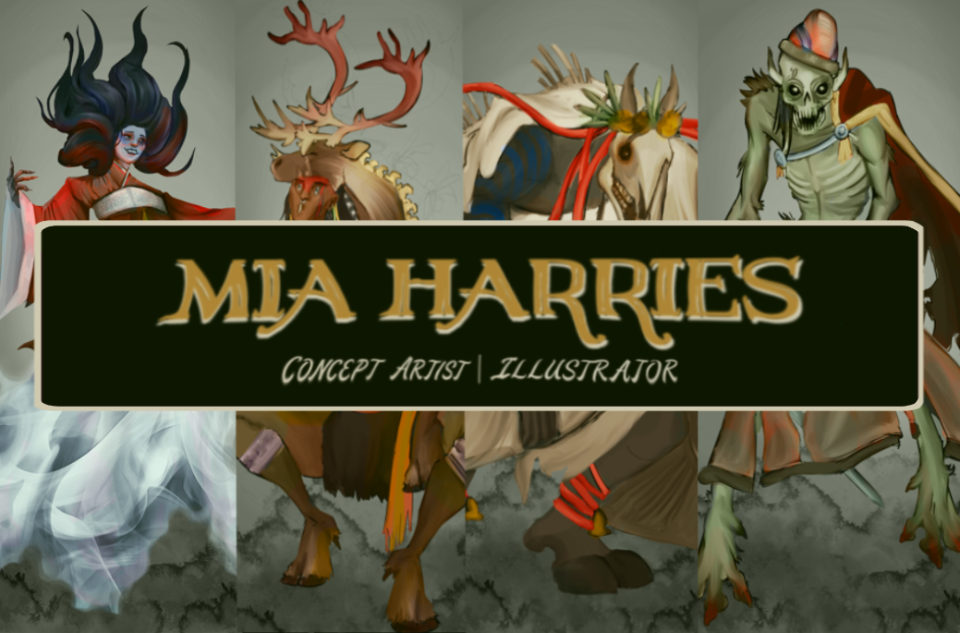

Bibliography
VistaPrint UK, “Business Card Dimensions & Size Guide,” VistaPrint, Nov. 22, 2022. [Online]. Available: https://www.vistaprint.co.uk/hub/business-card-size-guide?srsltid=AfmBOoorTOYvfhqkLt5TA_v1Z0k2HllCilV6NV7x5Sk_H1yaiIlACUVV [Accessed: May 11, 2026].
Contemporary Art Issue, “The Best Business Cards for Artists,” CAI, [Online]. Available: https://www.contemporaryartissue.com/the-best-business-cards-for-artists/ [Accessed: May 11, 2026].
Satori Graphics, “Designing A Business Card That Doesn't Suck! (6 Pro Tips),” YouTube. [Online]. Available: https://www.youtube.com/watch?v=JiBCYPAKydQ [Accessed: May 12, 2026].
Mohamed Bouniar, “Step-by-Step Mastery: Build Your Job Applications Tracker in Google Sheets!,” YouTube. [Online]. Available: https://www.youtube.com/watch?v=tPfH8ERd1Qg. [Accessed: May 12, 2026].
The University of Melbourne, “Writing a rationale,” The University of Melbourne Academic Skills, [Online]. Available: https://students.unimelb.edu.au/academic-skills/resources/reading,-writing-and-referencing/writing-effectively/writing-a-rationale. [Accessed: May 12, 2026].
Sneha Chakrabarty, “Concept art Showreel,” YouTube. [Online]. Available: https://www.youtube.com/watch?v=Fyp2cYUzFBw [Accessed: May 12, 2026].
Hamzilla,“Concept Art Demo Reel,” YouTube. [Online]. Available: https://youtu.be/5pGJnW-T4EQ?si=9rGTSYr9hPF4iZC3. [Accessed: May 12, 2026].
Escape Studios, “Reel Talk by Escape Studios,” PDF document. [Online]. Available: https://webdocs.aub.ac.uk/Reel%20Talk%20by%20Escape%20Studios.pdf [Accessed: May 12, 2026].
Mia Harries, “LinkedIn Profile,” LinkedIn. [Online]. Available: https://www.linkedin.com/in/mia-harries-54a20b296/ [Accessed: May 12, 2026].
Jagex Limited, “The RuneScape Company,” Jagex. [Online]. Available: https://www.jagex.com/ [Accessed: May 12, 2026].
Climax Studios, “About Us,” Climax Studios. [Online]. Available: https://www.climaxstudios.com/ [Accessed: May 12, 2026].
The Walt Disney Company, “About the Company,” The Walt Disney Company. [Online]. Available: https://thewaltdisneycompany.com/ [Accessed: May 12, 2026].
Epic Games, “Epic Games Store,” Epic Games. [Online]. Available: https://store.epicgames.com/ [Accessed: May 12, 2026].
Roblox Corporation, “About Roblox,” Roblox. [Online]. Available: https://www.roblox.com/ [Accessed: May 12, 2026].
Nintendo, “About Nintendo,” Nintendo UK. [Online]. Available: https://www.nintendo.com/en-gb/?srsltid=AfmBOopXpXwjGy7F1UY2gAS6RaBDDfJXkSCPPfUZmYbDZ_NZFvywqwbt [Accessed: May 12, 2026].
Voldex, “About Us,” Voldex. [Online]. Available: https://voldex.com/ [Accessed: May 12, 2026].
Cloud Imperium Games, “About,” Cloud Imperium Games. [Online]. Available: https://cloudimperiumgames.com/ [Accessed: May 12, 2026].
Frontier Developments plc, “Games,” Frontier. [Online]. Available: https://www.frontier.co.uk/games [Accessed: May 12, 2026].
Ubisoft, “About Us,” Ubisoft. [Online]. Available: https://www.ubisoft.com/en-gb [Accessed: May 12, 2026].Games Workshop Group PLC, “Warhammer,” Warhammer. [Online]. Available: https://www.warhammer.com/en-GB/home?srsltid=AfmBOopJqLDQu1xGlIcujGQEy4nBwwZTZRsq7SCQ1P2MAu3mzpGjpZQY [Accessed: May 12, 2026].

