

University of Wales Modular M.A. (Ed.) Programme

Student Number: 1504531

Overcoming Educational Disadvantage in Wales

Level: MA(Ed)

Assignment Number: 1 2 3 4

Tutor: Miriam Norton

Abstract
The Welsh Government has made reducing the ‘poverty gap’ a national priority for education in Wales (Welsh Government, 2014). It has long been acknowledged that socioeconomic status has a significant impact on educational attainment and schools face the challenge of reducing this attainment gap. The key indicator used by the Welsh Government to identify deprivation is eligibility for Free School Meals (e-FSM), and it provides the Pupil Deprivation Grant to schools for every e-FSM and Looked After Child (LAC) learner they have on roll to be used to develop interventions which will reduce the attainment gap. Literature identifies a range of strategies that can be used to tackle this attainment gap, focusing on whole school approaches, pupil wellbeing, teaching and learning and parental engagement. Schools need to focus on all of these areas in order to have the greatest impact on the attainment of e-FSM learners. This report studies the strategies implemented by School X to tackle its attainment gap. It was found that School X focused strongly on teaching and learning and whole school approaches to benefit all learners, but lack parental engagement which has been found to have the biggest influence on a child’s educational attainment. It is recommended that moving forward School X focuses on developing more accessible methods of parental engagement in order to maximise the impact they have on their e-FSM learners.

Contents
Abstract 1
1.0 Introduction 4
2.0 Literature Review 5
3.0 Methodology 12
4.0 Findings 13
5.0 Conclusion and Recommendations 19
6.0 References 21
7.0 Appendices 23

1.0 Introduction
Estyn (2012) states that effective schools in challenging situations must use a wide range of strategies tailored to their individual context in order to positively impact disadvantaged learners. This report will examine the specific context of a school in South East Wales, which will be anonymised as School X due to ethical considerations (BERA, 2011). This report aims to examine the extent of the impact of poverty on the educational attainment of pupils in Wales. A literature review will be conducted to develop an understanding of the extent of the impact poverty has on the educational attainment of pupils in Wales, as well as highlighting suggested strategies schools can utilise in order to address this. Research will then focus specifically on the extent of the attainment gap between learners who are eligible for Free School Meals (e-FSM) and non-FSM (n-FSM) learners at School X, and the strategies put in place by School X to close this gap. An overall evaluation of the impact of these strategies will be conducted, followed by some recommendations for how to ensure the school has the most significant impact on reducing this gap.

2.0 Literature Review
  - 2.1 Socio-economic disadvantage in Wales
The Welsh Government (2014) states that a good education is essential for improved life chances and has made developing and improving its’ education system a public priority. The Welsh Assembly’s vision for education in Wales is to have high expectations for every learner regardless of socio-economic background, and to make sure that every learner is provided with an equal opportunity to achieve these expectations (Welsh Government, 2014).
Wales embarked on a large scale education improvement reform in 2011, following a report from the Programme for International Student Assessment (PISA) which showed that Wales was performing significantly lower than average (Cook et al., 2014). The key objectives of this reform were to improve overall performance in literacy and numeracy, as well as reducing the impact of socioeconomic status on student performance (OECD, 2014). Although there is a need for improvement in the attainment of all learners in Wales, the main focus is to improve the educational outcomes of learners who are eligible for Free School Meals (e-FSM) at a quicker rate in order to reduce the ‘gap’ in attainment that currently exists between e-FSM learners and n-FSM learners (Welsh Government, 2014). The ambition of this reform is to develop an education system characterised by quality and equity (OECD, 2014). Equity in education is linked to social justice, human rights and notions of equality. In simple terms, when we talk about equity in education we are talking about fairness in education, which is reflected in the Welsh Assembly’s vision for its education system to allow all learners to succeed (Ainscow et al., 2012).
The Welsh Government (2014) defines poverty simply as a lack of money, and views deprivation as a wider concept referring to a lack of resources and opportunities to which we would expect access to. Poverty is a relative concept, with relative poverty being judged by how well people are able to live in comparison to the typical living standards of wider society (Grigg et al. 2014). UNICEF (2012) measure absolute child poverty on the basis of whether children have access to particular items that are considered to be normal and necessary in an economically advanced nation such as three meals a day, regular leisure activities, fresh fruit and vegetables and access to the internet. In Wales 1 in 3 children (200,000) live in relative poverty with 1 in 7 (90,000) experiencing severe poverty with household income of below £12,200 per year. On both counts Wales has the highest levels of child poverty in the UK (Grigg et al., 2014; Welsh Government 2014). For these children poverty means not being able to eat properly, lacking items such as a winter coat and shoes and not being able to join friends in social activities. This poverty also forms a major barrier to success in education (Grigg et al., 2014).
Research has shown that educational outcomes are powerfully influenced by learners’ socioeconomic background (Schools Analysis and Research Division, 2009) causing e-FSM learners to ‘lag behind’ at all stages of education. The gap initially becomes present at 9 months old, and continues to grow at an accelerating pace throughout primary and secondary education (Egan, 2012). It has been shown that:
- By the age of 3 children from poorer homes are estimated to be an average of 9 months behind the development of their more wealthy peers
- By the end of primary school e-FSM learners are estimated to be almost three school terms behind their n-FSM peers
- By the age of 14 this gap has widened to 5 school terms
(Grigg et al., 2014)
By the end of compulsory education at age 16 the gap is at its largest, with an average of only 21% of e-FSM learners achieving 5 A* - C GCSE’s including English and Maths, compared to 55% of non e-FSM learners (Egan, 2013). This has a life-long impact on job prospects and standards of living. The Welsh Government (2014) states that the impacts of poverty and deprivation are varied and complex. Although the impacts of socio-economic status are evident before children start school, the Government believes that schools can play a significant role in reducing these impacts particularly when working together with parents/carers and the wider community.
According to the Welsh Index of Multiple Deprivation (WIMD) (2011) there is an uneven spread of deprivation across Wales. The purpose of the WIMD is to identify and understand the levels of deprivation in Wales in order to target funding, policies and intervention programmes effectively on the most disadvantaged areas (Cook et al., 2014). Higher percentages of poverty are found in urban areas, especially Cardiff, Newport and the South Wales Valleys. Children in these areas are at an increased risk of social issues such as drug abuse, high crime rates, family breakdown and a culture of low aspirations. Furthermore, Welsh Government figures show that e-FSM learners living in the most deprived areas of Wales are four times more likely to be persistently absent from school and are more likely to have moved schools at least once, further impacting the educational attainment of these learners (Welsh Government, 2014; Grigg et al., 2014). This has resulted in e-FSM learners being three times more likely to become NEET (Not in Education, Employment or Training) upon leaving school than their n-FSM peers.
In order to tackle this issue the Welsh Government has developed the Tackling Poverty Action Plan which sets out a number of aims in relation to poverty and its impact on educational attainment. These include:
- To raise attainment of e-FSM learners of the Level 2 inclusive to 37% by 2017
- To reduce the number of young people who are NEET between ages 16 – 18 to 9% by 2017
(Welsh Government, 2014)
A key theme of this Action Plan is the focus on family and community, with programmes including Flying Start, Families First and Communities First being introduced in order to provide community based support for families in some of the most disadvantaged areas of Wales (Egan, 2013). These have been assessed to be relatively successful in contributing to improving attainment for children living in poverty in Wales, however Egan (2013) argues that there is a need for more substantial evidence and detail on the specific impacts of such programmes.
Although it is widely agreed that there is a link between poverty and educational attainment, there is disagreement in the literature as to why this is the case. It is important to note that the vast majority of the research into poverty and its’ impact on attainment are based on a functionalist perspective. This perspective assumes that education plays an important role in the proper functioning of a society, but these supposed benefits often do not materialise for individuals or groups of people from poorer backgrounds due to some immediate social contexts such as the limited social and cultural capital provided by the family and community. Many of the initiatives developed by the Government such as ‘Flying Start’ and ‘Communities First’ focus on this functionalist view and only take immediate social contexts such into account. As this report will be examining specific school interventions such as these and the impact on pupils in a specific community, the findings will be presented from a functionalist perspective considering immediate social contexts. However other studies focus on broader social structures, and argue that the relationship between poverty and education is a result of underlying social structures which create social inequalities and exclusion in society, resulting in those from poorer areas attaining lower levels in their education. This view assumes that education is potentially beneficial for individuals but education in its current form reflects the unequal distribution of power and resources in the UK and therefore excludes learners from lower socioeconomic backgrounds. Currently very little in educational policy focuses on broader social structures, with the focus being targeted at smaller communities, families and school engagement, however it could be argued that until broader social structures are addressed at a national level, the attainment gap will not close regardless of specific school interventions (Raffeo et al., 2007).
  - 2.2 The PDG
In order to reduce the impact of deprivation on educational outcomes the Welsh Government has introduced several initiatives including a grant specifically designed to help schools move towards the three national priorities:
- - Improve the standards of literacy
- - Improve the standards of numeracy
- Reduce the impact of poverty on educational attainment (Cook et al., 2014)
The Pupil Deprivation Grant (PDG) is given to schools directly to support e-FSM pupils, as this is the key measure of pupil deprivation used by the Welsh Government, and Looked After Children (LAC). This grant is provided on the basis of the number of e-FSM and LAC pupils in a school (£1150 per child in 2017-18) and should be used for interventions focusing on literacy and numeracy, developing effective tracking systems for attainment and wellbeing and managing support interventions for pupils who may have an additional learning need. Egan et al. (2014) advise that the starting point for allocating the PDG is to identify the individuals entitled to the additional support, recognising gaps in their development and devising a programme to raise the attainment of these specific pupils whilst simultaneously closing the attainment gap between them and their peers. Ofsted (2012) reviewed the use of the Pupil Premium Fund which was introduced in England in 2010 to support e-FSM learners, and highlighted some key characteristics of successful allocation of the grant. These included:
- a clearly defined target group
- progression data frequently checked to track development and impact of interventions
- research evidence is used to select activities most likely to have a positive impact on progress and development
- class and subject teachers know which children are e-FSM
- a focus on strengthening links with families presenting barriers to learning
- carefully planned monitoring and evaluation of the process from the outset
  - The grant is not to be used to support other groups of pupils such as n-FSM learners, or learners who may benefit from separate funding such as ethnic minority learners or learners with an additional learning need who are n-FSM. Schools are closely monitored to ensure they are using the PDG effectively in order to reduce the attainment gap (Egan et al., 2014; Cook et al., 2014).
  - 2.3 Interventions
A large amount of research has been conducted since the introduction of the PDG which can provide useful insight on how to best structure interventions (Estyn, 2012; Ofsted, 2012; Egan 2013). A summary of this research suggests that schools should target their interventions in three main areas:
- Whole school approaches focused on:
  - Leadership – it has been found that if the leadership within a school has the belief that they can have a positive impact on every pupil it leads to a culture of high expectations which is often a key determinant of success for all pupils regardless of their background. Estyn (2012) states that in effective practise it is leadership who should be responsible for tracking the progress of learners who face a barrier to learning such as being e-FSM and evaluate the impact of all interventions designed to support them. Therefore effective whole school leadership is an important factor in schools that are able to succeed in tackling the attainment gap.
  - Effective teaching and learning – the Sutton Trust carried out extensive research into the impact a vast range of teaching and learning strategies can have on pupils who are considered low-achievers, including those who are disadvantaged. It uses an ‘effect-size’ method of measuring the impact of each strategy on pupil development compared with the cost in order to ascertain the ‘value for money’ of each strategy. This provides an extremely useful tool for schools when selecting methods for their interventions, as Ofsted (2012) recommend using a research based approach to ensure the most effective strategies are put in place (Sutton Trust, 2014). A full summary of the Sutton Trust’s analysis of teaching and learning strategies can be found in Appendix 7.1.
  - Pupil wellbeing – tackling pupil wellbeing, particularly for those pupils who are experiencing poverty and its effects, is seen as fundamentally important to ensure pupils are making progress towards their potential. Strategies to promote this focus on developing resilience, self-esteem and the social skills of pupils. All schools do this to a certain extent through their pastoral systems, however targeted intervention strategies could include improving attendance, developing behaviour for learning approaches and working on personal and social skills. Although it is difficult to measure the specific impact of these strategies they are seen to be a precursor to successfully engaging pupils in teaching and learning and are therefore seen to be a positive use of the PDG (Egan et al., 2014).
- Engaging families – parents have the biggest influence on children and their educational attainment. The research has shown that children from lower socioeconomic families are already 9 months behind their more affluent peers developmentally by the age of 3, before they have had any contact with the education system (Grigg et al., 2014). Research by the Joseph Rowntree Foundation stated that parental engagement is the most important factor outside of schools to influence the attainment of children from disadvantaged backgrounds (MacInnes et al., 2013). Therefore it is critical that efficient links between school and families are established, and strategies to develop this have the potential to be an extremely beneficial use of the PDG.
- Strengthening community links – community also has a significant impact on the attainment of young people. Communities in low socioeconomic areas may have developed a culture where academic success is not considered to be the norm, and there may be few role models of people who have achieved success via higher education or training. This can lead to a culture of low aspirations, causing these learners to become disengaged with education and widening the attainment gap (Baker et al., 2014). It is the role of the school to impact positively on the aspirations and attitudes of their learners, and combat this culture of low aspirations (Goodman and Gregg, 2010). Interventions to address this and strengthen the links with the community is therefore an effective use of the PDG and if successful have the potential to greatly reduce the attainment gap (Grigg et al., 2014).
The Joseph Rowntree Foundation studied the progress made in tackling poverty and educational attainment over the 5 year period since the PDG was introduced in 2012 to gauge its’ impact using a simple scale:
- Worse
- No change
- Better
The research suggests that there has been some improvement in the following areas:
- the proportion of children not reaching the expected levels at age 11 and 16
- the e-FSM attainment gap at age 19 for Level 3 qualifications such as A Levels
However, they reported ‘no change’ in the attainment gap between e-FSM and n-FSM learners aged 16. Clearly more work needs to be done to improve this (MacInnes et al., 2013). The progress against child poverty has been slower in Wales than elsewhere in the UK, with e-FSM learners in England being on average 50% more likely to achieve the Level 2 inclusive threshold (5 GCSE’s of grade A* – C including English and Maths) than their Welsh counterparts at age 15. Furthermore learners in the North East of England, the region most socioeconomically comparable with Wales, are more than a third more likely to achieve the Level 2 inclusive than their peers in Wales. In every region of England the rate of development in the attainment of e-FSM learners has been significantly faster than in Wales (Grigg et al., 2014). This has been further impacted following the GCSE results in 2017, due to the percentage of Year 11 pupils in receipt of Free School Meals achieving the Level 2 inclusive falling to 28.5%, with the attainment gap increasing 1.1% from the previous year to 32.3% as shown in Figure 1:
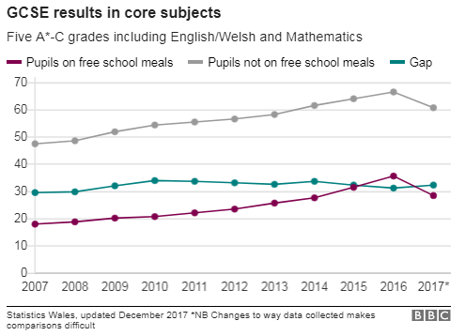
FIGURE 1: Percentage of pupils achieving the Level 2 Inclusive in Wales
(BBC News, 2017)
Although this appears disastrous at first glance, there are underlying factors which may have led to this fall in attainment. In 2016-17 some of the biggest changes to the exam system in over a decade took place in Wales, with new English and Maths exams being counted in the indicators. These policy changes have led to a discontinuity in the data from the previous year to this year, and may not therefore be indicative of a fall in standards (BBC News, 2017).
As Estyn (2014) state, there is not a simple explanation for the link between socioeconomic status and educational attainment, or an easy solution to break it.

3.0 Methodology
Prior to undertaking this research, consideration was given to the ethical requirements of the report. BERA (2011) state that all researchers must comply with the legal requirements outlined in the Data Protection Act 1998 relating to the storage and use of information which consider it the norm for any sensitive data involved in research to be kept confidential and anonymous. In accordance with these ethical guidelines the name of the school and any individuals involved in the study will be kept anonymous. The school involved will be referred to as School X.
In order to examine the impact of School X’s use of the PDG to tackle the attainment gap, research will be conducted using school documents such as the School Improvement Plan (SIP) and PDG Plan, as well as comments from Estyn’s report regarding the strategies used by School X to overcome educational disadvantage. An interview will also be conducted with the Assistant Head of School X to develop an understanding of the rationale behind the decisions relating to the allocation of funding, as well as the impact these are perceived to be having. A full transcript of this interview can be found in Appendix 7.2.

4.0 Findings
  - 4.1 School X
School X is a mixed gender comprehensive school in Newport, South East Wales. There are currently 806 pupils on the roll, with 30.4% e-FSM; well above the national average of 17.5%. In 2017 44.6% of students achieved the Level 2 threshold at Key Stage 4, falling from 53.7% of pupils in the previous year. However prior to this the percentage of pupils achieving the Level 2 threshold had been rising steadily since 2011, so this fall in attainment is likely due to the changes to the exam systems during this academic year.
In 2016 the attainment gap between e-FSM and n-FSM was at 24.2%, with only 35.6% of e-FSM pupils achieving the Level 2 inclusive compared to 59.8% of n-FSM. In the years prior to this the gap had been reducing (Estyn, 2013). Furthermore in 2017 the gap reduced further to 21.9% despite the overall fall in attainment suggesting that the interventions put in place by School X are having an impact on e-FSM learners (My Local School, 2018).
Despite the level of e-FSM being 30.4%, Estyn (2013) state that 43% of learners at School X live in the 20% most deprived areas in Wales. The reason for this discrepancy in the data is the characteristics of the schools unique cohort. There is a high proportion of learners who speak English as an Additional Language (EAL); 22.9% of the population which is significantly higher than the national average of 3% and even the local authority average of 11.1%. In addition to this, there is also a high proportion of Minority Ethnic students, currently standing at 37.6%. A significant proportion of this figure is a community of Roma children, originating from Eastern Europe. Data has shown that learners of Roma Heritage have the highest percentage of pupils eligible for free school meals of any ethnic group by a significant amount, as shown in Figure 2:
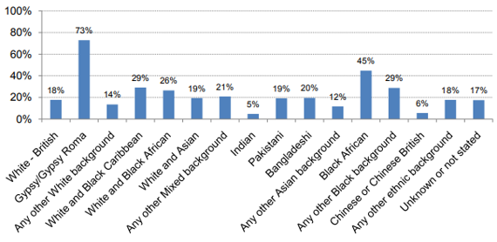
Figure 2: the Percentage of e-FSM pupils across different ethnic groups
(Cook et al., 2014).
However, many of these learners are not e-FSM as their parents are classed as Migrant Workers and therefore do not qualify despite living in the most deprived areas. It is important to note that although pupils may not be e-FSM they may still be exposed to deprivation (Cook et al., 2014). Cook et al. (2014) states that although eligibility for free school meals is the main indicator used in Wales, research shows that there are a number of factors which interact with educational attainment including living in a deprived area. Indeed, Taylor (2017) states that when it comes to deploying funding within a school, many senior leaders identify other children who they feel need this support despite not being classed as e-FSM. Furthermore research has highlighted that many parents who would be eligible to apply for free school meals do not apply either because they are unaware that they are eligible or do not know how to apply. Research in England found that between 17% and 20% of children entitled to free school meals may not be registered (Halse and Ledger, 2007). This calls into question whether e-FSM should be the main factor taken into account when developing educational policies. It could be argued that policies to tackle the attainment gap need to have a broader focus to be able to address the multi-faceted relationship between deprivation and education (Cook et al., 2014). This was highlighted in the interview with the Assistant Head of School X, who felt that e-FSM is not a reliable measure to track the level of deprivation experienced in their context. She said:
“We have our PDG plan, but we are actually more inclusive than that because of the make-up of the deprivation in our school. We tend to put money into an intervention which will raise the level of all learners, not just FSM. FSM is important but it’s not the only indicator.”
(Assistant Head of School X, 2018)
Another challenge faced by School X when looking at deploying PDG funds is the mobility of their pupils. Research has shown that e-FSM and LAC learners are more likely to have moved schools at least once, and School X has the added impact of a high proportion of Roma and Eastern European learners coming and going sometimes several times within a school year. The Assistant Head commented:
“The transiency of our pupils has a massive impact. It links to the funding, for example when we do our PLASC in January, that is what our funding is based on. So everyone on roll on that day in January, that’s what we are basing it on, but if we then get an influx of more learners the funding is completely transient.”
(Assistant Head of School X, 2018)
15% is considered a high level of pupil mobility, and in 2016-17 School X had a mobility rate of 17.8%. The Pupil Level Annual School Census (PLASC) is taken from schools every year in January to calculate the amount of funding each is entitled to (StatsWales, 2018). One challenge for schools with high mobility rates such as School X is that this data is not accurate throughout the year and therefore they may have an influx of learners who are e-FSM after this data has been submitted who will not receive any PDG. The attainment of these pupils will still be reflected in school data and the attainment gap, and therefore these learners need to be supported but schools will have to allocate the funding to accommodate this shortfall.
Although the main focus of this report is to assess the impact School X is having on the attainment gap between e-FSM learners and their n-FSM peers, it is clearly important to consider the work the school is also doing to benefit deprived learners who do not qualify for free school meals.
  - 4.2 Deployment of the PDG
This report will study the deployment of the PDG in line with the main areas for intervention highlighted in the literature.
  - 4.2.1 Whole School Approaches
Leadership
According to Estyn (2012) a school should have a clear vision from leadership which unites staff, students, parents and governors to work towards a clear and distinct goal. In September 2017 School X had a new Head teacher who developed a new vision for the school:
To be the best school in Wales
All learners make progress appropriate to their ability in every lesson, demonstrate mutual respect and positive behaviour for learning.
An inclusive learning community where ambition, belief, determination and resilience underpin the shared common purpose of preparing our learners for a successful future.

Figure 3: School X Vision
This vision clearly demonstrates a belief that the school can have a positive impact on all learners and creates the culture of high expectations that Estyn (2012) and Egan et al. (2014) identified as a key determinant of success for all pupils regardless of their background. This culture encouraged by the leadership team should therefore encourage all learners to succeed regardless of their socioeconomic status.
Teaching and Learning Strategies
School X places a huge importance on the quality of teaching and learning and the impact this can have on attainment. This is evident in the interview with the Assistant Head who said
“high quality teaching and learning will hit more people than anything else, no other strategy that you can put in place is ever going to be as impactful as teaching and learning within the classroom, because if we get that then every child will make progress. We will raise the bar for everyone.”
(Assistant Head of School X, 2018)
Due to this ethos School X focused a large proportion of its’ PDG money on strategies to improve teaching and learning. This includes:
- £64,298 on extra staff deployment in the English and Maths departments in order to reduce class sizes and a further £45,445 on Teaching Assistant support in the English, Maths and Science departments to focus on e-FSM learners as a priority.
- £7,667 on improving the numeracy standards for all learners via extra intervention groups and a more targeted tracking system focusing on specific skills.
(School X School Improvement Plan, 2017)
The Sutton Trusts’ research into the impact of a vast range of teaching and learning strategies found that both reducing class sizes and teaching assistants have a very low impact on attainment but a very high cost. This would suggest that School X is wasting a large proportion of their PDG funding on strategies that are not going to help significantly reduce the attainment gap (Higgins et al. 2012). However, the research carried out by the Sutton Trust focused on the impact these strategies could have on general pupil attainment, rather than focusing on e-FSM and LAC learners and therefore the strategies may have a more significant impact on these learners. Furthermore, the research itself notes that the evidence to suggest Teaching Assistants have low impact is very limited. The real impact of teaching assistants depends heavily on how they are deployed within the classroom (Egan et al., 2014). When discussing these strategies with the Assistant Head, it was clear that the decision to use the funding was based on trying to get the biggest impact with the lowest cost. She stated that the school can employ three support assistants for the cost of one teacher, so they feel they are able to spread the funding across more areas to have the greatest possible impact in this way. Furthermore, she stated that as the school has such a strong focus on teaching and learning there is the expectation that teachers are effectively planning for the support staff in the lesson to be able to have the strongest impact for the target learners. This supports Egan et al.’s (2014) view that if planning is effective then the Teaching Assistant should be able to have a significant positive impact on the learners they support. School X clearly feel that the deployment of Teaching Assistants and the reduction of class sizes has had a positive impact on their attainment gap and, as the Assistant Head stated, the gap is closing.
The Sutton Trust’s research found that small group tuition such as the numeracy intervention groups implemented by School X tend to have a moderate impact on attainment, with pupils having the potential to gain 4 months of additional progress within a school year (Education Endowment Foundation, 2014). It is therefore fair to say that this is a beneficial use of the PDG funding for School X in reducing the attainment gap of e-FSM and LAC learners.
Wellbeing
Egan et al. (2014) also highlighted strategies that promote pupil wellbeing as a positive use of the PDG. School X focuses a large proportion of its’ PDG funding on strategies to promote pupil wellbeing such as:
- £7550 on a breakfast club for e-FSM learners
- £4240 on a reward tracking system
- £19,323 on behaviour support
- £50,050 on improving the attendance of e-FSM learners
Maslow’s Hierarchy of Needs states that if our most basic physiological needs are not satisfied, we are unable to move up the hierarchy to feelings of belonging and increased self-esteem (McLeod, 2007). By providing a breakfast club for e-FSM learners who are more likely to come to school without having had breakfast at home, the learners are able to satisfy this physiological need and are therefore more likely to engage in their learning throughout the day. This is a common and positive use of the PDG funding.
The Sutton Trust found that behaviour interventions have a moderate impact on the attainment of learners (Higgins et al. 2012). Steer (2005) states that in order to enable learning effectively, schools must have a clear and firm strategy in place to help learners manage their own behaviour. As seen in the literature, e-FSM and LAC learners are more likely to become disengaged with school and therefore more likely to engage in negative behaviour. However, by having a clear and consistent behaviour policy learners are able to manage their own behaviour and take a more positive approach to their learning. School X’s strong focus on behaviour for learning is therefore likely to have a positive impact on these learners. Furthermore, providing rewards as well as sanctions allows learners to take pride in their achievements and develop their self-confidence and self-esteem, which was highlighted by Egan et al. (2014) as essential to engage disadvantaged pupils in their learning and positively impact their attainment.
Attendance is a critical factor in the educational attainment of pupils. The literature shows that e-FSM and LAC children are four times more likely to be persistently absent from school further impacting their educational attainment (Welsh Government, 2014). School X has deployed the largest amount of the PDG to focus on this issue in order to overcome this. As discussed in the interview with the Assistant Head, in 2016-17 the School used Schools Challenge Cymru (SCC) funding to employ a member of staff whose sole role was to focus on the attendance of e-FSM learners, which had a positive impact on attendance levels. Now that the SCC funding has stopped the school has lost that member of staff, however still aims to focus on this issue as a priority using PDG funding. If the school is successful in continuing to improve the attendance of their e-FSM learners this will have a knock on effect on attainment and will be a very positive use of the funding.
  - 4.2.2 Family and community engagement
Research has shown that parental engagement is essential in improving the attainment of disadvantaged students. However Estyn (2009) state that this is only possible when the school has effective communication channels with parents. One of the strategies School X has implemented this year as part of the SIP is to provide home visits for Year 11 e-FSM pupils prior to their exams to ensure parents are aware of the process and how best to support their child through this time. This is a new strategy which has started in early 2018 so it is impossible to gauge the impact of this, however this direct engagement between school and parents at such a crucial time in a pupils education should be expected to have a very positive impact on attainment. However, it could be argued that this type of parental engagement should be implemented earlier in a pupils education as research has shown that by the age of 15 e-FSM learners are on average 5 school terms behind, so an intervention at this late stage is unlikely to be able to make as significant an impact as it would in earlier school years (Grigg et al., 2014).
Other than this intervention, School X does not have a clear plan for parental or community engagement. Most contact with parents occurs at annual parent’s evenings, but School X has an average attendance rate of 60% with the vast majority of absent parents being those with e-FSM children. Quigley (2018) states that there are several reasons for this including parents own negative experiences with school causing them to be reluctant to engage, and time constraints due to work or childcare commitments. In order to overcome this schools need to increase the flexibility and scope for parents to positively engage. Research has shown that an effective method for boosting parental engagement is texting parents with key information, as this is viewed as more accessible and less time consuming than an allocated parents evening session (Quigley, 2018). It would be beneficial for School X to look into more flexible and accessible methods for parents to engage in order to have a positive impact on e-FSM learners.

5.0 Conclusion and Recommendations
School X faces a significant challenge in reducing the attainment gap due to its unique and complex cohort. The PDG funding received by the school is heavily focused on teaching and learning strategies in line with the vision of the school, and overall appears to be having a positive impact as the gap has reduced in recent years, and is significantly lower than the Local Authority and Wales average as shown in Figure 4.
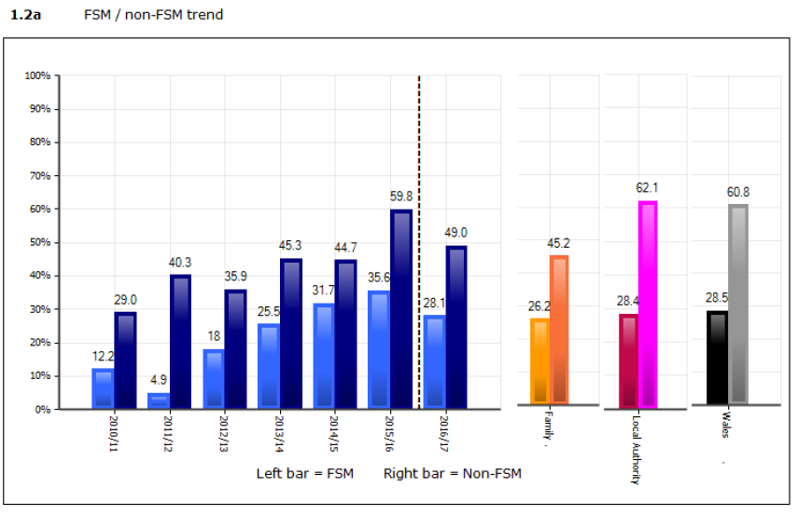
Figure 4 : The attainment gap of School X in relation to the Local Authority, Family and Wales average
(School X Profile, 2018)
However, it is clear when looking at the allocation of the funding and the discussion with the Assistant Head that the focus for School X is not to specifically target e-FSM learners, but to raise attainment for every learner. Very few of the strategies funded by the PDG state that they are specifically targeting groups of e-FSM, but are instead whole school strategies such as the behaviour policy or reduced class sizes which will benefit all learners. This may be due to the fact that the School is aware that a high proportion of its poorest learners are not entitled to e-FSM but still require the additional support, as suggested by Taylor (2017).
Recommendations for continued development
Although School X has had some success in improving the attainment of its most deprived pupils, it is lacking the parental engagement which has been highlighted as potentially the most important factor in raising attainment (Estyn, 2009). It is therefore recommended that School X develops a more accessible method of engagement with parents such as the text messaging strategy highlighted by Quigley (2018).
Also, many of the strategies implemented by School X are difficult to measure accurately, particularly when they are not being focused on a specific group such as e-FSM. It may be beneficial to focus some interventions more specifically on these learners in line with the aims of the PDG funding in order to be able to more accurately track and measure the impact of these strategies.

6.0 References
Ainscow, M., Dyson, A., Goldrick, S. and West, M. (2012). Developing Equitable Education Systems. London: Routledge.
Baker, W. Sammons, P. Siraj-Blatchford, I. Sylva, K. Melhuish, E.C. Taggart, B. (2014) ‘Aspirations, education and inequality in England: insights from the Effective Provision of Pre-school, primary and Secondary Education Project’. Oxford Review of Education, 40, pp. 525-542. [Online], Available at: http://web.b.ebscohost.com/
BBC News (2017) ‘GCSE results gap grows between poorer pupils and classmates’ Available at: http://www.bbc.co.uk/news/uk-wales-41513404 [Accessed 12 April 2018].
BERA, 2011. Ethical Guidelines for Educational Research.
Cook, R., Rutt, S. and Sims, D. (2014). Deprivation in Education. Slough: NFER.
Egan, D. (2012). Communities, Families and Schools Together: A route to reducing the impact of poverty on educational achievement in schools across wales. Cardiff: Save the Children Wales.
Egan, D. (2013). Poverty and Low Educational Achievement in Wales: Student, Family and Community Interventions. York: Joseph Rowntree Foundation.
Egan, D., Saunders, D. and Swaffield, L. (2014). Making Effective Use of the Pupil Deprivation Grant. Cardiff: University of Wales.
Estyn (2009) Good practice in parental involvement in primary schools. Cardiff: Estyn.
Estyn (2012). Effective practice in tackling poverty and disadvantage in schools, Cardiff: Estyn.
Estyn (2013) A report on ‘School X’. Cardiff: Estyn.
Estyn (2014). Pupil Deprivation. Cardiff: Estyn
Grigg, R., Egan, D., McConnon, L. and Swaffield, L. (2014). The Good News….. What Schools in Wales are doing to reduce the impact of poverty on pupils achievement. Centre for Equity in Education. University of Wales & UWTSD.
Halse, J. and Ledger, A. (2007) The use of free school meal status as a proxy for socioeconomic status: Evidence from matching the Longitudinal Study of Young People in England to the National Pupil Database.
MacInnes, T., Aldridge, H., Bushe, S., Kenway, P. and Tinsom, A. (2013). Monitoring Poverty and Social Exclusion 2013. York: Joseph Rowntree Foundation.
McLeod, S. A. (2007). Maslow's Hierarchy of Needs http://www.simplypsychology.org/maslow.html
Ofsted (2012). The Pupil Premium: How schools are using the Pupil Premium funding to raise achievement for disadvantaged pupils. London: Ofsted.
Organisation for Economic Cooperation and Development (2014). Improving Schools in Wales: an OECD Perspective. Paris: OECD.
Quigley, A (2018) A teachers hunt for evidence on… getting students’ parents involved with school. Available at http://www.tes.com/news
Raffeo, C., Dyson, A., Hall, D. and Jones, L. (2007). A review of research on the links between education and poverty. York: Joseph Rowntree Foundation.
Schools Analysis and Research Division, (2009) Deprivation and education: The Evidence on Pupils in England, Foundation Stage to Key Stage 4. London: DCSF
StatsWales (2018) Pupil Level Annual School Census.
Steer, A. (2005). The Report of the Practitioners Group on School Behaviour and Discipline. London: DFES.
Sutton Trust/Education Endowment Foundation (2014). The Sutton Trust/EEF Teaching and Learning Toolkit. London: Education Endowment Foundation.
Taylor, C. (2017) The Reliability of Free School Meal Eligibility as a Measure of Socio-Economic Disadvantage: Evidence from the Millennium Cohort Study in Wales. British Journal of Educational Studies, 66 (1), pp. 29-51. [Online], Available at: http://www.tandfonline.com/ [Accessed 12 April 2018].
UNICEF Innocenti Research Centre (2012) Measuring Child Poverty: New league tables of child poverty in the world’s rich countries’. Florence: UNICEF.
Welsh Government (2011). Welsh Index of Multiple Deprivation 2011: Summary Report. Cardiff: Welsh Government.
Welsh Government (2014). Rewriting the future raising ambition and attainment in Welsh schools, Cardiff: Welsh Government.
Welsh Government (2018). My Local School: ‘School X’. Available at: http://mylocalschool.wales.gov.uk/school

7.0 Appendices
  - 7.1 Research conducted by the Sutton Trust into the impact of teaching and learning strategies
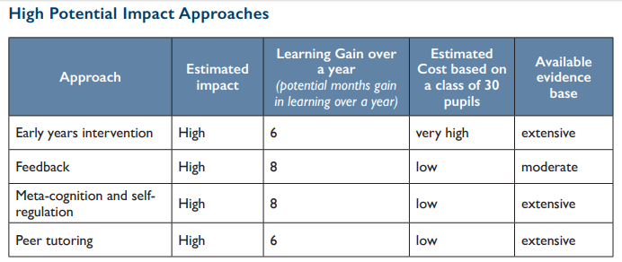
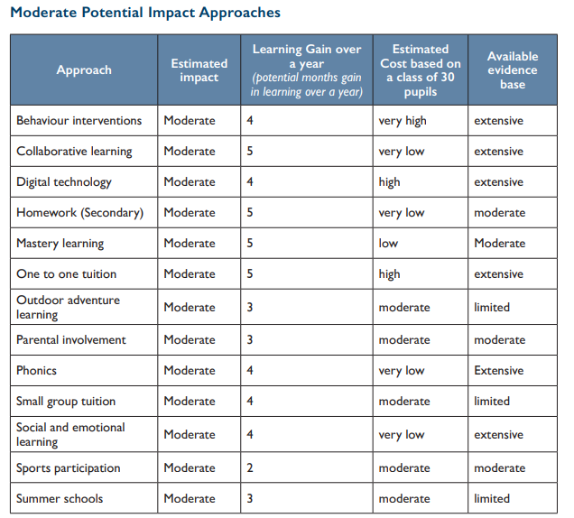
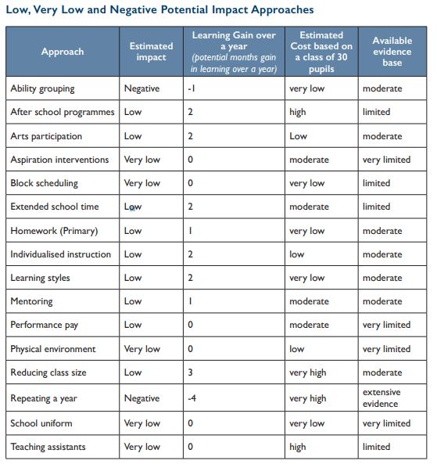
  - 7.2 Transcript of interview with the Assistant Head of School X
Interviewer: What are the current priorities for whole school development?
Respondent: Our main one is improving standards and progress across all key stages, and then obviously the skills. Within that we’ve got groups of learners which includes FSM and LAC learners. If you have a look at our whole school vision which we have recently re-evaluated it talks about all learners making progress appropriate to their ability in every lesson. That vision feeding into high quality teaching and learning will hit more people than anything else, no other strategy that you can put in place is ever going to be as impactful as teaching and learning within the classroom, because if we get that then every child will make progress. We will raise the bar for everyone.
I: Yes, in a lot of the reports I’ve been reading the focus especially for e-FSM kids is that they often lack the literacy and numeracy skills that they need in comparison with n-FSM learners.
R: Absolutely. That’s why one of our key focuses this year is to improve and develop our tracking of skills for all groups of learners, so we can monitor this development. And tracking their attendance as well as that’s another key factor for the attainment gap, e-FSM learners’ attendance on average is lower.
I: One of the things that has been highlighted strongly in the research is the use of e-FSM as the main indicator for deprivation in Wales. For your school context do you feel like that’s an accurate measure of the educational disadvantage in this school?
R: when you talk about groups of learners it’s across lots of different areas. It’s not a reliable measure for tracking the level of deprivation we experience. We’ve got 30.9% of e-FSM, but we also have WAG stages A and B learners and Roma learners who have never been to school before, they are not in receipt of e-FSM because they fall under the category of ‘Migrant workers’, but these are our poorest learners. So we have our PDG plan, but we are actually more inclusive than that because of the makeup of the deprivation in our school so we tend to put money into an intervention which will raise the level of all learners, not just FSM. FSM is important but it’s not the only indicator. It’s interesting actually when you look at England and their Pupil Premium Grant. The way they do it is any child who has been on the FSM register in the last 6 years, because when you’ve got communities like ours where a parent might be in and out of work frequently and they may not always fill in the forms every time it changes, or maybe they don’t know how to fill the form in, or are unable to fill it in, so they may be eligible for FSM but not receiving it. So in England if you were on it 5 years ago you will still be in receipt of the Pupil Premium. And that has a massive impact.
I’ve actually been working on a project looking at our EAL learners and I have looked at our mobility rate. So in London they say they have a high pupil mobility rate and they say 15% is high. Last year we were 17.8%. So we have a really transient cohort which has a big impact on teaching and learning.
I: and how does that impact resource allocation throughout the year?
R: well for example let’s have a look at Year 8. In year 8 we decided we would have 4 forms, because obviously we are in a deficit budget and couldn’t stretch to more than 4 forms, but our PAN (Pupil Allocation Number) is around 200. We aren’t on PAN so we have to accept children but we can’t because we don’t have enough room in the forms for more pupils, and we can’t just magic more teachers to be form tutors. The transiency of our pupils has a massive impact. Also it links to the funding, for example when we do our PLASC in January, that is what our funding is based on. So everyone on roll on that day in January, that’s what we are basing it on, but if we then get an influx of more learners the funding is completely transient. That has a massive impact on everything.
I: So we said as well, more focusing on the teaching and learning side now. We looked at the Level 2 inclusive data from last year, and the gap here between e-FSM and n-FSM is actually smaller than the national average. What sort of strategies have you implemented which you feel has had the most impact?
R: So we had the SCC funding which we used to focus on this. So for example we had a member of staff employed to focus solely on the attendance of e-FSM learners so their attendance improved. We created extra classes in English and Maths to make them smaller. We also have the LSAs in English and Maths who focus on the eFSM learners. So really focused strategies in English and Maths, if you get English and Maths the other three are fairly straight forward. It’s the English and Maths which are the critical. Again, yes they were employed to focus on e-FSM if they had a C/D borderline group we wouldn’t have said ‘you can’t come because you’re not FSM’. Tracking is also a major factor, you do have to look at the tracking and focus on the FSM group. We also had a member of staff with a TLR to focus on FSM to remove barriers for FSM learners. It is a key area we are looking at and our gap is narrowing.
I: Are there any other impacts you can think of which perhaps took place outside of the classroom?
R: One of the biggest impacts we have had for our results, not just for FSM but overall, is not letting them go on study leave. For many of our children they don’t have the home environment conducive to learning and so when they go home they don’t do any work. Not all of them but a large percentage I would say, particularly our FSM learners. So for example last year the last maths exam wasn’t until the end of June so we had learners coming in right up until the last day to get that revision. We give them all a bespoke timetable and get them to come in.
I: you mentioned a lot of these strategies used the SCC funding. What impact has it had not that funding has been removed?
R: You’d have to look for evidence, particularly on attendance. We had to lose the member of staff who focused on attendance of FSM learners, and I think that has had a negative impact. We have been able to keep the LSA’s in English and Maths. But as it’s only half way through the year we can’t measure the direct impact, we will have to wait until the results come out at the end of the year. But I would say there are definitely things that are no longer in place. However saying that all the way through we were trying to future-proof it so that if it was cut we would still be able to keep some interventions in place which we have been able to do. I can’t be sure what the impact is going to be, I think we just have to fill the gaps with other things because we are always focused on the Level 2 inclusive, and any child that is not going to get that whether eFSM or nFSM we are focused on them.
I: Yeah, obviously the cut in funding is bound to have an impact.
R: Yes, well as you know we made redundancies last year in English and Maths so we don’t have the same level of provision as we did, it just isn’t feasible without the funding. We don’t have as many classes now in KS4 but we don’t know what impact that has had yet. The thing is when you put so many interventions in place it is difficult to pin down the different impact of each one.
I: When we looked at the PDG obviously we saw that a lot of our funding goes towards classroom support and LSAs, as a whole school level what is the rationale behind that decision to focus on that and what is the impact of this?
R: it’s about using the money as best we can. Obviously an LSA costs less than a teacher, so it’s about spreading the funding we have to have the biggest impact. It’s about value for money, the biggest impact with the lowest cost so you know, BTA’s and LSAs, we can get three of those for the cost of one teacher. And as I said previously, we have a strong focus on teaching and learning so if we are effectively planning for the support staff to be in the lesson then they can have a huge impact for those target pupils, it’s all about the quality of the planning. Any kind of funding, especially within the current climate you need to assess every single penny, what do we need, how can we have the biggest impact?
I: Great, so one final question. We’ve got the new tracking system in place, SMID. How is the implementation of this system benefit e-FSM learners?
R: I mean it doesn’t matter what tracking system you use. What you need is every single member of staff should know their class. That is at teacher level and it should start there rather than from leadership down. Teachers know their classes and who is on track and who isn’t. The only thing that data shows us is where the gaps are and we can use that information to look at how we can address them. It’s knowing the minute detail of your class, the actual data and the sift data from your relationship with them. That’s an integral part of being a teacher and that has a huge impact on all learners. Yes we have to be mindful of different groups, but actually every child counts.

