Contents:
Part 1- Study Timetable – page 2-4
Part 2- Using AI & Reference List - page 5-10
Part 3- Study Skills Poster - page 11
Part 4 – link to oral prestation also shared with lecture team- page 12

AI acknowledgment
I acknowledge the use of Microsoft 365 Copilot on 19/09/2026 to support my work for part 2 and 3 of the portfolio.
prompt(s):
1. Could you give me points to help with time management as a student and a mother of 3.
2. Find me suggestions for accurate note taking whilst studying for a degree in Early Years Education and Care.
3. Refine responses to 3 clear bullet points.
4. Provide academic resources to support response received.

I confirm that I have not presented any AI generated text as my own work. I confirm I have copies of my drafts, notes, and other resources I used before, and after the use of AI tools which I may be asked to provide in evidence.

Part 1 : Study timetable template
Amser /Time | Llun  Monday | Mawrth  Tuesday | Mercher  Wednesday | Iau  Thursday | Gwener  Friday | Sadwrn  Saturday | Sul  Sunday
00:00 - 00:59 | Sleep | Sleep | Sleep | Sleep | Sleep | Sleep | Sleep
01:00 - 01:59 | Sleep | Sleep | Sleep | Sleep | Sleep | Sleep | Sleep
02:00 - 02:59 | Sleep | Sleep | Sleep | Sleep | Sleep | Sleep | Sleep
03:00 - 03:59 | Sleep | Sleep | Sleep | Sleep | Sleep | Sleep | Sleep
04:00 - 04:59 | Sleep | Sleep | Sleep | Sleep | Sleep | Sleep | Sleep
05:00 - 05:59 | Sleep | Sleep | Sleep | Sleep | Sleep | Sleep | Sleep
06:00 - 06:59 | Morning Routine | Morning Routine | Morning Routine | Morning Routine | Morning Routine | Sleep | Sleep
07:00 - 07:59 | Breakfast with children | Breakfast with children | Breakfast with children | Breakfast with children | Breakfast with children | Morning Routine | Sleep
08:00 - 08:59 | School Drop Off | School Drop off | School Drop Off | School Drop off | School Drop off | Gym | Morning Routine
09:00 - 09:59 | Gym | Work | Work | Work | Shopping with grand mother | Breakfast with children | Breakfast with children
10:00 - 10:59 | Gym | Work | Work | Work | Shopping with grand mother | Shopping | Swimming
11:00 - 11:59 | Shower | Work | Work | Work | Gym | Out with children | Swimming
12:00 - 12:59 | Lunch | Work | Work | Work | Gym | Out with children | Afternoon relax
13:00 - 13:59 | Study (Reading time) | Gym | Gym | Gym | Study (reading) | Out with children | Lunch with family
14:00 - 14:59 | Study (making notes) | Gym | Gym | Gym | Study (making notes) | Family film | Lunch with family
15:00 - 15:59 | School Pick up | School Pick up | School Pick up | School Pick up | School Pick up | Family film | Meal prep
16:00 - 16:59 | Dance | Tea with children | Football | Tea With Children | Gymnastics | Tea with children | Tea with children
17:00 - 17:59 | Uni | Quick change | Tea & Wind down | Wind down | Gymnastics | Wind down | Wind down
18:00 - 18:59 | Uni | Football | Bed Time Routine | Bed Time Routine | Tea & wind down | Bed Time routine | Bed time routine
19:00 - 19:59 | Uni | Put children to bed | Put Children to bed | Put Children to bed | Put children to bed | Put children to bed | Put children to bed
20:00 - 20:59 | Netflix | Go through notes, make a start on assignment | Netflix | Read uni books – make notes of relevant references | Work on Assesment | Work on Assessment | Netflix
21:00 - 21:59 | Wind down | Assignment | Wind down | Wind down | Wind down | Wind down | Wind downs
22:00 - 22:59 | Sleep | Sleep | Sleep | Sleep | Sleep | Sleep | sleep
23:00 - 23:59 | Sleep | Sleep | Sleep | Sleep | Sleep | Sleep | Sleep

Part 2 – Using AI

Microsoft CoPilot was accessed to explore ways to help me with 2 study skills.

Prompt
“I am a Level 4 student studying Early Years in University. Could you give me points on how to manage my time for studying. I have 3 school aged children that attend after school activities 4 days a week. I attend University one evening a week and work 3 days a week.”

Response
“The key is to create small, predictable study blocks that fit around your family routine, and to treat studying like a series of *micro‑tasks* rather than big sessions.
1. Build a Weekly Study Framework (Not a Strict Timetable)
You don’t need a rigid schedule — you need anchors
Try these three anchors each week:
- Anchor 1: One main study session (1–2 hours)
Choose a time when the house is calm:
- After kids’ bedtime
- Early morning before school
- A weekend slot when someone else can take over for an hour
This is where you do reading, writing, or planning.
- Anchor 2: Two mini sessions (20–30 minutes)
- Reviewing lecture notes
- Reading one journal article
- Planning the next paragraph of an assignment
- Anchor 3: One “mobile study” session (10–15 minutes)
Use your phone while waiting at activities or on a lunch break.
- Watch a short video
- Read a summary
- Make bullet‑point notes
- Record a voice memo of ideas
2. Use Micro‑Tasks to Reduce Overwhelm
- Read the brief
- Highlight key verbs
- Find 1 source
- Write 100 words
- Add one reference
- Edit one paragraph
3. Match Tasks to Your Energy Levels
- High energy: reading theory, writing paragraphs
- Medium energy: organising notes, finding sources
- Low energy: watching videos, highlighting, listening to podcasts
4. Use Your Children’s Activity Time Wisely
- Bring one article to read
- Use noise‑cancelling headphones for focus
- Keep a “study bag” ready with notebook, pens, laptop
- Do 20 minutes of focused work while they’re in their activity
- Use the car as a quiet study space if needed
5. Create a Home Study Routine That Doesn’t Disrupt Family Life
- Keep your study materials in one basket or drawer
- Use the same spot each time (your brain learns the cue)
- Tell your kids “Mum is doing her 20‑minute study block”
- Use timers so it feels manageable
- Reward yourself after finishing a block (tea, snack, 5 minutes scrolling)
6. Make Your University Evening Work Harder for You
- Clarify assignment expectations
- Ask lecturers what to prioritise
- Note down 3 actions to complete before next week
- Review your notes within 48 hours (this boosts memory massively)
7. Protect One Day as a “No Study” Day
This prevents burnout and gives your brain space to recover.”

Refined Prompt
“Could you refine to three clear bullet points”
Response
• Create small, consistent study blocks each week. Use one deeper session (1–2 hours) when the house is quiet, plus short 20–30 minute blocks during after‑school activities, lunch breaks, or evenings. This gives you steady progress without overwhelming your routine.

• Break every task into tiny, manageable steps. Turn big jobs into micro‑actions like find one source, write 100 words, or highlight key points. These fit easily around work, parenting, and university evenings.

• Match study tasks to your energy levels. Do heavier work (reading theory, writing paragraphs) when you’re fresh, and lighter tasks (organising notes, watching short videos) during busy or tired moments. This keeps your study time productive and realistic.

Finding Resources
AI Resources
1. Cottrell, S. (2019) The Study Skills Handbook (5th ed.). London: Red Globe Press.
2. McMillan, K. and Weyers, J. (2021) How to Study: A Practical Guide for Students. (2nd ed.). Harlow: Pearson Education
3. Race, P. (2020) The Lecturer’s Toolkit: A Practical Guide to Learning, Teaching and Assessment. (5th ed.). London: Routledge.
Library Search
1. Nathan, D. (2026) ‘7 Time Management Tips for Students’, Prospects. Available at: https://www.prospects.ac.uk/applying-for-university/university-life/7-time-management-tips-for-students
2. Cottrell, S. (2024). The study skills handbook (Sixth edition.). Bloomsbury Academic.
3. Bedford, D., & Wilson, E. (2020). Study skills for foundation degrees (Third edition.). Routledge.

Academic Writing
The student used Microsoft CoPilot to explore two study techniques which were time management and effective note taking.
Co pilot suggested that the best way to improve time management would be to use small study blocks, break all tasks in to small manageable steps and to match study with energy levels (small tasks during low energy and larger tasks during high energy). Through research the student found that Nathan,D. (2026) would agree to “Break larger ambitions into smaller, time-based goals” Nathan, D. (2026) which would help the student fit these tasks into their daily routine. The student researched other ways to help with time management and found that Bedford, D., & Wilson, E. (2020) suggest that planning your week with a simple planner will help avoid spending too much time on meaningless tasks and more time on the tasks needed to complete.
Along with researching time management the student also researched ways to help with note taking. Co Pilot recommended using simple structure, focusing on key points, linking theory to real practice, colour coding, and ending each lecture with a 4-5 sentence summary. Moore, S. (2010) agrees that focusing on key points is the most productive way to take notes ensuring that you only focus on the important points which will make it easier to read over. Studies by Mueller, P.A. and Oppenheimer, D.M. (2014) show that the most effective way to make notes would be by hand rather than typing on a laptop. Cottrell, S. (2024) Agrees with choosing hand written notes as “The physical act of writing helps memory – especially writing by hand rather than typing notes.” Cottrell, S. (2024).

Reflection
In this part of the assignment I used Microsoft Co Pilot to research two study skills that would help a new student in their first year studying at University. I used two prompts to find more information on the two study skills I had chosen, those prompts included tips on time management and effective note taking. The response from Co Pilot was long and not very specific. It was difficult to distinguish specific points from the information provided by Co Pilot due to the length of the response, which led to further prompts to refine and create a more specific response.
The prompt used to refine the response was “could you refine to 3 clear bullet points”. This resulted in a more clear and specific response which made it easier to take on board. Although co pilot was helpful in retrieving information to help with these two study skills, it did take an additional prompt to gain more accessible structure with a clear guide. Once I had sent the additional prompt the information was easier to read and easier to follow.
To help with further study another prompt was used to find academic resources to support the responses for both of the original prompts. Microsoft Co Pilot provided three academic resources for each study skill that were specific to the points raised from the refined prompt. The resources offered were a number of different academic books and university websites which proved very helpful and reliable, some of which were books on the reading list recommended by lecturers. To find more resources that were suitable for my area of study I used the UWTSD library online with Moodle.
The library offered relevant books and resources from the study skills reading list recommended by lecturers. This process proves that Microsoft Co Pilot can be very useful in providing helpful tips and resources for students studying in University which is a great stepping stone for further research to back the advice and resources they provide. However, the library is more reliable and offers more relevant and easy accessible resources. I would recommend using Microsoft Co Pilot to students to begin their research as it can prove to be a great start, however this would have to be followed by further research in libraries or online for reliable resources.

Reference List
Bedford, D., & Wilson, E. (2020). Study skills for foundation degrees (Third edition.). Routledge.
Moore, S. (2010). The ultimate study skills handbook. McGraw-Hill/Open University Press.
Mueller, P., & Oppenheimer, D. (2014). The pen is mightier than the keyboard: Advantages of longhand over laptop note taking (Vol.26)
Nathan, D. (2026) ‘7 Time Management Tips for Students’, Prospects. Available at: https://www.prospects.ac.uk/applying-for-university/university-life/7-time-management-tips-for-students

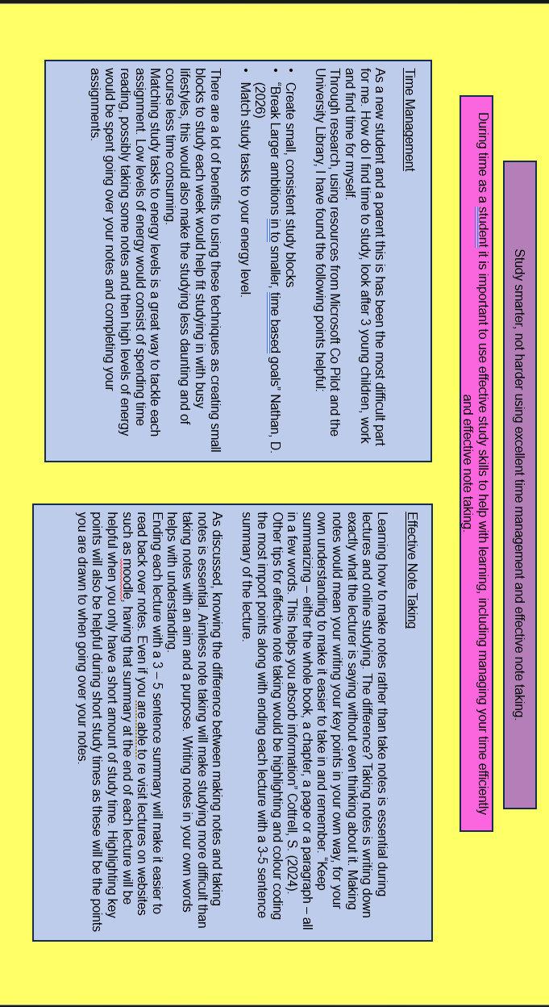

https://1drv.ms/p/c/b715051991921afa/IQA8j21zWwU-SJcLBhqezINfAfJQ7e65bDv6Z0LkWm4v9aU?e=RndTFm

