

RESULT

BACHELORS DEGREE ASSIGNMENT SPECIFICATION

Student name: |  | Student P number:
Programme: | Cert HE STEM
Module: | Manufacturing and Materials | Module Level (4, 5, 6): | 0
Module code: | M4X01511 | Contribution to Overall  Module Assessment (%): | 50
Lecturer: | Andrew Tibbott | Internal Verifier: | Greg Owen
Assignment Title: | Bike frame manufacture | Assignment No (x of x): | 2 of 2
Hand Out Date: | 20/03/2018 | Submission deadline: | 01/05/2018
Referencing: | In the main body of your submission you must give credit to authors on whose research your work is based. Append to your submission a reference list that indicates the books, articles, etc. that you have read or quoted in order to complete this assignment (e.g. for books: surname of author and initials, year of publication, title of book, edition, publisher: place of publication).
Disclosure: | I declare that this assignment is all my own work and that I have acknowledged all materials used from the published or unpublished works of other people. All references have been duly cited.
Student’s Signature: | Assignments will not be accepted without a signature here | Date:
Turnitin: Lecturer to tick to indicate if an electronic version of the assignment must be submitted to Turnitin. Note: the Turnitin version is the primary submission and acts as a receipt for the student. Penalties for late submission: Up to four weeks late, maximum mark of 40%. Over four weeks late, Refer. Only Year Tutors and the Programme Director may grant an extension. | YES
 | NO

Learning Outcomes tested  (from module syllabus) | Assessment Criteria To achieve each outcome a student must demonstrate the ability to:
Demonstrate an understanding of material properties and selection.  Demonstrate an understanding of manufacturing processes and selection. | Comparison of possible materials for the production of a bike frame. Using sound academic research to choose the most suitable giving clear reasons for the choice.  Comparison of possible production methods using the chosen material. Using sound academic research to choose the most suitable giving clear reasons for the choice

- DO NOT put this form into Turnitin or it will match many similarities with other students’ submissions.
TASK DESCRIPTION

This task requires you to compare differing materials and manufacturing methods that could be used to produce the bike frame shown.

GUIDANCE FOR Students IN THE COMPLETION OF TASKS

Research suitable materials and associated manufacturing methods for the bike frame shown below.

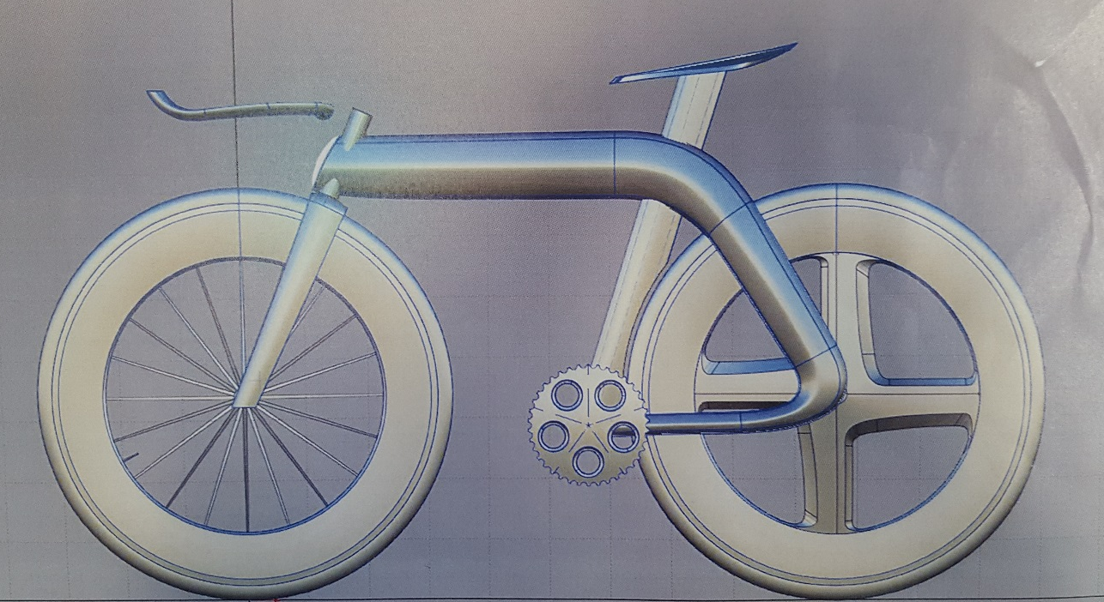

Your report should include;-

- An overview of possible materials for the frame, clearly stating the pros and cons of each material listed. (400 words)
- A final material choice. This should be selected based on sound academic research, clearly stating the reasons for your choice. (600 words)
- An overview of possible manufacturing methods using the material chosen, clearly stating the pros and cons of each process listed. (400 words)
- A final manufacturing process choice. This should be selected based on sound academic research, clearly stating the reasons for your choice. (600 words)

Structural Section marking criteria and Student FEEDBACK

This section details the assessment criteria. The extent to which these are demonstrated by you determines your mark. The marks available for each criterion are shown. Lecturers will use the space provided to comment on the achievement of the task(s), including those areas in which you have performed well and areas that would benefit from development/improvement.

Common Assessment Criteria Applied | Marks available | Marks  awarded
1. Research-informed Literature
Extent of research and/or own reading, selection of credible sources, application of appropriate referencing conventions.
 | 30
2. Knowledge and Understanding of Subject
Extent of knowledge and understanding of concepts and underlying principles associated with the discipline.
 | 30
3. Analysis
Analysis, evaluation and synthesis; logic, argument and judgement; analytical reflection; organisation of ideas and evidence
 | 15
4. Practical Application and Deployment
Deployment of methods, materials, tools and techniques; application of concepts; formulation of innovative and creative solutions to solve problems.
 | 15
5. Skills for Professional Practice
Attributes in professional practice: individual and collaborative working; deployment of appropriate media; presentation and organisation.
 | 10

Assignment Mark Overall (Assessment marks are subject to ratification at the Exam Board. These comments and marks are to give feedback on module work and are for guidance only until they are confirmed. ) | Late Submission Penalties (tick if appropriate) |  | %
 | Up to one-week late |  | %
 | Over one week late |  | %

Student Self Evaluation Form
Student name: |  | Student P number:
Programme: |  | Year of programme
Assignment Title:

This section repeats in brief the common assessment criteria detailed on previous pages. The extent to which these are demonstrated by you determines your mark. Using these criteria, tick the box that best indicates the level of achievement you feel you have achieved with regard to each of them.

Common Assessment Criteria Applied | Level of Achievement
Common Assessment Criteria Applied | REFER |  |  | 3rd |  | 2:2 |  | 2:1 | 1st | 1st
 | OUTRIGHT FAIL | UNSATISFACTORY | SATISFACTORY |  | GOOD |  | VERY GOOD |  | EXCELLENT | EXCEPTIONAL
1. Question Paper | 0-29% | 30-39% | 40-49% |  | 50-59% |  | 60-69% |  | 70-79% | 80-100%
2. Apparatus and Method | 0-29% | 30-39% | 40-49% |  | 50-59% |  | 60-69% |  | 70-79% | 80-100%
3. Results and Analysis | 0-29% | 30-39% | 40-49% |  | 50-59% |  | 60-69% |  | 70-79% | 80-100%
4. Practical Application and Deployment | 0-29% | 30-39% | 40-49% |  | 50-59% |  | 60-69% |  | 70-79% | 80-100%

PLEASE COMMENT ON AREAS IN WHICH YOU FEEL THAT YOU HAVE PERFORMED WELL | PLEASE COMMENT ON AREAS you feel that you need TO DEVELOP

Student’s Name |  | Date
Student’s Signature

