


RESUME
PERSONAL

Student’s Name：Songtao Fang
Student ID number:2304106
Lecturer:Gwyneth Jones
Module:International Business Communication
Module code:BMBM6021

Tradition and Individualism: Cross-cultural Business Communication in Britain and the United States

Executive Summary
This paper explores the importance of cross-cultural business communication in the UK and the US, with a particular focus on the role of effective communication in international business and the linguistic and cultural differences between the UK and the US. The paper first emphasizes that in the context of globalization, successful business communication is crucial to the success of an organization. In international business, Britain and the United States are two important business partners. Cross-cultural communication faces many challenges and requires deep understanding and adaptation.

In discussing language and cultural differences, we focus on the differences between high-context societies and low-context societies, exploring the misunderstandings and challenges that may arise in the Anglo-American business environment. As a high-context society, the UK emphasizes the importance of non-verbal speech and context, while the United States pays more attention to direct and clear expression. These differences can lead to miscommunication, misunderstandings, and difficulties in business negotiations.

After analyzing these differences, this article further explores the challenges faced by British and American cross-cultural business communication. These challenges include cultural sensitivities, different business etiquette and customs, and the use and interpretation of language. Understanding and addressing these challenges is critical to building strong business relationships.

Finally, this paper puts forward some suggestions to improve the effectiveness of British and American cross-cultural business communication. Recommendations include strengthening cross-cultural training, using professional translation services, adopting clear and direct expressions, and recommending focusing on the understanding of non-verbal signals in business communications. By taking these measures, companies can better adapt to cross-cultural environments, improve communication efficiency, and strengthen cooperative relationships.

Contents

Executive Summary 2
Contents 3
1 Introduction 4
2 Research Model: High Context and Low Context 5
3 British and America 6
4 Challenges and Solutions 9
5 Conclusion 10
6 Reference 11

1 Introduction

Effective communication is crucial to successful business interactions, especially in today's globalized world. However, when engaging in cross-cultural communication, it is important to recognize and overcome the differences that exist between countries (Tse et al., 1988). This article focuses on how cultural and language differences between the UK and the US can hinder business communication and how we can overcome these obstacles.

The UK and the US are both English-speaking countries, share a common language, and have close and complex national and historical ties. However, there are also differences in vocabulary, spelling, idioms and cultural norms between the two countries that cannot be ignored, and will seriously affect cross-cultural communication. This article uses the two concepts of tradition and individualism as analytical clues, and uses the high context and low context proposed by Hall (1976) as the theoretical model to explore the unique characteristics and challenges of business communication between these two countries.

The United Kingdom and the United States have two different cultural models, which are reflected in their respective language and behavioral habits, and will have different effects on how people interact. On the one hand, Britain is known for its rich historical traditions and hierarchical social structure, which affects business interactions. The British value proper etiquette, politeness and a sense of formality in professional situations. Understanding and adhering to these cultural differences is critical to establishing rapport and building trust in business relationships (CGC, 2022). The United States, on the other hand, prides itself on its individualistic culture, which places a high value on personal achievement and independence. American business communication tends to be more direct, informal, and results-oriented. Informal greetings, open discussions, and a focus on efficiency are common in the American business environment (CGC, 2022).

In the following sections, we will examine specific areas of linguistic and cultural differences between the two countries, such as vocabulary differences, spelling changes, idiomatic expressions, and communication styles. First, I will draw on existing literature to outline the differences between high-context societies and low-context societies, using this as a theoretical model for subsequent analysis. Next, I will introduce British and American society and culture, highlighting the differences between the two. Finally, through some case discussions, I will point out how cultural differences hinder cross-cultural business communication between the United Kingdom and the United States, and propose some practical solutions. Through this exploration, we hope to provide insights for individuals engaged in cross-cultural business interactions between the United Kingdom and the United States. and organizations provide valuable insights.

2 Research Model: High Context and Low Context

Hall proposed the two concepts of "high-context culture" and "low-context culture" in his book "Beyond Culture", and reiterated the analytical effectiveness of this pair of categories in many subsequent papers. Simply put, various cultures are divided into high-context cultures and low-context cultures based on their dependence on the context in which information is disseminated. The culture with a higher degree of dependence is a high-context culture.

In a high-context culture, most information exists in the material-cultural context and is internalized deep in the communicator's thinking and memory. In other words, the encoding and dissemination of information depend on the sociocultural environment and the specific situation in which the communicator finds himself. In this environment, communication between people is ambiguous because information is not conveyed based on clear language, but is understood through some subtle clues. Clear language will lose a lot of culturally specific information. In contrast, in low-context cultures, when people communicate, they carry a lot of information through explicit, direct encoding. In other words, both parties in a low-context culture are accustomed to communicating through the power of language itself (Hall, 1976). Of course, this pairing of opposite categories are only two ideal types in Weber's sense, since no clear boundary can be discerned between high context and low context. In fact, some research shows that in actual communication, these two types of communication may coexist (Yang et al., 2021).

The two cultural models of high context and low context have given rise to two different social communication models, and we can observe obvious differences between the two. In high-context societies, communication relies heavily on nonverbal cues, implicit meanings, and shared cultural knowledge. This knowledge is largely hidden in cultural traditions and is therefore highly related to information such as rituals and identities embedded in socio-historical contexts. Thus, people in high-context cultures prioritize relationships, harmony, and group well-being over individual achievement (Croucher et al., 2012). This type of communication is often indirect, relying on gestures, body language, and context to convey meaning. Therefore, the communication patterns in high-context cultures develop themselves into many expression habits that people must rely on to communicate appropriately. Convey your thoughts. Therefore, high-context societies rely strongly on shared cultural norms and values. In contrast, in low-context societies, communication is more explicit, direct, and relies heavily on verbal communication. People in low-context cultures separate their personal relationships, work, and daily life and expect detailed and clear information in their interactions. People do not rely on non-verbal cues or shared cultural knowledge to communicate, so people's communication patterns do not rely on cultural traditions and social structures, but are more about personal style based on the pursuit of efficiency and clarity (Hofstede, 2008).

Therefore, the differences between high-context and low-context societies can be split into two dimensions. The first dimension is individualism and collectivism, which is Hofstede's complement to Hall (Hofstede, 2008). The second dimension is traditional culture and modern culture. The former emphasizes the concepts, discourse and behavioral norms carried by a community as a community with a common history and memory. People in the community are encouraged to follow these norms. To carry out interactions, the latter pursues the simplicity and efficiency of industrialization and simplifies many specific rituals with the goal of communication efficiency.

Next, I will analyze the differences in communication patterns between the United States and the United Kingdom based on this more refined high/low context theory, and discuss challenges and solutions for business communication.

3 British and America

Due to limited space, I cannot present here all the differences between the UK and the US. The basic point I hope to argue is that Britain is a relatively high-context society, while the United States has a lower-context culture. Therefore, I discuss the UK and the US separately along the two dimensions analyzed in the previous section.

The first is the dimension of traditional culture and modern culture. In this dimension, Britain is more "traditional" than the United States, which can be supported by following facts.

Social Structure: Historically, Britain has had a class system, headed by the "upper classes" and the "nobles." These are high-ranking aristocrats with hereditary titles, wealth, and privileges. The next classes are called the "middle class" and the "working class." Traditionally, the working class defined itself as hard-working, without social privileges, and born into a family that relied on unskilled labor. The difference between the two classes is more obvious in terms of education. Historically, the working class has been less likely to obtain higher education. Those who belong to the middle class are considered "white collar" workers, live in privately owned suburban homes, and have access to higher education (CGC, 2022). This social and cultural class distinction has allowed Britain to retain a relatively complete traditional culture, which is still influential today. In contrast, America is not a class-based society. The premise of the American Dream is that anyone from any background can achieve any goal. Despite the fact that some inequalities still exist, American culture is indeed world-renowned for its diversity and tolerance. The United States receives a large number of immigrants from different cultural and economic backgrounds every year, which brings strong cultural mobility and internal cultural differences to this land (CGC, 2022). Therefore, for the United States, universal traditional culture is an almost non-existent concept.

Language: The style of language used in the UK is more traditional, characterized by the retention of many colloquial sayings and proverbs, and a relatively fixed style. Understanding British-style language requires the listener to have a good understanding of local culture and history (Scott, 2000). The American style of using English is exactly the opposite. Studies have shown that Americans pursue efficiency and conciseness in their use of English, so they produce many abbreviated and colloquial uses, which are uncommon in the UK (Famworld, 2022). At the same time, Americans' use of language also depends on personal style because of the strong cultural diversity in the United States (Scott, 2000).

The second dimension is individualism and collectivism. It is not difficult to imagine that Britain is closer to collectivism than the United States on this dimension. This is partly determined by the previous dimension: British culture relies strongly on a shared community history, so people have a stronger sense of belonging to the community. In the United States, this unified national culture does not exist. People come from different backgrounds. This is why the American dream came about, in which everyone can pursue their dreams through personal struggle. Differences in this dimension shape the different value systems of Americans and British people.

After the above analysis, it can be determined that the United States is closer to a low-context society than the United Kingdom. In fact, this conclusion is supported by empirical research (Kim et al., 1998). At the same time, The Business Culture Complexity Index published by CGC also supports this point (CGC, 2022). The UK's score is lower than that of the United States, indicating that it is more difficult to enter the British culture for business communication than the United States. This reflects the British culture's emphasis on the local context.

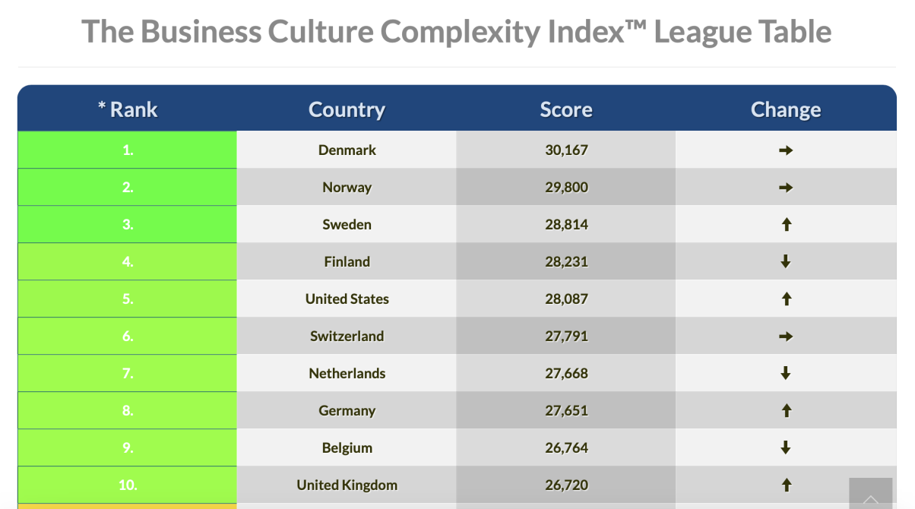
Figure 1: The Business Culture Complexity Index Table (CGC, 2022)

4 Challenges and Solutions

The challenges of business communication are different in high/low context societies. Next, I illustrate the importance and difficulties of cross-cultural business communication through case analysis in two scenarios, and tentatively provide solutions.

The first scenario is collaborative work. A qualitative study of British and Italian business transactions illustrates the challenges faced by workers unfamiliar with the local culture entering a high-context society. In the study, Indians, as non-native English speakers, cooperated with British people in business. However, due to Indians' lack of cross-cultural communication awareness, they did not actively adapt to the language system and behavioral norms used by the British at work, which resulted in many misunderstandings (Incelli, 2013). This can be said to reflect the conflict between traditional and modern styles. Therefore, it is necessary for people from low-context cultures to proactively understand the characteristics of high-context cultures. For example, researchers have proposed that corpus technology can be used to mine discourse patterns in business activities in high-context societies such as the United Kingdom, thereby helping to break cultural barriers (Incelli, 2013). On the other hand, when workers from high-context cultures communicate with countries with lower cultural complexity, such as India and the United States, they can appropriately make their expressions more popular and clear to reduce the probability of misunderstandings.

The second scenario is about the management of multinational companies. A study on Cao Dewang opening and managing a company in the United States pointed out that the reason why Cao Dewang failed at the beginning was because he did not realize that the American workers he managed came from a low-context society that focused more on individual struggle. In the United States, people generally believe that individuals can reap rewards through hard work and that everyone has individual differences. However, the Chinese entrepreneurs represented by Cao Dewang tend to arrange employees across the board and create a unified corporate culture. Therefore, when operating multinational companies, managers should consider local values to formulate management strategies. For example, when a manager from a high-context society, such as the UK, enters a low-context society, such as the US, to manage a company, he or she may consider creating a flatter company, making the systems as simple as possible, while ensuring that each employee has a freer atmosphere in which to work. However, this management strategy may be ineffective for high-context societies; instead, creating and maintaining a company culture is important in high-context societies such as the UK and Japan.

Of course, even in high-context societies, embracing low-context cultures is an option worth considering for some businesses such as technology companies that seek to innovate and export. Such companies need efficient decision-making and flexible cross-functional collaboration to achieve technological innovation, agile development and rapid marketing (Kittipoomwong et al., 2023). At the same time, these businesses may accept a large number of employees from multicultural backgrounds. In this case, managing according to a more traditional high-context social style may result in a lot of misunderstandings.

5 Conclusion

In this article, I reinterpret the concept of context proposed by Hall through the two dimensions of tradition-modernity and individualism-collectivism, and analyze the United States and Britain based on this. But it must be noted that the differences I analyze between the United States and the United Kingdom are not absolute. On the contrary, some research shows that the differences between the United Kingdom and the United States are not as big as people think. For example, the individualism prevalent in the United States also exists in the United Kingdom (Sun et al., 2004), and America's individualistic tendencies are not as strong as traditionally believed (Takano et al., 2018). At the same time, there is evidence that the younger generation in the UK is beginning to gravitate towards modernizing American culture (CGC, 2022). So as a conclusion, the most important principle in business communication is still flexibility.

6 Reference

Commisceo Global Consulting Ltd (CGC). (2022). UK Guide. Retrieved from https://www.commisceo-global.com/resources/country-guides/uk-guide?highlight=WyJicml0aXNoIiwiJ2JyaXRpc2giXQ==

Commisceo Global Consulting Ltd (CGC). (2022). USA Guide. Retrieved from https://www.commisceo-global.com/resources/country-guides/usa-guide

Commisceo Global Consulting Ltd (CGC). (2022). The Business Culture Complexity Index™. Retrieved from https://www.commisceo-global.com/resources/bcci

Croucher, S. M., Bruno, A., McGrath, P., Adams, C., McGahan, C., & Suits, A. (2012). Conflict Styles and High-Low Context Cultures: A Cross-Cultural Extension. International Journal of Intercultural Relations, 36(1), 64-73. https://doi.org/10.1080/08824096.2011.640093

Famworld. (2022, June 11).[Differences between British and American English]. Retrieved from https://famworld.com/zh/blogs/diferencias-entre-el-ingles-en-gran-bretana-y-estados-unidos

Hall, E. T. (1976). Beyond culture. New York: Anchor Press-Doubleday.

Hofstede, G. (2008). A summary of my ideas about national culture. Retrieved from http://feweb.uvt.nl/center/hofstede/page3.htm.

Incelli, E. (2013). Managing discourse in intercultural business email interactions: a case study of a British and Italian business transaction. Journal of Multilingual and Multicultural Development, 34(6), 515-532. https://doi.org/10.1080/01434632.2013.807270

Kim, D., Pan, Y., & Park, H. S. (1998). High-versus low-context culture: A comparison of Chinese, Korean, and American cultures. Psychology & Marketing, 15(6), 507.

Kittipoomwong, P., & Salamzadeh, Y. (2023). Business Continuity and Strategic Resilience in High-Context Cultures: A Case of an Asian Insurance. Journal of Entrepreneurship and Business Resilience, 6(1), 45-65. ISSN 2956-0721.

Scott, J. C. (2000). Differences in American and British Vocabulary: Implications for International Business Communication. Business and Professional Communication Quarterly, 63(4). https://doi.org/10.1177/108056990006300403

Sun, T., Horn, M., & Merritt, D. (2004). Values and lifestyles of individualists and collectivists: A study on Chinese, Japanese, British, and US consumers. Journal of Consumer Marketing, ISSN: 0736-3761, 21(4), 318-331.

Takano, Y., & Osaka, E. (2018). Comparing Japan and the United States on individualism/collectivism: A follow-up review. Asian Journal of Social Psychology. Retrieved from Wiley Online Library.

Tse, D. K., Lee, K., Vertinsky, I., & Wehrung, D. A. (1988). Does culture matter? A cross-cultural study of executives' choice, decisiveness, and risk adjustment in international marketing. Journal of Marketing. Retrieved from https://journals.sagepub.com/doi/abs/10.1177/002224298804200408

Yang, J., & Chen, K. (2023). To De-exoticize Chinese Stereotypes: US-Sino Communication in American Factory. Critical Arts: South-North Cultural and Media Studies. Advance online publication. https://doi.org/10.1080/02560046.2023.2277294

Yang, X., Hou, J., & Arth, Z. W. (2021). Communicating in a proper way: How people from high-/low-context culture choose their media for communication. International Communication Research Journal. Retrieved from https://journals.sagepub.com/doi/abs/10.1177/10776990211003429

