

Project planning

Student Name: Megan Gwilym
Student ID: 2200683
Course Title: Engineering Management
Course Code: ACHA5012
Instructor’s Name: Mark Sandford

Date of Submission: 17th November 2024

Contents
1.1Introduction 3
2.1 Group individual tasks 4
2.1.1 Members and roles 4
2.1.2 Authors (Megan Gwilym) tasks 4
3.1 General group tasks 5
3.1.1 Personal tasks 6
4.1 Bills of materials 7
4.1.1 Specialized equipment 7
5.1 Milestones & Gateways 9
5.1.1 Authors Milestones & Gateways 9
6.1 GANTT chart 11
6.1.1 Overall Group GANTT chart 11
7.1 Areas of concern 13
8.1 Conclusion 14
9.1 Reference 15

1.1Introduction
This project plan provides a comprehensive outline for the improvement and optimization of the NSF250 motorcycle. Covering all key tasks, milestones, and areas of concern over a three-semester period. The plan is designed to guide the team systematically through each phase, from initial research and development to prototype testing and final track performance assessments.
Each milestone is strategically placed to ensure that progress is measurable, achievable, and aligns with both performance and project deadlines. By organizing tasks, defining roles, and establishing checkpoints for quality and safety, this plan aims to ensure that the NSF250 meets all targeted standards, setting the foundation for a successful outcome.

2.1 Group individual tasks

2.1.1 Members and roles
- Oska Robertson – rear set
- Harry Rogers – yokes, adjustable rear suspension
- Aaran Lilly – Fuel tank
- Edward Walden – Airbox
- Jake Davies – intake
- Harvey Merrett – Front fairing
- Olly Gillson – Fueling maps/engine strategies, secondary injector and bell mouth
- Megan Gwilym-Alternative fuels

2.1.2 Authors (Megan Gwilym) tasks
- Understanding of alternative fuels and calculations.
- Chemistry and Combustion – 3rd year lecture.
- Fuel regulations – discussing what fuel we can use for racing.
- Fuel blending – 3rd year lecture.
- Fuel ratio.
- Fuel cost.
- Fuel calculator.
- Alternative fuel testing.
- Monitoring and adjustments.

According to ‘Belbin’s’ model, there are nine primary role characteristics that can be associated with individual members of a team. i.e. Plant, Resource Investigator, Coordinator, Shaper, Evaluator, Implementer, Finisher, Team worker and Specialist.
Reading through the individual outlines it is concluded that the author has characteristics that straddle two distinct groups within the model.
- Implementer - Disciplined, organised and dependable, Implementers have a knack for turning abstract ideas into concrete actionable plans. Their systematic and task-oriented approach is essential for moving the work of the team forward strategically. (Indeed, 2022).
However, Implementers may be less flexible and adaptable to change than other team members and require persuasion to adapt their approach.

- Shaper - A dynamic team-member who loves a challenge and thrives on pressure. This member possesses the drive and courage required to overcome obstacles, seeks patterns in group work; pushes the group toward agreement and decisions; challenges others. (Indeed, 2022).
Belbin’s team role model categorizes people into specific roles within the team simplifying individuals by assigning them to one dominant role based on specific personality traits. However, in real-life situations, people often exhibit a combination of overlapping traits and can shift roles depending on the team’s needs.
Belbin’s model, which can seem too rigid by categorizing individuals into static roles rather than recognizing the dynamic and multi-dimensional nature of personalities within teams, it may not fully address the complexity of individual strengths and how they interact in diverse situations.

3.1 General group tasks
Name | Task | Duration (days) | Start date | End date
Olly | Install & Test new ECU | 31 | 30/9/2024 | 31/10/2024
Olly | Optimize fueling maps & strategies | 30 | 31/10/2024 | 30/11/2024
Olly | Bellmouth/Secondary injector RD&T | 123 | 30/9/2024 | 31/1/2025
Olly | Design & Prototypes | 92 | 15/10/2024 | 15/1/2025
Olly | CFD Bellmouth Designs | 30 | 15/1/2025 | 14/2/2025
Olly | Production | 28 | 14/2/2025 | 14/3/2025
Olly | Dyno runs. | 58 | 1/1/2025 | 28/2/2025
Oska | Initial Measurements. | 15 | 15/10/2025 | 15/10/2024
Oska | First design & prototype | 31 | 15/11/2024 | 15/11/2024
Oska | Design Refinement | 92 | 15/1/2025 | 15/1/2025
Oska | Final Testing | 30 | 14/2/2025 | 14/2/2025
Oska | Production | 28 | 14/3/2025 | 14/3/2025
Harry | Initial measurements | 15 | 30/9/2024 | 15/10/2024
Harry | First design & prototype | 31 | 15/10/2024 | 15/11/2024
Harry | Design refinement | 92 | 15/10/2024 | 15/1/2025
Harry | Final testing | 30 | 15/1/2025 | 14/2/2025
Harry | Production | 28 | 14/2/2025 | 14/3/2025
Jake | Initial measurements | 15 | 30/9/2024 | 15/10/2024
Jake | First design & prototype | 31 | 15/10/2024 | 15/1/2024
Jake | Design refinement | 92 | 15/10/2024 | 15/1/2025
Jake | Final testing | 30 | 15/1/2025 | 14/2/2025
Jake | Production | 28 | 14/2/2025 | 14/3/2025
Harvey | Initial measurements | 15 | 30/9/2024 | 15/10/2024
Harvey | 3D scans | 92 | 30/9/2024 | 31/21/2024
Harvey | First design & prototype | 31 | 15/10/2024 | 15/11/2024
Harvey | Design refinement | 92 | 15/10/2024 | 15/1/2025
Harvey | Final testing | 30 | 15/1/2025 | 14/2/2025
Harvey | Production | 28 | 14/2/2025 | 14/3/2025
Megan | Research alternative fuels | 123 | 30/9/2024 | 31/1/2025
Megan | Research secondary injector | 123 | 30/9/2024 | 31/1/2025
Megan | Check Championship Regulations | 15 | 30/9/2024 | 15/10/2024
Megan | Dyno runs | 58 | 1/1/2025 | 28/2/2025
Edward | Retrieve CAD drawings | 15 | 30/9/2024 | 15/10/2024
Edward | Update designs | 31 | 15/11/2024 | 15/11/2024
Edward | Prototyping | 92 | 15/1/2025 | 15/1/2025
Edward | Design refinement | 92 | 15/1/2025 | 15/1/2025
Edward | Final testing | 30 | 15/1/2025 | 14/2/2025
Edward | Production | 28 | 14/2/2025 | 14/3/2025

3.1.1 Personal tasks
This is a more detailed table of the Authors’ tasks:
Task | Description | Hours | Start | Finish
Overall
Research:
Understanding alternative fuels and calculations | Individual research with a goal of basic knowledge. | 2 | 06/10/2024 | 06/10/2024
Chemistry and Combustion | Attending 3rd year lecture. | 2 | 16/10/2024 | 16/10/2024
Fuel regulations | Checking regulations at race events. | 1 | 23/10/2024 | 24/10/2024
Fuel blending | Attending 3rd year lecture and individual research. | 2 | 25/10/2024 | 27/10/2024
Secondary injector | Research | 5 | 25/11/2024 | 5/12/2024
Analysis:
Fuel calculator | Research into the alternative fuels to use. | 3 | 25/10/2024 | 27/10/2024
Fuel air ratio | Chosen fuels, calculate the ratio. | 4 | 26/10/2024 | 27/10/2024
Fuel cost | Total for the fuel taken on race events. | 1 | 27/10/2024 | 28/10/2024
Practical work:
Alternative fuel testing | Testing the alternative fuels and blend tests. | 5 | 15/11/2024 | 20/11/2024

4.1 Bills of materials
For racing events requiring 20 Liters of fuel:
Fuel | Price per Liter | X20 | Total
SUSTAIN classic racing 50 | £5.24 | 5.24 X 20 | £104.80
SUSTAIN Racing moto 40 | £5.25 | 5.25 X 20 | £105
SUSTAIN classic supper 80 | £4.65 | 4.65 X 20 | £93
SUSTAIN 100 98RON E10 | £5.24 | 5.24 X 20 | £104.80

If filling a regular road vehicle with 20 Liters of conventional petrol costs approximately £140, which is the fuel used by the team now. Alternative fuels like SUSTAIN Racing 50 could offer substantial savings, with prices ranging from around £90 to £105 for the same volume. These alternative fuels are not only designed to provide high performance but also incorporate renewable components that reduce the carbon footprint, making them a more sustainable option.

4.1.1 Specialized equipment
Choosing alternative fuels, such as biofuels, hydrogen, or synthetic fuels, can be a better choice for reducing environmental impact and reliance on fossil fuels. These fuels often emit fewer greenhouse gases, which helps combat climate change and improve air quality.
SUSTAIN Fuels are a line of advanced environmentally friendly fuel blends developed by the British company Coryton to reduce the carbon footprint of transportation and motorsport. Coryton developed these fuels with a focus on reducing CO₂ emissions and minimizing reliance on fossil fuels, all while maintaining high-performance standards essential in racing. (ASPEN group, 2024).
SUSTAIN Racing fuels are created using second-generation biofuels derived from agricultural waste (farming waste), along with e-fuels, which utilize carbon captured from the atmosphere. This combination enables significant reductions in greenhouse gas emissions without sacrificing the power output crucial for motorsports.

- SUSTAIN classic racing 50 = £5.24 per liter
SUSTAIN Classic Racing 50, is a sustainable fuel that's made from 50% renewable ingredients including agricultural waste. It is designed for competition drivers and is intended to reduce greenhouse gas emissions by at least 65% compared to fossil fuels. (ASPEN group, 2024).

- SUSTAIN Racing moto 40 = £5.25 per liter
SUSTAIN Racing Moto 40 fuel is a sustainable, high-performance fuel specifically formulated for motorcycle racing. (ASPEN group, 2024). Developed to reduce environmental impact, this fuel blend often includes biofuels or renewable additives, aiming to lower carbon emissions while maintaining top-tier engine performance.
The focus of SUSTAIN Racing Moto 40 Fuel is to provide a cleaner, more eco-friendly alternative to traditional racing fuels, catering to racers who prioritize sustainability without sacrificing speed and power.
- SUSTAIN classic supper 80 = £4.65 per liter
SUSTAIN Classic Super 80 Fuel is a premium, eco-conscious fuel designed for classic or vintage-style engines, often found in older or retro-styled motorcycles. (ASPEN group, 2024). This fuel blend likely incorporates renewable resources or advanced additives that reduce emissions while preserving engine performance tailored to older models.

- SUSTAIN 100 98RON E10 = £5.24 per liter
SUSTAIN 100 98RON E10 Fuel is a high-octane, sustainable fuel blend with a 98 RON (Research Octane Number) rating and 10% ethanol content (E10). This fuel is designed to deliver excellent performance for high-compression engines, often found in sports and performance vehicles, while also supporting environmental goals through its ethanol component, a renewable biofuel.

Dynamometer:
When testing alternative fuels for the NSF250, a dynamometer is essential to measure performance changes such as horsepower, torque, and fuel efficiency under controlled conditions. By simulating real-world riding conditions on a stationary platform, a dyno provides precise data on how each alternative fuel impacts the engine's output and fuel consumption. This testing will allow assess the compatibility and efficiency of each fuel blend while ensuring they meet performance and emissions standards.
A new dyno can cost between £15,000 and £60,000, depending on the model and capabilities (e.g., two-wheel vs. four-wheel, data logging, or advanced diagnostics). If purchasing is not feasible, renting a dyno remains an option, typically costing £600 to £1,200 per day.

5.1 Milestones & Gateways
Each milestone contributes to a structured improvement plan, preparing the NSF250 to meet high standards of performance, efficiency, and sustainability. The final race day will confirm the success of these efforts, demonstrating the bike's competitiveness as a fully optimized racing machine. A GANTT chart was created to balance workload and track progress throughout the project.
A Gantt chart is a visual project plan that lists tasks and milestones on the vertical axis with time plotted on the horizontal axis. Gantt charts are used in project management to schedule, track, and communicate deliverables, deadlines, dependencies, and resource assignments. (Teamgantt, 2024).
- Pre-Session Testing: Conduct baseline tests to measure the NSF250's current horsepower, torque, and fuel efficiency. This initial data serves as a benchmark for tracking the impact of modifications.
- Engine Runs on New Components: After installing upgrades, such as the new intake, airbox, fuel tank, secondary injector, bell mouth, and optimized fuel maps/engine strategies. The team can conduct engine tests to confirm compatibility and enhanced power. This milestone ensures that each engine improvement aligns with the project’s performance goals.
- Chassis Components Fitted: Fit new chassis components, including rear sets, yokes, and adjustable rear suspension, to improve handling and rider control. This can ensure that all structural and ergonomic changes meet the NSF250’s design and safety standards.
- Front Fairing 3D Scan/Modelled: Performing a 3D scan and modelling of the redesigned front fairing to refine aerodynamics. This step aims to reduce drag, improve airflow, and increase fuel efficiency and speed.
- Dyno Run Proves Successful: Conduct comprehensive dyno testing to validate the improvements and test the impact of alternative fuels. This milestone ensures that all performance metrics, including power, fuel efficiency, and emissions, meet the project’s objectives.
- All Measurements Taken from Design Projects: Finalize measurements for each modification, confirming alignment with design and quality standards. This milestone ensures the NSF250 is optimized for competitive performance and safety.
- First Race Day with Full Improvements: Test the fully modified NSF250 in a competitive race environment. This milestone serves as the ultimate test of all improvements, assessing real-world handling, speed, fuel efficiency, and durability under race conditions.

5.1.1 Authors Milestones & Gateways

Milestone 1: Choosing Alternative Fuels
Choosing the right alternative fuel is critical for optimizing the NSF250 motorcycle’s performance, sustainability, and compatibility. Each fuel type directly impacts several key areas of the NSF250's operation. First, the performance alignment of the fuel influences power output, fuel efficiency, and emissions. High-performance fuels enhance engine power, improve efficiency, and meet the regulatory standards required in motorsports.
Second, the environmental impact of the chosen fuel aligns with project goals to reduce carbon emissions and overall environmental footprint. By selecting a fuel like SUSTAIN Racing 50 or Classic Super 80, which includes renewable content, the project supports sustainability objectives while addressing the rising demand for eco-friendly racing alternatives. Renewable fuels are produced from sources that can be replenished over time, in contrast to finite fossil fuels, which contribute more heavily to greenhouse gas emissions.

Gateway Objectives:
- Initial Research and Criteria Development: Conduct a detailed review of potential fuels with a focus on high octane and renewable content allowing for a more powerful and efficient combustion. The objective is to shortlist fuels that meet baseline criteria for performance, emissions, and compatibility.
- Performance Modelling and Simulation: Use engine simulation tools to predict how each shortlisted fuel will perform. Fuels that meet performance and environmental benchmarks in simulations will move forward to physical testing.
By following these structured gateway objectives, the NSF250 project can evaluate and implement the best alternative fuel for optimal performance, environmental sustainability, and engine compatibility.

Milestone 2: Blending Alternative Fuels for Improved Performance
The blending of two or more solid fuels involves combining the desired materials together in a careful, reproducible manner (Tillman, Duong and Harding, 2012). Once the primary alternative fuel has been chosen, the next step is to create a custom blend that maximizes performance. Blending alternative fuels is a critical milestone because it allows the team to optimize the fuel, specifically for racing, ensuring maximum power and torque output under competitive conditions.
By fine-tuning the fuel’s properties, the team can achieve the precise energy output needed for high performance. Additionally, a custom blend minimizes engine wear, which helps to extend the engine’s lifespan by reducing internal stress and optimizing combustion. This not only contributes to the durability of the NSF250 but also improves operational reliability during races.
Furthermore, blending allows the team to balance cost and performance, adjusting the fuel mix for both efficiency and stability within a budget. These adjustments ensure that the NSF250 can perform consistently and effectively without compromising financial resources or fuel quality.
Gateway Objectives:
- Blending Process Development: Define an initial blending process, including potential additives or agents, to ensure that the fuel composition meets compatibility and performance needs.
- Preliminary Small-Batch Testing: Produce small batches of the blend and conduct combustion and stability tests to verify that the blend is consistent and performs as expected. Then confirm stability and performance characteristics for scaled-up blending if the small batches meet expected standards, allowing the team to make full-scale blends.
- Dyno and Track Testing: Test the blended fuel on the dyno to assess power, torque, emissions, and fuel efficiency, followed by track testing to validate the blend under competitive conditions. Gives final approval for race use if testing shows the blend meets all project benchmarks for performance, efficiency, and sustainability.

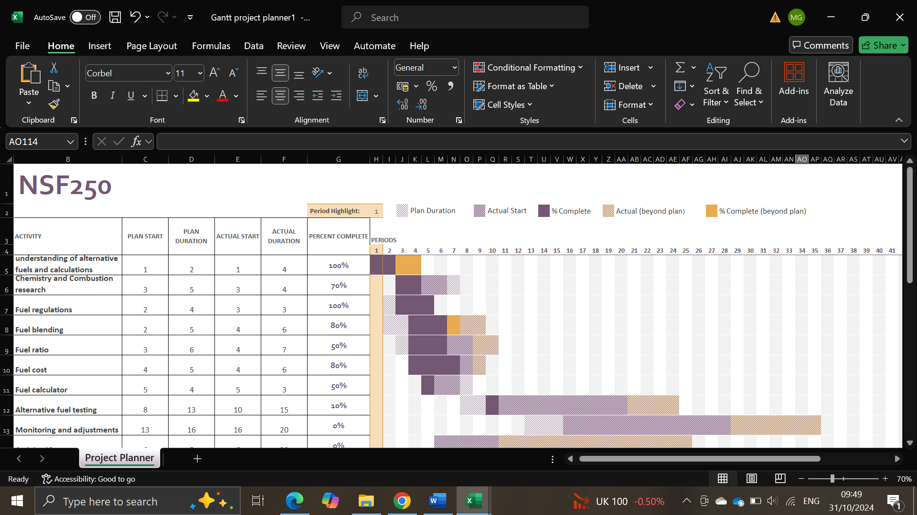
6.1 GANTT chart

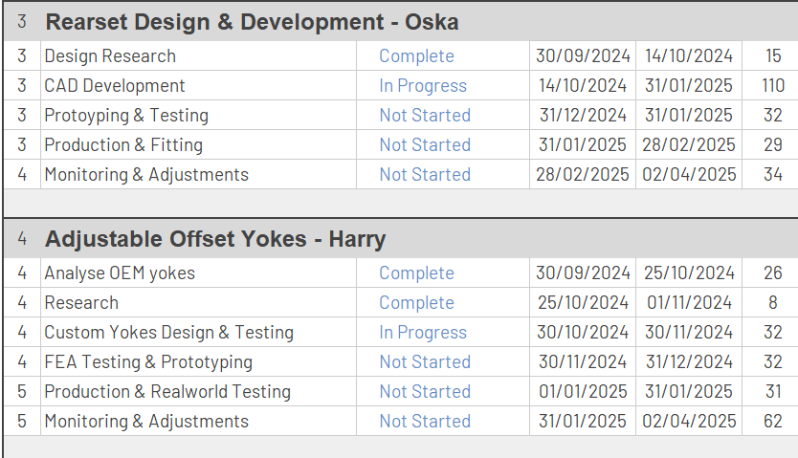
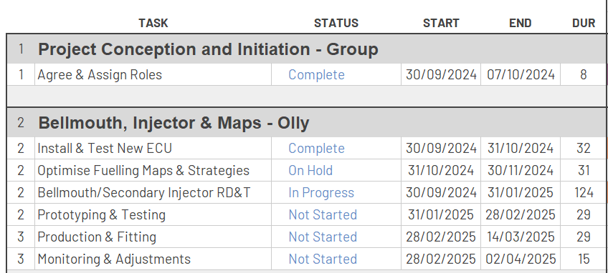
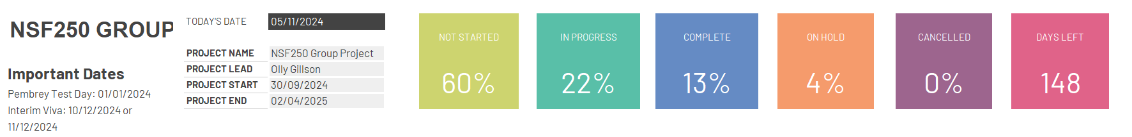
6.1.1 Overall Group GANTT chart
This GANTT chart outlines all the tasks planned for completion over the three semesters, with designated breaks available for catching up on any outstanding work if necessary.

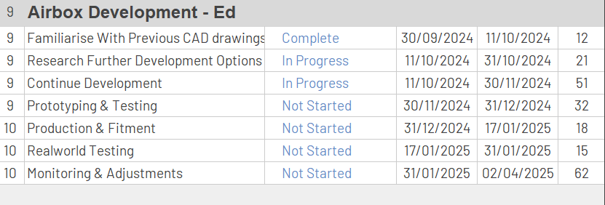
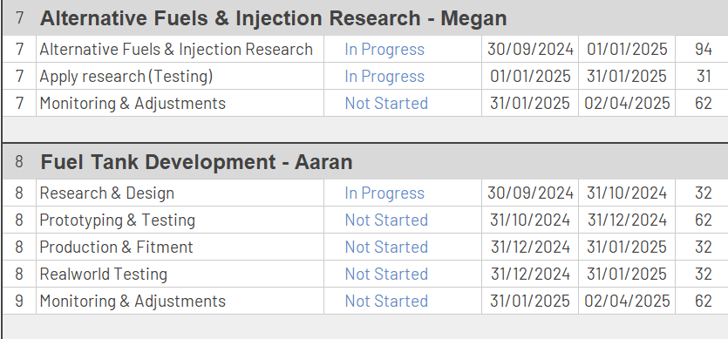

7.1 Areas of concern
When implementing alternative fuel usage and fuel blending for the NSF250, there are areas of concern must be addressed to ensure project success. These concerns revolve around fuel compatibility with engine components and achieving consistent and stable fuel blends. Both factors can impact the effectiveness and reliability of alternative fuels in a high-performance environment. Addressing these concerns throughout the blending and testing process will be essential for meeting the NSF250’s performance, durability, and sustainability objectives.
Alternative fuels, especially those with bio-based or renewable content, can sometimes cause incompatibility with standard engine materials. These fuels may lead to corrosion or deterioration of certain engine parts, such as fuel lines, seals, and injectors, which are not always designed for biofuel or ethanol blends. Testing and potentially upgrading these components to avoid damage is crucial.
Achieving a consistent fuel blend can be challenging, as any variation in the blend ratios can affect combustion efficiency and stability. This is particularly important if the fuel blend is to be stored over time, as biofuels can degrade more quickly than traditional fuels. Ensuring stability in the blend will require rigorous quality control during the blending and storage processes.

8.1 Conclusion
This project plan establishes a structured roadmap for the NSF250, ensuring that all tasks are executed efficiently and within the set timeline. Through clearly defined milestones and gateways, it provides a solid framework to manage resources, track progress, and address any areas of concern proactively.
The final track test will serve as the ultimate assessment, confirming the successful implementation of all project goals. By sticking to this plan, the team can ensure that the NSF250 is thoroughly prepared and optimized, ready to deliver peak performance in competitive settings.

9.1 Reference
- ASPENgroup (2024). Advanced Sustainable Biofuels For Racing & Classic Vehicles. [online] SUSTAIN Fuels. Available at: https://sustain-fuels.com/.
- Indeed (2022). The 9 Belbin Team Roles (With Examples and Definitions). [online] Indeed Career Guide. Available at: https://uk.indeed.com/career-advice/career-development/belbin-team-roles.
- Teamgantt (2024). What is a Gantt Chart? Gantt Definitions & Uses | TeamGantt. [online] Teamgantt. Available at: https://www.teamgantt.com/what-is-a-gantt-chart.
- Tillman, D.A., Duong, D.N.B. and Harding, N.S. (2012). Introduction to Fuel Blending. Elsevier eBooks, [online] (978-0-12-380932-2), pp.1–29. doi:https://doi.org/10.1016/b978-0-12-380932-2.00001-5.

10.1 Appendix

