Introduction to Web Development
  - Lecture 9 Lab Tutorial Exercise

Setting up the Film Web Application Site

Objectives
In today’s exercise, you will set up your movie web application and add films and their details as content to the site. To do this, you will create a custom film content type.

Exercise 1: Adding another Site
- First, you need to add another site to your web server or you can reuse your existing site (considering how long it took to set up on some computers).
  - If you want to reuse your existing site, skip this exercise.
- Download Drupal and extract the contents to your UwAmp www folder.
- Rename the extracted folder to something that reflects your website.
- Launch your website.
  - Go to the UwWamp console (open it if it is not running)
  - Click on the Browser www button.
  - In the page that opens, locate the Virtual Host section and look for the name of the folder from the previous step and click on it.
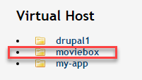
- Follow the steps to configure the new site.
- While it is installing, make a logo for your site.

Exercise 2: Customising the Site’s Appearance
If you have done this already, skip to the next exercise.

Changing the Site’s Title and Slogan
- Locate the black menu bar at the top of the page and click on Manage Configuration
- Locate the System block, and click on Basic site settings
  - Change the site name and slogan if you wish
  - Save any changes by clicking the Save configuration button.

Changing the Site’s Theme
- To change the site theme, you first of need to locate a theme that you like
  - Open the following link in a new tab (so you can easily return to your website): https://www.drupal.org/project/project_theme
  - In the Search Themes text field, enter a search term (e.g. films, movies, gallery, etc.) to filter themes and then click the Search button.
  - Look through the options and download a theme that you like.
- Return to your website
- Click on the Appearance tab in the menu
  - Click the +Install new theme button
  - Locate the Choose File button, click and browse to the theme file that you downloaded and Install it.
  - Note: If you get an error about the file size being too large
    - Go to your UwAmp window.
    - Click on the notepad icon beside PHP Config
    - When the file opens, search for “upload_max_filesize” and increase this as shown
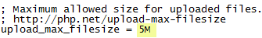
    - Save the file and close it.
    - Restart the Apache server.
  - Once it is done installing, you should see your listed theme with the other themes currently installed.
  - You will need to click on the Install and set as default link to set the new theme for your site.

Configuring the New Theme

The Logo
- At the minimum, you probably want to change the logo for your website.
- Click on the Appearance tab and click on the Settings link beside your chosen theme.
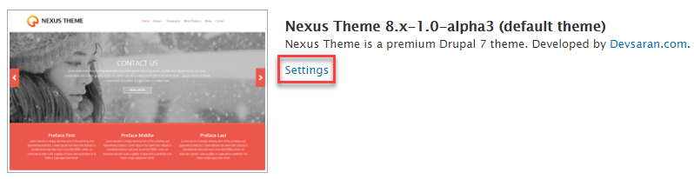
- Locate the settings for Logo Image. If you do not want to use the default logo:
  - Uncheck the “Use the logo supplied by the theme box”
  - Use the Choose File button to upload your preferred logo file.
  - Save your changes.
  - Preview your website.
  - Note: if your logo image does not display, it may be too large to fit into the space reserved for the logo in the theme template. Try resizing (making it smaller) using GIMP or Adobe, etc.

The Banner or Slideshow Images
- Your chosen theme may let you add a banner or slideshow to it. If it does, there will be settings for you to change the images and any captions.
- Make any changes that you want.

Exercise 3: Creating a Taxonomy
- Go to the Admin Section of your Site.
- From the menu, click on the Structure menu option and then select Taxonomy.

Film Category
- You will create a new Taxonomy vocabulary for categorising films as Top Films, New Releases, Coming Soon, Highest Rated.
- Click the Add vocabulary button and specify a name and description as follows and click the Save button:
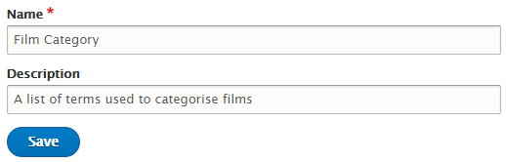
- In the window that follows, click the Add term button and add terms for the following (you can change as you wish):
Name | Description
Top Films | Films coming soon
New Releases | New at the cinema
Coming Soon | Films coming soon
Highest Rated | Rated 4* and up

Age Rating Classifications
- Now create another taxonomy vocabulary called Age Rating Classification (A list of film age rating classifications) with the following terms.
Note: For the description, use the images available on Moodle.
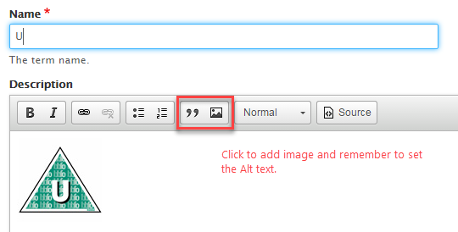
Name | Description
U | Suitable for all
PG | Parental Guidance
12 | Suitable for 12 years and over
12A | Suitable for 12 years and over, under 12's must be accompanied by an adult
15 | Suitable for 15 years and over
18 | Suitable only for adults
TBC | To be confirmed

Viewing Experience Type
- Now create another taxonomy vocabulary called Viewing Experience Type (A list of viewing experience types) with the following terms or anything you like.
Name | Description
2D | 2D means two dimensional. No 3D glasses required.
3D | 3D images that pop out of the screen. 3D glasses required.
iMax | Stunning image quality, extraordinary sound and big screen experience.

Exercise 4: Creating a Custom Film Content Type
- In this exercise, you will create a custom content type for adding the details of a new film to the website.
- From the menu, go to Manage Structure and select Content Types.
- Click the Add Content Type button. Set the following:
  - Name: Film
  - Description: Use to add the details of a film.
- In the section for Submission form settings, change the Title field label to Film Title
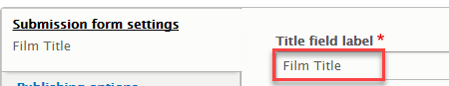
- Select the Display settings tab and untick the “Display author and date information” as public users do not need to see this option.
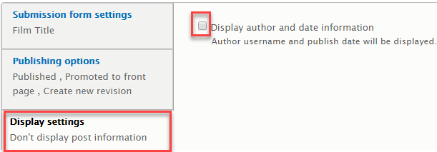
- Under menu, uncheck the box for Main navigation. Listing all the films in the main menu will be untidy.
- Click Save and Manage fields.

Adding Fields
- At the moment there is only one field: Body. Click the Edit button beside it.
- Make the following changes to the film.
  - Label: Summary
  - Help text: A summary description of what the film is about
  - Required: tick this box.
- The fields required are listed below. For a description of the field types, go to the Appendix section. Note: you can change any of these settings as you wish (these are just guidelines).
Name | Field Type | Required
Title
Genre | Type: Text (plain)  Allowed number values: 1 | Yes
Age Rating | Type: Taxonomy term  Allowed number values: 1  Reference Type: check the Age Rating classifications.  Default value: you can set to TBC | Yes
Summary
Duration | Type: Number (integer)  Allowed number values: 1  Help Text: The duration of the film in minutes  Minimum: 0  Maximum: 300  Suffix: minutes (put a space before, so the it will display as “120 minutes” for example)
Cast | Type: Text (plain)  Allowed number values: unlimited
Director | Type: Text (plain)  Allowed number values: 3
Trailer | Type: Link  Allowed number values: 1  Default value for Link text: View Trailer
Poster | Type: Image  Allowed number values: 1  Default image: You can set the default image to the coming soon poster image  Maximum upload size: 200 KB or whatever you want.
Thumbnail Poster | Type: Image  Allowed number values: 1  Default image: You can set the default image to the coming soon poster image  Maximum upload size: 200 KB or whatever you want.
Language | Type: Text (plain)  Maximum length: 30  Allowed number values: 1  Default value: English
Release Date | Type: Date  Date type: Date only  Allowed number values: 1 | Yes
Review Rating | Type: List (float)  Allowed number values: 1  Allowed values list:  0  0.5  1  1.5  2  2.5  3  3.5  4  4.5  5
Tags | Type: Taxonomy term  Allowed number values: unlimited  Reference Type: check the Film category.  Does not need to be required

- Add another field but select:
  - Re-use and existing field: Comments
  - Label: Reviews
  - Set the following in the settings:
    - Default value: Open
    - Comments per page: any number you like
- Add another field and select
  - Re-use and existing field: Entity reference: field_tags
  - Label: Tags
  - Set the following in the settings:
    - Reference Type: Check the Film Category box
    - Required: Yes (check)

Managing Form Display
- At the top of the page, select the Manage form display tab. This section allows you to manage the input display form when adding a new film.
- Scroll down the list and make the following changes. Remember to save when done.
  - Age Rating: change to Select list
  - Review Rating: Check boxes/radio buttons
  - Reviews: hidden

Managing Display
- At the top of the page, select the Manage display tab. This section allows you to manage the how the film is displayed on the public website.
- There are default views for displaying your content: Teaser, Full Content, RSS and Print. You can also configure additional custom views. For now we will focus on Teaser and Full Content.

Full Content
- At the top, make sure Default is currently selected (it should have an underline)
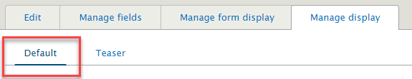
- Age Rating
  - Label: Make the label hidden
  - Format: Rendered entity
  - Remove the link to the referenced entity – click the gear icon on the right to show options
- Trailer (you will change this later). For now, click on the gear icon and make the following changes.
  - Label: Hidden
  - Check add rel="nofollow" to links (you can Google to find out what this does)
  - Check open link in new window
- Poster
  - Label: Hidden
  - Image Style: I leave you to decide (remember you can make changes if you are not happy)
  - You probably also want to drag the poster image to the top of the page.
- Thumbnail Poster
  - Drag to Disabled fields so it stays hidden.
- Tags
  - Drag to Disabled fields so it stays hidden.
- Remember to save your changes.

Teaser
- Change the selection at the top from Default to Teaser.
- Drag the poster into the section above Disabled, so it gets displayed.
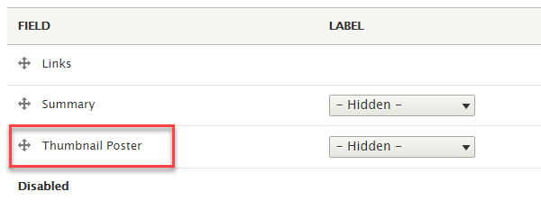
- Click the little gear icon beside poster and set the following:
  - Label: Hidden
  - Image style: Thumbnail
  - Link image to: content
- Remember to save your changes.

Exercise 5: Adding Films
- Download the films excel document from Moodle and use to add films to your site.
  - The images for the films are also available to download
  - Thumbnail Poster: Use the image without the _L at the end of the file name
  - Poster Image: Use the image with _L at the end of the file name
- The display of the film items is probably not great at the moment.
  - You can have a play around.
  - We will do some more with this in next lesson to improve the display.
- That’s all for today!

Appendix – Field Types

General
Type | Description
Boolean | A yes or no field or checkbox.
Comments | Allow visitors to the site to add comments.
Date | A date and time.

Number
Type | Description
List (float or integer) | A predefined list of values that the user can pick from when creating new content.
Number (decimal, float, or integer) | To hold a number in a specified format.

Reference
Type | Description
Content | A preconfigured reference field for setting up a relationship between one entity and another. Defaults to the node entity type.
File | A preconfigured reference field for setting up a relationship between one entity and binary file entity, such as a PDF.
Image | A preconfigured reference field, similar to a File field, but intended for images that will be displayed visually.
Taxonomy term | A preconfigured reference field to useful for creating an association with one or more taxonomy (classification) terms and a specified Taxonomy vocabulary.
User | A preconfigured reference field for setting up a relationship to one or User entities.
Other | A reference field useful for referencing any type of other entity, for example, Commerce Product(s).

Text
Type | Description
Text (formatted, long) | For use where there will be longer descriptive text possibly with html markup.
Text (formatted, long, with summary) | As for Text (formatted, long) but with an additional short version of the text that can be used in a teaser for good SEO.
Text | For short text, generally fewer than 256 characters without markup.

