RESEARCH REPORT
ARE STUDENTS CONFIDENT IN USING TECHNOLOGY TO COLLABORATE?
Andreea Alina Tudorache
Student Number: 2130698
Lecturer’s Name: Seyed Navid Nasirpour
BMSW4003
Digital Skills and Research Methods
TABLE OF CONTENTS
1 Introduction 3
2 Research Design 3
2.1 Research Question 3
2.2 Methods 3
2.3 Ethical Consideration 5
3 Results 5
4 Discussion 11
5 Conclusion 12
6 References 14
7 Appendix 15
7.1 Appendix A: Questionnaire 15

Introduction
This research report aim aims to show the skills with respect to the implementation of the methods. Particularly in this research, the aim is to answer the question that whether the student feels confident to use technology to collaborate. According to Susanty et al. (2021); Palieraki, and Koutrouba, (2021), in order to collaborate with each other the use of the technology helps the student in order to expand their access to education, this technology is being used while using different tools which include the laptop, smartphone, tablet so on. On the other hand, De Freitas, et al. (2018; Akinloye et al., 2018), have mentioned that with the use of technology the schools or the education instituted have the potential in order track more students, and it is making the essay the process of the learning, as well as the gained process, have become more reliable for the instructor and the for the learner as well. In addition to this, the collaboration of the use of technology has become more popular (Seguí et al., 2019). While the learning model of the collaborative is contributing to the engagement of the teacher as well as the student. In contrast, the use of technology enables the students in order to empower their activities with respect to massive success.

Research Design

Research Question
In order to work on the research and reach the desired outcome there is a need to work on the desired outcome and promote research there is a need to design the appropriate research question, this research question is need to have complied with the research development effectively. In line with this in this research the deigned research question has been mentioned below:
- Are students confident in using technology to collaborate?
For giving the answer to the inserted question above a specific methodology has been designed which has been further defined below:

Methods
In this research methodology, the researcher has selected the quantitative research approach in order to answer the designed question. According to Snyder, (2019), the data is based on the numerical aspect and tends to incorporate the perception of the participants in order to answer the research questions or to resolve the research issue. Along with the use of the quantitative research approach the researcher has used the deductive research approach in order to find out the result of the developed hypothesis. In addition, the involvement of the deductive research approach would lead to the indication that they are interlinked with the development research question and are contributing to the success of the research issue. The selection of the indicative research approach is based on the fact that according to Mohajan (2018), the use of the deductive research approach helps to identify the relationship of the variable which explores the research issue. On the other hand, it has been noted that in the case of the research success role of the research there is a need to decide on the appropriate data collection method which leads the research towards success. In line with this, the research has used the primary data collection the student of the university was targeted and the close-ended questionnaire was prioritised in this research. The sample, size of this research was 10 participants. In the research survey, there are the following questions were asked and their responses were observed.

Asked Questions
- Are you familiar with using a laptop, pc, tablet or smartphone?
- Do you feel anxious if you are asked to collaborate using technology?
- Have you ever avoided using technology to collaborate?
- Do you see the value of using technology to collaborate?
- Would you prefer to work in a group or alone?
- Do you think that the use of technology in the classroom improves how a student is learning?
Statements
- Technology helps students to be confident.
- On a scale of 1-5, rate the importance of technology in learning.
- I avoid using technology when I can
- Using technology to collaborate feels easy for me.
- Collaborating with my peers to create a group task feels very difficult for me.
- Rank these words in order according to how you feel about using technology to collaborate.
- The technology helps students to collaborate.
Based on the responses of the participants and their answers the researcher has represented the discussion where the perceptions of the participants were measured through the already present research and the valuable conclusion has been rerepeated which gives the proper answers to the asked questions.

Ethical Consideration
According to Pandey, and Pandey, (2021), in the research, the implementation of ethical consideration is the most considerable aspect in order to comply the research with the legal aspects. In line with this, it has been noted that in this research survey the personal data of all the participants were kept confidential and their personal identities were not revealed in this research. All the participants were aware of the real aim and the objectives of the research, in addition to this they were not forced to be part of this survey all the participants were allowed to leave the survey anytime, in case they feel insecure. The consent form was filled out by all the participants and before the survey, the whole ethical practices were taken place.

Results
Demographically, in the research survey, the total sample size was 10 where 4 were male and 5 were female and 1 preferred not to say about his/her gender. All the responses to the questions have been described below in the form of tables and charts.

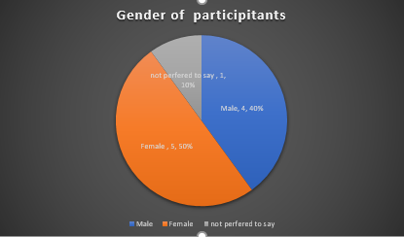
Figure 1 Demographic Of Participants
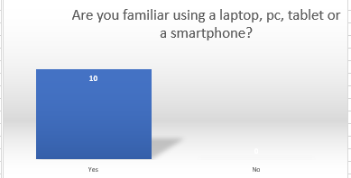
Figure 2 Response Of Ques 1
Figure 2 has indicated that in the response to the question are you familiar with using a laptop, pc, tablet or smartphone, all the participates said that they are aware from the technologies.
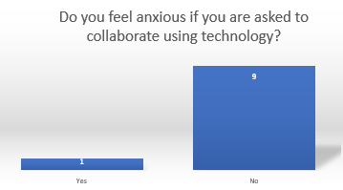
Figure 3 Response Of Ques 2
Figure 3 has shown that only 1 participant feels anxious if you are asked to collaborate using technology, however, the other 9 participants are comfortable while using it.

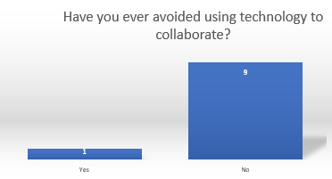
Figure 4 Response Of Ques 3
In figure 4 it has been noted that only 1 student avoids technology in order to collaborate, however 9 do not do it.

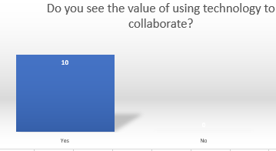
Figure 5 Response Of Ques 4
All are aware of the value of technology.
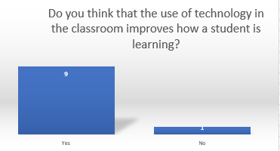
Figure 6 Response Of Ques 5
90 % of participants were in favour that in the class technology is working in order to improve the learning.
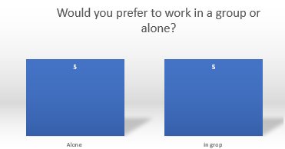
Figure 7 Response Of Ques 6
Ratio 50 50 % have been identified in working alone and in groups.
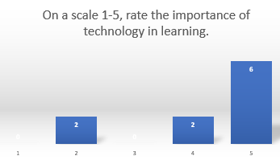
Figure 8 Rating of Participants
Based on the preferences of the participants have ranked the significance of technology in learning.

STATEMENT | AGREED | STRONGLY AGREED | DISAGREED | STRONGLY DISAGREED | NEUTRAL
The technology helps students to be confident. | 1 | 6 | 2 | 0 | 1
I avoid using technology when I can | 3 | 0 | 2 | 4 | 1
Using technology to collaborate feels easy for me. | 5 | 4 | 0 | 0 | 1
Collaborating with my peers to create a group task feels very difficult for me. | 1 | 0 | 3 | 4 | 2
The technology helps students to collaborate. | 2 | 5 | 0 | 0 | 2
Table 1 responses of the participants to the statements

Discussion
In the results, it has been indicated that most of the students were in the favour of the use of technology in order to promote collaborative activities. In addition to this, the gained results from the survey have indicated that in the case the promoting the use of the technology all the participants were familiar with the use of the technology. The agreement of all the participants towards the awareness of the technology has indicated that the youth is becoming more aware of the use of the technology. As Ahmadi, and Reza 92018), explored as well that the 21st century has become the era of technology and due to the increased demand for technology all aspects are interlinked in the need for life. Since the use of technology has made the different aspects of life much easier that is why the focus of the community has been found more focused on the use of technology (Akinloye et al., 2020). At the same time, during the survey, the response to the other questions indicated that the incorporation of the technology is leading the students towards confidence and it is helping the improving the environment of the classroom.
Apart from that, explored research has promoted the use of the technology as well in collaboration as wells, as Palieraki, and Koutrouba, (2021) has shed the light on the use of the technology in academic learning and stated that the advances in the technology have allowed the students a far easier method of the collaborative as well as the collaborative learning is now as accessible and in the present era, the technology is promoting the collaborative relation along with the use of the different technological devices which includes the smart mobile, laptop as well as tablet. In a similar manner, it has been noted while talking about the value of the technology all the participants agreed that it is interwoven with the development of the communicational era. Seguí et al., (2019), have explored that along with the help of technology students can be able to communicate in an effective manner no matter how far are they. In addition to this majority has marked the positive with the response of the mentioned below statement The technology helps students to collaborate. 50 % were strongly and 20 % agreed in order to say that it is positivity contributes to helping students collaborate.
In contrast, the previous research has not only worked in the enhancement of the collaboration between the student but is also shearing their role in the development of a healthy study environment is the need of both the student as well as of the teachers. In this manner, Ma (2020), have reflected that the use of technology and teaching together creates a learning environment in which students are engaged, stimulated and motivated. Technology also helps teachers be more helpful and boost the performance of the students and plays a remarkable role in making them effective students. All the research's shreds of evidence as well as the responses to the survey are reflecting the single element, that the technology is promoting collaboration in the students to student and student to teacher collaboration is becoming more effective.
The result of this research was expected since the hypothesis of the researcher was that technology has a positive role in the collaboration between the students, and the perception of the students as well as the previous researcher has confirmed this hypothesis and explored that it is developing the relation in between the teachers as well as the students in a positive way. All the result of has not surprised the researcher at all since the results were already expected and it was assumed already in the form of the hypothesis that technology has a positive role in enhancing the collaboration between the students and that all the students are confident in order to use the technology for empowering the collaboration.

Conclusion
This research has concluded that in student learning the use of technology is contributing positivity in order to empower the studies as well. The following research has concluded that The 21st century has been characterised as the "period of technology," in which all facets of life are interconnected by the need for technology, and as the use of technology has made various facets of life easier, the community has been observed to be more focused on using technology. At the same time, poll responses to other questions revealed that using technology in the classroom makes pupils more self-assured and contributes to a better learning environment. Along with this the research has concluded that the majority of the pupils appeared to support using technology to encourage collaborative activities, according to the data. Additionally, the survey's findings showed that, in the case of promoting the use of technology, all of the participants were familiar with its application. The consensus among all the participants on awareness of technology has shown that young people are getting more aware of how to use technology. However, in this survey some of the student were found disappointed with the use of the technology that is why they are recommended to provide the clear evidence for using of the technology which will help them in order to gain the effective side of the technology.

References
Ahmadi, D. and Reza, M., 2018. The use of technology in English language learning: A literature review. International Journal of Research in English Education, 3(2), pp.115-125.
Akinloye, G.M., Adu, E.O., Adu, K.O. and Olawumi, K.B., 2020. Information and Communications Technology (ICT) and teaching-learning capacity: The classroom management interconnectivity. e-BANGI, 17(7), pp.13-30.
De Freitas, S., 2018. Are games effective learning tools? A review of educational games. Journal of Educational Technology & Society, 21(2), pp.74-84.
Ma, W.W., 2022. Effective Learning Through Project-Based Learning: Collaboration, Community, Design, and Technology. In Digital Communication and Learning (pp. 317-341). Springer, Singapore.
Mohajan, H.K., 2018. Qualitative research methodology in social sciences and related subjects. Journal of Economic Development, Environment and People, 7(1), pp.23-48.
Palieraki, S. and Koutrouba, K., 2021. Differentiated Instruction in Information and Communications Technology Teaching and Effective Learning in Primary Education. European Journal of Educational Research, 10(3), pp.1487-1503.
Pandey, P. and Pandey, M.M., 2021. Research methodology tools and techniques. Bridge Center.
Seguí, F.L., de San Pedro, M., Verges, E.A., Algado, S.S. and Cuyàs, F.G., 2019. An intergenerational information and communications technology learning project to improve digital skills: user satisfaction evaluation. JMIR aging, 2(2), p.e13939.
Snyder, H., 2019. Literature review as a research methodology: An overview and guidelines. Journal of business research, 104, pp.333-339.
Susanty, L., Hartati, Z., Sholihin, R., Syahid, A. and Liriwati, F.Y., 2021. Why English teaching truth on digital trends as an effort for effective learning and evaluation: opportunities and challenges: analysis of teaching English. Linguistics and Culture Review, 5(S1), pp.303-316.

Appendix

Appendix A: Questionnaire

Statement | Agree | Strongly agree | Disagree |  | Strongly disagree | Neutral
Collaborating with my peers to create a group task feels very difficult for me. | O | O | O |  | O | O
Using technology to collaborate feels easy for me. | O | O | O |  | O | O
I avoid using technology when I can | O | O | O |  | O | O
The technology helps students to collaborate. | O | O | O |  | O | O
The technology helps students to be confident. | O | O | O |  | O | O
The technology helps students to collaborate. | O | O | O |  | O | O
Questions |  | Yes |  | No
Are you familiar using a laptop, pc, tablet or a smartphone? |  | O |  | O
Do you feel anxious if you are asked to collaborate using technology? |  | O |  | O
Have you ever avoided using technology to collaborate? |  | O |  | O
Do you see the value of using technology to collaborate? |  | O |  | O
Do you think that the use of technology in the classroom improves how a student is learning? |  | O |  | O
Do you think that the use of technology in the classroom improves how a student is learning? |  | O |  | O

