For this reflective journal I will be looking at a recollection of the lectures that I have had during the period of February 8th until March 22nd 2018. The reflective journal will contain what I learned each week throughout mu lectures, as well as my own input regarding anything that I did not know before the lectures. Some of the reflections will also contain information regarding methods of fieldwork that was carried out outside of the lecture room. As all of the sessions started at 2pm and finished at 4pm on Thursdays, I shall write that information in the introduction, as none of the sessions had different start times or a change of day that the lecture was held on.
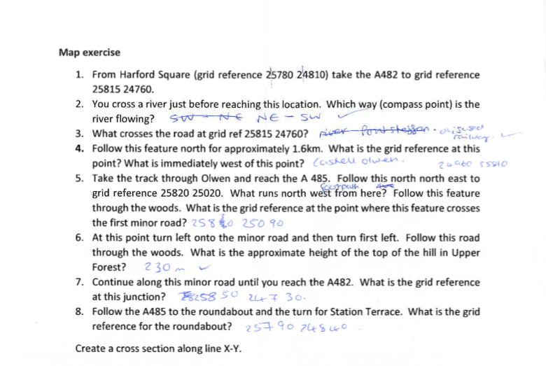
The first session was held on the 8th February 2018, and although the session was an indoors one, the weather was reasonably calm, with grey skies but no rain. The session began with introductions from the lecturers that would be taking the different aspects of the sessions, as well as the importance of wearing suitable shoes and clothing to every session due to the possibility of going outside. The other half of the session was an interactive one, involving the use of OS maps to determine if I could use them in order to follow directions, as well as read 4, 6 and 8 figure grid references. It is very useful to be able to understand OS maps, as Brown(2004, p14)states that the ‘certain basic initial requirements must be met in the form of Ordinance Survey maps’, illustrating that learning a skill such as map reading is an integral part of carrying out fieldwork. This part I found quite challenging, as although I have used OS maps frequently in the past I still struggled with working out the grid references and how to read them after not having used one of these maps since early June of 2017. This session, whilst slightly challenging and frustrating was a good way to re familiarise myself with map reading and also how to read the grid references, even if my attempts did not go as smooth as image 1 on the left shows, with a few crossings out on my worksheet. However as the lecturer explained how to read them I was able to understand my mistakes and correct them as the session progressed, and also how to ensure that my grid references were read as accurately as possible for reliable results.
Image 1
The second session was held on 15th February 2018, this session was also held indoors for the first part of it. The first part of this session focused on how a cross section of a diagram could be transferred into a graph format. This part of the session was a very useful reminder of how to do this, as I learnt it during A level Geology. However I could not recollect the method that I knew, and the way that the lecturer explained the process was a lot simpler to understand and apply. The second part of the session was held outdoors, and luckily the weather was dry with blue skies, although it was slightly breezy and cold, as I forgot to bring a coat with me to the session. This part of the session involved splitting into pairs and making a rough map of the Arts Building on campus. My partner and I decided to share the drawing parts in order to have more than one perspective of the building. For this exercise our teamwork was successful as we both agreed on an efficient way to share the responsibility of the drawing and when it was time to swap the drawer around. This sort of grouping was good for me as I tend to work better in smaller groups and also with people I am familiar with as I know how they can approach things. However, in our eagerness to get the drawing completed we both forgot to include the basic information when drawing maps and diagrams, such as a scale and also what direction magnetic North is facing.
The third session was held on 22nd February 2018, and it was an entirely indoors session. The first part of the session involved the steps you should do in order to set out a square for a test pit, which you would do before digging the trench. I was not aware that a test pit was needed before digging a trench, so this was something new that I found out during the session. As this was an entirely new area for me to learn, I found out that geometry is a very important aspect to making the square as accurate as possible, by using the Pythagoras theorem $a^{2}+b^{2}=c^{2}$. For this type of method, it is always more accurate the larger the overall square is, and there are charts available that give the number that will be the diagonal line, which would be the hypotenuse of the triangle that will make up the overall square of the pit. The second part of the session was used in preparation for what we would be doing the following week, which would be using a dumpy level in order to work out the height of the land. The session focused on what the tools we would be using were, such as a tripod with a telescope set on top of it in a horizontal position. A spirit level on the device will aid us in whether the telescope is horizontal. For the sake of also having a bench mark to work with, if we do not know it we are allowed to use an arbitrary number for the height. I had never heard of this method of measuring the land before this session, so all of this information was new to me, also as I have not done any archaeological fieldwork yet.
The fifth session was held on 8th March 2018, and was a continuation of the fourth session, of which I was absent due to illness. For this part of the session, it was an outdoors practical, with the aim being to measure the layout of the land using the dumpy level method. As this session was our first actual outdoor practical, the lecturers went over the health and safety measurements that we would need to take in order to transport the equipment that we were using safely. For the two poles that each group had, that would mark off the distance that we would measure, the ends were a potential danger as they were pointed, and so we were instructed to carry them with the point facing the ground and not being held past our shoulders, to avoid potentially hurting someone. Once we were outside and had moved all of the equipment over to our site, as the weather was raining with grey skies we were advised to keep the cases that held the telescopes closed, as any water that could get in could damage the telescopes once they were placed away at the end of the session. We split off into groups of four in order to carry out this group work. The one problem that can arise from using the telescope to measure the layout of the land is that it is set up to balance on a tripod, and if a significantly tall person sets the tripod up, smaller people would struggle to see and read the measurements. As my group had an even split of two tall people and two small people, we came to an agreement that we would set up the tripod height to the smallest persons height, in order to ensure everyone would be able to take measurements in turns. To ensure the height was not to short, the tallest member of our group looked through the telescope, to see if he could see through it without crouching down uncomfortably low, just to make it suitable for the taller group members as well.
As it was our first time with setting up and handling this type of equipment it was very much a trial and error method in order to get the telescope to be laying level when it was rotated 360°. This is an important aspect to get as accurate as possible, as it ensures that the readings are all accurate if the telescope is lying horizontal. It is also important to ensure that the telescope is horizontal at all times, as any slight movement such as a person holding the telescope to see through could throw off the reliability of the measurements as it would not match the arbitrary bench mark we set up. Once all of the equipment was set up, in order to ensure that everyone could see clearly we all took it in turns to stand at the arbitrary bench mark to allow the others to read the height. After a few minor adjustments we were all able to see the same height reading on the meter sticks that we were using. When it came to carrying out the measurements along our section, we decided to measure every half meter, as we would be more likely to see changes in the slope of the land as opposed to taking readings every meter. Although we did not do a method called field walking, Brown’s (1987, p32) notion that ‘absolutely vital to the success of any piece of field walking is the condition of the ground’ applies to the ground on which we carried out our land levelling measurements, as the ground was quite marshy due to the rain. As it could get very cold and boring for the same person to hold the meter stick, we rotated it amongst three of the group, whilst the fourth person took note of the measurements and worked out the differences. Again, as the groups were small I found that we worked effectively, as we shared out all of the jobs in order to let everyone have a turn with taking measurements and to set up the dumpy level, which would have been more difficult to implement if we had been a larger group, as it would have take too long to let everyone take turns.
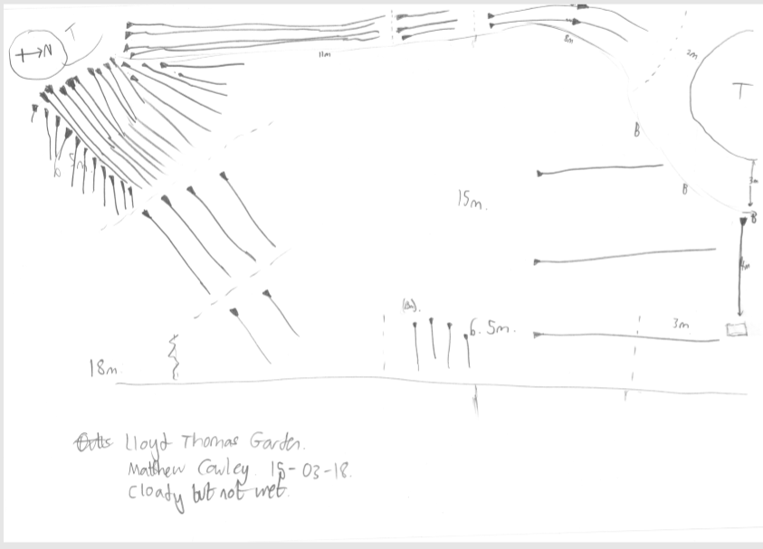
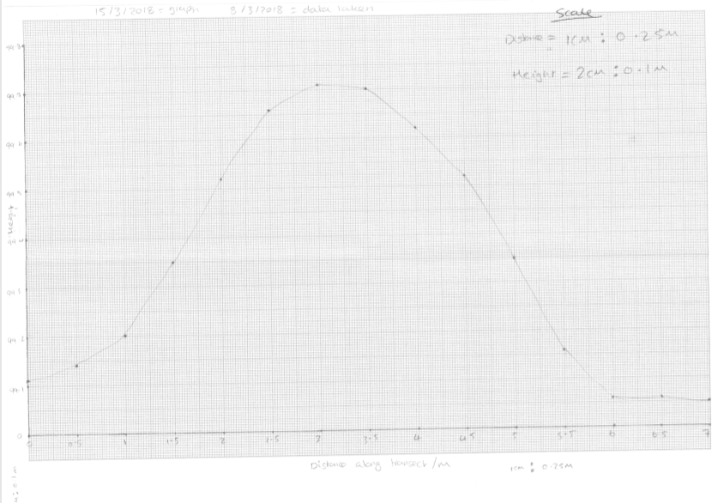
The sixth session was held on 15th March 2018, and was for the first part of the session indoors, as it was a continuation of the dumpy level session from the previous week. This part of the session involve the data that we had gathered the previous week, and turning the data into a cross section graph of the area we had chosen to measure. When it came to drawing the graph, we discussed as our group as to what would be the best way to represent the data, such as what scale we would put on the vertical and horizontal axis. We eventually agreed on the vertical axis having a ratio of 2cm: 0.1m, and the horizontal axis having a ratio of 1cm: 0.25m. The graph results helped as it showed us that the land did indeed start out flat, then rise as it was a mound and then fall flat again, and if our data from the previous session had actually been inaccurate, the graph would show this. We would be able to tell as we knew the land had a big bump on it, and if the graph had a lack of a bump we would be able to see where we would have potentially gone wrong with our measuring during the previous session. But in order to make this a wider and more precise study, as Brown (1987, p131) mentions, ‘field survey is only one aspect of the wider study’, in the future we could look at any evidence of things such as excavations or environmental studies to widen the scope of information that we could find from a project such as this one.
Image 3
Image 2
The second part of the session involved an explanation of what a hachure diagram was and how it could be useful in terms of showing the direction that the landscapes could be going, such as an incline to the left of a potential benchmark. We were then grouped up and set out to attempt to create our own hachure map in an area of our choice on Lampeter campus. However, as the area was on the campus, and had been altered by human interactions, and as Wildesen (1982, p55) comments, ‘impact types most commonly observed are alteration, transfer and removal’, in regards to how we as people can change the landscape and end up making things such as the mapping of the landscape more difficult over time. My group again was a small one, and as we had worked together previously on the data collection of the dumpy levels, we had an understanding of how we all worked, and found it easy to split the different roles to each other. We had the tallest person in the group act as a measure for meters, as he was able to do a meter stride due to his height. The rest of us all provided things such as which direction he should walk in as well as any noticeable landmarks to our artist, who was mapping the landscape shown in image 3.
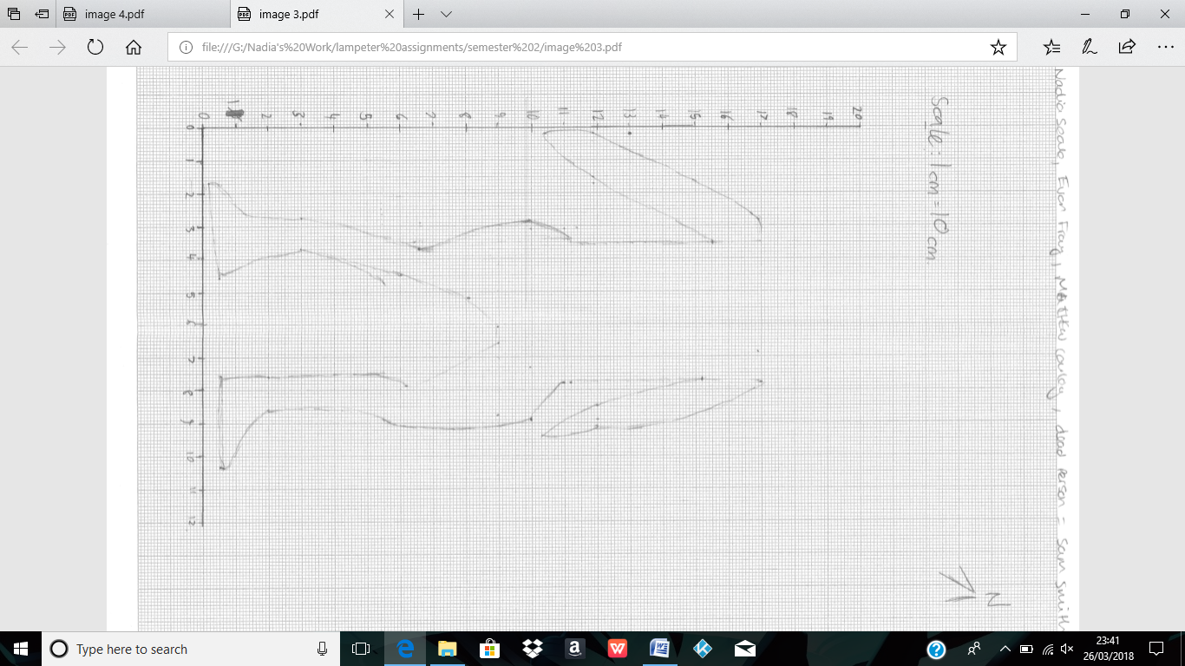
The seventh session was held on 22nd March and was an indoor practical that involved trying to draw a person to scale on graph paper. As this was another group project, my group consisted of the same people as previous task, as we had become quite familiar with each other and how we worked together. We selected one of the members of our group to be a ‘dead body’ in order for us to try and draw him to scale, using a ratio of 1:10, with 1cm on the paper being equal to 10cm in real life. As I had not been the group artist yet, I was designated that role, but as we progressed with taking measurements of the body, it became apparent that I was not an artist, as the body proportions of the feet and legs looked vastly different from the actual person on the floor. But we persevered with the drawing and eventually it began to look vaguely like a human being, as opposed to a cartoon character outline. As the session ended before we could finish our drawing, the picture remained incomplete at the time it was added into this reflective journal. After taking not of our previous experiences, we remembered to include crucial information such as the artist, the direction of magnetic North and also a scale.
Image 4

Bibliography
Image 1 provided by Nadia Seale, 1700647, created on 8th February 2018, given on 22nd March 2018
Image 2 provided by Nadia Seale, 1700647, created on 15th March 2018, given on 22nd March 2018
Image 3 provided by Matthew Cowley, 1700561, created on 15th March 2018, given on 22nd March 2018
Image 4 provided by Nadia Seale, 1700647, created on 22nd March 2018, given on 22nd Macrh 2018
Aston, M. (2013), Interpreting the landscape. Haboken: Taylor and Francis.
Brown, A. (1987), Fieldwork for archaeologists and local historians. London: B.T. Batsford.
Goldberg, P. and Macphail, R. (2006). Practical and theoretical archaeology. Maiden (MA): Blackwell.
Wildesen, L.E, (1982). The study of impacts on archaeological sites. Archaeological Method and Theory, (ed) Schiffer.M, Volume 5.
Schiffer, M. (1982). Archaeological method and theory. New York: Academic Press.

