

LOCATION: Swansea | LLEOLIAD: abertawe
LEVEL 4 | LEFEL 4
EXAMINATION PERIOD | CYFNOD ARHOLIADAU
May 2017 | Mai 2017

MODULE CODE: M1X9615
Physical Landscape

TIME: 2 HOURS
answer all questions

answer all of section A (50%) and 1 essay style question from section B.

Place examination paper in the answer book.

Equipment or materials required – None
Adnoddau neu ddefnyddiau sydd eu hangen - Dim

Section A

Please answer ALL of section A & B

Question 1

Draw a diagram to show the terminology used to describe coastal waves
e.g. Wave length, trough, height, crest, amplitude). (10%)

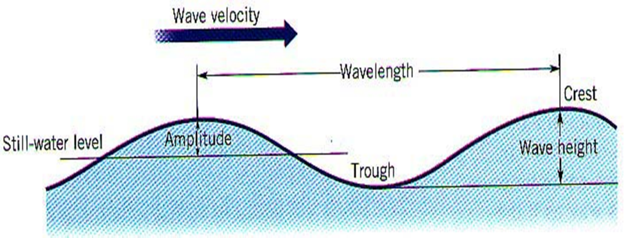

Question 2

Describe and explain 5 types of mechanical weathering. (10%)
Freeze thaw
Aeolian (wind)
Salt Crystallisation
Pressure release
-Sheeting
-Exfoliation domes
Thermal Expansion
-Exfoliation
Raindrop impact

Question 3

Describe and comment on slow slope failure. (10%)
Soil Creep
  - Almost continuous
  - < 1cm a year
  - 5⁰
  - Wet dry periods esp. in clay
    - Wet- weight, expansion- gravity
    - Dry- contract in droughts even very shallow slopes in clay can creep (e.g. Kent 1976)
  - Freeze thaw- heave ice crystals
  - Terracettes
Solifluction (Faster 5-20cm year)
    - Permafrost melts surface in summer
    - Solifluction terraces e.g. Gower Pleistocene

e.g. Rock type
Soil form
Slope Angle
Climate
Vegetation
Human activity

Question 4

Describe the principal features of urban climate. (10%)

Macro
Meso Scale
• Local Winds
Micro Scale
• Urban Climates (Heat Island see next slide)
- Anthropogenic heat release
- Albedo effect. (Heat retaining (non-reflective) and emitting properties of building materials)See next slide
- The lack of vegetation within towns and cities means that less light is intercepted, less evapotranspiration, thus less vapour is released (which naturally cools air surrounding vegetation).
- Canyon Geometry Traps heat
- Venturi effect: Buildings change wind velocity
- urban canopy layer

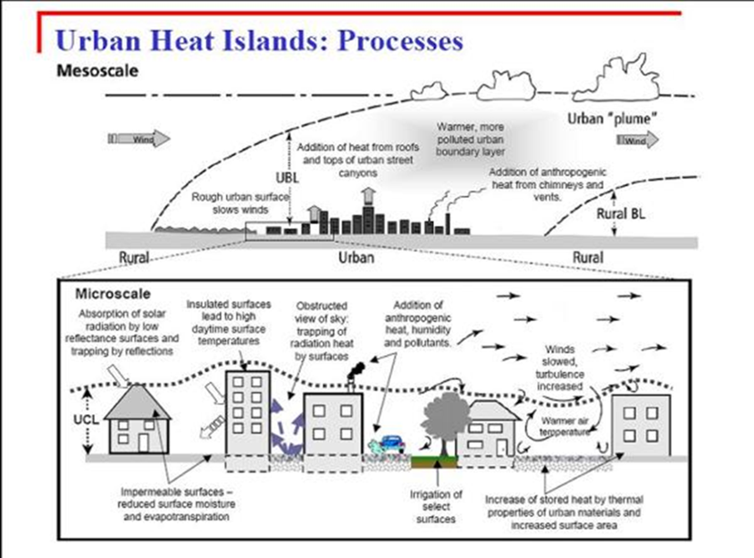

Question 5

Using diagrams, describe the formation of varves. (10%)

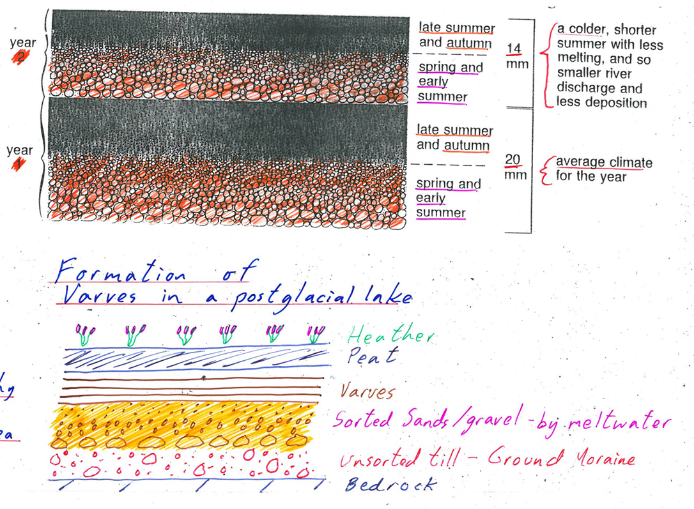

Section B

Question 1

“An understanding of physical processes is important in all environmental management”
(Fitt, 2016: 45). Discuss. (50%)

Using examples from across the curriculum the answer should consider the importance of physical landscape to conservation issues and practice. E.g. river processes and conservation. The complex differentiated relationship between physical processes and environmental management needs to be highlighted.

Diwedd/End

