
Programme: BA (Hons) Business Management
Module code: Project Management
Module code: LCBB6006
Lecturer: Dr Said Usman
Assignment Title: Coursework: Essay
Student ID Number – 2226760
Name: Alfred Ojekere

Construction of a Three-Family Bungalow with Swimming Pool

Contents
1. Introduction 3
2. Aim, Objectives, and Scope 4
2.1. Aim 4
2.2 Objectives 4
2.3 Scope 4
3. Project Outputs (Deliverables) 5
4. Project Management Methodology 7
5. Work Breakdown Structure (WBS) 8
6. Activities, Tasks and Sub-Activities 9
7. Milestones and Timeline 10
8. Resource Allocations 11
9. Risk and Quality Considerations 12
10. Conclusion 13
References 14

Introduction
Project management involves applying knowledge, skills, tools and techniques to meet defined time, quality and cost requirements (PMI, 2021). Construction projects are especially complex, requiring multidisciplinary coordination, legal compliance and financial risk control (Kerzner, 2017). Residential developments add further challenges due to client‑driven customisation, multi‑unit layouts, safety risks and environmental constraints (Fewings and Henjewele, 2019).
This plan outlines the construction of a three‑family bungalow with an outdoor swimming pool on private land. The building will contain three independent units under one roof, with shared landscaping, recreational areas and supporting service spaces. The estimated project duration is 14 months.
Although construction often follows predictive (waterfall) methods due to clearly defined scope (Turner and Huemann, 2024), modern practice recognises the need for flexibility in design coordination and stakeholder engagement (Nicholas and Steyn, 2025). Accordingly, this project adopts a predictive, process‑based PMBOK approach covering scheduling, risk management and resource allocation (PMI, 2021). The plan defines the project deliverables, key activities and milestones, and the resources required to complete the work in line with professional project management standards.
Aim
Build a fully compliant, high-quality three-family bungalow complete with a swimming pool in 14 months to agreed cost and quality, safety & regulations.
Objectives
- Get all the required architectural and engineering design approvals in 3 months.
- 9 months to structural completion
- Design and build a swimming pool in 4 months.
- Adhere to building regulations and occupational health and safety.
- Conduct the project within approved budget limits.
Scope
- Architectural and structural design
- Site preparation and foundation works
- Superstructure construction
- Electrical, plumbing, and HVAC systems
- Swimming pool construction
- Landscaping and external work
- Interior finishing
Out of Scope:
- Furniture procurement
- Long-term maintenance services
- Property management post-handover
Proper scope definition is critical for preventing scope creep and ensuring clarity among stakeholders (Al-Rubaiei, Nifa and Musa, 2018). Well-defined scope boundaries make for accurate scheduling and cost control, also.
Project Outputs (Deliverables)
Project outputs are measurable deliverables produced throughout the project life cycle, providing milestones and control metrics against scope, time, cost, and quality baselines (Kerzner, 2022). Specifying key deliverables in advance enables clear sequencing, accountability, and effective work packaging (Walker, 2015). The following outlines and justifies the building’s essential deliverables.

Architectural and structural approved : Architectural, structural, and MEP designs were rigorously reviewed for technical and compliance feasibility, reducing scope changes and costly rework (Nicholas and Steyn, 2020).
Obtained building permits and regulatory approvals: Reviewing and getting approval from local authorities assures compliance with zoning, safety, and environmental regulations; any construction cannot be responded legally without this delivery, and therefore it is important to mitigate the risk and act on statutory regulations (Fewings and Henjewele, 2019).
Completed site preparation and foundation: Excavation, soil preparation, reinforcement, and concrete works are all a well-laid foundation that is critical for the structural integrity and longevity of a construction project, minimizing the potential for structural failures (Walker, 2015).
Constructed bungalow superstructure: Columns, beams, slabs, and walls are components that make up the superstructure, which defines the whole framework of a building, and completion is an important milestone and reduces uncertainty on the project (Kerzner 2022), allowing other interior functions to happen in parallel.
Installed roofing system: Roofing protects the structure from exposure to the weather elements and enables finishing internal works to continue with relative ease, and the on-time completion reduces the probability of environmental delays (Burke, 2013).
MEP Systems (electrical, plumbing, and HVAC installations): These systems maintain operational integrity, as well as safety and comfort for the occupants, and correct installation is required both for regulatory compliance and long-term efficiency (PMI, 2021).
Swimming pool (construction, filtration, and finishing): Includes structural shell, waterproofing, and filtration systems. As one of the time-based deliverables, it adds value to the property and is subject to strict quality standards for both safety and durability (Fewings and Henjewele, 2019).
Finishes by the RPO (flooring, painting, fixtures, and fittings) : Alters the skeleton into a livable home. At this stage itself, quality affects client satisfaction, and what constitutes success in the project (Meredith and Mantel Jr, 2003)
Landscaping and driveway construction: Enhancing accessibility, drainage, and aesthetic appeal of the environment while shielding underlying structural foundations through optimal surface water management (Walker, 2015).
Handover with final inspection certification : Including signs of Compliance certificates, as-is sketches, and guarantees. Confirming contractual completion and formal project closure (PMI 2021)
Project Management Methodology: The project will use a predictive, phase‑based approach aligned with PMI’s (2021) initiation, planning, execution, monitoring/controlling, and closure stages. This is appropriate because construction deliverables are well‑defined and sequential (Turner, 2014). The WBS will guide planning by decomposing scope into manageable work packages for scheduling and costing (Kerzner, 2022). Critical Path Theory will assess task relationships and efficiency (Heagney, 2016). Risk management principles will also be integrated to identify potential cost overruns, material shortages, and weather‑related delays (Fewings and Henjewele, 2019), ensuring the construction quality process aligns with ISO‑based standards.
Work Breakdown Structure (WBS) : A work breakdown structure is one of the tools that project management uses. As stated in PMI (2021), the WBS provides a hierarchical view of deliverables with systematic tracking that formulates all outputs and allows others to validate whether everything done is necessary. Through defining work packages that can be scheduled and budgeted for at a level of detail that allows those packages to be assigned to the team who is responsible, the WBS clarifies focus, accountability, and cost control within construction projects (Kerzner, 2022). The WBS for the construction of the three-family bungalow with swimming pool takes a top-down hierarchical approach, and in Level 1, these are the main deliverables in the project, and Level 2 is where you have the various phases of each major component. By doing so, this organized division eliminates uncertainty, prevents overlaps of effort, and enhances overall performance tracking and monitoring (Nicholas and Steyn 2020)
Level 1:
Three-Family Bungalow with Swimming Pool is Under Construction
Level 2 Components:
- Project Initiation and Planning
- Design and Approvals
- Site Preparation
- Foundation Works
- Superstructure Construction
- Roofing
- Mechanical, Electrical, and Plumbing (MEP)
- Swimming Pool Construction
- Interior Finishing
- Landscaping and External Works
- Inspection and Handover
Level 2 is then decomposed into level 3 and finally into level 4 work packages (tasks, sub-tasks). For instance, “Foundation Works” can be broken down into excavation, placing reinforcement, concrete pouring, and curing. This is known as progressive elaboration because every time you input an activity within a work package, you clearly define someone responsible and that each output is measurable. Such decomposition facilitates the accuracy of cost estimation and the efficiency of scheduling (Burke, 2003).

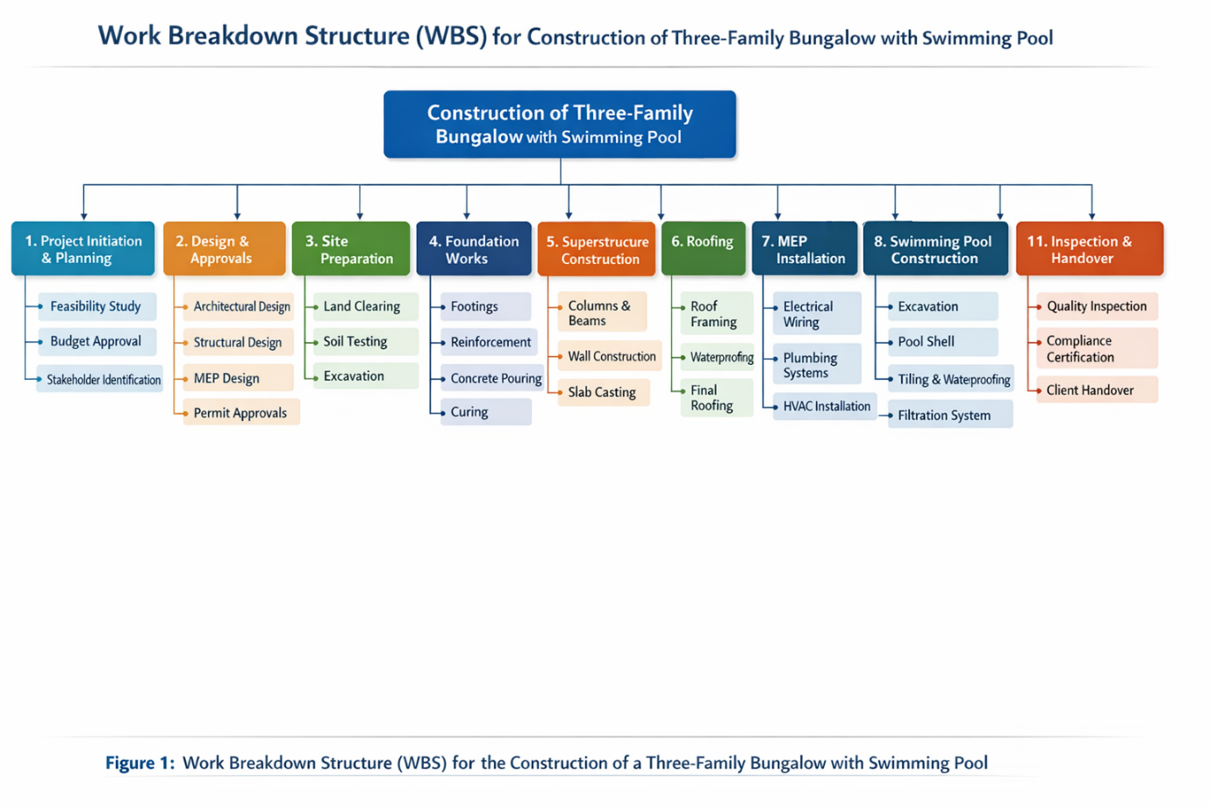
Figure 1 Work Breakdown Structure
6. Activities, Tasks and Sub-Activities
The identification and structuring of activities, tasks, and sub-activities were performed through a systematic decomposition process aligned with the Work Breakdown Structure (WBS) methodology shown in Figure 1.
In a classic tradition of project management, the high-level project scope has been successively decomposed into mostly granular deliverables and afterwards into work packages (PMI, 2021). Such an approach guarantees that each one of the high-level phases: design, construction, and even installation and handover, is translated into manageable operational components. The results of decomposition started by scrutinizing the major deliverables identified in Section 3. The next step was to break down each delivery into a logical sequence of completion tasks. Activities were organized based on standard construction workflows, including technical dependencies, regulatory requirements, and industry best practices (Kerzner, 2022). For example, design activities come before site preparation, which in turn comes before foundation and structural works, as per the natural sequencing of construction, and the tasks and sub-tasks further detail work, enabling scheduling, resource allocation, and performance monitoring. This top-down approach facilitates accountability by assigning responsibility to a work-package level and is also conducive to accuracy in cost estimation (Lock, 2020). A clear, less ambiguous hierarchical decomposition, as shown in Figure 1, provides greater overall project control throughout the construction lifecycle.
Milestones and Timeline: The milestone schedule shown in Figure 2 represents a logical and time-bound trail of high-level deliverables throughout the project, which spanned 14 months. Initiation and design phases (Months 1–3) were completed early to allow the project to clear regulatory requirements and stabilize the scope prior to physical construction. Due to their critical path status, the foundation and structural works are taken within the first nine months, as any delay in these stages would depend on the activated roof submissions, which will further result in MEP and finishing activities (Meredith et al., 2017). Swimming pool and interior works are planned only after the structural enclosure to minimize environmental risk. The last inspection milestone at Month 14 helps verify whether the Final Compliance has been done properly.
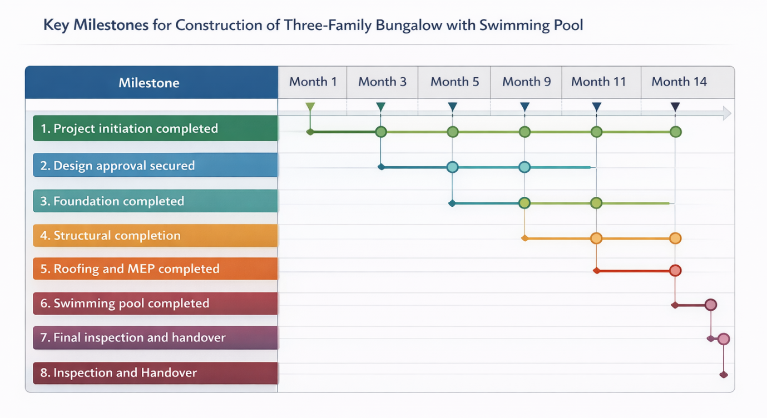
Figure 2 Timeline
Resource Allocations
Resource allocation: Plays an important role in the successful execution of a project by managing it in accordance with time, cost, and quality. According to Kerzner (2022), Human resource planning delegates distinct responsibilities to qualified individuals, thus improving coordination and minimizing labour shortages or work duplication. Likewise, material planning needs to be in line with the schedule of the project so as to avert delays, storage inefficiencies, and cost increase (Fewings and Henjewele, 2019), and Tables 1 and 2 summarize the resources required to build the three-family bungalow with a swimming pool.
Table 1 Human Resource
Personnel Role | Key Responsibility | Project Phase Involvement
Project Manager | Overall planning, coordination, monitoring, and stakeholder communication | Entire project lifecycle
Architect | Design development, layout planning, aesthetic, and regulatory compliance | Design and approvals
Structural Engineer | Structural calculations, load analysis, foundation, and superstructure design | Design and structural phases
Site Supervisor | On-site coordination and supervision of daily activities | Construction phases
Civil Engineers | Technical oversight of foundation and structural works | Site preparation, foundation, superstructure
Electricians | Installation of electrical systems and wiring | MEP phase
Plumbers | Installation of water supply and drainage systems | MEP phase
Masons | Brickwork, concrete works, and structural assembly | Foundation and superstructure
Carpenters | Formwork, roofing framework, and finishing works | Structural and roofing phases
Pool Specialist Contractors | Pool shell construction, waterproofing, and filtration installation | Swimming pool phase
Health and Safety Officer | Implementation of safety standards and compliance monitoring | Entire construction phase

Table 2 Material Allocation
Material | Primary Use | Project Phase
Cement and aggregates | Concrete production for foundation and structure | Foundation and superstructure
Reinforcement steel | Structural strengthening of concrete elements | Foundation and superstructure
Bricks and concrete blocks | Wall construction | Superstructure
Roofing sheets or tiles | Weather protection and structural covering | Roofing
Electrical cables and fixtures | Power distribution and lighting systems | MEP
Plumbing pipes | Water supply and drainage systems | MEP
Pool filtration systems | Water circulation and purification | Swimming pool construction
Tiles and paint | Interior and exterior finishing | Interior finishing

Risk and Quality Considerations
Construction-related projects are constantly interrupted by environmental factors, construction cost inflation, materials shortage, and legal regulations (Meredith et al., 2017) The project manager will create the risk register including likelihood and impact, mitigation strategies like buffer time and contingency budgeting, and quality assurance will be based on inspections of foundations, structures and finishes. According to PMI (2021), constant monitoring leads to better performance and ensures lower costs from rework, whereas managing safety management plans will help adhere to Occupational Safety regulations to protect workers as well as stakeholders.
Conclusion
This project plan implements common principles to manage the construction of a three-bedroom bungalow with a swimming pool, and by specifying the relevant WBS, expected deliverables, resource allocation strategies as per PMBOK guidelines along with integrated risk and quality process will enable keeping the project within 14 months. Overall, this plan allows for the practical application of basic project management concepts to an actual construction scenario, demonstrating the necessity of methodical planning, milestone tracking, and resource coordination. When done correctly, projects can be executed and completed effectively and meet the professional benchmarks.
.

References
Al-Rubaiei, Q.H.S., Nifa, F.A.A. and Musa, S. (2018) “Project scope management through multiple perspectives: A critical review of concepts,” AIP Conference Proceedings. Available at: https://doi.org/10.1063/1.5055427.
Burke, R. (2003) Project Management: Planning and Control Techniques. Chichester Weinheim: John Wiley & Sons.
Fewings, P. and Henjewele, C. (2019) Construction Project Management: An Integrated Approach. 3rd ed. London: Routledge. Available at: https://doi.org/10.1201/9781351122030.
Kerzner, H. (2017) PROJECT MANAGEMENT A SYSTEMS APPROACH TO PLANNING SCHEDULING AND CONTROLLING 12ED. Hoboken, New Jersey: JOHN WILEY.
Meredith, J.R. and Mantel Jr, S.J. (2003) Project Management: A Managerial Approach. Boca Raton: John Wiley & Sons.
Nicholas, J.M. and Steyn, H. (2025) Project Management for Engineering, Business, and Technology. 7th ed. Available at: https://www.routledge.com/Project-Management-for-Engineering-Business-and-Technology/Nicholas-Steyn/p/book/9781032665887 (Accessed: March 3, 2026).
PMI (2021) PMBOK Guide | Project Management Institute, PMBOK Guide.
Turner, J.R. and Huemann, M. (2024) The Handbook Of Project-Based Management. 6th ed. London: McGraw-Hill Education / Europe, Middle East & Africa.
Walker, A. (2015) Project Management in Construction. Chichester, West Sussex, United Kingdom: Wiley-Blackwell.

