The Human Resource Professional

Developing Professional Practice


MODULE NAME: The Human Resource Professional (M5X00869)
student Name: HAROON TERIA
Student Number: 1704624
lecturer: Julie Hayward

Table of contents
- Introduction……………………………………………………………………………………………………………1
  - Evaluate what it means to be an HR professional, referring to the current CIPD Profession Map
  - Briefly describe the elements of group dynamics and give at least two examples of conflict resolution methods within an HR context.
  - With reference to a recent or current project (large or small) which you have led (or been part of a project team):
- Main Findings………………………………………………………………………………………………………2
  - Provide evidence of using project management and problem-solving techniques in the course of the project.
  - Explain how you successfully influenced, persuaded and negotiated with others in the course of the project (or other related activity).
  - Undertake a self-assessment of one area of your practice to identify your professional development needs in that area and options to address these.
  - Produce a professional development plan (PDP) plan to meet your professional development needs which includes a justification of the option(s) chosen.
- Conclusion………………………………………………………………………………………………………………3

List of Figures
Figure 1.2.3: The core elements of professionalism (CIPD, 2017)……………………………………………….10

- Introduction

This report contains 4 activities that need to be fulfilled. The first activity has discussed the meaning of being an HR professional. This includes the various roles and characteristics that need to exist in an HR professional. The second task has discussed the group dynamics and the methods to resolve conflicts. This included the various characteristics of a group and how the members interact and resolve the issues. The third activity discussed project management and problem-solving skills from past knowledge and practice. Moreover, it discussed the ways of negotiation and persuasion when it comes to group projects. The fourth case discussed the professional development plan (PDP) for myself and the way forward to achieve this.

Activity 1:
Evaluate what it means to be an HR professional, making reference to the current CIPD Profession Map
Human Resource Management (HRM) is one of the key functions of enterprises and is concerned with the recruitment and management of individuals working in the enterprise. It can be defined as a process implemented by institutions and companies for the management of individuals to achieve organisation goals (Armstrong, 2006). In the other hand, HRM is the performance of events and activities which the planning, organization, development and leadership process of the organisation. Management has the responsibility to motivate employees to reach the highest level of productivity, efficiency and to be effective. All these activities help to bring the company and its employees in one direction and contribute to the achievement of the organisation and contribute to increasing the company's share in the market (Woodhams, 2016). However other studies have shown that (HRM) is one of the key foundations of enterprises because people are key resources to the organisation. (HRM) has acquired great importance in the business world because of the important role and function it provides in various institutions, companies and organizations. As a result of ongoing developments, it can also be defined as management that cares about people at work in the enterprise or company, thus contributing to the realization of the interests of the facility, employees and society (Gold, 2010).
The role of human resource (HR) profession should include developing its expertise in human and organisation behaviour in order to help to create business solutions that can have benefits for all stakeholders. However, creating ethical cultures in organisations should become a priority for any business. Despite the fact that profits are important, this should not be at the expense of workers and society It has been seen that some businesses either lack the ability to come up with a decision about ethics and cultures within their work environment or ignore such principles. Here it comes the role of HR professionals applying situational judgement and moral integrity to resolve issues and provide sustainable solutions. In other words, the HR professional should have a social and ethical responsibility, commitment and the ability to help with continuing professional development. There is always a gap between the desire to implement professional decisions and the practical decisions taken in this regard, (CIPD, 2017). This brings up the fact that there should be core elements for professionalism as shown in Figure 1.
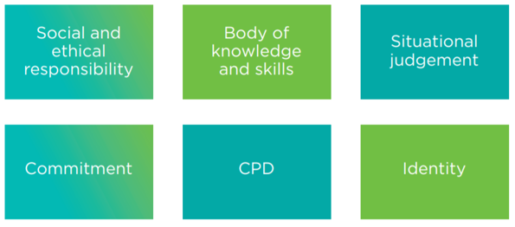

Figure 1: The core elements of professionalism (CIPD, 2017).

As a matter of fact, creating a sense of professional identity within the HR community helps to build credibility in the HR profession. The process of professionalism is gradual as any professional will need time to develop their profession to attain the highest level of professional status (Banning, 1999). This means that the development of professionalism can be considered as a scale or continuum rather than a set of characteristics (Hurd, 1967). In addition to the elements discussed in Figure 1, more elements are seen as core characteristics as shown in Table 1. In a world of distrust, HR professionals should have moral integrity when it comes to making decisions and makes judgements within an institution (CIPD, 2017).

Table 1: The various elements of professionalism in HR (CIPD, 2017).
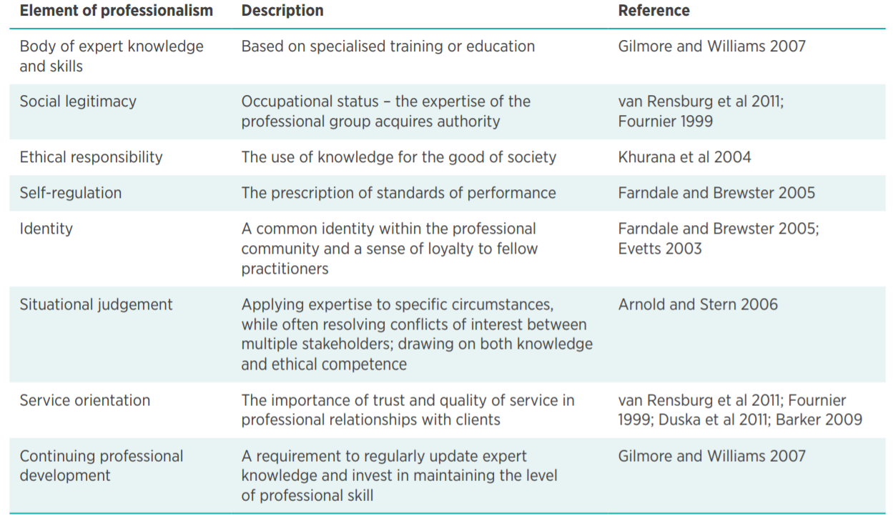

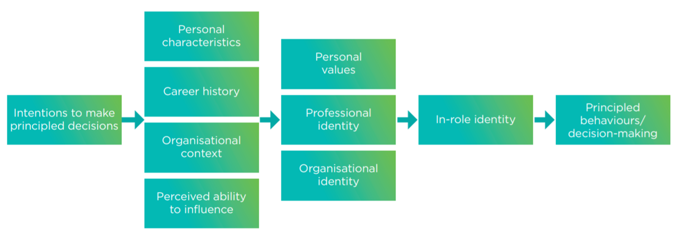
In the past, the HR profession was seen as only having a managerialist orientation while downplaying the voice of employees and ethical considerations. This has given the impression that HR professionals are only demonstrating credibility with the top management while ignoring the other values (Wooten, 2001). This means that, on certain occasions, the HR profession focuses on the organisational performance but not on the people within an organisation due to the increasing external pressures and competitiveness (Keegan & Francis, 2010). In order to maintain its credibility and social responsibility, and due to the fact that the HR profession makes decisions that affect the lives of workers, it should become more focused on human beings and not only on business profit. In this regard, the process of making decisions should take into consideration several factors as can be seen in Figure 2. This process should consider personal values as well as the professional and organisational identity that will then lead to fair and correct decisions.

Figure 2: The process and sequence model for HR decision making (CIPD, 2017).
In summary, the HR professional should be able to act ethically and challenge any unethical behaviour within an organisation. This will ensure that the HR profession works for both the organisation and the workers which increase its credibility levels amongst employees to achieve the best practice. In other words, while the HR should focus on the profit of the business, however, it should not ignore the role and voice of workers and this will lead to the overall success of the business and increases the loyalty of workers to their organisation which is beneficial for all parties.
Activity 2:
Briefly describe the elements of group dynamics and give at least two examples of conflict resolution methods within an HR context.
The term group dynamics refers to interactive activities in a group of people in order to achieve a certain goal. This includes businesses, classrooms social events, etc (HRZone, 2019). This is applicable to a group of people or more than three individuals interacting or talking together, and this presents a form of group dynamics. As a matter of fact, there is always a person who tends to take the lead in a conversation by offering their thoughts and opinions about a certain topic (Armstrong, Michael, 2006, p. 144). In addition, there is always someone who is quiet and seems to be not interested in a conversation alongside another person who interrupts other people and another one who would like to focus on another topic. Moreover, there could be another person who would like the conversation to move quicker and another one who would like to get everyone involved in the conversation. The combination of these people and roles form the interaction between all members in a group. The way of interaction within a group can be improved by training programmes that focus on the best practice for interaction and express feelings and opinions without causing troubles to other people. In order to improve the group dynamics, the discussion has to be managed in order to accomplish the goals of the discussion and reach conclusions. The management of the group discussions means to effectively respond and redirect the discussion in a way such that everyone participates and express opinions. With learning and further interaction, the person learns how to behave, respond and improve the effectiveness of the group discussions (Nazzaro, 2009).
The progression of team development contains several stages according to Tuckman (2014). Figure 3 shows the steps involving the success of tasks, time and efforts consumed in order to achieve that success and become a team. The first stage is the ‘forming’ stage wherein the group members have different views and little trust. At this stage, people tend to be cautious about what they say and how they say it and therefore everyone is on their best behaviour (Mullins, 2016, p. 280). The second stage is called the storming stage which involves possible arguments and conflict about the purpose and leadership. This gives the feeling that the team will never come together and therefore might produce a certain level of dissatisfaction. Afterwards, the ‘norming’ stage wherein the group members start to develop shared views and vision and set up goals and objectives. The individuals start to understand each other and come in the best way to work together. At this point, the ‘performing’ stage of high trust and open communication commences and this strengthens the relation between them. The final level is the ‘transforming’ stage during which the team becomes stronger and more effective with shared leadership. This provides a better level of communication and a higher level of trust (Nazzaro, 2009). In other words, the elements of group dynamics include the group structure, communication, content and process, tasks and relationships, influence, membership, feelings, atmosphere, maturity, power and norms and cohesiveness within the group. These elements interact with each other to form a successful group (Tuckman, 2014).
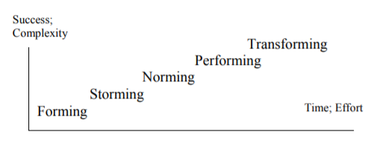

Figure 3: The various stages of team building and group dynamics (Nazzaro, 2009).

If a conflict takes place within a group or at the workplace, it is essential for the conflict to be resolved professionally and effectively. There are various methods for resolving conflicts and this requires HR to act as a mediator to ensure that all parties are involved in the process. One of the ways involves assertiveness wherein the manager takes the initiative to set up a meeting between the two conflicting parties (Mullins, 2013). HR can suggest a solution to the conflict to suggest working together peacefully in order to achieve the various goals. This requires HR to carefully listen to both parties in order to formulate a decision and reach a solution and this requires listening and negotiating skills. On the other hand, an empathy approach can be implemented such that a mediator might get involved by asking the conflicting parties about their feelings about the situation and how each party understand the conflict from their perspective. HR should also document the behaviour of each party in order to establish a way for accountability. This means conflicts can be resolved at the workplace and the HR professionals should be involved based on the fact the HR is an independent body which works to resolve issues without favouring one party over the other (Conflict_Resolution, 2018). Communication is an important part of the HR department. However, Communication helps the HR to perform their jobs and responsibilities. Communication serves as a foundation for planning. All the essential information must be communicated to the HR plans to implement demoralising also requires effective communication with others about their job task. Similarly, leaders as managers must communicate effectively with their subordinates to achieve the team or organisation goals according to MSG Management Study Guide, (2019).

Activity 3:
With reference to a recent or current project (large or small) which you have led (or been part of a project team):
- Provide evidence of using project management and problem-solving techniques in the course of the project.
I have worked in a group and this involved a group project on the notes and tones in music for business in Swansea. The aim of the project was to set up a marketing campaign to advertise for the project. The advertisement for the campaign was through Facebook, blog posts, leaflets, etc. There have been different ideas in order to promote the work and target the relevant audience. The main goal was to create a music organisation to develop and support the local artists of Swansea through fundraising activities (Urban Foundry, 2019). We have set up a website for people to see the various activities and donate wherever possible (Bright Hub Project Management, 2019). There have been several stages to implement the work and this included: planning the advertising campaign, the execution stage and the examination of the results. During the project, we have used project management skills such as ordering priorities, time management, stress control and planning alongside setting up milestones and deliverables. The tasks for instance, were prioritised based on the importance of the task, impact on the group aims and objectives and the consequences of any delays. The project plan was agreed amongst the team members and a Gantt chart was created and reviewed regularly. In terms of problem-solving, we have encountered this on certain occasions, and this was solved by following a systematic approach such that the problem is evaluated, managed and then a decision was taken to resolve the issue. The results were then evaluated and examined to ensure that the solution is applicable (Schein, 2010).

Project Plan | Weeks
Project Plan | 1 | 2 | 3 | 4 | 5 | 6 | 7
Visit Notes and Tones
Fundraising activities
support the local artists of Swansea
Meet with (Ben) direct manager
Visit Unit 19
Charlie sloth at fiction Swansea

The aim of the gig guide to enhance and sustain the growth of Swansea music industry by providing free gig listing service to professional amateur and semi-professional musicians in the notes and tones.
At the start of the project, the workload was low, and this allowed changes to the initial plan for the project. This was possible through brainstorming and proposing ideas (Smith, 2011). The collaboration between group members was very helpful for the project to proceed and succeed. During the project, the leadership has been circulated such that everyone leads the group for a certain period. During my turn of leadership, I managed the group members effectively for almost 3 weeks. I was less confident at the start; however, this has changed during the course of the project. In order to follow up on the work, I have suggested regular meetings, distributed the tasks and suggested deadlines. All ideas have been discussed and feedback was required for improvement. At the end of the project, almost all milestones have been achieved according to the initial plan and all members were pleased about the performance of the group.
- Explain how you successfully influenced, persuaded and negotiated with others in the course of the project (or other related activity).
In this regard, I used the principle of rationalising through which any ideas are supported by evidence and facts. When I suggest new ideas, I only do so if I am confident about them and this falls under the assertiveness. I do, sometimes, insist on certain ideas if I feel that the other members are not proposing opposing or supportive thoughts, and this is necessary for the work to proceed. In addition to the above, negotiating my ideas and look for compromises was essential on many occasions in order to satisfy others while maintaining my beliefs in my ideas. This has successfully worked, and I was able to support the project and examine my ideas and this was very rewarding at the end of the project (Best University Papers, 2019).
Activity 4:
- Undertake a self-assessment of one area of your practice to identify your professional development needs in that area and options to address these.
In terms of self-assessment, I believe that I lack the basic skills to organise my time and tasks when it comes to university submissions and work commitments. This becomes even worse when I become under pressure and therefore a development in this area is required. I started to use the calendar to organise my tasks and commitments and I have also started to do things in advance to avoid the late submissions (Course Hero, 2019). Moreover, when I have more than a single assignment, it has become better if I start working on these in parallel rather than focusing on one and leaving the other till later. This has at least made me comfortable with all assignments at once and gives me the chance to ask my tutors in case I have any questions regarding the work. This plan has started to work effectively, and I have started to feel that the work can be done this way better than before. Moreover, I started to manage my time effectively by setting up targets and work towards these. I have given myself a few days before the deadline to review my work with my tutor and get it improved. This has also reflected on my performance over the past months which is good for me (5STAR ESSAY HELP, 2009). To develop this in the future my responsibility for the implementation of the work and develop better to achieve the goals. to improve myself by watching the videos, also creating new ideas that can be implemented any working patterns and try to use those new ideas.

REFERENCES

5STAR ESSAY HELP, 2009. 5STAR ESSAY HELP.. [Online]
Available at: https://5staressayhelp.com/479-31Undertake-a-self-assessment-of-one-area-of-your-practice-to-identify-your-professional-development-needs-in-that-area-and-options-to-address-these
[Accessed 11 March 2019].
Armstrong, Michael, 2006. Strategic Human Resource Management. 3nd ed. London: A Guide to Action.
Armstrong, M., 2006. Strategic human resource management. 3nd ed. London: A Guide to Action.
Banning, S., 1999. The professionalization of journalism: a nineteenth-century beginning. Journalism History, 24(4).
Best University Papers, 2019. Best University Papers. [Online]
Available at: http://bestuniversitypapers.com/2016/10/01/hr-developing-professional-practice/
[Accessed 14 March 2019].
Bright Hub Project Management, 2019. Bright Hub Project Management. [Online]
Available at: https://www.brighthubpm.com/resource-management/87541-problem-solving-techniques-in-project-management/
[Accessed 11 March 2019].
CIPD, 2017. HR professionalism: what do we stand for?, s.l.: CIPD.
Conflict_Resolution, 2018. Examples of Conflict Resolution Skills. [Online]
Available at: https://www.thebalancecareers.com/conflict-resolutions-skills-2063739
[Accessed 26 2 2019].
Course Hero, 2019. Course Hero. [Online]
Available at: https://www.coursehero.com/file/p3ddt9v2/Activity-4-Undertake-a-self-assessment-of-one-area-of-your-practice-to-identify/
[Accessed 14 March 2019].
Gold, J., 2010. Human resource development : theory and practice. New York: Palgrave Macmillan.
HRZone, 2019. HRZone. [Online]
Available at: https://www.hrzone.com/hr-glossary/what-are-group-dynamics
[Accessed 14 March 2019].
Hurd, H., 1967. Who is a professional?. Journal of Cooperative Extension.
Keegan, A. & Francis, H., 2010. Practitioner talk: the changing textscape of HRM and emergence of HR business partnership. International Journal of Human Resource Management, 21(6).
MSG Management Study Guide, 2019. MSG Management Study Guide. [Online]
Available at: https://www.managementstudyguide.com/importance-of-communication.htm
[Accessed 14 March 2019].
Mullins, L. J., 2013. Management and organisational behaviour. 10nd ed. Harlow: Pearson Education.
Mullins, L. J., 2016. Management and Organisationl Behaviour. 11nd ed. New York: Person.
Nazzaro, A., 2009. Group Dynamics and Team Building, s.l.: HEMOPHILIA ORGANIZATION DEVELOPMENT - WHF.
Schein, E. H., 2010. Oranisation Culture and Management. 4nd ed. San Francisco: Jossey Bass.
Smith, M., 2011. Fundamentals Of Management. 2nd ed. Maidenhead: McGraw-Hill Education.
Tuckman, B., 2014. Group Dynamics-stages, theories, elements. [Online]
Available at: http://www.nsgmed.com/management/group-dynamics-stages-theories-elements/
[Accessed 26 2 2019].
Urban Foundry, 2019. Forgoing Great Ideas. [Online]
Available at: http://www.urbanfoundry.co.uk/
[Accessed 13 March 2019].
Woodhams, S., 2016. Human resource management : people and organisations. 2nd ed. London: Chartered Institute of Personnel and Development.
Wooten, K., 2001. Ethical dilemmas in HRM: an application of a multidimensional framework, a unifying taxonomy, and applicable codes. Human Resource Management Review, 11(1).

