
Software Development Report

Image belongs to UWTSD
Link: https://www.uwtsd.ac.uk/msc-software-engineering/
Contents
Page 1: Introduction
Page 1: Problems solved
Page 2 - 4: Flowcharts
Page 5 - 7: Stages of development
Page 7: Testing
Introduction
During this report I will be briefly talk about the problems that I had to solve to get all three of the applications working (in theory, during the planning phase) the flowcharts for the applications themselves stages of development and my testing.
Problems solved
This will only include major issues and not include solutions, this will be included in the stages of development section.
Task | Problem | Difficulty
1 | Must hide user input, so that player 2 can’t cheat. | Hard
2 | Have to make sure all treasure is placed before switching to player 2 | intermediate
2 | Have to change the location of a correct treasure to X when player 2 guesses its location correctly. | Intermediate
2 | Have to perform power ups when player 2 presses the corresponding button | Easy

Flowcharts
Task 1
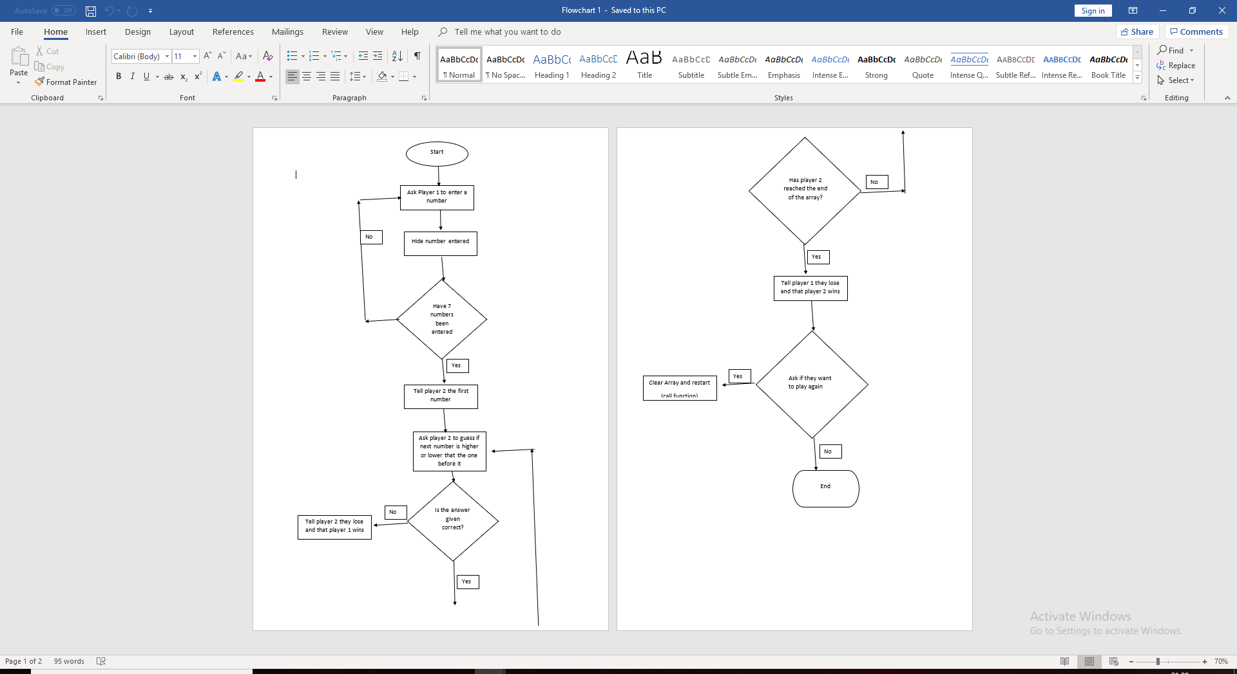

Task 2
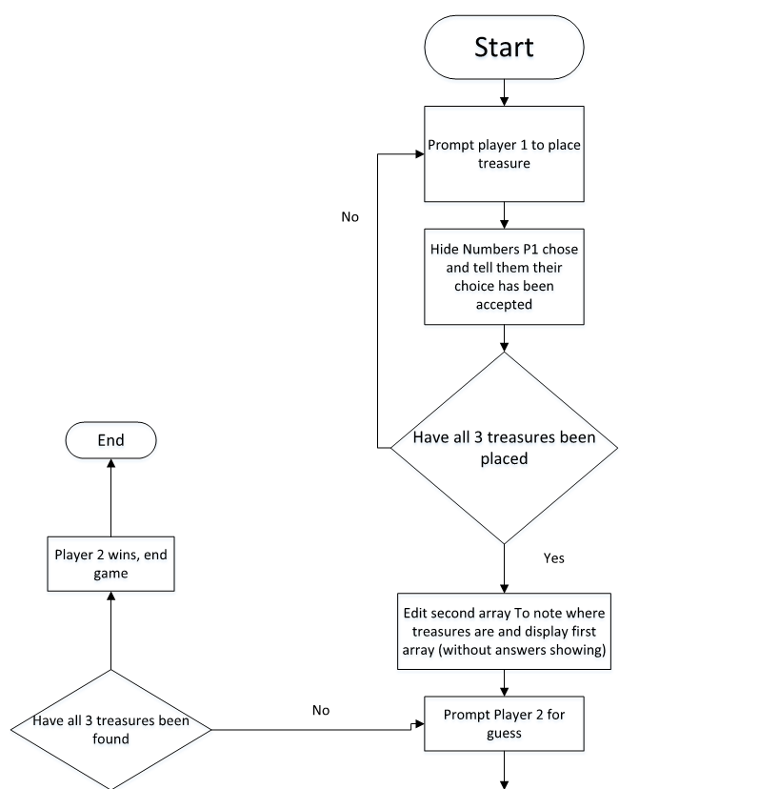
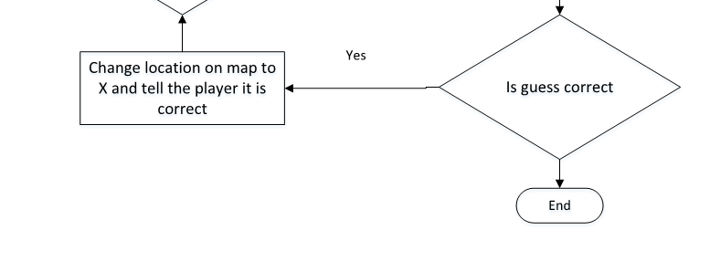

Stages of development
Task 1
Include
#include "pch.h"
#include <iostream>
#include<string>
#include<sstream>
Start the program
using namespace std;
int main()
{
p1();
}

Player 1 Input
int p1()
{

// to store Player 1's numbers for tests
int P1[6];

//to help change where player 1's numbers are saved, also for testing
int pNum = 1;
int i = 0;
string userinp;
while (pNum != 8)
{
cout << "Please enter a whole number (no decimals) " << endl;
cin >> userinp;
Hiding user input
//the following is to hide user input
int len = userinp.length();
for (int i = 0; i < len; i++)
{
cout << "*";
}
cout << endl;
Player 1 input cont
if (pNum == 1)
{
cin >> P1[0];
pNum = pNum + 1;
}
This is repeated until the array if full

Player 1 error proofing

if (pNum < 0)
{
return 0;
}
Player 2 input (separate function)
char HL;
int point = 0;

cout << "P2 First number is " << P1[0] << endl;

cout << "Is the next number higher (H) or Lower (L)? ";
cin >> HL;
Error proofing
// error proofing
if (HL != 'H' || HL != 'L')
{
int errorcount = 0;
cout << "invalid Try again" << endl;

int P2(P1[6]);
}
Higher or Lower
if (HL == 'H')
{
if (P1[1] > P1[0])
{
cout << "Congrats you are onto the next stage" << endl;
point = point + 1;
}
}

if (HL == 'L')
{
if (P1[1] < P1[0])
{
cout << "Congrats you are onto the next stage" << endl;
point = point + 1;

}
}
else
{
cout << "You lose" << endl;
}

if (point == 1)
{
cout << "Is the next number higher (H) or Lower (L)? ";
cin >> HL;

if (HL == 'H')
{
if (P1[2] > P1[1])
{
cout << "Congrats you are onto the next stage" << endl;
point = point + 1;
}
}Repeated until point = 6;
Checking if player 2 wins
if (point == 7)
{
cout << "Congratulations you are winner!" << endl;
}
}
Testing
Test No | Test name | Task | Description & Expected Result | Actual result | Pass/Fail | Date carried out
01 | User input hidden | 1 | When the user (P1) types in their number it is displayed as an empty space or turned into an *. | User input changed to a * | Pass | 21/03/2019
02 | Error proofing | 1 | If the user (P2) enters anything that isn’t H or L It will tell them it is invalid and to try again, and return to the beginning of the function | It told me it was invalid after entering A | Pass | 21/03/2019
03 | Moving on to the next ‘stage’ | 1 | When P2 guesses correctly the application should move on to the next stage | It ended the program | Fail | 22/03/2019
04 | Moving on to the next ‘stage’ | 1 | When P2 guesses correctly the application should move on to the next stage | Moved on the next stage and continued until the end of the game | Pass | 25/03/2019

Appendix
Task 1
#include "pch.h"
#include <iostream>
#include<string>
#include<sstream>

using namespace std;
int main()
{
p1();
}

int p1()
{

// to store Player 1's numbers for tests
int P1[6];

//to help change where player 1's numbers are saved, also for testing
int pNum = 1;
int i = 0;
string userinp;
while (pNum != 8)
{
cout << "Please enter a whole number (no decimals) " << endl;
cin >> userinp;
//the following is to hide user input
int len = userinp.length();
for (int i = 0; i < len; i++)
{
cout << "*";
}
cout << endl;

//to save the input to the array
if (pNum == 1)
{
cin >> P1[0];
pNum = pNum + 1;
}
if (pNum == 2)
{

cin >> P1[1];
pNum = pNum + 1;
}
if (pNum == 3)
{
cin >> P1[2];
pNum = pNum + 1;
}
if (pNum == 4)
{
cin >> P1[3];
pNum = pNum + 1;
}
if (pNum == 5)
{
cin >> P1[4];
pNum = pNum + 1;
}
if (pNum == 6)
{
cin >> P1[5];
pNum = pNum + 1;
}
if (pNum == 7)
{
cin >> P1[6];
pNum = pNum + 1;
}

//error proofing
if (pNum < 0)
{
return 0;
}

}

int P2(P1[6]);
}

int P2(int P1[6])
{
char HL;
int point = 0;

cout << "P2 First number is " << P1[0] << endl;

cout << "Is the next number higher (H) or Lower (L)? ";
cin >> HL;

// error proofing
if (HL != 'H' || HL != 'L')
{
int errorcount = 0;
cout << "invalid Try again" << endl;

int P2(P1[6]);
}
// end of EP

if (HL == 'H')
{
if (P1[1] > P1[0])
{
cout << "Congrats you are onto the next stage" << endl;
point = point + 1;
}
}

if (HL == 'L')
{
if (P1[1] < P1[0])
{
cout << "Congrats you are onto the next stage" << endl;
point = point + 1;

}
}
else
{
cout << "You lose" << endl;
}

if (point == 1)
{
cout << "Is the next number higher (H) or Lower (L)? ";
cin >> HL;

if (HL == 'H')
{
if (P1[2] > P1[1])
{
cout << "Congrats you are onto the next stage" << endl;
point = point + 1;
}
}

if (HL == 'L')
{
if (P1[2] < P1[1])
{
cout << "Congrats you are onto the next stage" << endl;
point = point + 1;

}
}
else
{
cout << "You lose" << endl;
}
}

if (point == 2)
{
cout << "Is the next number higher (H) or Lower (L)? ";
cin >> HL;

if (HL == 'H')
{
if (P1[3] > P1[2])
{
cout << "Congrats you are onto the next stage" << endl;
point = point + 1;
}
}

if (HL == 'L')
{
if (P1[3] < P1[2])
{
cout << "Congrats you are onto the next stage" << endl;
point = point + 1;

}
}
else
{
cout << "You lose" << endl;
}
}

if (point == 3)
{
cout << "Is the next number higher (H) or Lower (L)? ";
cin >> HL;

if (HL == 'H')
{
if (P1[4] > P1[3])
{
cout << "Congrats you are onto the next stage" << endl;
point = point + 1;
}
}

if (HL == 'L')
{
if (P1[4] < P1[3])
{
cout << "Congrats you are onto the next stage" << endl;
point = point + 1;

}
}
else
{
cout << "You lose" << endl;
}
}

if (point == 4)
{
cout << "Is the next number higher (H) or Lower (L)? ";
cin >> HL;

if (HL == 'H')
{
if (P1[5] > P1[4])
{
cout << "Congrats you are onto the next stage" << endl;
point = point + 1;
}
}

if (HL == 'L')
{
if (P1[5] < P1[4])
{
cout << "Congrats you are onto the next stage" << endl;
point = point + 1;

}
}
else
{
cout << "You lose" << endl;
}

}

if (point == 5)
{
cout << "Is the next number higher (H) or Lower (L)? ";
cin >> HL;

if (HL == 'H')
{
if (P1[6] > P1[5])
{
cout << "Congrats you are onto the next stage" << endl;
point = point + 1;
}
}

if (HL == 'L')
{
if (P1[6] < P1[5])
{
cout << "Congrats you are onto the next stage" << endl;
point = point + 1;

}
}
else
{
cout << "You lose" << endl;
}
}

if (point == 6)
{
cout << "Is the next number higher (H) or Lower (L)? ";
cin >> HL;

if (HL == 'H')
{
if (P1[6] != (P1[6] + 1))
{
cout << "Congrats you are onto the next stage" << endl;
point = point + 1;
}
}

if (HL == 'L')
{
if (P1[6] != (P1[6] - 1))
{
cout << "Congrats you are onto the next stage" << endl;
point = point + 1;

}
}
else
{
cout << "You lose" << endl;
}
}

if (point == 7)
{
cout << "Congratulations you are winner!" << endl;
}
}

