

ACDA5001 RLC Report

AC Response of an Network

Leon Scammell

Date : 29/12/2020

—

Course Title : ACDA5001 Electrical Engineering

—

Student Number : 2017986

This report will cover my investigation results, calculations, and the answers to these calculations for an RLC AC circuit network. This is a circuit with an AC supply, a single resistor, and an inductor and capacitor wired in parallel. The intended outcome of this task was to investigate how this RLC circuit responds to a range of different frequencies with the voltage remainign constant, and display this on various graphs to explain the results. The circuit achieved resonance at 38Hz and caused the circuit to resist current flow and act as an open circuit. I looked at how this impacted the voltage phases and power factor. I also calculated components that allow a circuit to achieve maximum power transfer with minimum reactive losses.

Abstract
Introduction
The circuit being investigated was a simple RLC circuit with a constant AC supply. 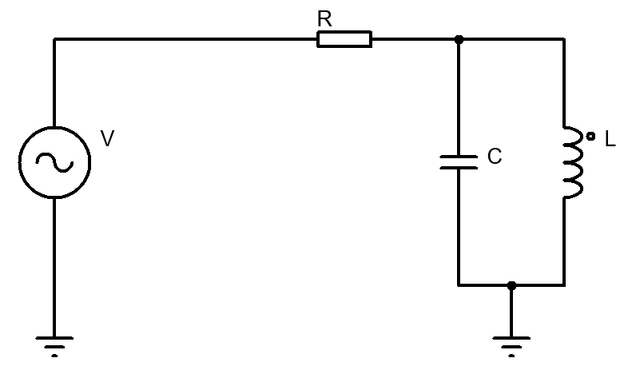
The values for the components were to be taken from my student number (2017986).

The voltage was to be 10V peak from a sinusoidal source (AC).
The inductor value was the first there numbers (201mH) [Henries]
Resistor value was the fourth and fifth (79Ω) [Ohms]
Capacitor value was taken from the last two digits (86µF) [Farads]

I will calculate the characteristics of the circuit and analyse the ways it responds to a varying frequency, as well as display the corresponding graphs for the following:
- Circuit current
- Component voltage drops
- Active, reactive and apparent power
- Power factor
- Energy stored in the capacitor and inductor at resonance
I will also produce phasor diagrams showing the phase shifts depending on the frequency.
I will also look into how maximum power transfer relates to power factor correction and resonance in AC circuits.

$$X_{L}=2πfL$$

$$X_{C}=\frac{1}{2πfC}$$

R | 79 | Ω
L | 201 | mH
C | 86 | µF
V | 10 | V

Task 1.1.

First task was to calculate the circuit current plotted against frequency.
The range of frequencies was created to be used in the calculations. This ranged from 1Hz, up to 1000000Hz.

Reactance of the inductor ($X_{L}$) is calculated using the formula [ ]. So with my value for frequency (1Hz) being entered:

Capacitive reactance was calculated using the formulae [ ]. I entered my values for 1Hz to get:

$$X_{C}=0-\left(\frac{-1}{2×π×1×86x{10}^{-6}}\right)j=0-1850.6389j$$

I calculated the combined impedance of the capacitor and inductor in the circuit (ZLC) for 1Hz. I did this using product over sum of the inductive and capacitive reactances.

$$ZLC=\frac{0.001+1.2629×0-1850.6389}{0.001+1.2629j+0-1850.6389}=0.001+1.2638$$

$X_{L}=0.001+\left(2×π×1×201x{10}^{-3}\right)j$= 0.001+1.2629j

Procedure
Figure 1
$$|z|= \sqrt{x^{2} + y^{2}}$$

Resonance – 38.2801Hz
Resonant frequency was calculated. 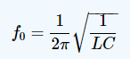
𝑓𝑟𝑒𝑠=12𝜋𝐿𝐶 [12]
𝑓𝑟𝑒𝑠=12𝜋0.201×0.000086
=38.28Hz

I calculated the impedance of the entire circuit by adding the resistance of the resistor to ZLC.
𝑍𝑡𝑜𝑡𝑎𝑙=79+0𝑗+1.2638𝑗=79.001+1.2638𝑗
The current in the circuit was calculated by dividing circuit voltage by total impedance.
10+0𝑗79.001+1.2638𝑗=0.1265−0.002𝑗𝐴
To produce a graph, I need to produce the absolute value of the current for each frequency value. This is because I can only add either the real or imaginary number of the current into the graph axis, which will not display what is actually happening in the circuit. I did this with the formulae [ ].

This uses pythagorean theorem to calculate z from x and y as a triangle.[2]
𝐼= 0.1265²−0.002²=0.12648𝐴
I repeated this for each value of frequency increasing as 1,2,5,10,20,50,100,200, and so on until it reached 1000000Hz. I used the values for frequency and absolute current to produce a graph to display how current changes depending on the frequency in this circuit.

Procedure
Figure 2

Task 1.2.

The next task was to determine the voltage drop across the resistor as well as the inductor and capacitor which are in parallel.
The voltage across the resistor is calculated using ohms law for each value of frequency. 𝑉=|𝐼|×𝑅
𝑉𝑅=0.12656×79=9.998𝑉
And then repeated this for the |𝐼| of each frequency.
Next the voltage across the inductor and capacitor is parallel was calculated using complex numbers.
𝑉𝑅=𝐼×𝑍𝐿𝐶
𝑉𝑅=0.1265−0.002𝑗×0.001+1.2638𝑗=0.002685+0.1599𝑗
Then the absolute value for VLC was calculated.
𝑉𝐿𝐶= 0.002685²+0.1599²=0.16𝑉
This was then repeated for each value of VLC for each frequency.
The values for VR and 𝑉𝐿𝐶 were then plotted on a graph with the frequencies being on the x axis and voltage being on the y axis. Resonant frequency is the one that produces the most voltage drop.

Procedure
Figure 3

Task 1.3.

Next I plotted the active, reactive and apparent power against each frequency in the range.

𝑃= |𝐼|2𝑍𝑡𝑜𝑡𝑎𝑙
𝑃=0.126562×79.001=1.2655𝑊 𝐴𝑐𝑡𝑖𝑣𝑒 𝑃𝑜𝑤𝑒𝑟
This was repeated for the absolute current for each frequency, and plotted on a graph.
Reactive power was calculated with the formulae: 𝑄=$\text{I}$2𝑋 (X being the imaginary part of ZLC).
𝑄=0.12662×1.26378=1.26378W Reactive Power
Next, apparent power was calculated using the power triangle and trigonometry, for the values of Q and P.
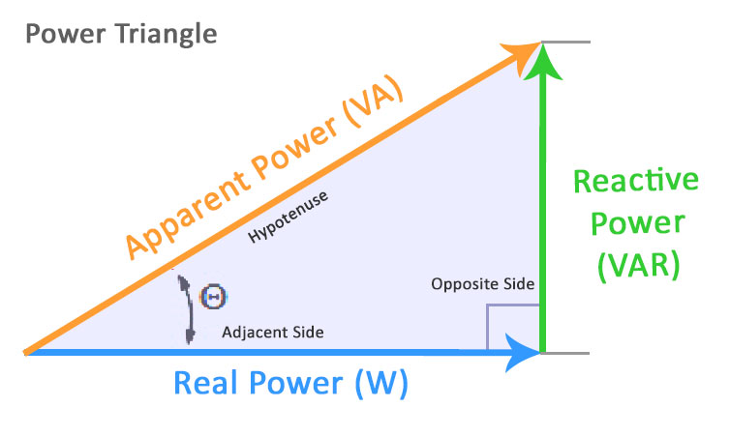 [5]
𝑆=(𝑃2+𝑄2)
𝑆=(1.265482+0.0202442) =1.26564𝑊
This was also repeated for the values of P&Q for each frequency. These were all plotted on a graph.

Procedure
Figure 4

Task 1.4.

Power factor against frequency was calculated by first working out the phase angle (φ) for each frequency.
𝜃=$\text{tan}$−1𝑦𝑥With the complex number being in the form (x+yj).

𝜃=$\text{tan}$−1𝑃𝑆
The values of total impedance were used (79.001+1.26378j).

𝜃=$\text{tan}$−11.2637879.001= 0.9165˚ , repeated for each Ztotal for each frequency in the range.

Then power factor for each was calculated using cos𝜃=𝑝𝑓.

Pf=cos(0.916485)=0.99987
This was repeated for each frequency in the range, and plotted onto a graph against the frequencies.

Procedure
Figure 2
Figure 1

Task 1.5.

In this graph with a logarithmic frequency axis, the circuit is at resonance at 38.2801Hz where the current drops down to 0.000004278A or 4.28µA, down from around 0.13A at other frequencies which is effectively nothing (no flow). Resonance in this circuit is when the inductive and capacitive reactances are equal. [7] This occurs when the impedances of the inductor and capacitor are greatest and are at their peak in the range of frequencies, being 2337209.3Ω which is enough to pretty much fully prevent any current flow. [3] At low and higher frequencies the impedance drops drastically, which allows current flow as can be seen in figure 1 above. The inductive and capacitive reactances are both equal at resonance and cause the circuit to effectively act as an open circuit. Therefor this circuit absorbs the most power and current at the resonant frequency. The inductor will allow current flow at low frequencies but the capacitor will resist, however at higher frequencies the reverse is the case. When they both have the same impedance, current flow is impossible because the two components have current flows which are 180˚ out of phase of each other and therefor cancel eachother out and prevent current flow at resonance. [4] Voltage drop is greatest at resonance.

Procedure

Task 2.
The next task was to produce phasor diagrams to show the component current and voltages for the above circuit, when the circuit is at resonance as well as at 25Hz above and below.

 | Freq
 | 13.280084Hz
Resonance | 38.280084Hz
 | 63.280084Hz

I then repeated the same calculations used previously in task 1 to work out the inductive reactance (XL), capacitive reactance (XC), ZLC, total impedance, as well as the current (I) for each of the three new frequencies.
VR was then calculated using ohms law. This is for the first frequency (13.28008Hz)
$$VR=I×R=0.1196-0.02887j×79=9.4494-2.2806j$$
Then the absolute value was calculated.
$\left|VR\right|= \sqrt{x^{2} + y^{2} }=\sqrt{real^{2}+imaginary^{2}}$ [2]

$$\left|VR\right|= \sqrt{{9.4494}^{2} - {2.2806}^{2}}=9.7207V$$
Next I calculated the voltage across the inductor and capacitor (VLC). This was calculated by multiplying the current (I) with the impedance of the inductor/capacitor section (ZLC).

$$VLC=I×ZLC=0.119613+0.028868j×0.001292+19.06638j=0.55056+2.28055j$$
Then the absolute value calculated again.
$$\left|VLC\right|=\sqrt{{0.55056}^{2}+{2.28055}^{2}}=2.34607V$$
Next, the voltages and currents need to be converted to angles for the phasor diagrams.
$$θVr=\tan^{-1}\left(\frac{b}{a}\right)=\tan^{-1}\left(\frac{-2.28055277}{9.4494419}\right)=-13.57˚$$
$$θVLC=\tan^{-1}\left(\frac{b}{a}\right)=\tan^{-1}\left(\frac{2.28055277}{0.5505581}\right)=76.43˚$$
$$θI=\tan^{-1}\left(\frac{b}{a}\right)=\tan^{-1}\left(\frac{-0.0288678}{0.11961319}\right)=-13.57˚$$
These are the calculations for the first frequency (13.28008Hz). These calcualtions were then all repeated for the other two frequencies (.38.280084Hz) and (63.280084Hz).

Procedure

Graphs for the phasor diagrams of each frequency were produced.
To do this I converted the magnitudes and angles into x and y coordinates. I did this using trigonometry (SOH CAH TOA). X is the adjacent, with the angle θ being the hypotenuse. The Y component is opposite the angle.
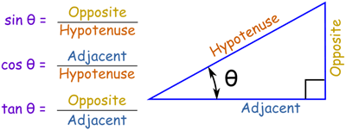 [6]
I used the current angle in degrees as a reference for the phasor diagrams. So the current phasor is on the horizontal x axis, normalising the angles of the other phasor diagrams. Using theta I (-13.5684). The Resistor voltage will also be horizontal since there is no phase shift, whereas the inductor and capacitor phasor will be inductive, and will point upwards rather than horizontally. As I am looking at voltage phasors, I will take current as the reference point and normalise all phasors to be in-line with the current phasor.

I used the magnitude of VLC being $\left|VLC\right|=2.346$
The angle being Theta θ VLC=76.4276
Current angle θI= -13.5684Ω with the absolute value of this being added in the equation shown below.
25Hz Before Resonance Phasor Calculations
VLC
$$x=2.34607\cos\left(76.4277+13.5684\right)=0.000159$$
$$y=2.34607\sin\left(76.4277+13.5684\right)=2.346068$$

VR = $\left|VR\right|=9.7207$ multiplied with Theta VR.
VR
$$x=9.7207\cos\left(-13.568+13.568\right)=9.720744$$
$$y=9.7207\sin\left(-13.568+13.568\right)=2.10962x{10}^{-15}$$
I
$\left|I\right|=0.12305$
$$x=0.12305\cos\left(-13.568+13.568\right)=0.123047$$
$$y=0.12305\sin\left(-13.568+13.568\right)=0$$

These values for x and y for VLC, VR and I were then plotted onto a phasor diagram, shown on the next page.
Procedure

The calculations were then repeated with the VLC, VR and I of the other frequencies (resonance, 38.2801) and (25Hz above, 63.2801). In this phasor the voltage is leading the current as the circuit is inductive at this frequency.

In this phasor the voltage is lagging the current as the circuit it mainly capacitive at this frequency.

In this phasor the circuit is purely resistive at resonance as the inductor and capacitor cancel eachother out, leaving just the resistance. This means the voltage is in phase with the current. The power factor will be improved here with the circuit being more in phase, improving efficiency and reducing losses.
The phase angle here is 0˚ as the impedance is purely resistive (no inductive or capacitive reactances) at resonant frequency.
Procedure
Positive = inductive
[8]
Opposite of inductive source, thus cancels out for purely resistive circuit. Improving the power factor

Task 3.
R= 5Ω, L = $150×{10}^{-6}$H
Maximum Power Transfer = Zsource=Zload.

This relates to power factor correction as the internal impedance of the voltage source will have a significant effect on the current phase which is being supplied. The larger this phase shift, the more the actual power is reduced, with reactive power being increased. So for maximum power transfer, I want the real power and apparent power to be at their maximum whilst reactive power is at its minimum so that losses are minimised. The smaller the phase shift, the less the reactive power and the closer to maximum power the circuit becomes.

Internal impedance – Zs
Load Impedance – ZL
XL=XC
Inductive reactance XL=2πfL, $2×π×50×150×{10}^{-6}=0.047124Ω$
The source is inductive so for maximum power transfer
XC=0.047124
$$Z=R+jXL$$
$$Z=5+j0.047124$$
$$\left|Z\right|=\sqrt{5^{2}+{0.047124}^{2}}=5.000222Ω$$
$$θ=\tan^{-1}{}\left(\frac{0.047124}{5}\right)=0.54˚$$
So the reactive part of the impedance is j0.047124Ω. This is positive as the reactive power is inductive due to the inductor at the source. This must be eliminated for maximum power. This will make the circuit purely resistive which is minimum overall impedance. The combined impedance is given by $Z=R1+R2+jXL-jXc$. [8] With the reactances being equal, they will cancel out.
$$XC=\frac{1}{2πfC}$$
$$C=\frac{1}{2πfXc}$$
$$C=\frac{1}{2×π×50×0.047124}=0.0675F, 67.5mF$$

This capacitance will result in a capacitive reactance XC of 0.047124, which will eliminate the reactive part of the impedance, and will make the circuit purely resistive, which will produce maximal current flow with this circuit. [9]
$$Z=\sqrt{R^{2}+X^{2}}$$
$$Z^{2}-X^{2}=R^{2}$$
$R=\sqrt{\left(Z^{2}-X^{2}\right)}$=$\sqrt{{5.000222}^{2}-{0.047124}^{2}}=4.9999Ω$
$$θ=\tan^{-1}{}\left(\frac{-0.047124}{5.000222}\right)=-0.54˚$$

The load impedance is equal to the source for maximum power. If the source impedance was smaller than the load, the power that gets used up at the load will be greater which reduces efficiency. [10]
This relates to power factor correction as with the circuit being purely resistive (reactances cancelled out), the current is in phase with the voltage, improving the power factor. Lagging power factor reveals that the current lags the voltage, which would be the case for an inductive circuit. With there being a capacitor of equal reactance being 180˚ phase difference from an inductive circuit, this cancels out and allows the current to be in phase with the voltage. [11]
Use a 5Ω resistor and 0.0675F capacitor at the load for maximum power transfer.

This relates to resonance as the formulae used was for maximum power transfer ($Rsrc+jXsrc=Rlaod-jXload$, which follows the same principle as resonance $\left|XC\right|=\left|XL\right|$, in which they cancel eachother out for maximum power and current flow. They are effectively the same thing and are calculated the in the same manner.

Procedure

The findings of this work include the following:

- A parallel RLC circuit will act an an open circuit and prevent current flow at resonance. But will allow it at other frequencies. (Figure 1)
- Greatest volt drop is at resonance. (Figure 2)
- Active power, and apparent power crash at resonance. Reactive power increases before and crashes after. Capacitive loads generate Q whereas inductive loads deplete Q, shown here in (Figure 3).
- Power factor is improved at resonance (Figure 4)
- Voltage is in phase with the current at resonance.
- Maximum power transfer occurs when the impedance of the load is equal to the complex conjugate of the source. When XL=XC.
Conclusion

Referencing

References

[1] | M. v. Biezen, "Physics - E&M: RCL Circuits (2 of 13) Complex Numbers," Youtube, 25 2 2014. [Online]. Available: https://www.youtube.com/watch?v=jD1WjaopIEM. [Accessed 29 12 2020].
[2] | D. E. Joyce, "Dave's Short Course on Complex Numbers Absolute Value," Clarke University, 1999. [Online]. Available: https://www2.clarku.edu/faculty/djoyce/complex/abs.html#:~:text=For%20a%20complex%20number%20z,on%20the%20real%20number%20line.. [Accessed 29 12 2020].
[3] | R. Nave, "HyperPhysics***** Electricity and Magnetism," hyperphysics, [Online]. Available: http://hyperphysics.phy-astr.gsu.edu/hbase/electric/parres.html#c1. [Accessed 29 12 2020].
[4] | "artsites," 10 1 1998. [Online]. Available: http://artsites.ucsc.edu/EMS/music/tech_background/Z/impedance.html#:~:text=As%20the%20frequency%20rises%2C%20the,you%20get%20no%20current%20flow.&text=It's%20because%20of%20the%20phase,inductor%20is%2090%C2%B0%20behind.. [Accessed 29 12 2020].
[5] | testguy, "Power Triangle Calculator," https://testguy.net/, [Online]. Available: https://testguy.net/content/358-Power-Triangle-Calculator. [Accessed 30 12 2020].
[6] | R. Pierce, "Introduction to Trigonometry," mathsisfun, 10 2 2020. [Online]. Available: https://www.mathsisfun.com/algebra/trigonometry.html. [Accessed 26 12 2020].
[7] | "Simple Parallel (Tank Circuit) Resonance Chapter 6 - Resonance," allaboutcircuits, [Online]. Available: https://www.allaboutcircuits.com/textbook/alternating-current/chpt-6/parallel-tank-circuit-resonance/. [Accessed 26 12 2020].
[8] | C. Smith, "Impedance and the j Operator," gm4riv.org, 2 2019. [Online]. Available: https://www.gm4riv.org/wp-content/uploads/2019/01/z-and-j-operator.pdf. [Accessed 5 01 2020].
[9] | J. M. Fiore, "James M. Fiore," libretexts, 14 9 2020. [Online]. Available: https://eng.libretexts.org/Bookshelves/Electrical_Engineering/Electronics/Book%3A_AC_Electrical_Circuit_Analysis%3A_A_Practical_Approach_(Fiore)/05%3A_Analysis_Theorems_and_Techniques/5.5%3A_Maximum_Power_Transfer_Theorem. [Accessed 5 1 2021].
[10] | ADMINISTRATOR, "Maximum Power Transfer Theorem (MPTT)," electronicshub, 4 6 2019. [Online]. Available: https://www.electronicshub.org/maximum-power-transfer-theorem/. [Accessed 5 1 2021].
[11] | R. Nave, "Electricity and Magnetism," HyperPhysics, [Online]. Available: http://hyperphysics.phy-astr.gsu.edu/hbase/electric/phase.html#:~:text=When%20capacitors%20or%20inductors%20are,peak%20at%20the%20same%20time.&text=This%20leads%20to%20a%20positive,the%20current%20leads%20the%20voltage.. [Accessed 5 1 2021].
[12] | J. S. (. M. U. a. B. M. Samuel J. Ling (Truman State University), "15.6: Resonance in an AC Circuit," libretexts, 5 11 2020. [Online]. Available: https://phys.libretexts.org/Bookshelves/University_Physics/Book%3A_University_Physics_(OpenStax)/Map%3A_University_Physics_II_-_Thermodynamics_Electricity_and_Magnetism_(OpenStax)/15%3A_Alternating-Current_Circuits/15.06%3A_Resonance_in_an_AC_Circuit#:~:t. [Accessed 5 1 2021].

