DS 1 Adnan Tahir

My Screenshots/Photos

Screenshot/Photo 1
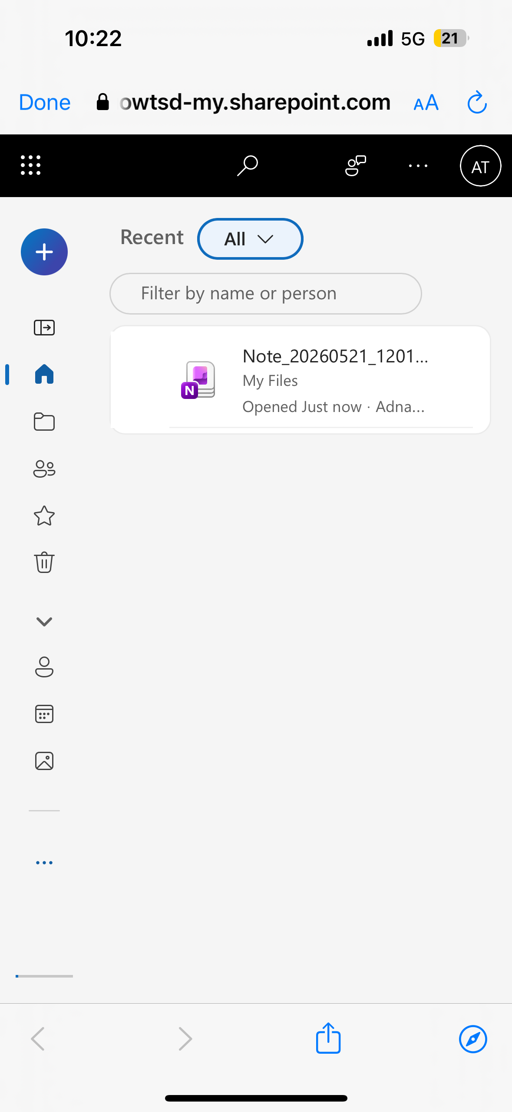

I have leant how to use One note in my daily life which will help me throughout my university studies and can help my when I decide to open my business to keep things organised.

Screenshot/Photo 2
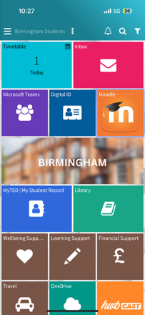

Using the university interface (moodle) has helped my organise my daily work and allowed me to use different applications such as; one drive, moodle, travel, hub cast and many more.

Screenshot/Photo 3

I use whatsapp on a daily basis to communicate, send and receive images/ videos with my friends and family.

Screenshot/Photo 4


Youtube gets used everyday as it’s my downtime and i get to watch all my favourite content. Sometimes ill upload videos if i think others will find them interesting.

Screenshot/Photo 5
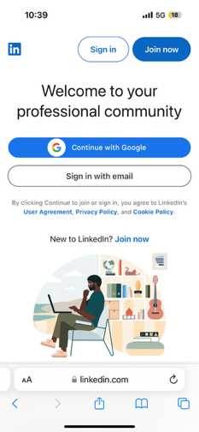

I have recently used LinkedIn and will be using it for the foreseeable future as i can apply to different jobs i would otherwise not find. I can also learn different lessons on many subjects ranging from healthcare to business development.

Screenshot/Photo 6

I used safari daily without fail as im able to do so many things such as view the news, apply for jobs, shop and most importantly find funny videos to send to friends and family.

My Short Reflection

Throughout the use of my digital life I’ve learned that I’m able to easily search for information, shop online, communicate with family/friends, view news and upload work. I would like to think I am quite capable enough to help others if needed. However I also understand the need for me to develop my digital skills in areas such as being on social media as it may help me boost my confidence and ability to meet new people and this will help me explore certain job opportunities. I am also interested in learning how to edit videos to a higher degree with newer and sharper transitions to keep up to date with the technology as it changes over times. This module has helped my organise my own work as I have learned how to organise a messy folder into clear files which make it easier and quicker for me to find and upload my work therefore improving my productivity and reducing my mistakes. Ok completion of this course I would like to be able to recognise phishing emails, search reliable information and be able to confidently converse using digital platforms such as; Google Meet, Skype and Teams.

Submission Checklist
Before you submit, please check:
​​​ ☒ I added 4–6 screenshots
☒ I wrote short sentences for each screenshot
☒ I wrote my short reflection
☒ My work is my own
☒ My file opens correctly
​​☒ My file opens correctly

