Title:
PIC Programming

Module:
Micros, Peripherals and Interfaces
ACDA4004

Electronics and Electrical Engineering HND

University of Wales Trinity St David

By: Nick Regan
Student No: 1803871
Date: 31.1.19
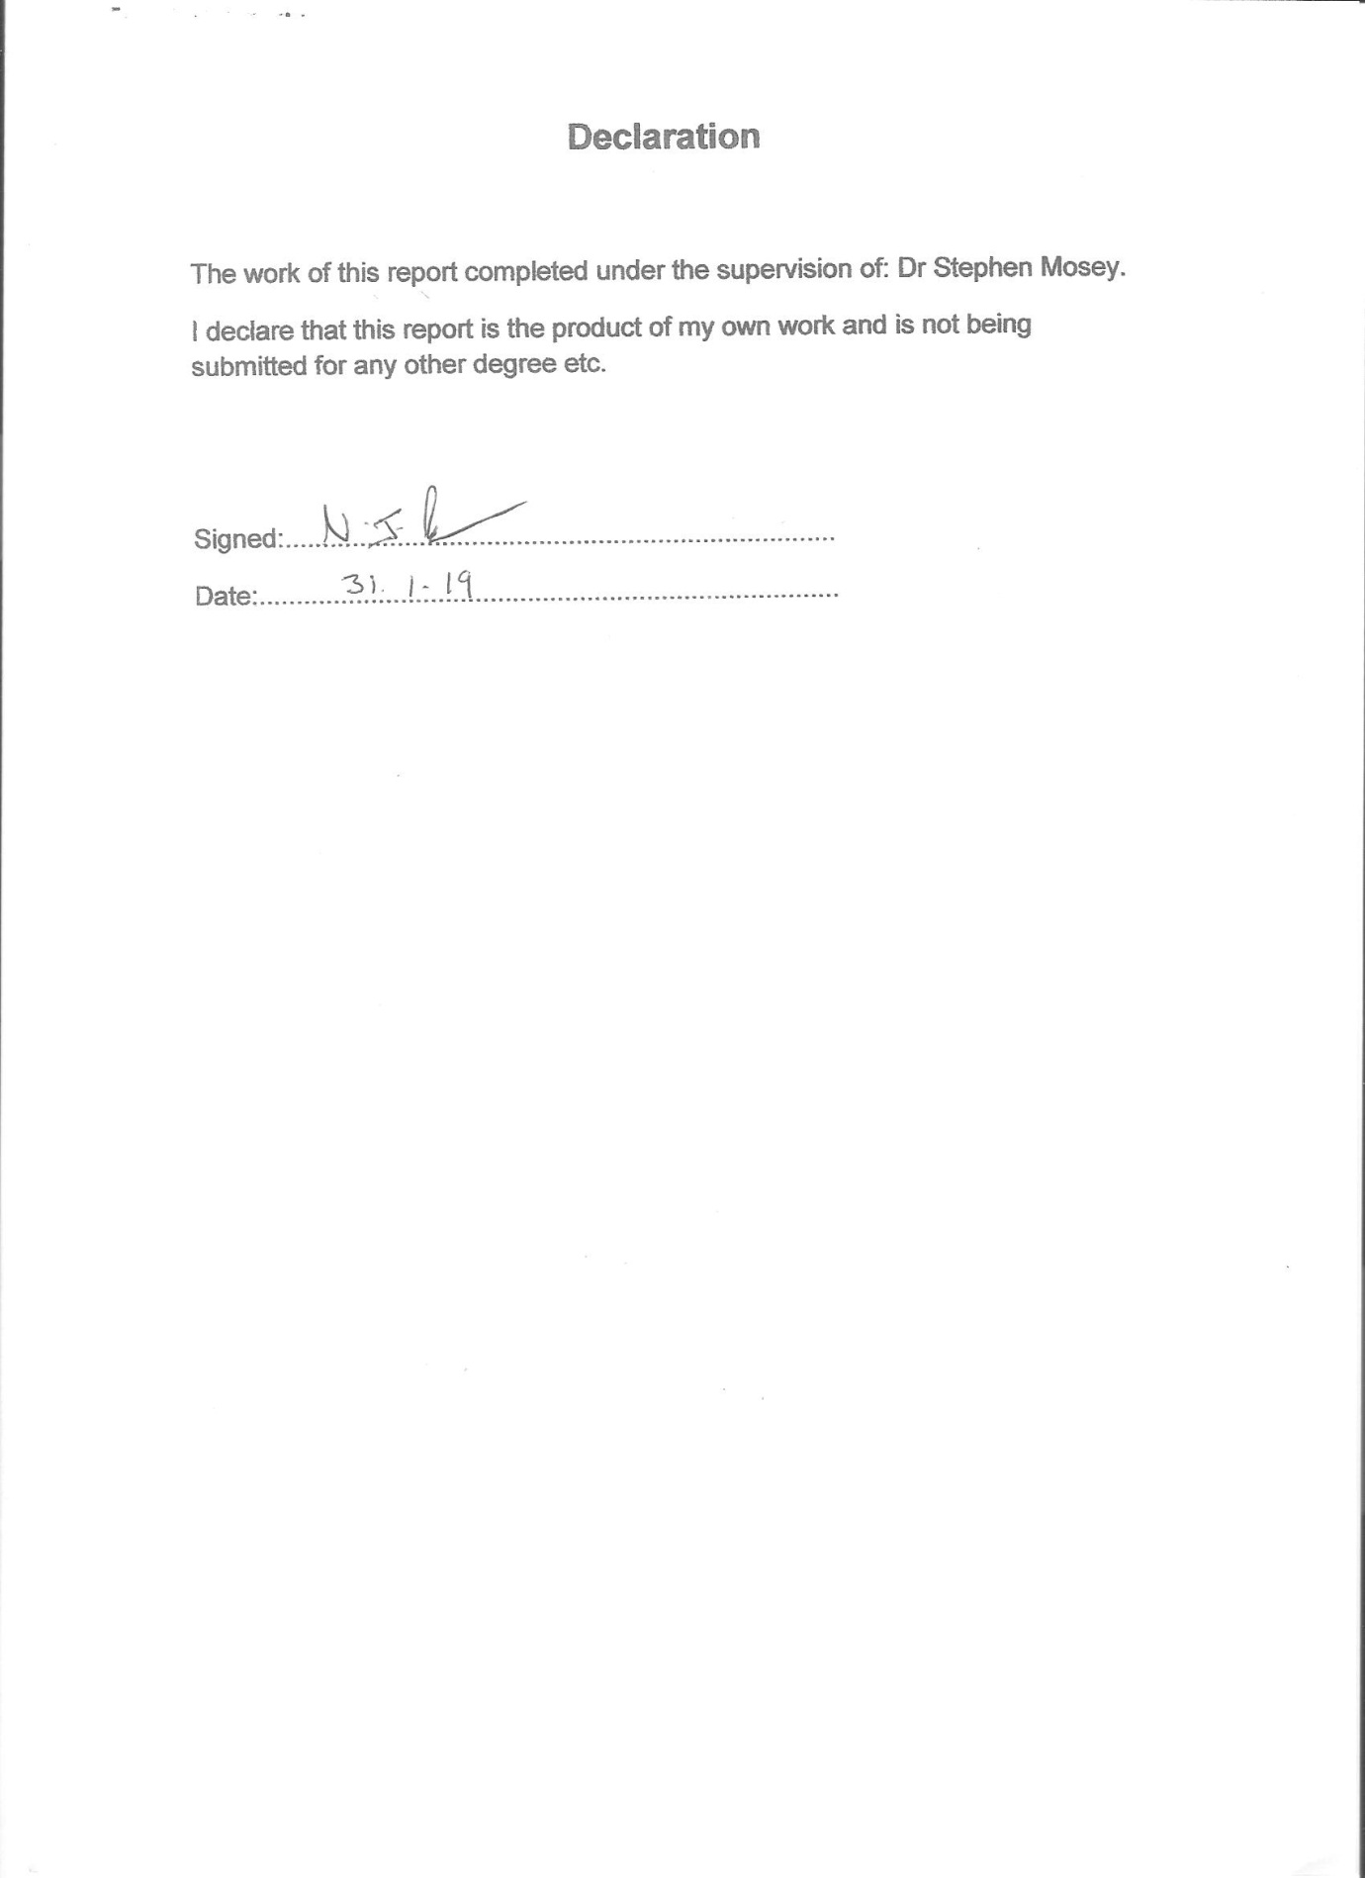

Contents

Subject Page Number

Introduction 1
1.1 Explanation of MPLAB IDE 1
Illustration of MPLAB IDE 2
1.2 Components of the MPLAB IDE 2
2. The Assignment Board 4
3. Count Errors 6
4. Count Help 7
5. Count Sound 9

References 11
Figure List 12
Further Reading 12
List of Appendices 13

Introduction
This assignment covers reports of tasks using PIC programming. The tasks involved the use of MPLAB IDE, PICSTART PLUS and a PIC16F84 Assignment Board.
The features and components of the MPLAB IDE are described. The circuit diagram of the Assignment Board is illustrated and described. Reports of the tasks using the Assignment Board are accompanied and illustrated by flow charts.

1. Explanation of MPLAB IDE
In the booklet provided in the module tutorial, Young has described MPLAB as “ a programme development suite called an “IDE” which is short for “Integrated Development Environment”. [1]. He explains that It helps people develop programmes for the PIC series of microcontroller integrated circuits. [1] It is produced by Arizona Microchip and can be downloaded free as it is a freeware product.
Bates describes it as “a primary development system toolset for PIC applications.” [2 p62], and Tomar explains further, it is a “large suite of software and hardware development tools integrated within one software package…..development of embedded application on microchip PIC controllers.” [3].
In basic terms, according to Microchip in its review of the product, [4], it is a 32 bit application that can be used on up to date versions of Windows. It requires 16MB memory, ideally 32MB and 45MB of hard disk space. It enables the user to create software development projects, embedded applications, for use with Microchip’s PIC. It contains components, several tools which can be used for development and debugging. For example, create source files, group them into a project, assemble file and link source code, debug source code and test it using built in simulators or in-circuit emulators or in-circuit debuggers.
Features (as listed by Tomar in his overview of the product: [3].)

- Create and edit source code using the built-in editor.
- Assemble, compile and link source code.
- Debug the executable logic by watching program flow with the built-in simulator or in real time with in-circuit emulators or in-circuit debuggers.
- Make timing measurements with the simulator or emulator.
- View variables in Watch windows.
- Program firmware into devices with device programmers

Figure 1: Diagram of MPLAB IDE

1.1 Components of MPLAB IDE

Project Manager
Tomar introduces the project manager as providing “integration and communication between the IDE and language tools”, [3].
The Project Manager organises files, (files to be edited and those connected to them). The files at the beginning of the process are called ‘source files’ and are written according to the rules of the assembler and compiler. They are then converted into “modules of machine code and references to functions and data storage. The linker resolves these placeholders and combines all the modules into a file of executable machine code,” [5]. The linker also produces a file for debugging, and makes it possible for the executing machine codes to be connected back to the source file.
The code is written by a text editor, part of another component known as the Editor.
Editor
Tomar gives a brief description by writing that the editor “programmes the text editor and also acts as a window into the debugger”, [3].
As mentioned above, the code is written by the text editor. The text editor uses colour coding for identification of various parts. The text editor in MPLAB IDE is designed especially for use with Microchip MCU’s.
The code is written and the Editor (together with other tools) is able to display code execution in the debugger.
Language Tools
The language tools include the assembler, compiler and linker, to assemble, compile and link source code. The assembler can be used alone for a single file, or with the linker for several files. [5]. Any errors found by the assembler, compiler and linker can be viewed in a results window. [6].
Debugger
According to Microchip in their Quick Start Guide, [5], the debugger allows “breakpoints, single stepping, watch window and all the features of a modern debugger…. Works in conjunction with the Editor to reference information from the target being debugged back to the source code. “
The code that is being produced is tested by using the debugger. MPLAB IDE have software programmes included which simulate the microprocessor that the code is intended for. There are also hardware debuggers that can be used, known as in-circuit emulators (ICE) to act as the target microprocessor. The process is necessary as it allows the user to view variables regularly, at each step, so that changes can be made to correct or improve. [5].
Execution Engines
. Tomar lists the tasks of the execution engines in the overview of MPLAB IDE: [3]
- They use the PC to simulate the instructions and some peripheral function of the PIC Micro devices.
- Create and edit source code using the built in editor Assembler compile and link source code.
- Debug the executable logic by watching programme flow with the built in simulator, or in real time with in-circuit emulation or in-circuit debugger.
- Make timing measurable with the simulator or emulator.
- View variables in Watch Windows
- Programme firmware into device programme.

2. PIC16F84 Assignment Board
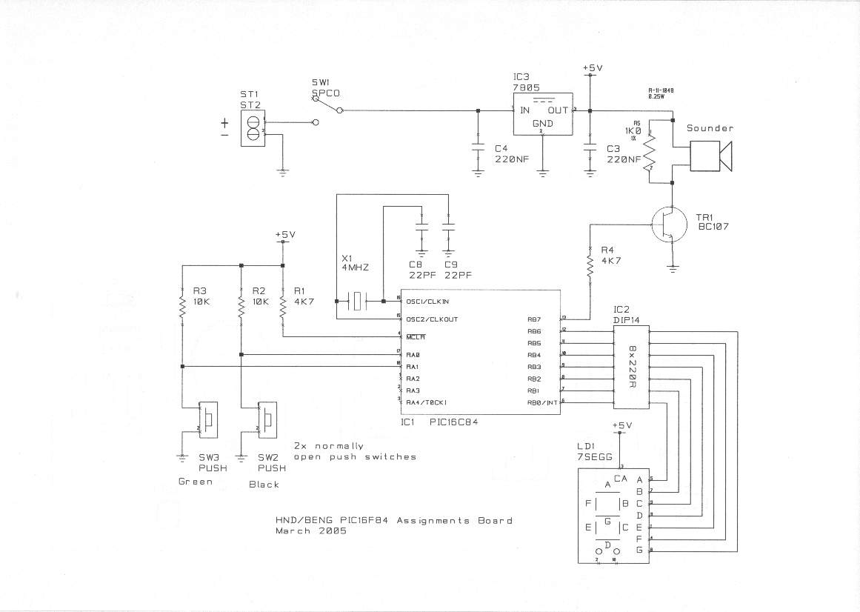
Figure 2: Circuit Diagram
A printed circuit board (pcb) controls and regulates electrical flow though a circuit. “It serves as a conductor helping currents get where they need to go and do what they need to do.” [7]. It consists of several components which are placed in particular positions.
Resistors control the electric current as it passes through them and prevent excessive electrical current. [8]
Diodes direct the electrical current in the right direction.
Transisters amplify electrical current or switch it to a different direction.
Integrated circuits are miniature pcb’s within a microchip.
The crystal X1 and it’s two capacitors, Cx and Cy will provide a regular clock signal. A crystal clock of 4MHz is used to achieve this timing precision. A quartz oscillator consists of a thin piece of quartz crystal. When a voltage is applied, the crystal changes shape. This is known a piezo -electric effect. The electrical charge produces a mechanical effect by changing the shape of the crystal and vice versa. A quartz oscillator has been chosen as they have a very high frequency stability”. That is “ability to provide a constant frequency output” [7]. One capacitor is placed at each end to ground the quartz oscillator.
Capacitors are cylinder shaped and store electrical energy. They allow a small amount of charge through to maintain a steady flow. [8].

“The seven segment display SSD requires seven outputs from the microcontroller. Active high operation can be provided by a common cathode LED display and the displayed decimal point can be used as the power indicator.” [2 p211].
The audio transducer requires one output. A piezo buzzer has sufficient bandwidth and output power and its power consumption is low. [2 p211].

3. Count Errors
When introduced to the count project there were a number of deliberate errors (see appendix A) which needed to be corrected. These errors were:
- Line 30, 31, 33 and 36 – symbol not previously defined (status)
- Line 57 – symbol not previously defined (get count)
- Line 74 – argument out of range. Least significant bit
- Line 75 symbol not previously defined (mcont)
- Line 89 found label after column 1 (en)
- Line 89 illegal opcode (d)
- Line 98 expected end
For lines 30, 31, 33 and 36 status in the memory map has an upper case ‘S’ whereas the status in the initialisation has a lower case ’ s’. These have to be the same otherwise the program will not recognise the instruction so to fix this error the upper case ‘S’ was changed to a lower case ‘s’.
For line 57 ‘count’ was spelt differently to ‘count’ on line 41 which was spelt ‘counnt’. To fix this error, ‘ counnt’ was changed to ‘count’, as this is the correct spelling.
For line 74 the value was ‘OXfff’ which was incorrect. It should have been ‘OXff’, so to fix this error ‘OXfff’ was changed to ‘OXff’.
For line 75 was another spelling error occurred as ‘mcont’ should be spelt ‘mcount’. To fix this error, ‘mcont’ was changed to ‘mcount’.
Lastly, to correct the error in lines 89 and 90 the space was deleted between the ‘n’ and ‘d’ on line 89 to make the word read ‘end’.
These errors were fixed and the program build was successful, (see Appendix B).

4. Count Help

The flowchart shows a program for a microchip to show the word ‘help’, (see Appendix C) on the assignment board. This is done by programming a microchip PICSTART PLUS programmer and inserting the microchip into the assignment board.
Before the program is made the values for each letter of the word ’help’ and the blank letter must be figured out. This is done using the binary table and the seven segments of the display. The values for each letter are:-
- H – 0x09
- E – 0x06
- L – 0x47
- P – 0x0c
- ‘ ‘ - 0x7f
As it can be can seen in the flowchart the first instruction is the initialisation. This is where the direction of the pins are decided and whether port B is going to be used for inputs or outputs.
The next instruction to be executed is to load the LED status for the letter ‘H’ (0x09) into the w register also known as the working register,r which is where main operations are used.
The next instruction to be executed is to delay the program for 1 second which is done by calling a pause for 200ms five times.
The next instruction to be executed is load the LED status for the letter ‘E’ (0x06) into the w register and again, delay for 1 second.
The next instruction is to load the LED status with the letter ‘L ‘(0x47) into the w register and again, delay for 1 second.
The next instruction to be executed is to load the LED status for the letter ‘P’ (0x0c) into the w register and again, delay for 1 second.
The next instruction to be executed is to load the LED status with the blank letter (0x7f) into the w register, this is to create a space between the last letter and first letter. Again, delay for 1 second.
The last instruction is to go back to ‘ write_help’ which is the label at the start of executions for the word ‘help’. This program will then keep repeating until switched off.

5. Count Sound

This flowchart shows the program for a PIC to make sound at 440Hz when the black button is pressed (See Appendix D). Just like the program for ‘help’ this is done by programming a microchip though PICSTART PLUS and inserting the chip into the assignment board.
The first instruction is initialisation which is where all the variables are set up and the direction of the pins and the inputs and outputs are decided.
The next instruction to be executed is to press the black button. This is port A because port A are all inputs and ‘btfss’ means bit test file skip on set, so if the black button is pressed then move on to the next instruction but if it’s not pressed then jump over the next instruction.
The next instruction is ‘call sounder’ which makes the sound if the black button is pressed.
And the last instruction is to go to ‘loop’ which returns to the label at the start of the executions.

References

[1] J. Young article title: MPLAB v8.92 handout booklet supplied in module Micro’s Peripherals and Interface ACDA4004, 2016.
[2] M. Bates, PIC Microcontrollers An introduction to Microelectronics, 3rd Ed., Oxford, Newnes, 2011.
[3] A.Tomar, article title: Microchip: MPLAB Integrated Development Environment (IDE) Overview, found online at: www.element14/community/docs/DOC-39318/l/microchip-mplab-integrated-development-environment-ide-overview, last updated 25th June 2014,. Accessed on 4th Jan 2019.
[4] Anon Author, employee of Informer Technologies Inc., article title: MPLAB IDE v8.92 Free, found online at: https://mplab-ide.software.informer.com/ review of MPLAB updated 21st Dec 2018 Accessed on 8th Jan 2019
[5] Anon Author, employee of Microchip Technology Inc., article title: MPLAB IDE Quick Start Guide, found online at: http://ww1.microchip.com/downloads/en/DeviceDoc/MPLAB_Getting_Started_51281g.pdf, 2007, Accessed on 27th January 2019.
[6] Anon Author, employee of Microchip Technology inc., article title: MPLAB IDE Simulator, Editor User’s Guide, 2002, accessed on 28th January 2019
[7] J. Uhl, article title: What is a Printed Circuit Board?, found online at: https://www.wisegeek.com/what-is-a-printed-circuit-board.htm, last updated 25th Dec 2018, accessed on 30th Jan 2019.
[8] Anon Author, employee of Aspencore, article title: Quartz Crystal Oscillators, found online at:https://www.electronics-tutorials.ws/oscillator/crystal.html, updated 2018, accessed on 30th Jan 2019.

Figure List
Figure 1: Diagram of MPLAB IDE taken from A. Tomar, article title: Microchip: MPLAB Integrated Development Environment (IDE) Overview, found online at www.element14/community/docs/DOC-39318/l/microchip-mplab-integrated-development-environment-ide-overview, last updated 25th June 2014,. Accessed on 4th Jan 2019.
Figure 2: Circuit Diagram taken from Micro’s Peripherals and Interfaces Module Tutorial Handbook written by J.Young 2016.

Further Reading
S.R. Rizvi, Microcontroller Programming, An introduction, London, CRC Press, 2012.
J. Stokes, Inside the Machine, San Francisco (USA), No Starch Press Inc. 2007.
N. Senthil Kumar, et al, Microprocessors and Interfacing, New Delhi (India), Oxford University Press, 2012.
R.S. Kaler, Microprocessors An introduction, Second Ed. New Delhi (India), L.K. International Publishing House Pvt Ltd. 2019

.

List of Appendices

Page No.

Appendix A PIC Programme Containing Deliberate Errors, 14
Appendix B PIC Programme Showing Corrected Errors, 18
Appendix C PIC Programme for ‘HELP’ 22
Appendix D PIC Programme for ‘Sound’ 27

Appendix A
; FILE: count.asm
; AUTHOR: JMY
; DATE: 24th March 2005
; DESCRIPTION: Count to 255 at 1 second intervals and display on a seven
; segment display in binary.
; The pause subroutine takes apx. 0.2 sec.
; Pause is called 5 times

list p=16F84 ; select processor type
radix hex ; define radix as hexadecimal
; #include "p16f84.inc"
;----------------------------------------------------------------------
; cpu equates (memory map)
portB equ 0x06 ;port B address
trisb equ 0x06 ;trisB address in register bank 1

Status equ 0x03 ;status register
RP0 equ 5 ;bit 5 of status register
RP1 equ 6 ;bit 6 of status register

count equ 0x0c ; counter 0 to 255
nCount equ 0x0d ; pause routine inner loop counter
mCount equ 0x0e ; pause routine outer loop counter

;----------------------------------------------------------------------

org 0x000

start
bcf status,RP0 ; clear bank selection bits in the status reg
bcf status,RP1

bsf status,RP0 ; select bank 1
movlw 0x00 ; load w with 0x00
movwf trisb ; load it into trisb to make portb all outputs
bcf status,RP0 ; reselect bank 0

clrf portB ; clear all lines low
clrf count ; initialize counter to 0

get_counnt
movf count, w ; move count to W

movwf portB ; move W to port B to update the display

addlw 1 ; add +1 to W

movwf count ; save W in count

call pause ; delay 200ms by subroutine
call pause
call pause
call pause
call pause ; five pause executions equals ~ 1 second

goto get_count ; repeat forever

;--------------------------------------------------------------------
;subroutine pause: lets waste some time....
;
;inputs: nothing
;outputs: nothing
;
;does: nothing but waste some time
;corrupts: register W
;
;description: two loops using "mCount" and "nCount" register files
; "mCount" is the outer loop counter (255 down to zero)
; "nCount" is the inner loop counter (255 down to zero)
;
;--------------------------------------------------------------------
pause
movlw 0xfff ; set w = 255 decimal
movwf mCont ; mCount = w: outer loop counter
loadN
movlw 0xff ; set w = 255 decimal
movwf nCount ; nCount = w: inner loop counter
decN
decfsz nCount, f ; nCount--
goto decN ; if nCount != 0 then repeat nCount--

decfsz mCount, f ; else decrement Count
goto loadN ; if mCount != 0 then
; reload nCount to 255 and decrement
return ; else exit subroutine

en d
;----------------------------------------------------------------------
; Configuration! Important!
;
; at blast time, select:
; memory uprotected
; watchdog timer disabled
; standard crystal (4 MHz)
; power-up timer on

Appendix B

; FILE: count.asm
; AUTHOR: JMY
; DATE: 24th March 2005
; DESCRIPTION: Count to 255 at 1 second intervals and display on a seven
; segment display in binary.
; The pause subroutine takes apx. 0.2 sec.
; Pause is called 5 times

list p=16F84 ; select processor type
radix hex ; define radix as hexadecimal
; #include "p16f84.inc"
;----------------------------------------------------------------------
; cpu equates (memory map)
portB equ 0x06 ;port B address
trisb equ 0x06 ;trisB address in register bank 1

status equ 0x03 ;status register
RP0 equ 5 ;bit 5 of status register
RP1 equ 6 ;bit 6 of status register

count equ 0x0c ; counter 0 to 255
nCount equ 0x0d ; pause routine inner loop counter
mCount equ 0x0e ; pause routine outer loop counter

;----------------------------------------------------------------------

org 0x000

start
bcf status,RP0 ; clear bank selection bits in the status reg
bcf status,RP1

bsf status,RP0 ; select bank 1
movlw 0x00 ; load w with 0x00
movwf trisb ; load it into trisb to make portb all outputs
bsf status,RP0 ; reselect bank 0

clrf portB ; clear all lines low
clrf count ; initialize counter to 0

get_count
movf count, w ; move count to W

movwf portB ; move W to port B to update the display

addlw 1 ; add +1 to W

movwf count ; save W in count

call pause ; delay 200ms by subroutine
call pause
call pause
call pause
call pause ; five pause executions equals ~ 1 second

goto get_count ; repeat forever

;--------------------------------------------------------------------
;subroutine pause: lets waste some time....
;
;inputs: nothing
;outputs: nothing
;
;does: nothing but waste some time
;corrupts: register W
;
;description: two loops using "mCount" and "nCount" register files
; "mCount" is the outer loop counter (255 down to zero)
; "nCount" is the inner loop counter (255 down to zero)
;
;--------------------------------------------------------------------
pause
movlw 0xff ; set w = 255 decimal
movwf mCount ; mCount = w: outer loop counter
loadN
movlw 0xff ; set w = 255 decimal
movwf nCount ; nCount = w: inner loop counter
decN
decfsz nCount, f ; nCount--
goto decN ; if nCount != 0 then repeat nCount--

decfsz mCount, f ; else decrement Count
goto loadN ; if mCount != 0 then
; reload nCount to 255 and decrement
return ; else exit subroutine

end
;----------------------------------------------------------------------
; Configuration! Important!
;
; at blast time, select:
; memory uprotected
; watchdog timer disabled
; standard crystal (4 MHz)
; power-up timer on

Appendix C
; FILE: count.asm
; AUTHOR: JMY
; DATE: 24th March 2005
; DESCRIPTION: Count to 255 at 1 second intervals and display on a seven
; segment display in binary.
; The pause subroutine takes apx. 0.2 sec.
; Pause is called 5 times

list p=16F84 ; select processor type
radix hex ; define radix as hexadecimal
; #include "p16f84.inc"
;----------------------------------------------------------------------
; cpu equates (memory map)
portB equ 0x06 ;port B address
trisb equ 0x06 ;trisB address in register bank 1

Status equ 0x03 ;status register
RP0 equ 5 ;bit 5 of status register
RP1 equ 6 ;bit 6 of status register

count equ 0x0c ; counter 0 to 255
nCount equ 0x0d ; pause routine inner loop counter
mCount equ 0x0e ; pause routine outer loop counter

;----------------------------------------------------------------------

org 0x000

start
bcf Status,RP0 ; clear bank selection bits in the status reg
bcf Status,RP1

bsf Status,RP0 ; select bank 1
movlw 0x00 ; load w with 0x00
movwf trisb ; load it into trisb to make portb all outputs
bcf Status,RP0 ; reselect bank 0

clrf portB ; clear all lines low

write_help

movlw 0x09 ;load LED status for letter 'h' into w reg
movwf portB ;put W reg onto Port B pin
call delay1s

movlw 0x06 ;load LED status for letter 'e' into w reg
movwf portB ;put W reg onto Port B pin
call delay1s

movlw 0x47 ;load led states for letter 'l' into w reg
movwf portB
call delay1s

movlw 0x0c ;load led states for letter 'p' into w reg
movwf portB
call delay1s

movlw 0x7f ;load led states for letter ' ' into w reg
movwf portB
call delay1s

goto write_help ; repeat forever

;--------------------------------------------------------------------
;subroutine pause: lets waste some time....
;
;inputs: nothing
;outputs: nothing
;
;does: nothing but waste some time
;corrupts: register W
;
;description: two loops using "mCount" and "nCount" register files
; "mCount" is the outer loop counter (255 down to zero)
; "nCount" is the inner loop counter (255 down to zero)
;
;--------------------------------------------------------------------
pause
movlw 0xff ; set w = 255 decimal
movwf mCount ; mCount = w: outer loop counter
loadN
movlw 0xff ; set w = 255 decimal
movwf nCount ; nCount = w: inner loop counter
decN
decfsz nCount, f ; nCount--
goto decN ; if nCount != 0 then repeat nCount--

decfsz mCount, f ; else decrement Count
goto loadN ; if mCount != 0 then
; reload nCount to 255 and decrement
return ; else exit subroutine

delay1s

call pause
call pause
call pause
call pause
call pause

return

end
;----------------------------------------------------------------------
; Configuration! Important!
;
; at blast time, select:
; memory uprotected
; watchdog timer disabled
; standard crystal (4 MHz)
; power-up timer on

Appendix D

; FILE: count.as
; AUTHOR: JMY
; DATE: 24th March 2005
; DESCRIPTION: Count to 255 at 1 second intervals and display on a seven
; segment display in binary.
; The pause subroutine takes apx. 0.2 sec.
; Pause is called 5 times

list p=16F84 ; select processor type
radix hex ; define radix as hexadecimal
; #include "p16f84.inc"
;----------------------------------------------------------------------
; cpu equates (memory map)

portB equ 0x06 ;port B address
trisb equ 0x06 ;trisB address in register bank 1

portA equ 0x05
trisa equ 0x05

Status equ 0x03 ;status register
RP0 equ 5 ;bit 5 of status register
RP1 equ 6 ;bit 6 of status register

black equ 0 ;black button connects to bit 0 port A (count UP)
green equ 1 ;green button connects to bit 1 port A (count DO)

nCount equ 0x0d ; pause routine inner loop counter
mCount equ 0x0e ; pause routine outer loop counter

;----------------------------------------------------------------------

org 0x000

start
bcf Status,RP0 ; clear bank selection bits in the status reg
bcf Status,RP1

bsf Status,RP0 ; select bank 1
movlw 0x00 ; load w with 0x00
movwf trisb ; load it into trisb to make portb all outputs

movlw 0x03
movwf trisa ;setting RA0 and RA1 as inputs

bcf Status,RP0 ; reselect bank 0

clrf portB ; clear all lines low

Loop

btfss portA,black ;is black button pressed
call sounder

goto Loop ; repeat forever

sounder
bsf portB,7 ; turn sounder on
call pause
bcf portB,7 ; turn sounder off
call pause
return

;--------------------------------------------------------------------
;subroutine pause: lets waste some time....
;
;inputs: nothing
;outputs: nothing
;
;does: nothing but waste some time
;corrupts: register W
;
;description: two loops using "mCount" and "nCount" register files
; "mCount" is the outer loop counter (255 down to zero)
; "nCount" is the inner loop counter (255 down to zero)
;
;--------------------------------------------------------------------
pause
movlw 0x13 ; set w = 255 decimal
movwf mCount ; mCount = w: outer loop counter
loadN
movlw 0x13 ; set w = 255 decimal
movwf nCount ; nCount = w: inner loop counter
decN
decfsz nCount, f ; nCount--
goto decN ; if nCount != 0 then repeat nCount--

decfsz mCount, f ; else decrement Count
goto loadN ; if mCount != 0 then
; reload nCount to 255 and decrement
return ; else exit subroutine

delay1s

call pause

return

end
;----------------------------------------------------------------------
; Configuration! Important!
;
; at blast time, select:
; memory uprotected
; watchdog timer disabled
; standard crystal (4 MHz)
; power-up timer on

