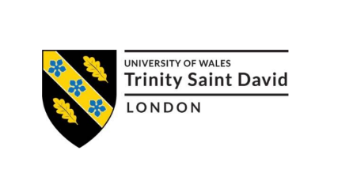

Dissertation on
Evaluating the Role of Integrated Marketing Communication (IMC) in Enhancing the Brand Awareness and Customer Engagement of the UK Consumer Goods Industry: A Case Study of Unilever

Student Name: RAHEL GOITOM BERHANE
Student ID: 2246028

Abstract
The present study aimed to assess, to what extent the marketing activities of Unilever affected the purchasing behaviour of the consumers, particularly with reference to the promotional strategies. Conducting quantitative research done within the positivist epistemological orientation, the studying used the deductive method to affirm hypothetical propositions that were derived qualitatively from theories. Surveys were administered to 100 customers of Unilever and the findings were used for analysis since random sampling was used to ensure an all-rounded customers’ responses were obtained. The data collected in the present study were analysed using descriptive and inferential statistical analysis techniques to gain understanding of the consumers’ preferences and behaviour.
Drifting from the marketing efforts of Unilever, the study discerned positive trends between promotion campaigns and consumer behaviour indicating stimulus influence on purchasing behaviour. But sources of limitations are potential biased results of the sample size and self-reporting the dependent variables. Finally, participants’ identity was kept anonymous, and every participant was willing to participate in the study. Based on these findings, recommendations for improving the various aspects of marketing as informed by this research was also provided: Implications for marketing practice The study proposed suggestions for future research direction that may build on the findings presented in this study and offered ways of improving marketing mix strategies as informed by the consumer complexities as identified in this study: Implications for academic research This research provided meaningful insights into the areas of marketing and consumer behaviour and highlighted the need to use flexibility in the marketing approaches in the current market.

Table of Contents
Abstract 2
Chapter-1 Introduction 7
1.1 Background of the Study 7
1.2 Company Overview 8
1.3 Problem Statement 8
1.4 Research Aim 9
1.5 Research Objective 9
1.6 Research Question 10
1.7 Research Rationale 10
Chapter-2 Literature Review 12
2.1 Literature Overview 12
2.2 Integrated Marketing Communication (IMC) 12
2.3 Different Components of IMC 13
2.4 IMC Strategies in the Consumer Goods Industry 13
2.5 Brand Awareness and Customer Engagement 14
2.6 Factors Influencing Brand Awareness 15
2.7 Factors Affecting Customer Engagement 16
2.8 The Role of IMC in Brand Awareness 17
2.9 The Role of IMC in Customer Engagement 18
2.10 Conceptual Framework: 19
2.11 Challenges in Implementing IMC Strategies in the UK Consumer Goods Sector 21
2.12 Literature Gap 21
2.13 Literature Summary 22
Chapter-3 Methodology 23
3.1 Research Philosophy 23
3.2 Research Approach 24
3.3 Data Type 25
3.4 Research strategy 26
3.5 Data Source and Collection method 26
3.6 Sampling Method 27
3.7 Data analysis procedure 27
3.8 Limitations 27
3.9 Ethical consideration 28
3.10 Methodology Summary 28
Chapter-4 Data Analysis and Discussion 29
4.1. Demographic Profile 29
4.2 Result of the Findings from the Survey 30
4.2.1 Independent Variable 1: Advertisement 30
4.2.2 Direct Marketing 32
4.2.3 Public Relations 34
4.2.4 Sales Promotion 35
4.2.5 Implications of IMC Strategies 37
4.2.6 Factors Impacting Brand Awareness and Engagement 39
4.2.7 Role of IMC in Enhancing Brand Awareness and Engagement 41
4.2.8 Recommendations for Improving IMC Strategies 43
Chapter-5 Discussion 46
5.1 Discussion on Variable Advertisement 46
5.2 Discussion on Variable Direct Marketing 46
5.3 Discussion on Variable Public Relations 47
5.4 Discussion on Variable Sales Promotion 48
5.5 Discussion on Variable Integrated Marketing Communication (IMC) 48
5.6 Discussion on Variable Brand Loyalty 49
5.7 Discussion on Variable Customer Satisfaction 49
5.8 Discussion on Variable Purchase Intention 50
Chapter-5 Conclusion and Recommendations 51
5.1 Conclusion 51
5.1.1 Objective 1: Identifying the Implications of Different IMC Strategies Used by Unilever 51
5.1.2 Objective 2: Examining the Factors Impacting Brand Awareness and Customer Engagement of Unilever 51
5.1.3 Objective 3: Analyzing the Role of IMC in Enhancing Brand Awareness and Customer Engagement in the UK Consumer Goods Industry 51
5.1.4 Objective 4: Recommending Effective IMC Strategies for Improved Brand Awareness and Customer Engagement 52
5.2 Recommendations 52
Increasing awareness on social culture in advertisement. 52
Utilise Data Analytics to do Personalisation 53
Share Emphasis on the Dynamic and Participatory Content 53
Strengthen Corporate Social Responsibility (CSR) Initiatives 53
Cross-Channel Campaigns. 53
5.3 Limitation of the Research 54
5.4 Areas for Future Research 54
References 56
Appendix 61
Survey Questionnaire 61

Table of Figures
Figure 1: Conceptual Framework 18
Figure 2: Saunders’ Research Onion model Source: (Saunders et al., 2006) 21
Figure 3: Deductive vs Inductive Research Approach Source: (Cameron and Price, 2009) 22
Figure 4: Advertisement 29
Figure 5: Direct Marketing 31
Figure 6: Public Relations 33
Figure 7: Sales Promotion 35
Figure 8: Implications of IMC Strategies 37
Figure 9: Factors Impacting Brand Awareness and Engagement 39
Figure 10: Role of IMC in Enhancing Brand Awareness and Engagement 41
Figure 11: Recommendations for Improving IMC Strategies 43

Table 1: Demographic Profile 28
Table 2: Mean, Mode and SD for Advertisement 30
Table 3: Mean, Mode and SD of Direct Marketing 32
Table 4: Mean, Mode and SD of Public Relations 34
Table 5: Mean, Mode and SD of Sales Promotion 36
Table 6: Mean, Mode and SD of Implications of IMC Strategies 38
Table 7: Mean, Mode and SD of Factors Impacting Brand Awareness and Engagement 40
Table 8: Mean, Mode and SD of Role of IMC in Enhancing Brand Awareness and Engagement 42
Table 9: Mean, Mode and SD of Recommendations for Improving IMC Strategies 44

Chapter-1 Introduction

1.1 Background of the Study
Consumer goods segment is one of the most effective industries in the UK with high-stake competition and short and quick product life cycle. This is because the industry is very dynamic in meeting consumer needs and as a result there is always a need to come up with innovative ideas to sustain the business (Hossain et al., 2024). The pandemic has shifted the landscapes of purchasing and consumption around the world into a different level leaving opportunities as well as threats for the retailers. IMC stands for Integrated Marketing Communication which is a business strategy that seeks to coordinate all the communication efforts used in the promotion of an organization’s products in order to help it accomplish its promotional goals (Kitchen and Tourky, 2022). As consumers in UK and all over the world are becoming more discerning with ever changing needs and wants also, companies in consumer goods industry are experiencing cut throat competition and thus there is the need for Integrated Marketing Communication. Through integrated advertising communications and promotions and public relations and digital marketing communications, IMC assists organisations in their aim of reaching consumers. In doing so, this integration not only fortifies the brand association but also develops customer relations all the more making the IMC ever important tool for growth and sustaining the competitive advantage in the market (Alrajhi, 2023).
An interesting real-life example is the British multinational consumer goods company also known as Unilever where IMC is a crucial aspect. Approximately, 2.5 billion people consume the food, beverage, home, and personal care products manufactured and distributed by Unilever. Such widespread use is attributed to the brand, thanks to uniform IMC strategies, backed by heavy internationalization and advertising dollars (Mishra and Vijay, 2023). The company is not without competition problems besides having huge rivals such as Procter &Gamble and Colgate Palemi. Besides, there remain challenges in sustainable marketing at Unilever and it has faced challenges in pricing its products due to inflation. Such challenges require effective IMC strategies in order to build and sustain company position in the market place, including that of Unilever (Twum and Yalley, 2021). Exploring how IMC strategies can positively impact on brand recognition and customer interactions is the main research question of this study by focusing on the UK consumer goods industry particularly Unilever. Thus, it aims at exploring and discussing the significance of a selected number of IMC strategies and the features that explain brand familiarity and customer engagement, as well as offering relevant recommendations and insights for Unilever and other organizations interested in the improvement and effectiveness of IMC activities for the enterprise growth.

1.2 Company Overview
Unilever is a British multinational conglomerate company, which is producing consumer goods and it’s based in London. Today, Unilever is one of the pure consumer goods’ giants that was founded in 1885 (Bakalo and Amantie, 2023). It has more than 400 brands in its kitty that falls under the food, beverages, home care and personal care categories. Unilever currently has operations in 190 countries and touches the lives of 2. 5 billion consumers daily, the brands include Dove, Knorr, Lipton, and Hellmann’s. The tows company had net sales of €52 (Blakeman, 2023). It has forecasted the Rosemark sales of the Will called USD 4 billion in the year 2020, and its products are dominating the international markets and are found in 90% of the households. The company’s promotions mix focuses on IMC, whereby the messages are consistent across all the chosen media (Kamau et al., 2023). Through IMC, Unilever is fully prepared to convey what they stand for and what they offer to the consuming public, hence realizing extensive patronage. The firm devotes about €7 billion every year on advertisements and promotions as the company emphasizes IMC (Pearson and Malthouse, 2024).
Unilever’s corporate strategies include scientific innovation, environmental harmony, and social responsiveness. Over the years the company has remained awake to the task of embracing the needs of the customers across the world through sustainable practices in doing business as well as appropriate procurement (Kitchen et al., 2022). The company’s strategy is known as Sustainable Living Plan that will guide Unilever to grow sustainably, decreasing its negative impact on the environment and boosting its ability to bring better to more people; specific objectives include cutting the environmental impact of the company in half by 2030 and helping to positively impact the health and wellbeing of more than one billion people.

1.3 Problem Statement
The UK consumer goods industry is competitive to maximum levels and innovative products are being introduced in the market most frequently as consumers’ expectations are changing constantly. The COVID19 period has altered the purchasing patterns of consumers and thus present prospects and threats to various firms (Lopes, 2020). Consumers are known to be a crucial target in the case of every product, which is why IMC is regarded as one of the best ways of simplifying the communication process; however, the problem is that while it is widely used the IMC is not used comprehensively, which causes confusion and weakens its effect.
Industry giant, Unilever for example applies IMC to sustain market competitiveness. Nonetheless, Unilever has an efficient IMC approach; however, it experiences stiffness competition from international players such as Nestlé, Procter & Gamble, and Johnson & Johnson (Alam, 2022). Furthermore, specific macro business factors incline to affect Unilever like inflation because it forces the company to hike the price of its products and ponder on its strategies for advertising. These challenges have revealed the paramount importance of creating and implementing strategies which are unique and effective to keep the impacts of IMC alive and to increase the levels of customer awareness (Casemajor, 2023). It is therefore important to examine how and which of these IMC strategies can enable Unilever overcome these challenges and strengthen the company’s brands in the competitively intense and economically fluctuating environment. This research will seek to address this research question by evaluating the effectiveness of different IMC strategies on Unilever UK’s brand recall and customers’ responses (Iglesias et al., 2023). As a result, the study aims at discussing best practices of IMC and the results achieved based on the given approaches in an attempt to offer strategic directions and solutions to guide Unilever and other related firms in standardizing their IMC strategies to guarantee continuous growth and competitive edge.

1.4 Research Aim
This research aims at investigating how IMC strategies can contribute to improve the brand awareness and increase customer engagement in the UK consumer goods industry.

1.5 Research Objective
The following objectives are meant to be achieved:
- To identify the implications of different IMC strategies used by Unilever.
- To examine the factors impacting the brand awareness and customer engagement of Unilever.
- To analyse the role of IMC in enhancing the brand awareness and customer engagement of the UK consumer goods industry.
- To recommend how Unilever or other businesses can employ effective IMC strategies to improve brand awareness and increase their customer engagement for overall business growth.

1.6 Research Question
The research questions are:
- What are the implications of different IMC strategies used by Unilever?
- What are the factors impacting the brand awareness and customer engagement of Unilever?
- What is the role of IMC in enhancing the brand awareness and customer engagement of the UK consumer goods industry?
- What are the recommended ways in which Unilever or other business can employ effective IMC strategies to improve brand awareness and increase their customer engagement?

1.7 Research Rationale
The UK consumer goods industry is highly saturated and the competition is high, for instance Unilever is more or less in a state of a continuous battle for the control of market share with other competitors while constantly dealing with other challenges such as increasing rate of product development and consumer buying behaviour change (Ihsan et al., 2023). The post COVID situation has even contributed to this, where shifts in the purchasing behaviour and other economic factors like inflation requires a more integrated and coordinated marketing concept. One of the strategies that has come out clearly due to these complexities is what is known as Integrated Marketing Communication (IMC), which offers coherent and efficient ways to get across to the consumers and consolidate brands (Kang et al., 2023). Yet, this concept’s practical effectiveness of IMC strategies in increasing existing brand familiarity and consumer base is a relatively understudied subject, especially when focusing on large companies such as Unilever.
Choosing Unilever as the research topic enables me to look into the IMC strategies in light of its factor; it has a wide array of brands and a broad coverage. Thus, the company’s experience indicates the opportunities and the threats that are inherent in application of IMC in the intensely competitive environment. To that end, the research focuses on the prominent ways in which Unilever applies IMC in an effort to sustain and strengthen the company’s brand so that the results will be applicable across the board.
Therefore, this research is crucial as it attempts to fill a void in the current literature concerning the operational consequences of IMC implementation on enhancing brand familiarity and consumers’ involvement. moreover, it offers recommendations on what should be done by businesses that experience the same conditions and need to improve the effectiveness of their marketing strategies. In addition, by investigating a company of the scale of Unilever, the study does not risk oversimplifying the issues and tools in question and, thus, guarantees the results’ relevance. Thus, the findings of the study will not only extend scientific knowledge but also help IMC practitioners and industry stalwarts to enhance the effectiveness of their future IMC strategies for steady growth and competitive advantage.

Chapter-2 Literature Review

2.1 Literature Overview
IMC is a concept that ensures the right combination of several marketing communication media to give a unified brand communication message which the consumer goods industry requires for it to function optimally. According to Manoli and Hodgkinson (2020), the marketing communication includes advertising, direct marketing, public relation, and sales promotion; thereby, under the umbrella of IMC, all marketing communications are consistent, converging to provide the customer with a consistent brand image. Advertising involves an organization’s ability to spread information about its products through the mass media while direct marketing involves communication with special interest groups. As per Miraki et al. (2020), public relations are involved in the management of the brand, its image, and its prestige while sales promotions are involved in the stimulus of short-term consumer interest through the use of the promotion offers. Galloway (2020) claimed that, this sort of an integration not only serves the purpose of improving the visibility of the brand but at the same time it looks into the building of a firm relationship with the customer and developing a continuous association with the customers. Considering the contemporary condition of people’s distraction, IMC represents the sound strategy that brands need to employ in attempts to capture their attention and continue to grow.

2.2 Integrated Marketing Communication (IMC)
According to Kushwaha et al. (2020), integrated marketing communication (IMC) is a management concept that entails the coordination of marketing communication activities so that all point to an agreed on strategic vision. The need for IMC can therefore be attributed to the realization that marketing department in organizations worked in isolation and therefore was creating confusion about the organization’s goals and objectives as well as undermining its brand image. Hereyah and Faradella (2020) added that, IMC strengthens the communication of the core brand message across the four marketing communications tools, namely: advertising, public relation, sales promotion, and digital marketing.
Kaziba (2020) stated that, IMC is more consumer-oriented as it aims at providing consumers with value and developing long-term client engagements. It aims to interact with the consumer at each of the buying decision process, before, during and after the purchase decision, with an aim of making them loyal customers of the brand. Hence in the highly competitive UK consumer goods industry, IMC is critical in helping organizations create brand distinctions. As per Eagle et al. (2020), IMC is also adopted by firms such as Unilever to strengthen brand images and customer contact since the messages are consistent across both the traditional and the new media outlets. Such an approach guarantees that amongst the audiences, brand messages will indeed ring a bell; consequently, this improves its engagement levels and the ultimate business goal.

2.3 Different Components of IMC
Zwerin et al. (2020) claimed that, IMC include elements that are used in presenting an overall and uniform brand image to the consumer. Advertising promotes the product through media advertisements, whether on TV, in magazines, or on the Internet; public relations ensures that the corporation handles the brand’s image and its relations with the public; lastly, sales promotion involves giving out minimal incentives such as coupons or limited offers.
Butkouskaya et al. (2021) added that, direct marketing is the final aspect, that is oriented to individual communication with consumers by using such instruments as e-mail, mail or other types of short message sending. Internet marketing which includes the social networking, content marketing along with SEO is vital in reaching out to customers online. In this case, personal selling refers to face to face communication and interactions with other people involving persuasion. According to Ang (2021), IMC connects all these components to make certain that every communication impacts the intended message at every contact point, thereby increasing overall marketing communication impact.

2.4 IMC Strategies in the Consumer Goods Industry
As per Anani-Bossman and Mudzanani (2021), in consumer goods business particularly, Integrated Marketing Communication systems are crucial in development of a harmonised brand communication message. These are basic strategies that help to establish a coherent and engaging brand image; something is extremely important while the market is filled with choices and consumers’ attention is divided. In IMC, advertisement is equally an essential component with a major purpose of making a brand familiar to the public and customers. Pisicchio and Toaldo (2021) stated that, other firms, for instance, Unilever provide a lot of attention to high-impact image advertising that involves the use of the media-most especially the television, print and electronic media. These campaigns are often established with the purpose of articulating brand values and promoting the benefits of the products, with the long-term goal of imprinting the mind of the target market with the brand and its intent to stand out from the competitors. Thus, using various techniques in advertisements, brands are able to improve the awareness level of their existence and explore a more solid position on the market.
Twum and Yalley (2021) claimed that, direct marketing is also regarded as a key that in the IMC strategies. This strategy uses targeted media stations like emails, mobile phone text messages and mail. Due to the individual focus, separate messages and promotional campaigns can be designed for separate consumer segments. As per Chakraborty and Jain (2022), this personalization results to higher interactions and better relationship with the consumers since it is seen that nobody would like to receive messages that are not interesting or, are inconsequential to him/her.
According to Kadia (2022), PR is a paramount factor that is involved in the management as well as the determination of the image of the brand. Such activities as producing press releases, coverage in media, and stakeholders’ engagement assist the organization in garnering public trust. Public relations when well driven can help in management of brand perception and the general reputation of the brand. Syeda (2022) claimed that, with proper coverage of the media and participation in community activities, the brands are able to build their rapport with the stakeholders by supporting any issues of concern.
As per Yu (2022), sales promotions are employed to target short term consumers’ interest, which seeks to elicit an immediate response in purchase. These strategies include provisions of discounts, coupons, offers, etc., that tries to make consumers alter their buying behaviour and try to buy the particular product at a faster rate. These promotions are coordinate with another IMC parts to make sure that the promotions equivalent with the brand message. According to Mensah and Amenuvor (2022), timing and implementing the right promotions help organizations to increase sales while at the same time reminding or re-emphasizing marketing goals and/or strategies.

2.5 Brand Awareness and Customer Engagement
Syeda (2022) claimed that, brand awareness is defined as the state whereby a consumer has acquired pertinent knowledge about a brand, product, or service and is able to recall it. It is essential for a brand since it helps define the overall image of the brand or product and affect the consumer’s decision-making process. Brand targeting propels a brand high and in the minds of the consumers thus making them more likely to resort to the brand whenever they are in a position to purchase a product from the particular category. Mietra and Wibowo (2022) added that, this recognition is created through a series of marketing communication activities that are constant and planned in consumer touch points such as advertising promotion, public relation and other versions of digital media promotion.
As per Shakila and Nasution (2023), brand awareness has the greatest value in putting strong emphasis on the market presence as well as to gain and sustain consumers’ trust. It provides a brand with a competitive edge in the existing markets and builds a consumers’ emotional bond with the intended brand, hence attracting more customers and encouraging them to recommend the brand to others. In the digital world, brand awareness plays a significant role in the promotion of brands online because people are more comfortable with brands they know when it comes to social media, search engine results, and online shopping.
According to Alrajhi (2023), customer involvement, on the other hand, means the degree of interaction that consumers have with a brand and the extent of feeling that they have towards it. It incorporates the total communication that a customer has with the firm, whether in social media, on the website, while using the product, or when dealing with customer care services. As per Kamau et al. (2023), the involved consumers are usually loyal and are likely to buy the brand more than once and even recommend the brand to other people.
According to Blakeman (2023), some of the important measures that relate to the level of engagement that customers exhibit include social media activity, website traffic and data acquired from customer opinion polls, and overall customer loyalty rates. Rashkova et al. (2023) claimed that, it is a significant factor for companies since the degree of engagement is positively associated with the brand loyalty level and customer’s lifetime value. Thus, brands needed to create more extensive and deep relationships with the customers apart from just establishing awareness levels of their brands, so as to make customers loyal and foster growth in the long run.

2.6 Factors Influencing Brand Awareness
There are several account factors that affect brand awareness in the UK consumer goods industry, and these impact the way that consumers recall or recognize a brand. According to Kadia (2022), advertising is top because such meaningful campaigns in television, print, and online media create awareness of brands to consumers. The perception of an advertisement can go a long way in increasing brand recall or repetitiveness of the advertisements. This is where social media, SEO, and content marketing come in, all of which fall under the umbrella of digital marketing and play a vital role in helping to improve a brand’s presence on the web. According to Hossain et al. (2024), they also state that by using these platforms, brands can extend and enhance its communication by mass and target communication through being involved. Brand image is another critical factor because consumer-perceived quality, durability, and the level of trust have a significant impact on brand recognition on the market. Recommendations, testimonials, hard-sell publicity and other such communications help to build a favourable image and information recall around the brand logo. As per Gordon-Isasi and Ronda (2024), overall, packaging and product placement also play a role in influencing brand recognition. Signages such as attractive packaging and strategic placement of products within a store or in an online platform will help grab the consumer attention reemphasizing their brands. Also, Sobhy (2024) claimed that, working with events or influencers is another way for brand recognition as they establish the brand as a popular or associated with trusted personalities. When combined, these aspects help in creating and further enhancing the Toms brand identity while operating in a competitive UK market segment for consumer goods.

2.7 Factors Affecting Customer Engagement
According to Kushwaha et al. (2020), engagement of customers in the UK consumer goods industry is chartered by various factors that determine customers’ behaviour with the brands. There is one main area that can be defined as a critical success factor: the quality of customer’s service. Brands that offer courteous, efficient, and relevant customer care increase the bonding experience of the customers hence foster product loyalty.
Kaziba (2020) stated that, the second element of the presented analysis is the significance and popularity of the content. Communication activities that post valuable and entertaining contents for instance blog updates, updates on social media pages, and videos can be effective to capture the consumers’ attention and build brand-consumer relationships. There is nothing like putting it in simple terms and choosing what suits the target group the most in relation to the content. As per Eagle et al. (2020), another important factor is a digital one. Some examples of brand relevant capabilities are accessible and commercial web sites, as well as the use of social media profiles for direct communication with the consumers. Especially social media, where brands can engage or directly communicate and get feedback from the consumers and be able to serve them on real time basis.

2.8 The Role of IMC in Brand Awareness
Zwerin et al. (2020) claimed that, when it comes to managing and promoting the brand, IMC plays an important role in the promotion of the brand awareness because it ensures the consistency of the brand message regardless of the channel being employed. In the consumer goods industry, it means that all marketing communication activities including advertising, direct marketing, public relation and sales promotion are co-ordinated to ensure that the organisation’s brand is clearly communicated and made highly noticeable in the market.
Butkouskaya et al. (2021) added that, please remember that advertising is one of the four pillars of IMC, whereby clients use means such as television, newspapers, and the internet to communicate with a large number of individuals and reinforce brand identity. The high impact advertising campaigns such as those created by companies such as the Unilever enlighten the customers on the perception that the brand has regarding the specific products and its unique selling propositions. According to Ang (2021), these are kinds of campaigns aimed at attracting the consumer’s attention and imprinting a memorable image of the brand in his/her mind compared to other brands. When one includes attractive advertisements when marketing the brands, then it is only natural that they achieve a strong market profile.
As per Anani-Bossman and Mudzanani (2021), direct marketing is used in conjunction as it continues the advertising initiatives in a more targeted manner using media such as email, SMS and direct sending of mails. Such an approach helps the brands in focusing on the exact requirements of the consumers thus making the experience all the more unique. This way, it becomes easier to cultivate a more familiar tone of interaction with the audience keeping the brand at the forefront of their minds. Inputs into direct marketing help to achieve better communication and consumer connection since it customizes the messages that are relayed to consumers.
Pisicchio and Toaldo (2021) stated that, another significant component of brand management is the public relations (PR) activities. Press releases and media are part of the PR activities, community involvement creating a favorable brand image. It is crucial for the long-run success that PR still helps in mostly building the trust and improving the reputation of the brand. Media contact and companies’ active participation in community media events are helpful in enhancing image identity. Twum and Yalley (2021) claimed that, special offers or coupons, located near the product in supermarket shelves, for example create interest with consumers in the product and increase its recognition. These promotions are usually a part of other IMC elements to present a cohesive message and to remind the audience of the brand. As per Chakraborty and Jain (2022), sales promotions are tools that increase consumers’ awareness and activate them, as they use the feeling of getting something for a limited time and fear of losing the opportunity to make a purchase.

2.9 The Role of IMC in Customer Engagement
According to Kadia (2022), IMC in the context of the consumer goods is indeed a significant factor that impacts a customer and renders him an engaging experience through the compliance of brand touch points. Integrated marketing communication, commonly abbreviated as IMC, seeks to ensure that all forms of communication with the target audience is harmonized including advertising, direct marketing, public relations and sales promotion, all working together to use a single convincing message.
Syeda (2022) claimed that, advertising is a key component of IMC since it serves as a main way of engaging the customers. Advertising communication can take place through more than one media; there is the television, newspaper, magazine and online media to talk to the consumers and elicit response. Intensive advertising commercials, such as those being promoted for Unilever, are developed strictly to bring focus to essential brand propositions and appeal to a populace’s sense of reason. Besides, these campaigns not only build up the brand image but also engage the consumers calling them with intensive messages and content.
As per Yu (2022), direct marketing is a useful tool, which supplements advertising since it establishes direct communication with customers. Services like e-mail marketing, SMS, direct mailing help brands to send target messages and relevant promotions with reference to specific clients’ characteristics. The implementation of a long-term approach for each consumer helps increase satisfaction from communication with individual salesmen. According to Mensah and Amenuvor (2022), the customer is appreciated, which makes her trust the brand and makes her relations with it deeper and longer than those of a non-target customer.
Mietra and Wibowo (2022) added that, promoting the product in the market also requires effective public relations (PR) that help in enhancing the levels of customer engagement. The public relations activities such as the press releases, media coverage and participation can act as crucial components of the brand that are charged with the responsibility of navigating public relations to ensure optimum facilitation of the public relations for the brand. As per Shakila and Nasution (2023), public relations strategies are always useful in achieving the objective of developing the much-needed trust and believability between those, who control the means of communication and those to whom these means are directed. Thus, brands which use the media technologies will be able to improve their status and perform customer relationship better.
According to Alrajhi (2023), sales promotions are another important element of IMC that directs consumers’ attention. Micromarketing tools include sale promotions; coupons, bargains, and other promotional items make the consumer aware and reacted promptly. These promotions elicit psychological pressures such as time pressure and reward the consumers with offers which they feel has to be employed by them either as the brand’s product or promotion.
As per Kamau et al. (2023), these are the IMC strategies: Advertising, Direct Marketing, Public Relations and Sales Promotion; these need to be applied harmoniously in a brands’ engagement framework. Apart from enhancing customer relations, this integration ensures the delivery of long-term brand loyalty. This is because IMC creates better audience-brand relations through regular engagements that consequently improve customer relations and the brand’s sustainability.

2.10 Conceptual Framework:
The following conceptual framework will be followed by the researcher throughout the study:

Figure 1: Conceptual Framework
Source: Self-made
The researcher has utilized a conceptual framework to guide the study, categorizing Integrated Marketing Communication (IMC) strategies into four key areas: Can be classified as advertisement, direct marketing, public relation, and sales promotion. That is, each of these categories has been examined to determine how it influences brand recognition and consumers’ interaction within the consumer goods market. In the same manner data has been systematically collected based on these four variables with special reference to effectiveness of every strategy.
In the case of advertisement, more importance has been given to the assessment of mass communicative campaigns and their significance for brand awareness. Direct marketing has been scrutinized regarding consumer contact for its efficiency. These mediated communications have been looked at in order to establish an understanding into their effect on brand credibility and customer trust. Thus, sales promotions have been evaluated for their capacity to generate consumer interest and encouraging an instant response. The breakdown of these variables has thus responded to the research question and produced information that is implementable.

2.11 Challenges in Implementing IMC Strategies in the UK Consumer Goods Sector
According to Blakeman (2023), challenges facing the UK consumer goods in the implementation of IMC strategies One of the biggest issues here is how to maintain consistency when engaging through various channels. In addition, when there are multiple media types for transmitting information, it becomes a challenge to keep the brand message consistent. Rashkova et al. (2023) claimed that, the disparity between advertising and social media consumption, direct marketing, and other promotional campaigns reduces the potency of the brand message and discourages customer patronage. Another challenge is how to manage data and incorporate the use of technology. Measurement is critical in IMC since it is used to analyse data on audiences and adjust messaging to its best outcomes. However, according to Hossain et al. (2024), for various enterprises, there are great difficulties to synthesize data from multiple sources and utilize them to develop targeted and timely marketing plans. Such a structure can pose a challenge in the effectiveness of consistently coordinated as well as clearly targeted IMC efforts. There is also the issue of limited funds for implementation of policies and programs in response to cases being highlighted. As per Gordon-Isasi and Ronda (2024), intensive IMC plans normally involve sizable commitment to different media and techniques. Budgeting and cost control might be challenging for some organisations especially the small ones on how to distribute their available resources. Furthermore, the coordinating role of the IMC may create co-ordination problems between departments and teams in IMC operations. Marketing and sales and public relations professionals have to be coordinated to achieve a common goal and thus need effective communication and this can be hard.

2.12 Literature Gap
Despite a vast amount of literature from the field of IMC, there is a significant dearth of research about the IMC campaigns’ effects on the brand awareness and customers’ engagement, hoping in Consumer Good industry especially at the times of emerging digital technologies. Almost all prior studies have in a more or less extensive manner discussed the main pillars of IMC, namely advertisement, direct marketing, public relation, and sales promotion; however, many of the research studies fail to provide a comprehensive insight and analysis of how these strategies interrelate within a digital environment. Further, where there is some concentration on IMC there is a paucity of empirical investigation of IMC in terms of its application and efficacy within context such as the Unilever company that deals with consumer goods. This gap has left literature wanting as to exactly how and to what extent each of the IMC components contributes towards brand creation and customer engagement in response to advanced market experiencing the increased adoption of new generation digital tools and techniques beyond the traditional measures comprehensively to give an account of the overall effect of these components.

2.13 Literature Summary
Integrated Marketing Communication (IMC) enhances the consistent and coordinated communication of the marketing messages via the usage of the appropriate channels in the consumer goods industry. Some of the major pillars of IMC are advertising, which informs existing and potential clients about the existence of the product or service through mass media; direct marketing, which entails direct communication with certain markets in order to influence their actions; public relations which involves management of the image of the product or service and creating awareness of this image among the market; and sales promotions which involves creating awareness of a certain product or service to the market at a given time. It is through IMC strategies that these elements are correctly synchronized in a way that reiterates the brand message and gets the attention and/or interest of the target consumers. Thereby not only does this help raise brand awareness, but the consumer relationships become more intimate and the business establishes a considerable market presence and growth.

Chapter-3 Methodology
One such model that has been put to use is the research onion designed by Saunders, Lewis, & Thornhill that assists in the determination of layers such as research philosophy, approach, and strategy, choices, time horizon, data collection techniques (Saunders et al., 2006). The researcher has employed this model to provide a structure to the process of the study to achieve the objective of the study. The researcher has effectively followed the model by providing exhaustive thoughts to each layer, and that lead to logically constructed and methodologically solid model of research. It has made it easier to approach a concept in a broad manner hence making it easier to organize the study.
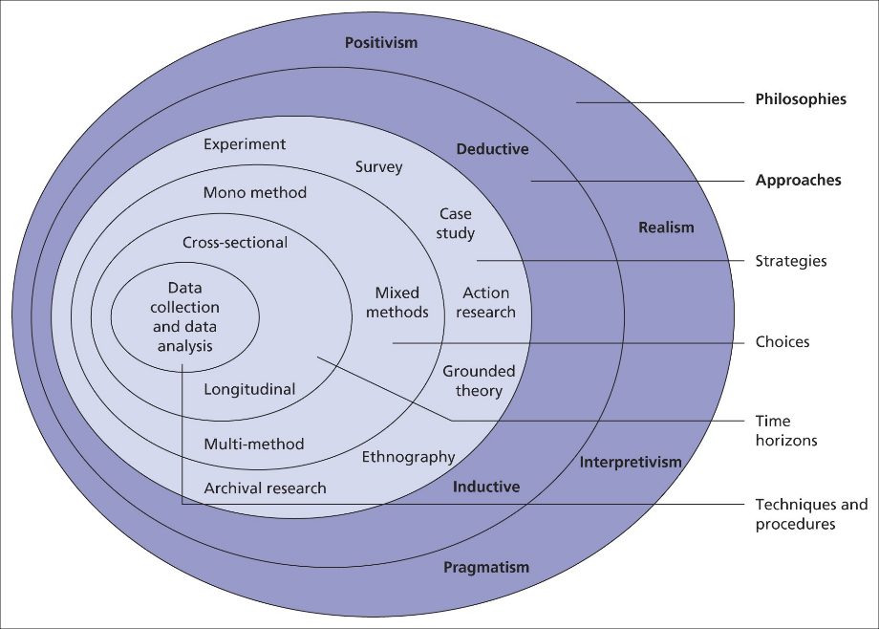
Figure 2: Saunders’ Research Onion model
Source: (Saunders et al., 2006)

3.1 Research Philosophy
Research philosophy broadly defines the fundamental beliefs and assumptions about the nature of knowledge testing, reality and how knowledge about this reality is obtained. It determines how the researchers conduct their research, the techniques to be used and the analysis of results and findings.
Interpretivism is a research philosophy that embraces the notion of reality that focuses on meaning of particular phenomenon from the perspective of the subjects (Anderson and Kanuka, 2006). It is concerned with the environmental and developmental aspects of the person as well as using approaches like interviews and observations to ask questions such as ‘What does the person perceive and understand?’ Interpretivism presupposes that people and things are not objective and that the reality is socially created (Saunders et al., 2006).
The positivism, on the other hand, is fully rooted on the opinion that knowledge can be gained through laboratory work (Brown, 2006). It regards the reality as factual and tangible and it uses techniques such as questionnaires and experiments to compile data that can be quantified.
The researcher has adopted the positivism research philosophy. The positivism has provided a systematic way of measuring and analysing the numeric data so as to validate the stated hypothesis statistically. This approach tallies with the notion of objectivity espoused by this researcher and the generalisability of the conclusions that are arrived at thus pointing out that research conclusions do not necessarily emanate from the researcher’s input.

3.2 Research Approach
The research approach determines the manner in which research questions are to be addressed, in terms of how data is to be gathered, examined and comprehended. In particular, it decides whether the study will aim at proving or disproving hypotheses drawn from theories or generate new theories (Cameron and Price, 2009).
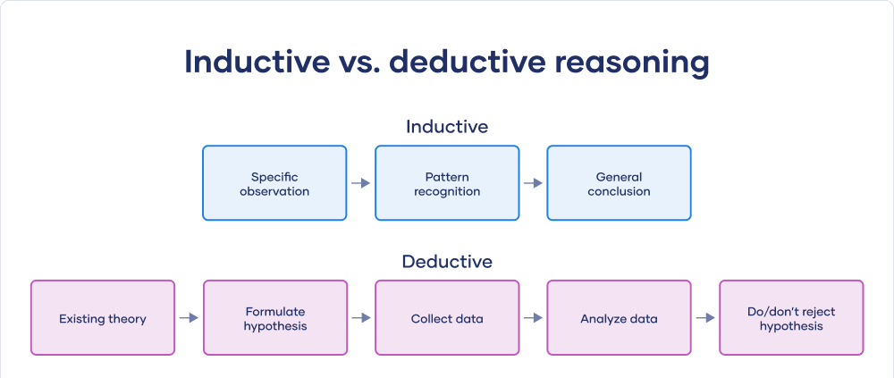
Figure 3: Deductive vs Inductive Research Approach
Source: (Cameron and Price, 2009)
Deductive research will have a theory or hypothesis in place and will then use data to analyze the theory. It can be connected with the so-called variable-oriented approach, the core of which is that researchers formulate certain predictions or hypotheses and study their empirical manifestations (Cameron and Price, 2009). This approach is mainly marked by the emphasis put on structuring procedures, aimed at proving given theories.
Inductive research approach on the other hand starts with observations and tries to develop theories from the patterns that have been obtained from research (Kinnear and Gray, 2007). It is characterized with an inductive approach in that the researcher gathers a lot of data and aims at generating general theories to explain the phenomenon that is under study, and very often the study employs an array of qualitative research techniques.
The researcher has preferred using the deductive research as it involves testing of hypothesis developed from the existing theories. As a result, Deductive research, has helped a researcher to build on existing theories so as to form hypothesis to be tested and validated through empirical data. This has in a way facilitated the creation of accurate and measurable hypotheses, making the research process stand out in terms of results analysis and conclusion-making.

3.3 Data Type
Data type refers to the division or categorization of data based on the source of the data and the process of acquiring the data. They establish how the researchers acquire information and put it into practice in order to answer their questions.
Primary data is that which is gathered by the researcher himself using techniques like questionnaires, interviews, experiments or observing events (Cresswell, 2002). It offers real-time data related to the research study, which means that it can be more effective in addressing the research questions. This type of data is collected in order to obtain recent and specific information that cannot be obtained through other methods.
Secondary data can be described as data that has been collected by someone else other than the user, and can be in the form of a published report, a journal article or any data set. It provides more general information and historical context and may contain less current and more descriptive information than primary data (Davies, 2007).
The researcher has opted for primary data collection in his research process with a view to collecting data that is most relevant to the research questions. Primary data has offered the researcher a chance to collect data, which is precise, current and most appropriate for the research since it is collected in relation to the project in hand, thereby increasing the reliability and credibility of the research study.

3.4 Research strategy
Research strategy outlines and guides the general approach that researchers are going to use in collecting and analysing their data to address their research questions. With this issue, it decides whether the study will encompass numbers and computation of probabilities or delve into the patterns or relations and their meanings and experiences attached to them.
Quantitative research is therefore oriented towards the discovery of general knowledge about objects of study while quantitative research is on the detailed examination of phenomena not through number-based data (Davies, 2007). It occurs through processes, including a survey that involves interviews, focus groups, and observation in order to gather views or products, history or construct and circumstances of participants. Non probability research entails gathering as much information about the topic of study as possible and obtaining thick descriptions.
On the other hand, quantitative research deals with the use of numbers to come up with other numbers for the purpose of establishing certain patterns, correlation or trend. It employs formal techniques such as questionnaires and experiments, analysing results statistically to reach conclusions and prediction on larger, random samples (Fisher and Buglear, 2010). Quantitative research is directed at expressing outcomes in terms of quantity, as well as toward proving hypotheses.
The type of research being used in this study is quantitative research because it enables the measurement of the amount of a variable and hence generalizes the results. Quantitative research has allowed the researcher to have a clear way of defining hypothesis and checking the correlation between one variable and the other, which makes the findings fully analytically sound and can be replicated in different settings.

3.5 Data Source and Collection method
The data sources in this study have therefore been the 100 randomly chosen customers to whom primary data has been directly collected from. To achieve this, the researcher has decided to use the primary data collection techniques, particularly the ones that are interactive, to make certain that the data obtained is in line with the customers’ perception and reality. This approach has enabled the researcher to get specific and less generalized explanation from the customers, and this has been significant for knowing the customers’ view as a backbone for this study (Gardiner, 2015). In this study, the researcher has been able directly engage the customers, and directly collect data that answers the research issue hence increasing the credibility of the research findings.

3.6 Sampling Method
Due to the nature of the research and an attempt to obtain the primary data, the researcher has chosen the sample size of one hundred customers of Unilever company utilizing simple random sampling technique. This method has been adopted because it allows all customers to be represented equally reducing bias and increase the probability of getting a representative sample. The researcher has calculated that 100 is the appropriate sample size in order to obtain the desired regression values. Simple random sampling makes it easier for the researcher to choose the participant randomly, hence enhancing the validity of the study results and their generalizability to the other customers.

3.7 Data analysis procedure
With regard to the analysis of the data that would have been gathered, the researcher has used quantitative data analysis technique. This method has been considered the most appropriate one because the data collected from primary sources are often numeric. The researcher has employed both qualitative and quantitative methods in the analysis of the results and these include use of graphs, regression analysis as well as measures like mean, mode and standard deviation. Thus, adopting a quantitative means of analysing the collected data, the researcher has taken advantage of a systematic approach to the analysis of data and this means that the conclusions that are made possess a great deal of validity (Hart, 2004). This has helped the researcher in the analysis and presentation of the results in giving a precise, correct and reliable information in the study.

3.8 Limitations
Some challenges have however been observed in the course of the study. The study has a limitation that it used only 100 customers as a sample and, therefore, may not represent all the customers in Unilever. This sampling technique has however been criticized for bias in sample-selection which can be non-response or selection bias. The use of survey data raises questions about validity such as response bias; respondents may provide answers based on what is considered socially acceptable or the answers might not be factually correct. The research has also been limited to Unilever customers and the researcher do not know whether the findings can work across different brand customers. Further, there are limitations towards the type and extent of data that can be gathered and analysed due to time and resource limitations. Lastly, some limit and external factors, which are economic conditions and market situation during the study period may have somehow biased the responses from customers as well as add variation in the data.

3.9 Ethical consideration
Before carrying out the study, the researcher has explained the research objectives to all the identified participants so that they can give their consent to participate in the questionnaire phase of the study. To eliminate any form of coercion, the researcher has also made it possible for participants to withdraw from the study at any given time. For the uses of secondary data, the researcher has captured the proper citation of all the sources to give credit to rightful owners. The researcher has ensured that no harm has befallen any concerned party and that the identity of the participants has been kept private. This approach has been ethical as it considers the issues of consent, voluntary participation and anonymity of participants.

3.10 Methodology Summary
Research methodology has been developed by following research onion model from which guidance has been taken for the study. According to the study, the researcher has embraced a positivism paradigm since they prefer the use of quantitative research since the results obtained are generalizable. A deductive research approach has been applied so as to test hypothetical constructs that have been pulled from theoretical frameworks; and primary data has been gathered from one hundred Unilever customers selected at random by means of surveys. Descriptive and inferential analysis has been used together with charts and graphs in quantitatively analysing the data collected. Some of the limitations that have faced the research include issues that relate to generalizability of the samples and self-reporting biases. Some of the concerns dealing with ethical issues have been met by explaining the purpose of the study to the participants and their voluntary nature of participation as well as the issue of anonymity. The given approach has made it possible to adhere to the highest standards of research ethics in the process of developing and implementing the study, while guaranteeing the validity and reliability of the data retrieved.

Chapter-4 Data Analysis and Discussion
Questionnaire survey was used in the study. A deductive research approach has been applied so as to test hypothetical constructs that have been pulled from theoretical frameworks; and primary data has been gathered from one hundred Unilever customers selected at random by means of surveys. Descriptive and inferential analysis has been used together with charts and graphs in quantitatively analysing the data collected. Some of the limitations that have faced the research include issues that relate to generalizability of the samples and self-reporting biases.

4.1. Demographic Profile
The researchers proceeded by learning more about the subjects' demographic backgrounds.
Table 1: Demographic Profile
The demographic attributes of the 100 respondents employed in Unilever’s advertising effectiveness study reflect a rather fair gender distribution, whereby 50 percent of the respondent were male while the remaining 50 percent were female. This even distribution ensure that the study get a balanced view of both male and female perceptions towards Unilever’s advertising strategies. In the present study, the largest group is the one constituted of the respondents of 18-30 years representing 40 % of the sample followed by the 31-40 age group representing 30% of the total sample. These two ‘younger’ age groups make up a reasonable amount of the consumer base, and so are valuable targets for digital and social media. 15% of respondents is Aged 41-50 years old while 12% is Aged 51- 60 years. Just 3% of responses are from people that are 61 years and above which presents a skewed number of the older consumers. This age distribution is especially beneficial for Unilever as it emphasizes the significance of the young audiences to its marketing plans as well as covers a broad age spectrum of consumers’ opinions.

4.2 Result of the Findings from the Survey
This research aims at investigating how IMC strategies can contribute to improve the brand awareness and increase customer engagement in the UK consumer goods industry. Therefore, the following action was taken.

4.2.1 Independent Variable 1: Advertisement
After going through the results of the Advertisement test the following conclusions were made
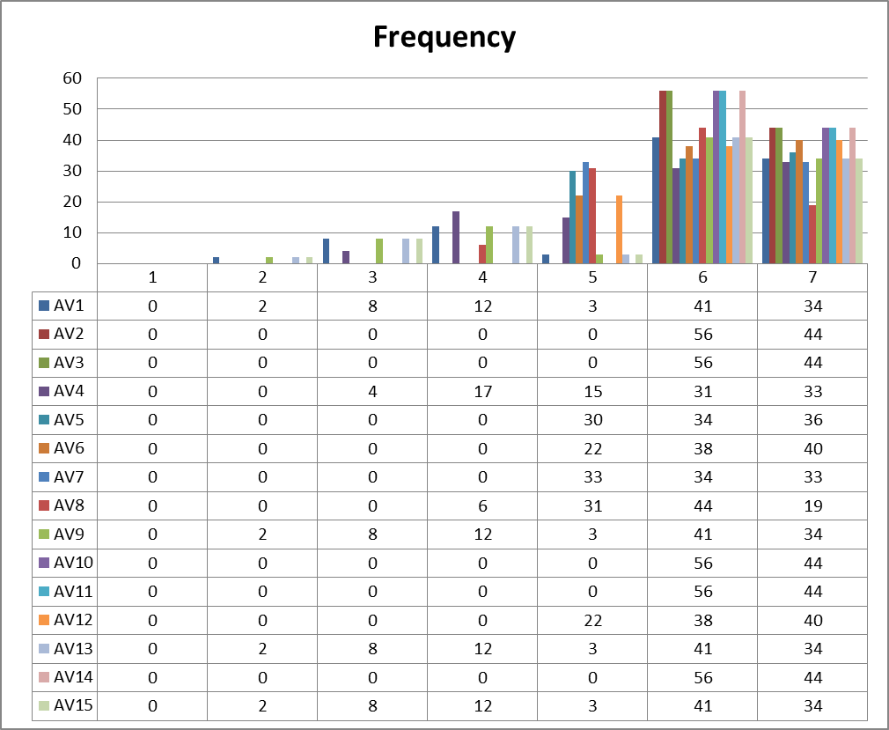
Figure 4: Advertisement
From the perception collected from the survey, it can be concluded that Unilever has received moderate success in the advertisement strategies it has implemented. A percentage of 56% of the respondents considered the company’s promotional content as attractive and easily understandable, 57% of respondents stated that the advertisements had a positive impact on their buying behaviour and 58% of them argued that the appeal to emotions make the persuasive communication more persuasive. However, there are areas for improvement: unfortunately, the perception that Unilever targets the right culture has only been committed by 33% by strongly agreeing and only 36% felt that the advertising policies of the company endow it with competitive edge. Facebook involvement does not seem to be maximized yet, 40 percent out of the respondents strongly agreeing that strategies developed for Facebook enhance interaction with Unilever. Also, only 33% said they ‘strongly agreed’ that Unilever’s omnichannel capability places it in a better standing vis-a-vis competitors. However, majority of the respondents were of the view that the advertisements placed by Unilever are unique, in touch with the current trends and clarion with the call for communicating product virtues.
Table 2: Mean, Mode and SD for Advertisement
Data collected from the surveying for the advertising variables of Unilever (AV1 to AV15) incorporate an important detail regarding the preferences of the customers by applying the mean, mode and the SD for each of the variable. The mean values vary from 5. 72 and 6. 44 which shows that most respondents have a mean perception,perceived in a positive light or generally positive about Unilever’s concerned advertising efforts. Particularly, five videos; AV2, AV3, AV10, AV11, and AV14 receive the highest mean scores of 6 out of 7. 44 which means there is almost a consensus of agreement or satisfaction with these aspects, which may be associated with the clarity/cogency of the Advertising campaigns of Unilever. The mode is also equal to 6 which indicates that this was the most representative score across all the variables, however variables such as AV4,AV5,AV6 and AV12 have a mode of 7, which implies that consumers had a higher level of satisfaction within these areas, especially the area of advertising differentiation and the use of emotional appeal. The co-efficient SD reveals slightly different responses with a slightly less variability and it ranges between 0.50 to 0.98, hence the AV2, AV3, AV10 and AV11, AV14 constant responses confirms that all the participant responded similarly to these audio-visual aids. However, as noted earlier, AV1, AV4, AV9, and AV15 have slightly higher SDs (1. 21 to 1. 36), reflecting greater variability in perception regarding some aspects, for instance, how memorable the ads are or whether they o ℝ˚er insensitive portrayals of culture. In totality the results suggest high degrees of approval in certain areas of advertising with mixed feelings about some aspects that may elicit variegated customer response.

4.2.2 Direct Marketing
After analyzing the Direct Marketing, the following observations were reached
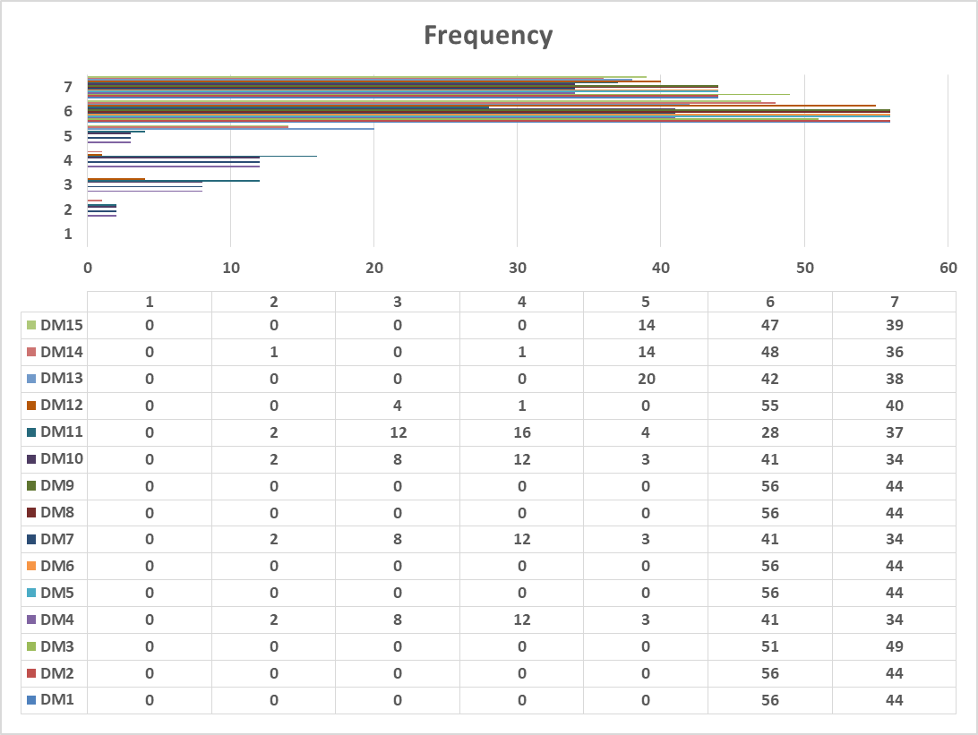
Figure 5: Direct Marketing
The survey results of the direct marketing variable present the respondents’ level of agreement in respect of various elements of direct marketing practices that are adopted by Unilever, with the level of agreement rated on a 7-point Likert scale. The results also depicted the general trend of moderate to strong agreement with several of the direct marketing initiatives. For instance, questions DM1, DM2 and DM5 of the research indicate that a large percentage of the respondents expressed a high level of satisfaction with the Unilever’s email marketing strategies; content alignment; and the overall efficiency of direct marketing for customers’ retention with scores of 56 and 44 respectively. On the other hand, DM3, DM4, DM6 & DM7 have quite a diverse response indicating that the direct marketing campaign was a matter of controversy as well as the use of digital media in marketing and the applicability of the marketing mechanism towards repeat purchases. However, DM11 and DM12 suggest that direct marketing is seen as an effective tool in conversion of leads and improving customer relations but the results show that it has a moderate potential ranging from 28 to 55. The decreased results in questions DM13, DM14, and DM15 show that segmentation and personalization initiatives are acknowledged, however, there may be incongruities within the approach or results since we got such ratings like 34 and 37. Taken together, it can be stated that the specific aspects of Unilever’s direct marketing strategies are generally viewed favourably, especially the role of the company in the mailing list, the value of the used media in reaching consumers and the priority given to the relevancy of content; However, there are definite opportunities for improvement identified in the perceived effectiveness of the marketing mechanisms and the incorporation of feedback into direct marketing practices.
Table 3: Mean, Mode and SD of Direct Marketing
The mean scores for the direct marketing variables were also rather high illustrating Unilever consumers are fairly satisfied with the company’s strategies in this particular field. 75 to 6. 49, indicating strong agreement. The Mode value of 6 for the most of the variables indicates the existence of a highly dominant level of agreement. However, one can differentiate between few of them namely, DM4, DM7, DM10 where the means are considerably low. 1.36 standard deviations have been revealed which proves that these are not as much agreed upon with high standard deviation meaning that there is significant variation of opinion about its effectiveness. It is possible to have data problems in DM11 as most of the results are anomalous and have a high standard deviation when compared with the mean. All in all, respondents are mostly agreeable towards Unilever’s direct marketing strategies with some variation both in minor details.

4.2.3 Public Relations
The following findings were drawn after information on Public Relations was analyzed.
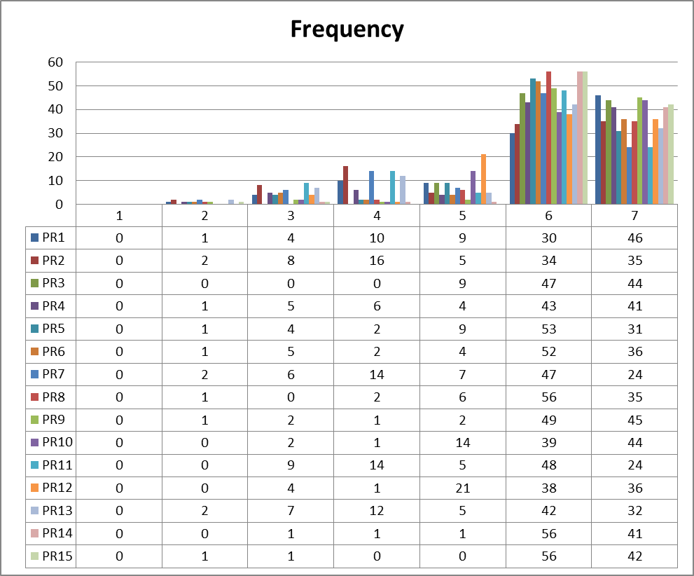
Figure 6: Public Relations
From survey results of the PR variable we can conclude that there is a rather favorable attitude toward the PR activities of Unilever. Regarding the various aspects of Unilever’s PR, the respondents agrees in prost of the following: For example, out of all the responses, many participants expressed high perceptions about Unilever’s PR strategies, including sponsorships and the creation of a positive brand image are positive as manifested by high response counts in the mid to high Likert scale. This is also observed in the responses for PR7 and PR9, as there is a clear consensus that for Unilever’s PR the activities are well suited to customer relations and enhancing brand confidence. Nonetheless, to some extent, responses to PR11 and PR12 indicate that the effectiveness of the PR efforts seen by the organisation, Unilever, varies in terms of awareness in macro context and especially on how it addresses corporate social responsibility and controlling brand crises. Variability could therefore be attributed to several factors such as experiences or expectation which the respondents might have about management of crises and their engage- ments in community activities. Thus, the results reveal that Unilever’s PR approaches are positively perceived but there is potential that their enhancements can improve the PR impact and have consistent perception.
Table 4: Mean, Mode and SD of Public Relations
The results obtained in the analysis of the variable responses in relation to PR are, on average, positive in their assessment of the PR action in Unilever. Meaning scores slightly varied with the range being between 5. 63 to 6. 35 indicating high level of import with PR efforts of Unilever. As highlighted earlier, PR3 and PR15, which attract the highest mean score of 6. 35, supports this hypothesis as it shows that Unilever’s PR activities are perceived as sincere in improving brand perception. The mode of 6 for most of the variables indicates that, the majority of the participants had a positive reaction. Standard deviations range from 0. 64 to 1. 41, although there was some variation in the answers which shows deviation in all the aspects but particularly higher variation in PR2, PR8 and PR14 respectively, which may mean that some clients had different perceptions regarding these factors. In total, the findings show that although the majority of the respondents have a favourable perception of Unilever’s PR strategies, and there is still variability in perceptions of some aspects, which can be explained by the fact that people can have different attitudes.

4.2.4 Sales Promotion
After assessing the Sales Promotion variable, the following results were found.
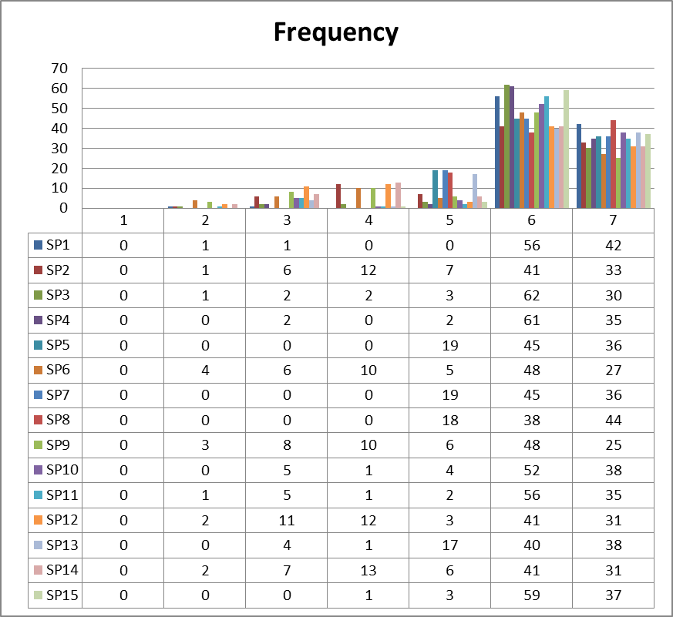
Figure 7: Sales Promotion
From the survey results of the Sales Promotion variables, Unilever has favourable perception towards its promotional strategies since the mean scores are relatively high, and ranging between 5. 63 to 6. 62. Among such statements, the highest mean scores were observed for the questions concerning the relevancy of promotional activities to create brand recognition (SP1), the controllability of selected promotional techniques (SP3), and their sufficiency to shape consumers’ behavior (SP4). That most variables are 6 reemphasises the fact that majority of the respondents strongly agree with these statements. That is why, except for the necessity of independence in decision making when choosing a product, and the importance of recommendations of relatives and friends (SP4, SP6), there is a concern about the variability, especially regarding SP2, SP7 and SP8 with the st. dev. reaching 1. 36 According to Page 133 of 184 Members, there are different opinions regarding the appropriateness of the promotion techniques and the multiple Also, some of the questions that got very high mean scores and may, therefore, be considered perceived as very effective include: Promotions that increase brand identification (SP10) and those that created a market for brands (SP14). From such results aforementioned, it is inferred that Unilever’s sales promotions are percieved to be effective and timely although there is variation concerning effective sales promotion and relative pricing that is fairer compared to competitors.
Table 5: Mean, Mode and SD of Sales Promotion
As it may be seen from the following results, the mean scores of the Sales Promotion variables show a moderately positive attitude towards Unilever’s promotional strategies with scores ranging from 5. 63 to 6. 35 which shows a positive response towards the statement by the respondents. Out of ten, the mean scores for many of the variables including SP1; The extent to which each of the promotional strategies was useful in raising brand awareness – mean = 7.9, SP3; Timeliness and relevance of each of the promotional strategies – mean = 7.2 were high, indicating a positive attitude towards Unilever’s promotional strategies. The mode of 6 across most variables indicate that a large number of the respondents strongly agree with the statement concerning Unilever’s sales promotions. The standard deviations are ranging from 0. 58 to 1. 42, which means that there is some variation in the responses of participants and perhaps, a greater variability in the assessments of some of the SPs such as SP2 and SP6 the coefficients of which were higher than the average variability coefficient of 42. Still, the indicated variability indicates that the ‘’overall mean scores’’, positive 6 and the frequent mode suggest that the Unilever’s sales promotions are mostly appreciated, do shape consumer purchase behavior and are seen as timely and relevant.

4.2.5 Implications of IMC Strategies
The following findings were drawn after looking at Implications of IMC Strategies.
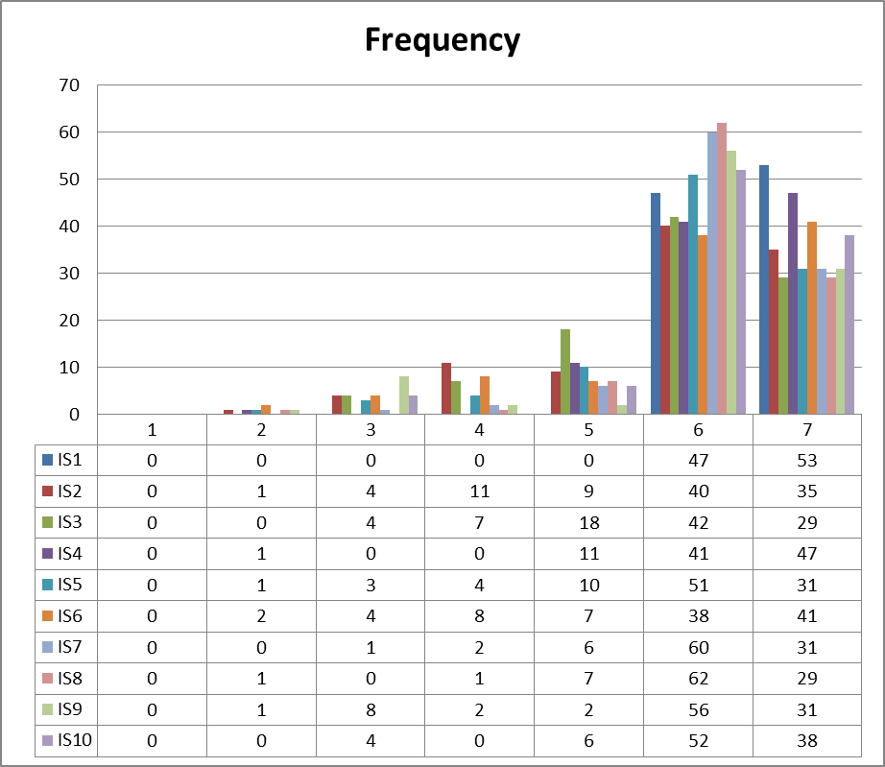
Figure 8: Implications of IMC Strategies
The data analysis for the Implications of IMC Strategies variable show that consumers’ overall impression towards Unilever’s IMC strategies is positive with the mean ratings varying between 5. 84 to 6. 38. This implies that the respondents are also in agreement with the IMC strategies in use by Unilever as very effective and useful. For instance, the high mean scores that participants accorded to statements such as, IS1 (strategic uniqueness), IS4 (online strategy in synergy with offline strategy), show that Unilever has a competitive edge in executing the IMC strategies as compared to its competitors. The constant mode of 6 across the items widens the evidence that the number of respondent was large and they were strongly agreeing on the effectiveness of these strategies. Nevertheless, the standard deviations vary with a minimum of 0. 68 to 1. 06, oscillates slightly which implies that there is diversity in perception towards some of the factors such as IS2 which concern the use of data and analysis and IS5 which concerns the use of customer insight. Taken together with these findings, perceptions of Unilever’s IMC strategies are considered to be strategically appropriate and useful in strengthening brand image and position in the market place; however, these strategies are perceived differently in terms of how they relate to data integration and competitive advantage.
Table 6: Mean, Mode and SD of Implications of IMC Strategies
The analysis of the Implications of IMC Strategies variable also show a favourable attitude towards Unilever’s IMC campaign with the mean scores falling between 5. 85 to 6. 53. An analysis of the mean scores recorded across all items show that the respondents perceive Unilever’s IMC strategies to have a high effectiveness. However, 2 items, IS1 (strategic uniqueness) and IS4( compatibility with online and offline strategies) gained the highest mean of 6. 53 and 6. 32, and 32 respectively these figures express a paradisaical confirmity in regard to the improving, uniqueness and coherence that Unilever has in the application of these strategies. An average of 6 for most of the items reinforce the idea that many of the respondents are in strong agreement on the strategies mentioned above. However, the standard deviations, ranging from 0. 50 to 1. 22, reveal a variance in reaction mainly for IS2 and IS6 using perspectives and data and analysis and competitive advantage respectively where there are somewhat equivocal opinions observed. In totality, the study’s finding suggests Unilever’s IMC strategy as being perceived to fit its business objectives’ requirements and effective for brand and market positioning enhancement; however, there is a certain divergence concerning the elements of the strategies.

4.2.6 Factors Impacting Brand Awareness and Engagement
The following findings were drawn after looking at Factors Impacting Brand Awareness and Engagement.
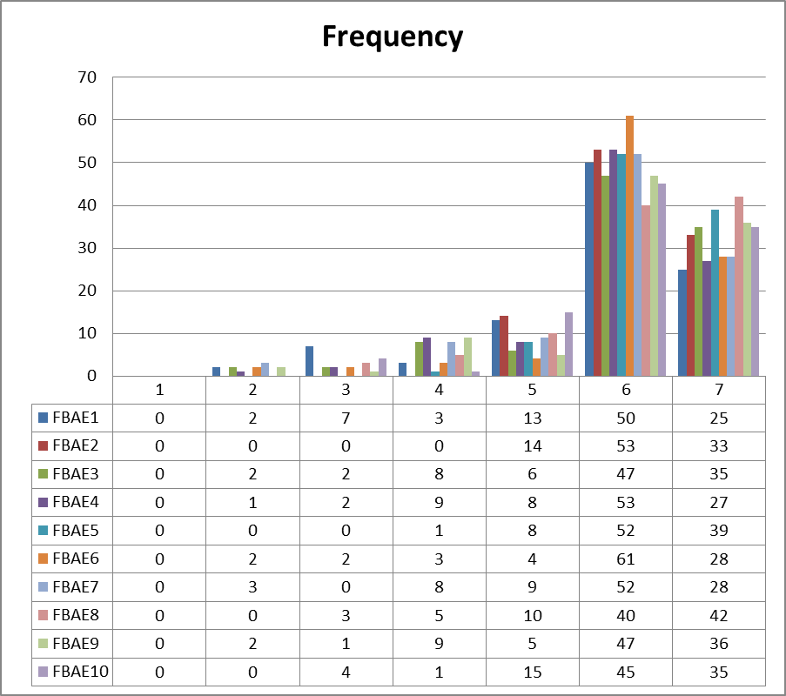
Figure 9: Factors Impacting Brand Awareness and Engagement
With regard to the Factors Impacting Brand Awareness and Engagement variable measured on the 7-point Likert scale it can be observed that there is a general agreement with most of the IMC strategies employed by Unilever. The majority of respondents approve the Unilever’s IMC activities in terms of brand awareness increase and leveraging customers (FBAE1, FBAE2). For example, majority of response in FBAE6, FBAE7 and FBAE8 were in the 50s and 40s which indicates a positive perception towards organisation: Unilever’s capability of creating brand reminders and encouraging consumer participation. Nevertheless, some of the aspects, namely the clarity and relevance of the campaign messages and the extent to which the campaigns match customers’ needs (FBAE3, FBAE4), show lower variability in responses, expressed in means varying between 13 and 28 and indicating that there is potential for further development in some of the aspects. In general, there is strong support of the respondents that all the IMC strategies of Unilever are helpful in the ways of strengthening brand recognition and the carrier of the long-term relationship (FBAE9, FBAE10).Nevertheless, there are still some opportunities of improvement in customer interactivity and customization.
Table 7: Mean, Mode and SD of Factors Impacting Brand Awareness and Engagement
Analyzing the results in the table about Factors Affecting Brand Familiarity and Interaction, it can be concluded that all in all, there is the tendency to a positive response toward the implementation of IMC strategies in Unilever. Mean values distributed between 5 and 6 are not very distinct from one another and even closer to one another when compared to their extremes of 1 and 10. 77 and 6. , with an average response of 29, hence, implying that the respondents agree, though to strongly agree with the statements made regarding Unilever’s attempt in increasing the brand awareness and the consequent engagement. The median values also render support, where the values were consistently 6 on most of the variables, which depicted that most of the respondents had a high rating of the level of agreement. The median and mode which are both 6 with the exception of FBAE8 where the mode is 7 reflects the fact that respondents made a relatively high number of similar selections as far as the scores are concerned. Altogether the standard deviation values are moderate and do not exceed 0. 66 to 1. 19, this means that the responses where closely related and most of participants had similar perceptions. On the whole, the findings indicate that people are largely satisfied with how Unilever manages its brands, with little variation in the respondents’ assessments.

4.2.7 Role of IMC in Enhancing Brand Awareness and Engagement
The following findings were drawn after looking at Role of IMC in Enhancing Brand Awareness and Engagement.
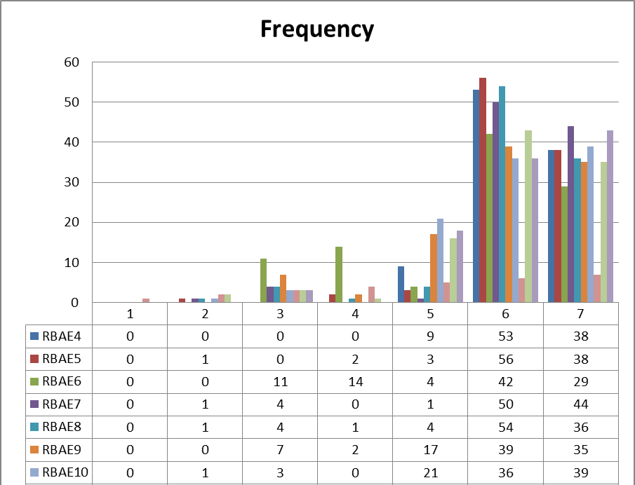
Figure 10: Role of IMC in Enhancing Brand Awareness and Engagement
The survey results on DIMS-IMC on brand awareness and engagement are represented by means of 7- point Likert scale ranging from strong disagreement (1) to strong agreement (7). In the responses, there is the general consensus towards supporting the organisation’s IMC approaches towards branding with customers. For instance, the four questions with the highest scores are RBAE6, RBAE7, RBAE8, and RBAE9 which revealed high level of agreement on the satisfaction towards the IMC effort in reinforcing brand recall, loyalty and advocacy. Such responses indicate that the strategies that have been adopted by Unilever are; useful in the provision of coherent communication and reaching out to the customers at various stages of the purchasing cycle. In contrast, respondents’ answers to questions RBAE2, RBAE3 and RBAE4 indicate a lower level of consensus, and variability, regarding ideas about how effectively the strategies contribute to engagement. In this respect, the gathered information indicates that the accounts and constituents of IMC have a clear impact towards enhancing brand identification and consumer reach for Unilever. The analysis of the results reveal that overall the IMC efforts are positively received; although the communication might still have some deficiencies in specific aspects of customer relations.
Table 8: Mean, Mode and SD of Role of IMC in Enhancing Brand Awareness and Engagement
The table indicates mean, mode, and SD in relation to role of IMC in relation to brand awareness and engagement. The means scores are presented as follows; 5. 64 to 6. 38, indicate that the respondents have a similar opinion with the IMC strategies that Unilever deploys impact on brand awareness and engagements. A higher mean of such a thing, for instance, 6. 38, suggest very high level of endorsement on some parts of IMC. The mode which is predominantly 6 across variables indicates that majority of the participants agreed with these statements. Last, the standard deviation values have been obtained and varied from 0. 55 to 1. 39, have different degrees of response consistency; the lower SD scores such as 0. 55 indicates that the respondents are almost in agreement while the higher SD scores such as 1. 39, means that the respondents were more diverse in their opinions.

4.2.8 Recommendations for Improving IMC Strategies
The following findings were drawn after looking at Recommendations for Improving IMC Strategies.
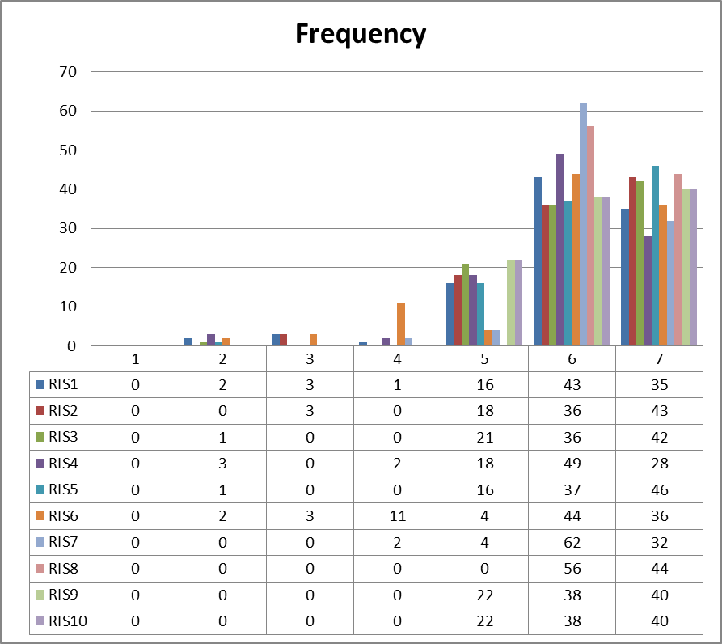
Figure 11: Recommendations for Improving IMC Strategies
Data obtained from the survey results of the Recommendations for Improving IMC Strategies, on the use of the 7- point Likert scale, show that respondents have different views regarding the different areas of improvement. There are a number of respondents who have very strong affirmative response to some of the suggestions being put forward, as evident in the high means for the recommendations such as the RIS1 the RIS2 and the RIS 4 which concern use of more Internet/ Social media/ and correct messaging across the media/platforms received some fairly high scores for example 43, 36 and 49 respectively. Also, the expectations for using new technologies and for personal communications were rather high (RIS6 and RIS7) with 44 and 62 points respectively. Nevertheless, there are slightly lower results in RIS3 and RIS8 meaning that some respondents seemed less confident in the necessity of involving influencers and using interactive content right now; responses vary from 0 up to 22. The results show that whilechances for the overall improvement of Unilever’s IMC strategy have been indicated, digitisation, sustainability, and new technologies especially are seen as specific A&As activity strengths, further potential for future development in terms of less explored areas such as feedback integration and creative agency collaboration has been identified.
Table 9: Mean, Mode and SD of Recommendations for Improving IMC Strategies
The table depicting the mean mode and standard deviation for the variable Recommendations for Improving IMC Strategies also gives the idea of how much agreement is there among the respondents. The aforementioned mean values (average scores between 5.93 and 6.44) also show a high level of agreement in which the respondents have supported most the ideas presented to them regarding Unilever’s IMC improvements. For example recommendations such as; enhancing digital engagement this recommendation has received a Reliability Index Score of 8 with the mean being 6. 44; increasing influencer collaboration this recommendation has received a Reliability Index Score of 3 with the mean being 6. 17. The mode is the most frequently used response that in this case is 6 or 7, thus it is clear that majority of the respondents agreed more with the proposed improvements. Standard deviation is expressed in figures ranging from 0. 50 to 1. 20, assesses dispersion of the responses. Observed results seek SD values low than 0. 70: The RIS8 response is 0. 50 and RIS7 response is 0. 62 while high SD figures like RIS6 response 1. 20 are indicator of diverse response. In total, the results are generally supportive of the recommended improvements to the IMC strategy where some areas appear somewhat more varied.

Chapter-5 Discussion
The conclusion drawn from this study provide considerable knowledge of how Unilever’s marketing communication affects consumers’ decisions. All the variables examined: advertisement, direct marketing, public relation, sales promotion, integrated marketing communication, brand loyalty, customer satisfaction and purchase intention, provides a precious insight into Unilever’s position in a crowded market.

5.1 Discussion on Variable Advertisement
No one would argue the power of adverts in building brand equity. Among the respondents 56% found the advertisement appealing and 57% of the respondents opined that the advertisement had a favorable influence to buy the product. This indicates that Unilever brand manager has ensured that he aligns his firm’s marketing messages to appeal the consumer’s buying interest. However, only 33% of the respondents feel that ads address the right cultural demographics which present a cause for concern. It is to this that the following feedback has been pointing at – the need to see more culturally sensitive adverts that can appeal to the different customer segments. When people today are beginning to appreciate the need to be associated with peers in one way or the other, the 40% of the respondents claiming to be connected with a friend or acquaintance through Social Media seems to depict a perceived social disconnect. That is why Unilever should further develop its internet marketing initiatives, including the use of Internet advertisements and social nets follows examples of local traditions. Staying relevant through culturally engaging content could also make Unilever’s consumer engagement and loyalty increase subsequently.
Relevance with Literature Review: Manoli and Hodgkinson (2020) establish that IMC consists of “advertising, direct marketing, public relation and sales promotion” all of which seek to present a coherent brand image to the customers. This alignment is particularly important in the currently chaotic world in which consumers receive numerous different messages.

5.2 Discussion on Variable Direct Marketing
The overall reception of direct marketing as seen in the study includes a favorable attitude toward its practice especially with reference to e-mail marketing since most of the respondents claimed to have received relevant messages. However, there is some disagreement on whether digital marketing is effective in encouraging customer to buy the product more than once. This implies that although there multiple centrally initiated, direct marketing strategies currently in management’s use they indeed target and start off the consumer but are inadequate in keeping the consumption going round. To this end, there is a need for Unilever to ramp up efforts in personalisation when undertaking direct marketing communications. It is very effective to use big data to personalize the content that is presented to the audience in the social media platform. For example, the use of emails announcing promotions that a customer has made before or sending exclusive material related to the customer’s preferences is useful in case of nurturing the customer base into producing more business. Moreover, the feedback integration could enable consumers to state their opinion on which option to select, thus, earn their loyalty and participation.
Relevance with Literature Review: According to Butkouskaya et al. (2021), “Direct marketing is oriented to individual communication with consumers, which not only makes messages more relevant, but creates stronger consumer bonds.”

5.3 Discussion on Variable Public Relations
Unilever’s public relation works have received good Patronage especially on proponents such as sponsorships and brand identity. However, CSR and crisis management mentioned as the drawback focus on aspects which should be improved. It has become the norm for the general public to began to pay more attention to a company’s ethical behavior and contribution to society, in today’s market place. Since Unilever plays an important role for all its stakeholders by providing products that reflect sustainable and socially responsibility, it must make sure that stakeholders have confidence in what it does and it is by regularly reminding them of its stand on these two aspects. In addition, the proper management of crisis situations is attractive in the consumer trust and loyalty program. The study recommends that the performance of the respondents was consistent with their doubts concerning Unilever’s effectiveness in managing crises. Thus, it means that Unilever must have totally transparent communication and vision concerning the matters in question, and it is crucial for the firm to be prepared for efficient crisis management. Communicating CSR activities frequently whilst being accountable during the time of major incidents can be of benefit to Unilever and strengthen the trust from the clients.
Relevance with Literature Review: Kadia (2022) opines that press releases, media coverage, and stakeholders’ relations produce PR activities that can enhance public trust and control brand image. something like this is particularly relevant especially at a time when customer loyalty is anchored on trust.

5.4 Discussion on Variable Sales Promotion
Even though the research problem formulated specifically for this study reveals that Unilever’s sales promotions are well-received and consequently contribute to consumers’ brand recognition and purchase decision-making processes, the aim of this dissertation was broader. However, variability in perception of the promotional techniques being proper makes it clear that not all promotions appeal to all the target consumers. These differences make it crucial to divide the audience into segments, and advertise for a product based on that segmentation. The value delivered to its target consumers should not be just a price cut plan but incorporated creativity in its promotion avenues that Unilever should consider. For instance, identifying the possibility of including such promotions as taste tests or incorporating the promotion with local events can help in the engagement. He has also pointed out that it enhances an emotional connection to the brand thus creating brand loyalty and a brand ambassador.
Relevance with Literature Review: Sales promotions are also included in the IMC strategies These are some of the most commonly used elements of the integrated marketing communication mix. According to Yu (2022), they noted that such promotions create awareness with an intention of producing an ‘immediate call to purchase,’ which presents a great future influence on consumer buying behaviours.

5.5 Discussion on Variable Integrated Marketing Communication (IMC)
The positive sentiment for the IMC agenda shows that a coherent strategy made for Unilever was beneficial. In terms of the particular elements highlighted, respondents approved the integration of online and offline promotion stating that one has a coherent brand message of Unilever. However, the signal of variation in perceptual mean points to the possibility of there being areas that need some tweaking within IMC. In addition to developing the IMC strategy, Unilever may conduct periodic analysis of resource output to increase the compatibility of the message and the channel. Using some type of fun and entertaining content that will allow consumers to engage and make their response as well as allowing their response on the communications can be very useful in managing the process. Due to engaging a continual discussion with consumers, Unilever will be ready to match its messaging marketing communications with the consumers’ altered preferences and behavior.
Relevance with Literature Review: According to Mietra and Wibowo (2022), brand awareness is crucial for ‘providing the overall image of the brand’ as well as the ‘brand decision-making system’. According to Shakila and Nasution (2023), the practice of building solid brand familiarities are also play crucial roles in attaining consumers’ confidence and particularly being the key success factor in the competitive markets.

5.6 Discussion on Variable Brand Loyalty
Brand loyalty is an essential indicator of consumers’ connections and Recommendations for any brand or company. The study revealed fairly high level of brand attitude among the respondents with many of them preferring Unilever brands to those of its competitors. Still, when consumers willing to switch brands to get a lower price or a better quality it is clear that the competitive nature of the market exists. Thus, the ideas are clear for Unilever: to maintain and increase the company’s sales and brand loyalty it must develop and offer superior value. This could mean that efforts were made to increase quality of the products, the packaging of the products and the prices at which the products were being sold were reassuring. Also, the use of a loyalty program that is intended for the frequent consumers will also enhance brand loyalist since they will help market Unilever products.
Relevance with Literature Review: Refining the place utility characteristics, Kushwaha et al. (2020) stressing that ‘’the quality of customer service’’ is a key determinant of customer engagement as brands are encouraged to offer high quality customer service for sustainable engagement.

5.7 Discussion on Variable Customer Satisfaction
Loyalty is achieved if customers are happy with the products they are using, and from the results presented in this study the attitude of consumers towards products manufactured by Unilever is relatively positive. Despite a majority of the respondents giving satisfactory responses concerning quality and value for their money there is need to address issues to do with product accessibility and customer service response. Unilever should also focus on the supply chain in a bid to improve on the stock of the available products to ensure consumer appeal of the preferred brands. Increasing customer service responsiveness is equally crucial; the availability of contacts such as chatbots, social medial, and the traditional customer-service phone lines is vital in handling the consumers’ complaints. This means that, continued supervision of customer comments and indexes of satisfaction will help in steering changes to make certain that Unilever aptly serves customer requirements.
Relevance with Literature Review: As claimed by Shakila and Nasution, 2023, intense brand awareness does more than assist consumers in trusting the brands; it also creates a competitive advantage in the market area.

5.8 Discussion on Variable Purchase Intention
In terms of purchase intention, the study reveals that everday, respondents demonstrate a high inclination of buying Unilever products in the future. This outlook is positive which is quite encouraging since it clearly points that all the efforts put by Unilever has paid off with the right message getting to the consumers. Also, admission that price promotions could affect the purchase decisions shows how effective pricing strategies matters. To benefit off this situation, Unilever must come up with promotional strategies that help create a niche market for the products with the view nearly achieving market saturation. Consequently, such incentive as limited time offers, two products for the price of one, or web-only promotions can generate the feeling among customers that they need to act quickly. However, use of customer testimonials or any kind of reviews can strengthen positive perceptions and increase the chances of the customers to buy the product.
Relevance with Literature Review: This is especially important in the current marketplace because customers are much more likely to transact with brands they are familiar with, as explained by Alrajhi (2023).

Chapter-5 Conclusion and Recommendations

5.1 Conclusion

5.1.1 Objective 1: Identifying the Implications of Different IMC Strategies Used by Unilever
The study outlined the strategies of IMC implemented by Unilever which includes advertising, direct marketing, public relation and sales promotions. Each of them serves the purpose of building the consistent picture of the brand and speaking to the chosen audience. For example, the respondents acknowledged that appealing and culturally appropriate marketing messages can considerably boost the popularity of advertisements The respondents also pointed at the general lack of cultural sensitivity in advertising, and the need for improvement in this area. Also, the study reiterated that strategies under the IMC have to not only educate, but also persuade, the consumer and make the consumer feel connected to the brand. In sum, strategic marketing message alignment within Unilever has all in all had positive outcomes regarding brand recall and consumer buying behaviour with changes identified for cultural sensitivity.

5.1.2 Objective 2: Examining the Factors Impacting Brand Awareness and Customer Engagement of Unilever
This paper discussed different variables that may influence brand recognition and consumer interest. The results showed that advertisement effectiveness, direct marketing and the public relation affect consumers’ perception on the brand of Unilever in a considerable way. Although the large number of respondents noted that advertisements and direct marketing helped create awareness, questions were noted concerning sustained customer interaction. The research findings showed that while personalization in direct marketing, improvements in public relations mainly through CSR, and managing crisis were indispensable for the sustenance of consumer interest. So, the research also pointed out the fact that brand loyalty and customer satisfaction serve as measures of consumer interaction showing that Unilever needs to consistently change its marketing tactics related to consumers.

5.1.3 Objective 3: Analyzing the Role of IMC in Enhancing Brand Awareness and Customer Engagement in the UK Consumer Goods Industry
This paper demonstrated that IMC is a crucial component in the enhancement of brand recognition and ensuing customer relationships with firms in the UK consumer goods industry. The outcomes revealed that integrated communication also improved the consumers’ recognition of the brand and made the purchase intention more robust. The feedback provided for IMC strategies for Unilever shows that a multiple message convergence approach of the same brand when taken online and offline are equally impactful in its reach to the end users. At the same time this analysis also revealed the ongoing need to monitor and adjust the IMC strategies because the markets evolve, and the strategies have to reflect that change. This paper established that by integrating organizational communication strategies with consumer requirements, Unilever can improve its market standing and consumer satisfaction.

5.1.4 Objective 4: Recommending Effective IMC Strategies for Improved Brand Awareness and Customer Engagement
From the consumer perception analysis, the following recommendations were given to Unilever and other companies that want to enhance the brand recognition and customer interactions through efficient IMC plans. First of all, Advertisers should strive to increase the cultural appeal of advertisements and utilize less obtrusive direct marketing appeals to wider consumer niches. Furthermore, the infusion of interesting and amusing content in communicating services and products makes it easier to maintain a continuous feedback from the customer on the latest communication trends that will suit changing consumer behavior. Unilever should also improve its public relations strategic communication in terms of relation to CSR activities and response to crises to be proactive in convincing consumers to trust its products. Finally, the integration of new sales promotion techniques like experiential selling or selling targeted for particular markets make it possible to strengthen the affective-conative ties to the brand and increase loyalty.

5.2 Recommendations
When these suggestions are adopted, Unilever is in a position to optimize its IMC approaches and hence connect with its vast client base to support company’s growth and development for the long-run.

5.2.1 Increasing awareness on social culture in advertisement.
Hence, it is clearly apparent that Unilever should enhance cultural sensitivity of the company’s subsequent advertising campaigns. Market research that indicates knowledge about cultural differences between one consumer group and the other will have to be carried out. It’s possible to involve the local people and even conduct focus groups that help in creating the relevant commercial stimuli to address the cultural segments of interest to Unilever. The application of this approach will not only enhance the perception of the brand, but also enable creation of a bond with the consumers to enhance their commitment to the brand.

5.2.2 Utilise Data Analytics to do Personalisation
In particular, application of the modern tools of data analysis helps to improve the effectiveness of marketing communication in the activities of Unilever. Thus, through the identification of all the pattern and preference of consumers, one can be able develop social campaigns that addresses the needs and issues of each consumer. Such personal data may help enhance the levels of people’s engagement, enhance satisfaction and result in higher conversion levels. A combination of AI and machine learning technologies will be useful for the brand to be flexible with the message and match it well to the audience.

5.2.3 Share Emphasis on the Dynamic and Participatory Content
As for the consumer engagement, Unilever should create more responsive and appealing content on its web optimistically. To ensure consumers are more proactive in sharing their experiences the following strategies include; quizzes, polls and user generated content campaigns. With this understanding, Unilever can promote customer engagement and develop a richer brand story that consumers can easily relate with and ultimately make them loyal customers.

5.2.4 Strengthen Corporate Social Responsibility (CSR) Initiatives
Corporate Social Responsibility (CSR) is one of the significant aspects of brand that belongs to the Unilever Company. In order to establish a better rapport with the LCs, Unilever should further strengthen its CSR communications and publicise them across the media. With the help of target special sections, it will be possible to focus on the aspects of sustainability, as well as community performance, which will add credibility to the brand and attract customers who consider the problem of ethical values ​​in product selection settlements.

5.2.5 Cross-Channel Campaigns
Last of the strategies the Unilever should adopt is the consistency and coordination of marketing communication. This will introduce a coordinated way in approaching cross channel campaigns, the messages, images and the branding that will in turn offer consumers a harmonized brand experience. This will ensure that an organisation maintains a strong brand image and support its clients in achieving consistent interaction between brands across the various channels as it helps customers to retain brand information and cyclicly interact with this information.
When referring to cultural compliance, individualization, interaction, CSR, and integration of available channels, it will be possible for Unilever to become a market leader and to meet all the requirements of customers.

5.3 Limitation of the Research
The major research limitation worth pointing out is the fact that this research only used primary data collection techniques. Primary data, however, enables the collection of highly specific and valuable data regarding the consumers’ behavior and attitude, which presents various biases and limited aspects. For instance, the data obtained from polls and interviews might not be accurate in view of the fact that the sample is not random. Third, the qualitative responses are likely to be general and therefore can be interpreted in many ways which would reduce the reliability of the study. Moreover, the source of data and time and resources in the process of their primary collection may sometimes pose a problem that reduces the number of respondents to be interviewed and the coverage area, thus restricting the external validity of the findings. Subsequent research works should apply secondary data collection techniques to make the research results more reliable as well as to capture all the effects of IMC strategies to consumer behaviour and brand loyalty.

5.4 Areas for Future Research
Subsequent studies should extend the understanding of how new technologies affect the consumer attitudes and the brand allegiance linked to IMC campaigns. As the current trend in digital marketing exhibiting an increased technological rate in the communication tools as well as the media platforms, there is need for research on the consumers’ engagement of brands across the various communication interfaces. Research topics may encompass such issues as the role of media influencers, individualized promotion and sales strategies, and immediate customer interactions. Also, research into the state of IMC and its efficiency depending on the culture could be very interesting as consumers’ attitudes and behaviors may differ greatly from country to country.
Furthermore, the achievement of longitudinal studies could be used to gain a better insight into the impact of IMC strategies in consumers’ brand loyalty patterns in the long run. Following consumer attitude and behavior, the researchers can determine customer retention and advocacy level while shifting the marketing communication strategy. It also would enable the analysis of shifting consumer expectations and these expectations’ consequences for brands throughout the competitive space. Investigiting these areas will help to develop a richer understanding of IMC and its essential function of maintaining consumer loyalty when threatened by new developments on the market.

References
Alam, M.I., 2022. Sales Activities of the Enterprise: The Case of Mousumi Enterprises Limited (MEL)-A trading and distribution house of Aman Group of Companies.
Alrajhi, A., 2023. Exploring the Challenges of Incorporating Social Media into Integrated Marketing Communications (IMC) (Doctoral dissertation, Macquarie University).
Anani-Bossman, A. and Mudzanani, T.E., 2021. Analysing the Influence of Public Relations in the Integrated Marketing Communication Process. Marketing Communications in Emerging Economies, Volume I: Foundational and Contemporary Issues, pp.105-136.
Anderson, T. and Kanuka, H., 2006. E-research methods, strategies and issues. London: Allyn and Bacon.
Ang, L., 2021. Principles of integrated marketing communications. Cambridge University Press.
Bakalo, A. and Amantie, C., 2023. The Advertising & Promotion an Integrated Marketing Communications Perspective Scientific Literature Review. Global Media Journal, 21(63), pp.1-9.
Blakeman, R., 2023. Integrated marketing communication: creative strategy from idea to implementation. Rowman & Littlefield.
Brown, R.B., 2006. Doing your dissertation in business and management: the reality of researching and writing. London: Sage Publications.
Butkouskaya, V., Llonch-Andreu, J. and Alarcón-del-Amo, M.D.C., 2021. Inter-country customer-perspective analysis of strategic antecedents and consequences for post-purchase behaviour in integrated marketing communications (IMC). Journal of International Consumer Marketing, 33(1), pp.68-83.
Cameron, S. and Price, D., 2009. Business research methods: a practical approach. London: Chartered Institute of Personnel and Development.
Casemajor, C., 2023. Strategies for Building Brand Awareness and a Competitive Edge in Social Media in a Cross-Field Industry: Establishing a Social Media Strategic Plan for Henua.
Chakraborty, A. and Jain, V., 2022. Leveraging Digital Marketing and Integrated Marketing Communications for Brand Building in Emerging Markets. In Marketing Communications and Brand Development in Emerging Economies Volume I: Contemporary and Future Perspectives (pp. 281-305). Cham: Springer International Publishing.
Cresswell, J., 2002. Research design: qualitative, quantitative, and mixed methods approaches. London: Sage Publications.
Davies, M., 2007. Doing a successful research project. New York: Palgrave Macmillan.
Davies, M.B., 2007. Doing a successful research project: using qualitative or quantitative methods. Basingstoke: Palgrave Macmillan.
Eagle, L., Czarnecka, B., Dahl, S. and Lloyd, J., 2020. Marketing communications. Routledge.
Fisher, C.M. and Buglear, J., 2010. Researching and writing a dissertation: an essential guide for business students. 3rd ed. Harlow: Financial Times/Prentice Hall.
Galloway, C., 2020. Integrated marketing communication. In Public Relations (pp. 186-207). Routledge.
Gardiner, P., 2015. Project management: a strategic approach. 2nd ed. Basingstoke: Palgrave.
Gordon-Isasi, J. and Ronda, L., 2024. Creating student value in higher education through customer-centric integrated marketing communication. Journal of Marketing for Higher Education, pp.1-24.
Hart, C., 2004. Doing your masters dissertation (Essential Study Skills series). London: Sage Publications.
Hereyah, Y. and Faradella, S.J., 2020. Omni Channel Marketing Communication Strategic in Building Brand Engagement with Millennial Consumers (Case Study at PT Brodo Ganesha Indonesia). International Journal of Latest Research in Humanities and Social Science (IJLRHSS), 3(10), pp.141-150.
Hossain, M.I., Akter, N. and Muzareba, A.M., 2024. Integrated Marketing Communications. In Marketing in a Transition Economy: New Realities, Challenges, and Prospects (pp. 325-375). Singapore: Springer Nature Singapore.
Iglesias, O., Mingione, M., Ind, N. and Markovic, S., 2023. How to build a conscientious corporate brand together with business partners: A case study of Unilever. Industrial Marketing Management, 109, pp.1-13.
Ihsan, N., Firda, D. and Khaddafi, M., 2023. Factors Influencing Success and Failure in Mergers and Acquisitions: A Case Study of PT Unilever Indonesia Tbk. Journal of Accounting Research, Utility Finance and Digital Assets, 2(1), pp.445-449.
Juska, J.M., 2021. Integrated marketing communication: advertising and promotion in a digital world. Routledge.
Kadia, S., 2022. Influence of IMC on Communication Dissemination. In Integrated Marketing Communications for Public Policy: Perspectives from the World’s Largest Employment Guarantee Program MGNREGA (pp. 15-44). Singapore: Springer Nature Singapore.
Kamau, F., Mberia, H. and Ndavula, J., 2023. Integrated Marketing Communication Strategies and Rebranding of Telkom Kenya. International Journal of Communication and Public Relation, 8(3), pp.36-51.
Kang, J., Lee, S. and Choi, S., 2023. Asymmetric Vacillation in the FMCG Industry: A Case Comparison of Procter & Gamble and Unilever. Administrative Sciences, 13(8), p.187.
Kaziba, K., 2020. Achieving Effective Integrated Marketing Communications Through a Dealer Network System. A comparative case study of the United Kingdom and Uganda's New Car Market (Doctoral dissertation, Cardiff Metropolitan University).
Kinnear, P.R. and Gray, C.D., 2007. SPSS 15 made simple. Hove: Psychology Press.
Kitchen, P.J. and Tourky, M.E., 2022. Integrated marketing communications: a global brand-driven approach. Springer Nature.
Lopes, A.C.H., 2020. Shaping customer engagement, repurchase intention and positive word-of-month in omnichannel retailing context (Master's thesis, ISCTE-Instituto Universitario de Lisboa (Portugal)).
Manoli, A.E. and Hodgkinson, I.R., 2020. The implementation of integrated marketing communication (IMC): evidence from professional football clubs in England. Journal of Strategic Marketing, 28(6), pp.542-563.
Mensah, K. and Amenuvor, F.E., 2022. The influence of marketing communications strategy on consumer purchasing behaviour in the financial services industry in an emerging economy. Journal of Financial Services Marketing, 27(3), pp.190-205.
Mietra, A.B. and Wibowo, S.A., 2022. Proposed Integrated Marketing Communication Strategy to Promote Brand Awareness of Online Learning Portals: Study of MOJADIAPP. COM. Asia Pacific Journal of Management and Education (APJME), 5(1), pp.108-125.
Miraki, M., Yektayar, M. and Esmailie, N., 2020. The role of Integrated Marketing Communications in Brand Engagement and Consumer Behavior. Consumer Behavior Studies Journal, 7(2), pp.199-215.
Mishra, A. and Vijay, T.S., 2023. Integrated advertising, promotion, and marketing: communicating in a Digital World. Taylor & Francis.
Pearson, S. and Malthouse, E., 2024. Fifth Generation IMC: Expanding the scope to Profit, People, and the Planet. arXiv preprint arXiv:2404.04740.
Pisicchio, A.C. and Toaldo, A.M.M., 2021. Integrated marketing communication in hospitality SMEs: analyzing the antecedent role of innovation orientation and the effect on market performance. Journal of Marketing Communications, 27(7), pp.742-761.
Rashkova, Y., Moi, L., Marku, E. and Cabiddu, F., 2023. Online integrated marketing communication strategies of international brands: standardization vs. adaptation approaches. Journal of Marketing Communications, pp.1-24.
Saunders, M. et al., 2006. Research methods for business students. Harlow: Prentice Hall.
Shakila, B. and Nasution, R.A., 2023. Proposed Customer Engagement-Oriented Digital Strategy and Integrated Marketing Communication for PT. Ready-Mix X. International Journal of Current Science Research and Review, 6(02).
Sobhy, M., 2024. The role of integrated marketing communications in enhancing omnichannel marketing effectiveness. Journal of Mass Communication Research, 71(1), pp.755-804.
Syeda, M.S., 2022. COMPONENT OF IMC STRATEGIC PLANNING. SAARJ Journal on Banking & Insurance Research (SJBIR).
Twum, K.K. and Yalley, A.A., 2021. Green integrated marketing communication. Green Marketing in Emerging Markets: Strategic and Operational Perspectives, pp.117-144.
Whitburn, D., Karg, A. and Turner, P., 2020. The effect of digital integrated marketing communications on not-for-profit sport consumption behaviors. Journal of sport management, 34(5), pp.417-434.
Yu, P., 2022. The Implementation of Integrated Marketing Communications in the Automotive Industry.
Zwerin, A., Clarke, T.B. and Clarke III, I., 2020. Traditional and emerging integrated marketing communication touchpoints used in Effie award-winning promotional campaigns. Journal of Promotion Management, 26(2), pp.163-185.

Appendix

Survey Questionnaire
Strongly Disagree | Disagree | Somewhat Disagree | Neutral | Somewhat Agree | Agree | Strongly agree
1 | 2 | 3 | 4 | 5 | 6 | 7

Coding of Question | Questions | Strongly disagree | Disagree | Somewhat disagree | Neutral | Somewhat agree | Agree | Strongly agree
Section 1: Advertisement
AV1 | All the Adverting campaigns developed by the Unilever are related to the company’s brand message. | 1 | 2 | 3 | 4 | 5 | 6 | 7
AV2 | Unilever’s promotional content is appealing to me. | 1 | 2 | 3 | 4 | 5 | 6 | 7
AV3 | Many of Unilever’s advertising messages can be understood without much effort. | 1 | 2 | 3 | 4 | 5 | 6 | 7
AV4 | In marketing communication, Unilever has been able to target the right culture and be sensitive to it. | 1 | 2 | 3 | 4 | 5 | 6 | 7
AV5 | One way through which the advertising policies and practices are helpful to Unilever is that it sets out the company apart from other competitors. | 1 | 2 | 3 | 4 | 5 | 6 | 7
AV6 | The Facebook advertising strategies adopted by Unilever compel me to interact with their advertisements. | 1 | 2 | 3 | 4 | 5 | 6 | 7
AV7 | They continue to advertise in different platforms making their brand have a cutting edge in the consumer goods market. | 1 | 2 | 3 | 4 | 5 | 6 | 7
AV8 | The advertising messages of Unilever are easy to understand and leave a trace in the memory of the consumer. | 1 | 2 | 3 | 4 | 5 | 6 | 7
AV9 | It is seen, therefore, that the efforts of Unilever in advertising assist in getting this message through to the consumer. | 1 | 2 | 3 | 4 | 5 | 6 | 7
AV10 | This is so because through advertising Unilever has been able to sway my purchasing decisions. | 1 | 2 | 3 | 4 | 5 | 6 | 7
AV11 | Emotional appeals are applied in organizational specialized advertising campaigns to sell products, and Unilever is not exceptional. | 1 | 2 | 3 | 4 | 5 | 6 | 7
AV12 | Their advertises are excellent in relaying the benefits of their products in the best way possible. | 1 | 2 | 3 | 4 | 5 | 6 | 7
AV13 | In the current society, the type of adverts run by Unilever is in line with the trends. | 1 | 2 | 3 | 4 | 5 | 6 | 7
AV14 | Unilever’s advertising is good at employing the appeal of testimonials to boost the persuasion. | 1 | 2 | 3 | 4 | 5 | 6 | 7
AV15 | In so doing, it can be said that Unilever’s advertisements are useful in the communication of product features and benefits. | 1 | 2 | 3 | 4 | 5 | 6 | 7
Section 2: Direct Marketing
DM1 | 1. Unilever has effectively implemented its email marketing strategies by delivering interesting and targeted messages. | 1 | 2 | 3 | 4 | 5 | 6 | 7
DM2 | 2. The official website of Unilever also contains much information and is easy to navigate; the company also actively addresses visitors. | 1 | 2 | 3 | 4 | 5 | 6 | 7
DM3 | 3. It can be agreed that Unilever’s direct marketing campaigns are a perfect way of customer retention. | 1 | 2 | 3 | 4 | 5 | 6 | 7
DM4 | 4. The direct marketing approach used by Unilever is effective and straight on their target customers. | 1 | 2 | 3 | 4 | 5 | 6 | 7
DM5 | 5. It is noteworthy to mention that all of Unilever’s content marketing is aligned with my interests and requirements. | 1 | 2 | 3 | 4 | 5 | 6 | 7
DM6 | 6. Direct marketing promotes high levels of satisfaction among its customer hence integrates well with Unilever. | 1 | 2 | 3 | 4 | 5 | 6 | 7
DM7 | 7. Insofar as the tailor-made marketing communications are concerned, Unilever’s direct marketing takes care of my concern about their products in a very efficient way. | 1 | 2 | 3 | 4 | 5 | 6 | 7
DM8 | 8. The digital medium integration improve the plans of IMC by Unilever. | 1 | 2 | 3 | 4 | 5 | 6 | 7
DM9 | 9. Some of the direct marketing mechanisms that Unilever employs are quite useful in making the customers to repurchase the products. | 1 | 2 | 3 | 4 | 5 | 6 | 7
DM10 | 10. Unilever’s direct marketing activities are good examples of how customer feedback can be utilised. | 1 | 2 | 3 | 4 | 5 | 6 | 7
DM11 | 11. Another area that has effectively being utilised in achieving Unilever’s direct marketing goals is in the conversion of leads to customers. | 1 | 2 | 3 | 4 | 5 | 6 | 7
DM12 | 12. The various personalised direct marketing methods used by Unilever enhance customer relations. | 1 | 2 | 3 | 4 | 5 | 6 | 7
DM13 | 13. Direct marketing means, through which Unilever targets its customers works well in the sense that it helps retain customers. | 1 | 2 | 3 | 4 | 5 | 6 | 7
DM14 | 14. In Unilever’s direct marketing communications, segmentation completes the nice work of using demographics to contact only the requisite consumer niches. | 1 | 2 | 3 | 4 | 5 | 6 | 7
DM15 | 15. It agrees with the fact that the direct marketing that Unilever has been undertaking in the marketplace is very helpful in improving the level of customer appeal that is occasioned by tailor made offers. | 1 | 2 | 3 | 4 | 5 | 6 | 7
Section 3: Public Relations
PR1 | 1. The IMC strategies of Unilever can be considered as especially good in terms of sponsorships and partnerships. | 1 | 2 | 3 | 4 | 5 | 6 | 7
PR2 | 2. The PR activities carried out in Unilever lead to the generation of good talks about its brand. | 1 | 2 | 3 | 4 | 5 | 6 | 7
PR3 | 3. It is important that these IMC efforts are perceived as genuine and, in relation to Unilever, they are. | 1 | 2 | 3 | 4 | 5 | 6 | 7
PR4 | 4. The public relation activities of Unilever improve its market standing. | 1 | 2 | 3 | 4 | 5 | 6 | 7
PR5 | 5. PR activities carry a positive brand image to consumers, which in the case of Unilever is true. | 1 | 2 | 3 | 4 | 5 | 6 | 7
PR6 | 6. In IMC strategies developed by Unilever, consumer trends within the market are well addressed. | 1 | 2 | 3 | 4 | 5 | 6 | 7
PR7 | 7. Unilever’s product public relations relate well with its long-term customer relations goals. | 1 | 2 | 3 | 4 | 5 | 6 | 7
PR8 | 8. PR activities of the Unilever Company are sensitive to the cultural differences of its consumers. | 1 | 2 | 3 | 4 | 5 | 6 | 7
PR9 | 9. These PR approaches by Unilever increase my confidence in the brand from the following ways. | 1 | 2 | 3 | 4 | 5 | 6 | 7
PR10 | 10. PR efforts are also used in the construction of customer loyalty as seen in the IMC activities of Unilever. | 1 | 2 | 3 | 4 | 5 | 6 | 7
PR11 | 11. This is to say that through these campaigns, Unilever gets to explain itself or defend its operations thus impacting the reputation of the brand positively. | 1 | 2 | 3 | 4 | 5 | 6 | 7
PR12 | 12. However, Unilever’s PR strategies are well used when it comes to dealing with brand crisis as and when they occur. | 1 | 2 | 3 | 4 | 5 | 6 | 7
PR13 | 13. The Business: In aspects of public relations, Unilever’s campaign is effective in promoting their corporate social responsibility programmes. | 1 | 2 | 3 | 4 | 5 | 6 | 7
PR14 | 14. Another way that Unilever’s PR impact is to achieve media reach to popularize brands. | 1 | 2 | 3 | 4 | 5 | 6 | 7
PR15 | 15. It is evident that many of Unilever’s PR campaigns use the involvement of the community in the right way to improve brand perception. | 1 | 2 | 3 | 4 | 5 | 6 | 7
Section 4: Sales Promotion
SP1 | 1. Promotional activities are also useful in the sales promotion strategies of Unilever as they help in raising brand awareness. | 1 | 2 | 3 | 4 | 5 | 6 | 7
SP2 | 2. The existing promotional techniques being employed by Unilever are quite market appropriate. | 1 | 2 | 3 | 4 | 5 | 6 | 7
SP3 | 3. What makes Unilever’s sales promotions effective is the fact that they are always on time, and they are relevant. | 1 | 2 | 3 | 4 | 5 | 6 | 7
SP4 | 4. To a greater extent, it is evident that Unilever’s sales promotions influence consumers in the way expected by the company. | 1 | 2 | 3 | 4 | 5 | 6 | 7
SP5 | 5. The above presented IMC campaigns of Unilever also make good use of story telling in its campaigns. | 1 | 2 | 3 | 4 | 5 | 6 | 7
SP6 | 6. It has to be noted that Unilever’s different sales promotion techniques are particularly vivid and effective. | 1 | 2 | 3 | 4 | 5 | 6 | 7
SP7 | 7. Its sales promotions form my buying decisions, as am a user of Unilever products. | 1 | 2 | 3 | 4 | 5 | 6 | 7
SP8 | 8. The idea of promotions evident in Unilever’s IMC strategies makes it easier for customers to be attracted to make multiple purchases. | 1 | 2 | 3 | 4 | 5 | 6 | 7
SP9 | 9. Due to secured consumer awareness, Unilever successfully handles its sales promotion to fit the consumers’ shifting demands. | 1 | 2 | 3 | 4 | 5 | 6 | 7
SP10 | 10. The case studies presented illustrate that Unilever’s sales promotions strategies are effective in enhancing brand identification. | 1 | 2 | 3 | 4 | 5 | 6 | 7
SP11 | 11. The sales promotions which are often adopted by Unilever are effective in establishing the products in the market. | 1 | 2 | 3 | 4 | 5 | 6 | 7
SP12 | 12. This is particularly the case because sales promotions as applied by Unilever are useful in increasing short-term sales. | 1 | 2 | 3 | 4 | 5 | 6 | 7
SP13 | 13. From the sales promotions, Unilever’s appeals are usually timely based and this cobbles consumer action. | 1 | 2 | 3 | 4 | 5 | 6 | 7
SP14 | 14. The current brand sales promotions by Unilever are actually aimed at creating a market for the brands. | 1 | 2 | 3 | 4 | 5 | 6 | 7
SP15 | 15. Unilever’s promotional offers are fairly priced compared to other brands in the market. | 1 | 2 | 3 | 4 | 5 | 6 | 7
Section 5: Implications of IMC Strategies
IS1 | 1. Unilever is strategic in the implementation of its IMC than its competitors and the strategies are unique. | 1 | 2 | 3 | 4 | 5 | 6 | 7
IS2 | 2. Unilever Integrated Marketing Communication (IMC) planning and execution are rich in the use of data and analysis. | 1 | 2 | 3 | 4 | 5 | 6 | 7
IS3 | 3. Unilever’s IMC techniques are integrated to suit the general environment in the market today. | 1 | 2 | 3 | 4 | 5 | 6 | 7
IS4 | 4. Online and offline marketing communication strategies of IMC adopted by Unilever are largely compatible with each other. | 1 | 2 | 3 | 4 | 5 | 6 | 7
IS5 | 5. Unilever’s IMC strategies employ customer insights to several degrees in their advertisements. | 1 | 2 | 3 | 4 | 5 | 6 | 7
IS6 | 6. In IMC strategies, Unilever outcompetes the rival firms. | 1 | 2 | 3 | 4 | 5 | 6 | 7
IS7 | 7. Unilever’s IMC strategies have implications for the improvement of their business prospects. | 1 | 2 | 3 | 4 | 5 | 6 | 7
IS8 | 8. In general, it can be stated that Unilever’s IMC strategies are highly beneficial in creating a proper brand identity. | 1 | 2 | 3 | 4 | 5 | 6 | 7
IS9 | 9. In general, ideas of IMC in Unilever are consistent with company’s strategic goals. | 1 | 2 | 3 | 4 | 5 | 6 | 7
IS10 | 10. The IMC employed by Unilever help in the strengthening of its position on the market place. | 1 | 2 | 3 | 4 | 5 | 6 | 7
Section 6: Factors Impacting Brand Awareness and Engagement
FBAE1 | 1. The various strategies used by Unilever in its integrated marketing communication therefore has the impact of raising awareness of the brand. | 1 | 2 | 3 | 4 | 5 | 6 | 7
FBAE2 | 2. IMC strategies are useful for Unilever in engaging customers on whatever it markets to them. | 1 | 2 | 3 | 4 | 5 | 6 | 7
FBAE3 | 3. What has remained clear throughout the Unilever’s marketing communication materials is the brand’s message. | 1 | 2 | 3 | 4 | 5 | 6 | 7
FBAE4 | 4. Regarding Unilever’s IMC strategies, there is nothing that can be said that fails to meet my preferences and needs. | 1 | 2 | 3 | 4 | 5 | 6 | 7
FBAE5 | 5. The marketing communications of Unilever influence my interest in their products in ways the following. | 1 | 2 | 3 | 4 | 5 | 6 | 7
FBAE6 | 6. These strategic campaigns of IMC of Unilever are effective in case of customer interaction. | 1 | 2 | 3 | 4 | 5 | 6 | 7
FBAE7 | 7. Its IMC strategies serve to promote brand recall accordingly for Unilever. | 1 | 2 | 3 | 4 | 5 | 6 | 7
FBAE8 | 8. The efforts made through the marketing campaigns of Unilever help in increasing brand awareness. | 1 | 2 | 3 | 4 | 5 | 6 | 7
FBAE9 | 9. Conclusively, the analysis of Unilever’s IMC strategies shows how the firm utilizes data to enhance the results of its communication initiatives. | 1 | 2 | 3 | 4 | 5 | 6 | 7
FBAE10 | 10. The IMC strategies that have been adopted by Unilever are useful in the building of long-term relationship with customers. | 1 | 2 | 3 | 4 | 5 | 6 | 7
Section 7: Role of IMC in Enhancing Brand Awareness and Engagement
RBAE1 | 1. The IMC strategies used by the Unilever organization increases the establishment of brands in the market. | 1 | 2 | 3 | 4 | 5 | 6 | 7
RBAE2 | 2. Looking at the IMC strategies that Unilever has adopted, the strategies work to improve customer engagement with the brand. | 1 | 2 | 3 | 4 | 5 | 6 | 7
RBAE3 | 3. Most of the Unilever’s IMC activities are in close harmony with their strategic brand management issues. | 1 | 2 | 3 | 4 | 5 | 6 | 7
RBAE4 | 4. Among the key aspects of Unilever’s IMC approach, especially in relation to customers, one can identify the following: | 1 | 2 | 3 | 4 | 5 | 6 | 7
RBAE5 | 5. Basically, Unilever’s IMC strategies have applied cross-channel integration to enhance the overall brand impact. | 1 | 2 | 3 | 4 | 5 | 6 | 7
RBAE6 | 6. In as much as Unilever implements its IMC strategies they provide improved overall customer consumption experience. | 1 | 2 | 3 | 4 | 5 | 6 | 7
RBAE7 | 7. In IMC, strategies put in place by Unilever help in the formulation of better and consistent brand message. | 1 | 2 | 3 | 4 | 5 | 6 | 7
RBAE8 | 8. With these connect approaches, Le’s IMC strategies are used by Unilever to address the consumers at various points of the purchasing process. | 1 | 2 | 3 | 4 | 5 | 6 | 7
RBAE9 | 9. The strategies that Unilever has employed in its IMC campaigns have shown a positive impact in enhancing brand loyalty as well as brand advocacy. | 1 | 2 | 3 | 4 | 5 | 6 | 7
RBAE10 | 10. These IMC strategies well suit the Unilever and its brands as well as its positioning in the marketplace. | 1 | 2 | 3 | 4 | 5 | 6 | 7
Section 8: Recommendations for Improving IMC Strategies
RIS1 | 1. Unilever’s IMC plan should consider emphasizing the use of the internet and social media for marketing. | 1 | 2 | 3 | 4 | 5 | 6 | 7
RIS2 | 2. In the aspect of IMC, Unilever should increase their employment of influencer collaboration. | 1 | 2 | 3 | 4 | 5 | 6 | 7
RIS3 | 3. The IMC should incorporate more of the customer feedback for Unilever. | 1 | 2 | 3 | 4 | 5 | 6 | 7
RIS4 | 4. There is still a lack of homogeneity in the company’s message received by consumers from different sources: Unilever should work on this aspect. | 1 | 2 | 3 | 4 | 5 | 6 | 7
RIS5 | 5. Unilever needs to explore the incorporation of more interactive content into more of its IMC plans. | 1 | 2 | 3 | 4 | 5 | 6 | 7
RIS6 | 6. Unilever should apply new technologies to improve their IMC planning. | 1 | 2 | 3 | 4 | 5 | 6 | 7
RIS7 | 7. Unilever needs to pay more attention to sustainability in their IMC communications. | 1 | 2 | 3 | 4 | 5 | 6 | 7
RIS8 | 8. This organization should consider using more of personal communication promotion within the framework of IMC. | 1 | 2 | 3 | 4 | 5 | 6 | 7
RIS9 | 9. IMC channels at Unilever should be developed further to increase brand presence. | 1 | 2 | 3 | 4 | 5 | 6 | 7
RIS10 | 10. The IMC should be further extended by working with creative agencies as Unilever does not fully leverage this strategy. | 1 | 2 | 3 | 4 | 5 | 6 | 7

