


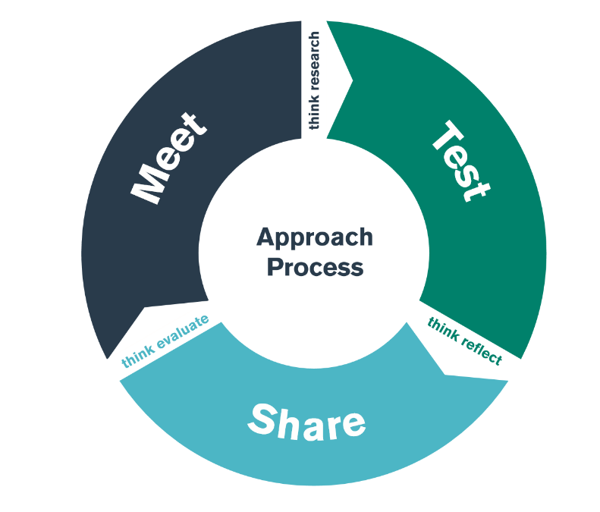

Emotional Development
TEST Day

Student-Teacher Enquiry Evidence Record

11th November 2019

What is the purpose of the ‘EMOTIONAL FOCUS’ bridging activity?

By the end of the ‘Emotional focus’ TEST day, you should have an understanding of some of the strategies, policies and approaches that the school use to ensure the emotional development of their learners, especially within the Foundation Phase.

How does the school develop children’s emotional wellbeing?

Which policies include children’s wellbeing as a focus?

What does/ do the policy/cies state?

How is the importance of children’s wellbeing evident throughout the school/ class? (eg posters/ charts)

How do staff get to know their children? What approaches / strategies are used to find children’s likes/ dislikes/ interests/ talents etc? How are these interests and likes used to aid development/ progress?

How are children made to feel special?

What do the staff do to create a classroom climate that promotes self-esteem?

How does the physical environment of the classroom promote self-esteem? Are there specific resources that aid this?

What strategies do staff utilise to support children who are less emotionally secure?

How do staff enable children to acknowledge and express their feelings?

What strategies do staff use to avoid temper tantrums and manage anger?

Did you see any of the following:

Activity/ Strategy | Where?/ With who? | Purpose/ Aim
Mindfulness

Circle time

Independent choices

Positive responses & praise

Let’s share
(personal news)

Other strategies observed
Comments / Observations

