Workshop Skills Logbook

Aaron Bell
Student No: 2410529

L4 - Workshop Skills
ACDA4022

Electrical & Electronic Engineering Degree Apprenticeship

Contents
1 - Introduction 3
2.0 - Proteus Circuit Design and Simulation 3
2.1 - Initial Circuit Design using Proteus 3
2.2 - Circuit simulation and data collection 4
3.0 - Breadboard Plan, Build and Test 6
3.1 - Bread-boarding the circuit 6
3.2 - Testing the breadboard 7
4.0 - PCB Design, Build and Test 8
4.1 - Designing the printed circuit board 8
4.2 - Building the circuit board 8
4.3 - Testing the circuit board 9
5.0 - Conclusion and final remarks 10

1 - Introduction
The following lab report demonstrates the processes taken to simulate, breadboard and assemble a circuit board for a non-inverting amplifier circuit.
The process begun with circuit simulation using proteus, where measurements were taken with virtual versions of lab equipment, these measurements were plotted and a graph demonstrating the gain-bandwidth product was created.
Following from that a breadboard was designed and built, tested with physical lab equipment and measurements plotted in a manner consistent with the simulation.
Lastly, the PCB followed in a similar manner to the breadboard. Being soldered, then tested with the same equipment and the same numbers used to test the breadboard. Results were also plotted in a manner consistent with the two previous graphs.

2.0 - Proteus Circuit Design and Simulation

2.1 - Initial Circuit Design using Proteus
I was given the design of the circuit and values of components, which I replicated in my own proteus file with no changes that would affect its behaviour, other than small changes to the placement of junctions.
I then had to go through the menu and find the correct op-amp IC that was required for this circuit as well as selecting generic components like resistors and amending the value as and when they were placed into the circuit schematic
I attached a virtual signal generator and virtual oscilloscope to the design, changing the frequency parameters and sampling time on the virtual generator and scope then allowed me to simulate the circuit with parameters of my choice and take measurements of the gain. These measurements were put into a spreadsheet and a graph was created.
I had to go back at the end and find the maximum gain * RMS (Root mean squared being 0.707) to find the 3dB point required to be able to interpret the operating bandwidth of the op-amp.

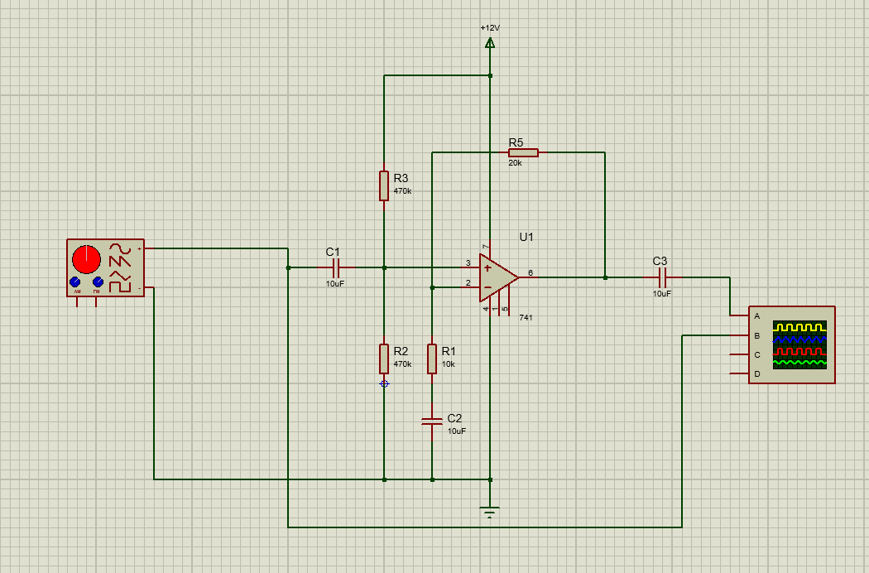
Figure 1 – Displaying a circuit schematic for a power amplifier, with a signal generator on the left hand side and a digital oscilloscope on the right.

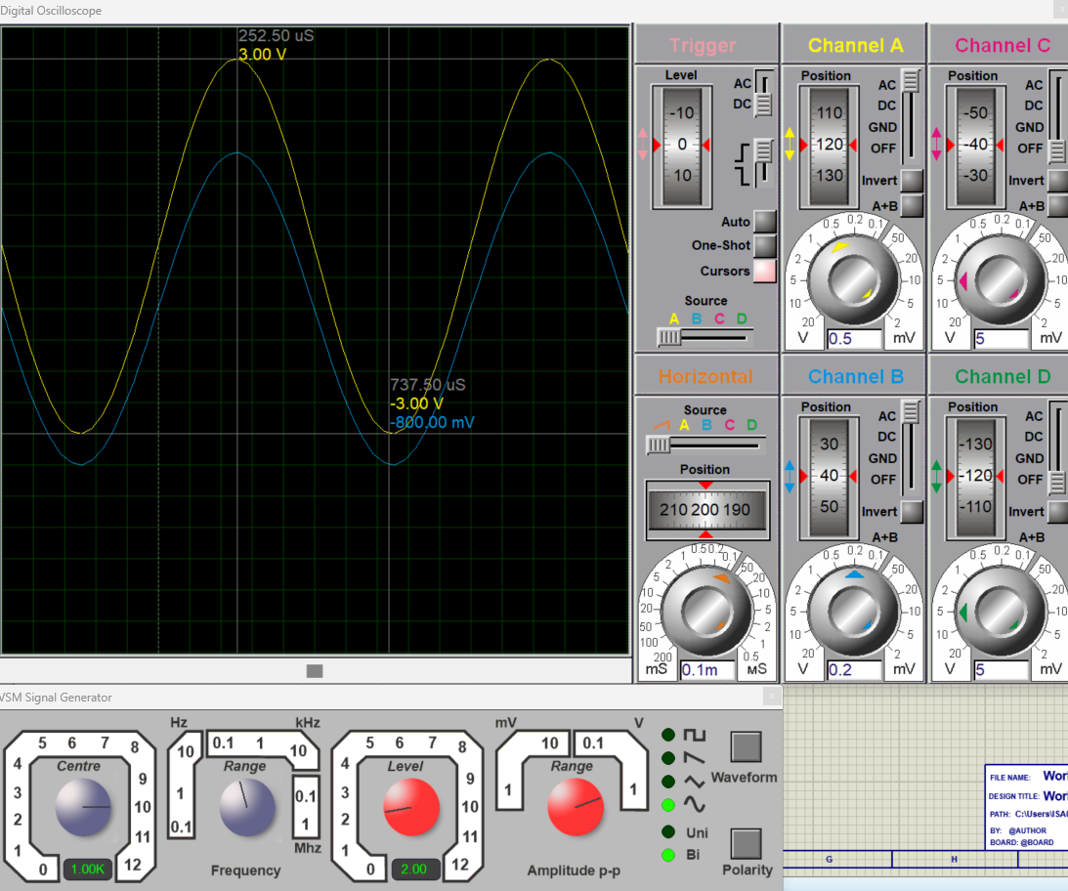
2.2 - Circuit simulation and data collection
Figure 2 – Simulated Digital Oscilloscope (top) and Signal Generator (bottom left) in Proteus

Once my circuit design was complete in proteus, I then needed to simulate the circuit with different values to find the performance of the integrated circuit op-amp being used, this was done using the signal generator and digital oscilloscope. This is where I then simulated two different op-amps so I could decide which one might be better for my circuit. I lacked a little bit of understanding here and didn’t investigate any more op amps or look at compatibility with my circuit, it might be better in the future to seek datasheets from the manufacturer to allow more thorough reasoning on my end.
Figure 2 shows the simulated signal generator (bottom left) with a setting of 2V (red dials) and 1KHz (blue dials). In order to test the output of the op-amp, firstly the resolution of the scope had to be tuned so that a full sine wave was visible such to allow for peak to trough measurements to be taken. There was a point where both op-amps I tested began to show a drop off in performance, this point was found to be around 5KHz, hence I stopped the simulating from 10KHz onwards each value was recorded, it was recorded in a table on Microsoft Excel. With the columns being as follows: Frequency in hertz, voltage input, voltage output and gain in dB.
Gain in dB was calculated from the data in Vin and Vout via the following formula:
$$Gain \left(dB\right)=20log⁡(\frac{Vout}{Vin})$$
This then allowed for clear presentation of the data and the comparison of the op-amps performance across the same frequency range.
Figure 3 and figure 4 show the results of my circuit simulation in proteus for the 747 and LM741 respectively. This enabled me to decide that the LM741 gives me a better performance and was indeed the better choice for this circuit. I then used excel to graph the results of both op-amps gain in dB with respect to frequency using a logarithmic scale to allow others to easily interpret my data.

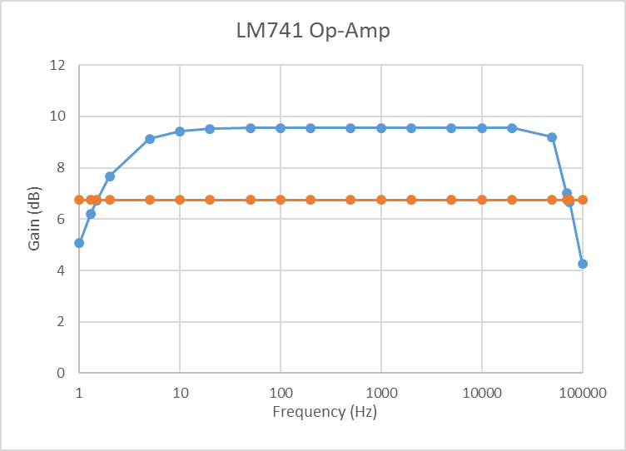
Figure 3 - Graph of results for the proteus circuit simulation showing Gain over Frequency (Blue) and 3dB point (Orange)

3.0 - Breadboard Plan, Build and Test

3.1 - Bread-boarding the circuit

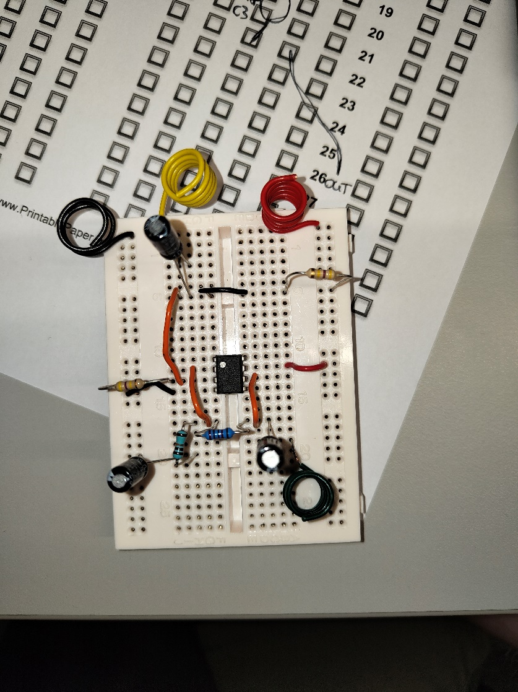
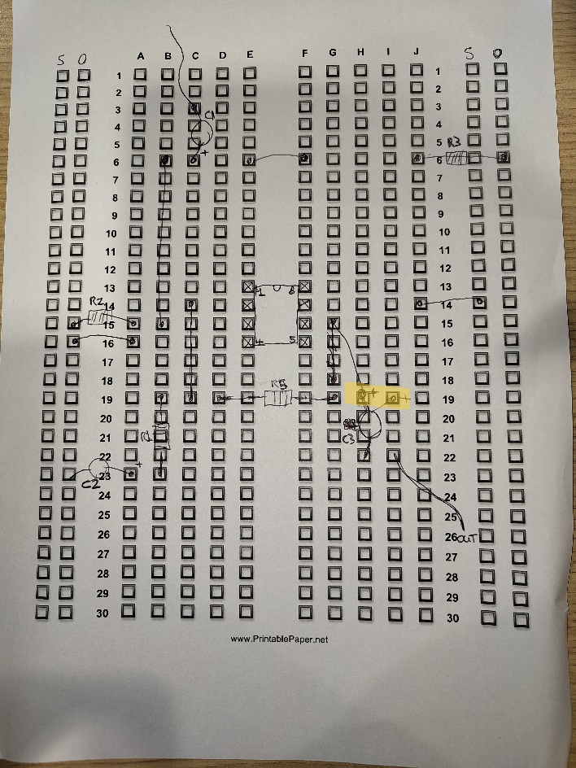
Figure 4 – Planning of the breadboard circuit (left) and the completed breadboard (right)

Firstly, I planned a design on my breadboard on a sheet of A4 paper with a breadboard layout printed on it. This allowed me to cleanly plot out my design without getting too confused where wires and components would go, because I had it figured out beforehand. I did make a slight error (highlighted in orange in figure 5), which wasn’t so much an error but for cleanliness reasons I “corrected” it to move the capacitor so it was neatly slotted vertically rather at a slight diagonal angle.
After planning my breadboard design, I then filled a breadboard with the components as they were listed from my proteus design. However one thing I would probably change here, is that rather than just writing “R1” or “C2” from my previous design, it would be better in the future to also list the component values on the breadboard design sheet, to avoid any possible ambiguity. I had slight confusion over the values but with the reference of my schematic was able to figure out where I thought the components should be going.

3.2 - Testing the breadboard
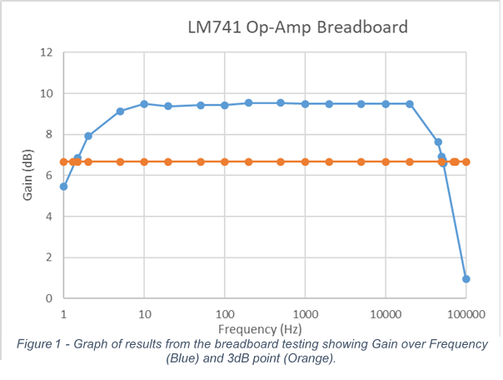
When it came to testing the breadboard I connected my oscilloscope to the SIGIN and SIGOUT, connected a variable DC power supply at 12V and attached all my grounds to a common ground. Initially there was no feedback on either SIGIN or SIGOUT and I asked for help, it was pointed out to me that one of my capacitors was off by one hole and needed to be moved up a row and that I had for my power input confused and had to move that over and move a resistor to ground.
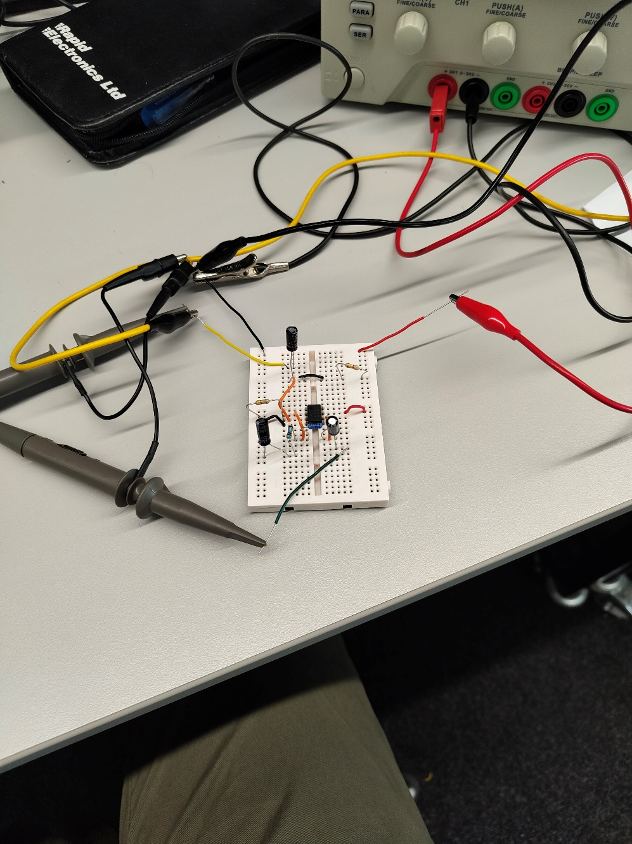
Following these amendments to the circuit, it was functional as I was able to take gain measurements using the oscilloscope, plot them on a spreadsheet using Microsoft Excel and create another logarithmic plot as shown in Figure 5.
Figure 6 - Image of the breadboard after amendments and in working order with probes attached
Figure 6 shows the connection of my probes during the testing, yellow is the SIGIN, blacks are 0v ground leads and red is my +12v power lead. Scope probes are attached to the green cable (SIGOUT) and yellow cable (SIGIN).

4.0 - PCB Design, Build and Test

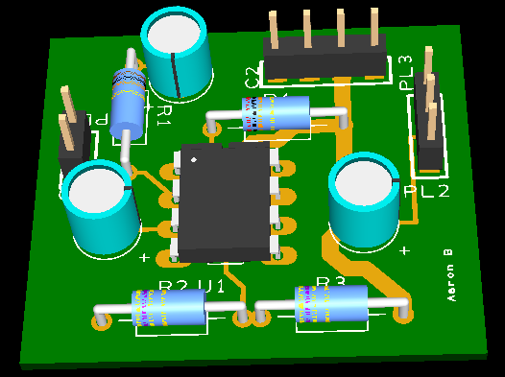
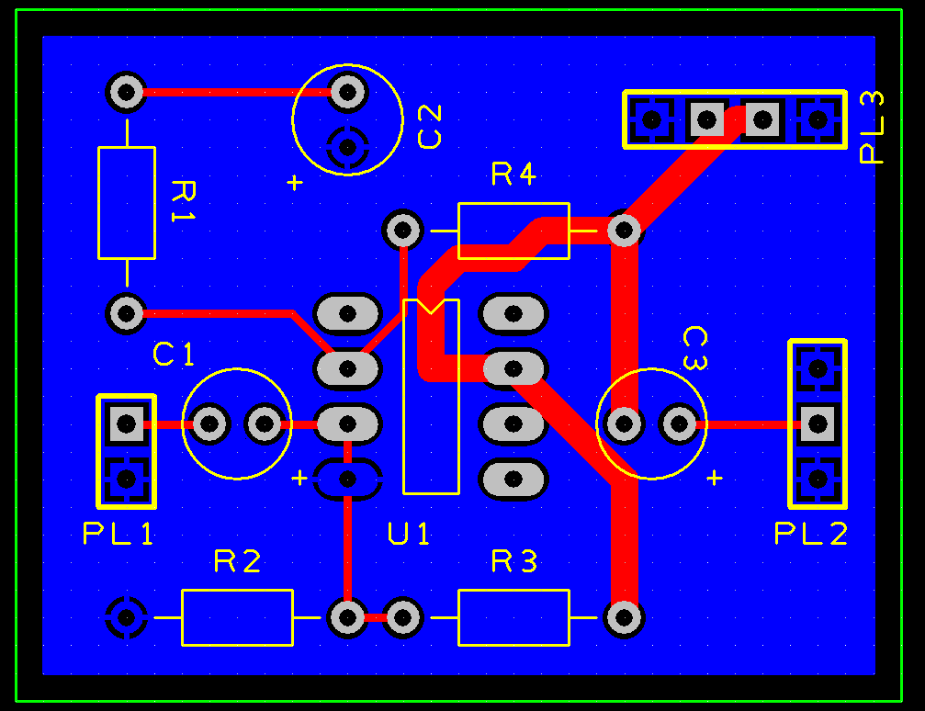
4.1 - Designing the printed circuit board
Figure 7 - PCB design shown in EasyPC
Based on my design and simulation from proteus, I chose to use the LM741 Op-Amp. This then allowed me to select the components I needed in EasyPC and design a circuit board that could be sent off for printing.
Once I had selected the components I required from the menu inside EasyPC, I first placed them on the board in a random order and it was quite messy. However I then sought to tidy it up and try to optimize my use of the space to the best of my ability, this came with the side effect of having to think more about how my traces were going to work.
After adding a copper pour onto the bottom of my circuit board to act as a ground plane I was ready to connect my traces on the top side of my board. I didn’t use auto-route and tried to keep the routing as simple as possible, this was help by advice I followed to keep all my pins to the outside of the board as best practice.
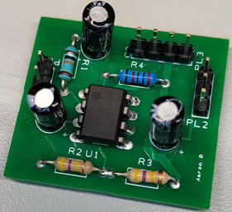

4.2 - Building the circuit board
Once my board had arrived, I needed to move the components from my breadboard prototype to the PCB. This process itself went smoothly, I used a rosin pen to allow the solder to stick better, however struggled with the soldering iron as I found its tip to be an awkward type and the lack of temperature control created some dull joints from where I had got the solder too hot.
I made a mistake by soldering the headers last, since I had previously soldered the capacitors it meant I could not balance the board on the headers and had to hold the board and push the headers by hand to get them to stick. This had to be done quickly as the headers got very hot when I holding them. Once everything was soldered, I came to realise that my 4-pin and 3-pin headers were too close together and I was unable to connect both connectors, so I had to connect probes directly to the header pins instead of using a cable for the SIGOUT, but this didn’t cause any inconvenience.
Figure 8 - Soldered PCB

4.3 - Testing the circuit board
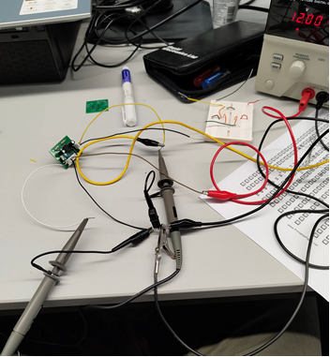
When it came to testing the circuit board, I connected up my power and attached oscilloscope probes to my SIGIN and SIGOUT pins, using the common ground that was coming directly from the power supply. I noticed that the oscilloscope showed a sine wave for SIGIN but there was absolutely no output from SIGOUT. It was realised that the PCB design was incorrect and I needed to drill away some of the traces that were incorrect and attach jumpers on the bottom of my board to act as the correct traces.
Figure 9 - Incorrect circuit board being tested
After successfully making these amendments I then had a flattening of the peak of my SIGOUT, and it was realised that two capacitors had been placed incorrectly resulting in a signal that was not usable and did not have a peak since it was flattened by the incorrect capacitor placements.
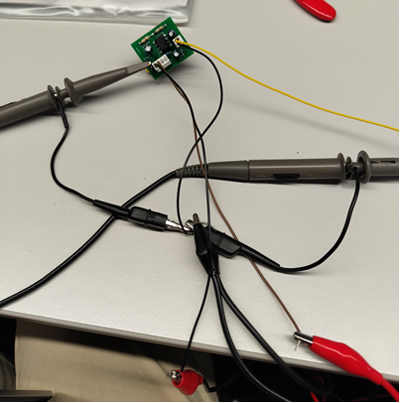
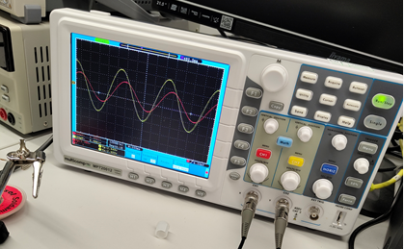
These capacitors were then replaced and soldered into the board the other way round, after connecting the probes back up the output signal was then functioning as intended and measurements were taken.
Figure 10 - Image showing oscilloscope with a gain on the signal out

Figure 11 - Amended breadboard being tested

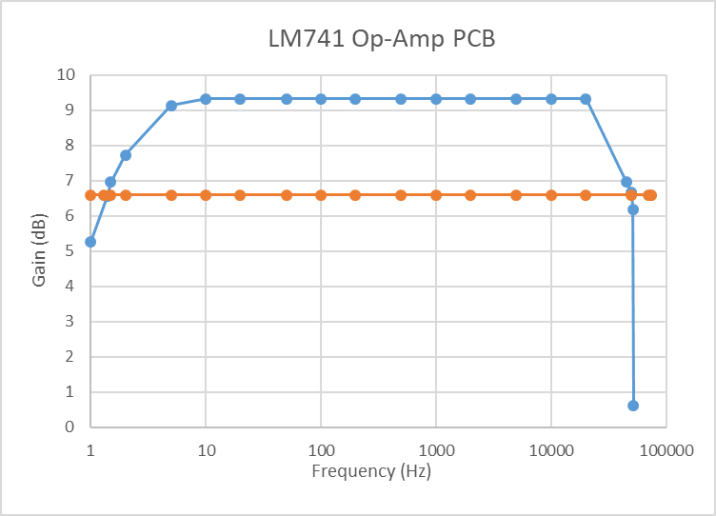
Shown below is the final graph from the testing of the circuit once it was all in working order, this biggest difference I noted from the circuit simulation was that the gain appears to drop off much faster than in my proteus simulation, however the rest of the points seemed to match up relatively well with my initial simulation.
Figure 12 - Graph showing the Gain over Frequency (Blue) and 3dB point (Orange) of the PCB

5.0 - Conclusion and final remarks
To conclude this logbook, my design encountered a few problems during both the breadboard and PCB phase. Here’s a summary of those errors and how they were corrected.
During the testing of my breadboard, there was no output signal coming from my SIGOUT area of the circuit, it was discovered that the cleaning capacitor, with the purpose to smooth the incoming power signal was connected to an incorrect row on the breadboard. In addition to this error, I had muddled the power columns, with ground being connected to the wrong place and input voltage also being incorrectly placed. Luckily both these mistakes were easily corrected by simply moving around the placement of cables and components to correspond with the correct columns and rows.
During the PCB testing there were some major issues discovered, as I had traces on my board that were incorrect and would need removing. Hence, three traces were removed, those between the 4-pin header and C3, between C3 and R3 and finally between R4 and a pin on the op-amp. Following the removal of these traces, three jumper cables were soldered on the bottom of the board to allow for correct function of the circuit. However, problems persisted with myself experiencing a flattening of my output wave on the scope, after asking for help from someone more experienced and taking note of them probing areas of the board with the scope, it was concluded that I had also designed the board with two capacitors in the wrong polarization, hence these were desoldered and replaced the correct way around. Following this last amendment the power amplifier circuit performed as intended.

