  Component One: Student Journal (learning log) 750 words +/- 10%  Contribution to Overall Module Assessment: 25% | Student No: | Mihai Serban  2244688
 | Module Title: | Hotel Placement - Operating Hotel Facilities
 | Module Code: | BMIH4006
 | Lecturer:
  Lisa-Marie Bassler
Introduction
Over my time working in the housekeeping department, I went on a journey that involved significant personal and professional growth as well as self-discovery. I will use the Gibbs Model of Reflection to analyse the details of my experience in detail in the upcoming journal. I will explain the work completed, feelings felt, abilities developed, and the significant impact it has had on how I view the hospitality sector within its parameters.
Description
In the housekeeping department, I played various roles which entailed ensuring that the guest rooms are clean and well-maintained as well as ensuring the orderliness of public areas such as the washrooms, dining areas, lobby, corridors, conference and ball rooms among others. These responsibilities played a very essential role in enhancing the overall guest service experience. In addition, attention to detail was paramount in upholding the standards of the hotel, as even the slightest error could affect the satisfaction of the guests.
Feelings
In the beginning of my placement, I was both anxious and eager about starting this new experience. But over time, as I grew more cautious and committed to the parts I played, I started to feel confident and satisfied with myself. I worked hard to make sure my job was nearly flawless, and my supervisor's encouraging comments gave me a lot of confidence. Nevertheless, I faced a number of difficulties, particularly in the beginning, with time management and critical thinking. In order to fulfil my responsibilities at the housekeeping department, I had to come up with solutions for unforeseen circumstances and fulfil tight deadlines. However, I took comfort in the established teamwork and communication, and I felt energised by the fast-paced atmosphere, which motivated me to give my best in every capacity.
Evaluation
After giving my performance in the housekeeping department some thought, I was able to pinpoint both my strengths and my areas for development. I demonstrated my dedication to excellence by performing my duties efficiently and on time. I also said that in order to make sure that every guest is satisfied, every detail must be paid attention to. These were admirable qualities that, on the whole, helped the department succeed. Time management was, nevertheless, a significant difficulty for me. To maintain the efficient operation of the business, the housekeeping department must complete a number of jobs. Occasionally, I would finish a task later than expected, which would cause another work to be postponed. Therefore, I embraced the need for improvement in my time management skills to handle multiple tasks efficiently. Also, with time, I came to realize that improving communication and teamwork with my colleagues would foster better teamwork and streamline operations.
Analysis
My placement experience in the housekeeping department provided various invaluable insights into the crucial role of the housekeeping department in enhancing the satisfaction of guests. I realized that every task, regardless of how minute or insignificant it seemed, contributed to the overall impression guests have of the hotel. From the cleanliness and organization of rooms to the presentation of common areas, each aspect plays a vital role in shaping the guest experience. Gaining this understanding deepened my appreciation for the meticulous work carried out by housekeeping staff.
Conclusion
In conclusion, my placement in the housekeeping department has been a transformative experience, both personally and professionally. Through the experience gained while carrying out my roles, my perspective regarding the hospitality industry has broadened. I have come to understand the importance of teamwork, attention to detail and continuous improvement. I have gained a passion to deliver exceptional service in all the tasks I carry out. Through the skills I have gained, I am confident that I am equipped in my future endeavors within the hospitality sector.
Action Plan
Moving forward, I am committed to continuous growth and development within the housekeeping department. To improve my skills and knowledge further, I intend to enroll on various training programs and workshops that focus on time management and communication. In addition, I will actively seek feedback from supervisors and colleagues to point out the specific areas that call for further improvement and employ the specific strategies that enhance improvement. Through the desire to being open to learning and development, I am confident that I will excel in my role and make meaningful contributions to the success of the housekeeping department and the overall guest experience.

Component Two: Health and Safety Guide
Contribution to Overall Module Assessment: 25%

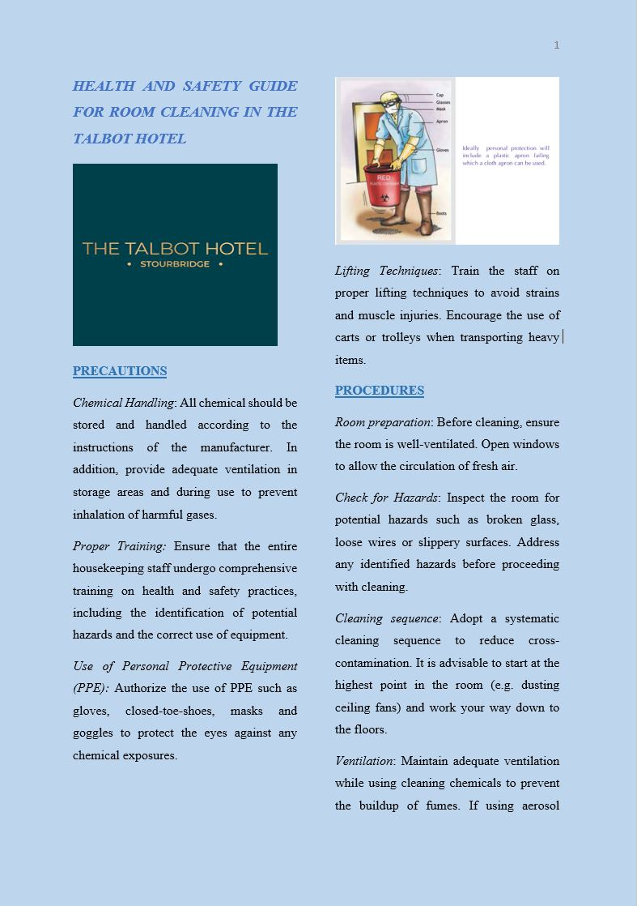

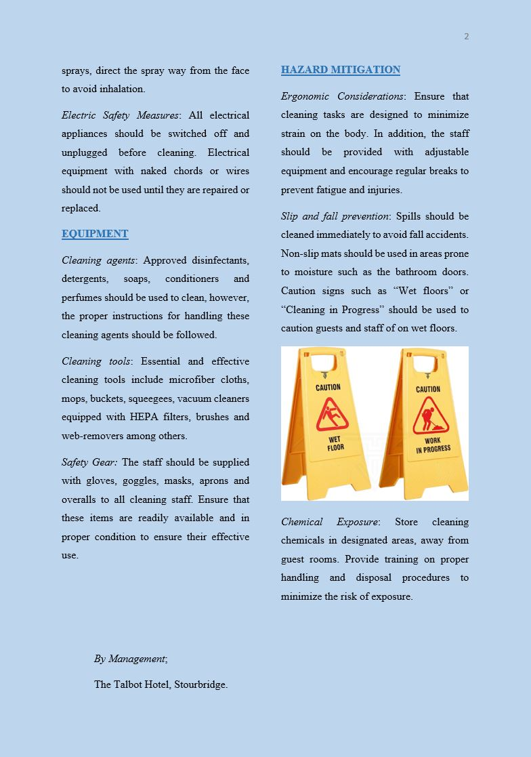

Reference List

He, K. N., Parkinson, L., & Doyle, A. K. (2018). Gibbs’ Reflective Cycle.
Mullins, L. and Dossor, P. (2013) Hospitality Management and Organisational Behaviour. 5th ed. Harlow: Pearson.
Raghubalan, G., & Raghubalan, S. (2009). Hotel housekeeping: Operations and management. Oxford University Press.

